Meeting commenced at 1.45pm.

BUSINESS:

1) Apologies

2) a. Confirmation of Minutes of the Meeting held 18th July, 2013.
b. Matters arising out of Minutes. (Not elsewhere reported)

3) Correspondence
a. Agenda A (Information Only)
b. Agenda B

4) General Manager’s Report
4.1 General Manager’s Report
4.2 Executive Manager, Corporate & Community Services’ Report
4.3 Executive Manager, Engineering & Technical Services’ Report
4.4 Deputy General Manager, Planning & Environmental Services’ Report

5) Reports: Delegates/Mayor/Councillors

6) Recommendations of a Committee of a Whole Meeting held 15th August, 2013.

7) Recommendations of the Noxious Weeds Meeting of Coolamon, Junee & Temora held 30th July, 2013.

PRESENT: Clrs Seymour (Chairman), Logan, Brill, Huxtable, White, McCann and Hutcheon.

STAFF: General Manager; Executive Manager, Corporate & Community Services; Executive Manager, Engineering & Technical Services; Deputy General Manager, Planning & Environmental Services.

APOLOGIES: Clrs Beard and Maslin.

1) APOLOGIES

RESOLVED on the motion of Clr McCann and seconded by Clr White that the apologies of Clrs Beard and Maslin be accepted. 187/08/2013

2a) CONFIRMATION OF MINUTES OF THE MEETING HELD 18TH JULY, 2013.

RESOLVED on the motion of Clr McCann and seconded by Clr Brill that the Minutes of the Meeting held 18th July, 2013 as circulated be confirmed and adopted. 188/08/2013

3) CORRESPONDENCE

AGENDA A (FOR INFORMATION ONLY)

1a) INFORMATION PAPERS

➔ The following papers have been distributed with Council’s supplementary material as being matters of information/interest to Councillors. If Councillors desire any further information on the matters distributed then that can be raised with the General Manager. Attachment No. 1

1) Local Government NSW Weekly Circulars 28, 29, 30 and 31.

2) NSW Government Weekly Updates from Adrian Piccoli dated 5 July 2013, 12 July 2013 and news updates from NSW in Focus.

3) Media Release from Local Government NSW titled Councils oppose merger focus of Future Directions Paper.

4) Minutes of the Coolamon Showground Management Committee Meeting held 20th June, 2013.

2a) ACTIVITY REPORTS

1) Coolamon Shire Multi Service Outlet Coordinator’s Monthly Report for the month of July 2013.

2) Operating Statistics of the Coolamon Shire Library for July 2013.

3) Youth & Community Development Officer’s Report for July 2013.

4) Tourism & Business Development Monthly Update for July 2013.

General Manager’s Note

➔ The above reports are operating reports only for use by Senior Staff. They are submitted to Council as part of Agenda A for information only. Attachment No. 2

3a) LOCAL GOVERNMENT NSW (C.12-05)

➔ Forwarding a copy of the Councillor Professional Development Program Calendar for July to December 2013. Attachment No. 3

General Manager’s Note

A copy of the Program is distributed with Councillor’s information papers.

RESOLVED on the motion of Clr Huxtable and seconded by Clr Hutcheon that the Correspondence listed in Agenda A be received. 189/08/2013

AGENDA B

1b) NATIONAL SERVICEMENS ASSOCIATION (C.07-05)

Advising that the Wagga Wagga & Districts Sub Branch in conjunction with the Coolamon RSL have completed an exhibit of the National Service Schemes of 1951 to 1972. This exhibition will be perpetual record and commemoration of National Service in general, and a visible tribute to the efforts of Riverina members.

There will be an official opening of the exhibit on Monday, 4th November, 2013 at 2.00pm with the NSW State President, Mr Ron Brown performing the opening. Council’s Mayor, Clr John Seymour has been invited to be in attendance.

RESOLVED on the motion of Clr Logan and seconded by Clr White that the Mayor’s attendance at the official opening of the exhibit be noted. 190/08/2013

2b) MRS SONYA SPENCER, MATONG (P.01-05)

Advising Council that at a recent meeting of Matong residents the matter of researching and displaying heritage items about the town was raised as an issue. The residents are seeking comment from Council as to how this may best be achieved.

General Manager’s Note

This matter will be dealt with by Council Staff but was brought to Council to enable Councillors to be aware of the interest of Matong residents in continuing to promote their town.

This correspondence was deferred to be dealt with in conjunction with the Executive Manager, Engineering & Technical Services’ Report (ES4).

4. GENERAL MANAGER’S REPORT

4.1 GENERAL MANAGER REPORTS

GM1) RECOGNITION OF SERVICE AWARDS (S.09-01)

➔ Council at its December 2012 Meeting adopted the Recognition of Service Policy. (See Attachments). This policy is in recognition of the importance to Council of long serving Councillors and staff and awards will be presented on an annual basis at the August Ordinary Meeting of Council. Attachment No. 4

The following staff members qualify for this award:

20 Years Gail O’Brien, Peter Dennis, Clarence Hilton, Dianne Suidgeest
30 Years Don Wood
35 Years Vince Hilton

Each employee will be presented with a gift voucher and framed Certificate in recognition of their continuous service to Council. This presentation will be made at the conclusion of the Council Meeting where they will then join with Councillors and staff for afternoon tea.

Recommendation

For Council information.

RESOLVED on the motion of Clr McCann and seconded by Clr White that the Seal of Council be affixed to the Certificates of Recognition. 191/08/2013

GM2) LOCAL GOVERNMENT REFORM (L.05-05)

The Local Government Reform process is still moving along.

➔ REROC has determined the model that it sees as most appropriate to Local Government activities in this region. A paper outlining that model has been remitted to the Panel. A copy is attached to Council’s information papers. It must be accepted that the model as determined is obviously work in progress and will need refining if and when implemented. Attachment No. 5.1

➔ The Panel has recently submitted a further paper for the information of Councillors. The Panel is not seeking a submission on the paper, however, it is out there for information purposes. A copy is also attached with the information papers. Attachment No. 5.2

Recommendation

For Council information.

RESOLVED on the motion of Clr Hutcheon and seconded by Clr Brill that the report be received. 192/08/2013

GM3) REMUNERATION TO COUNCILLORS (C.12-03)

➔ Councillors are required to determine the fees payable effective on and from the 1st July, 2013. Attached is a copy of the range of fees as determined by the Local Government Remuneration Tribunal. Attachment No. 6

Council currently pays the following fees:

Mayor - $12,000
Councillor - $7,740

The highlighted section of the report being Category Rural is applicable to Coolamon Shire Council.

Recommendation

For Council decision.

RESOLVED on the motion of Clr McCann and seconded by Clr Brill that the annual fee for a Councillor be set at the minimum of $7,930 and the annual fee for the Mayor be set at $12,500. 193/08/2013

GM4) COLLECTION OF HISTORICAL DATA (H.04-01)

Some time back (2009) Council decided (Report attached) to arrange for a collection of memories from some of the Shire’s older citizens. That process did commence and a copy of the research done at that time is tabled for Council information.

The process stalled (again) probably due to volunteer fatigue and pressure of other activities. I think it is a worthwhile project to continue and it maybe one that is done on a staged basis.
I would like to reactivate the programme and I have had discussions with Clr McCann who has a personal interest in this type of work. Clr McCann and myself (on a personal level) would like to continue with this project and are seeking Council’s authorization to continue. There may be some small expenditure involved in terms of voice recording material and a laptop.

Councillors are requested to advise of people from within their own areas from which historical data can be obtained.

Recommendation

For Council discussion.

RESOLVED on the motion of Clr Brill and seconded by Clr Hutcheon that Council continue with the Collection of Historical Data project. 194/08/2013

GM5) LEASE TO THE MINISTER FOR POLICE AND EMERGENCY SERVICES (FIRE & RESCUE NSW) (F.03-12)

The Lease documents in relation to the relocation of the Coolamon Fire Station have now been obtained. The lease is for a five year term with a nominal annual rental of $1.00. Council is requested to execute the lease under the Seal of Council.

Recommendation

That the Seal of Council be affixed to the Lease Agreement between the Council and The Minister for Police and Emergency Services NSW (Fire & Rescue NSW).

RESOLVED on the motion of Clr McCann and seconded by Clr White that the Seal of Council be affixed to the Lease Agreement between Council and the Minister for Police and Emergency Services NSW (Fire & Rescue NSW). 195/08/2013

GM6) MATONG PARK (P.01-05)

Council has received letters from the Matong School and from Mrs Sonya Spencer (writing on behalf of Matong residents) concerning issues at the Matong Park.

➔ A copy of the letters have been attached to Council information papers.
Attachment No. 7

Whilst a great number of these are obviously maintenance issues and can be dealt with, it is interesting to note the enthusiasm with which the School and the Community are embracing their local assets. This point was reinforced during Local Government Week when during the course of the Mayor’s Civic Reception for School students, the representatives of the Matong Public School spoke openly and quite articulately concerning work that Council could do at their park. It wasn’t just a case of we want this or that, it was a case of it would be good if the park had such and such an asset and we as a community are prepared to work with you and help that occur.

As indicated earlier a lot of the issues raised can be dealt with under Council’s maintenance votes and those that require capital expenditure will be brought back to Council during the course of its next round of budget discussions.

Recommendation

That a letter be forwarded to the Matong Public School and to Mrs Spencer, thanking them for their interest in the Matong public infrastructure and noting that these matters will be dealt with either as a maintenance item or brought forward for Council’s next budget.

This report was deferred to be dealt with in conjunction with the Executive Manager, Engineering & Technical Services’ Report (ES4).

GM7) REROC ECONOMIC DEVELOPMENT GROUP (R.13-01)

➔ The REROC Economic Development Group has been meeting for some time and trying to glean information from businesses throughout the REROC Councils concerning their particular industries and the inhibitors to existing businesses and the promotion of new enterprises. Attached to this report is a copy of the discussions emanating out of the REROC Meeting together with a copy of the Survey of the businesses throughout the region. It was noted at the REROC Meeting that it was disappointing that the businesses throughout the region chose not to respond to the survey as in a sense it is REROC seeking information as to how it can help the businesses help themselves. Attachment No. 8

Recommendation

That the matter be noted and the Economic Development Group be congratulated and encouraged to continue their activities.

RESOLVED on the motion of Clr Hutcheon and seconded by Clr Brill that the report be received. 196/08/2013
4.2 EXECUTIVE MANAGER, CORPORATE & COMMUNITY SERVICES’ REPORTS

CS1) FINANCE REPORT AS AT 31 JULY 2013

RESOLVED on the motion of Clr Logan and seconded by Clr Brill that the report be received. 197/08/2013
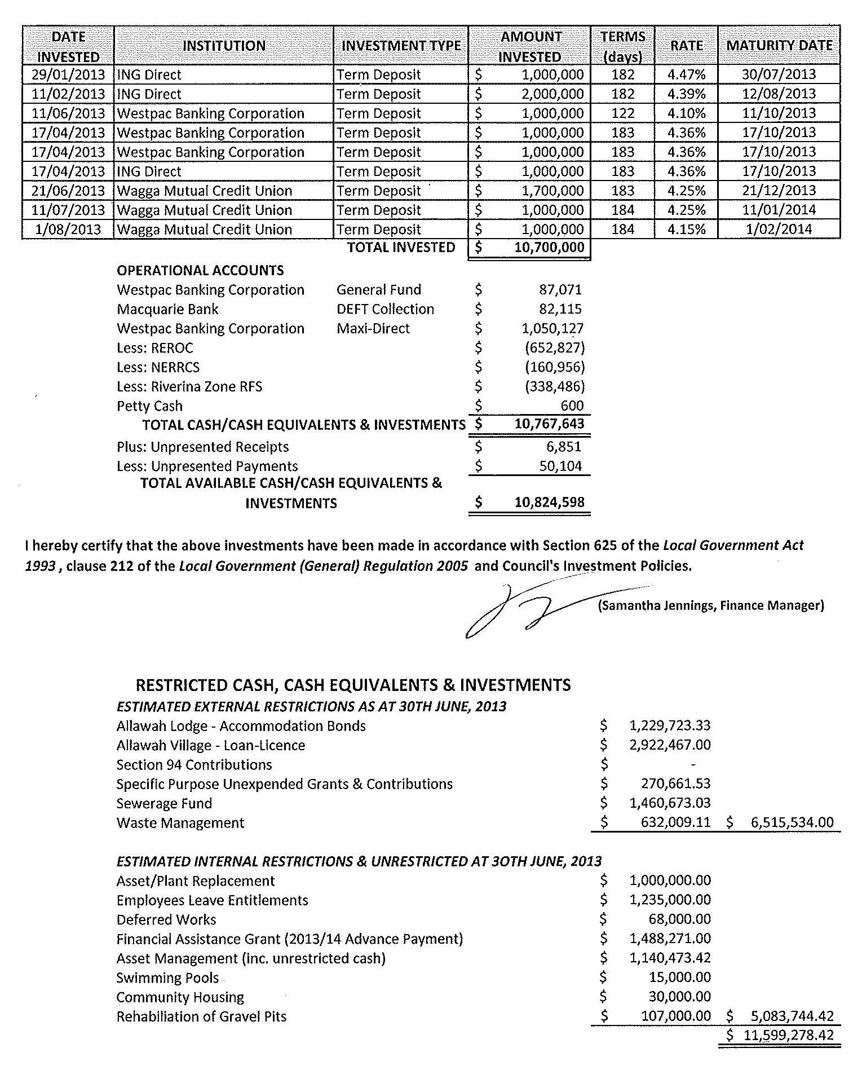
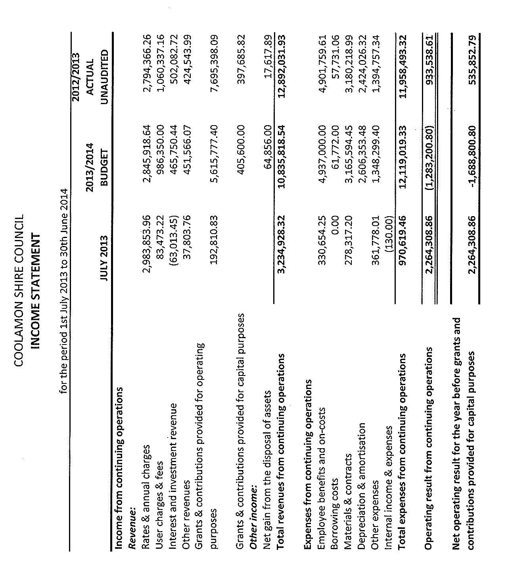
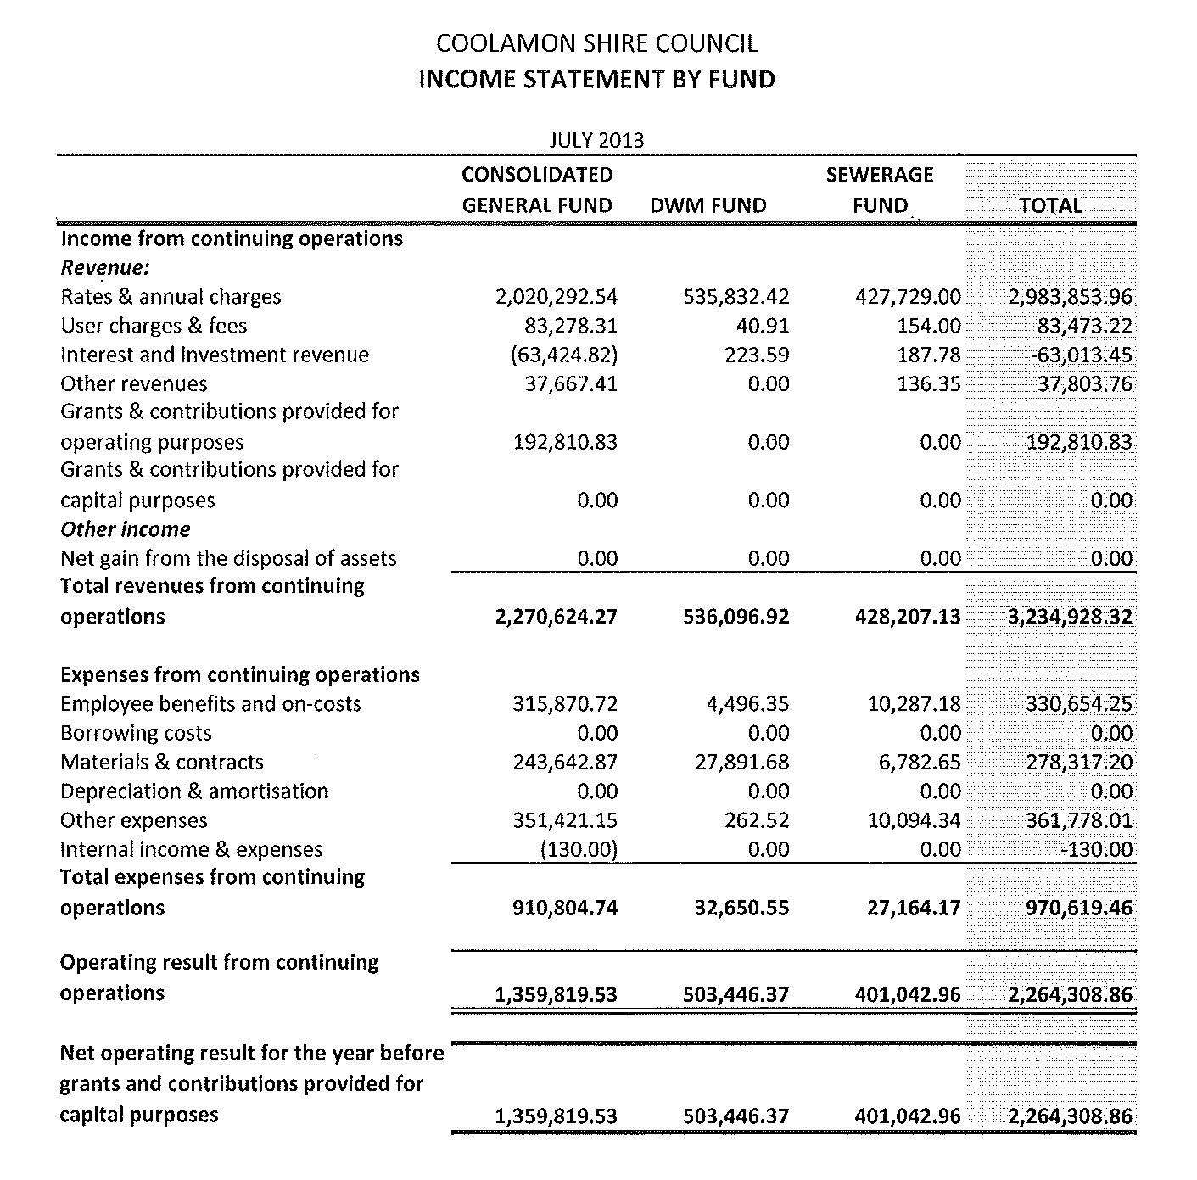
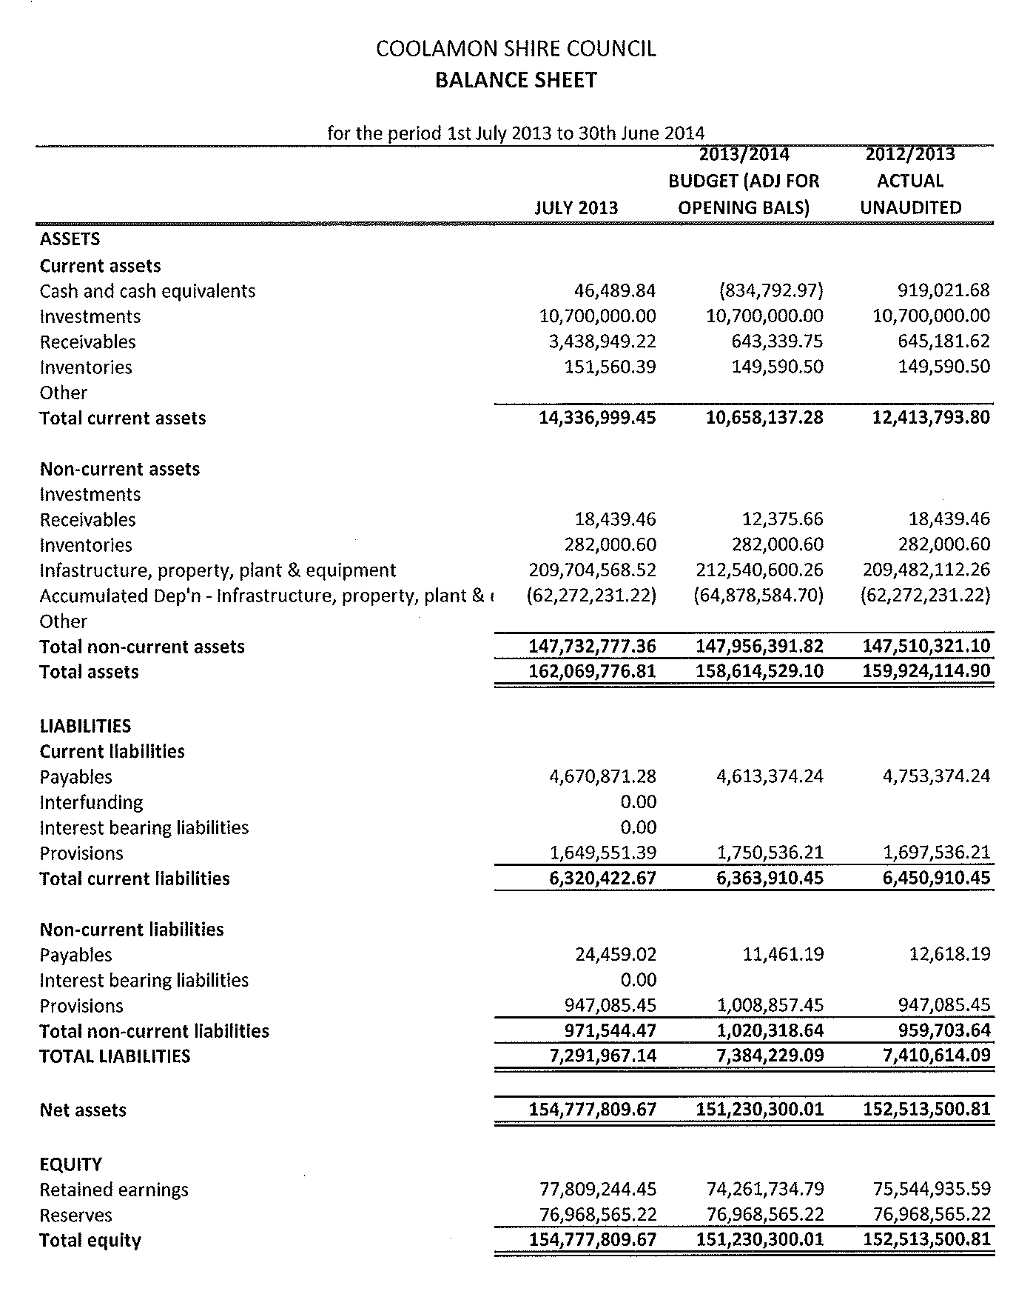
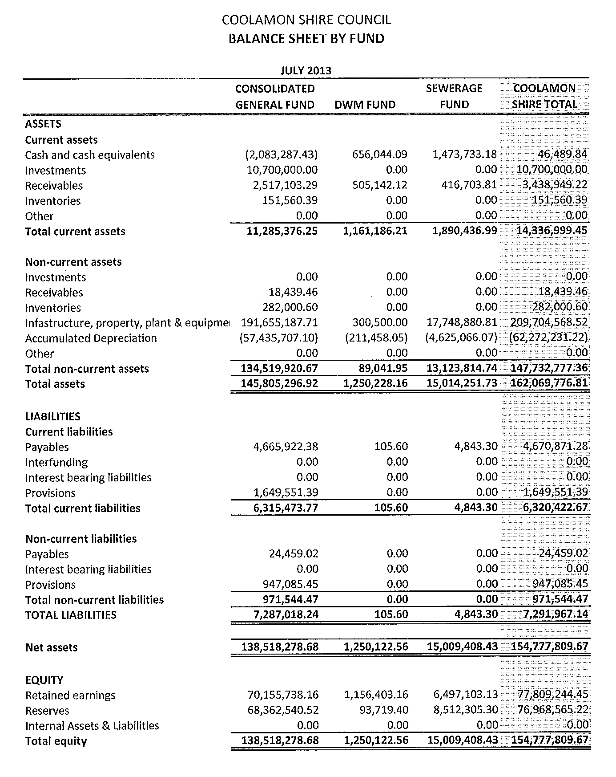
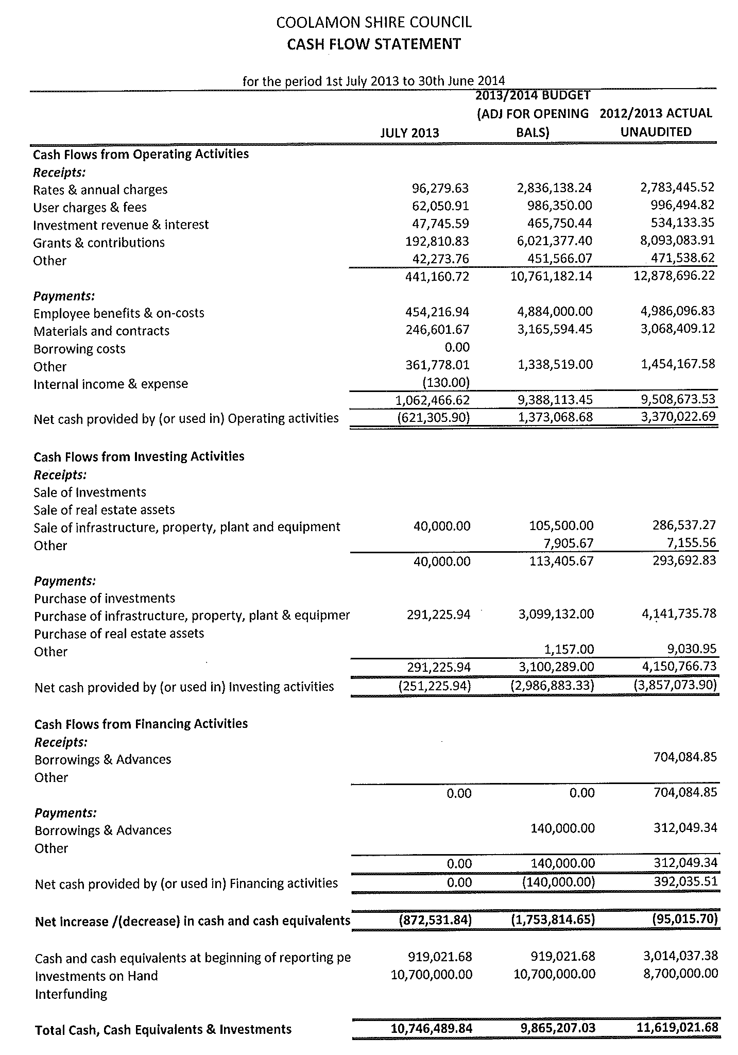
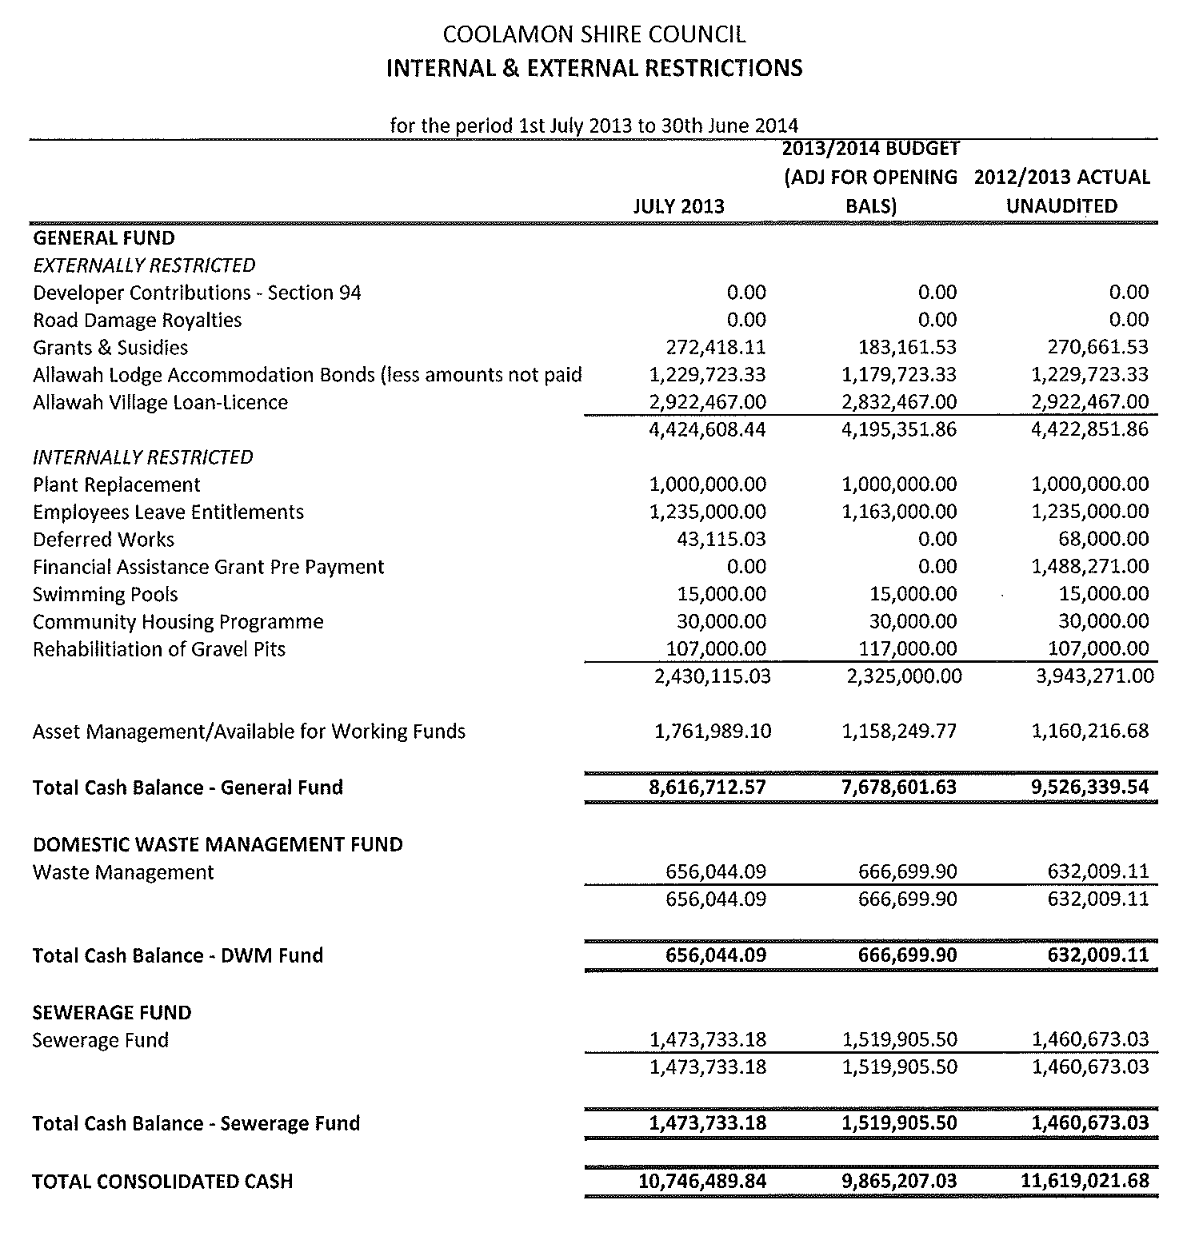
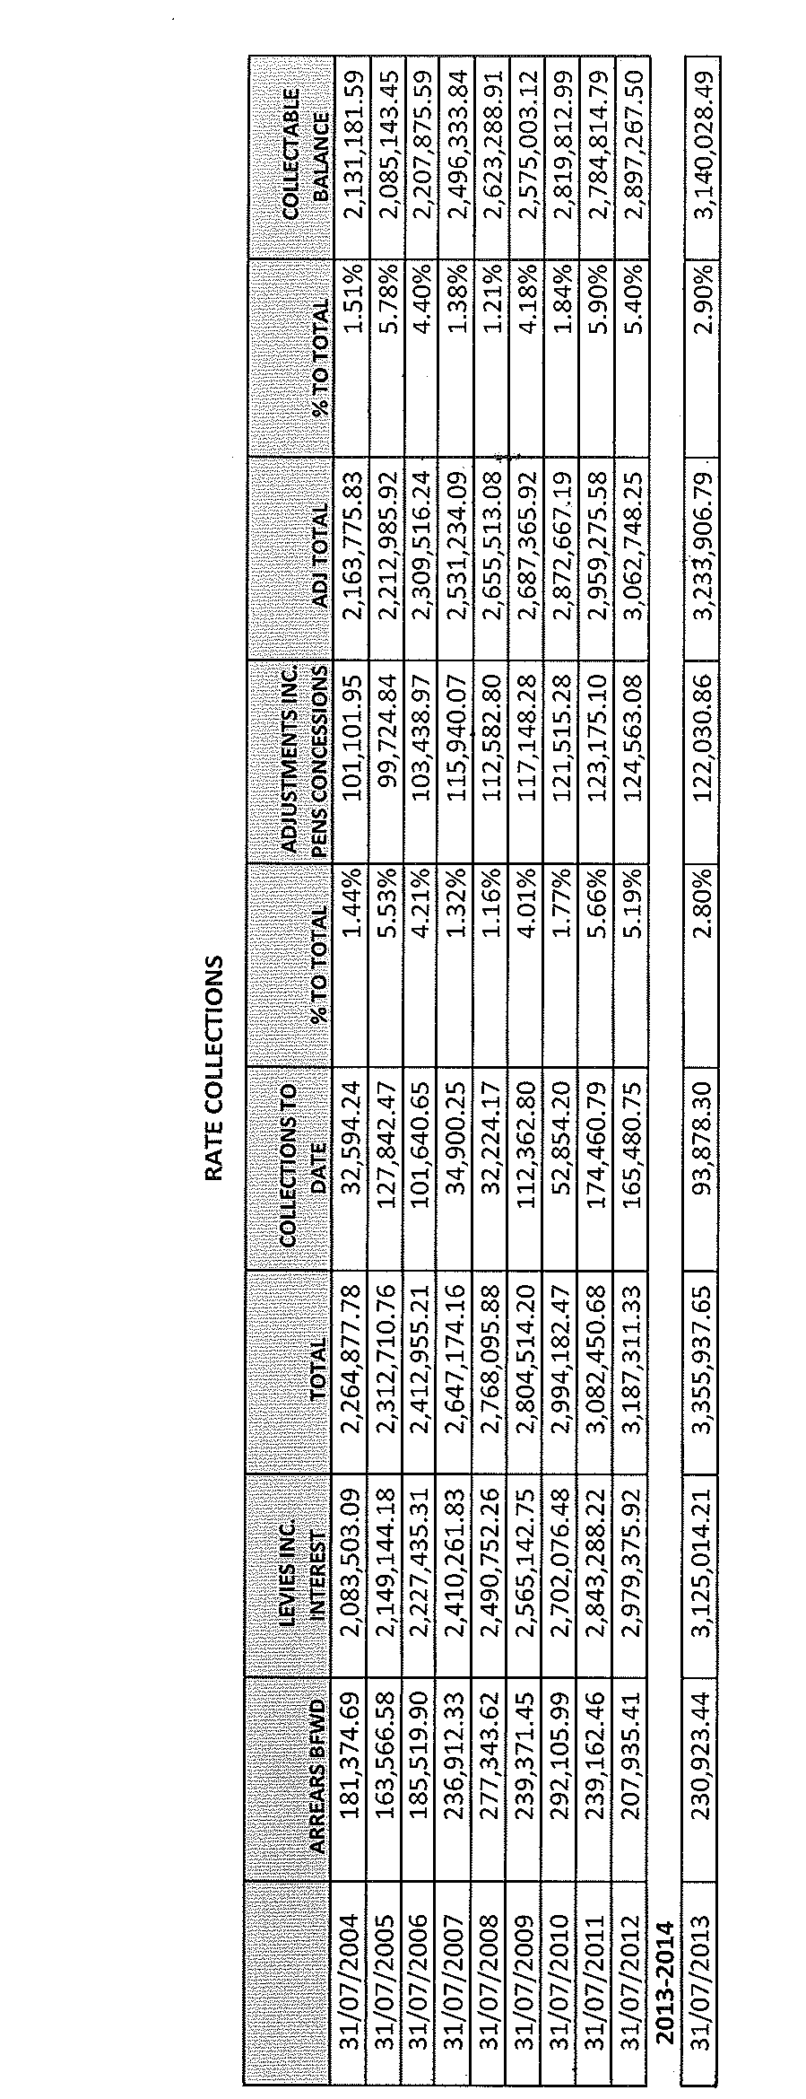
CS2) SECTION 355 COMMITTEE RESTRUCTURE (C.09-01)

Following the alterations to the Section 355 Committee Structure, Council is required to formally resolve as to what should occur with the funds held by each of the committees that no longer have delegated responsibilities under Section 355 of the Local Government Act.

The following ex-committees have advised of their financial situation;

Committee Name | Date | Bank Balance
Marrar Hall | 31 December 2012 | $ 8,603.30
Marrar Progress Association | 4 June 2013 | $ 2,753.26
Ganmain Progress Association | 31 March 2013 | $ 6,880.27
Ganmain Hall | 31 March 2013 | $ 10,230.97  Less approximately $4,000 for supper room air-conditioning
Ganmain Haystack | 27 May 2013 | $ 1,255.00
Beckom Hall | 28 February 2013 | $ 3,887.81

Council staff has scheduled a meeting with the representatives of the Advance Ardlethan Committee to further discuss the authorities delegated to them and the transfer of financial responsibilities of the Ardlethan Progress Association, Ardlethan Hall Committee, Ardlethan Cultural Development Centre and Mullins Centre Committee. The result of these discussions will be brought to Council at a later date.

Recommendation

1) That the funds held by the Marrar Hall Committee and Marrar Progress Association be transferred to the Advance Marrar Committee.

2) That the funds held by the Ganmain Progress Association remain with that organisation.

3) That the funds held by the Ganmain Hall and Ganmain Haystack committees be transferred to the Advance Ganmain Committee.

4) That the funds held by the Beckom Hall Committee be transferred to the Beckom Hall and Community Committee.

RESOLVED on the motion of Clr Huxtable and seconded by Clr McCann that: 198/08/2013

1) The funds held by the Marrar Hall Committee and Marrar Progress Association be transferred to the Advance Marrar Committee.

2) The funds held by the Ganmain Progress Association remain with that Organisation.

3) The funds held by the Ganmain Hall and Ganmain Haystack Committees be transferred to the Advance Ganmain Committee.

4) The funds held by the Beckom Hall Committee be transferred to the Beckom Hall and Community Committee.

CS3) UP-TO-DATE STORE HIRE POLICY AND FEES (H.04-06)

➔ Council has not previously adopted a policy in relation to the hire of the Up-to-Date Store and to ensure that the asset is preserved and that it is utilised for the purposes that Council intends the attached policy has been developed. Part of the policy development has also included the drafting of a more appropriate Hire Agreement that covers the terms of the hire including fees, insurance requirements and general conditions of hire. Attachment No. 9

In addition to this Council’s 2013/2014 Fees included the following in relation to the hire/use of the Up-to-Date Store

Fee | 2013-2014  (inc GST) | GST component
Hire of Up-to-Date Store per day | $121.00 | $11.00
Hire of Up-to-Date Store 4hr maximum | $60.50 | $5.50
Up-to-Date Store Cleaning Fee | $50.00 | $4.55

Given previous use of the hall for exhibitions and events, the current fee structure needs to be altered to reflect usage that may extend beyond one or two days. It is also more appropriate for a bond to be set when an event involves catering or when the hire period is for one day or more as opposed to setting a cleaning fee. The new Hire Agreement includes provisions for the use of the bond to offset cleaning expenditure or the rectification of damage. The proposed new fee schedule is as follows:

Proposed Fees | 2013-2014  (inc GST) | GST component
Hire of Up-to-Date Store 4hr maximum | $60.50 | $5.50
Hire of Up-to-Date Store per day | $121.00 | $11.00
Hire of Up-to-Date Store per week (7 days) | $550.00 | $50.00
Hire of Up-to-Date Store per fortnight | $880.00 | $80.00
Up-to-Date Store Bond | $350.00 | $0.00

Recommendation

1) That the Up-to-Date Store Hire Policy be adopted by Council

2) That the new schedule of fees and charges relating to the Hire of the Up-to-Date Store be put on public exhibition for the required period.

RESOLVED on the motion of Clr McCann and seconded by Clr Logan that: 199/08/2013

1) The Up-to-Date Store Hire Policy be adopted by Council

2) The new schedule of fees and charges relating to the Hire of the Up-to-Date Store, as detailed below, be put on public exhibition for the required period.

Proposed Fees | 2013-2014  (inc GST) | GST Component
Hire of Up-to-Date Store 4hr maximum | $60.50 | $5.50
Hire of Up-to-Date Store per day | $121.00 | $11.00
Hire of Up-to-Date Store per week (7 days) | $550.00 | $50.00
Hire of Up-to-Date Store per fortnight | $880.00 | $80.00
Up-to-Date Store Bond | $350.00 | $0.00


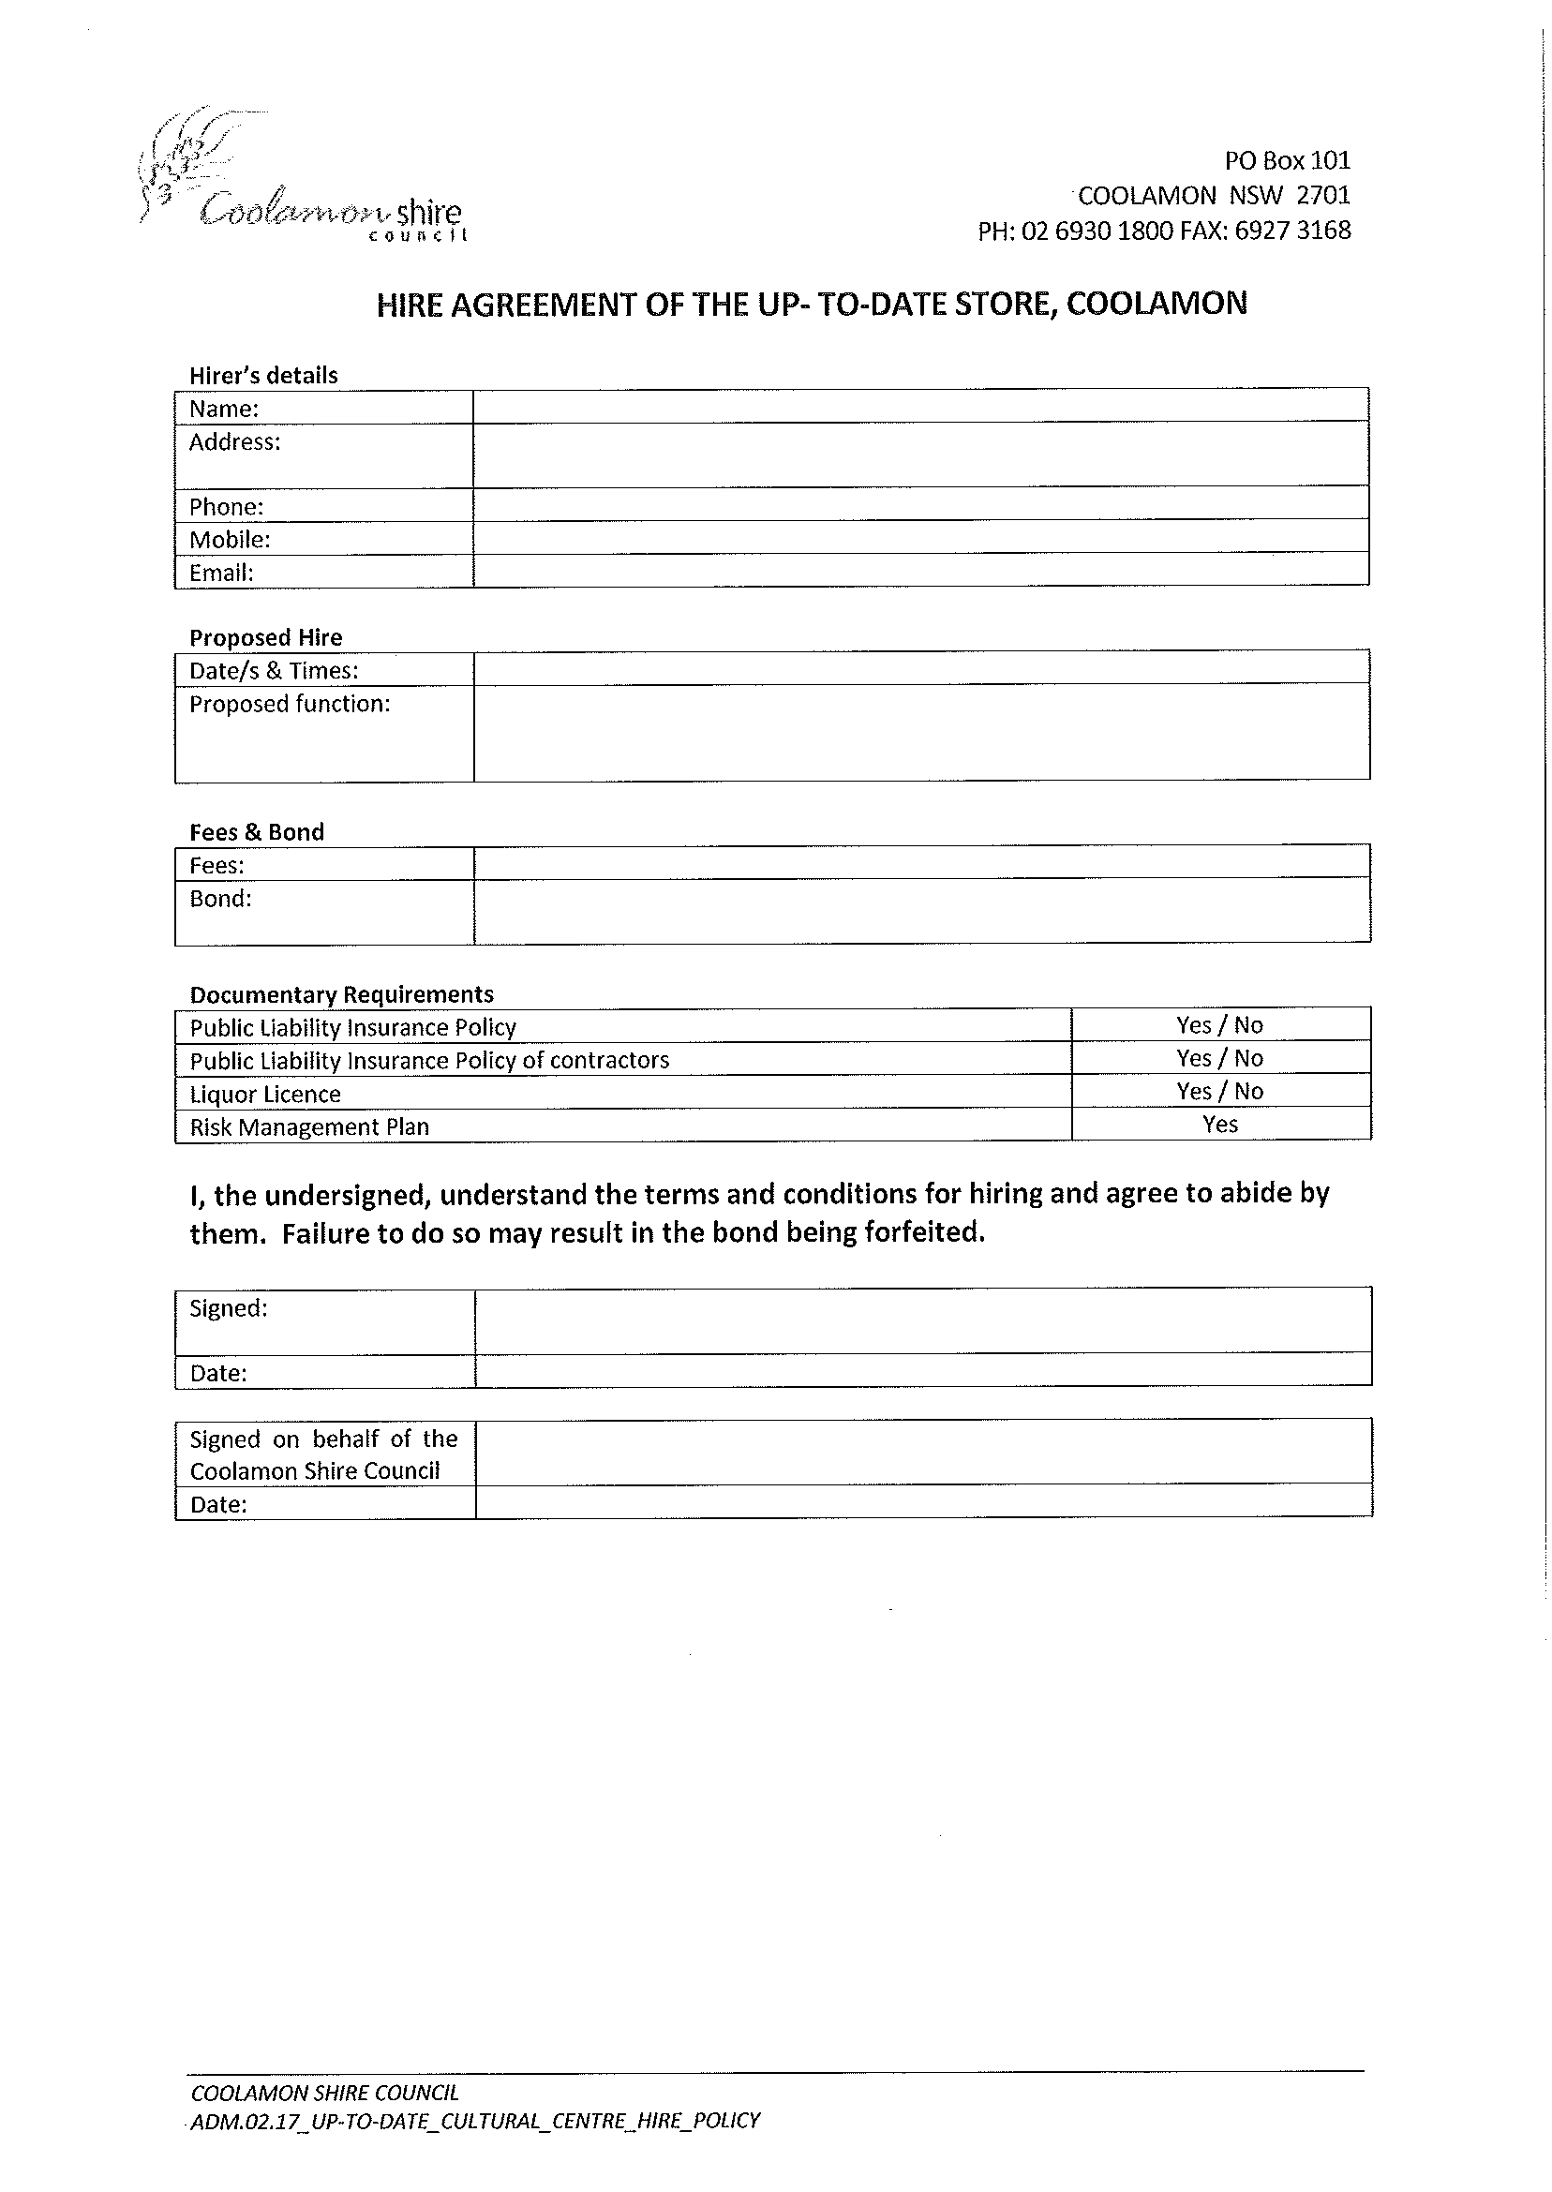
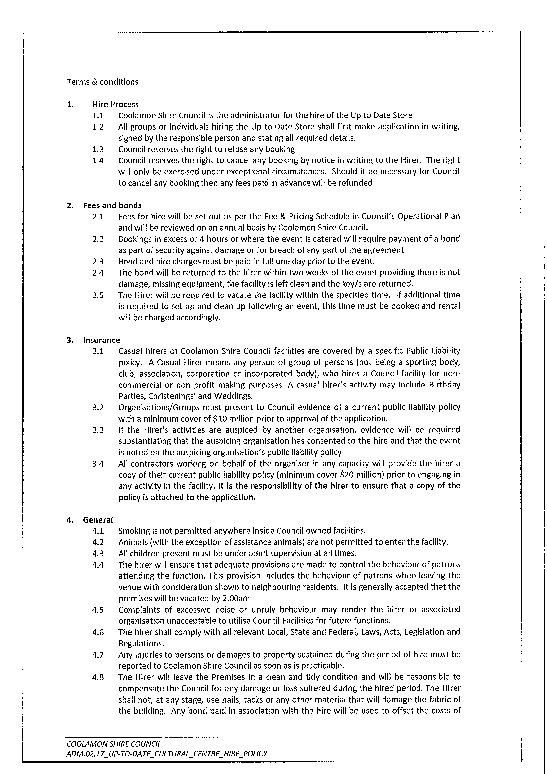

CS4) POLICY REGISTER REVIEW (P.12-01)

➔ The following policies are presented to Council as part of the review of Council’s Policy register: Attachment No. 10

Payment of Expenses & the Provision of Facilities for Mayors & Councillors

Under the provisions of the Local Government Act, Council must, within 5 months after the end of each year, adopt a policy concerning the payment of expenses incurred and the provision of facilities to the Mayor and Councillors in relation to their civic role.

The process requires that public notice be given of Council’s intention to adopt the policy.

The existing policy, with a minor proposed deletion has been attached for Council’s information.

Policy Review

The following policies are presented to Council, with recommended marked amendments. See attachments

Pensioner Rebates for Rates and Charges Policy – minor amendments relating to review.

Rates & Charges Hardship Policy – minor amendments relating to review.

Plant Replacement Policy – following the recent internal audit into heavy plant and the report presented to the July 2013 meeting of Council, the recommended alterations have been made regarding the replacement cycle of steel drum rollers.

Policies to be Removed

Preschool Service Charge Policy – This policy was in place prior to the formal lease arrangements with the Coolamon and Ganmain Preschools. Both lease arrangements deal with monies payable by Council and the preschools and therefore this policy is no longer required.

Aged Persons Accommodation Vacancies Policy – This was policy was in place when the Section 355 Committee existed to review applications for Council’s Aged Persons Accommodation. The Section 355 committee has been removed and therefore the policy is no longer required.

Coolamon Early Childhood Centre Policies – a certain number of the policies adopted for the Coolamon Early Childhood Centre are related to operational issues and are therefore not required to be included in Council’s Policy Register.

These include:

- Administration of Medication
- Evacuation Policy
- Guidance & Discipline Policy
- Antidiscrimination Policy
- Communication Policy
- Staff Relationships with Children Policy
- Sun Smart Policy
- Supervision Policy
- Transition to School Policy
- Dental Policy
- Arrival & Departure Policy
- Clothing Policy
- Media Policy
- Behaviour Guidance & Management Policy
- Open Door Policy
- Nappy Changing & Toileting Policy
Feral Animal Trap Policy – this is the general operations that apply to the hire and use of Council owned feral animal traps and is therefore not required to be included in Council’s Policy Register.

Cheque Signing Policy - This document is related work practices and procedures and is therefore not required to be included in Council’s Policy Register.

Recommendation

- That Council’s intention to adopt the Payment of Expenses & the Provision of Facilities for Mayors & Councillors Policy be advertised.

- That the following policies be adopted:
  - Pensioner Rebates for Rates and Charges Policy
  - Rates & Charges Hardship Policy
  - Plant Replacement Policy

- That the following policies be removed from Council’s policy register:
  - Preschool Service Charge Policy.
  - Aged Persons Accommodation Vacancies Policy
  - Coolamon Early Childhood Centre Policies
    - Administration of Medication
    - Evacuation Policy
    - Guidance & Discipline Policy
    - Antidiscrimination Policy
    - Communication Policy
    - Staff Relationships with Children Policy
    - Sun Smart Policy
    - Supervision Policy
    - Transition to School Policy
    - Dental Policy
    - Arrival & Departure Policy
    - Clothing Policy
    - Media Policy
    - Behaviour Guidance & Management Policy
    - Open Door Policy
    - Nappy Changing & Toileting Policy
  - Feral Animal Trap Policy
  - Cheque Signing Policy

CS4) POLICY REGISTER REVIEW (P.12-01) (Continued)

➔ Attached please find donation policies relating to the payment of rates and charges by Council on behalf of a number of community organizations. These policies were reviewed at the October 2012 meeting of Council and were to be readdressed in another 12 months. Specifically, the use of the Marrar CWA rooms was to be determined. As the rates have been levied for the 2013/2014 year and the first instalment is due on 31st August 2013, it seems pertinent that they be reviewed now. Attachment No. 10

Recommendation

For Council discussion

CS4) POLICY REGISTER REVIEW (P.12-01) (Continued)

➔ Further to the section of the report dealing with the Domestic Waste Collection Charge Donation Policy and Community Organisation Rates Donation Policy, Council has received a request from the Ganmain & District Mens Shed Inc. for a rebate or reduction to the current and future rates for 71 Ford Street, Ganmain. (See attachments). Attachment No. 15

Recommendation

For Council discussion.

RESOLVED on the motion of Clr McCann and seconded by Clr Huxtable that the Draft Payment of Expenses & the Provision of Facilities for Mayors & Councillors be placed on public exhibition as required by the Local Government Act 1993. 200/08/2013

RESOLVED on the motion of Clr Hutcheon and seconded by Clr Brill that the following policies be adopted: 201/08/2013

  - Pensioner Rebates for Rates and Charges Policy
  - Rates & Charges Hardship Policy
  - Plant Replacement Policy

and that the following policies be removed from Council’s Policy Register:

  - Preschool Service Charge Policy.
  - Aged Persons Accommodation Vacancies Policy
  - Coolamon Early Childhood Centre Policies
    - Administration of Medication
    - Evacuation Policy
    - Guidance & Discipline Policy
    - Antidiscrimination Policy
    - Communication Policy
    - Staff Relationships with Children Policy
    - Sun Smart Policy
    - Supervision Policy
    - Transition to School Policy
    - Dental Policy
    - Arrival & Departure Policy
    - Clothing Policy
    - Media Policy
    - Behaviour Guidance & Management Policy
    - Open Door Policy
    - Nappy Changing & Toileting Policy
  - Feral Animal Trap Policy
  - Cheque Signing Policy
Clr White declared a non-pecuniary interest as a member of the Wagga Rod & Custom Club who have secured a “peppercorn lease” of the Marrar CWA rooms.

RESOLVED on the motion of Clr Logan and seconded by Clr McCann that the Domestic Waste Collection Charge Donation Policy as presented, with the removal of the Beckom Hall be adopted. 202/08/2013

The above motion (Resolution Number 202/08/2013) was Rescinded by the below Resolution Number 203/08/2013.

RESOLVED on the motion of Clr McCann and seconded by Clr Logan that the previous motion relating to the Domestic Waste Collection Charge Donation Policy be “Rescinded” and that Council staff prepare a comprehensive report detailing the applicable breakup between land rates and service charges and the respective organizations. 203/08/2013
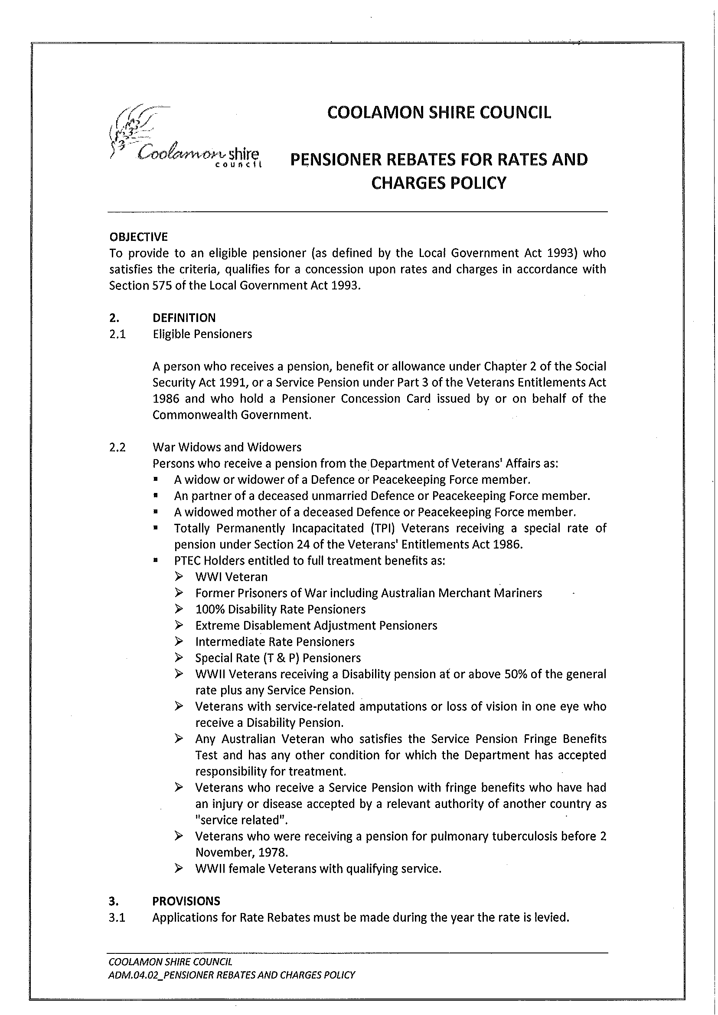
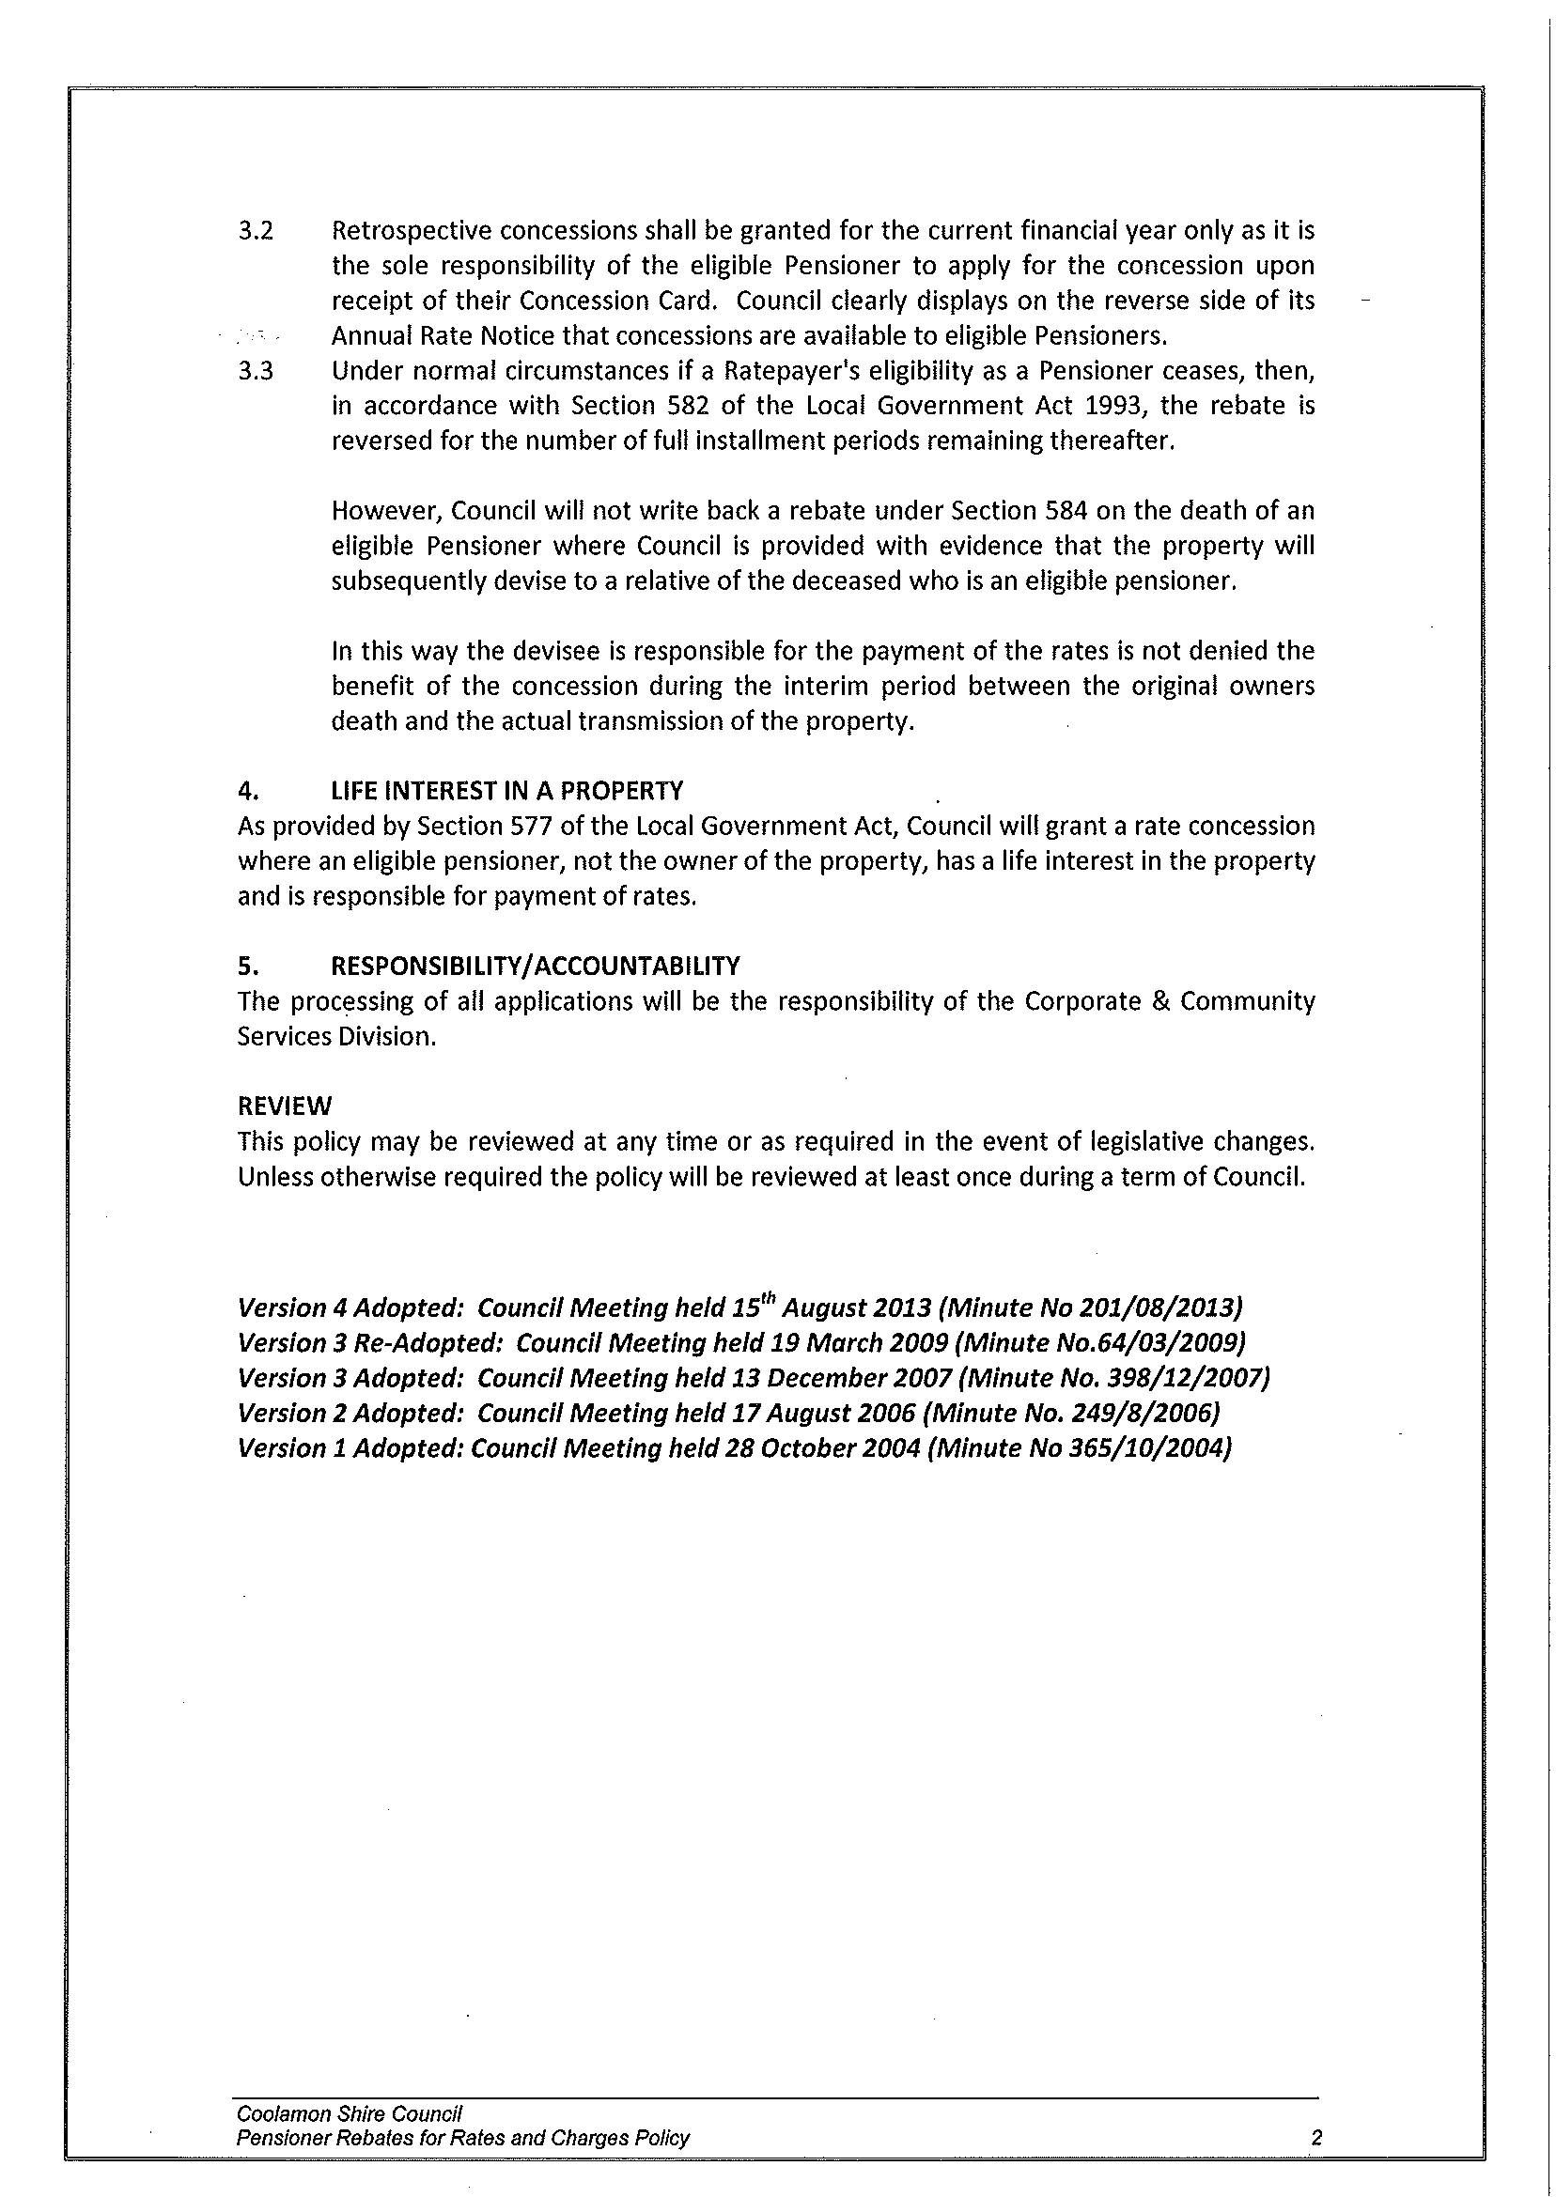
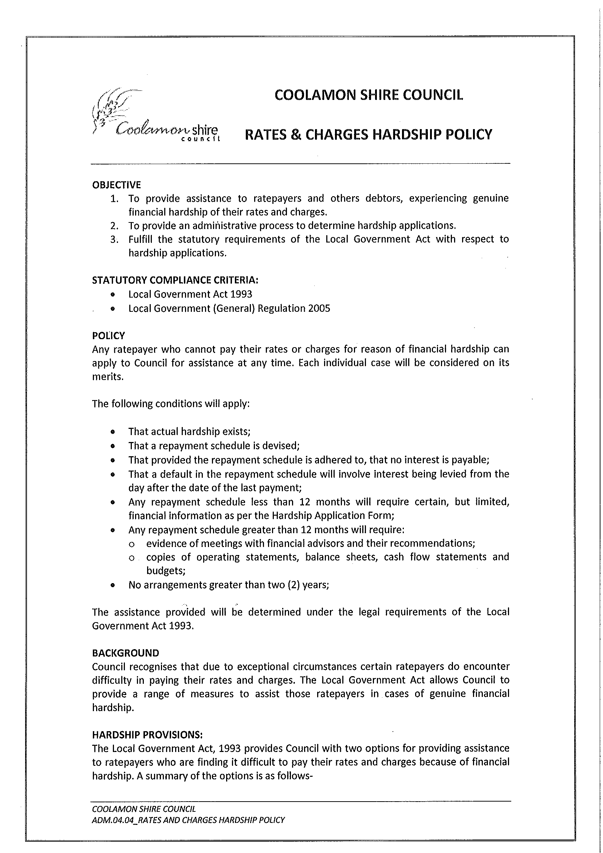
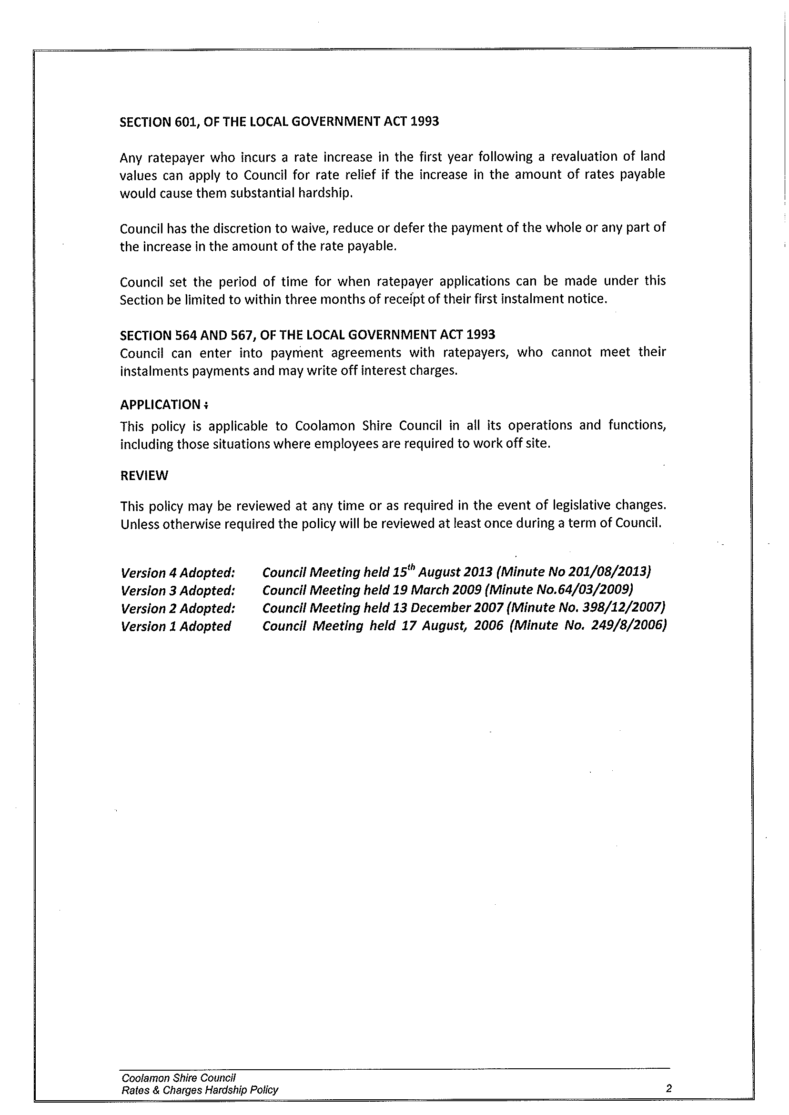

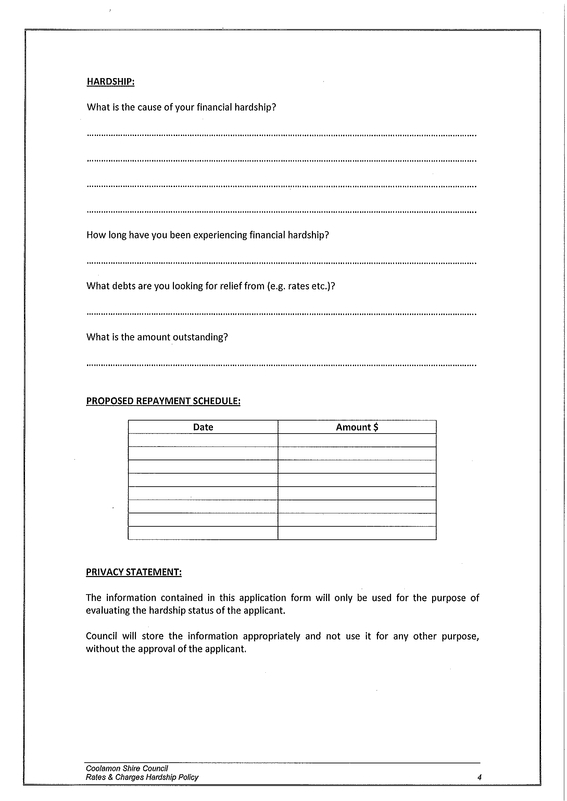
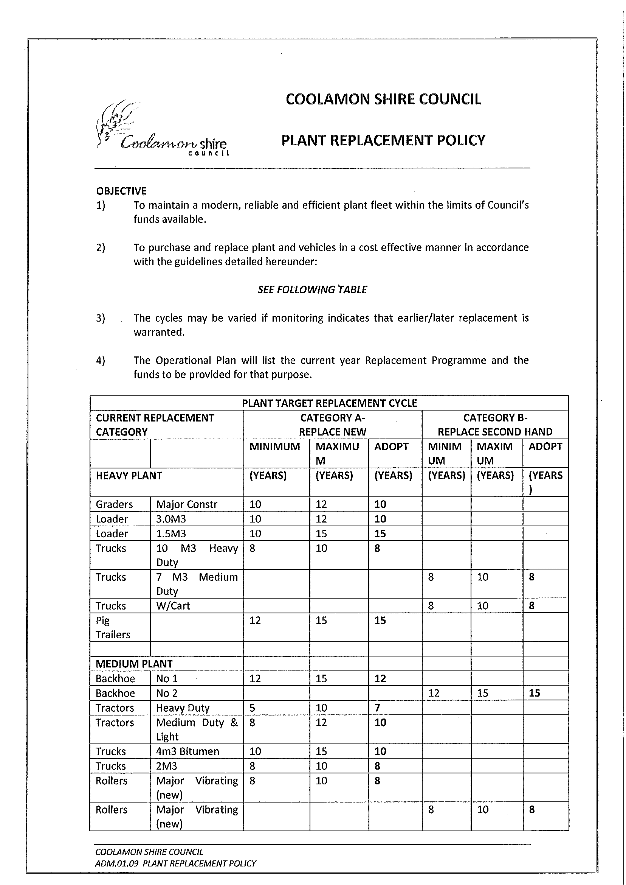
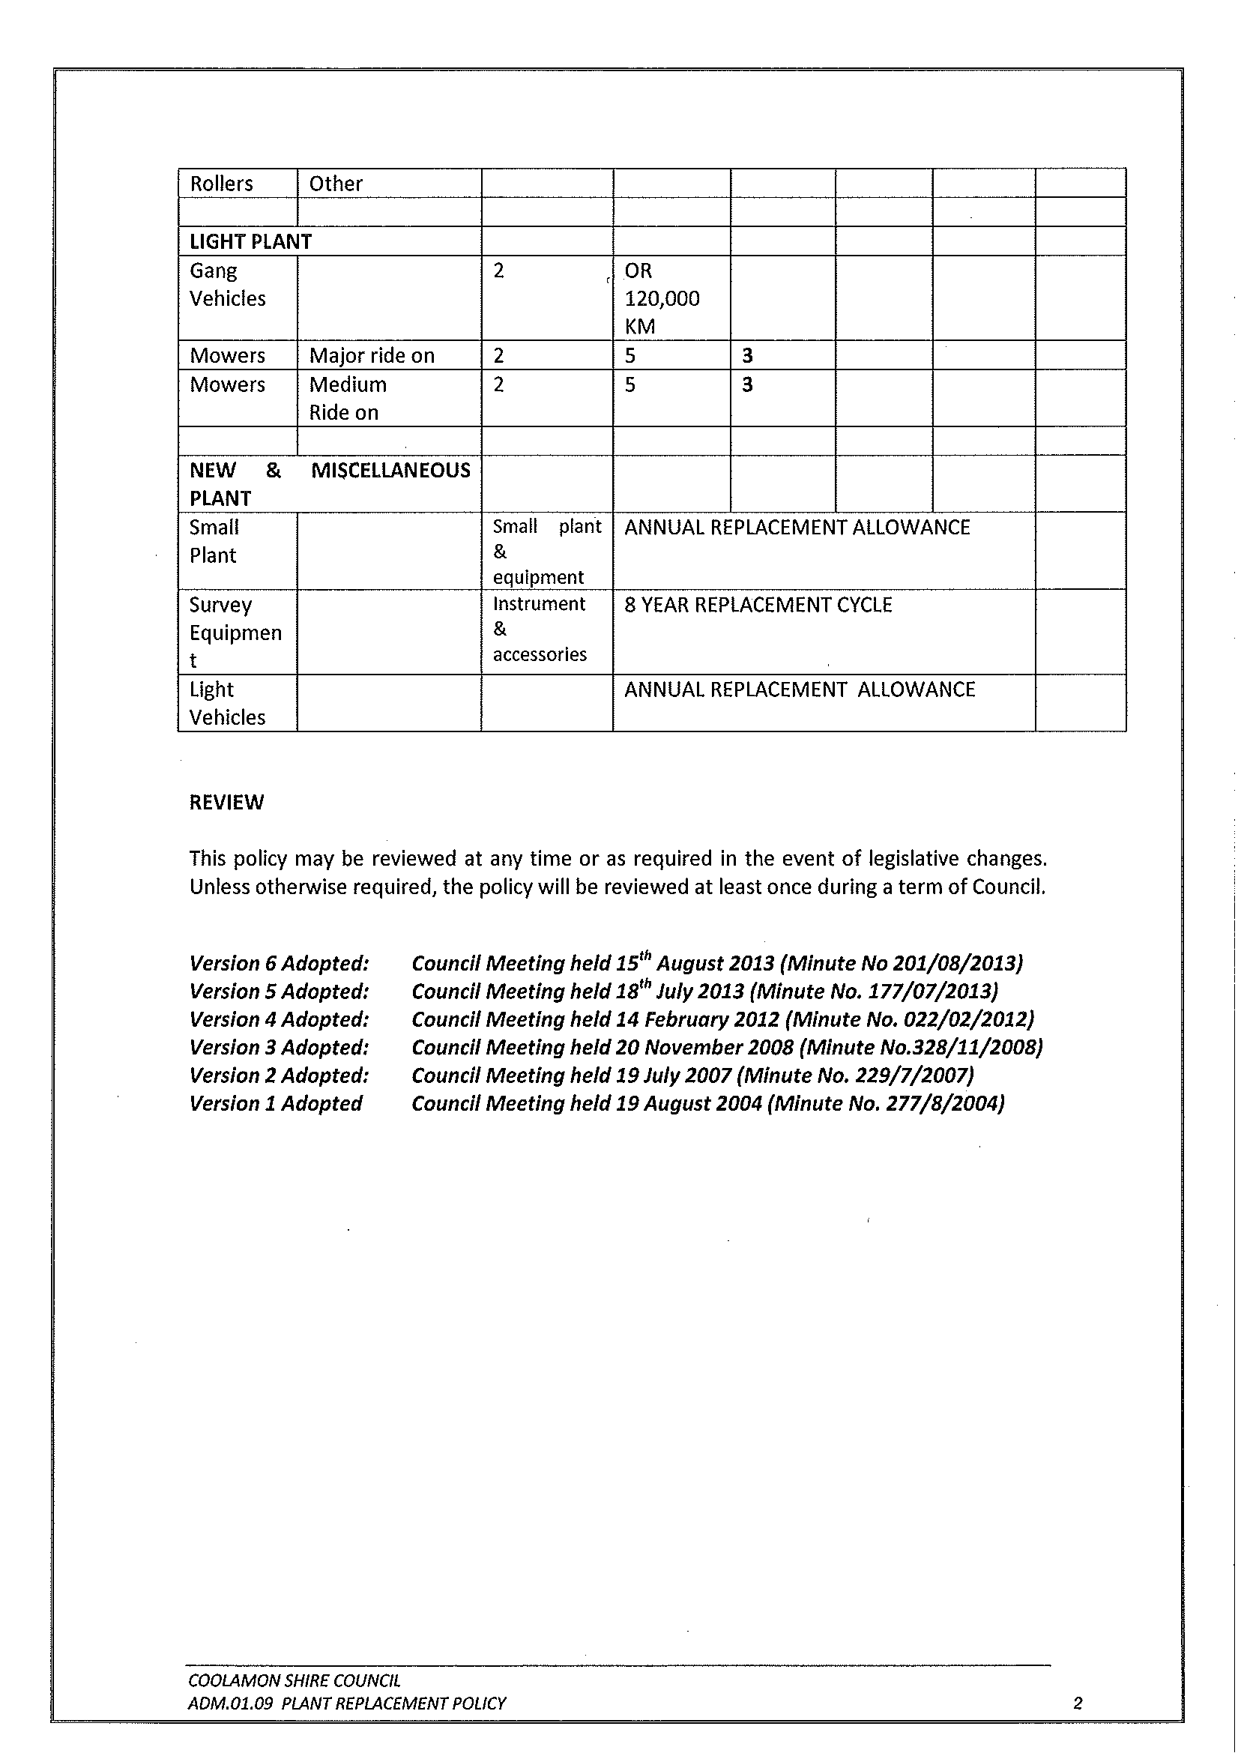
CS5) REGIONAL DEVELOPMENT AUSTRALIA FUND – ROUND 5 – LOCAL GOVERNMENT – ALLOCATIVE ROUND (I.03-08)

Council will recall a report to the July 2013 meeting of Council regarding an allocation of $183,803 to the Coolamon Shire Council under the Regional Development Australia Fund – Round 5. Council resolved in response to this report to confirm the application made to the Regional Development Australia for the allocation to be assigned to the ongoing upgrade of Council’s swimming pool facilities.

As the Federal Government Election has now been called and the government has gone into “caretaker mode” the processing of these applications is now uncertain. This may mean that the projects proposed for the pools may be in jeopardy.

Recommendation

For Council information.

RESOLVED on the motion of Clr Brill and seconded by Clr White that the report be received. 204/08/2013

4.3 EXECUTIVE MANAGER, ENGINEERING & TECHNICAL SERVICES’ REPORTS

ES1) SHIRE ROAD RESHEETS, STABILISATION & MAINTENANCE

Since the last meeting the following roads have received maintenance and resheeting attention:

1) MAINTENANCE

- Brushwood North Road (Canola Way to Murphys Lane) (patches)
- Coxs Lane (Dullah Road to Showground gate)
- Maslins Lane (Walleroobie Road to London Hill Road)
- McPhanns Lane (Methul Road to O’Dwyers Lane)
- O’Dwyers Lane (McPhanns Lane to Mary Gilmore Way)
- Mollers Lane (Mary Gilmore Way to Dyasons Lane)
- Dyasons Lane (Mollers Lane to East West Road)
- Blairs Lane (Rannock Road to Breust gate)
- East West Road (Mary Gilmore Way to Rannock Road)

2) RESHEETING

- Harrisons Lane (Pamandi Road to Matong North Road)
- Forest Road (Yarranjerry Exchange Road to boundary)
- Aikens Lane (Yarranjerry Exchange Road to gate)
- Brushwood North Road (Canola Way to Ardlethan Road)

Two of Council’s Grader Gangs are currently moving into the Rannock/Marrar area to provide gravel maintenance. Council attempted to provide maintenance in the area some months ago but were restricted due to the lack of water reserves. With recent good rain water reserves in the area have been replenished. Grader Gangs will be completing works in their current vicinity then moving to the Rannock/Marrar area. Works will be prioritised accordingly taking into consideration road hierarchy and conditions.

ES2) NOXIOUS WEEDS OFFICER’S REPORT (N.02-01)

Noxious Weeds Officer Reports

- All roads, lanes and weed harbours continue to be inspected throughout the three Shires, in particular, ABT is the major target for this season. Good rains have ensured a good crop of these woody weeds.

- Non-government, government agencies and organisations, as well as rural landholders, need to take responsibility for African Boxthorn control on their lands. Smaller landholders who are unable to carry out control measures will be able to get their properties sprayed for a fee at the same time Council Contractors are conducting spraying operations. More information will be available closer to the day. Fruit fly, the common house fly and tomato fly breed in the fruit of this weed.

- Preparations for the Henty Machinery Field Days have commenced with the potting up of weeds and planning for the collection of biological agents as conditions become warmer.

- A project in Junee Shire to make road reserves capable of carrying boom sprays is picking up pace with a number of local brigades making preparations for burns on targeted areas. This will make viewing of vehicular obstacles easy and their removal possible.

- Noxious weeds management in rail corridors controlled by the John Holland Group remains a concern.

- The 13th NSW Weeds Conference takes place at the Corowa RSL Club, 9-12 September 2013. Key note speakers are Dr John Keniry AM, NSW Natural Resources Commissioner and Dr Tony Grice, CSIRO Townsville. Full program and details at www.nswweedsconference2013.com

- Annual DPI reports are complete and submitted.

- Road verge spray mixes are holding up against regular winter rain.

- Fire Weed discovered and controlled by Wagga City Council at Tarcutta Bypass site

ES3) PARKS & GARDENS REPORT (P.01-01)

Facilities Maintenance Officer Reports

- ARDLETHAN

An avenue of trees has been planted at the Ardlethan Cemetery to replace Kurrajongs removed due to disease.

We are trialing a new type of tree guard at this site to give the trees the best chance to establish themselves. These guards will be removed in 12-18 months time.

Roses have also been planted in the Memorial section of the Cemetery as part of a minor landscape upgrade.

- GANMAIN

Pruning and mulching of Ford Street was undertaken recently along with a landscape upgrade of the garden bed adjacent to the Haystack. The existing tree was removed and a buxus hedge planted to reflect the landscape along Ford Street. This also allows better vision of the Haystack attraction.

- COOLAMON

Landscaping works have been completed on the Corner of Booth and Cowabbie Street which included installation of edging, synthetic grass and mulch.

- MARRAR

Street furniture has been ordered for the Wood Street upgrade. Work will commence over the coming months.

- ASSET INSPECTIONS

All building assets owned by the Shire have had an inspection undertaken to check their status in relation to fire safety measures, electrical safety and general state of the building.

RESOLVED on the motion of Clr Huxtable and seconded by Clr White that the Executive Manager, Engineering & Technical Services Reports’ (ES1 to ES3) be received. 205/08/2013

ES4) MATONG PARK (P.01-05)

Council is in receipt of a letter from Sonya Spencer on behalf of the Matong residents and the Matong Public School Leadership Group regarding the condition and request for upgrade to the local park.

➔ Council have replied and advised that the minor maintenance issues have already been addressed or listed for attention in upcoming work schedules. A number of the requests are not considered maintenance issues and will require capital expenditure from Council for the projects to proceed. Attachment No. 16.1

The issues requiring capital expenditure are as follows:

- BBQ Lighting

The Matong community believe lighting is inadequate to use the BBQ area at night and safety concerns for children when light becomes dim. Council was of the belief that the BBQ facility would predominantly be used during summer daylight saving hours and would not necessitate the installation of lighting. A number of lighting options are available and include:

- Installation of light and timer button – $1,000
- Installation of power point which residents can utilise to plug in lighting which they provide – $700

Council has experienced a number of minor vandalism issues with the facilities and believe the installation of a light will provide another target.

- Water Drinking Station

➔ The community proposed the relocation of the old water drinking fountain in the carparking bay opposite the park (photo attached). Attachment No. 16.2

The existing fountain is of a poor state and not functional. To relocate the fountain would require the dismantling of the structure, reconstruction and plumbing and not considered viable.

Another option could be the installation of a more modern water station where water bottles could be filled up at a cost of $2,000.

Access to water is currently be provided by existing taps in the toilets.

- Basketball/Netball area

Students of the Matong School raised the issue of a concrete area including a basketball/netball hoop, handball squares and rising ramp for scooters and bikes. The cost to install a concrete slab 7.5 metres X 7.5 metres and hoop equates to $3,700.

Sonya has indicated that the Matong Social Club may have funds available that they could contribute to a basketball/netball ring.

Council has the options to redirect existing funds, draw down additional funds or list the items for consideration in the 2014/2015 town works budget.

Recommendation

For Council discussion.

RESOLVED on the motion of Clr McCann and seconded by Clr Hutcheon that the Executive Manager, Engineering & Technical Services liaise with Mrs Spencer from the Matong Social Club concerning their contribution to the issues raised in their submission to Council. Furthermore, dependent on the success of those negotiations the matters raised be attended to out of Council’s maintenance vote for Matong. 206/08/2013

4.4 DEPUTY GENERAL MANAGER, PLANNING & ENVIRONMENTAL SERVICES’ REPORTS

HS1) DEVELOPMENT APPLICATIONS (B.05-01)

The following applications have been approved:-

DEVELOPMENT APPLICATIONS

16/2013 28//1096316 – 7 Hakea Drive, Coolamon – Shed.
18/2013 2//217741 – 92 Ford Street, Ganmain – Alterations & Additions.

COMPLYING DEVELOPMENT CONSENT

2013/19 110//750829 – Doubleday Lane, Coolamon – Change of Use – Games Room.
2013/21 203//750847 – 1517 Canola Way, Marrar – Shed.

Recommendation

For Council information.

HS2) LOCAL HERITAGE GRANTS (H.04-09)

➔ Coolamon Shire Council has run this grant in conjunction with the NSW Heritage Office since 2002 and a total of $77,923.26 has been allocated by Council towards Heritage projects. This has lead to a total of $485,964.02 worth of work being carried out in the Shire. A full list of all recipients and the funding allocation has been included in the attachments. Attachment No. 11

As can be seen this is an extremely positive project that helps to protect and enhance the heritage values of the Shire. Projects range from painting, building repairs, community heritage projects, interpretation of local heritage and many more. Council has fought hard to maintain the current funding levels from the Heritage Office and would like to continue the grant as it currently exists.

Not only does this project support the important Heritage Streetscape of our Towns and Villages, it also creates the financial benefit of money being spent in our communities.

Recommendation

For Council information.
RESOLVED on the motion of Clr White and seconded by Clr Brill that the Deputy General Manager, Planning and Environmental Services’ Reports (HS1 to HS2) be received. 207/08/2013

HS3) GANMAIN HALL (H.01-05)

Clr Logan declared a non-pecuniary interest due to her personal family relationship with the owner of the adjacent land

Informal discussions have previously been held in regard to the use of land at the rear of the Ganmain Hall.

A small portion of this land has been historically used by Logan & Hitchens to store machinery and run their business. An area to the rear of this land has been used specifically for the changing of oil.

Research appears to indicate that this deal was an historic handshake with the original owner and the Hall about maintaining the rear area free of weeds etc.

➔ Barry Logan as the current owner of Logan & Hitchens has advised that they would be agreeable to undertaking a boundary adjustment to include the subject land in his legal ownership. A copy of this correspondence has been provided for your information. Attachment No. 12.1

This area has become excess land not relevant to the use of the Ganmain Hall and can be included into land owned by Logan & Hitchens which would be suitable to their business. A plan of this proposal is included for your information.
Attachment No. 12.2

The past use of this land is not conducive to the operation of the Hall and provided the land can be included into the adjacent property it can be cleared up by way of fencing or screening. The transfer of this land would only be confirming the past and current use and be beneficial to the Hall and surrounding land.

Recommendation

That Council excise the rear portion of land by way of a boundary adjustment to be included into the land owned by Logan & Hitchens.

RESOLVED on the motion of Clr Brill and seconded by Clr Hutcheon that Council excise the rear portion of land by way of a boundary adjustment to be included into the land owned by Logan & Hitchens. 208/08/2013

HS4) COUNCIL SWIMMING POOLS (S.19-01)

➔ Issues were raised last season over the length of operation of the pools both for daily or weekly opening hours and also regarding the length of season. Further to this Council has also received a request from one of the pool operators to commence the pre season very early this year. A copy of the request is provided for your information. Attachment No. 13.1

➔ In accordance with this request it is thought appropriate that Council should consider the financial implications of opening the pools and the increased burden of costs. A summary of the last five year working budgets for each of these pools has been attached for your information. Attachment No. 13.2

As can be seen from the costings provided there has been a significant increase in pool running costs at the Coolamon Pool. This has been attributed to the increase cost of running the new pump and filtration equipment. This is a requirement of meeting the public health guidelines for water quality in public pools.

The work being undertaken in Ardlethan and proposed work at Ganmain are to also upgrade the pump and filtration equipment to meet public health requirements. From this it can be assumed that there will be similar increases in running costs.

SEASON LENGTH

A table of the running costs for last season has been broken into weekly amounts and provided below to show the implications of opening for each additional week during the season.

Coolamon Pool

Power Use |  | Per Month | Per Week
2 billing cycles  (6 months) | $22,964.16 | $3,827.36 | $956.84
Pool Season  (4 months) | $22,964.16 | $5,741.04 | $1,435.26

Water Use |  | Per Month | Per Week
2 billing cycles  (6 months) | $7,148.48 | $1,191.41 | $297.85
Pool Season  (4 months) | $7,148.48 | $1,787.12 | $446.78

As can be seen from the above figures, the cost of running the pool, just in the provision of water and power, is somewhere between $1,254.69 and $1,882.04. This is based on a season that runs from November to March that is flexible at either end of the season. So to average out the above costs, it is approximately $1,500 to run the Coolamon Pool for a week. This excludes chemical and other associated costs.

When Council receives requests from Contractors or the Community over starting early or extending the season, then these costs must be taken into consideration.

WEEKLY OPERATING HOURS

The last several seasons has seen some contention over the operating hours of the pools during the season. Council has always allowed some flexibility around when the Contractor opens or shuts but requires a minimum number of hours per day and per week.

As per the last season the pools operated on the following minimum hours:

Coolamon and Ganmain

- Monday to Friday (Outside School holidays) – 2.00pm to 6.00pm.
- Saturday, Sunday, Public Holidays and School Holidays – 10.00am to 12.30pm and 1.00pm to 6.00pm.

Ardlethan

- Monday to Friday (Outside School holidays) – 2.00pm to 7.00pm.
- Saturday, Sunday, Public Holidays and School Holidays – 1.00pm to 7.00pm.
- At times during School hours required by the Central School and other Government bodies to run Swimming Programmes.

Once again it must be stressed that these are minimum hours only and should the Contractors wish to open longer than that is permitted. It should also be noted that the Contractor may have to close the pool for safety reasons (eg: thunderstorm) at short notice.

Recommendation

1) That the Pool Season be defined with the opening and closing of the pool complex be between 1st November and 31st March. Contractors may close early should conditions be warranted subject to approval by the Deputy General Manager, Planning & Environmental Services.

2) That the above weekly operating hours be endorsed. Any change to these hours must be authorized by the Deputy General Manager, Planning & Environmental Services for incidental changes (eg: funerals, thunderstorms etc) or Council for changes to the spread of hours over a week.

RESOLVED on the motion of Clr Huxtable and seconded by Clr White that: 209/08/2013

1) The Pool Season be defined with the opening and closing of the pool complex be between 1st November and 31st March. Contractors may close early should conditions be warranted subject to approval by the Deputy General Manager, Planning & Environmental Services.

2) The above weekly operating hours be endorsed. Any change to these hours must be authorized by the General Manager for incidental changes (eg: funerals, thunderstorms etc) or Council for changes to the spread of hours over a week.

HS5) DEVELOPMENT APPLICATION 20/2013 – GRAIN HANDLING & RAIL LOADING FACILITY RAIL LEASE (PROPOSED LOT 2 DP 819718) – RAILWAY STREET ARDLETHAN (PF2492/55)

Council are in receipt of a development application to construct a grain handling and rail loading facility in Ardlethan. The site itself is located upon a lease within the rail corridor on the southern side of the main rail line, and bounding the northern and eastern sides of the existing concrete grain silo facility operated by Graincorp.

The applicant currently operates a bulk storage and handling facility on the Kamarah Tank Road and is required to freight bulk grain via road to Marrar in order to get the grain on rail and then to port. The proposal, if approved, would allow for the loading of bulk grain onto rail within Ardlethan and therefore remove a large quantity of heavy vehicles from local roads.

➔ A copy of the proposal has been attached. Attachment No. 14.1

The application was submitted following ongoing discussions between Council staff and Preston Grain, a grain merchant with operations based in Ardlethan and Temora.

As previously noted, the site of the proposed development is located upon a lease currently being finalised between the applicant and the rail authority. The leased area, as shown upon the attached plans, consists of a main triangular shaped allotment in which the majority of the operations will take place upon, whilst access will be obtained via the 9.2m ‘access handle’, providing access from Railway Street via a right of carriageway that also serves the existing Graincorp site.

Matters for Consideration

Section 79C of the Environmental Planning & Assessment Act 1979 requires Council to consider several matters prior to determining an application. In this instance these matters include consideration of the Coolamon Local Environmental Plan 2011, the likely impacts of the development on the surrounding area in terms of environmental, social and economic sustainability, the suitability of the site for the proposal, any submissions received, and the public interest.

- Compliance with the Coolamon Local Environmental Plan 2011

In accordance with Council’s LEP, the subject site is zoned SP2 – Infrastructure (Railway). As such, the proposal is permitted with consent within this zone. It should also be noted that an objective for this zone is for the provision of infrastructure and related uses, which in this instance relates specifically to rail infrastructure.

- Potential Impact on the surrounding area

From a planning perspective, there are a number of specific factors that need to be considered. These are as follows:

Amenity

Whilst the site is accessed via Railway Street, the operation will be visible from Ariah Street. The existing parks will provide the only buffer between the site and the Ariah Street commercial area. In reality this is no different to the current scenario with the existing Graincorp operation.

Also of note is the height of the grain elevator, which has a proposed height of 30m. This height is comparable to, and in keeping with, the existing surrounds and infrastructure (specifically the existing concrete silo operated by Graincorp located beside the subject site) and should therefore not be detrimental to the existing streetscape.

Traffic

The applicant proposes to enter the site via a right of carriageway from Railway Street with trucks loaded from the site located on Kamarah Tank Road. Initial estimates based on the details provided by Preston Grain suggest that there will be no actual increase in truck movements on the Kamarah Tank Road, only upon the portion of Railway Street and across the right of carriageway. This is based on the fact that the Preston Grain site must currently truck out bulk grain via the Ardlethan Road (towards Coolamon) to either Marrar or the ABA site located between Coolamon and Marrar. The trade-off is therefore reduced truck movements between Ardlethan and Marrar via Coolamon.

Preston Grain have indicated a willingness to contribute towards upgrading the fore mentioned section of Railway Street as a means of dust prevention, whilst additional dust prevention will be provided via a water truck already utilised by Preston Grain at their sister site. Full details of any required road upgrades will require further investigation by Council staff and negotiation between Council and the applicant. This can be provided through a condition of consent should an approval be granted.

In terms of managing traffic on-site, Preston Grain has provided a Traffic Management Plan upon request from Council.

➔ A copy of the Traffic Management Plan has been attached. Attachment No. 14.2

As indicated by this plan, there is some potential conflict between Preston Grain traffic and Graincorp traffic, particularly with regards to unloaded Graincorp vehicles. This issue was highlighted by Graincorp’s submission, and will be discussed further on in the report.

In terms of internal site movements, the applicant has provided evidence on site to confirm the ability to safely manoeuvre heavy vehicles onsite as per the traffic management plan. As reassurance, Council staff have undertaken further investigations relating to turning circles, etc. These investigations have proven that although manoeuvring may appear tight, truck movements can be undertaken within the defined area.

Site Operations

Within the statement of environmental effects, the applicant has advised that the site will not operate continuously, but rather when demand from end users or delivery commitments require. When the site is in use, the applicant has indicated hours of operation will be between 7.00am and 7.00pm weekdays, and between 8.00am and 7.00pm on weekends and public holidays. These timeframes are in keeping with past approvals issued by Council for industrial uses. It is worth noting that across the Shire, many competing Graincorp sites are known to load to rail well past midnight, particularly during peak harvest periods.

Site Security & Public Safety

From the initial discussions held with the applicant, site security has been a major focal point by Council staff. This was considered necessary based on the potentially sporadic use of the site, and the nature of the infrastructure. Accordingly, the applicant addressed these concerns by proposing a 2.4m high man-proof security fence surrounding the silo, elevator and hopper. The remainder of the site will be predominantly hard-stand vehicle manoeuvring areas, therefore not requiring the same level of security.

With regard to public safety, Council have been advised that the rail line is considered off-limits to the general public, whilst access to the subject site will only be permitted to authorised personnel. It is also noted that the rail corridor manager intends to remove the existing temporary level crossing located at the rear of the park (opposite the Men’s Shed). This will ensure that members of the public are not enticed into the site and therefore remain clear of heavy vehicles and grain handling machinery.

- Suitability of the site for the proposal

In terms of suitability, the site is located on the southern side of the main rail line alongside an existing grain terminal with rail loading capabilities. This suggests that the proposed ‘use’ of the site for grain handling and loading is suitable.

Council however must be mindful of the implications of intensifying the use in this area. Correspondence received by the applicant goes somewhat into allaying these concerns, as it is anticipated that the probability of the proposed Preston Grain and the existing Graincorp sites operating at the same time will be unlikely. Specifically, Preston Grain have stated that the proposed site will not be used for general grain deliveries over the harvest period (the exception being for Canola) but rather intermittent use over the non-harvest period as an inter-modal site. This scenario should therefore see little in the way of actual intensification of the area, as both sites should rarely be using the area at the one time.

Accordingly, the site is generally regarded as being suitable for this type of development.
- Submissions

As per Council policy, the proposal was advertised to neighbouring landholders. The advertising period commenced on the 1st July 2013 and concluded on 21st July 2013, with only 2 submissions being received. The applicant has also advised Council that direct discussions were held with nearby residents and landholders relating to the proposal during this period.

➔ Copies of the submissions received by Council have been attached, together with the applicant’s response. Attachment No. 14.3

In summary, the first of the submissions was received from a neighbouring residence and does not object to the proposal, but rather reiterates the importance of the applicants previously mentioned statement regarding dust suppression. The second submission was received from Gaden’s Lawyers on behalf of Graincorp, and subsequently objects to the proposal on several grounds, including traffic, congestion of the rail line, and various other issues such as waste management and chemical storage.

Council must be conscious not to create or protect a commercial interest when considering an application and this is no different. The matters that Council assess as part of this application are a fair and reasonable assessment of the proposal.

The concern regarding traffic relates to several key areas. These are the lack of a traffic management plan, lack of detail regarding traffic volumes and the capacity of the existing road network to deal with additional traffic flow, lack of other related infrastructure such as a weighbridge and sampling stand, use rights over the right of carriageway, on-site traffic safety, traffic conflict and the physical ability of the site to handle internal vehicle movements. As indicated within the applicant’s response to the submission, all points have been adequately addressed, either through the response statement itself, via the Traffic Management Plan or Conditions of Consent.

The most sensitive of the traffic issues appears to be the potential conflict between Preston Grain vehicles and Graincorp vehicles. At present Graincorp vehicles unload and then turn towards the railway line in order to exit the site. In doing so they in fact leave the land currently owned/leased by Graincorp, and encroach onto the land which is subject to this proposal (specifically the ‘access handle’ of the site), leased by Preston Grain.

Preston Grain has advised Council that they have approached Graincorp regarding the co-use of this land, however Graincorp has not made itself available for negotiation. Nevertheless, Council staff have made contact with management at both John Holland Rail (manager of the rail corridor) and Transport for NSW (State Government body and owner of the rail corridor), and interestingly each party confirmed that they have attempted to facilitate negotiations with Graincorp over access with little success.

Based on the information at hand, it appears that Preston Grain are in fact entitled to priority use of this land for access purposes as demonstrated by the lease agreement between themselves and Transport NSW, and that in order for Graincorp to continue their operations they must negotiate with Preston Grain.

With regards to congestion of the rail line, Preston Grain have provided details from Pacific National (a rail transport provider) confirming that loading of the trains is possible without detrimentally affecting site operations or rail traffic. This too has been confirmed with John Holland Rail. As with the site access issue, a reasonable degree of communication between Preston Grain and Graincorp will be required in order to satisfy this matter.

Other issues that have been raised as concerns by Graincorp include the impact on surrounding residential land uses (in terms of dust and noise), a lack of information regarding fumigation and the storage of dangerous goods and inadequate provision of onsite amenities and waste management.

As with previous issues however, the additional information as provided by Preston Grain appears to satisfactorily address these issues.

- The Public Interest

The public interest is represented by a number of factors in this proposal. First and foremost is the investment of substantial infrastructure in the Ardlethan community. This could be seen by Council and locals as a vote of confidence for the village. Further to this is the potential for job creation in the community, which can be regarded as both a social and economic gain.

Finally, and of equal importance, is the fact that the proposal would remove a large quantity of long-haul heavy vehicles off local roads. This would no doubt provide for much safer roads, as well as a reduced burden on road maintenance.

Summary

On face value, the proposal appears to benefit not only the community of Ardlethan, but also the wider Coolamon Shire. This is evident by the potential for additional jobs created by the proposal and the investment within the Ardlethan community itself, together with a real reduction on the number of long-haul heavy vehicles on local roads.

Whilst there does appear to be a fair degree of jostling in terms of location and access, Council’s assessment is based on the application as submitted. As a result, the assessment considered not only the plans and the associated statement of environmental effects, but also the submissions received from stakeholders as well as the applicant’s response to those submissions.

Recommendation

■ That Council approve Development Application 20/2013 subject to conditions to be tabled at the meeting.

RESOLVED on the motion of Clr McCann and seconded by Clr Hutcheon that Council approves Development Application 20/2013 subject to the following conditions: 210/08/2013

PRIOR TO CONSTRUCTION

- Prior to construction of the approved development it is necessary to obtain a Construction Certificate. A Construction Certificate may be issued either by Council or an appropriately accredited certifier. A separate application, complete with detailed plans and specification must be submitted and approved prior to any work on site.

These plans must include Certified Structural Engineers drawings prepared by a Practicing Structural Engineer of professional status in respect of:
a. Structural steelwork
b. Footing/slab design
c. Silo, elevator and hopper design
d. Tie-down and bracing detail

- Full details of the proposed upgrade to Railway Street and the right of access carriageway are to be submitted to Council’s Executive Manager, Engineering & Technical Services prior to the issuing of a Construction Certificate.
SITE MANAGEMENT

- The development shall not interfere with the amenity of the neighbourhood by reason of the omission of noise, vibrations, smell, fumes, smoke, vapour, steam, soot, ash, dust or water waste, waste products or grit, oil or any other form of pollution that may affect the neighbouring amenity.

- Stormwater (including run-off from downpipes and hardstand areas) shall be discharged clear of the proposed structures and existing rail infrastructure, and in a manner that does not cause disruption to neighbouring and/or adjoining land uses. All associated drainage infrastructure shall be suitably protected.

- All areas associated with on-site grain handling shall be fenced with a 2.4m high man proof security fence. No work is to commence on-site until the fence has been erected and inspected by Council.

- The proposed development shall comply with the requirements of Transport for NSW and the rail transport operator of the Country Regional Network. All such requirements shall be lodged with and approved by Council prior to an Occupation Certificate being granted.
- The operation of all machinery on-site must at all times comply with the NSW Industrial Noise Policy (1999), in which case the noise generated by the machinery or other such items would be considered unacceptable if it exceeds the background noise level (L_{Aeq}) by 5 dB.

- All vehicles entering and leaving the site shall do so in a forward direction, as indicated on the plan of traffic management. Any proposed alterations may only be done so following approval by Council.

- The internal manoeuvring and unloading areas associated with the grain handling operation shall be constructed to a suitably drained, waterproof and dustproof surface, with appropriate measures undertaken to ensure dust suppression is maintained.

- A detailed waste management plan is to be provided to Council for approval prior to the commencement of on-site operations. The plan should detail how waste generation will be minimised and how waste material will be dealt with (including any contaminated grain).

DURING CONSTRUCTION

- All requirements of the Workcover Authority (including the Dangerous Goods Branch) shall be complied with for the duration of all building and construction works.
- Construction work shall take place during normal working hours, namely 7.00 a.m. to 5.00 p.m. Mondays to Fridays and 8.00a.m. to 1.00p.m. Saturdays (no work on Sundays or Public Holidays) and in a manner so as not cause a nuisance (by the generation unreasonable noise or other activity) to the owners and/or residents of adjoining properties.

- For the purpose of inspection, twenty-four (24) hours notice must be given to the Principal Building Surveyor in respect of the following works for reasons of required inspections:-
- Footing;
- Slab and other Steel Reinforcement;
- Frame;
- Stormwater;
- Final prior to occupation.

- Building and construction materials, plant, equipment and the like are not to be placed or stored at any time on Council’s footpath or roadway.

- Provision shall be made on site for the proper storage and disposal of waste such that no builder’s waste shall be left in the open. Specific attention should be given to items which are subject to relocation by the action of wind, e.g. paper, sheets of iron, ridge capping, cement and lime bags and the like.

- Site signage shall apply, and must be erected on the site in a prominent, visible position, stating that unauthorised entry to the site is not permitted. It should show the name of the builder or another person responsible for the site and a telephone number at which the builder or other persons can be contacted outside working hours. Any structures erected to meet requirements of this condition must be removed when it is no longer required for the purposes for which it was erected.

PRIOR TO OCCUPATION

- The applicant is to obtain an Occupation Certificate pursuant to Section 109C of the EP&A Act 1979, as amended, from either Council or an Accredited Certifying Authority at the completion of the works to certify that works have been completed in accordance with the applicable standards of this consent.

FIRE SAFETY

- The owner shall submit to Council a Final Fire Safety Certificate stating that each essential fire safety measure specified in the current Fire Safety Schedule for the building to which the certificate relates:

- Has been assessed by a properly qualified person, and

- Was found, when assessed, to be capable of performing to a standard not less than that required by the current Fire Safety Schedule for the building.

Further, the assessment is to be carried out within a period of three (3) months of the date on which the Final Fire Safety Certificate was issued. The owner of the building shall forward a copy of the Certificate to the NSW Fire Brigades and also prominently display a copy in the building.

Note: A Final Safety Certificate must be provided before a Final Occupation Certificate can be issued for the building.

- The building is to comply with the attached Fire Safety Schedule.

Note: The attached schedule supersedes any earlier fire safety schedules and will cease to have effect when any later schedule is issued.

- The owner shall submit to Council an Annual Fire Safety Statement each twelve months after the Final Safety Certificate was issued.

- Portable fire extinguishers containing an extinguishing agent suitable for the risk being protected must be installed in accordance with AS 2444. Whilst the building is under construction not less than 1 extinguisher to suite Class A, B and C fires and electrical fires must be provided at all times adjacent to each required exit.

MISCELLANEOUS CONDITIONS

- This approval only provides consent for the use of the site as a bulk grain handling and rail loading facility. Any additional use (including the use of the site for the loading of containers onto rail) or structures that are not indicated on the stamped approved plans will require additional consent from Council.
The Mayor called for a Division.

Those voting in favour: All present
Those voting against: Nil

HS6) DOG ATTACK – 1 DEVLIN STREET COOLAMON (A.08-04)

Council Officers were recently informed of an alleged dog attack that took place on the afternoon of Friday, 12th July 2013 on the road outside of 1 Devlin Street, Coolamon.

According to accounts from Council’s Ranger, a teenage girl was running past the residence when a 15-month old Jack Russell Terrier exited the yard, chased her and bit her on the ankle. There is no evidence to suggest that the bite inflicted any severe wound or caused any serious injury. In the previous week, Council’s Ranger had already been to the premises to speak with the residents with regards to keeping their dog within the yard, as complaints had been received about the dog wandering.

At this point it is worth noting that the majority of dealings have been with the dog owner’s daughter and grandson, as the identified owner is an elderly pensioner. The dog has been microchipped and identified upon the NSW Companion Animals Register, but has not been registered.

Section 33 of the Companion Animals Act 1998 states that a dog can be declared dangerous if (without provocation) it attacks, threatens to attack or displays unreasonable aggression towards a person or animal. On the other hand, Section 21 makes provision for Nuisance Dogs in circumstances where, for instance, a dog repeatedly runs at or chases a person or animal. Nuisance Orders are valid for 6 months.

The allegations received by Council clearly state that the teenage girl was bitten, albeit in a minor way that caused little physical harm. Council staff has therefore been assessing the incident as an attack. Consequently, correspondence was issued to the owner of the dog indicating that Council was investigating an alleged dog attack and that they should provide any information relating to the incident, as the dog may be declared dangerous.

No correspondence was forthcoming from the owner or any other family member within the allocated timeframe. A statement was only received from the owner’s daughter following numerous visits from Council’s Ranger.

- Distributed with the information papers is a copy of the Submission received by Council on behalf of Dog Owner. Attachment No. 17

The statement does not provide any specific reason as to why the dog should not be declared dangerous. The letter does state however that the dog has since been de-sexed and is kept either on a chain or inside the home. No evidence has been received as yet to confirm the animals de-sexing.

Councillors may recall that if a dog is declared to be dangerous, the owner must take significant actions to prevent a repeat of the dangerous behaviour. These actions include having the dog de-sexed, having the dog wear a distinctive collar, the displaying of warning signs on the property boundaries, keeping the dog in a compliant child-proof enclosure and ensuring the dog is muzzled whenever outside of the enclosure. Nuisance dogs however must only comply with specific actions designated by Council to ensure the nuisance behaviour ceases.

On face value, many of the above listed items specified for dangerous dogs do appear to be overkill for a Jack Russell Terrier, for instance a muzzle and a child-proof enclosure; however, the dog has reportedly already been de-sexed since the incident occurred. Nevertheless, if a dog is declared dangerous it must comply with all of the prescribed ownership conditions regardless of breed, size or any other such factor.

There are also numerous penalties that can be applied to the owner of the dog. These include owning an unregistered dog ($220), owning a dog not under effective control ($220) and owning a dog that has attacked a person or animal ($550).

The determination before Council must therefore consider whether the dog should or should not be declared dangerous, and whether any further action is required.

The facts surrounding this incident can be summarised as follows:

1) Council staff had visited the property in the week prior to the alleged incident to ensure the dog was being kept inside the yard. This was in response to Council receiving a complaint.

2) The following week Council received a complaint alleging the dog had bit a teenage girl on the ankle whilst outside of its yard. No major injury or damage was reported as a result.

3) The dog was identified, but not registered.

4) The owner (including any family representative) did not produce a statement within the allocated timeframe, and only did so following numerous visits from the Ranger.

5) The full co-operation with Council by the owner is questionable, although the dog has reportedly since been de-sexed, and is being kept on a chain or inside. Evidence of the de-sexing is currently being sought.

6) If the dog was to be declared dangerous, it would be required to meet the requirements for dangerous dogs as listed above.

7) If the dog was instead declared a nuisance, it would need to only comply with any conditions imposed by Council for a period of 6 months.

8) A number of Penalty Notices can be applied.

In taking all of the above mentioned factors into consideration, the problem has arisen due to the owner of the dog not taking on board Council’s earlier advice relating to keeping the dog contained within its yard. Had the dog been contained in its yard, it would not have been able to wander and subsequently bite somebody. Additionally, evidence suggests that the ‘attack’ itself was not vicious (i.e., a lack of injury and damage) in comparison to past incidences across the Shire. An ankle bite from a Jack Russell should realistically not warrant the same degree of action by Council compared to a much larger dog that has caused physical damage, long-term harm, or even death.

The incident itself therefore should be considered a consequence of irresponsible dog ownership, rather than the doings of a dangerous dog. For this reason it is recommended that all action be taken against the owner of the dog rather than the dog itself. Specifically this action should include a Nuisance Dog Order requiring the owner to ensure the dog does not cause any further nuisance by wandering, and a penalty notice for owning a dog not under effective control.

Recommendation

That Council commence action for the issuing of a Nuisance Dog Order to the owner of the Jack Russell Terrier; a Penalty Notice of $220 be issued for owning a dog not under effective control and that the owner be required to finalise registration of the dog within 7 days of Council’s determination.

RESOLVED on the motion of Clr Hutcheon and seconded by Clr McCann that Council commence action for the issuing of a Nuisance Dog Order to the owner of the Jack Russell Terrier; a Penalty Notice of $220 be issued for owning a dog not under effective control and that the owner be required to finalise registration of the dog within 7 days of Council’s determination. 211/08/2013

HS7) LOT 1, DP 869499, KINILIBAH, MCINTYRES LANE, MARRAR (PF1648/3)

Council has received correspondence from the owners of the above mentioned land requesting information as to whether or not a building permit is allowed on this property.

➔ A copy of the correspondence has been provided for your information.
Attachment No. 18

The land is currently zoned RU1 Primary Production and under the current Local Environmental Plan (LEP) 2011 the minimum land size that permits erection of a dwelling is 200 hectares. There are a few exceptions to this rule, the first being whether or not the lot is an existing holding, and secondly whether or not a development consent has been granted prior to the commencement of the 2011 document.

Under this current definition the land is not an existing holding as the land was subdivided in 1997. This then requires further investigation of the clause that relates to Council approved Subdivisions.

Clause 4.2B (3)(b) of the LEP 2011, states that:

“Development consent must not be granted to the erection of a dwelling house on land which this clause applies, and on which no dwelling house has been erected, unless the land is a lot created before this Plan commenced and on which the erection of a dwelling house was permissible immediately before that commencement”.

The Plan known as the Coolamon LEP 2011 commenced on the 18 February 2011. Prior to this the Coolamon LEP 1995 was the preceding and relevant document. This 1995 Plan permitted the erection of a dwelling on “land comprising a lot in a Subdivision consented to by the Council for the purpose of erecting dwellings”.

The development consent for the Subdivision of land occurred in 1997. At the time the minimum land size that would permit a rural dwelling was 100 hectares. This is the reason the Subdivision was undertaken to that size.

Council will recall that when developing the 2011 document it was developed under the premise that all building rights that had been legally gained through either maintenance of an existing holding or approved Subdivisions would be retained. This was not in keeping with the proposed standard template and Council had to write it into the new 2011 LEP. The interpretation of this clause to allow the dwelling right to continue is in keeping with this strategic approach.

It is important to note that this issue is not to be confused with the concessional allotments that were removed by the previous Labour Government and were not permissible immediately prior to this 2011 document.

Recommendation

That Council advise the owner that a dwelling permit still exists on the above mentioned land.

RESOLVED on the motion of Clr Brill and seconded by Clr McCann that Council advise the owner that a dwelling permit still exists on the above mentioned land. 212/08/2013

The Mayor called for a Division

Those voting in favour: All present
Those voting against: Nil

 ADJOURNMENT

RESOLVED on the motion of Clr McCann and seconded by Clr Logan that Council resolve into Committee of a Whole for the purpose of considering confidential matters as listed in the Committee of a Whole agenda for the reason that such matters are considered to be of a confidential nature and in accordance with Council's policy thereto. 213/08/2013

Council adjourned at 3.10pm into Committee of a Whole and reconvened at 3.22pm.

5) RECOMMENDATIONS OF A COMMITTEE OF A WHOLE MEETING HELD 15TH JULY, 2013.

RESOLVED on the motion of Clr Huxtable and seconded by Clr McCann that the Recommendations of a Committee of a Whole Meeting held 15th August, 2013 be adopted. 214/08/2013

6) REPORTS: DELEGATES/MAYOR/COUNCILLORS

There were no Reports.

7) RECOMMENDATIONS OF THE NOXIOUS WEEDS MEETING OF COOLAMON, JUNEE & TEMORA HELD 30TH JULY, 2013.

RESOLVED on the motion of Clr White and seconded by Clr Hutcheon that the Recommendations of the Noxious Weeds Meeting of Coolamon, Junee & Temora held 30th July, 2013 be adopted. 215/08/2013

Meeting Closed at 3.30pm.

Confirmed and signed during the Meeting held this 19th day of September, 2013.

......................................................
MAYOR

