Meeting commenced at 2.00pm.

BUSINESS:

1) Apologies

2) a. Confirmation of Minutes of the Meeting held 20th March, 2014.
b. Matters arising out of Minutes. (Not elsewhere reported)

3) Correspondence
a. Agenda A (Information Only)
b. Agenda B

4) General Manager’s Report
4.1 General Manager’s Report
4.2 Executive Manager, Corporate & Community Services’ Report
4.3 Executive Manager, Engineering & Technical Services’ Report
4.4 Deputy General Manager, Planning & Environmental Services’ Report

5) Recommendations of a Committee of a Whole Meeting held 16th April, 2014.

6) Reports: Delegates/Mayor/Councillors

PRESENT: Clrs Seymour (Chairman), Logan, Beard, Huxtable, Hutcheon, Maslin, McCann and Brill.

STAFF: General Manager; Executive Manager, Corporate & Community Services; Executive Manager, Engineering & Technical Services; Deputy General Manager, Planning & Environmental Services.

APOLOGY: Clr White.

1) APOLOGY

RESOLVED on the motion of Clr McCann and seconded by Clr Maslin that the apology of Clr White be accepted. 63/04/2014

2a) CONFIRMATION OF MINUTES OF THE MEETING HELD 20TH MARCH, 2014.

RESOLVED on the motion of Clr Hutcheon and seconded by Clr Maslin that the Minutes of the Meeting held 20th March, 2014 as circulated be confirmed and adopted. 64/04/2014

2b) MATTERS ARISING OUT OF THE MINUTES

There were no matters arising out of the Minutes.

3) CORRESPONDENCE

AGENDA A (FOR INFORMATION ONLY)

1a) INFORMATION PAPERS

➔ The following papers have been distributed with Council’s supplementary material as being matters of information/interest to Councillors. If Councillors desire any further information on the matters distributed then that can be raised with the General Manager. Attachment No. 1

1) Local Government NSW Weekly Circulars 11, 12, 13 and 14.

2) NSW Government Weekly Update from Adrian Piccoli dated 21st March 2014, 28th March 2014 and 4th April, 2014.

3) Department of Social Services Home Care Standards Quality Review Report for Allawah Hostel and Community Aged Care Packages.

4) Minutes of the Advance Ganmain Committee Meeting held 19th March, 2014.

5) Weekly News Update from Adrian Piccoli dated 11th April, 2014.

2a) ACTIVITY REPORTS

1) Coolamon Shire Multi Service Outlet Coordinator’s Monthly Report for the month of March 2014.

2) Operating Statistics of the Coolamon Shire Library for March 2014.
3) Tourism & Business Development Monthly Update for March 2014.

4) Youth & Community Development Officer’s Report for March 2014.

General Manager’s Note

The above reports are operating reports only for use by Senior Staff. They are submitted to Council as part of Agenda A for information only. Attachment No. 2

RESOLVED on the motion of Clr Brill and seconded by Clr McCann that the Correspondence listed in Agenda A be received. 65/04/2014

AGENDA B

1b) COROWA SHIRE COUNCIL (R.06-01)

Advising of their formal withdrawal from REROC effective 30th June, 2014.

RESOLVED on the motion of Clr Hutcheon and seconded by Clr Logan that the correspondence be received. 66/04/2014

2b) RIVERINA EASTERN REGIONAL ORGANISATION OF COUNCILS (REROC) (L.05-05)

➔ Enclosing the Final Report in respect of the Submission to the Local Government Review Panel.

General Manager’s Note

A copy of the report has been attached for Council’s information. Attachment No. 8

RESOLVED on the motion of Clr Beard and seconded by Clr Maslin that the correspondence be received. 67/04/2014

4) GENERAL MANAGER’S REPORT

4.1 GENERAL MANAGER REPORTS

GM1) EMERGENCY SERVICE CONTRIBUTIONS (E.03-01)

Council has legal obligations to make a contribution to the Rural Fire Service, State Emergency Service and Fire & Rescue New South Wales. These payments for the past few years are detailed on the table below:
GL ACCOUNT | DESCRIPTION | FINANCIAL YEAR ACTUALS
GL ACCOUNT | DESCRIPTION | 2008 | 2009 | 2010 | 2011 | 2012 | 2013
2100-2290-0000 | BOARD OF FIRE COMM. CONT. | 13,466.00 | 13,906.00 | 14,094.00 | 15,328.00 | 15,401.00 | 15,180.00
2100-2295-0000 | RFS BUSH FIRE FIGHTING FUND CONT. | 104,780.00 | 107,567.00 | 78,870.50 | 125,543.57 | 138,659.04 | 133,371.86
2300-2296-0000 | SES CONTRIBUTION |  |  |  | 16,652.28 | 15,777.38 | 11,527.48
 |  | 118,246.00 | 121,473.00 | 92,964.50 | 157,523.85 | 169,837.42 | 160,079.34

The evolution of the Rural Fire Service and the transfer of responsibility from Local Government have had a number of significant effects. There has been a large increase in the bureaucracy of the Rural Fire Service and Coolamon Shire is now part of the Riverina Zone.

The Zone Office has approximately 10 staff and given that there are 5 Councils in the Zone, the equation on average is 2 full time persons per Council. Councils in the Zone are:

- Wagga Wagga
- Coolamon
- Lockhart
- Urana
- Junee

➔ The activities of the Riverina Zone in respect of the relationship with Local Government and the levels of service are covered by the Agreement between these Councils and the Rural Fire Service. A copy of the Agreement is included in the Attachments. Attachment No. 3

In the initial stages plant and building assets were vested in Council’s names with Council being responsible for all expenditures. In recent times the plant asset has been transferred, however, building assets do remain.

Coolamon Shire Council has:

- 9 sheds, not on Council land
- 6 sheds on Council land

Insurance costs for the sheds not on Council land would be in the order of $2,200 per annum. The Coolamon Complex which houses the Fire & Rescue, Rural Fire Service and State Emergency Service is still in a state of flux. Council is negotiating with Fire & Rescue regards their occupation and once this has been completed permanent arrangements can be put in place for all bodies.

The Rural Fires Act provides that all equipment shall be vested in the Council which therefore throws the responsibility for the insurance of these sheds back on to Council.

As regards the Plant Fleet it is interesting to note that the standards that are being adopted are State wide standards. This is in respect of firefighting equipment, trucks etc. A case could be made for an evaluation of standards for particular areas or Council by Council. The Brigades within the Coolamon Shire Council largely evolved out of the farming community who had a desire to protect their own agricultural interests. The equipment that was supplied enabled the farmer to suppress fires on their land prior to them becoming larger. The current situation is that the smaller (mosquito fleet) has been dismantled and the brigades have the larger trucks that are utilised to suppress larger fires and fires in other districts. In addition the replacement periods for the trucks is based on a State wide average. Some trucks within the Coolamon Shire Brigade System have very little usage, yet when their used by date in terms of years comes around, they are being traded.

Recommendation

1) That the Minister be requested to review the Rural Fires Act and associated operating Standards and Agreements in terms of vesting of equipment in Council which places additional responsibility on Council in terms of insurance and maintenance etc.

2) That the Minister be requested to initiate an Inquiry into the Rural Fire Service to ensure that the standards of service, provision of equipment and training etc., is relevant to the area within that particular Council.

3) That Council not increase its contribution to the Rural Fire Service for the year 2014 over and above the current contribution.
4) That the restriction on contributions in (3) above be maintained until the review of fire service activities within the Coolamon Shire Council area is undertaken.

GM10) ADDITIONAL RURAL FIRE SERVICE REPORT (F.03-11)

Following a further review of the Rural Fire Service Zone Agreement, it is suggested to Council that they formally resolve to activate Clause 8.5 of the Zone Agreement. That Clause states:

8.5 In preparing the budget forecast the Commissioner will consult with the Councils in relation to a range of matters including:

a) the Councils’ capacity to contribute to the Fund; and

b) RFS and government policies with respect to:

(i) the replacement of District Equipment;

(ii) the District’s requirements by reference to Standard of Fire Cover and other policies; and

(iii) standards for fire stations and other facilities.

Recommendation

That Council advise the Commissioner that it wishes to activate Clause 8.5 and initiate discussions on the matters within that Clause.

RESOLVED on the motion of Clr McCann and seconded by Clr Brill: 68/04/2014

1) That Council wishes to activate Clause 8.5 of the Zone Agreement which states:

8.5 In preparing the budget forecast the Commissioner will consult with the Councils in relation to a range of matters including:

a) the Councils’ capacity to contribute to the Fund; and

b) RFS and government policies with respect to:

(i) the replacement of District Equipment;

(ii) the District’s requirements by reference to Standard of Fire Cover and other policies; and

(iii) standards for fire stations and other facilities.

2) That the Minister be requested to review the Rural Fires Act and associated operating Standards and Agreements in terms of vesting of equipment in Council which places additional responsibility on Council in terms of insurance and maintenance etc.

3) That the Minister be requested to initiate an Inquiry into the Rural Fire Service to ensure that the standards of service, provision of equipment and training etc., is relevant to the area within that particular Council.

4) That Council not increase its contribution to the Rural Fire Service for the year 2014 over and above the current contribution.

5) That the restriction on contributions in (4) above be maintained until the review of fire service activities within the Coolamon Shire Council area is undertaken.

6) Council requests that the Riverina Zone Manager ensure that the payment to Coolamon Shire Council for carrying out administrative and accounting work be provided for in the Zone Budget.

MOTION RESCINDED AT COUNCIL MEETING HELD 19TH JUNE, 2014.
RESOLVED on the motion of Clr McCann and seconded by Clr Hutcheon that Resolution No. 68/04/2014 be rescinded. 152/06/2014

GM2) PUBLIC HALLS AND RECREATIONAL SITES (H.01-01)

Council has a variety of Public Halls dispersed amongst its communities. Council is also the Trustee for the Coolamon Showgrounds and this operates on a similar structure to the halls.

Listed below are the various locations of these facilities and the management structure and cost associated with their operation. The costs highlighted are standard annual costs and these do not include any maintenance expenditure.

HALL LOCATION | OWNER | RESPONSIBILITY | COSTS
Coolamon Showgrounds | Crown Land | Coolamon Shire as Trustees for the Crown with a dedicated 355 Management Committee | Council:  Insurance - $2045.64  Rates – Nil
Coolamon Showgrounds | Crown Land |  | Committee:  Electricity  Water
Ganmain Hall | Coolamon Shire Council | The hall is owned by Council and managed by a Section 355 Committee. | Council:  Insurance - $3,526.65  Rates - $1,240.77  Water – $167.10 (12/13)
Ganmain Hall | Coolamon Shire Council |  | Committee:  Electricity
Marrar Hall | Marrar Community Trustees | Coolamon Shire Council lease the Hall from the Trustees and delegate responsibility back to a Section 355 Committee. | Council:  Insurance - $2,761.38  Rates: $554.95
Marrar Hall | Marrar Community Trustees |  | Committee:  Electricity  Water
Ardlethan Hall | Coolamon Shire Council | Is delegated to a Section 355 Committee. | Council:  Insurance – $4,405.83  Rates - $535.29
Ardlethan Hall | Coolamon Shire Council | Is delegated to a Section 355 Committee. | Committee:  Electricity  Water
Beckom Hall | Coolamon Shire Council | Council delegates to a Section 355 Committee to manage on its behalf. | Council:  Insurance - $2,278.45  Rates - $293.82
Beckom Hall | Coolamon Shire Council |  | Committee:  Electricity  Water
Mullins Centre | Coolamon Shire Council | Council delegates to a Section 355 Committee to manage on its behalf | Council:  Insurance - $2,860.45  Rates - $1,214.18
Mullins Centre | Coolamon Shire Council |  | Committee:  Electricity  Water

The halls have a variety of management structure and each of the Committees accept varying degrees of responsibility for the payment of costs. All communities have indicated that the halls are a vital part of their community, although Council does not have any records of regular community usage.

At an earlier Council Meeting when this was discussed during the course of Council’s Budgetary discussions, the suggestion was made that perhaps the Management Committees through their individual community should accept some responsibility for the fixed costs, (ie. Insurance, rates etc). One of the options that could be available to Council is if the Management Committee were levied a charge based on a percentage of the actual fixed costs. This would then enable the fee paid by the community to reflect the size of their hall and the associated charges rather than an equal amount on each facility. The fact that the communities are then required to make a contribution towards their hall, would test the resolve of the community for its retention and usage.

Furthermore, it brings home some of the costs of managing that hall as a direct impost on the particular community as opposed to the ratepayer at large.

It is therefore suggested that the Managers of the Halls and the Showground facility be levied a cost equivalent to one third of the fixed costs payable by Council (ie. Insurance and rates). Furthermore, any electricity charges so incurred should be the full responsibility of the particular Committee.

Recommendation

That the Management Committees of all Halls and Showground facilities be advised that Council will levy them an amount equivalent to one third of the insurance and rates. Furthermore, that the Management Committees be fully responsible for all electricity and water rates.

RESOLVED on the motion of Clr McCann and seconded by Clr Maslin that the Management Committees of all Halls and Showground facilities be advised that Council will levy them an amount equivalent to one third of the insurance and rates. Furthermore, that the Management Committees be fully responsible for all electricity and water rates. 69/04/2014

GM3) LIBRARY SERVICES (L.03-03)

Library Services within the Coolamon Shire Council are delivered by the Riverina Regional Library Service. The Riverina Regional Library commenced in 1978. Original members of the Library Service were:

- Mitchell Shire
- Kyeamba Shire now amalgamated with Wagga City
- Coolamon Shire
- Wagga Wagga City Council
- Lockhart Shire

Since then other Councils have come on board, namely:

- Gundagai
- Tumut
- Temora
- Cootamundra
- Greater Hume
- Junee
- Corowa
- Urana
- Tumbarumba

Up until recent times Coolamon Shire relied solely on the Mobile Library Service which serviced the towns within the Coolamon Shire as well as Lockhart and parts of Wagga City Council including the former areas of Mitchell and Kyeamba Shires.

Various formulas have existed over the years for the funding of the headquarters costs and book purchases for the Riverina Regional Library. (See attached for current costs).

Coolamon Shire Council constructed its Static Library in 2008. This has been a service that has been well received with an average usage of around 650-700 visitations per week.

Services provided:

The Static Library has the following hours:

Tuesday to Friday, 10.00am to 5.00pm
Saturday, 9.00am to 12.00 noon
Mobile Library:

- Ardlethan – Friday, 9.00am to 12.45pm fortnightly – in front of park across the road from the NAB- street name Ariah St, Ardlethan

- Beckom – Friday, 1.30pm to 2.10pm – fortnightly at Park at the Beckom Public School, parking zone Welman Street, Beckom

- Ganmain – Wednesday, 10.15am to 12.00noon – fortnightly at in Parking Bay in Ford Street, Ganmain ( near the Park)

- Matong – Wednesday, 12.50pm to 1.35pm – fortnightly at Matong School Parks outside of school in parking zone.

- Marrar – Wednesday, 2.30pm to 3.30pm – fortnightly at Marrar School Parks in Bus Zone outside of Marrar Public School.
Costs of Library Services

Quite obviously Council’s costs have increased since the opening of the Static Library. Currently the total costs are running around $174,000 per annum of which $95,000 is the contribution to the Riverina Regional Library Service. The Mobile costs are included in the RRL contribution.

System Review

Council at its recent Workshop indicated that it would review the need for the Mobile services and whether these needed to be provided by alternate means. A review of the loans provided at the various service points, certainly casts doubts over the need for the service at Beckom, Ganmain, Marrar and Matong. Council should bear in mind that the Mobile was provided to these towns when a Static Library within the Shire was not in existence. The question can be asked as to who these libraries are actually serving and whether they are needed having regard to the travelling time to the Coolamon Library. If Council were to eliminate those services, there would be savings of approximately $17,000 per annum in Council’s overall Library costs.

The cost per loan through the Mobile for each of the current stops is as follows:

- Ardlethan - $3.55 per loan
- Beckom - $7.62 per loan
- Ganmain - $5.05 per loan
- Marrar - $9.13 per loan
- Matong - $3.92 per loan

Generally, the Mobile Library stops are at Schools. It is not Council’s responsibility to provide libraries to Schools. An examination of the users of each of the Mobile Libraries indicates that there is a mixture of both junior users and regular adult users. However, it should be noted that the Marrar and Ganmain users would be 10 minutes away from the Static Library, whilst the Matong customers would be 15-20 minutes distant.

In the north of the Shire it is suggested that the Mobile remain at Ardlethan and any Beckom users would only be a 10 minute trip to utilise that facility.

Council may consider a once fortnightly service via a bus from Matong through to Coolamon for those persons unable to access the Library or arrange transport to the Library in Coolamon. If the service was not patronised then it would be evidence that it was no longer needed. The cost of running a bus service would be $6,000 per annum.

Attached to this report are the Mobile Library Loan statistics and the expenditures in relation to the Library operations dating back to 2008.

Recommendation

That the Mobile Library Service be discontinued from the towns of Beckom, Ganmain, Matong and Marrar. Furthermore, that Council trial a once fortnightly bus service to Coolamon for those persons unable to access the Library. The service usage of the bus service to be evaluated after a six months trial.

RESOLVED on the motion of Clr Huxtable and seconded by Clr Maslin that the Mobile Library Service be discontinued from the towns of Beckom, Ganmain, Matong and Marrar. Furthermore, that Council trial a once fortnightly bus service to Coolamon for those persons unable to access the Library. The service usage of the bus service to be evaluated after a six months trial. 70/04/2014

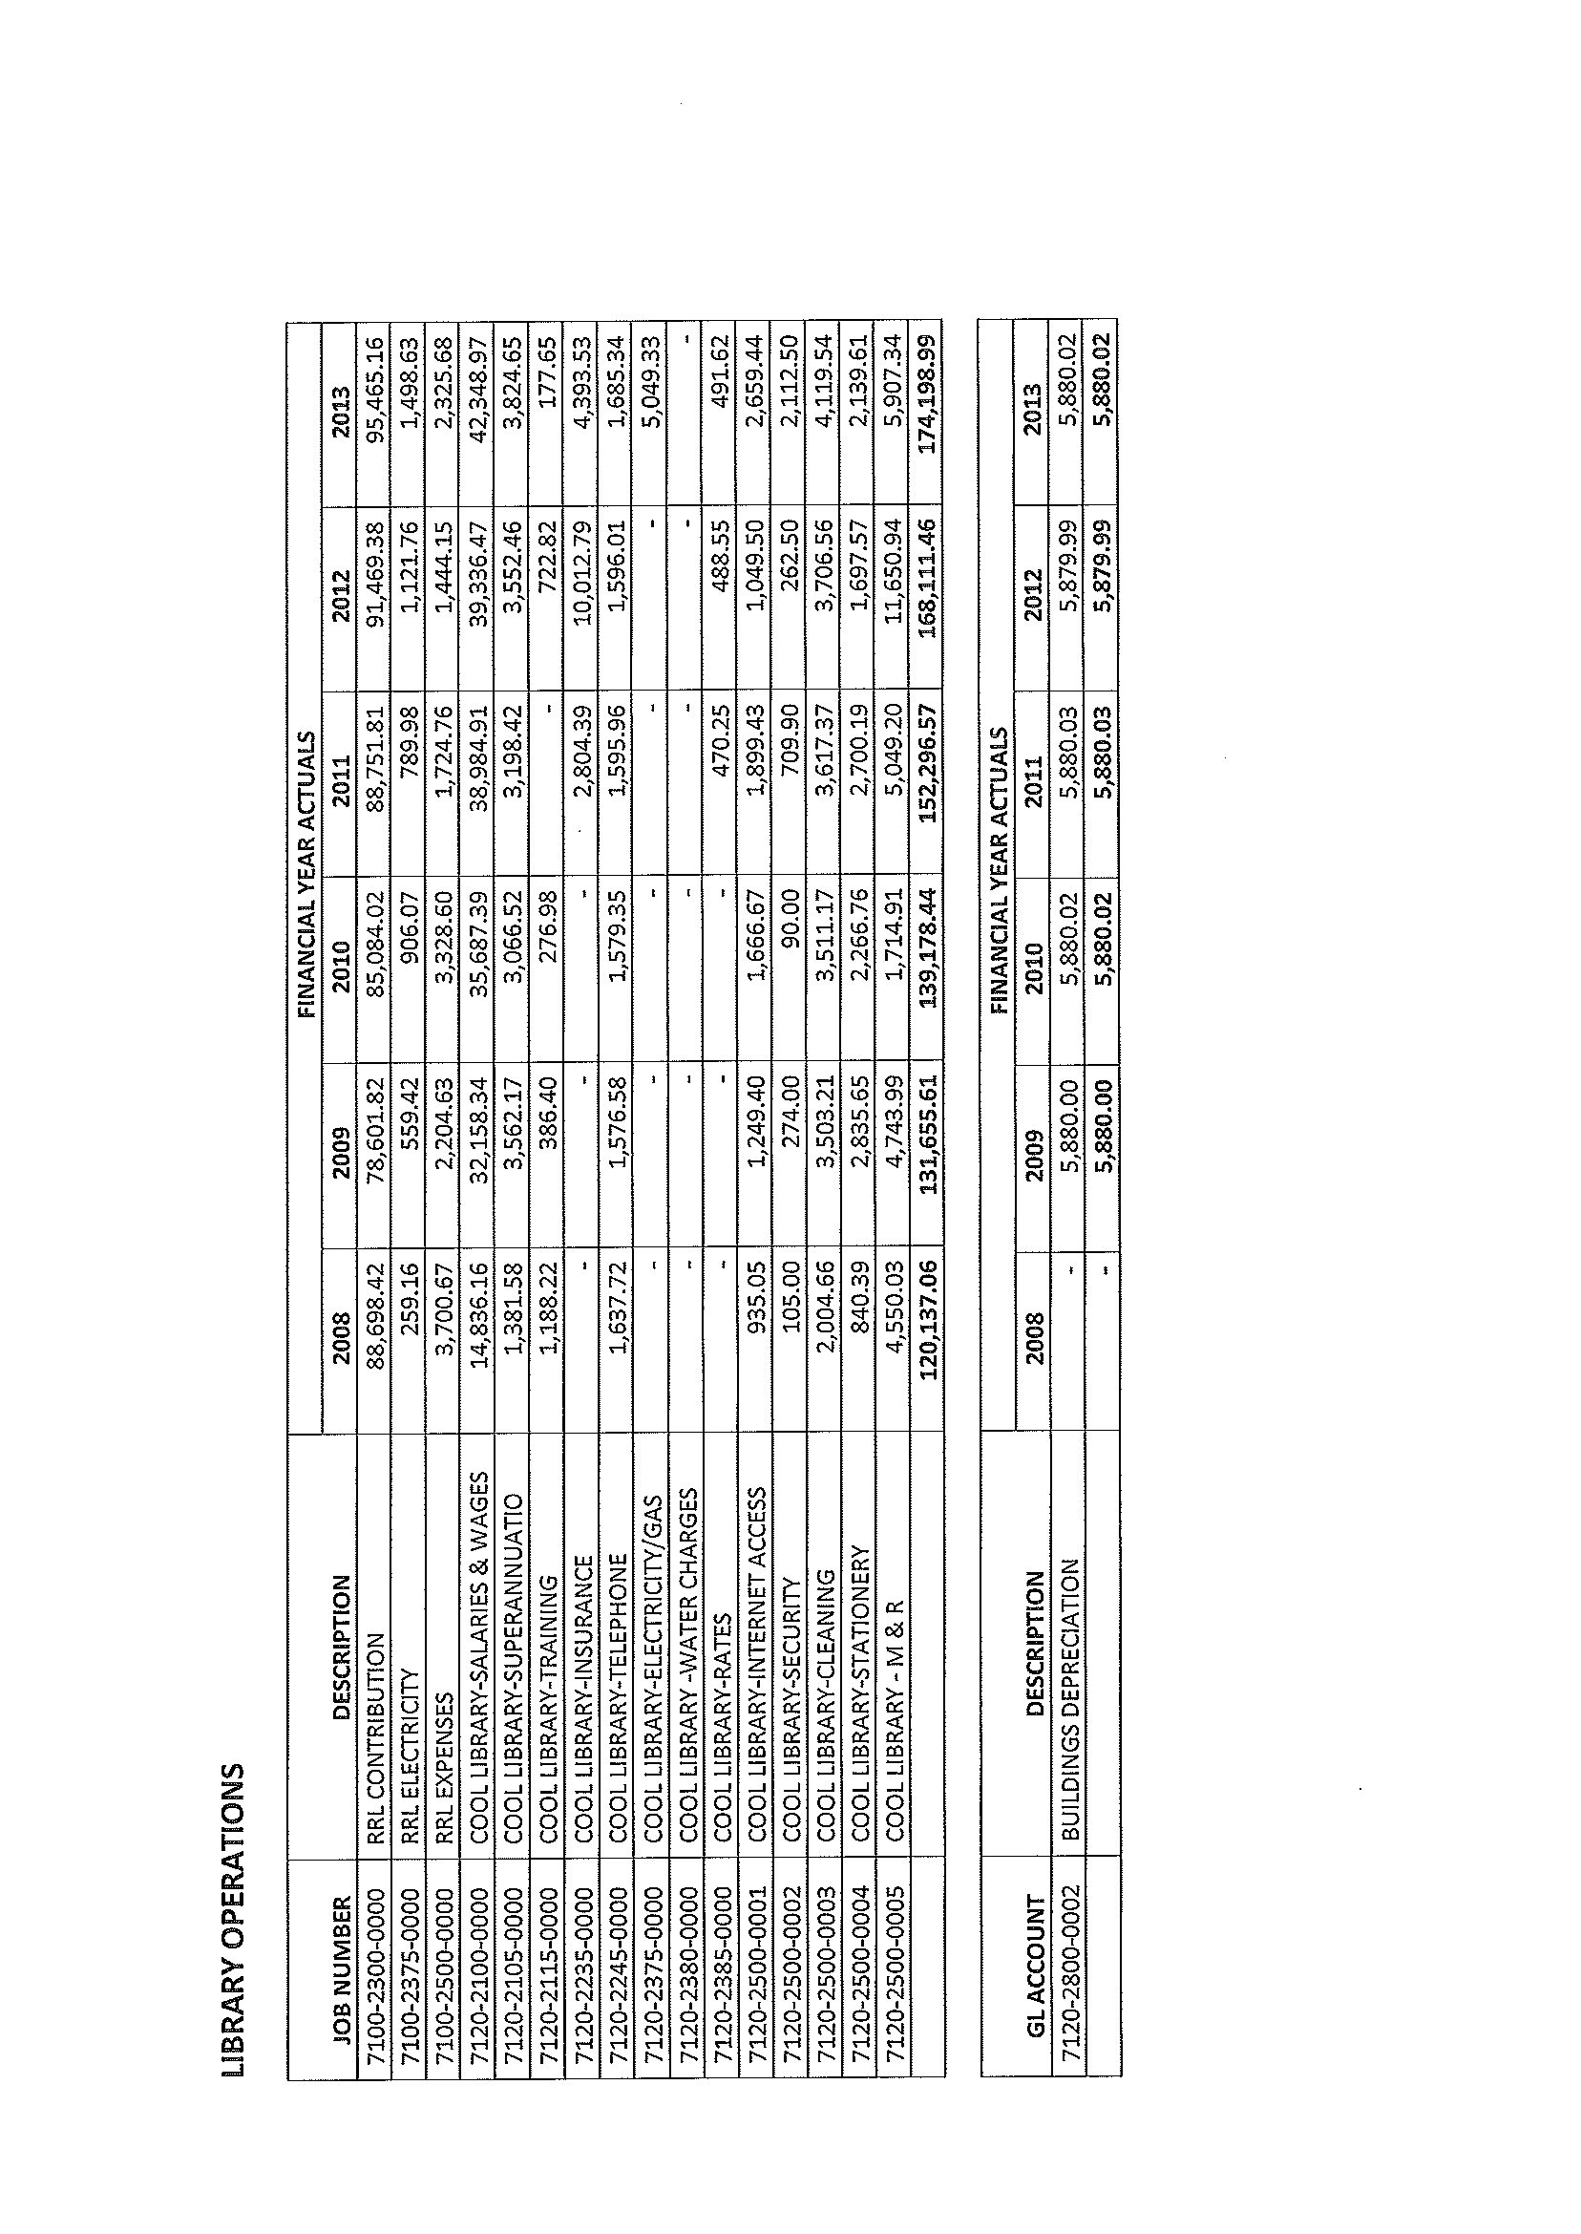
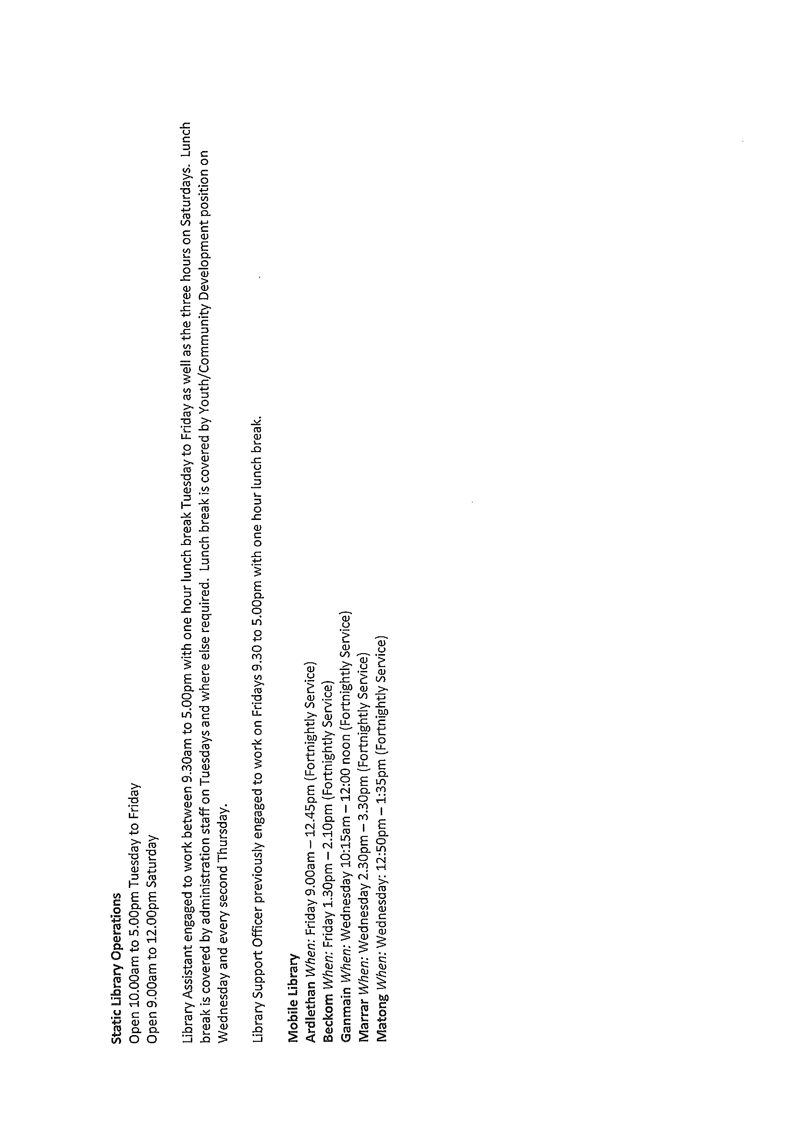
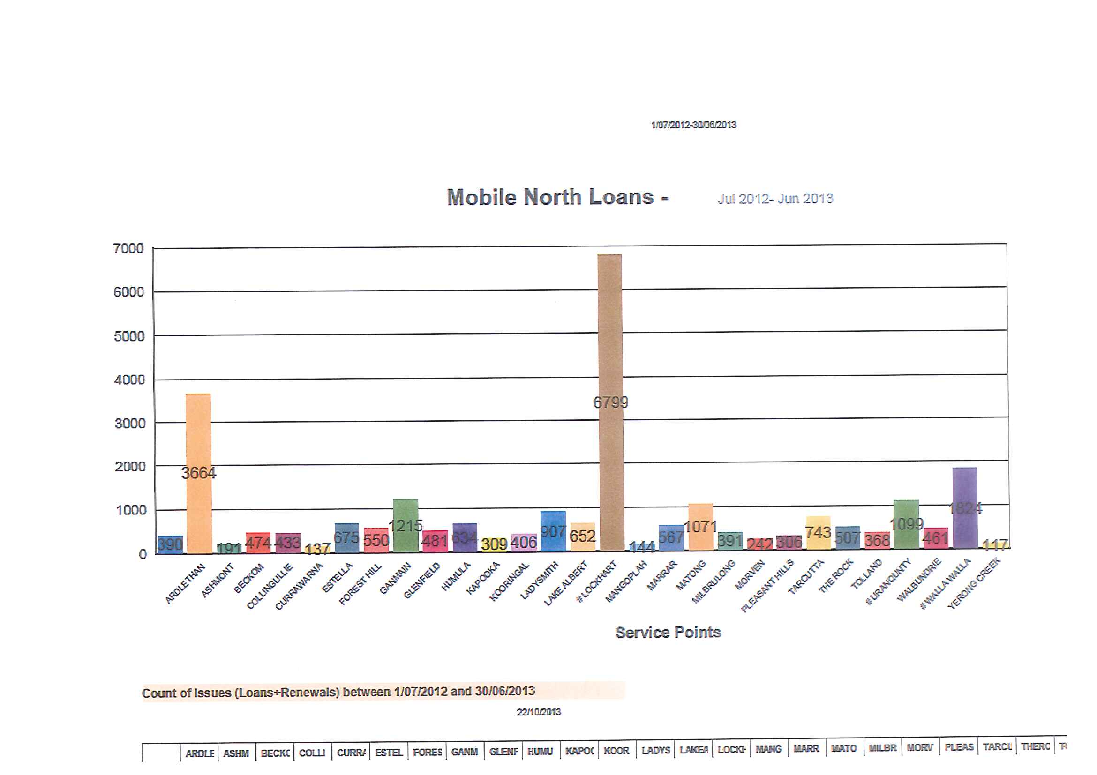

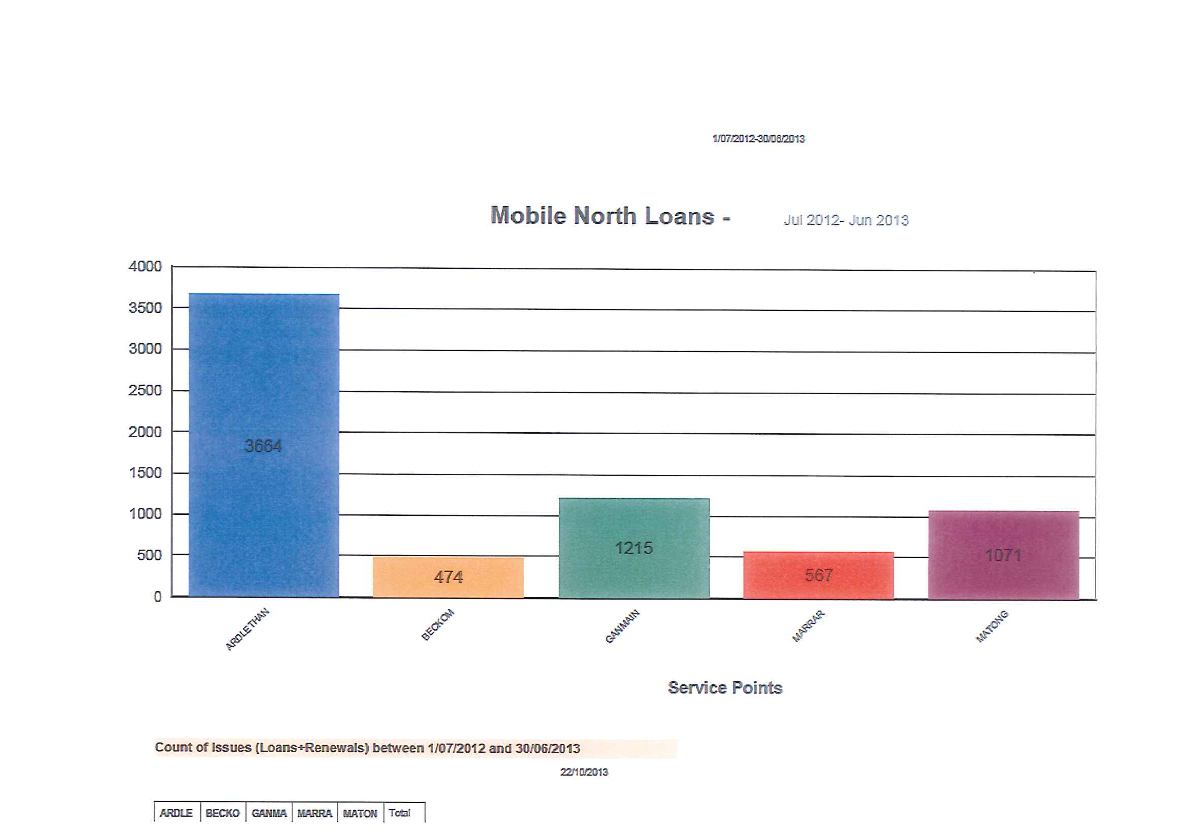
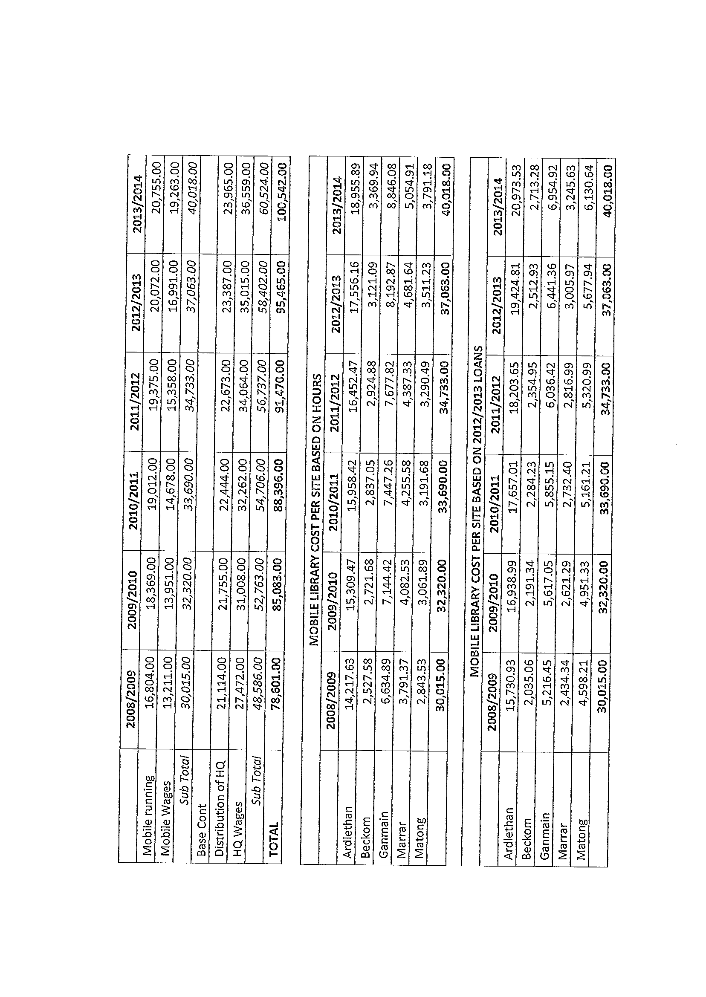
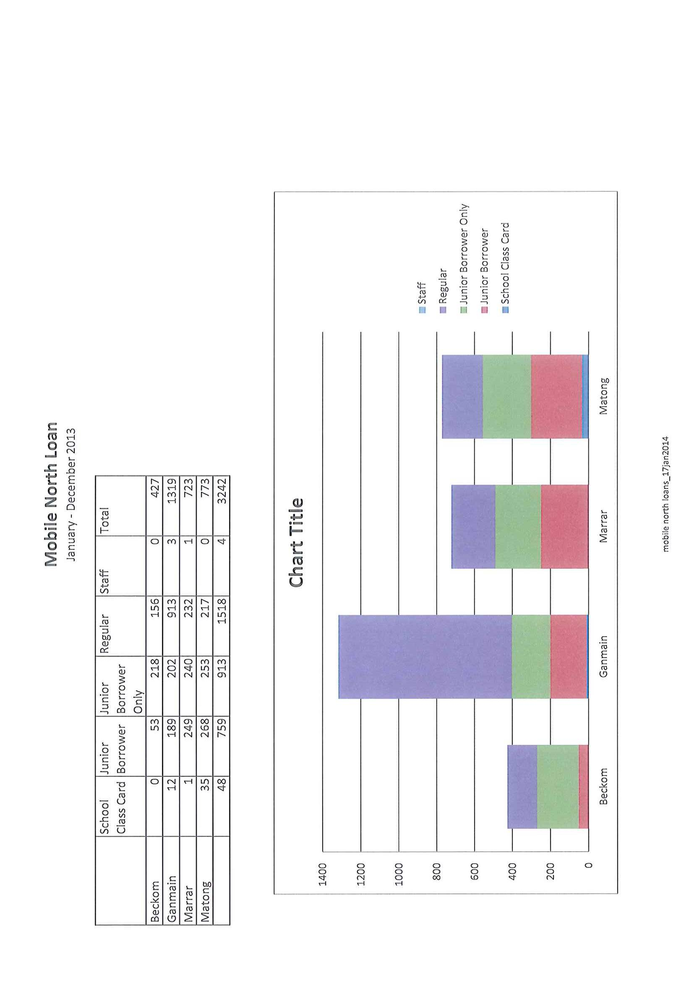
GM4) DRAFT 2014/2018 DELIVERY PROGRAM & 2014/2015 OPERATIONAL PLAN & LONG TERM FINANCIAL PLAN (S.11-06)

➔ The Draft Delivery Program 1 July 2014 - 30 June 2018 & Operational Plan 1 July 2014 – 30 June 2015 (incorporating Long Term Financial Plan) is presented for Council’s consideration. Attachment No. 7.1 & 7.2

Operational Plan 2014/2015

After allowing for capital grants and contributions, the consolidated operating result is a surplus of $1,172,030 for the 2014/2015 financial year.

The budgeted results, including internal transactions have been summarized in the following table:

 | Consolidated
Operating Results inc. Asset Sales | 494,467
Operating Results after Capital Amounts | 1,172,030
Capital Expenditure | 4,703,920
Cash Increase/ (Decrease) | (707,273)

ANALYSIS OF BUDGETED INCOME STATEMENT

INCOME

Rates & Charges $ 2,989,000

      - IPART announced a rate pegging limit of 2.3% which has been applied in full to both land rates and charges. The Shire has been revalued and those valuations will be applied for the 2014/15 year and therefore some alteration has been made to ensure that Council’s permissible income has not been exceeded.

- Council’s rating structure has remained the same as the 2013/14 year. The structure is detailed in the table below

RESIDENTIAL
Residential Ardlethan
Rateable land, the dominant use of which is for residential purposes in the Ardlethan township.
Residential Coolamon
Rateable land, the dominant use of which is for residential purposes in the Coolamon township.
Residential Ganmain
Rateable land, the dominant use of which is for residential purposes in the Ganmain township.
Residential Ordinary
Rateable land, the dominant use of which is for residential purposes not included in any other sub-category.

BUSINESS
Business Ardlethan
Land which cannot be categorised as farmland, mining or residential in the Ardlethan township.
Business Coolamon
Land which cannot be categorised as farmland, mining or residential in the Coolamon township.
Business Ganmain
Land which cannot be categorised as farmland, mining or residential in the Ganmain township.
Ordinary Business
Land which cannot be categorised as farmland, mining or residential not included in any other sub-category.

FARMLAND
Ordinary Farmland
Farmland Rates will be levied on all rateable land which in Councils opinion, qualifies as (farmland) as defined in Section 515 of the Local Government Act 1993.

The townships of Ardlethan, Coolamon and Ganmain have been defined as those areas zoned RU5 and RE1 for each locality. Where an assessment may be split by a zoning boundary, that assessment will be categorized as being within the relevant township in its entirety.

The increases to charges levied on properties are as follows:

Charge | 2013/2014 Amount | 2014/2015 Amount
Domestic Waste Management Charge | 170.00 | 175.00
Domestic Recycling Collection Charge | 82.00 | 84.00
Domestic Organics Collection Charge | 52.00 | 53.00
Domestic Waste Management Charge -Vacant Land | 31.00 | 32.00
Tip Access Charge | 46.00  (inc. GST) | 47.00  (inc. GST)
Commercial Waste Management Charge | 238.00  (inc. GST) | 243.00  (inc. GST)
Sewer Un-occupied (vacant land) | 155.00 | 180.00
Sewer Occupied | 360.00 | 380.00
Sewer Additional Pedestal Charge (excess of 2 toilets) | 98.00 | 101.00
Sewer Non-Rateable Pedestal Charge | 98.00 | 101.00
Sewer Capital Contribution | 330.00 | 330.00
Ardlethan Effluent Occupied | 155.00 | 180.00

It is proposed that Stormwater Management Charges for the towns of Coolamon, Ganmain and Ardlethan be introduced in the 2014/2015 year. The residential charge will be $25.00 per assessment whilst the business charge will be $25.00 per assessment plus $25.00 per 350 square metres or part thereof where the area exceeds 250 square metres up to a maximum of $300.00. Additional information relating to the application of these charges will be available on meeting day.

User Charges and Fees $ 1,109,000
- User Charges and fees are predominately dominated by Allawah Lodge fees and Child Care Fees totalling $751,000

Interest and Investment revenue $ 486,000
- The budget for the 2014/2015 year for investment revenue is based on an investment portfolio of $10.7 million earning an average interest rate of 4.25%

Other revenues $ 352,000
- Other revenues in the main can be attributed to lease rentals of Council owned properties - $ 303,000

Grants & Contributions provided for Operating Purposes $ 6,351,000
- The Financial Assistance Grant ($3,076,000) has been budgeted at the same level as the eligible amount for the 2013/2014 year.
- Aged Care, Allawah Lodge and Child Care are expected to receive operating grants and contributions totalling $1,375,000
- Road and Maritime Services Contributions total $1,051,000 and funding received under the Roads to Recovery funding model equates to $577,000

Grants & Contributions provided for Capital Purposes $ 678,000

Net gain from the disposal of assets $ 86,000

Share in joint venture (Riverina Regional Library) $ 5,000

EXPENDITURE

Employee Costs $ 5,083,000
- The budget allows for an estimated award increase of 3.25% for the 2014/2015 financial year along with estimated expenditures for workers compensation insurance, employees leave entitlements and other employee expenses. Superannuation guarantee has increased from 9.25% to 9.5%.

Borrowing Costs $ 66,000
- This is a non-cash expense related to the restoration of gravel pits.

Materials & Contracts $ 1,424,000
- This is the balance of expenditure that is not included in other items. It includes legal fees and audit fees.

Depreciation & Amortisation $ 2,930,000
- Roads and drainage assets contribute a total of $1,663,080 to this figure, whilst sewerage assets will be depreciated by a total of $210,000.

Other Expenses $ 1,375,000
- Contributions to emergency services of $177,000, Insurance expenses of $275,000, Electricity & Gas expenses of $224,000, Water Charges of $97,000 and the contribution to the operations of the Riverina Regional Library of $84,000 dominate this expenditure item.

Delivery Programme 2014-2018 & Long Term Financial Plan

Over the four years of the Delivery Programme, Council’s total cash is expected to increase by $573,000 whilst over the longer term of ten years there will be an increase in cash of $6,069,000.
Recommendation

That the Draft Delivery Program 2014/2018 and Draft Operational Plan 2014/2015 be placed on public exhibition for the legislated timeframe.

GM5) 2014/2015 BUDGET (F.02-02)

This report is presented as an addendum to that already provided with the Business Papers. The earlier report took Council through the statistical adjustments that were made in the current Budget. This latter report is meant to provide an overview of the issues that are seen to affect the long term sustainability of Council as an individual entity.

The Budget as presented is providing an operational surplus through the next 10 years. The two issues that were raised in recent times concerning Council’s financial performance has been the attainment of a long term operational surplus and an appropriate regime for Asset Management.

- OPERATIONAL SURPLUS

One of the requirements for Councils that was stressed in the Panel’s report and which emanated out of the TCorp analysis was that for Local Government Authorities to be sustainable there was a need to prove and achieve an operational surplus on a long term basis. Obviously over a period of time, ie 10 years, there are peaks and troughs in Council’s expenditures but on average the surplus should be on the upwards scale. The issue that Council has is that it must balance the attainment of the surplus, the management of its assets, whilst still maintaining meaningful services and levels of services to its communities. One of the difficulties that arose out of the recent analysis of Councils was that the accounting decisions being made by Councils were not always based on the same criteria. Coolamon Shire Council has made a number of adjustments to its Accounting practices and its provisions for Reserves. The outcomes of the recent Financial Structure Workshop that was held will be gradually introduced over the next few months as staff review the reports and investigations that were undertaken following that Workshop. These will also affect the levels of service and the financial result of Council’s current budget.

Council may also wish to give some consideration during the course of its budget debate as to some of the assumptions made. This Council has always taken a very conservative approach to budgeting and financial forecasting. Unfortunately, that conservative approach which whilst it has stood Council well in the past and has given it a buffer against unexpected events occurring, has lead to Council being unfairly judged by TCorp and the Office of Local Government. One of Council’s principle income factors lies within its investment return on surplus funds. Council’s current rate of return is in the order of 3.7-3.8%. It would seem there is an expectation that interest rates will rise and therefore the Staff have made a determination that the average rate of return for the next 12 months will be in the order of 4.25%. This may well be optimistic however, if it is not achieved Council’s income will decline accordingly. Alternatively Council has also applied a 3.25% increase for salaries and wages. This may also be over the odds with the Local Government network indicating that the increase in wages may well be around the 2.5%. for the current year. It is difficult to predict over the 10 year period and the 3.25% for future years may well be appropriate.

One of the issues of course in dealing with long term plans is the unpredictability of State and Federal Government Grant allocations. It seems an absurdity that Local Government is being expected to produce 10 year plans and judgement calls being made on the future of Local Government based on those predictions when there is complete uncertainty over the allocation of funding from higher levels of government. This was no more evident than what happed this year with Council having Federal funding withdrawn when the previous government had given a commitment to that funding.

As a matter of principle Council should accept the premise that it is dealing with a Coolamon Shire Community as opposed to six individual urban communities and a rural community. The creation of the same service levels and/or public facilities across a broad range of communities must cease. Council cannot continue to replicate the same assets nor the level of services across all of its communities.

- ASSET MANAGEMENT

Council has always relied on a practical approach in terms of Asset Management which has effectively meant that physical inspections and a budgetary allocation seem to suffice or Reserves created for future expenditure. The barometer however, that is now used by the Office of Local Government through TCorp has meant that the landscape has changed considerably. Council needs to have a formal process whereby it systematically manages its assets and gives appropriate consideration to the management of those assets in its budgetary processes.

In line with this approach Council should ensure that it takes a considered decision within its budgetary resolutions concerning the funds it will allocate to maintaining its existing assets. It should also ensure that it does not extend its asset base, (ie. its community services) beyond its revenue capacity thus restricting its ability to maintain them.

The integration of Asset Management into Council’s current budget in a more formal sense commenced with the preparation of the proposed budget. Council is referred to Appendix 12 where all Council Asset classes have been reviewed. This review reflects asset expenditure patterns and Council’s current allocation of funds to those particular assets. It must be said at this stage that the document is provided for information as the impact of the Review has not been included in the current budget results. Over the course of the coming year Council will need to examine the results of this Review and line the theoretical accounting approach with the practical view point as well as Council prioritising the importance of particular assets when compared with each other.

In terms of the asset classes outlined in Appendix 12, some of these are listed as the principle item and there needs to be sub classes developed. This will occur in the not too distant future. Roads which are Council’s principle asset were broken down into the various road categories. The breaking down of those roads into the categories allowed a better examination of road assets. If the result that was determined on an overall category for roads was examined, it gave a misleading result in the sense that Council was seen to be over allocating expenditure to its roads whereas an evaluation of each of the road sub classes tells a different story.

There have been two results determined in respect of each asset. The TCorp ratio only takes into account the capital expenditure on the asset as a percentage of the depreciation of the asset. The other result that has been determined is known as “the man in the street” test. This allows for maintenance on each particular asset category to be added to the capital expenditure which in the opinion of Senior Staff gives a more appropriate result. The “man in the street” test, may not apply to all asset classes and this is currently being analysed. The expectation of the Office of Local Government and TCorp is that Council will have a ratio of around 100% for each of its asset groups. This imposes an unrealistic expectation upon Council and one that would normally be beyond the financial resources of Council. Nevertheless, if Council considers these asset classes and those areas where there is a deficiency in expenditure highlighted within its current budgetary processes, it allows Council to take a considered decision as to which asset will be maintained and which asset is not maintained.

The current figures that have been produced do require an indepth analysis by Council. I refer to the category entitled “Unsealed Local Roads”. The TCorp ratio provides for 152.35% whilst the Coolamon Shire “man in the street” test gives a ratio of some 240%. This means that Council is effectively spending somewhere between 52% and 140% in excess of what is needed to maintain that asset in reasonable condition. What Council needs to undertake is an analysis of its Unsealed Local Roads and review the component parts of the ratio determination. I am sure that if Council were asked to reduce their expenditure on Unsealed Local Roads by the 140%, it would not be well received within the community. Council needs to look at the factors that make up the depreciation amount which is the value of the asset and the life of the asset together with the depreciation rate. It is these latter categories that bring a practical point of view to a theoretical accounting issue. The same situation applies in other categories where Council’s current ratio can indicate either significant under expenditure or significant over expenditure. At this point therefore Council must accept that the ratios are accounting theory. This accounting theory must be blended with a practical approach which then allows Council to give consideration to the allocation of funds to the maintenance of assets.

The budget as presented does provide for a consistent pattern of operating surpluses for the next 10 years. This is in accord with the expectations of the Office of Local Government. What has not been included however, within this budget is the determination by Council as to what it should be allocating to the maintenance of the assets. It must therefore be accepted that the financial results may well be adjusted over the coming year as Council gives further consideration to the Asset Management calculations as detailed above.

Council must ensure that over the next twelve months or so it reviews its Asset base to ensure that it has a clear understanding of the funds needed to maintain that Asset base and that when it contemplates significant renewals of existing assets, or the creation of new assets that it undertakes an analysis to ensure that it has the income stream that is capable of maintaining that asset well into the future.

In essence it becomes a balancing formula between Asset Management, Operational Result, the creation of new Assets, Service Provision and the gradual elimination of existing assets that may be extending beyond their economic life.

RESOLVED on the motion of Clr McCann and seconded by Clr Huxtable that the Draft Delivery Program 2014/2018 and Draft Operational Plan 2014/2015 be placed on public exhibition for the legislated timeframe. 71/04/2014

GM6) LICENSE AGREEMENT – COOLAMON SPORT & RECREATION CLUB (LD224)

Commins Hendriks have forwarded the License Agreement between Council and the Coolamon Sport & Recreation Club for occupation of land for the Coolamon Golf Course. The document is now required to be executed under the Seal of Council.

Recommendation

 That the License Agreement between Council and the Coolamon Sport & Recreation Club for occupation of land for the Coolamon Golf Course be executed under the Seal of Council.

RESOLVED on the motion of Clr Brill and seconded by Clr Maslin that the License Agreement between Council and the Coolamon Sport & Recreation Club for occupation of land for the Coolamon Golf Course be executed under the Seal of Council. 72/04/2014

GM7) APPLICATION TO CLOSE CROWN ROAD (S.03-02)

Advice has been received from NSW Trade & investment, Crown Lands that Council’s application for closure of the road between Lots 254 and 255, DP 750867, Ardlethan has been approved. The purchase price of the land has been determined at $1,021.00 which includes any concessions and provisions for limitations on land use. This land was previously purchased by Council for the purposes of the Ardlethan Sewerage Scheme.

Recommendation

 That the Seal of Council be affixed to the Contract for Sale of the Land and returned to NSW Trade & Investment, Crown Lands.

RESOLVED on the motion of Clr Logan and seconded by Clr Hutcheon that the Seal of Council be affixed to the Contract for Sale of the Land and returned to NSW Trade & Investment, Crown Lands. 73/04/2014

GM8) RIVERINA REGIONAL TOURISM (T.06-03)

Following Council’s resolution that it wished to have further discussions with the Chair of Riverina Regional Tourism concerning Council’s ongoing involvement with that organisation, discussions have been held with Mr Lawrence who will attend the May Council Meeting.

Recommendation

That the matter be noted.

RESOLVED on the motion of Clr Brill and seconded by Clr McCann that the report be received. 74/04/2014

GM9) COUNCIL’S FINANCIAL STRUCTURE (F.02-02)

Following the completion of Council’s Draft Budget and the commencement of its integration with the Long Term Asset Management Plan, arrangements were made with Willoughby City Council for their Finance Manager to visit Council for discussions with Council Staff. The intent of the visit was for a fresh set of eyes to review the direction that Council was taking with its Long Term Financial Plan and the Asset Management processes. I have had a long term involvement with the General Manager of Willoughby Council and hence the availability of their Finance Manager. Mr Mark McDonald visited Council for two days of discussions with Council Staff and was able to make a number of suggestions as to the direction that Council is heading.

Recommendation

That Council formally extends its appreciation to Willoughby Council and specifically to Mr McDonald for attendance at Coolamon Shire.

RESOLVED on the motion of Clr Brill and seconded by Clr McCann that Council formally extends its appreciation to Willoughby Council and specifically to Mr McDonald for attendance at Coolamon Shire. 75/04/2014

4.2 EXECUTIVE MANAGER, CORPORATE & COMMUNITY SERVICES’ REPORTS

CS1) FINANCE REPORT AS AT 30 MARCH 2014

RESOLVED on the motion of Clr Maslin and seconded by Clr Logan that the report be received. 76/04/2014

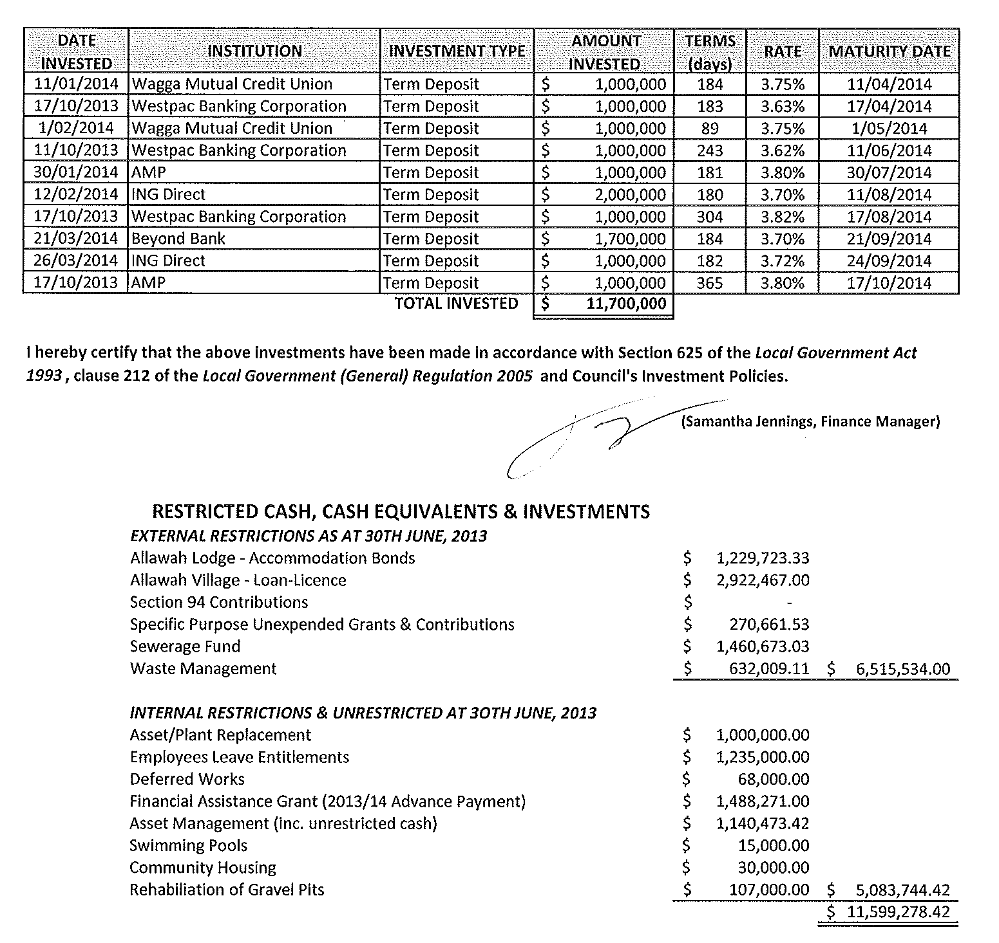
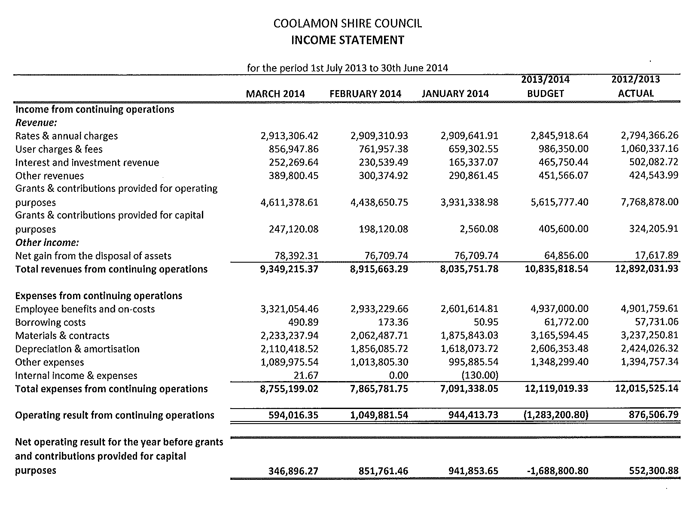
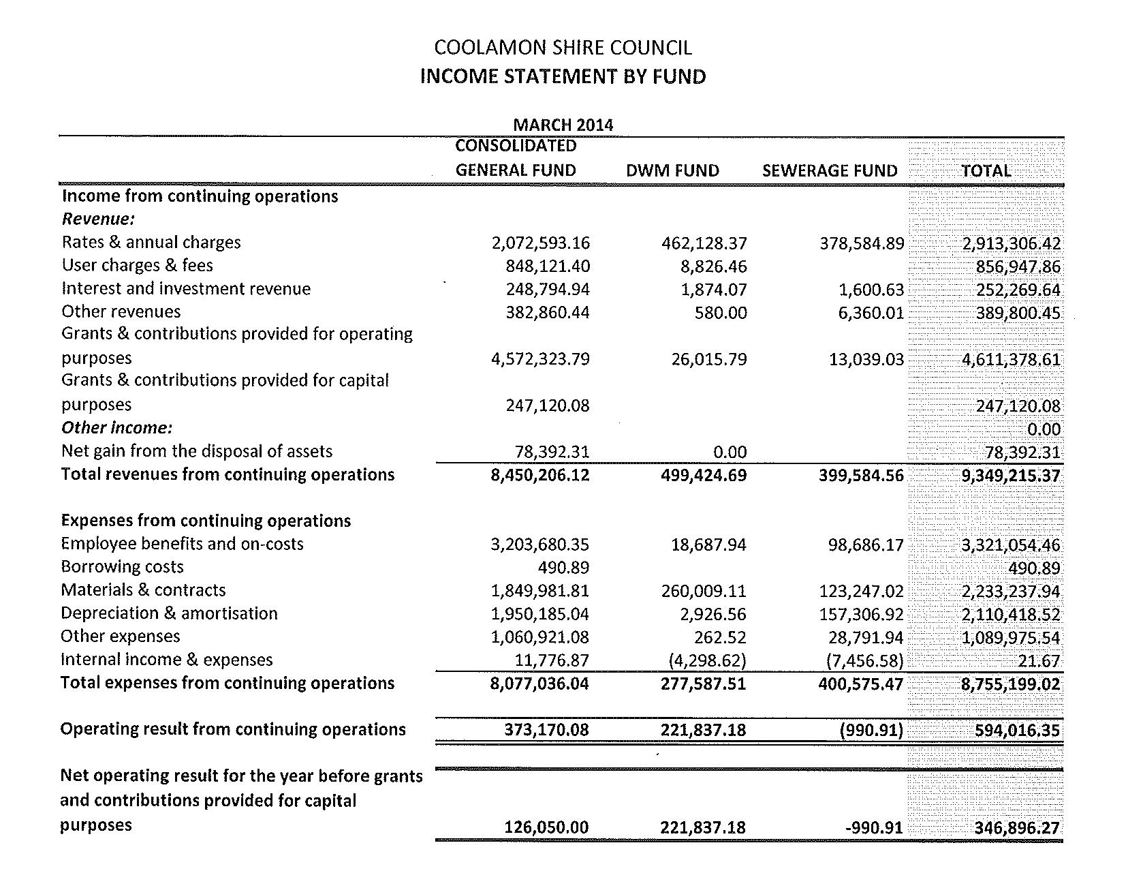
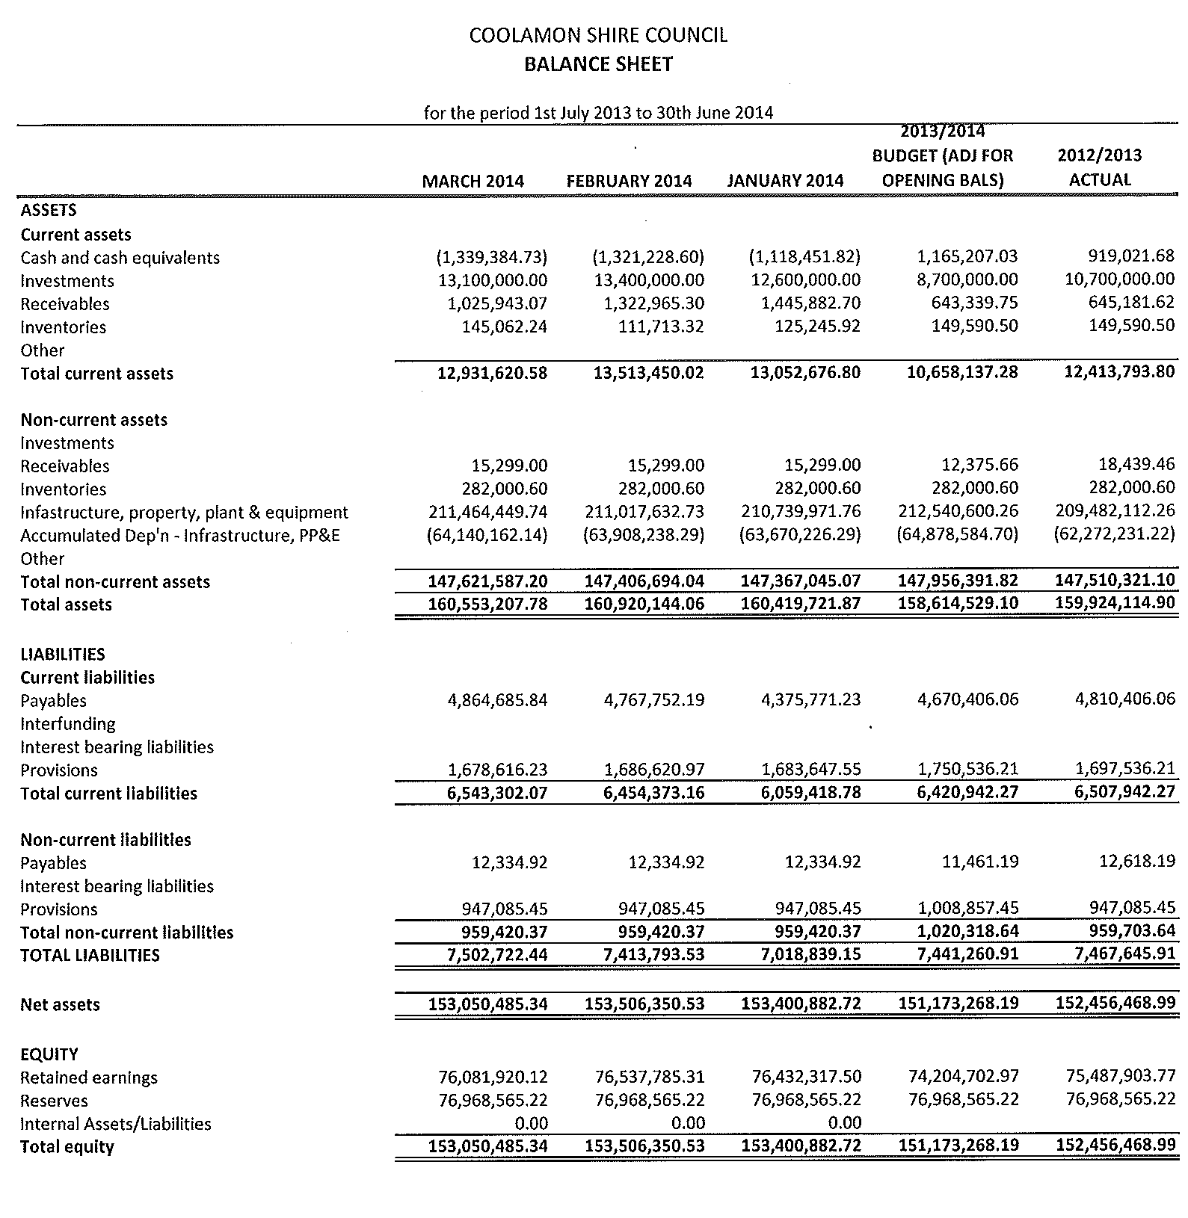
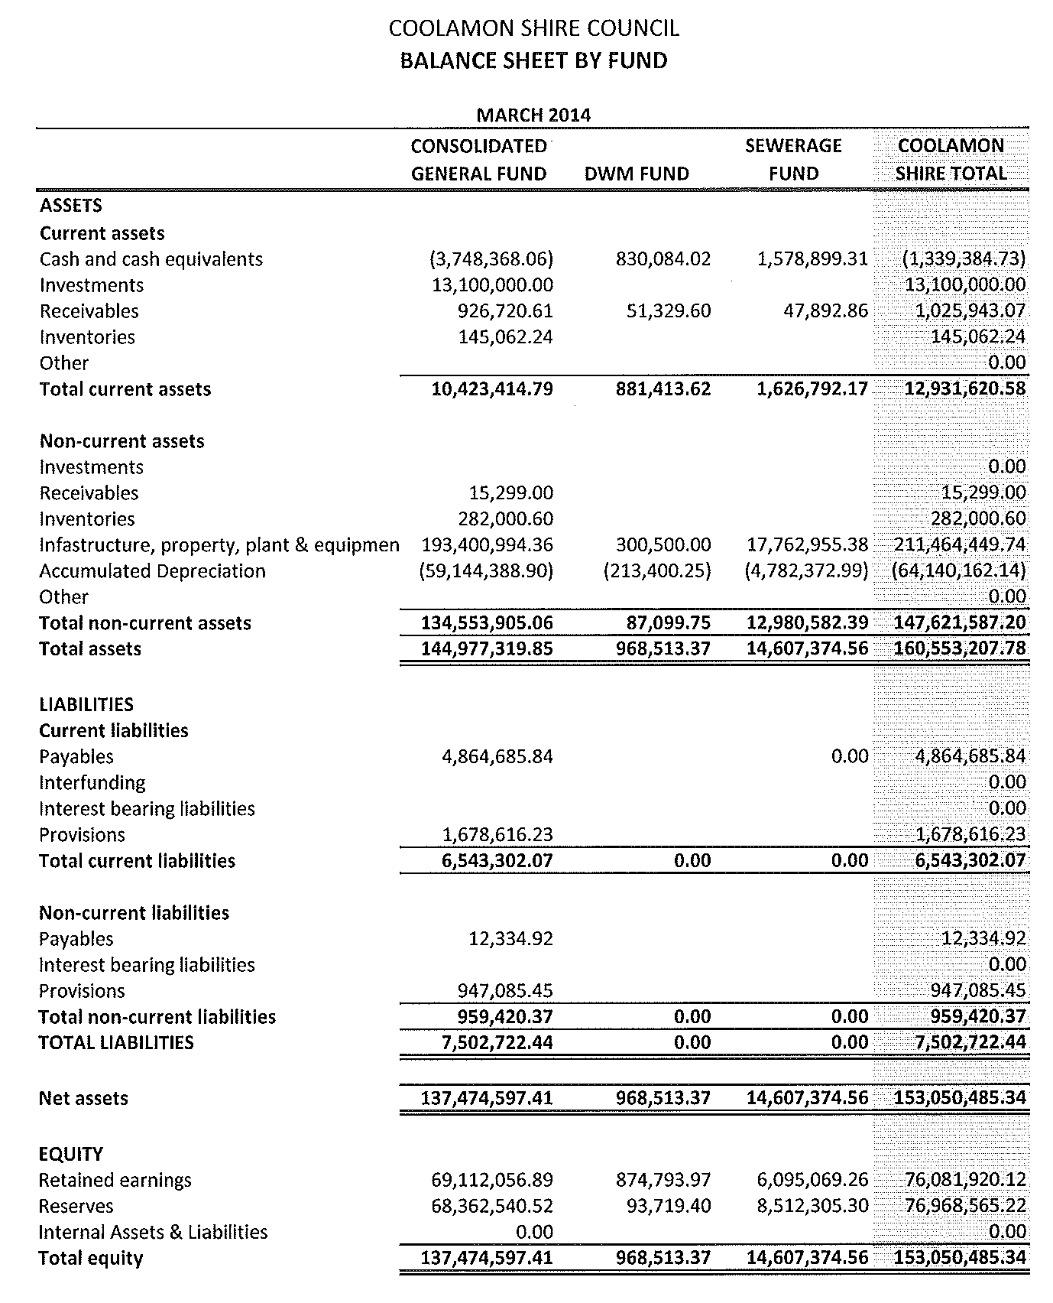
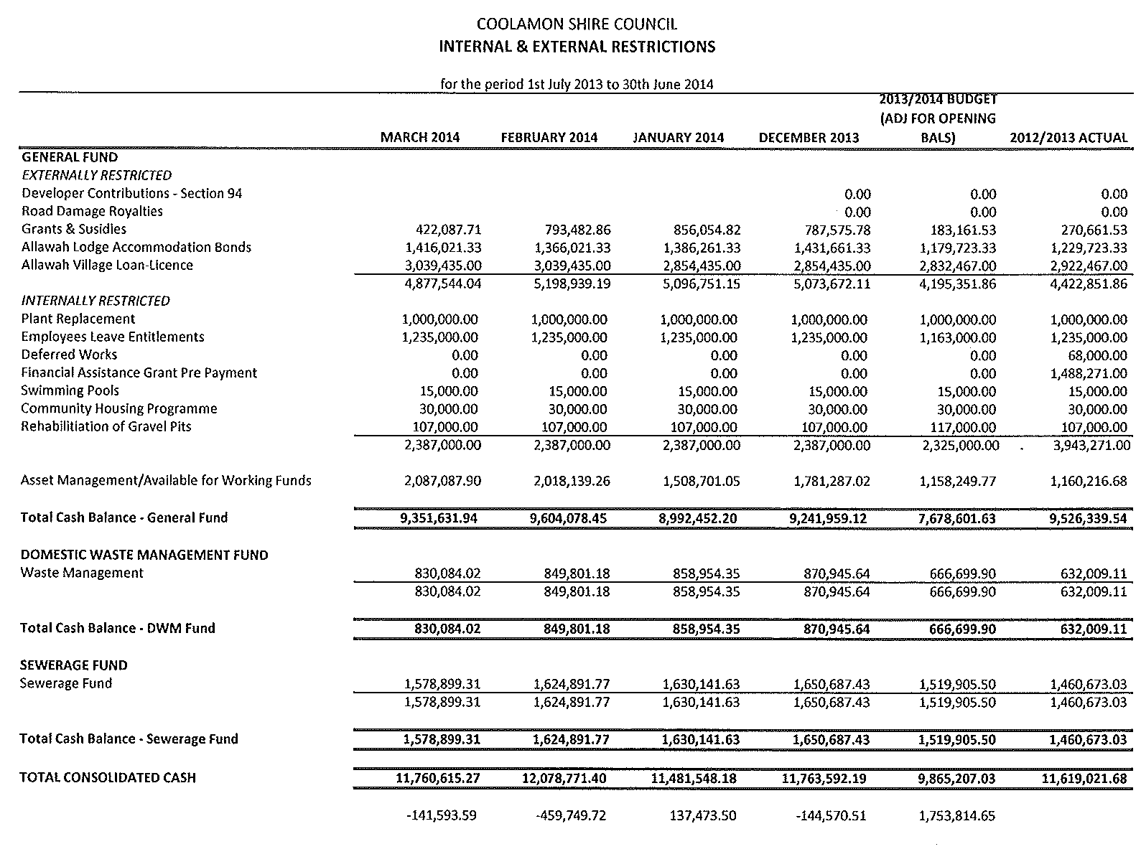
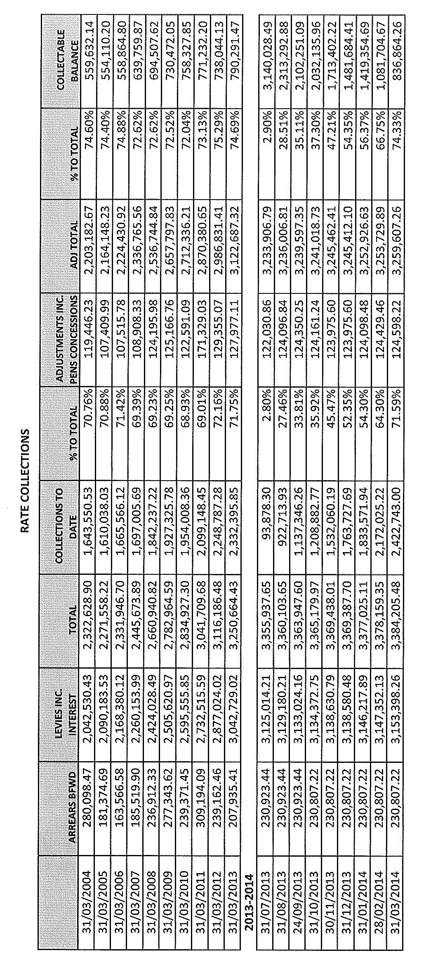
CS2) COMMUNITY SERVICES (C.08-01)

Council has been involved in “Community Care” Services for a number of years. This involvement has grown to the current levels of service where Council receives funding under the HACC program (Coolamon Shire MSO), Community Transport and Home Care Packages (previously known as Community Aged Care Packages) that in 2012/2013 collectively exceeded $330,000. This, when coupled with the income from clients of the services, brought the total income relating to these services to approximately $468,000 in the same year.

The sector has undergone significant changes over the past few years including the splitting of funding between the Federal and State governments and the introduction of the Home Care Standards and into the future the move to Consumer Directed Care will see the clients more directly involved in the financial decision making relating to their care.

Council has a well established “brand” in providing “Community Care” services and established relationships exist between the services provided by Council in the community, Council’s residential aged care service, other community care service providers and health providers within the Shire. To strengthen this brand it is proposed that Council give the services a brand name of “Allawah Community Care” so that clients can be directed to one identifiable service.

Opportunities may exist for Council’s “Community Care” services to grow through strengthening relations with the NSW Government Home Care Service. In order for this avenue to be pursued, Council should commence discussions with the NSW Government in relation to the provision of services to the communities of the Coolamon Shire by the Home Care Service.

Recommendation

1) That Council brand its community care services including its HACC funded services, Community Transport services and Home Care Packages as “Allawah Community Care”.

2) The Council arrange for a meeting with the NSW Government Department of Family & Community Services – Ageing, Disability and Home Care to discuss the provision of Home Care Services to the communities of the Coolamon Shire.

RESOLVED on the motion of Clr Huxtable and seconded by Clr McCann: 77/04/2014

1) That Council brand its Community Care Services including its HACC Funded Services, Community Transport Services and Home Care Packages as “Allawah Community Care”.

2) That Council arrange for a meeting with the NSW Government Department of Family & Community Services – Ageing, Disability and Home Care to discuss the provision of Home Care Services to the communities of the Coolamon Shire.

CS3) ACCOMMODATION PAYMENTS – ALLAWAH LODGE (A.05-02)

Council is now required to set and publish information about the maximum accommodation payment amount attributed to the rooms and facilities that it provides in Allawah Lodge. This maximum accommodation payment amount will replace the existing Accommodation Bond that applies to low care residents and Accommodation Charges that apply to high care residents.

Council staff has completed the Key Accommodation Factors for Allawah Lodge and have determined that one maximum accommodation payment should apply for all rooms.

It is proposed that Council sets its maximum accommodation payment amount at $250,000. This amount can be paid in a number of ways including:

- A Refundable Accommodation Deposit.
Paid in a lump sum of $250,000.

- A Daily Accommodation Payment
To calculate the equivalent daily payment of a refundable deposit, the refundable deposit is multiplied by the maximum permissible interest rate (MPIR) (as determined by the Department of Social Services on a quarterly basis) and divided the result by 365.

Currently the MPIR is 6.63 for the April-June 2014 quarter, therefore the Daily Accommodation Payment would be $250,000 * 6.63% / 365 = $45.41

- A combination of Refundable Accommodation Deposit and Daily Accommodation Payment.

For example if someone wanted to pay $100,000 of a $250,000 Refundable Accommodation Deposit they would pay a Daily Accommodation Payment on the $150,000 difference between the lump sum amount. $100,000 up front Refundable Accommodation Deposit and a Daily Accommodation Payment of $150,000 * 6.63% / 365 = $2.59

Recommendation

That Council sets the Maximum Accommodation Payment of $250,000.

RESOLVED on the motion of Clr Beard and seconded by Clr McCann that Council sets the Maximum Accommodation Payment of $250,000. 78/04/2014

CS4) COUNCIL POLICIES - SEWERAGE DEVELOPMENT SERVICING PLAN POLICY (P.12-01)

Attached is a copy of Council’s Sewerage Development Servicing Plan Policy which has been updated and is now presented for Council’s consideration.

Recommendation

For Council decision.

RESOLVED on the motion of Clr McCann and seconded by Clr Maslin that the Sewerage Development Servicing Plan Policy as attached be adopted. 79/04/2014
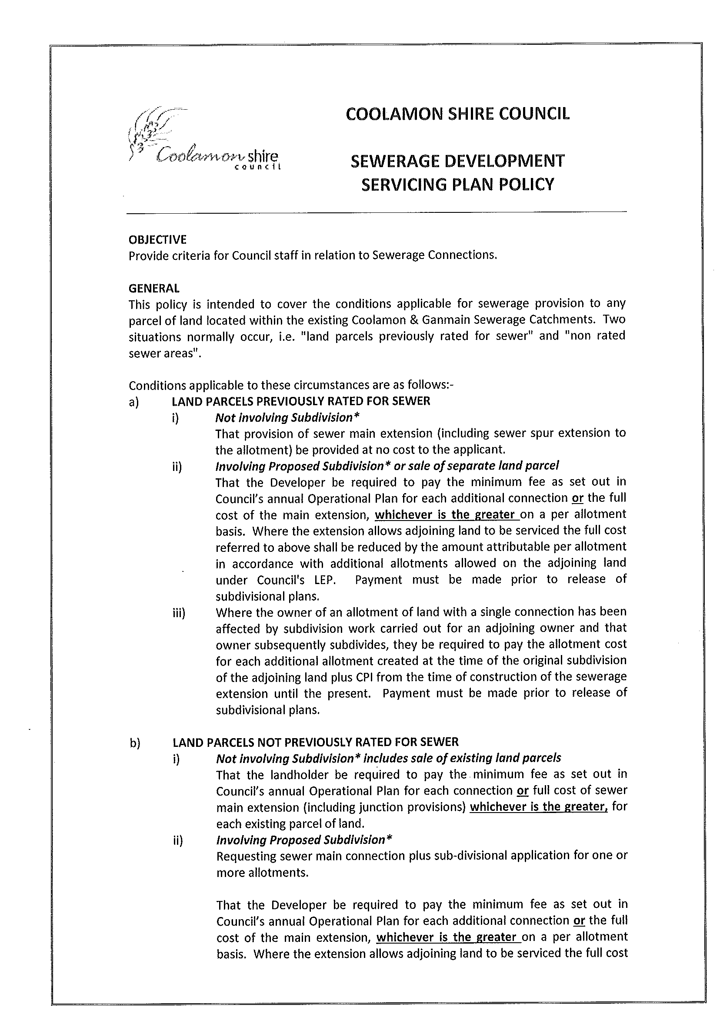
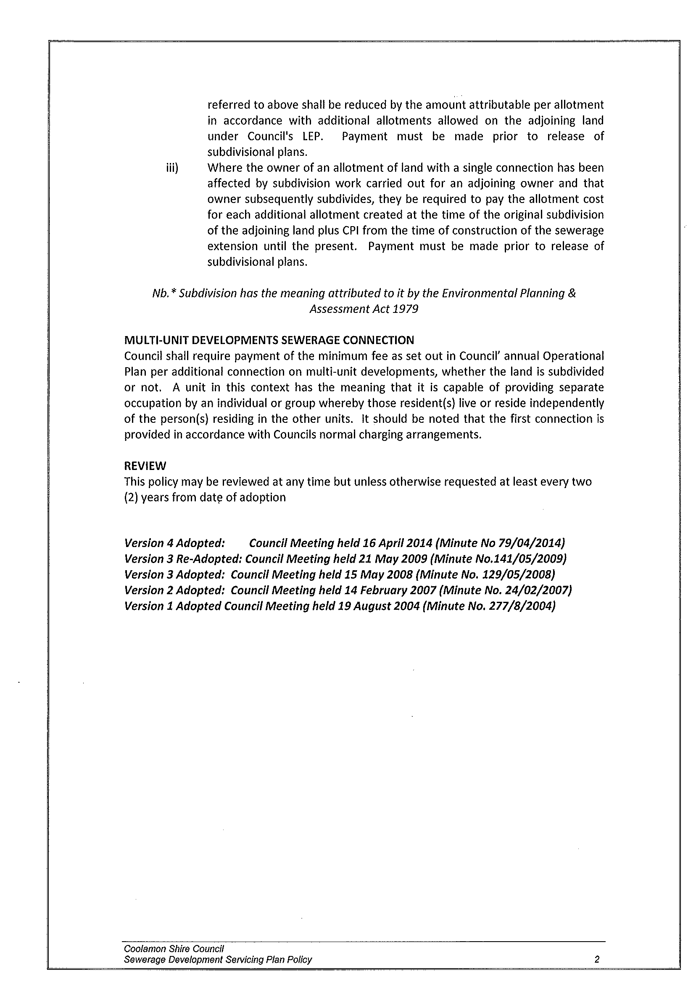
4.3 EXECUTIVE MANAGER, ENGINEERING & TECHNICAL SERVICES’ REPORTS

ES1) SHIRE ROADS RESHEETING, STABILISATION AND MAINTENANCE

The following roads have received attention:

1) MAINTENANCE

- Williamsons Lane (Millwood Road to Tooyal Road)
- Boundary Lane (Millwood Road to Wagga Boundary)
- Bradleys Lane (Millwood Road to Lesterfield Lane)
- East West Road (Jones Lane to Seberrys Lane)
- Seberrys Lane (East West Road to Walleroobie Road)
- Hawthorns Lane (Carlisle Park Road to Stinsons Lane)
- Stinsons Lane (Hawthorns Lane to Tilyards Lane)
- Carlisle Park Road (Hawthorns Lane to Tilyards Lane)
- Pattisons Lane (Carlisle Park Road to Mary Gilmore Way)
- Settlers Lane (Ardlethan Road to Carlisle Park Road)
- Yarrawong Road (Matong North Road to Pamandi Road)
- Hendersons Lane (Mary Gilmore Way to Ardlethan Road)
- Mattinglys Lane (Matong North Road to Derrain North Road)

2) RESHEETING

- Stewarts Lane (Bygoo Road to Boundary)

3) STABILISATON

- Coffin Rock Road (Ramp Road to un-named Lane)
- Carlisle Park Road (End bitumen to Hawthorns Lane)

ES2) 2013/2014 REPAIR PROGRAMME

COOLAMON ROAD RECONSTRUCTION (5.3 TO 7.5KMS)

Stabilisation, sealing and linemarking along this section of road has now been performed and brings this project to a conclusion.

ES3) 2013/2014 ROADS TO RECOVERY PROGRAMME

1) RANNOCK ROAD RECONSTRUCTION (27.76 TO 28.5KMS)

Formation corrections, stabilisation and sealing have been performed along this section of road and brings the project to a conclusion.

2) LOUGHNAN STREET, COOLAMON (COWABBIE STREET TO WILDMAN STREET)

This town street has received the application of a bituminous reseal.

3) LYNE STREET, MARRAR (WEBB STREET TO EASTICKS LANE)

Various sections along Lyne Street have received formation corrections which were followed by stabilisation and bituminous seal. An asphalt overlay to the section in front of the Croker Grain weigh bridge is anticipated to be performed in late May 2014.

4) RANNOCK ROAD – CULVERT EXTENSION (18.57KMS FROM CANOLA WAY)

Preparation works involving the removal of existing head wall and the laying of concrete foundations have commenced in the anticipated delivery of box culverts and headwalls by early May 2014. The extension of the culverts will remove the existing hazards that currently exist as a consequence of the narrow shoulder and large drop off.

5) WALLEROOBIE ROAD RESEAL (6.0 TO 8.5KMS)

A bituminous reseal has been completed on this section of Walleroobie road.

ES4) 2013/2014 BLOCK GRANT

Stabilisation, sealing and linemarking of the following sections of Ardlethan Road have now been performed and brings these projects to a conclusion.

- Ardlethan Road (26.75 to 27.00kms)
- Ardlethan Road (26.08 to 29.27kms)

ES5) SEALED REGIONAL AND LOCAL ROADS

1) ROADSIDE MAINTENANCE

Council’s Noxious Weeds Contractor, Rob Ferguson has been engaged to provide roadside verge spraying to all Council sealed roads. Works have commenced with priority going to Regional Roads with the remainder to be performed over coming weeks.

2) BITUMEN RESEALS

The following roads have received a bituminous reseal:

Regional Roads
Ardlethan Road 0.52 – 0.92
Coolamon Road 0.49 – 0.75
0.96 – 1.11

Local Roads
Rannock Road 0.05 – 0.30
1.78 – 3.56
Dyces Lane 0.0 – 1.03
Marrar North Road 0.4 – 3.00
Methul Road 5.30 – 7.30

3) TOWN RESEALS

Coolamon
Lewis Street Rannock Road to Dunrobin Street
Bredins Lane Various patches
Cowabbie Street Service Road - Devlin Street to Millwood Road
Mann Street Methul Street to Bruce Street
Devlin Street Angel Street to Maloney Street
Stinson Street Bruce Street to Methul Street

Ganmain
Devlin Street Moore Street to Showground Road
Intersection of Camp/Langham Street

Ardlethan
Keogh Street Wilson Street to Cassiterite Street

Marrar
Webb Street See Street to Wise Street
ES6) TOWN WORKS

1) YORK STREET, MARRAR UPGRADE (WISE TO SEE STREET)

Contractors have completed concreting, paving and garden edging works to the front of the Service Station and park area. Council staff have also installed street furniture and painted the park shade structure. Tree removal is scheduled in the coming weeks and will be followed by further garden maintenance and general cleanup.

2) WADE STREET, COOLAMON UPGRADE (COWABBIE STREET TO WALLACE STREET)

Pavement reconstruction works involving formation corrections, stabilisation, seal and linemarking along this 250m of road have now been completed.

ES7) NOXIOUS WEEDS OFFICER’S REPORT (N.02-01)

Noxious Weeds Officer Reports

- Surveillance of all roads and lanes across the three Shires continues. Substantial rainfall has occurred since the last report. This has given rise to a collection of weeds and in particular, Spiny Burr Grass.

- Outbreaks of Spiny Burr Grass were noted at Coolamon and Brushwood Grain Corp facilities on 21st February, 2014. Chris Slinger met onsite with contractors on 10th March, 2014 to examine the two outbreaks which were then sprayed. These two sites were sprayed again two weeks later as initial results were unsatisfactory.

- Research into chemical control into Silverleaf Nightshade will soon commence in Coolamon Shire. Research Officers from Wagga DPI have designed the project with benchmarking of present weed distributions soon to take place, followed by a range of herbicide treatments. This research is also aimed at demonstrating the importance of timely spraying. At this stage of the plants life cycle, the sprays will be targeting seeding by reducing flowering.

- Coolatai Grass has taken awhile to take advantage of the rain, although latest mapping has picked up small numbers.

- Johnson Grass and Bathurst Burr are being sprayed in a routine manner.

- An EARNWAG meeting held on 6th March, 2014 discussed two draft reports. The first being the Natural Resources Commission Review into Weed Management and Invasive Species Management. The former attracted many interested community members voicing a dim view of the draft report.

ES8) PARKS AND GARDENS REPORT (P.01-01)

Facilities Maintenance Officer Reports

- TOUCH FIELDS
Goal posts for this year’s Soccer Competition have been installed and a spraying programme has commenced to remove various weeds including kikuyu from the fields.

- YORK STREET UPGRADE
We are waiting for two trees to be removed to allow renovation of a garden bed adjacent to Raw Design along with replacement of a section of kerb and gutter. This will complete the project.

- BUILDING MAINTENANCE
Facilities receiving attention include:
- Coolamon Early Childhood Centre
- Allawah Village
- Allawah Lodge
- Coolamon Up-to-Date Store
- Ganmain Medical Centre
- Beckom toilets

- ARDLETHAN
A brick and concrete block wall has been constructed in Ardlethan to allow the placement of the Kelpie Dog Sculpture. The rendering of the wall and positioning of the dog will be completed in coming weeks, weather permitting.

Recommendation

For Council information.

RESOLVED on the motion of Clr Brill and seconded by Clr Hutcheon that the Executive Manager, Engineering & Technical Services’ Reports (ES1-ES8) be received. 80/04/2014

ES9) LEASE OF REDGRAVE PARK TENNIS CLUB (34/47)

Following on from a report presented to the March Ordinary Meeting of Council by the Deputy General Manager, Planning & Environmental Services, further investigation into the options available to the Tennis Club relocation have been performed. The attached plan identifies a possible location of the courts on the disused old 18th fairway.

This location would require the removal of a number of trees, redirection of stormwater drainage, survey and design and site preparation prior to construction of the actual courts. With the addition of a storage shed total costs equates to $249,400.

Item No | Works | Cost (GST Inc)
1 | Survey & Design | $ 2,000
2 | Site Preparation | $ 3,600
3 | Tree Clearing | $ 1,800
4 | Drainage Diversion | $ 9,000
5 | Fencing (powder coated) | $ 36,000
6 | Lights | $ 17,000
7 | Light Poles | $ 13,000
8 | Electrical Works | $ 10,000
9 | Base Construction | $ 49,000
10 | Synthetic Grass | $ 83,000
11 | Nets & Posts | $ 10,000
12 | Storage Shed | $ 15,000
 | Total Construction Cost | $ 249,400
 | PROJECT CONTRIBUTION
1 | Grant | $ 60,000
2 | Tennis Club Contribution | $ 40,000
3 | Council Contribution | $ 149,400

Grant funds of $60,000 have been approved and with a contribution of $40,000 from the Tennis Club, Council would be required to contribute the remaining $149,400.

Also attached is a concept plan identifying options available for the development of the existing Tennis Court and Childcare area, no costings have been determined for the work identified in the concept plan. See plan attached.
Recommendation

For Council discussion.

RESOLVED on the motion of Clr Hutcheon and seconded by Clr Huxtable that Council approve the concept plans in principle and that further discussions be undertaken with the Coolamon Tennis Club and the Coolamon Sport & Recreation Club and that a further report be presented to Council. 81/04/2014

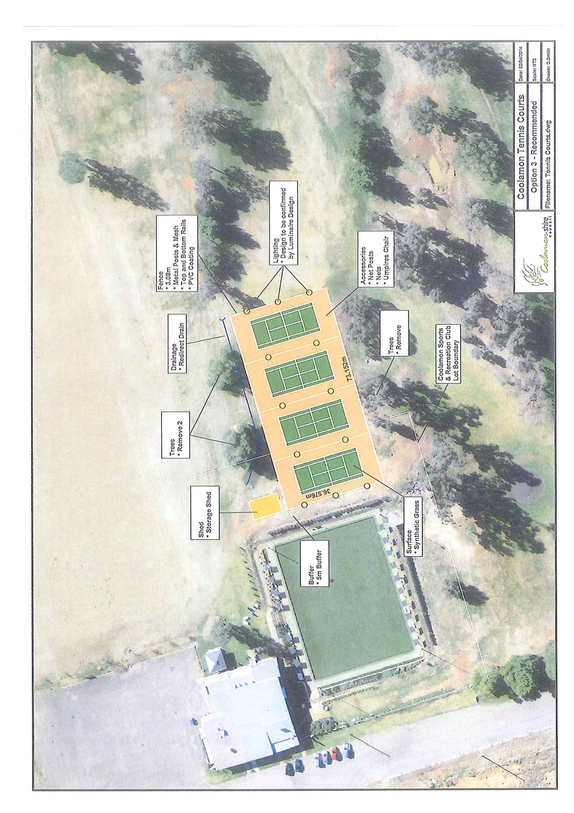
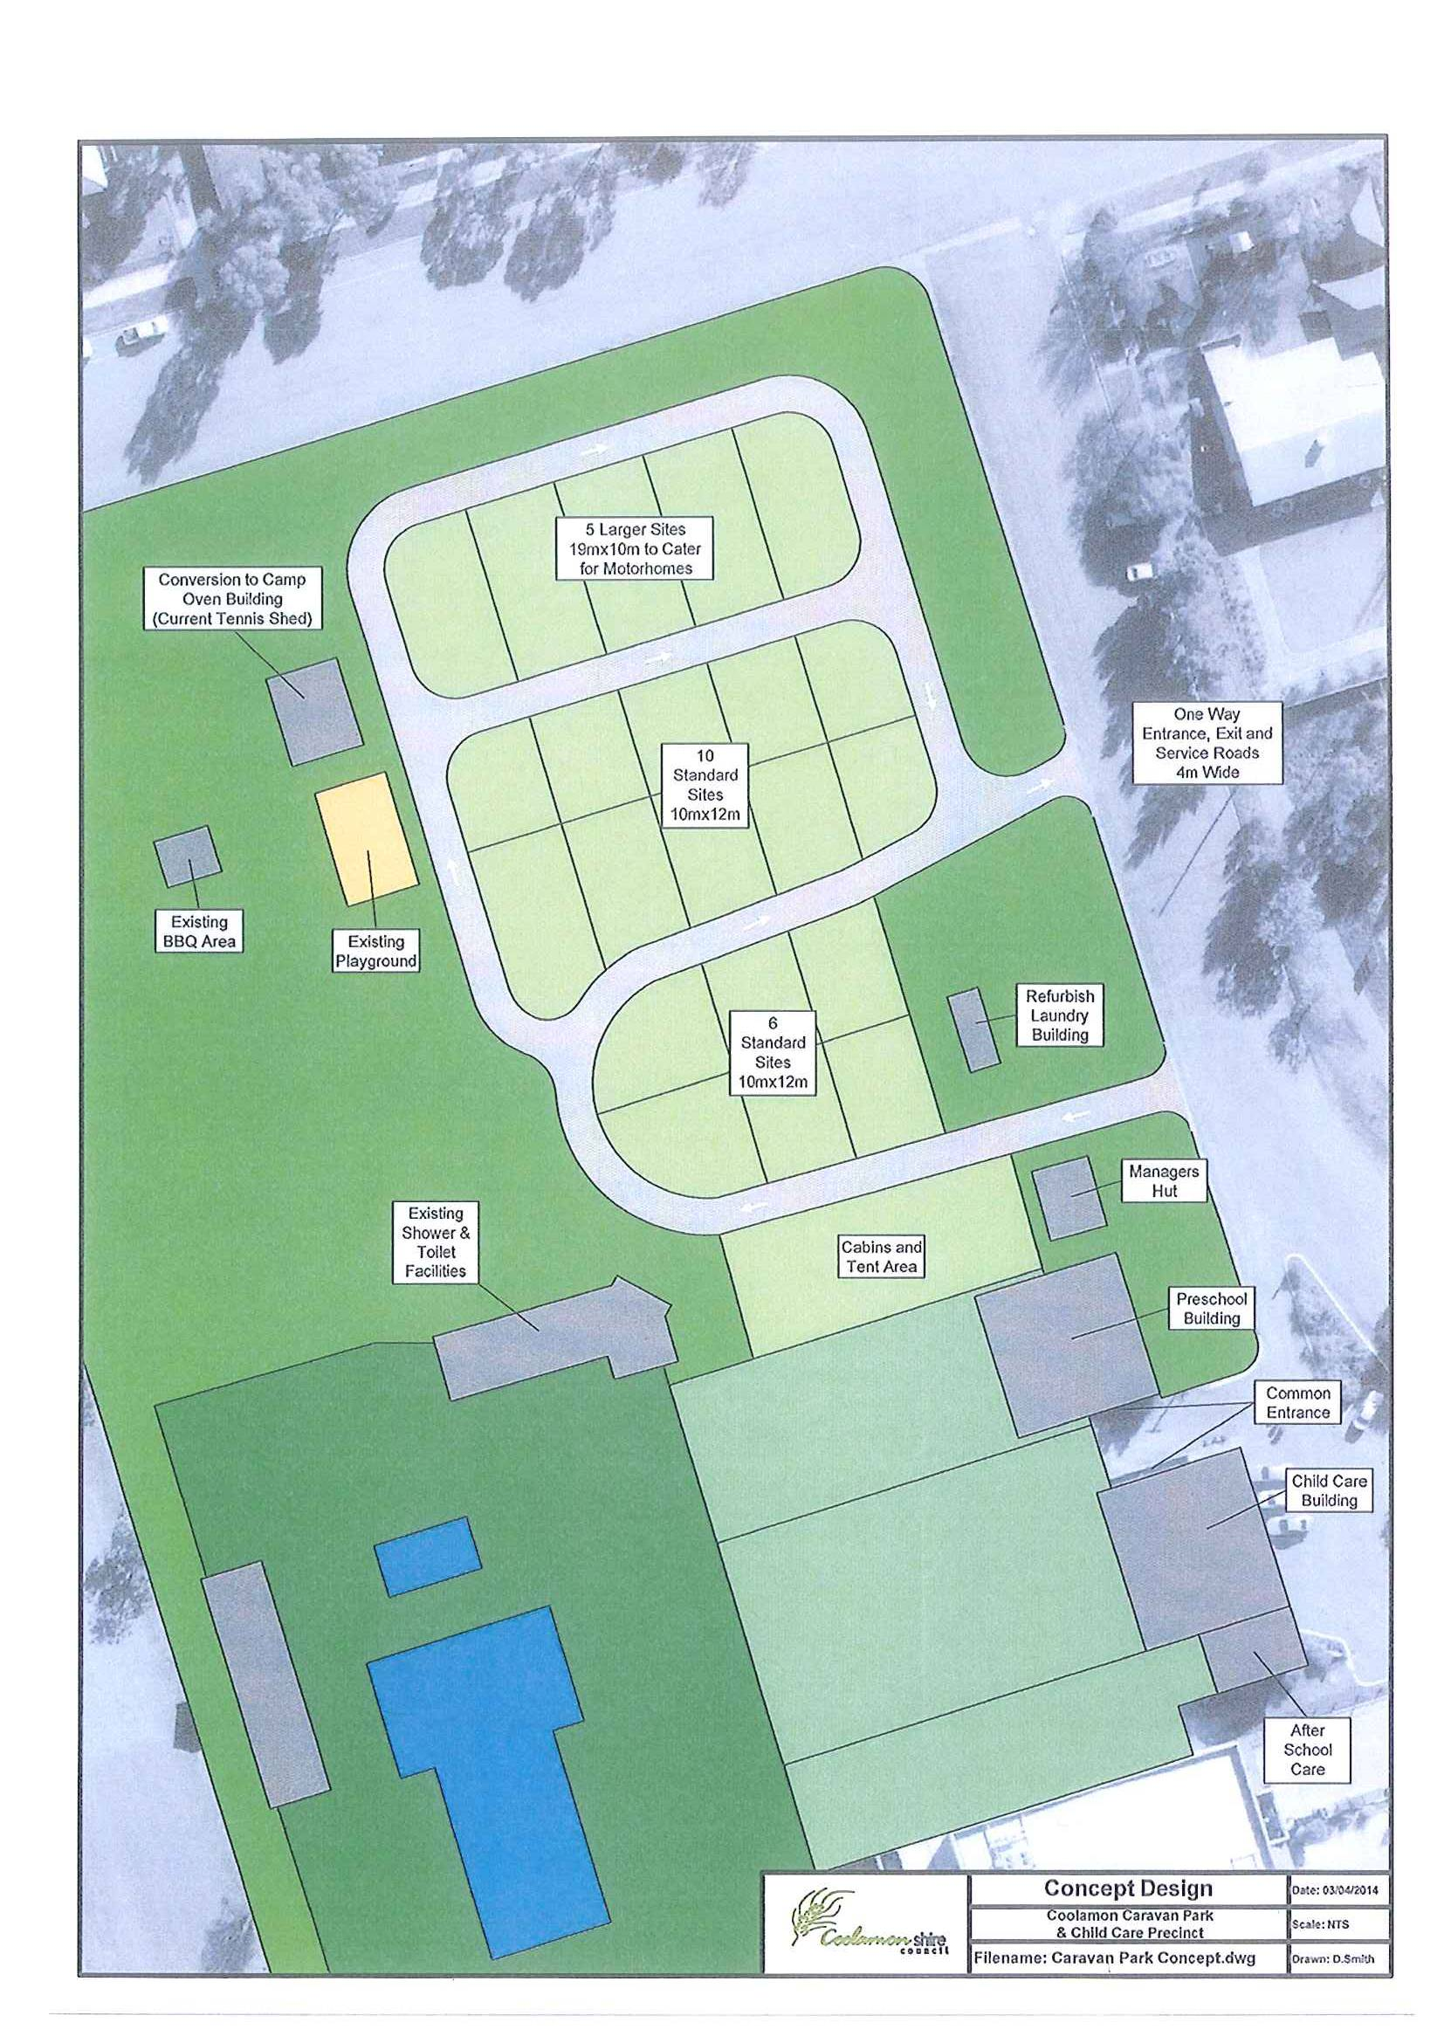

ES10) LONDON HILL ROAD – LINEMARKING (R.09-01)

Following concerns raised by Councillor Maslin at the March Ordinary meeting of Council regarding linemarking the bend along London Hill Road, an assessment has been performed and is as follows:

- SIGNAGE

➔ Motorists are advised of the bending nature of the road either side of the hill with advanced 3km bending road advisory signage. Following on through the hill every bend has advisory speed and bend directional signs for motorists. (See attachment). Attachment No. 4

- ROAD CONDITION

The 6.2m wide pavement seal is considered to be satisfactory for two lanes, two way traffic, is in very good condition with no defects evident and a reseal applied as recently as 2003.

- INCIDENT DATA

Traffic incident records indicate that there has been only two incidents along this section of road over the last 23 years and are as follows:

Date | 7 September, 1991
Location | 1.0kms East of Newell Highway (first bend)
Number of Vehicles | Single motor bike incident
Weather | Fine, dry
Cause | Excessive speed

Date | 11 April, 2010
Location | 3.2kms East of Newell Highway (crest of hill, currently linemarked)
Number of Vehicles | Single car
Weather | Fine, dry
Cause | Excessive speed

Both incidents are single vehicle, on fine dry days and attributed to excessive speed.

- EXISTING LOCAL RURAL ROAD LINEMARKING

Council has very little linemarking across its Sealed Local Road Network as a consequence of its low traffic volume with areas of high safety concern and traffic volume addressed. Local Sealed Road linemarking locations are as follows:
- Rannock Road – 1.4kms from Ardlethan Road, over crest
- Marrar South Road – centre line full length – 350 vehicles per day
- Dullah Road – 2.4kms from Ardlethan Road – high speed crest/bend
- London Hill Road – 3.2kms from Newell Highway – over crest/bend

In summary, extensive Road Advisory Signage is present notifying motorists of the upcoming road alignment and appropriate speed, a quality road pavement free of defects and width suitable for two lane two way traffic is provided, a lack of evidence identifying this location as a safety concern and for a Local road with an Average Annual Daily Traffic of 20 vehicles, linemarking cannot be justified.

Recommendation
For Council discussion.

RESOLVED on the motion of Clr Hutcheon and seconded by Clr McCann that the report be received. 82/04/2014

ES11) ROAD HIERARCHY (R.09-01)

A thorough review of Council’s Road Hierarchical Classification was performed as recently as October 2011. A further evaluation performed by Council’s Engineering Staff in November 2013 indicated that the hierarchical classifications of Road 1 to 4 are still true today. What this evaluation did highlight was that Council has many low hierarchical roads that are either Crown Roads or Council Public Roads which id does not maintain.

The attached list identifies Crown Road which should be removed from Council’s Road Register and Council Public Roads which are recommended for modification to their hierarchical classification.

Recommendation

That the reclassification and removal of roads identified in the attachment be adopted.
RESOLVED on the motion of Clr Hutcheon and seconded by Clr McCann that the reclassification and removal of roads identified in the attachment be adopted. 83/04/2014
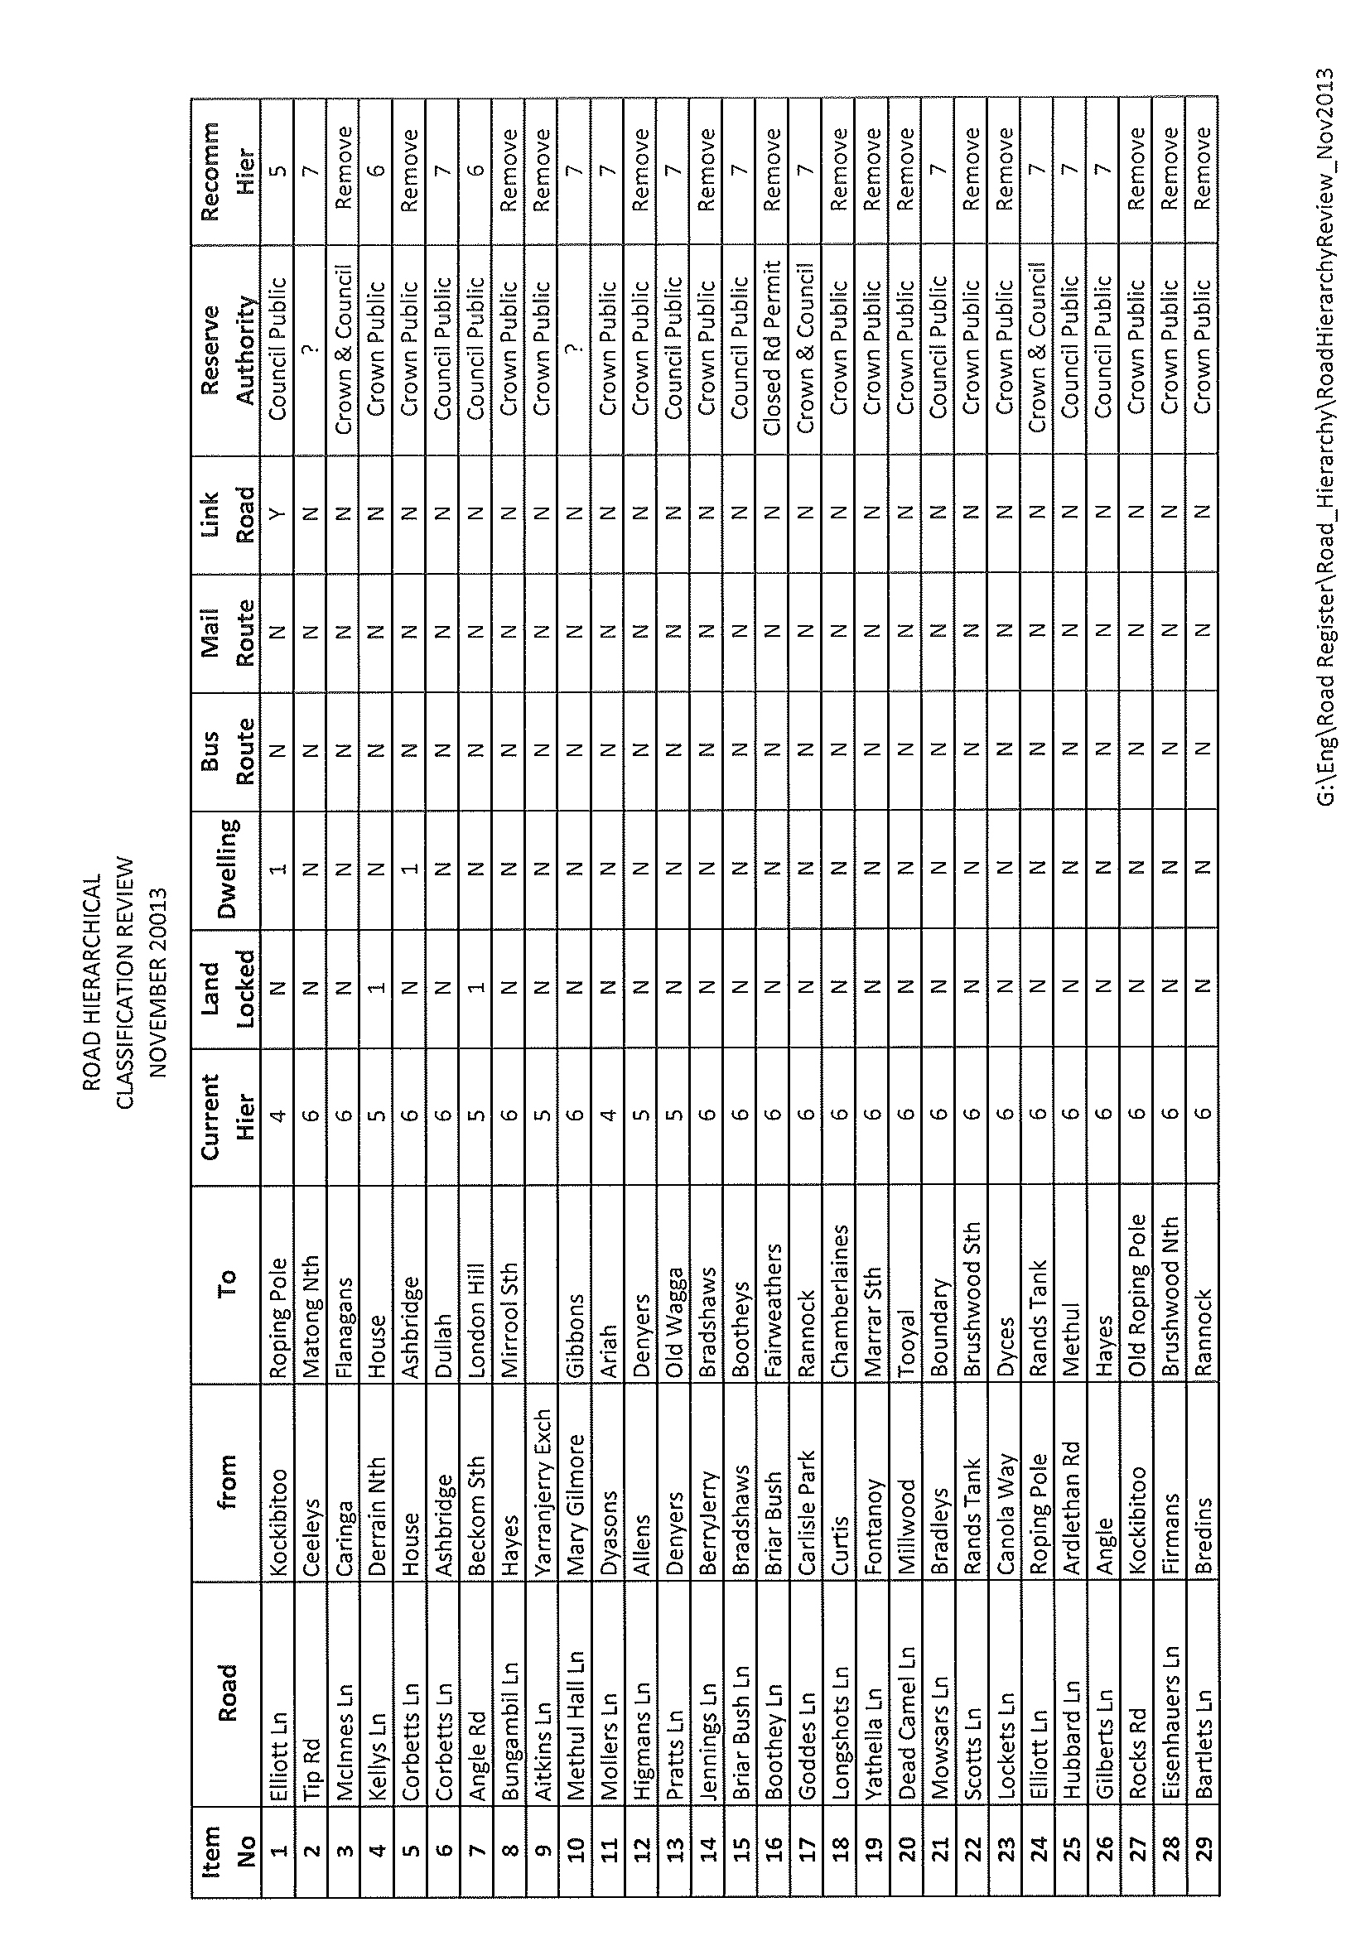
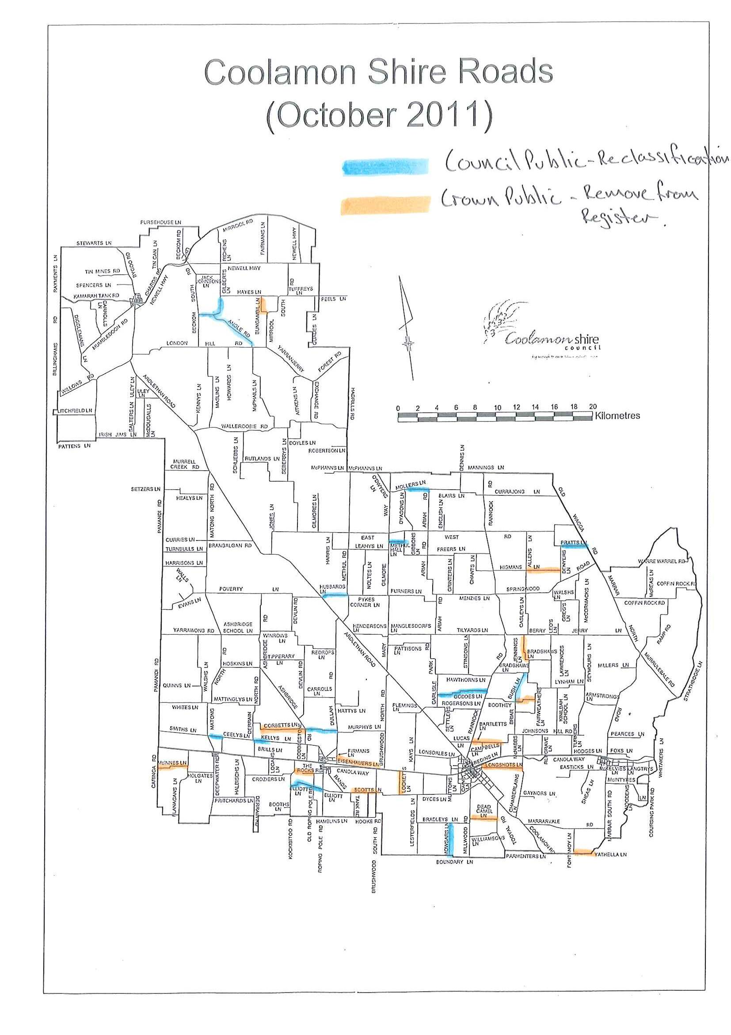
ES12) CEMETERIES (C.02-01)

Council maintains Monumental and Lawn Cemeteries in the following towns and villages:

- Ardlethan
- Coolamon
- Ganmain
- Marrar

Additional regional Monumental Cemeteries which Council maintain include Berry Jerry and Rannock.

Income for Cemeteries is generated via a burial fee which covers the digging of the plot, purchase and placement of a plaque and a maintenance fee. Cemetery expenses include the purchase and placement of plaques, burials and others which include parks and gardens maintenance, watering fees and weeds spraying. The attached spreadsheet indicates that over recent years income has exceeded expenditure to the value of approximately $5,500.00 but will come under further pressure with future increases to water rates, this does not take into depreciation.

- Coolamon Lawn Cemetery

50 vacant plots are available on the existing beam in the Lawn Cemetery and on a decease rate of approximate 1% of population per year this equates to 2.5 years remaining life in the beam. Further expansions are available west of the access road which would permit an additional 320 further plots which equates to a further 15 years life without significant works. Further room is available outside the existing clearing for future expansion but would require significant works involving tree clearing, road access and landscaping.

- Ardlethan Lawn Cemetery

18 plots are available on the existing beam which equates to 3 years of service. Further expansion is available to the east of the existing beam. This would create an additional 80 plots and extend the life of the lawn cemetery for an additional 13 years. Works required include the extension of the irrigation system, construction of kerb and guttering, new beam and landscaping.

There is sufficient space within the parcel of land for future expansion to service the area for many years to come.

- Ganmain Lawn Cemetery

14 plots are available on the existing beam which equates to 1.5 years remaining life. The existing infrastructure has the capacity to cater for an additional 3 beams creating a further 118 plots and extending the life of the lawn cemetery out for a further 13 years. Significant room for expansion within the parcel of land is available but will require significant works such as tree clearing, kerb and guttering, access roads and landscaping.

- Marrar Lawn Cemetery

Six plots are remaining on the current beam which equates to 3 years remaining life. Sufficient space for expansion is available with minimal works. An additional beam would create a further 40 plots and extend the life of the lawn cemetery out for a further 20 years.

At the time of construction it was agreed that the Marrar Community would maintain the Lawn Cemetery. Unfortunately this commitment did not last long and the maintenance was directed to Council. Council has maintained the Cemetery until mid 2013 where it was then able to negotiate an agreement with Junee Correctional Centre to provide these services by its inmates.

If the Marrar Community are unsatisfied with the service levels provided by the Junee Correctional Centre inmates they may wish to honour the original agreement and provide the service levels they desire.

In summary the order of new beam construction and remaining life until significant works are required is as follows:

Town | New Beam | Time until Significant Works
Ganmain | 1.5 years | 13 years
Coolamon | 2.5 years | 15 years
Marrar | 3 years | 20 years
Ardlethan | 3 years | 3 years

Ardlethan is the only Cemetery that requires associated significant works. Council may wish to review Cemetery merit when expansion and significant expenditure is required. It should be noted that Council would still be required to provide ongoing maintenance to any existing Cemeteries.

Recommendation

1) That Council reviews the need for four Lawn Cemeteries, especially given the location of the three Cemeteries in the south of the Shire.
2) Council to continue to operate the Cemeteries within the existing maintained footprint, no further expansion is proposed of the footprint.

RESOLVED on the motion of Clr Huxtable and seconded by Clr Maslin: 84/04/2014

1) That Council reviews the need for four Lawn Cemeteries, especially given the location of the three Cemeteries in the south of the Shire.

2) That Council continues to operate the Cemeteries within the existing maintained footprint, no further expansion is proposed of the footprint.

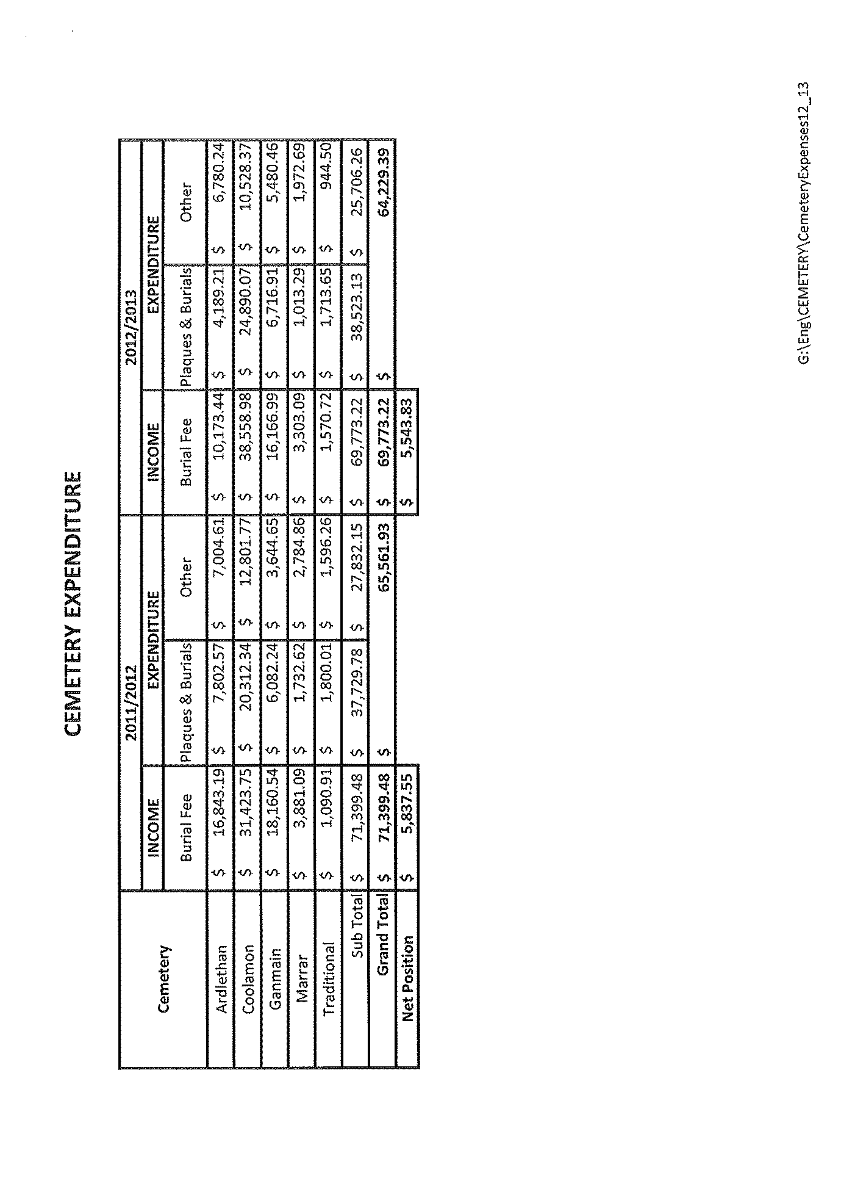
4.4 EXECUTIVE MANAGER, PLANNING & ENVIRONMENTAL SERVICES’ REPORTS

HS1) DEVELOPMENT APPLICATIONS (B.05-03)

The following applications have been approved:-

DEVELOPMENT APPLICATIONS

02/2014 102//750818 – 7452 Newell Highway, Beckom – New Awning.
09/2014 96//750846 – 29-31 Iverach Street, Coolamon – Shed.

COMPLYING DEVELOPMENT CONSENT

2014/13 3//608815 – 32 Park Street, Ardlethan – Shed.

Recommendation

For Council information.

RESOLVED on the motion of Clr Brill and seconded by Clr Hutcheon that the report be received. 85/04/2014

HS2) 2012-13 SEWERAGE PERFORMANCE MONITORING REPORT (S.03-01)

Council has received the most recent Sewerage Performance Report in relation to the Coolamon Shire facilities.

The previous report that has been provided to the Councillor Workshops in relation to Sewerage Treatment Works have provided recommendations in relation to operation and management of these facilities.

➔ It is thought important that the latest information from the NSW Office of Water in relation to the performance standards of this facility should be included for your information. This report has been provided in the attachments. Attachment No. 5

As can be seen from this report Council is compared to other Councils of similar sizes. In this regard Coolamon Shire performs adequately in the majority of these areas identified as operational indicators.

The TBL Sewerage Performance information reinforces that Council has performed quite well and it is worth noting that Column 1 in this table is the Coolamon Shire Council result, Column 2 is the average result for similar sized Sewerage Networks, column 3 is the ranking of all local water utilities. This can then be compared in column 4 and 5 with statewide and national medians.

The next summary sheet is an action plan which highlights where Council can review and improve its sewerage management. This information is included into the Strategic Sewerage Business Plan that is currently being developed by Consultants on behalf of Council. This information will be provided when the report has been completed.

In summary Council is aware of the issues required to maintain the Sewerage Networks at an acceptable and functional standard and will be undertaking the appropriate measures to ensure that this continues to occur.

Recommendation

For Council information.

RESOLVED on the motion of Clr Huxtable and seconded by Clr McCann that the report be received. 86/04/2014

HS3) DEVELOPMENT APPLICATION 07/2014 – STORAGE OF SHIPPING CONTAINERS FOR THE PURPOSE OF RESALE, HIRE AND SELF STORAGE – LOT 158 DP 750846 - 158 DEVLIN STREET, COOLAMON – (PF1286/1022)

Council received the above mentioned Development Application proposing to store shipping containers on the above mentioned land.

The land is currently zoned RU5 which permits the proposed activity subject to Council approval.

➔ A copy of the proposal has been provided in the attachments. Attachment No. 6

In accordance with Council’s policy this application was advertised to neighbouring properties with this notification period finishing between the writing of this report and the Council Meeting.

For this reason Council have been provided with the information pertaining to the proposal but assessment of the Development Application will be provided in a late report to Council.

As of the current date there are two submissions that have been received.

Recommendation

For Council information.

HS5) Development Application 07/2014 – Storage of Shipping Containers for the purpose of Resale, Hire and Self Storage – Lot 158, DP 750846 – 158 Devlin Street, Coolamon (PF1286/1022)

This is a late report in continuation of (HS3). To recount, the proposal is for the storage of shipping containers for the purpose of resale, hire and self-storage. The application was notified to neighbouring landholders.

In accordance with the earlier report, Council received a total of 4 submissions relating to the proposal.

- A copy of the submissions have been attached. Attachment No. 9

The submissions raise a number of matters that are required to be addressed by Council under section 79C of the Environmental Planning & Assessment Act. These are summarised as follows:

1) Zoning

As reported in HS3, the land subject to the application is zoned RU5 – Village. In accordance with the Coolamon Local Environmental Plan 2011 the proposed use is permissible with consent.

The site itself however is located in the south-western corner of the Coolamon RU5 zone. The boundary between this zone and the RU4 (Primary Production Small Lots) zone is located only 100m to the west. This has therefore created some confusion within several submissions, with several landowners mistakenly locating the proposal in the RU4 zone, and as a consequence applying expectations of a rural orientated zone to what is a legitimate land use in the village zone.

Ultimately the use is considered permissible in this zone under the LEP regardless of proximity to the adjoining zone.

2) Visual Amenity

Whilst the zoning issue described above is considered a clear-cut argument, the fact remains that the area still has an overall rural appeal. This is a valid issue that is raised in each submission. The rural appeal is reflected by all of the allotments in this vicinity having an area equal to or greater than 1 hectare, including the subject site and other adjoining parcels within the village zone. The overarching issue is therefore finding how a balance can be achieved.

In a previous self-storage development approved by Council (corner of Booth & Curtis Streets), a perimeter chain-link security fence was permitted as the proposed storage structures located beyond the fence were new colorbond clad sheds, whilst minor landscaping was also provided. In this instance the applicant is proposing refurbished shipping containers, which are generally much more difficult to make visually appealing. Screening trees are also proposed, however these will take time to become established. For these reasons it is considered appropriate for Council to require a more substantial solid type fence constructed of new materials to reduce the visual impact of the containers. Council generally permit a maximum solid type fence height of 1.8m; this height would be considered acceptable in this instance.

3) Traffic

Several issues relating to traffic have been raised. The first issue relates to traffic vision, speed and illegal road use along this section of Devlin Street. It has been suggested that these factors make the proposal unsuitable.

It should be noted that the proposed entrance to the site is located at least 80m from the Devlin Street/Iverach Street intersection, and at least 160m from the blind corner in question. This section of Devlin Street is also speed limited to 50 km/h, whilst illegal use of the road is a matter for the Police and not something that can be taken into consideration by Council.

What can be controlled by Council is the direction in which vehicles enter and exit the premises. Generally Council would require all vehicles to enter and exit the site in a forward direction. This requirement combined with the suitable sight distances and current speed limit negates the likelihood of site users reversing blindly onto the road, and effectively eliminates the risk of a collision with other traffic.

The second traffic issue raised is that of an increase in heavy vehicle traffic in the area and its impact on local road safety. The applicant estimates that a total of 2-4 vehicle movements will occur per week, however this figure takes into account light vehicles such as cars and utes. It is expected that the majority of heavy vehicle movements will be for the purpose of moving the shippings containers on and off the site. At this point in time it is difficult to gauge exactly how many heavy vehicle movements will occur as the actual figure will depend upon the success of the venture, however at this stage the number is not anticipated to be high. In effect it is not considered that road safety will be impacted upon by a minor increase in heavy vehicle traffic.

Further to the above traffic issues, an assessment by Council’s engineering staff has indicated that several matters will need addressing from a Council perspective. Firstly, an upgrade of the current access point will be required to a standard specified by Council’s Executive Manager Engineering and Technical Services. This will ensure that heavy vehicles have sufficient turning space, do not detrimentally affect Council’s road asset and minimises the impediment of stormwater drainage in the table drain.

Secondly, it is considered essential that all heavy vehicles using the site be restricted to approaching and departing via Iverach Street, using Millwood Road from the south or Canola Way from the north. Through heavy vehicular traffic from Cowabbie Street via Devlin Street will not be permitted regardless of the number of heavy vehicle movements anticipated. This requirement ensures that minimal damage occurs to Council’s road infrastructure whilst keeping heavy vehicles out of the more densely populated village areas.

4) Opening Hours & Site Access

An issue has been raised with regards to site accessibility and whether users of the site will be able to access stored belongings after hours. The applicant has advised within the statement of environmental effects that the gates will be locked outside the stated opening hours, therefore restricting access and site use at inappropriate times.

As a general rule, Council enforce opening hours via a condition of consent. The proposed opening hours of 8.30am – 5.30pm Mon-Fri and 9.00 – 5.00pm Sat-Sun are considered suitable for this type of use. Restrictions on the delivery and loading times of the actual containers should however be applied as a means of limiting noise impact. It is there considered appropriate to not permit such activities on Sundays.

5) Stormwater Runoff

Early discussions held by Council staff with the applicant indicated that a swale drain should be considered on the western boundary to eliminate any potential for overland runoff onto neighbouring properties. This is an effective manner in which to convey stormwater runoff and limit future neighbour issues.
It has been suggested within one submission that the proposed swale drain would concentrate stormwater flows to the Devlin Street table drain and therefore flood a neighbouring property entrance. Whilst a concentration of runoff will occur, there is no evidence to suggest flooding or impeded access will occur. Council’s Executive Manager Engineering and Technical Services has advised that a sufficient culvert is in place between the 2 points of interest and therefore should not be considered an issue.

6) Depreciation of Surrounding Land Values

The depreciation of surrounding property values has been flagged as a potential issue. Council are not required to address this as a matter for consideration. As it stands however, the proposed use is permitted within the zone, and any forthcoming approval would be conditioned to limit and/or mitigate any potential negative impact on surrounding properties.

7) Fire Safety

An issue has been raised with regards to fire safety, and in particular the potential spread of fire onto neighbouring properties as a result of a fire within one of the containers. In this instance the building code of Australia would require that any structure located within 3m of a property boundary be suitably fire-rated. As no fire-rating details have been supplied, it is considered necessary to require the applicant to provide evidence of the fire-rating for shipping containers, or alternatively adjust his site to be located at least 3m from each boundary.

The former option is the most desirable, as this would also allow a more accessible and usable area for landscaping. Brief discussions held with the applicant also indicate that this is a preferred option.

SUMMARY & CONCLUSION

As can be seen there have been a number of issues raised, consisting primarily of zoning permissibility, visual amenity, traffic, site access and opening hours, stormwater runoff and fire safety. Of these issues, it appears that those that must be considered by Council under the Act can be adequately addressed through the application of suitable conditions of development consent, allowing the proposal to go ahead with minimal impact upon the surrounding area.

It is further highlighted that the proposed use is considered permissible with consent in accordance with Council’s LEP.

At this point in time however circumstances have meant that sufficient time to carefully prepare suitable conditions of consent has not been achieved. It is therefore recommended that Council delegate the determination of the application to the General Manager to allow sufficient time to for this to occur.

Recommendation

That determination of Development Application be delegated to the General Manager.

RESOLVED on the motion of Clr Hutcheon and seconded by Clr Brill that determination of Development Application 07/2014 be delegated to the General Manager. 87/04/2014

HS4) POOLS (S.19-01)

CAPITAL AND MAINTENANCE

Council has recently upgraded the filtration, pipework and tanks at the Ardlethan Pool. This comes on the back of a complete upgrade of the Coolamon Pool over recent years. The implications of these upgrades have been an increase in maintenance costs.

In August 2013 a report was presented to Council that highlighted maintenance costs for the Coolamon Swimming Pool. This allowed the operational costs to be broken into a weekly cost in order for decisions to be made about starting and finishing times for the season.

Currently the Pool Contractor is permitted to open on 1st November and close on 31st March but in reality the season generally operates from mid November to mid March and is therefore on average 4 months long.

A cost per day for the last financial year has been established on this assumption.

COOLAMON | 2012/13 | Per Month | Per Week | Per Day
Power | 25,387.15 | 6,346.79 | 1,586.70 | 226.67
Water | 9,035.49 | 2,258.87 | 564.71 | 80.67
Rates/Phone/ Insurance | 7,359.93 | 1,839.98 | 459.99 | 65.71
Other | 51,072.73 | 12,768.19 | 3,192.05 | 456.01
Total | 92,855.30 | 23,213.83 | 5,803.45 | 829.06

ARDLETHAN | 2012/13 | Per Month | Per Week | Per Day
Power | 8,073.17 | 2,018.30 | 504.57 | 72.08
Water *
Rates/Phone/ Insurance | 6,173.95 | 1,543.49 | 385.87 | 55.12
Other | 58,757.55 | 6,410.66 | 1,602.66 | 228.95
Total | 73,711.23 | 18,427.81 | 4,606.95 | 658.14

*The annual cost of water in Ardlethan appears to be incorrect and in contrast to other pools.

GANMAIN | 2012/13 | Per Month | Per Week | Per Day
Power | 9,270.98 | 2,317.75 | 579.44 | 82.78
Water | 4,118.38 | 1,029.60 | 257.40 | 36.77
Rates/Phone/ Insurance | 5,546.70 | 1,386.68 | 346.67 | 49.52
Other | 25,642.67 | 6,410.67 | 1,602.67 | 228.95
Total | 44,578.73 | 11,144.70 | 2,786.18 | 398.02

The total cost to run all 3 pools last financial year was $211,145.26. With a population of 4,050 this equates to $52.13 per person to ensure our communities have access to three pools.

The ongoing infrastructure upgrades have shown an increase in running costs, primarily to meet the Public Health Guidelines for pools. At this stage the full impact of the Ardlethan upgrade is yet to be felt and Council has not yet started on improvements to Ganmain. The upgrade at Ardlethan cost $180,000.

As the fiscal constraints affect Councils operating budget, consideration needs to be given to the proposed pool improvements. Council is yet to undertake the following capital work.

ARDLETHAN | Estimated Cost
Improvements to change rooms/kiosk | $120,000.00

GANMAIN | Estimated Cost
New Filtration Plant | $40,000.00
Dosing Unit | $10,000.00
Storage Shed | $40,000.00
Pumps | $10,000.00
Demolition | $15,000.00
Power Upgrade | $5,000.00
Landscaping | $10,000.00
Plumbing | $20,000.00
Improvements to change rooms/kiosk | $120,000.00
TOTAL: | $270,000.00

The improvements to the Amenity buildings were identified in the last round of Regional Funding, unfortunately this programme was removed by the new Federal Government.

When investigating the cost to upgrade Ganmain Pool, Council needs to consider the value of this work to the community. The Ganmain Pool is the youngest pool and work can be undertaken to repair damage and change the current dosing unit. This would be a far cheaper cost than a complete upgrade of the filtration unit.

In reality the only way Council can consider undertaking the required work is through external funding.

OPERATIONAL COSTS

In addition to reconsidering the capital work, Council can also consider several options to reduce pool running costs:

OPTION | COST | SAVINGS PER ANNUM
Install variable pump speeds | $15,000.00 | To be determined
Provide Solar Power to pools | $60,000.00 | $4,000-$5,000

These options allow Council to reduce maintenance costs and with funding available for solar panels the repay timeframe is greatly reduced.

ENTRY FEES

Under the current management structure the pool operations are contracted out. This contract allows for the setting and collection of entry fees, the operation of the kiosk and the payment of a retainer. Council pay for all operational costs associated with the running of the pool.

Council needs to be mindful of how entry fees are set. It is of no benefit to have high fees set by the Contractor and limited use of the pool because of excessive charges. In the past Council has assumed that the kiosk operation would encourage the Contractor to have high patronage through smaller admittance cost to increase revenue of the sale of food. This year has seen one Contractor operate at higher entry fees, particularly the annual charge, to increase their income. This discourages attendance and is not seen as a benefit to community use of the pool.
A comparison of entry fees from surrounding pools was investigated. A copy of this table has been attached for your information. When remembering these comparisons it must be noted that Temora, Junee and Wagga are heated pools and therefore operate twelve months of the year, therefore the annual access is obviously considered higher than a 4 to 5 month season.

COMPARISION OF ENTRY FEES AT POOLS

Pool | Child  Visit | Child  School Age | Visit  Adult | Annual Family | Adult  Annual
Bland | Free | $2.60 | $4.40 | $235.00 | $120.00
Temora (heated) | $3.00 | $3.00 | $5.50 | $550.00 | $250.00
Junee (heated) | $3.80 | $3.80 | $5.70 | $577.00 | $265.00
Wagga (heated) | $3.50 | $3.50 | $6.00 | $850.00 | $440.00
Narrandera | Free | $3.20 | $3.20 | $200.00 | $90.00
Barellan | Free | $2.00 | $3.00 | $50.00 | $90.00
Ganmain * | Free | $2.50 | $2.50 | $160-$190 | $80-$100
Coolamon | $3.00 | $3.00 | $3.00 | $300.00 | $120.00
Ardlethan | Free | $2.00 | $2.50 | $150.00 | $80.00

*Ganmain offers an early bird annual price.

Recommendation

1) That Council investigates the option of setting fees.

2) That Council defers the kiosk and amenity upgrade at the Ardlethan Pool.

3) That Council defers the filtration and amenities upgrade at Ganmain.

4) That Council investigates options to reduce maintenance costs at all three pools.

RESOLVED on the motion of Clr McCann and seconded by Clr Beard: 88/04/2014

1) That Council investigates the option of setting fees.

2) That Council defers the kiosk and amenity upgrade at the Ardlethan Pool.

3) That Council defers the filtration and amenities upgrade at Ganmain.

4) Council investigates options to reduce maintenance costs at all three pools.
 ADJOURNMENT

RESOLVED on the motion of Clr Huxtable and seconded by Clr Beard that Council resolve into Committee of a Whole for the purpose of considering confidential matters as listed in the Committee of a Whole agenda for the reason that such matters are considered to be of a confidential nature and in accordance with Council's policy thereto. 89/04/2014

Council adjourned at 3.40pm into Committee of a Whole and reconvened at 3.55pm.

5) RECOMMENDATIONS OF A COMMITTEE OF WHOLE MEETING HELD 16TH APRIL, 2014.

RESOLVED on the motion of Clr Maslin and seconded by Clr McCann that the Recommendations of the Committee of a Whole Meeting held 16th April, 2014 be adopted. 90/04/2014

6) REPORTS: DELEGATES/MAYOR/COUNCILLORS

GOLDENFIELDS WATER COUNTY COUNCIL – ASSET MANAGEMENT AWARD

Clr McCann advised the Council that Goldenfields Water County Council had been the recipient of a Local Government NSW Asset Management Award.

RESOLVED on the motion of Clr McCann and seconded by Clr Hutcheon that a letter of congratulations be forwarded to Goldenfields Water County Council and the General Manager concerning that Council being the recipient of an Asset Management Award. 91/04/2014

Meeting Closed at 4.03pm.

Confirmed and signed during the Meeting held this 15th day of May, 2014.

......................................................
MAYOR

