Meeting commenced at 2.00pm.

BUSINESS:

1) Apologies

2) a. Confirmation of Minutes of the Meeting held 11th December, 2014.
b. Matters arising out of Minutes. (Not elsewhere reported)

3) Correspondence
a. Agenda A (Information Only)
b. Agenda B

4) General Manager’s Report
4.1 General Manager’s Report
4.2 Executive Manager, Corporate & Community Services’ Report
4.3 Executive Manager, Engineering & Technical Services’ Report
4.4 Manager, Planning & Environmental Services’ Report

5) Recommendations of a Committee of a Whole Meeting held 19th February, 2015.

6) Reports: Delegates/Mayor/Councillors.

7) Recommendations of the Coolamon Shire Consultative Committee Meeting held 18th December, 2014.

PRESENT: Clrs Seymour (Chairman), Hutcheon, White, Huxtable, McCann, Logan, Brill and Beard.

STAFF: General Manager; Executive Manager, Corporate & Community Services; Executive Manager, Engineering & Technical Services; Finance Manager; and Manager, Planning & Environmental Services.

APOLOGY: Clr K Maslin.

1) APOLOGY

RESOLVED on the motion of Clr Hutcheon and seconded by Clr Beard that the apology of Clr Maslin be accepted. 01/02/2015

2a) CONFIRMATION OF MINUTES OF THE MEETING HELD 11th DECEMBER, 2014.

RESOLVED on the motion of Clr McCann and seconded by Clr Huxtable that the Minutes of the Meeting held 11th December, 2014 as circulated be confirmed and adopted. 02/02/2015

2b) MATTERS ARISING OUT OF THE MINUTES
There were no matters arising out of the Minutes.

3) CORRESPONDENCE

AGENDA A (FOR INFORMATION ONLY)

1a) INFORMATION PAPERS

➔ The following papers have been distributed with Council’s supplementary material as being matters of information/interest to Councillors. If Councillors desire any further information on the matters distributed then that can be raised with the General Manager. Attachment No. 1

1) NSW Shires Association Weekly Circulars 47, 48, 49, 1, 2, 3, 4 and 5.

2) Minutes of the Advance Ganmain Committee Meeting held 16th December, 2014.

3) Minutes of the Advance Marrar Committee Meetings held 8th July, 2014 and 7th October, 2014.

4) Minutes of the Advance Ardlethan Committee Meeting held 1st December, 2014.

5) NSW Government Weekly Update from Adrian Piccoli dated 5 December, 2014.

6) Fit for the Future Newsletter – Issues 5 and 7.

7) Office of Local Government Circular No. 15-01 – Local Government Amendment (Elections) Bill 2014.

8) Media Release from Local Government NSW titled “Container Deposit Scheme will be a win for the environment and local communities”.
2a) ACTIVITY REPORTS

1) Coolamon Shire Multi Service Outlet Coordinator’s Monthly Report for the month of January 2015.

2) Operating Statistics of the Coolamon Shire Library for December 2014 and January, 2015.

3) Youth & Community Development Officer’s Report for December 2014 to February 2015

4) Tourism & Business Development Monthly Update for January 2015.

General Manager’s Note

The above reports are operating reports only for use by Senior Staff. They are submitted to Council as part of Agenda A for information only. Attachment No. 2

3a) THE HON VICTOR DOMINELLO MP (C.07-01, SC88)

Forwarding a copy of correspondence received from the Hon Gladys Berejiklian, MP regarding Volunteer Community Drivers.

General Manager’s Note

➔ Copies of the letters have been distributed with Councillors information papers. Attachment No. 3

4a) THE HON KATRINA HODGKINSON MP (H.03-03, SC225)

Forwarding a copy of correspondence from The Hon Jillian Skinner MP regarding the consultation process for the provision of ambulance services in Coolamon Shire.

General Manager’s Note

➔ Copies of the letters have been distributed with Councillors information papers. Attachment No. 4

5a) ADRIAN PICCOLI, MP (F.03-11, SC459)

Advising that he has conveyed Council’s concerns on the Review of the Rural Fires Act to the NSW Minister for Police & Emergency Services, the Hon Stuart Ayres MP., seeking his advice on the matter. A copy of the Minister’s response will be forwarded to Council when it comes to hand.

RESOLVED on the motion of Clr Brill and seconded by Clr White that the Correspondence listed in Agenda A be received. 03/02/2015

AGENDA B

1b) NSW RURAL DOCTORS NETWORK (D.03-01, SC154)

Advising Council of the availability of the 2015 Bush Bursary / Country Women’s Association Scholarship Scheme.

General Manager’s Note

➔ This matter has been an annual request and Council has not participated in the past noting the cost of $3,300. A copy of the letter has been attached to Council’s information papers. Attachment No. 5

RESOLVED on the motion of Clr McCann and seconded by Clr Huxtable that the correspondence be noted. 04/02/2015

4) GENERAL MANAGER’S REPORT

4.1 GENERAL MANAGER REPORTS

GM1) RIVERINA EASTERN REGIONAL ORGANISATION OF COUNCILS (REROC) (L.05-05, SC275)

As REROC moves forward with the Joint Organisation (JO) Pilot there are numerous ongoing issues that need to be addressed.

The timeframe set down by the State Government in relation to these Pilots is somewhat tight and has created some angst with some constituent members of REROC.

Since the last Council Meeting a Planning Meeting for all Councillors and Senior Staff was held on the 15th December, 2014. This was attended by some Councillors and Staff.

➔ From this meeting some strategic directions were brainstormed to see if there was any common themes and whether or not they reflected the current thinking of the REROC Board. A copy of these outcomes has been attached. Attachment No. 6

As you are aware REROC is administered by a Board that is represented by each Council. On the Management Board are the General Manager and the Elected Representative from each Council. In most cases this is the Mayor, however, some REROC Councils have elected to send a delegate in place of the Mayor.

In addition to this, the General Manager of Coolamon Shire Council sits on the Executive of the REROC Board as the Treasurer.

The REROC Organisation has been operating as a regional collective of Councils providing services and advocacy for the region since 1993. In the current political environment around Fit for the Future and amalgamations, Coolamon Shire has supported REROC in applying for a JO Pilot.

There has been some concerns raised in regard to the JO Pilot not being sufficiently explained to Councillors and therefore a general meeting of Councillors and Senior Staff has been proposed for 23rd April, 2015 commencing at 10.00am in Gundagai. All Councillors are invited to attend.

Recommendation

For Council information.
RESOLVED on the motion of Clr Hutcheon and seconded by Clr Huxtable that the report be noted. 05/02/2015

GM2) RIVERINA REGIONAL TOURISM (T.06-03, SC427)

Council has received the annual review of Riverina Regional Tourism indicating and updating the marketing initiatives carried out by RRT.

With this year’s budget looming, Council will be required to make a decision on the relevance and value that Coolamon Shire is receiving from this programme.

Early estimates of Council’s contribution towards this programme are in the vicinity of $3,000.

Recommendation

For Council information.

RESOLVED on the motion of Clr Beard and seconded by Clr Huxtable that Council not pay the membership to Riverina Regional Tourism for the 2015/2016 financial year. 06/02/2015

GM3) COOLAMON EARLY CHILDHOOD CENTRE (C.04-07, SC81)

Coolamon Shire Council has recently been assessed under the National Quality Framework for Early Childhood Education and Care.

As an approved provider Council is required to undertake this assessment where the services provided are rated. In all, Council satisfactorily met the National Quality Standards on 6 of the 7 ratings with the National Standard being exceeded on the 7th rating in regard to leadership and service management.

Corie Flanigan, the Manager at this facility, has worked hard to ensure that Council meets the National Quality Framework and should be congratulated on her and her Team’s efforts.

Recommendation
For Council information.

RESOLVED on the motion of Clr Hutcheon and seconded by Clr White that Council’s congratulations be extended to the staff at the Centre on the Accreditation Standards. 07/02/2015
GM4) NSW RURAL FIRE SERVICE (F.03-11, SC459)

Council has made regular requests to Local Government NSW (LGNSW) asking for a Review of the RFS Financial and Service Model.

➔ Council has since received a response from LGNSW and a copy of this correspondence has been provided for your information. Attachment No. 7.1

In short LGNSW has advised that they are regularly advocating Council’s position with the Premier, Minister, Commissioner and Departmental Staff.

Council will be providing LGNSW with all the required and relevant information to ensure that an appropriate review is carried out.

➔ In addition to this correspondence from LGNSW, Council has also received correspondence from the Riverina Zone RFS detailing the current red fleet within the system and the proposed maintenance schedule forecast. Attachment No. 7.2

With a fleet of 25 tankers and a service standard requiring vehicles only under 25 years of age, will now see a new truck required every year. The oldest vehicle in the fleet is 25 years old with 142,136kms of use and should be replaced. The next oldest is 22,800kms.

Currently the average for this fleet is 11,231kms of use and this seems a little excessive to require a complete replacement programme.

Council also believes that any money received from the sale of secondhand tankers should be distributed in accordance with the percentages that are required for the purchase.

Recommendation

For Council information.

RESOLVED on the motion of Clr McCann and seconded by Clr Hutcheon that Council continues to pursue the Rural Fire Service Funding. 08/02/2015

RESOLVED on the motion of Clr Brill and seconded by Clr Huxtable that Council extend its congratulations to Pat Quinn on the receipt of the Fire Medal. 09/02/2015
GM5) ALLAWAH RETIREMENT VILLAGE CONTRACTS (LD129/45, LF387 LD129/46, LF390)

The Allawah Retirement Village Contracts in respect of occupancy by the following persons are now available for sealing by Council.

- Mrs Lorna Cumming
- Mrs Helen Mary Pippen

Recommendation

 That the Seal of Council be affixed to the Allawah Retirement Village Contracts for Mrs Lorna Cumming and Mrs Helen Mary Pippen.

RESOLVED on the motion of Clr Hutcheon and seconded by Clr Beard that the Seal of Council be affixed to the Allawah Retirement Village Contracts for Mrs Lorna Cumming and Mrs Helen Mary Pippen. 10/02/2015

GM6) COOLAMON LIONS CLUB - OCCUPATION AGREEMENT (LD142, LF388)

The Coolamon Lions Club currently occupies the building located adjacent to the RFS/SES sheds and undertakes paper recycling in these facilities.

In order to ensure that the current arrangements are validated, an Occupation Agreement has been drawn up for both parties.

This Agreement is required to be signed under the Seal of Council and accordingly Council will need a resolution as such.

Whilst this has been an ongoing operation Council responsibilities revolve around the provision of a building and maintaining building insurance. The Lions Club is required to cover all appropriate insurances and undertake any repairs and maintenance to the building.

Recommendation

 That Council signs the Occupation Agreement under the Seal of Council.

RESOLVED on the motion of Clr Huxtable and seconded by Clr White that Council signs the Occupation Agreement under the Seal of Council. 11/02/2015

GM7) AUSTRALIA DAY AWARDS (A.13-09, SC449)

A very successful Australia Day Ceremony was held in Beckom this year with the community showing their wonderful hospitality. Both the Beckom Hall & Community Committee and Bronwyn Hatty should be formally congratulated on their efforts.

The Ambassador on the day was Debbie Watson, who proved to be a pleasant and easy going person who was popular with all who met her.
The award winners for the day were as follows:

- Citizen of the Year: Kaarin Edyvean
- Young Citizen of the Year: Emma Corbett
- Shane Till Memorial Award for Sportsperson of the Year: Noel ‘Buster’ Fairman
- Young Sportsperson of the Year: Beckom Public School P6 Relay Team (Oscar Day, Emma Collis, Jim Griffin and Benjamin Grinter)
- Community Event of the Year: Rural Women’s Gathering 2014

➔ Council now needs to look towards next year’s Australia Day event and decide upon a location. Attached is the list of previous communities that have held this Ceremony. Attachment No. 8

The time and format for the day is considered appropriate. So too is the concept of moving the event around to all communities within the Shire.

Recommendation

For Council decision.

RESOLVED on the motion of Clr McCann and seconded by Clr Beard: 12/02/2015

1) That the 2016 Australia Day celebration be held in Marrar and that the 2017 Australia Day celebration be held in Ardlethan with a long term schedule to be developed and presented to Council.

2) That a letter of congratulations be forwarded to the Beckom Hall and Community Committee with regard to their organization of the 2015 Australia Day celebration.

GM8) DEAD CAMEL LANE (R.09-12, SC346)

The owners of Lot 42, DP 870040, 104 Dead Camel Lane, Coolamon have held a meeting with Council Staff on the 21st January, 2015 to discuss issues over maintenance of Dead Camel Lane.

This road is defined as a Crown Road in accordance with previous policy decisions when determining Council’s Road Hierarchy Network. As a result of this classification it has been removed from Council’s maintenance schedule.

Council’s guidelines in relation to property access require that direct access is to be provided by Council at the nearest point to the property boundary. This principle extends to the highest order hierarchy road. Council has previously decided that the responsibility of access to the Road Network for landholders should be controlled, so as not to unnecessarily expand the Road Network for individual convenience.

This is to ensure that Council can adequately maintain a Road Network and allocate the resources to the road asset as provided to all users.

➔ The subject land is serviced by Millwood Road and this is indicated in their Development Approval at the time of the dwelling construction. Attachment No. 9.1

➔ In this instance the owners of the property believed that through previous correspondence, Dead Camel Lane was deemed their primary entrance point and that accordingly the road should be maintained. A copy of this information has been provided for Council’s information. Attachment No. 9.2

Council believes that the Development Consent as submitted and approved indicated that Millwood Road was the primary access to the property and that the current owners had begun using Dead Camel Lane as an alternate route to provide more convenient access.

There are no additional landowners that require access along Dead Camel Lane.

The owners believes that this policy, and in particular this situation, should be reviewed in light of the correspondence received and requested that the matter be placed before Council.

This is not an unusual request and Council has received similar requests in the past to maintain or upgrade convenience roads for use by landowners in providing alternative routes to town, better access between properties etc. In the past these requests have been denied.

Council’s position in relation to this matter has been held for a considerable time. Council’s letter dated 21st September, 1999 reinforces this position.

In reviewing any policy, Council would need to determine:

1) That they believe the policy is unfair or incorrect and therefore warrants a change.

2) That the particular instance in question is significantly different to require that it sit outside the policy.
3) That the policy stands.

In view of the fact that Council has received similar requests to provide maintenance on Crown Roads used for convenience access and to date declined those requests, indicates that in the past the policy has been deemed appropriate.

Access is provided to the property via Millwood Road which is a Regional Road and receives significant maintenance and repairs.

That there are no other users of Dead Camel Lane.

In summary, it is thought that the current position of Council determining property access is acceptable and should remain unchanged.

The owner does have options in regard to continuing to use this as a convenience access path by undertaking any of the following:

1) Purchasing the Crown Road.
2) Undertaking private works on the Crown Road.
3) Formalising their access of Millwood Road.

➔ In reviewing this matter, it is thought appropriate that the current policy is amended to reflect the need to reinforce Council’s policy on property access. Please see attached. Attachment No. 9.3

The submission also makes some remarks about Council’s staff and their response to being asked to undertake work outside Council’s policy. Staff will enforce the policies of Council and this may at times upset individuals who believe they are entitled to special treatment.

This particular issue has been taken up with Council staff previously and the reply has been that this road is not included in the road hierarchy of Council. That the request lies outside Council’s guidelines and therefore cannot be undertaken.
Council staff acted appropriately in not undertaking the work and directing the landowners to make representation to Council if they wished to to seek a change to this decision.

Recommendation

1) That Council’s policy in relation to property access be maintained and that the policy be amended to more accurately reflect this position.

2) That the previous decision of Council be endorsed that no additional maintenance be provided on Dead Camel Lane.

RESOLVED on the motion of Clr McCann and seconded by Clr White: 13/02/2015

1) That Council’s policy in relation to property access be maintained and that the policy be amended to more accurately reflect this position (see attached).

2) That the previous decision of Council be endorsed that no additional maintenance be provided on Dead Camel Lane.

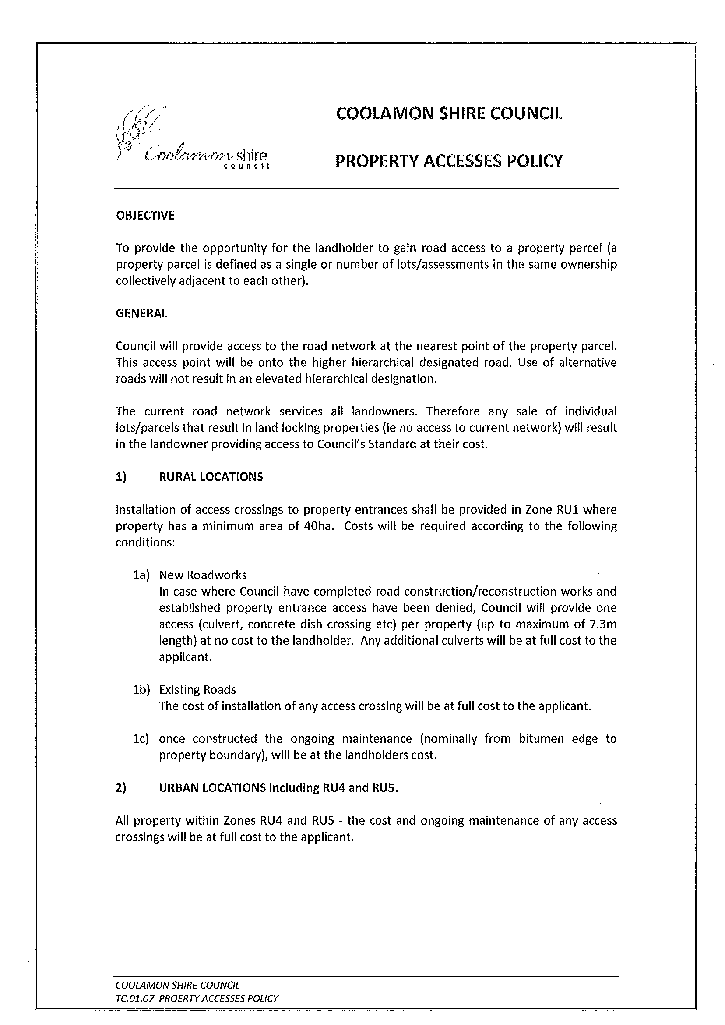
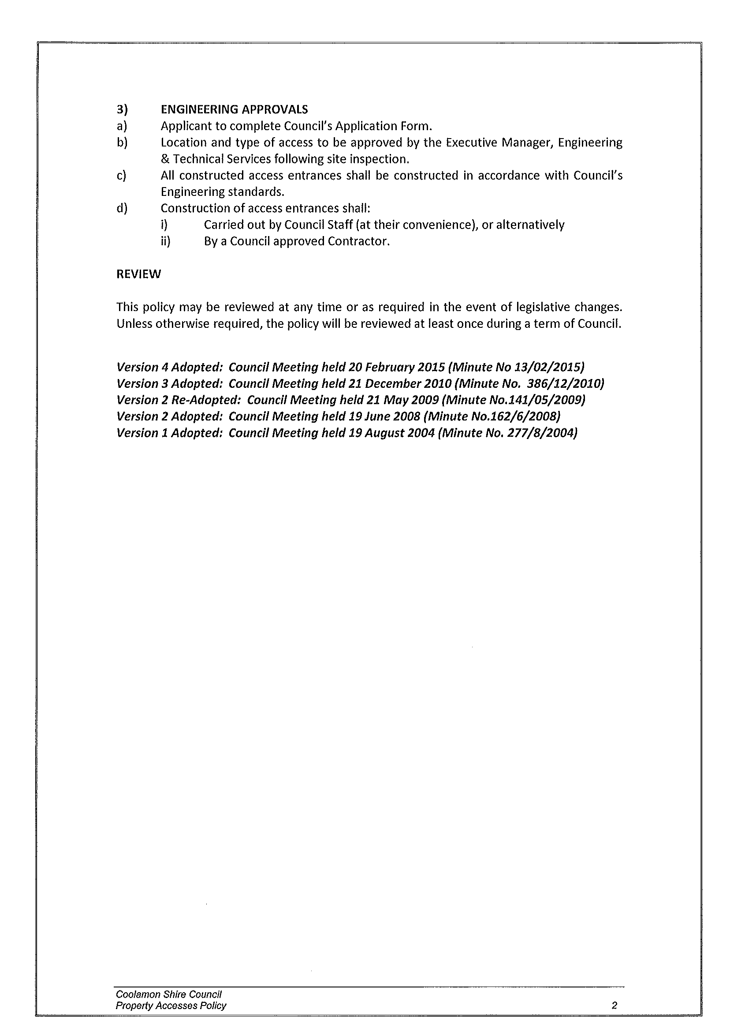
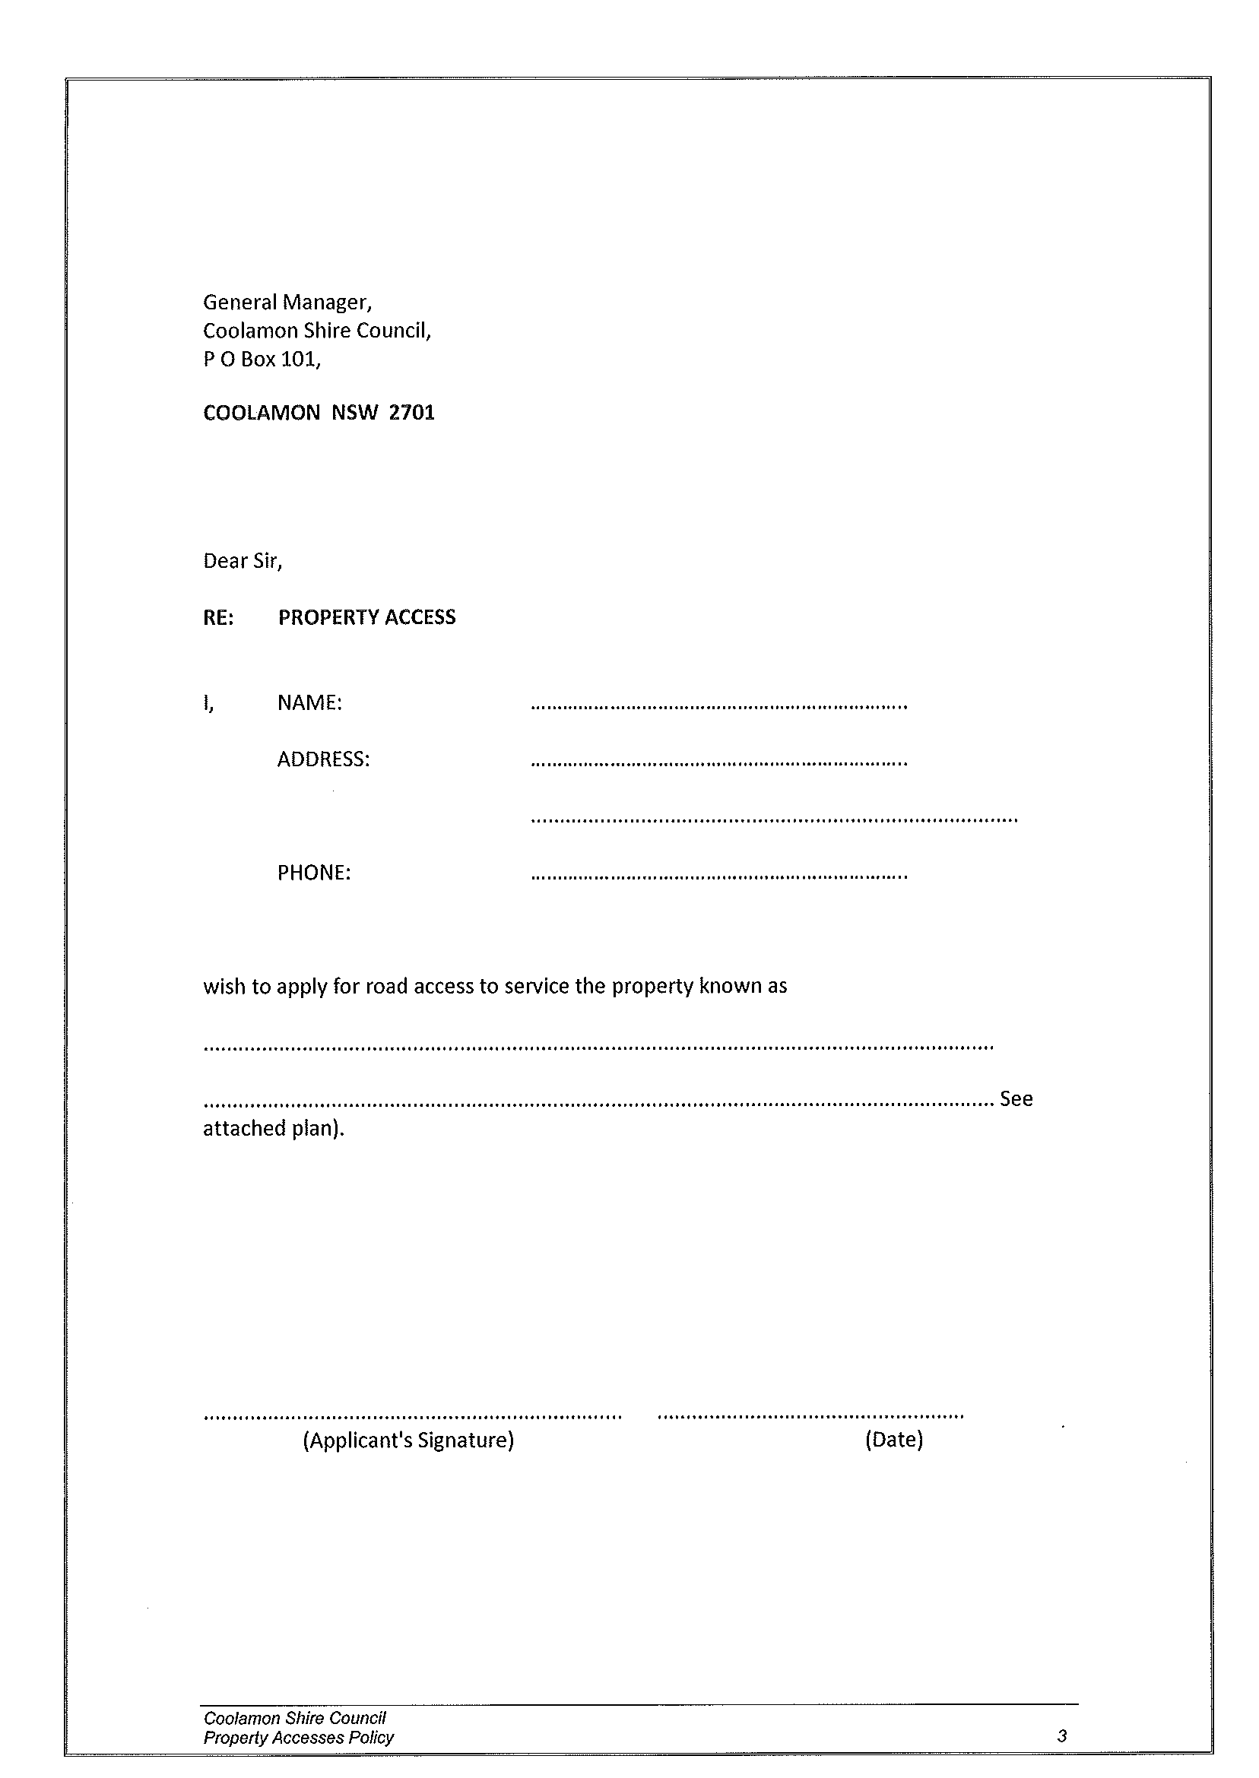
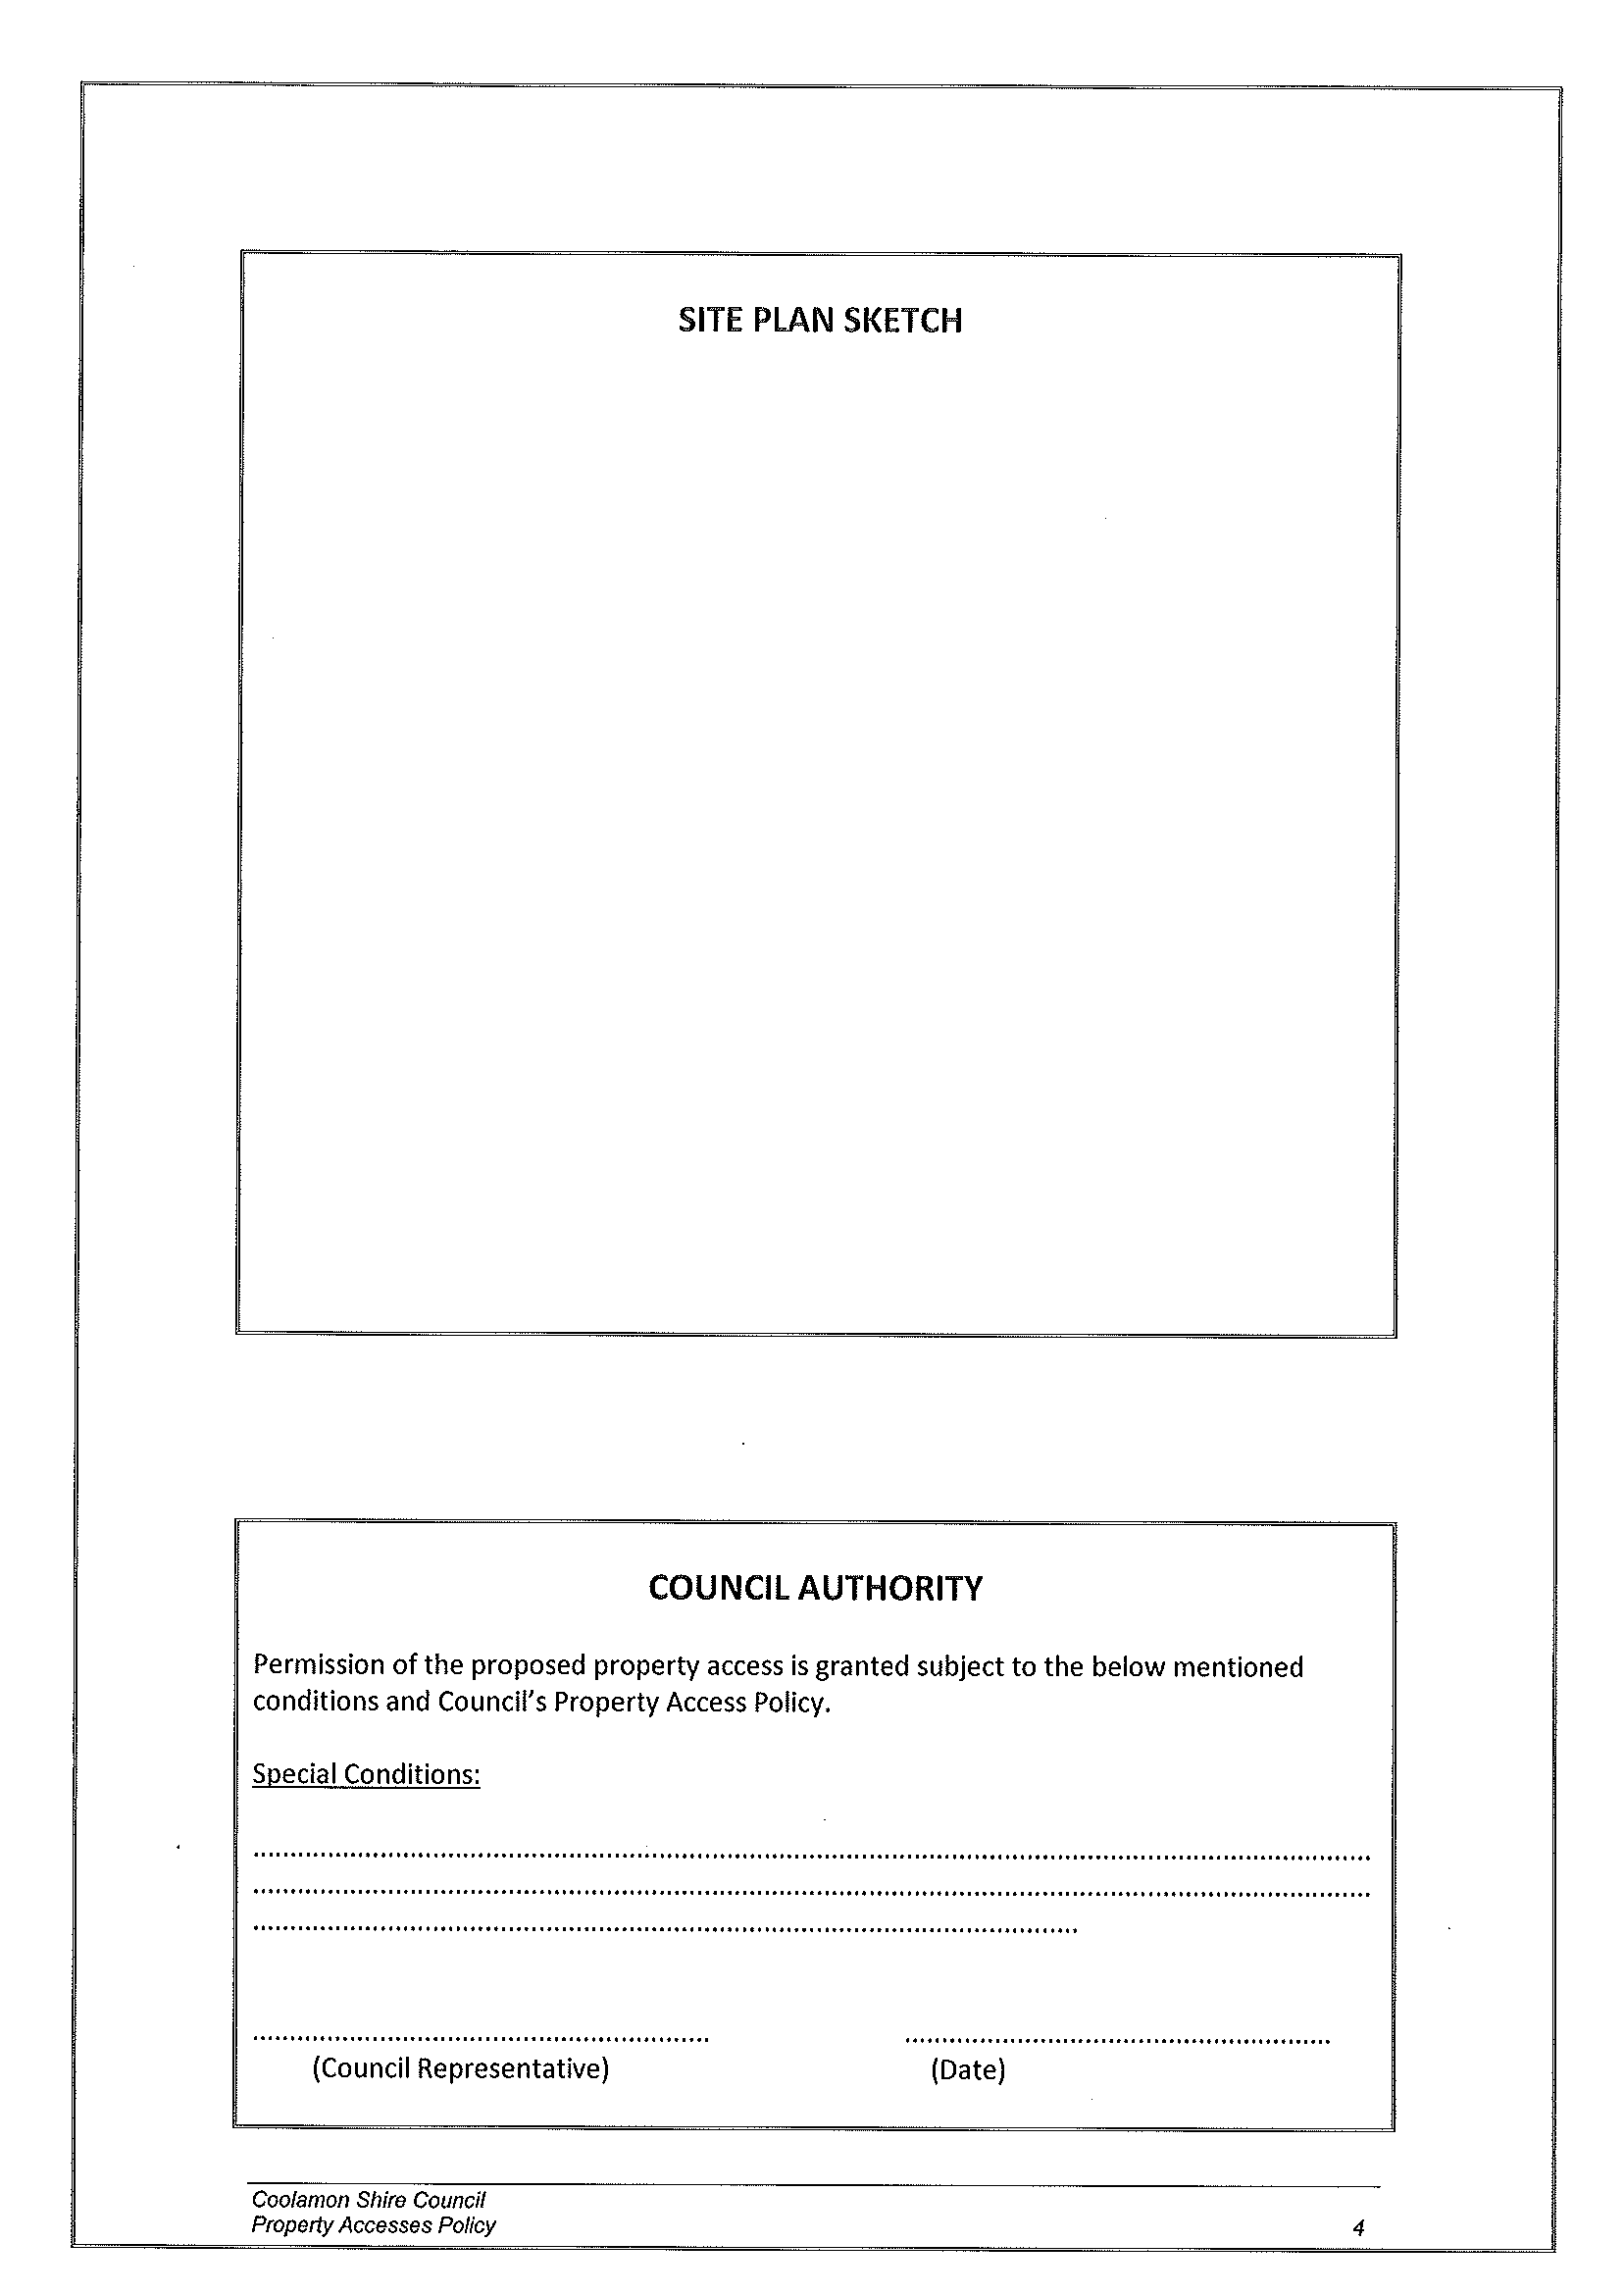
GM9) FIT FOR THE FUTURE (L.05-05, SC275)

At the end of January Council was provided with the final documentation for the Rural Council proposal.

This now means that Council has been provided with all of the guidance material and templates in assessing and submitting a Fit for Future Submission.

- Template 1 is a Merger proposal
- Template 2 is an Improvement proposal
- Template 3 is the Rural Council proposal

Council must now consider which submission it wishes to make.

Council may recall that at the November Council Meeting it was resolved to proceed with its Budget and Fit for Future Submission on the principle of maintaining its existing identity as a member of the REROC Joint Organisation.

This stance removes the option of a merger.

■ With this resolution Council has the option of considering whether the Rural Council or the improvement proposal meets the needs of Coolamon Shire Council together with the expectations of our communities. The templates and associated documents will be tabled for your information.

Coolamon Shire Council was identified in Group C of the Final Report and also meets the majority of Rural Council characteristics. Therefore the onus of proof is for Council to prove why they should not become a Rural Council.

This does not however, mean that this may be the best option for Council. When looking at the key performance indicators the same benchmarks are being used as an assessment of both the Rural Council Model or the improved Council proposal. The fact of the matter is that Councils will still be required to address the question of scale and capacity and determine a delivery programme that will show improvements towards meeting the key performance indicators.

In addition to this decision Council must also consult with the community to gain their thoughts on this matter. With time being limited, it is thought appropriate that the local Advance Committees should be utilised. This will allow some one on one discussion with each of the Shire Communities and reinforce the role of the Advance Committees as the conduit between Council and the Communities.

Late March and early April is considered a good time to meet with each organisation to discuss this issue.
Recommendation

That Council undertakes community consultation with the Advance Committees.

RESOLVED on the motion of Clr McCann and seconded by Clr Logan that Council undertakes community consultation with the Advance Committees regarding the Fit for the Future proposal. 14/02/2015

GM10) ARDLETHAN RFS SHED (F.03-01)

In this year’s budget a new shed has been proposed for Ardlethan. Currently the facility at the Works Depot at Ardlethan is considered unsatisfactory due to a large concrete plinth in the middle and access to the site.

Negotiations have been ongoing for some time now in order to determine the most appropriate location of a new shed. Council had earmarked land that was under the control of Crown Lands that had been leased to the Scouts and Small Bore Rifle Club.

Council has commenced negotiating with Crown Lands to secure this property, however, has been advised that the Ardlethan Lions Club has previously secured this for a Skate Park.

Council was aware that the Lions Club had been considering this project and had commenced raising money. Council had not been advised that any site had been earmarked and that land had been secured through this process.

Discussions have been held with the Lions Club to determine if they would be willing to relinquish the land they have become Trustees of and Council takeover management to locate the RFS shed on this property. The Lions Club has declined this as an option.

The land that has been identified by both Council and the RFS was considered appropriate and is currently located next door to the Ardlethan Caravan Park.

Council has been discussing the future of this park and with the growing approval of the short stay park in the centre of town, this has become somewhat of a redundant resource.

Council could consider closing this park and using the land for the RFS Shed. The services of water and power are already on site together with toilet and shower facilities.

Recommendation

That Council closes the Ardlethan Caravan Park and makes the land available for a RFS shed.

RESOLVED on the motion of Clr McCann and seconded by Clr Hutcheon that: 15/02/2015

1) Council closes the Ardlethan Caravan Park and makes the land available for a RFS Shed.

2) Council continues with the further development of the Short Stay Caravan Park subject to budget constraints.

GM11) ESTATE OF THE LATE JOAN MULLER (H.03-04)

Council has received advice from Commins Hendriks acting for the Estate of the Late Joan Beryl Muller informing that a sum of $20,000 has been left to Coolamon Shire Council to be held in trust for the benefit of the Coolamon-Ganmain Hospital.

Council will negotiate with the Hospital to determine and ensure that this money will be spent on local projects that enhance the local facility to the benefit of patients and staff at the Hospital.

This bequeathment reinforces the importance of the Hospital within our community and also the fact that individuals have confidence in the Council in fulfilling their wishes.

Recommendation

For Council information.

RESOLVED on the motion of Clr Hutcheon and seconded by Clr Huxtable that the report be noted. 16/02/2015

GM12) COOLAMON CHEESE COMPANY (I.03-12, SC246)

The Coolamon Cheese Company have now provided Council with the information required under the Deed of Agreement associated with the purchase of 87 Cowabbie Street, Coolamon.

Council will recall that at the last meeting delegation was provided to the General Manager to act on this matter provided all predetermined criteria had been met.

In accordance with this requirement the Coolamon Cheese Company have provided the relevant information relating to financial commitments and building works as set out in this Deed.

In accordance with these targets being met, Council has proceeded with the purchase of the building.

This purchase is subject to a Lease Agreement, whereby the Coolamon Cheese Company lease the building for three years when upon completion of the lease, they will purchase the property.

Council has entered into this commercial arrangement with the Coolamon Cheese Company that allows them to develop their project and establish their brand. This project is seen as a benefit to the Coolamon Shire by harnessing tourism potential and creating an anchor tenant in the Coolamon main street.

Recommendation

That Council endorses the actions of the General Manager.

RESOLVED on the motion of Clr Logan and seconded by Clr White that Council endorses the actions of the General Manager. 17/02/2015

GM13) RIVERINA REGIONAL LIBRARY – SERVICE LEVEL AGREEMENTS 2015/16 (L.03-03 SC269)

Please find attached correspondence indicating the Service Level Agreement between Coolamon Shire Council and the Riverina Regional Library. Council is required to sign these documents in order to confirm Council’s acceptance of the Delivery Programme proposed.

You will recall that as of next financial year, Council will be cutting back some of its Mobile Library stops.

Recommendation

 That Council signs the Service Level Agreement with the Riverina Regional Library.

RESOLVED on the motion of Clr Huxtable seconded by Clr Beard that Council signs the Service Level Agreement with the Riverina Regional Library. 18/02/2015

GM14) ARDLETHAN MEMORIAL (C.07-05, SC92)

In accordance with Resolution Number 319/12/2014 of the December Meeting (GM8), the matter relating to a Cenotaph at the Ardlethan Memorial Hall was deferred. Council decided upon deferment until additional information was provided.

➔ Council has now been provided with a photo of the proposed Memorial plaque, a copy of the cost together with a schedule of organisations contributing to the Cenotaph. (Please see attached) Attachment No. 14

In essence Council has been advised that the project will cost approximately $11,000 of which the following funding has been sourced:

- $4,000 – DVA, this is an application and is yet to be confirmed. The total project is reliant on this funding being received.
- $2,500 – Advance Ardlethan Committee (RSL fund held in Trust by ACDC).
- $1,000 – Coolamon RSL Sub Branch – Subject to DVA grant approval.
- $1,000 – Ardlethan Rural Women’s Gathering.
- $1,000 – Ardlethan Lions Club.
- $500 – Advance Ardlethan Committee.
- $200 – Ardlethan Women’s Auxiliary.

The total amount promised is $10,200. This leaves an outstanding amount of $800.

Recommendation

For Council decision.

RESOLVED on the motion of Clr Logan and seconded by Clr White that Council contributes $800 subject to the successful receipt of the DVA funding. 19/02/2015

GM15) CAPTURE COOLAMON SHIRE PHOTOGRAPHIC COMPETITION (C.08-14, SC112)

Each year the Capture Coolamon Shire Committee name its major prize after a Coolamon Shire resident, past or present, that has made a significant community/cultural contribution to our Shire.

This year the Committee wish to award the 2015 Cathie Thompson Prize to the image that “Best Depicts the Coolamon Shire”.

The Committee seeks Council’s endorsement of the above proposal.

Recommendation

For Council decision.

RESOLVED on the motion of Clr Logan and seconded by Clr Beard that the Capture Coolamon Shire Photographic Competition prize for image that “Best Depicts the Coolamon Shire” be named the 2015 Cathie Thompson Prize. 20/02/2015

4.2 EXECUTIVE MANAGER, CORPORATE & COMMUNITY SERVICES’ REPORTS

CS1) FINANCE REPORT

RESOLVED on the motion of Clr Huxtable and seconded by Clr Brill that the report be received. 21/02/2015

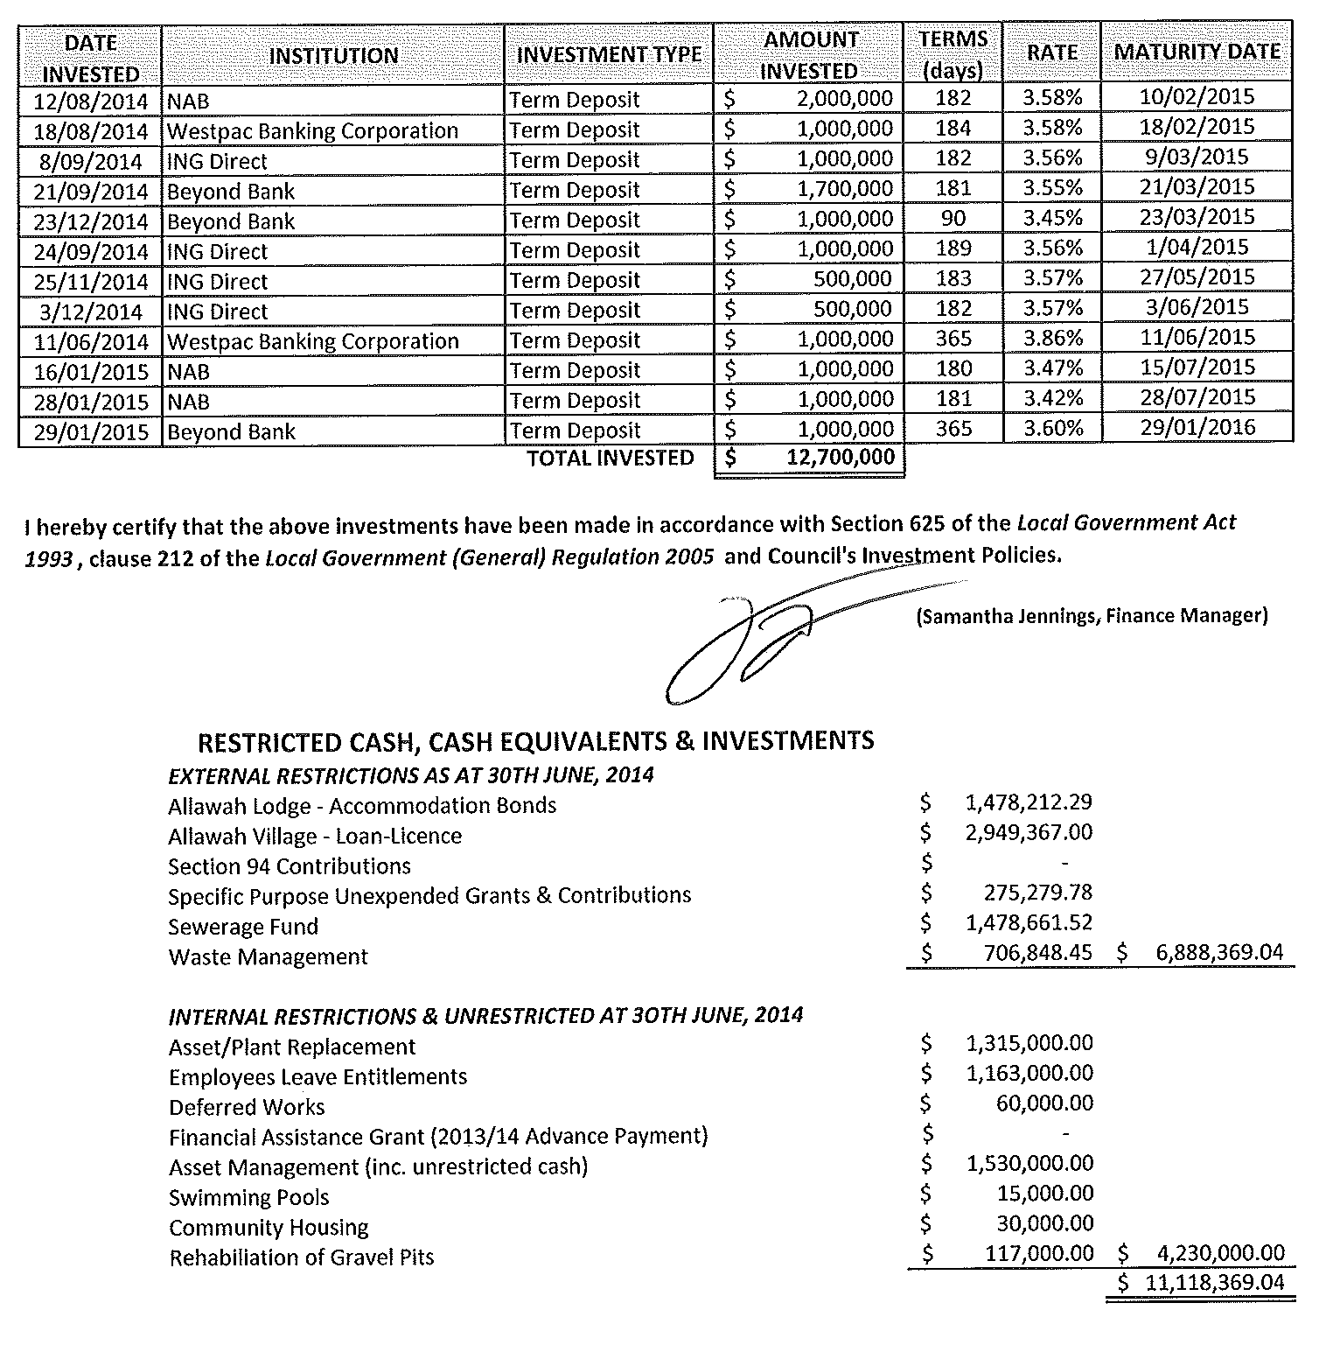
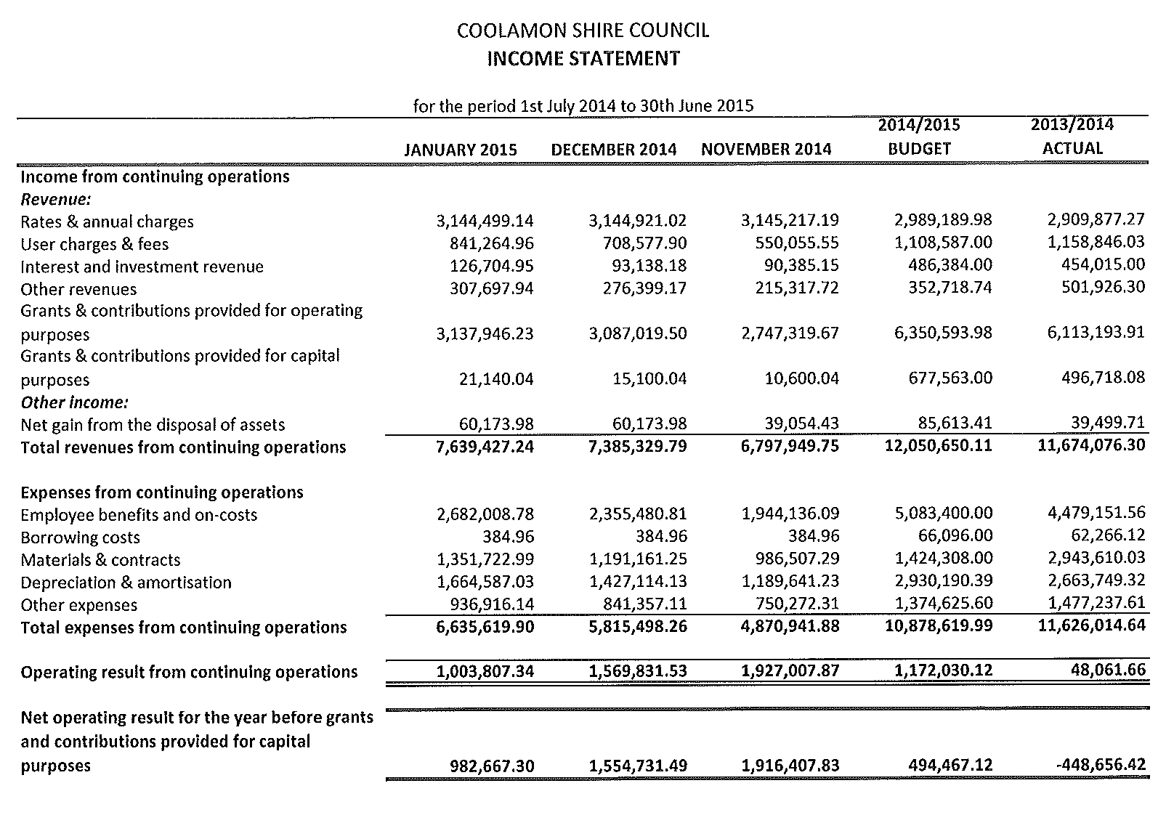
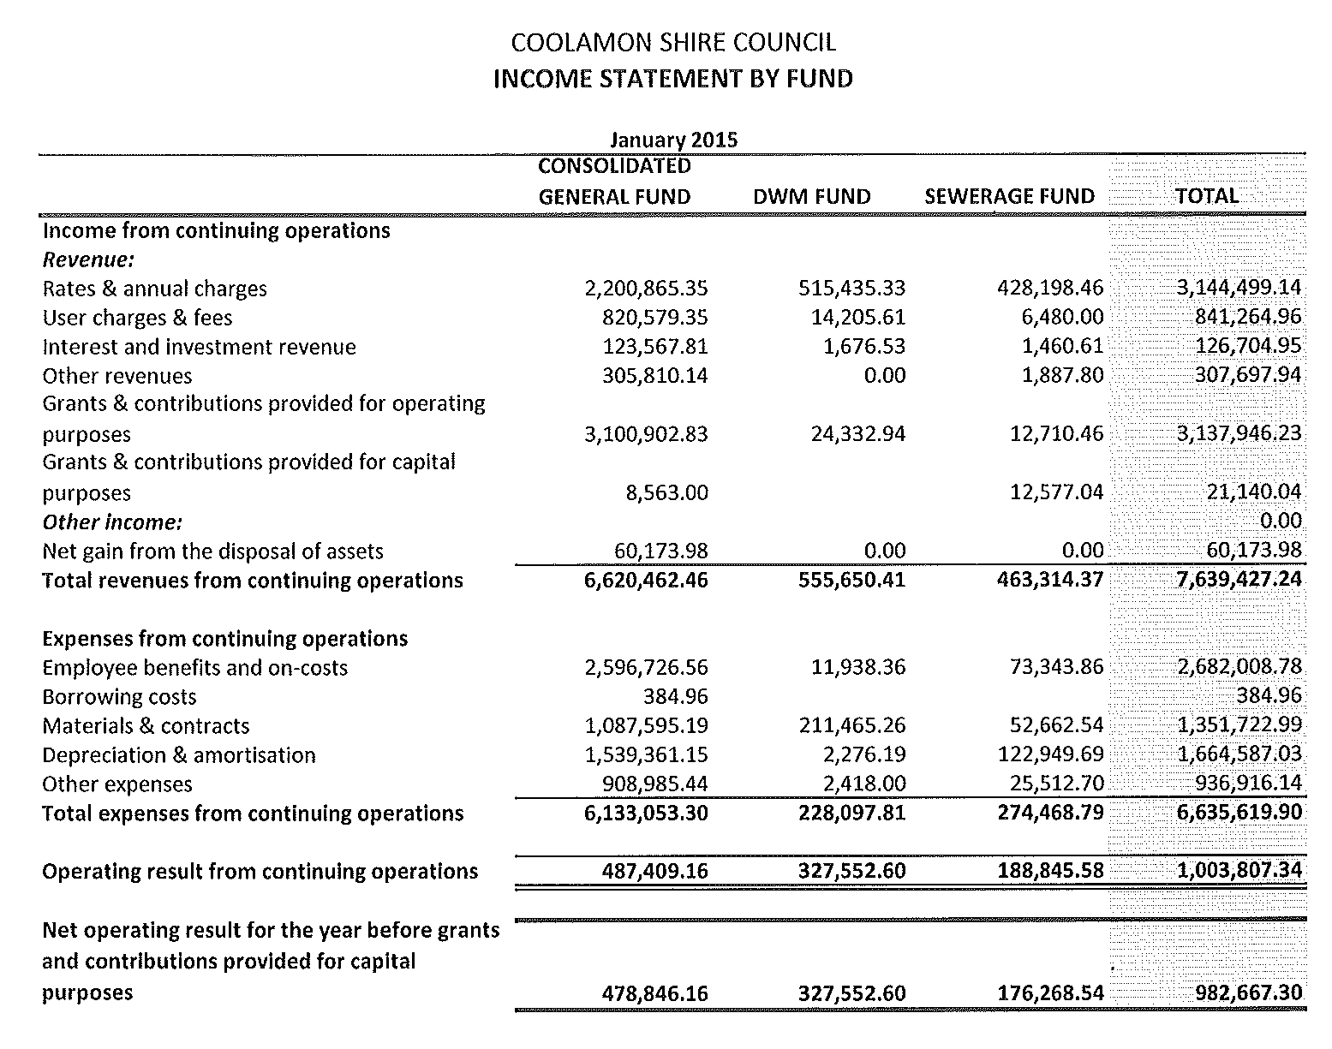
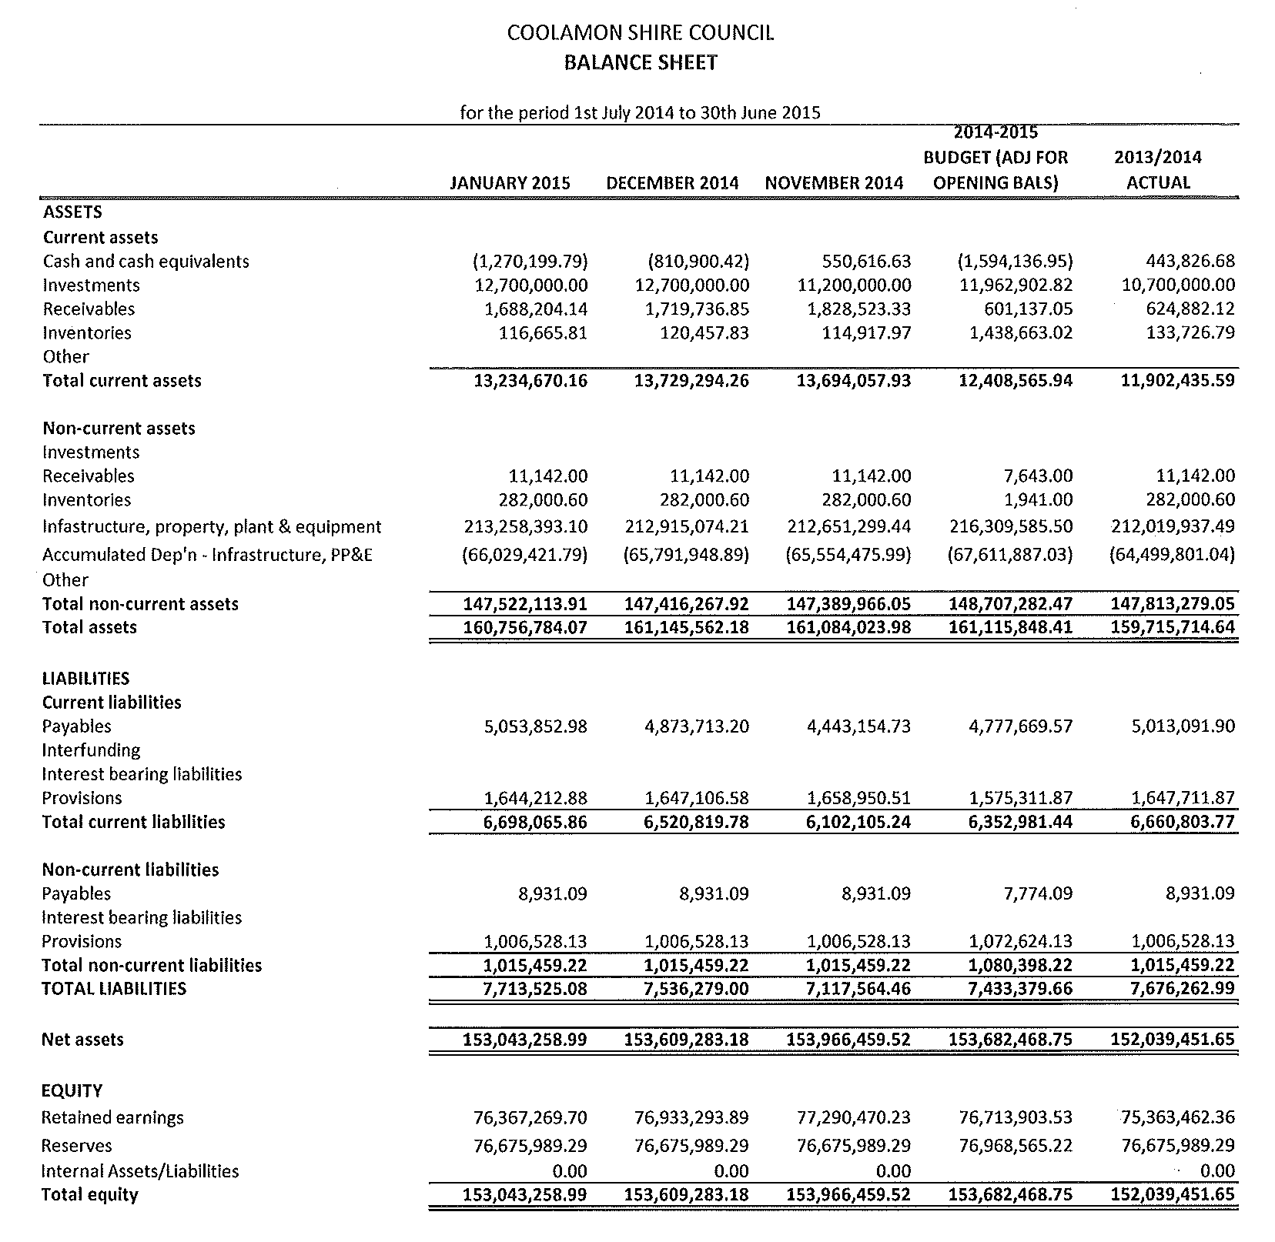
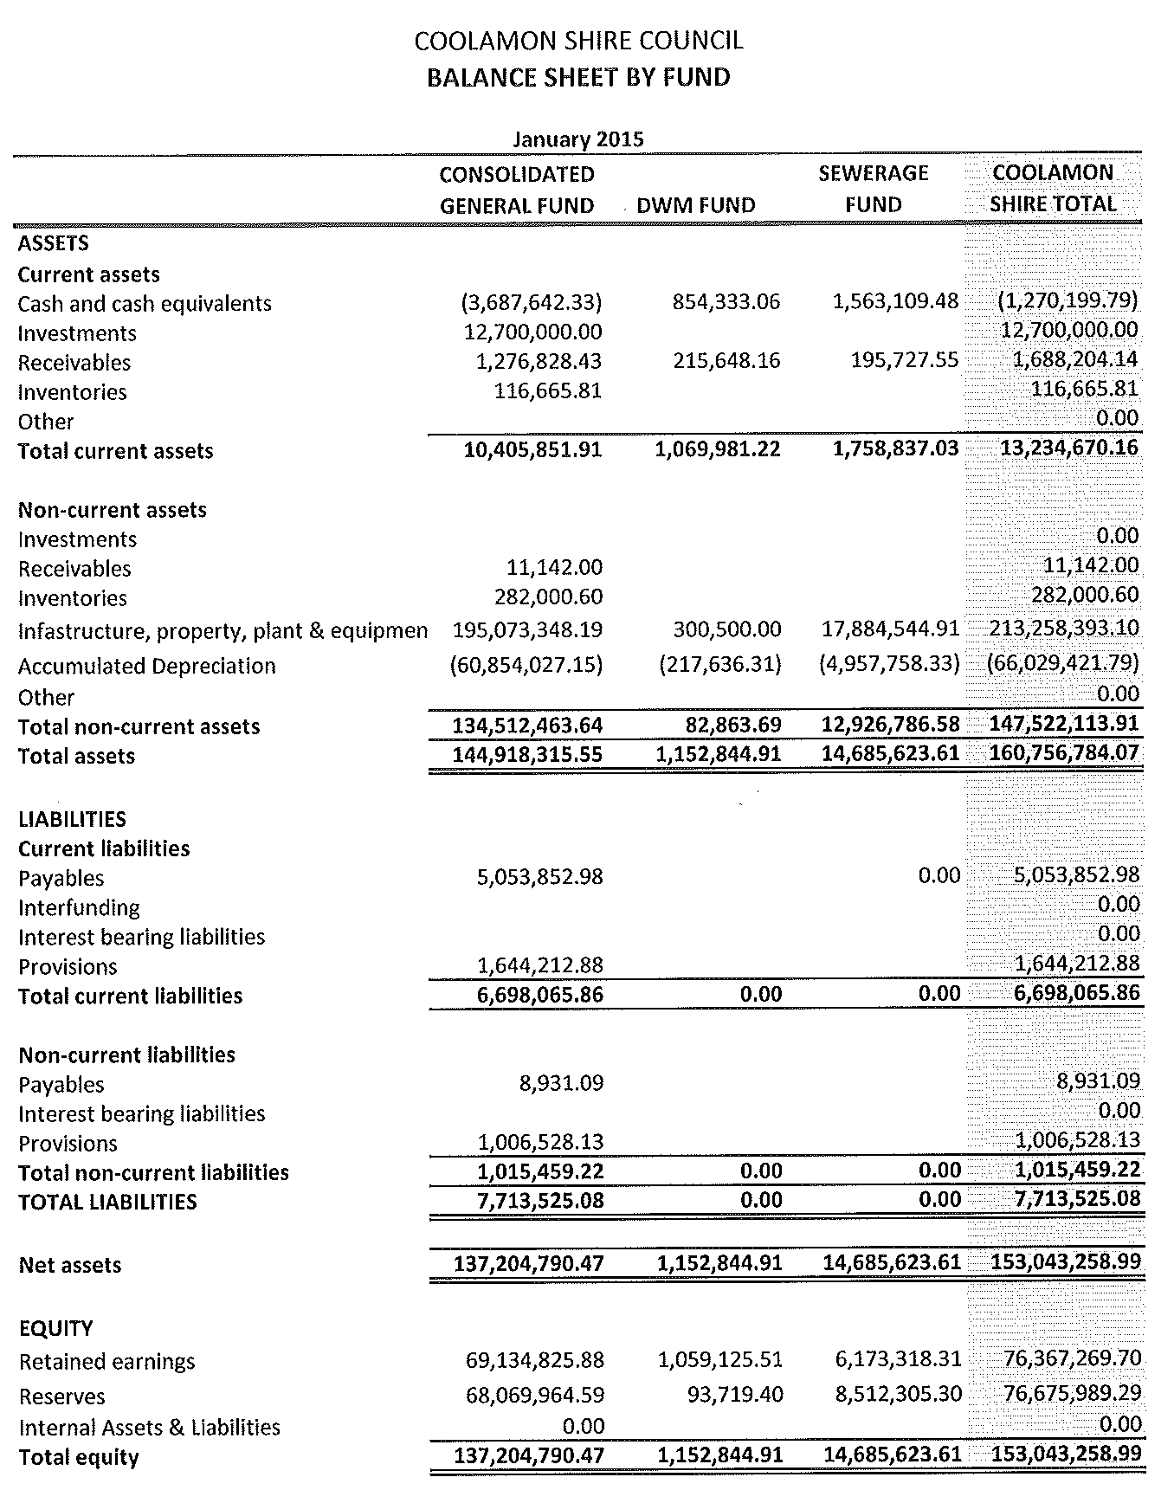
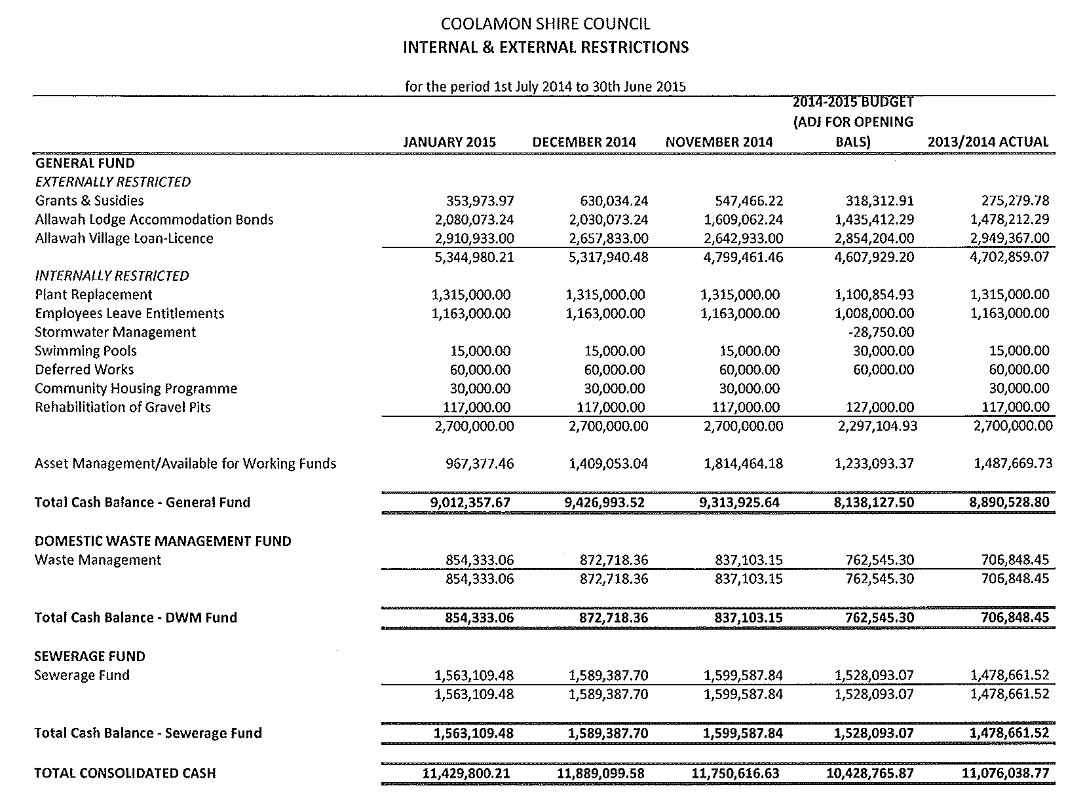

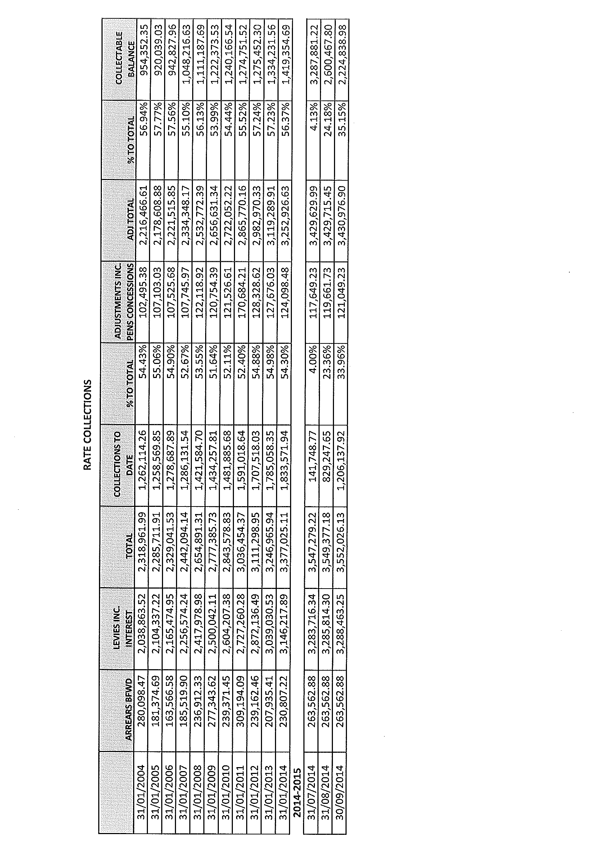

CS2) DELIVERY PLAN REVIEW

The following progress report in relation to the 2014-2018 Delivery Program is presented to Council reporting on the period 1 July 2014 – 31 December 2014.

Delivery Program Actions 2014-2015

Support local community organisations.
Over the past six months, Council has continued to support local community organisations in the following ways:
- Support to the Coolamon Lions Club in the production of the Coolamon Monthly Diary in addition to advertising in the Ganmain Guardian and Kelpie Bark where appropriate.
- Accounting and administrative support provided to the NERRCS and the Coolamon Shire Community Benefit Fund.
- Support to the Coolamon Lions Club with the provision of premises and subsidised transport to aid their recycling activities.
- Rate relief extended to various organisations as per Council’s policies.
- Continued support to various section 355 committees of Council.

Volunteer base to be maintained and expanded.

Council has continued its efforts to maintain volunteerism throughout the Shire as follows:
- Council has continued to support the Coolamon Lions Club in their recycling program by subsidising the transport costs of the recyclable materials.
- Council provides plant and equipment to the smaller villages of Beckom, Marrar and Matong that are then used by enthusiastic volunteers to maintain the various public areas in the towns
- Christmas lunch and activities held for social support volunteers
- Council recognized the importance of it’s Section 355 Committee Members at an afternoon tea during Local Government Week.

Provide information and resources to shire communities so that new residents can be welcomed and informed.
Council has continued to provide resources to welcome and inform new residents as follows:
- Ongoing updating of the Resident’s Guide, with distribution to new residents of the shire and publishing on Council’s Website
- Websites Coolamon Shire Council and Coolamon Shire Tourism and Business continually maintained, together with Facebook pages for the Coolamon Shire Library and Coolamon Shire Tourism

To provide childcare services that meets the needs of the Community.

Council continues to support the provision of preschool education in the towns of Coolamon and Ganmain with the provision of buildings. The operation of the Coolamon Early Childhood Centre and Ardlethan Preschool has continued over the last six months. Council continue to look for funding opportunities that would allow for the expansion of the Coolamon Early Childhood Centre to cater for both long day care and out of school hours care.

To provide a full range of Community Services to the frail, aged and disabled persons within the community within the constraints of Grants provided by State and Federal Governments.
Council continues to provide “home care” services and packages and community transport services from Allawah Community Care. These services maintain a holistic approach to the delivery of these services with ongoing Continuum of Care meetings held by other service providers for the Shire. During the reporting period Council has continued to work with Murrumbidgee Medicare Local in relation to the employment of a Healthy Shires Officer including co-ordinating a steering committee and providing office accommodation.

To promote services and access to services for people with diverse cultural, socially isolated and linguistic backgrounds where a need has been identified.
Council’s Access and Equity principles ensure that services for people with needs due to diverse cultural, socially isolated and linguistic backgrounds are met.

To ensure that the needs of young people in the Coolamon Shire are identified and met within financial constraints.

Council continues to address the needs of young people within the Shire by the ongoing employment of Council’s Community Development Officer. Various activities have been organised as part of the School Holiday Program and Council staff have participated in youth forums arranged by REROC. Council also successfully applied for funding under the “Links to Learning” Community Grants and will be working with the Coolamon Central School to develop and support school aged people who are disengaged from learning and/or risk of leaving school so that they can remain engaged in education or training.

That Council continue to provide accommodation for those persons with particular needs which will ensure that they continue to reside within those communities.

Provision of low cost Aged Accommodation in the townships of Coolamon, Ganmain and Ardlethan along with Allawah Village and Allawah Lodge Aged Persons Hostel ensure that Council provides accommodation for a wide cross section of people. Council staff continue negotiations with the NSW government regarding the sale of the Community Housing Properties in Coolamon.

To assist frail aged and disabled persons to continue to reside with dignity in their local Communities.

Council aged services facilities including Allawah Village, Allawah Lodge, Community Aged Care Packages, “home care” services and Community Transport ensure that people can continue to reside within their local communities with adequate in-home or residential support.

To provide professional, effective and cost efficient responses to all emergency incidents within the Shire in accordance with Service Level Agreement between Council and RFS.
To provide efficient and effective measures for the prevention and mitigation of fire impact on the local Community through effective planning initiatives, fuel management strategies, fire trail maintenance, and the continual assessment of bushfire risk across the District.
Council remained a member of the Riverina Zone of the Rural Fire Service over the past six months. Ongoing monitoring of service level and fire plans ensures that Council is happy with the service that is provided by the Zone to the communities of the Coolamon Shire. Council provides administrative services to the Riverina Zone of the Rural Fire Service at a fee. Representations have been made to the State Government regarding the engagement of Local Government in the financial management of the NSW Rural Fire Service.

To provide support to the Local State Emergency Services Group and ensuring they are capable of responding in an adequate manner to all emergency situations.
Council continues to support local SES activities with the provision of joint RFS/SES premises in Coolamon and payment of the annual levy with respect to the State Emergency Service. Meetings of the Local Emergency Management Committee have been attended by Council representatives.

To minimise and control the public nuisance effect of straying stock and animals.
When received, reports relating to straying stock and animals are dealt with by Council’s Ranger to ensure that the required responses are actioned. Where necessary, reports relating to dangerous dogs have been presented to Council meetings for Council to determine the appropriate course of action. Council has also undertaken activities to ensure the compliance of animal owners in relation to their responsibilities under the Companion Animals Act.

To develop and implement projects that address local road safety issues.
Coolamon Shire Council, together with the Council’s of Junee Shire and Wagga Wagga City continue negotiations with Roads and Maritime Services in relation to the Road Safety Program funding and how best it can be applied to those areas. Council staff have lead a project in conjunction with other Councils under the banner of REROC in developing a Regional Infrastructure Plan that identifies transport barriers including those related to safety.
Lobby for adequate local police working presence.
Council has continued to lobby for adequate police presence within the Shire’s communities with letters sent to the Minister for Emergency Services and the Local Member. Representations continue to be made also at a local level in an effort to boost the policing presence throughout the Shire. Council has a good working relationship with the Sergeant at Junee. Council staff and Councillors have represented the Shire at Police Community meetings.

The preservation and enhancement of public health by regulating and inspecting all premises and vehicles used for the preparation, storage, delivery and sale of food and refreshments.
Council staff continue to monitor and enforce where necessary all public health regulations including annual Food Shop inspections.

Address social standards and values in particular growing issues of alcohol abuse and vandalism
Council’s established Alcohol Free Zones expire in 2015. Council continues to monitor incidence of vandalism and anti social behaviour. Council continued support of the Coolamon Shire Community Drug Action Team.

Provide support for NSW Fire Brigades
The new Coolamon NSW Fire & Rescue Station was completed and occupied during the reporting period. Council will continue to liaise with NSW Fire & Rescue regarding the best long term solution to the control of the area. During the reporting period, Council paid the instalments due in relation to the annual contribution for NSW Fire & Rescue.

To ensure that all land and buildings owned and controlled by Council are maintained in an appropriate manner and utilised for their designated and appropriate community purpose.
All maintenance requests are directed to the Facilities Maintenance Foreman who then assesses whether the works can be undertaken by staff or whether they need to be contracted out. Fire inspections have been undertaken in accordance with required timelines and results of inspections have been acted upon. Council continued work on the priorities identified in it’s Asset Management Plan and with support of Goldenfields Water County Council plans were underway to engage a trainee in Asset Management/GIS. Council advertised an expression of interest for the provision of fire sprinklers at the Aitken Logan Wing of Allawah Lodge and will continue to work towards the installation by the date set by the State Government.

Ensure that all aspects of Council's Cemetery operations are carried out in an appropriate and dignified manner with due respect and accuracy.
Council’s Cemetery operations have been carried out with nil complaints.

To continue to maintain the existing public conveniences in a clean and tidy manner.

Expired contracts for Street & Public Privies cleaning are in place for Coolamon, Marrar, Ganmain and Ardlethan with Council staff to advertise in the coming 6 months. Contracts are managed by Council’s Facilities Maintenance Foreman.

To provide an overall system of management that allows Community Committees to control their own Halls in accordance with their needs and requirements.
Council’s Advance Committees for the towns of Beckom, Ardlethan, Ganmain and Marrar, together with the Rannock Community Centre Committee manage the various halls and community centres within the shire.

To ensure all urban roads within all communities are sealed or where unsealed are maintained via a system of programmed management.
To ensure that a quality sealed rural road system is in existence throughout the Shire.
To provide a quality unsealed rural road network throughout the Shire.
The provision and maintenance of a safe and adequate footpath system in close proximity to the commercial areas and public facilities of all communities.
Maintenance of Council’s sealed and unsealed local rural roads system has been undertaken in accordance with Council’s adopted Operational Plan. Inspections continue to be undertaken on a regular basis for both Council road and footpath assets.

The provision and maintenance of a suitable stormwater system inclusive of an adequate kerb and gutter network.
Regular inspections of Council’s stormwater network are being undertaken. Stormwater Management Annual Charges were levied for the first time during the reporting period with the funds used to support maintenance and asset management of the stormwater management network.

The provision of an adequate system of Street Lighting to all developed commercial and residential areas of the towns and villages.
Council continues to ensure that the street lighting network remains adequate as defined by Council’s policies.

To provide, maintain and operate a sewage disposal system and treatment works that meets the needs of the Coolamon and Ganmain Communities and to continue monitoring the developing areas in respect of the need for sewerage extensions.
Council has continued to meet all of its licensing requirements in relation to the Coolamon and Ganmain sewerage systems. Alterations to the Coolamon Treatment works were underway during the reporting period with future plans in place to ensure that the existing plant is working efficiently as it can.

To continue to investigate the most appropriate means of constructing and financing a sewerage scheme in the township of Ardlethan.
Council staff continue to look for appropriate funding mechanisms for the construction of the Ardlethan Sewerage Scheme. No such funding opportunities were identified during the reporting period.

Support the provision of improved public transport within the Shire.
Council staff have not pursued the provision of public transport within the Shire during the reporting period. The existing public transport available within the Shire is considered satisfactory.

Support the provision of adequate health services to the whole Shire.
Council continues to rent professional consultancy rooms in both Coolamon and Ganmain to the local Medical Practice and other allied health services. Ongoing discussions with the NSW Ambulance Service and representations to the State Government have been undertaken with regards to the establishment of a service centred in Coolamon. Council continues to have a good relationship with Murrumbidgee Medical Local.

Support local businesses with improvements to the access to their premises.
Council provides appropriate advice to businesses on access requirements to their premises when so requested.

Ensure the maintenance and enhancement of existing educational facilities within the Shire.

Council successfully applied for funding under the Community Grants and will be working with the Coolamon Central School to develop and support school aged people who are disengaged from learning and/or risk of leaving school so that they can remain engaged in education or training.

Support the provision of equitable telecommunication and broadband services for all residents of the Shire.
Council continues to make representations on behalf of its communities in relation to the provision of telecommunications and broadband services when required. Negotiations with the contractors responsible for the National Broadband Network were completed regarding the use of Council assets. NBN is now operational in some parts of the Shire.

Provide effluent reuse water to the benefit of sporting organisations.
Recycled water is being delivered to users when required.

Support sporting organisations with the retention of their assets.
Council is trustee of a number of showgrounds, community reserves and walking tracks. Council staff continue to assess Council’s involvement in activities undertaken on properties where Council is the trustee. The use of recycled water on the sporting fields of Kindra Park, the Coolamon Touch fields and the Coolamon Golf Course is continuing allowing residents to participate in the various sporting activities. Council accepted funding for improvements at the Ardlethan Showground and Coolamon Tennis Courts and is working with the relevant bodies to spend the grants.

To continue to provide a Mobile Library Service, in order to satisfy the information, cultural, educational and recreational needs of residents.

Continued operation of static library in Coolamon.
The provision of the static Coolamon Shire Library as part of the Up-to-Date Cultural and Learning Centre in addition to the visiting service of the Riverina Regional Mobile Library continues to ensure that Library services can be accessible to all residents.

Implement initiatives that will develop and maintain a vibrant and creative community, involved in cultural activities

Provide appropriate guidance for community organisations in identifying funding sources for cultural events.

Council acknowledge Aboriginal culture
Ongoing implementation of the Strategic Plan for the Up-to-Date Cultural & Learning Centre during the reporting period. Letters of support have been provided to community organisations seeking grant funding where required. Council is a member of the Eastern Riverina Arts.

To provide a safe and secure swimming pool facility in the towns of Ardlethan, Coolamon and Ganmain.

Pool lessees were trained in Pool Supervisors Course prior to the commencement of the swimming season. Solar power provision was undertaken at the Cooalmon and Ardlethan Pools at the start of the reporting period utilizing funding under the NSW Government Community Building Partnership program.

To provide parks and gardens that are aesthetically attractive and are available for passive recreational pursuits.

Inspections undertaken on playground equipment in accordance with Council’s inspection regime.

To implement an Urban Tree Management Plan and Tree Removal Programme that is both aesthetically attractive and ensures that Council's civil infrastructure is not damaged by such plantings. Furthermore, that the assets of Essential Energy are given consideration during the implementation of the programme.
Where necessary staff have continued tree planting throughout the urban areas of the Shire, incorporated with this has been a tree lopping program.

To enhance & promote local cultural heritage within the Shire to create benefit for the community
Council continues to receive funding for the engagement of a Heritage Advisor and for the Local Heritage Fund. Council continued negotiations with the RSL regarding transfer of the Coolamon RSL building to Council.

To promote the celebration & awareness of Australia Day

Plans are underway for the 2015 Australia Day celebrations in Beckom.

Support local community activities
Councils Tourism and Business Development Manager has supported a number of local community organisations/individuals in preparing for and conducting events within the Coolamon Shire over the past six months including the implementation of a seasonal marketing campaign and the events marketing fund.

Provide appropriate guidance for sports clubs in identifying funding sources.
No requests have been received from sporting clubs in relation to grant applications.

Establish ”need-based” tracks and paths within the Shire
PAMPS & Cycleways works undertaken were completed as per the funding requirements and approvals of Roads and Maritime Services. Application under the “Active Transport” funding program have been made for projects for 2015/2016. Council has begun investigations into the establishment of a mountain bike track in Coolamon.

Support local communities with endeavours to hold events that attract visitors.

Council has supported the following events during the reporting period:
- Coolamon NYE Street Party
- Up-2-Date Art Exhibition
- Capture Coolamon Photographic Competition

Council Events Management Strategy and event manual are available as a reference guide for event co-ordinators. Council has also provided support where necessary in relation to Risk Management. Council’s event marketing fund was also established and the first allocations under the fund made.

Adapt to climate variability through development of a climate variability strategy
Council adopted a Climate Change Strategy in conjunction with Statewide Mutual in a previous reporting period. Council, over the past few years, has been a member to a project headed by REROC funded under the Federal Government’s Strengthening Basin Communities initiative. The project resulted in regional and specific LGA reports and plans being developed addressing water security and climate change impacts, mapping of water dependent industries and infrastructure and planning documents.
Develop leadership on becoming energy efficient including carbon capture, water recycling and solar efficiency
Secure sustainable, affordable supplies of water and use our water even more wisely.
Encourage efficient water usage by Shire communities.
Encourage solar energy usage by Shire communities.
Council staff continue to investigate possible energy efficient and water efficient opportunities for Council facilities in addition to those measures that have previously implemented. Council has power saving kits available at the Coolamon Library to enable residents to identify potential energy savings within their homes, thus helping the environment. Over the past five years, solar panel installations have been undertaken at the Council Chambers, Coolamon Shire Library, Up-to-Date Store, Coolamon Early Childhood Centre, Allawah Lodge, Coolamon Pool and Ardlethan Pool. Council has also established effluent reuse on a number of parks and gardens in the township of Coolamon.

To protect the local environment or assist in maximising productivity of prime agricultural land by the removal of infestation of noxious plants.

Council has continued its relationship with Junee and Temora Shire Council’s with regards to the control of noxious weeds, with ongoing spraying and inspections undertaken.

To ensure all septic tanks throughout the Shire are operating in accordance with the minimum requirements of the Local Government Regulations, Public Health guidelines and industry standards.

Implementation of Council’s On-site Sewage Management Policy continued during the reporting period.

To develop an environment that is sustainable for future generations in terms of visual attractiveness and pollution free.

All environmental protection requests and requirements were undertaken during the reporting period.

To operate the quarrying service to Council's programmes in an environmentally sensitive manner.

Council maintains the appropriate approvals to undertake quarrying activities. Council staff continue to investigate potential sites for future quarrying activities. Council staff have undertaken a review of it’s quarries and the determining the potential rehabilitation requirements.

To ensure the protection of natural vegetation on Council controlled land.
Council has continued to support the two voluntary conservation agreements for the preservation of native vegetation.

To provide a Planning Instrument that ensures all land within the Shire is developed in an appropriate manner and reflects the rural nature of the communities.

Continued development of Development Control Plans in line with Council’s Local Environmental Plan 2011 has been undertaken during the reporting period with the plan placed on public exhibition.

Ensure that all building activity within the Coolamon Shire meets the requirements of the EP&A Act and the Local Government Act 1993.
Council staff continue to monitor building activity within the Coolamon Shire to ensure it meets all regulatory requirements. All building inspection staff have maintained accreditation with the Building Professional Board during the reporting period.

Identify, protect, enhance and celebrate all significant Indigenous and non-Indigenous heritage sites

Maintain our heritage through ensuring that development and restoration of shops and buildings is compatible with the heritage value of the surrounding area(s)
Funding is allocated under the Local Heritage Fund for the restoration and improvement of heritage assets within the Shire. This together with the engagement of a Heritage Advisor ensures that the heritage value of the Shire is maintained and enhanced.

The effective collection of all household garbage from within the defined scavenging areas in a regular and clean manner.
Minimise landfill disposal methods whilst still maintaining effective garbage depots within the Shire that are safe, environmentally friendly and effectively managed.
Council continues to collect household garbage and recyclables from defined areas within the Shire. Recycling is transferred to a recycling operation in Cootamundra and continues to ensure that the landfill sites have extended useful lives. Council continues to collect organics recycling for residences within the township of Coolamon with the organic materials being composted at one of Council’s landfill sites into a reusable product. Council has made an application for a grant to assist with the expansion of it’s organics program to Ganmain.

Council support the promotion of businesses within the Shire.
Provide high quality infrastructure to support the investment by businesses within the Shire

Encourage the development or relocation of employment generating industries within the Shire.
Further development of comprehensive Development Control Plans will address infrastructure requirements relating to businesses within the Shire. Engagement of Tilma Management as Council’s Tourism and Business Development Manager has provided ongoing support by Council to businesses located within the Shire. Ongoing maintenance of the dedicated Tourism and Business website for the Shire. Council continues close ties with Industry & Investment and Regional Development Australia Riverina for the benefit of businesses within the Shire.

To advertise training available throughout the Shire.
Council makes available facilities to training providers when requested.

Emphasis the importance of consolidating Council’s resources to defined focal points
Council continues to emphasise Coolamon as the Shire’s headquarters and Ardlethan as the northern entry point to the Shire. The upgrade to Ariah Street, Ardlethan and the establishment of the overnight stay area has helped to bring this focus to Ardlethan. Council staff continue to develop “strategic plans” for the towns and villages detailing infrastructure requirements. Councillors undertook an Organisational Structure & Finance Review Workshop in December 2013 with future reports to be presented to Council during the second half of 2013-2014 financial year.

To provide fully serviced residential land at a reasonable purchase price from Council's land bank.
Council’s long-term strategy is to provide residential subdivisions on the northern side of Coolamon with the land already purchased and provision of water already commissioned. Engagement of an external consultant to develop final design occurred in the reporting period.

Promote the Coolamon Shire as a place to work and live.
Council continues to participate in advertising campaigns to promote the Allawah Retirement Village, Allawah Aged Persons Hostel and Coolamon Early Childhood Centre. Ongoing maintenance of Council’s websites with a dedicated site for Business and Tourism as well as updated information for Residents in relation to services and events.

Proactively communicate the community and council’s achievements and events to the wider community
Council has continued to maintain contact with media outlets and used its website and Facebook to communicate events and achievements.

To encourage visitation and generally promote the area.
Council has maintained its membership with Riverina Regional Tourism and continued the engagement of Tilma Management in the role of Tourism & Business Development.

To provide a Caravan Park in Ardlethan and Coolamon that constitutes a basic level of service/short term accommodation to the travelling community.
More formal operating arrangements continue in relation to the bookings and stays at the Coolamon Caravan Park. The establishment of an overnight stay area in Ardlethan in previous years has proved successful. Council has applied for funding to undertake additional work at the Coolamon Caravan Park following the decision to relocate the tennis courts.

Improve the signage throughout our towns and villages
Council is continuing to monitor signage needs and appropriateness. The installation of new shire entrance signs was finalised during the reporting period.

Identify opportunities, programs and funding available for maintaining farming productivity
Council leases office accommodation for the Rural Financial Counsellor as well as supports NERRCS with leased office accommodation and accounting support.

Investigate alternative farming initiatives suitable to the area and climate
Contact has not been made with the Department of Industry and Investment to investigate alternate farming initiatives suitable to the area and climate.

Encourage farmers to investigate and undertake “green” economic opportunities.
Council has not undertaken any activities to encourage farmers in relation to “Green” economic opportunities.

Provide development programs to grow capability in our current and prospective leaders
Council has continued to encourage youth to be representative amongst their communities. As part of Local Government Week, school leaders were invited to a morning tea with the Mayor and senior staff. Council has actively participated in Youth Programs offered by REROC. Council hosted an afternoon tea to thank volunteers from the various Section 355 committees as part of Local Government Week.

Encourage involvement of respected community representatives in providing mentoring to youth.
Council will continue to identify opportunities where youth can be mentored by respected community representatives. Council continued to engage two engineering cadets during their university break.

Involve the community in Council’s planning processes

Community consultation with Council’s Advance Committees and a Councillor Bus tour are planned for the first three months of 2015 to aid in the preparation of the 2015-2016 Operational Plan and other forward planning documents.

Continue communication between Council and the Community.

During the reporting period, Council continued to distribute a monthly newsletter to residents detailing Council information and business and provided regular updates to Council’s website.

Development of long-term resourcing strategy, including long-term financial planning, workforce planning and asset planning to achieve the objectives of the Community Strategic Plan

Council’s Long Term Financial Plan, Workforce Management Plan, Asset Management Plan and Sewerage Strategic Plan have been developed.

To provide an effective staffing structure that is capable of carrying out Council's objectives in an efficient manner.
Council’s operational procedures in relation to staff appraisals/assessments have been in place for a number of years and were completed within the required timeframes. Training programs for staff have been implemented in accordance with training requirements

The continued maintenance of a realistic Delivery Program and Operational Plan.
Council staff continually assess the actions and activities detailed in the Delivery Program and Operational Plan to ensure that they are realistic and community focused. Ongoing reporting on both the Delivery Program (this report) and Quarterly Budget Review Statements inform Councillors on Council’s capacity to deliver facilities and services.

Participate with other councils in resource sharing projects to reduce operational costs
Council continues to participate in resource sharing projects with other Council’s including projects managed by REROC, membership of Eastern Riverina Arts, Internal Audit Alliance, Noxious Weeds Authority, Riverina Zone of NSW Rural Fire Service and Riverina Regional Tourism. Council will work in conjunction with Goldenfields Water County Council to employ a Trainee. This position will be advertised in the next six months. Council as part of the Pilot Riverina JO is working diligently in determining the direct that will be taken over the next six to twelve months as part of the State Government’s Fit for the Future proposals.

To ensure that Council's finances are managed in an effective and timely manner.
To continue to maintain sound finances, Council staff review investments and investment returns on a timely basis. Staff are in the process of developing sound financial indicators that Council can use to benchmark its performance. Staff present monthly abridged financial reports along with Quarterly Budget Review Statements to assess performance against budgets. Council received a report from its external auditor regarding the Council’s performance for the 2014 financial year in the reporting period.

Develop and implement Customer Service policies and procedures that are customer focused.
Council staff comply with its Customer Service Policy and Statement of Business Ethics.

Develop and implement a Risk Management System suitable for Council operations.

Council staff continually review and report in relation to the adopted Risk Management System. Senior Management receive a report regarding Risk Management activities at Senior Management Meetings. Council’s Risk Operations Committee continued to meet during the reporting period encompassing membership from Council’s Works Staff, Allawah Lodge, Allawah Community Care and Coolamon Early Childhood Centre.

Develop and implement suitable Internal audit process for Council operations.

Council is part of a group of Council’s that determine a rolling audit program that is then implemented in each individual Council by an externally contracted Internal Audit Consultant.

To ensure consultation with respect to Work, Health & Safety is carried out on a systematic basis.

Council staff continue to review of all WHS documentation and processes. Council’s Health & Safety Committee meets quarterly with recommendations presented to Council. Monthly reports regarding Council’s Risk Management System are presented to Council’s Senior Staff.

To ensure that training, instruction and performance evaluation of relevant parties is carried out.
Staff receive initial training and instruction on commencement, together with a copy of Council’s induction booklet and policy familiarisation. Evaluation of performance is undertaken on an annual basis.

To ensure that Council’s Accident/Injury/Public Liability Claims Management are administered in a competent manner.
The review of Work Activity Statements is ongoing annually with the Work Activity Statements to be discussed at tool-box meetings. Council has in place an incident reporting system which is operating satisfactorily. Council staff continue to carry out risk assessment inspections with the necessary remedial action being performed where risks are identified.

To ensure that documentation & records management provide a framework for easy retrieval and reference.
Council staff comply with its Records Management Policy and Procedures. Council staff implemented TRIM as it’s Electronic Document Management System during the reporting period.

Report to the community on the implementation of the Community Strategic Plan
Council’s 2014 Annual Report was published during the reporting period.

Undertake community satisfaction surveys to gauge the community’s response to the implementation of the Community Strategic Plan.
Council’s community satisfaction surveys are undertaken on a four yearly basis with the next due in 2016.

Strongly advocate our local interests with the State and Federal Governments.
Council has continued to make representations on behalf of its communities during the six month reporting period including representation on local government reform, policing, ambulance services, residential aged care, swimming pool regulations and “red tape” review.

To provide and maintain a clean and pleasant streetscape.
Streets in the central business district of the various towns have been cleaned in accordance with contract requirements. Rubbish has been collected and disposed of in accordance with designated practices and frequency. All the three major towns have well developed and planned central business districts.

RESOLVED on the motion of Clr Hutcheon and seconded by Clr Beard that the report be received. 22/02/2015

CS3) QUARTERLY BUDGET REVIEW AS AT 31ST DECEMBER, 2014 (F.02-02)

➔ Enclosed with the attachments is the Quarterly Budget Review Statements to the 31 December 2014 for Council’s information. The Review reveals a change in Council’s anticipated operating result after capital amounts from a surplus of $1,172,030 to a surplus of $1,123,003. Attachment No. 10

Council’s anticipated nett cash position has decreased from a deficit of $707,272 to a surplus of $469,116 being a favourable variance of $1,176,388.

The following items have been subject to material forecast changes:

Item | Original Budget | YTD  31/12/14 | Amended Budget | Variance  ($) | Variance  (%)
Workers Compensation Insurance | 178,700 | 19,078 | 59,927 | 118,773 | 66.46% (F)

- Workers Compensation Insurance – Council’s calculated Workers Compensation Insurance Premiums, together with an adjustment received with respect to the premiums for the 2013/2014 year have resulted in this favourable variance.

General Purpose Revenues
Income
Item | Original Budget | YTD  31/12/14 | Amended Budget | Variance  ($) | Variance  (%)
Financial Assistance Grant | 3,076,433 | 1,595,996 | 3,191,992 | 115,559 | 3.75% (F)

- Financial Assistance Grant – Council’s original budget allowed for a slight increase on the 2012/2013 grant but the actual amount to be received will exceed the original budget.

Administration/Engineering
Income
Item | Original Budget | YTD  31/12/14 | Amended Budget | Variance  ($) | Variance  (%)
Insurance Premium Incentives | 0 | 34,529 | 34,529 | 34,529 | (F)

- Insurance Premium Incentives – incentives of $34,529 have been received year to date. Council’s original budget did not provide for any incentives.

Expenditure
Item | Original Budget | YTD  31/12/14 | Amended Budget | Variance  ($) | Variance  (%)
Office/Chambers M & R | 17,000 | 38,640 | 46,000 | (29,000) | 270.59 (U)

- Office/Chambers M & R – additional expenditure incurred on minor maintenance and alterations at the offices has resulted in this unfavourable variance. It is offset by savings made in relation to the roof replacement.

Public Order & Safety
Income
Item | Original Budget | YTD  31/12/14 | Amended Budget | Variance  ($) | Variance  (%)
Ardlethan Floodplain Study | 0 | 30,015 | 30,015 | 30,015 | (F)

Expenditure
Item | Original Budget | YTD  31/12/14 | Amended Budget | Variance  ($) | Variance  (%)
Ardlethan Floodplain Study | 0 | 41,937 | 41,937 | (41,937) | (U)

- Ardlethan Floodplain Study – The completion of the floodplain study will be completed this year with joint funding from the State Government. The completion of the study was originally anticipated last financial year and therefore amounts were not allowed for in Council’s original budget.

Environment
Income
Item | Original Budget | YTD  31/12/14 | Amended Budget | Variance  ($) | Variance  (%)
Tip Access Fees | 2,000 | 13,159 | 1,3159 | 11,159 | 557.9 (F)

- Tip Access Fees – Additional tip access fees have been charged this year as compared to the original budget

Community Services & Education
Income
Item | Original Budget | YTD  31/12/14 | Amended Budget | Variance  ($) | Variance  (%)
Ardlethan Preschool Subsidy | 61,418 | 58,616 | 76,018 | 14,600 | 23.77 (F)
“Links to Learning” | 0 | 37,400 | 37,400 | 37,400 | (F)
Aged Care Packages Grant & Community Income | 120,000 | 31,243 | 80,000 | (40,000) | 33.33 (U)
Coolamon Early Childhood Centre – Fees | 390,000 | 229,288 | 440,000 | 50,000 | 12.8 (F)

- Ardlethan Preschool Subsidy – additional subsidy will be received this year based on the census week results. This amount will be held over for future years to account for the variances between census results and actual enrolments.
- “Links to Learning” Funding – following Council’s successful application this program will be rolled out. No co-funding is required and no net change to Council’s results should be experienced.
- Aged Care Packages Grant & Community Income – although Council has approval to provide 9 packages demand has been limited and therefore adjustments to both income and expenditure have been accounted for.
- Coolamon Early Childhood Centre Fees – Council can expect additional income as compared to the original budget due to increase and more constant enrolments.

Expenditure
Item | Original Budget | YTD  31/12/14 | Amended Budget | Variance  ($) | Variance  (%)
Allawah Community Care – Grants Funds | 0 | 0 | 46,000 | (46,000) | (U)
“Links to Learning” | 0 | 37,400 | 37,400 | 37,400 | (F)
Aged Care Packages Expenditure | 120,000 | 32,318 | 80,000 | 40,000 | 33.33 (F)
Coolamon Early Childhood Centre Wages | 2752,000 | 162,851 | 300,000 | (28,000) | 10.3 (U)

- Allawah Community Care – Grant Fund – Council, after acquitting the grant funds is required to return any excess monies held.
- Coolamon Early Childhood Centre Wages – additional wages are expected to be incurred as a result of the increased and more constant enrolments.

Housing & Community Amenities
Expenditure
Item | Original Budget | YTD  31/12/14 | Amended Budget | Variance  ($) | Variance  (%)
Mapping | 20,000 | 10,929 | 26,000 | (6,000) | 30.00 (U)
Public Privies | 25,000 | 16,472 | 35,000 | (10,000) | 40.00 (U)

- Mapping – Additional expenditure is expected to account for Council’s transfer across to a new mapping software solution.
- Public Privies – additional expenditure spent during the first six months indicates that Council’s original budget will be insufficient.

Sewerage
Income
Item | Original Budget | YTD  31/12/14 | Amended Budget | Variance  ($) | Variance  (%)
Sewerage Community Contributions | 0 | 12,577 | 12,577 | 12,577 | (F)

- Sewerage Community Contributions – capital contributions received year to date.

Recreation & Culture
Income
Item | Original Budget | YTD  31/12/14 | Amended Budget | Variance  ($) | Variance  (%)
Ardlethan Showground Grant | 0 | 8,000 | 8,000 | 8,000 | (F)

- Ardlethan Showground Grant – grant was accepted to undertake works at the showground and will be offset by expenditure

Expenditure
Item | Original Budget | YTD  31/12/14 | Amended Budget | Variance  ($) | Variance  (%)
Contribution to Riverina Regional Library | 83,541 | 52,360 | 104,720 | (21,179) | 25.3 (U)
Sporting Grounds M & R | 5,000 | 18,798 | 20,000 | (15,000) | 300.00 (U)

- Contribution to Riverina Regional Library – following the decision to maintain the mobile Library schedule until 30 June 2015, Council is required to continue with the higher contribution
- Sporting Grounds M & R – expenditure related to the Ardlethan Showground Grant together with additional expenditure incurred maintaining the Jim Thompson Playing fields has resulted in this unfavourable variance.

Transport & Communication
Income
Item | Original Budget | YTD  31/12/14 | Amended Budget | Variance  ($) | Variance  (%)
Road Royalties | 0 | 14,028 | 14,028 | 14,028 | (F)
Local Roads Disaster Funding (Dec 2010) | 0 | 44,758 | 44,758 | 44,758 | (F)
PAMPS/Cycleways | 10,000 | 0 | 0 | (10,000) | 100 (U)

- Road Royalties – budget increased to allow for income received year to date
- Local Roads Disaster Funding – additional funding received from RMS relating to restorations works undertaken in previous years.
- PAMPS/Cycleways – the original budget allocation was for the Grant funds expected as a result of re-writing the PAMPS/Cycleways Plan. This project was completed and the was received in the previous financial year.

Expenditure
Item | Original Budget | YTD  31/12/14 | Amended Budget | Variance  ($) | Variance  (%)
Unsealed Local Roads | 393,000 | 333,967 | 437,758 | (44,758) | 11.39 (U)
PAMPS/Cycleways | 20,000 | 0 | 0 | 20,000 | 100 (F)

- Unsealed Local Roads – additional expenditure allowed for the funding received from RMS.
- PAMPS/Cycleways – The project was completed last financial year.

Economic Affairs
Income
Item | Original Budget | YTD  31/12/14 | Amended Budget | Variance  ($) | Variance  (%)
Private Works | 40,000 | 7,627 | 20,000 | (20,000) | 50.00 (U)

- Private Works Income – based on year to date figures and anticipated works until the end of the year, the original budget was over estimated.

Capital Income/Loss
Item | Original Budget | YTD  31/12/14 | Amended Budget | Variance  ($) | Variance  (%)
Coolamon Tennis Courts Contribution | 0 | 40,000 | 40,000 | 40,000 | (F)
Loss from Asset Sales | 64,856 | 118,345 | 82,701 | 17,845 | 27.52 (F)

- Coolamon Tennis Courts Contribution – The Coolamon Tennis Club will be contributing $40,000 to the relocation and development of the Coolamon Tennis Courts
- Loss from Asset Sales – Property – once the Coolamon Tennis Courts are moved, the old courts will have to be written off to allow for the Caravan Park redevelopment and then the new Courts will be written off when the trusteeship for the Coolamon Golf Course and Touchfields is altered so that the Coolamon Sport & Recreation Club take possession.

Investing Activities
Expenditure
Item | Original Budget | YTD  31/12/14 | Amended Budget | Variance  ($) | Variance  (%)
Backhoe | 140,000 | 119,780 | 119,780 | 20,220 | 14.44 (F)
Council Chambers Roof | 40,000 | 23,727 | 23,727 | 16,273 | 40.68 (F)
Swimming Pools | 0 | 41,965 | 41,965 | (41,965) | (U)
Coolamon Caravan Park | 0 | 60,000 | 60,000 | 60,000 | (U)
Coolamon Preschool | 0 | 11,890 | 11,890 | 11,890 | (U)
Tennis Courts | 0 | 273,800 | 273,800 | 273,800 | (U)
Real Estate Development | 1,024,860 | 22,250 | 532,850 | 492,010 | 48.00 (F)

- Backhoe – savings have been achieved in the purchase of the new backhoe
- Council Chambers Roof – savings have been achieved in the roof replacement. These savings are offsetting additional expenditure with Office maintenance and repairs
- Swimming Pools – the installation of solar panels at the Ardlethan & Coolamon pools was undertaken this year with funds received last financial year.
- Coolamon Caravan Park – these works were held over from last year
- Coolamon Preschool – works have been undertaken to rectify subsidence issues. This will be offset by an insurance claim that is yet to be finalized.
- Tennis Courts – The construction of the Tennis Courts will be funded by the Tennis Club contribution expected this financial year together with grant funds received last financial year.
- Real Estate Development – The development of Doughty/Hornby subdivision will commence this financial year with sewerage, drainage and water expected to be completed with the completion of the works scheduled for the 2015/2016 year.

Incomes
Item | Original Budget | YTD  31/12/14 | Amended Budget | Variance  ($) | Variance  (%)
Carrying amounts of assets sold/Written Off | 36,387 | 25,457 | 481,094 | 444,707 | 1222.16 (F)

- Carrying amount of Assets Sold/Written Off – as a result of both the old and new tennis courts assets being written off Council’s Operating Statement is affected but cash is not affected so a corresponding favourable variance will be experienced.

In addition to the items listed above, the residents at both Allawah Lodge & Allawah Village have changed during the last six months that has resulted in the payouts of $794,594 and receipts of $868,011. By the end of the financial year it is anticipated that the balance repayable to residents will have risen from $4,427,579 to $4,918,924. This has also attributed to the change in net cash although the amounts are subsequently restricted.

Responsible Accounting Officer Statement

It is my opinion that the Quarterly Budget Review as presented to Council for the quarter ended 31 December 2014 indicates that Council’s projected financial position at 30 June 2015 will be satisfactory, having regard to the projected estimates of income and expenditure and the original budgeted income and expenditure.

Recommendation

That the Quarterly Budget Review Statements as at 31st December, 2014 be received and noted and the revised budgeted income and expenditure be voted.

CS3) ADDENDUM TO QUARTERLY BUDGET REVIEW AS AT 31 DECEMBER 2014 (F.02-02) (Continued)

An error was made in the reporting of the expected Loss from Asset Sales in the original report.

It is anticipated that the Loss will be $212,094 for the financial year when the Original Budget allowed for a profit of $85,613. This is an unfavourable variance of $297,707 that will affect Council’s reportable operating result.

This unfavourable variance is offset by the Carrying Amount of Assets Sold/Written Off to reflect that even though an operating loss is expected to be experienced, this loss does not affect Council’s cash balance.

The error shown above does not affect the operating surplus or cash surplus that was indicated at the start of the report, rather it was that the figures were incorrectly transcribed from the Budget Review Spreadsheets to the Report.

RESOLVED on the motion of Clr Huxtable and seconded by Clr Logan that the report be received. 23/02/2015

4.3 EXECUTIVE MANAGER, ENGINEERING & TECHNICAL SERVICES

ES1) SHIRE ROADS RESHEETING, STABILISATION AND MAINTENANCE

The following roads have received maintenance attention:

1) Maintenance

- Brushwood North Road (Ardlethan Road to Canola Way)
- Halbischs Lane (Canola Way to Croziers Lane)
- Tooyal Road (Coolamon Road to Parmenters Lane)
- McNabbs Lane (Hodges Lane to Johnsons Hill Road)
- Johnsons Hill Road (McNabbs Lane to Briar Bush Lane)
- Muttons Lane (Canola Way to Jerricks Lane)
- Bredins Lane (Coolamon Town to Briar Bush Lane)
- Briar Bush Lane (Johnsons Hill Road to Fairweathers Lane)
- Chamberlains Lane (Canola Way to Coolamon Road)

2) Resheeting

- Bredins Lane (Coolamon Town to Briar Bush Lane)

ES2) BLOCK GRANT

1) Ardlethan Road Reconstruction (12.5 to 13.56kms) 1.06kms

Reconstruction works involving the importing of suitable material, formation corrections, stabilisation and sealing have been performed. Contractors have been engaged to perform linemarking and are scheduled for late February.

2) Coolamon Road (4.0 to 5.3kms) 1.3kms

Reconstruction works involving formation corrections have commenced on this section of road. Over the coming months stabilisation and sealing works are to follow. In addition to these works private works will be performed to install a new property access which satisfies current design standards and suitable site distance along Coolamon Road.

ES3) REPAIR PROGRAMME

1) Coolamon Road (3.0 to 4.0kms) 1.0 kms

Reconstruction works involving the importing of suitable material, formation corrections, stabilisation and sealing have been performed. Contractors have been engaged to perform linemarking and are scheduled for late February.

2) Canola Way (26.7 to 28.1kms) 1.4kms West of Coolamon

Reconstruction works have commenced along this section of road. Over the coming month stabilisation and sealing works will be performed.

3) Wade Street, Coolamon (Cowabbie Street to Jacaranda Street)

Installation of a drainage line and conduit for possible future installation of streetlighting has now been completed. Reconstruction of the pavement is anticipated to commence in early March.

ES4) ROADS TO RECOVERY PROGRAMME 2014/2015

1) Marrar South Road - Reconstruction (5.28 to 6.78kms) 1.5kms

Reconstruction works involving formation, corrections, stabilisation and sealing have now been completed. Contractors have been engaged to perform centre line marking and are scheduled for late February.

2) Bygoo Road (1.8 to 4.9kms) 3.1kms

Reseal works have now been completed along this section of road.

3) Marrar North Road (3.0 to 7.6kms) 4.6kms

Reseal works have now been completed along this section of road.

ES5) 2014/2015 CYCLEWAYS AND PAMPS PROGRAMME

1) Waterview Street, Ganmain (Ford Street to Bowling Club North side)

Construction of a 2.1m wide path to replace the deteriorating concrete path continues along this section of nature strip. Inappropriate vegetation has been removed with stump grinding still to follow. The vegetation removed will be replaced with more suitable trees under Council’s Tree Management Plan.

2) Intersection Langham Street and Ford Street, Ganmain

Construction of pedestrian refuges at the North East and South East corners of the intersection has commenced. Works have progressed well with concrete stencil infill to follow.

ES6) KINDRA FOREST MOUNTAIN BIKE/RECREATIONAL COURSE

Following Council making an official approach to the Local Land Services seeking permission for the project, Local Land Services have contacted Council and arranged a site meeting for Monday, 9th February, 2015 to discuss a number of aspects of the proposal. Representatives of Council and Coolamon Rotary will be attending the meeting.

ES7) 2015/2016 REPAIR PROGRAMME (R.07-04, SC331)

➔ Council is in receipt of correspondence from Roads & Maritime Services (RMS) requesting Council submit project proposals for consideration in the 2015/2016 Repair Programme. (See Attachments). Attachment No. 11

Normally these programmes run for a four year term but a recent audit of RMS administration of Regional Road funding has resulted in projects requested for one year with the implementation of audit recommendations to follow in coming years.

Project proposals were required by 30th January, 2015 and with no January Ordinary Council Meeting it was not possible to obtain a Council resolution. As a result of the limited timeframe the following project was submitted for consideration:

- MR243 Canola Way West (4.74 to 7.36kms) 2.62kms

Rehabilitation of road involving formation corrections, pavement stabilisation and sealing.

A meeting is scheduled with RMS and other Area C Councils on Tuesday, 17th February, 2015 and following this meeting Council should know of its success.

ES8) FACILITIES MAINTENANCE OFFICER’S REPORT (P.01-01)

Facilities Maintenance Officer Reports

- AUSTRALIA DAY

Parks Staff gave special attention to Beckom leading up to Australia Day and support was given by Col Hay from Ardlethan and Volunteers from Beckom.

- JIM THOMPSON FIELDS

A spray programme for weed control is currently underway on the touch fields with the summer soccer competition currently underway.

- TREATED EFFLUENT

Treated effluent supplies are holding up well aided by summer rain. Investigations are underway to ascertain whether supplying this water to the Allawah Precinct is viable based on cost and consumption.

- POOLS

Pools have been functioning with no major issues reported by operators. Staff have undertaken gardening maintenance for pools hosting Swimming Carnivals.

- MAINTENANCE

Coolamon Railway Station has received attention to one of its room flooring. Original timber boards were replaced with timber sheeting overlaid with vinyl. A treatment for white ants was undertaken at the same time.

- ORGANICS

Current production is progressing well compared to last summer with Parks Staff using the final product at all Cemeteries and Parks throughout the Shire.

- ALLAWAH VILLAGE

Several units have been repainted and whilst vacant over past weeks with Unit 10 about to have a verandah installed to bring it in line with all other units.

- KINDRA AND CENTENARY UNITS

Current vacancies at each unit have allowed for painting and wet seal refurbishment to be undertaken. This work will be completed in the next fortnight.

- RTC BUILDING, GANMAIN

This building airconditioning unit has recently been replaced along with carpet in the bank area.

ES9) NOXIOUS WEEDS REPORT (N.02-01)

Senior Weeds Officer, Robert Ferguson Reports

- Continued rain in December/January, plus the warm soil temperatures, has meant that summer weeds have proliferated. Johnson Grass, Silverleaf Nightshade and Blue Heliotrope have emerged in unprecedented numbers. It is as well then, that St John’s Wort has done the opposite. It is believed that the poor rainfall in Spring 2014 and the high temperatures were responsible for this non-event.

- Preparation for the removal of African Boxthorn is being organised for the Effluent Treatment Works at Junee. The growth of the weed has escalated with the summer rain and there is also an issue with access due to the fact that the weed is on an island.

- Silverleaf Nightshade and Bathurst Burr spraying has commenced at the Junee Abattoirs. Completion is scheduled shortly.

- Preparations for an inspection at the Murrumbidgee River to detect Black Willow and other blackberries are being negotiated with Wagga Wagga City Council. This should be completed in early February.
- Facilities at Head Office of Department of Primary Industries in Orange are presently involved in the inoculation of Tiger Pear with a biological agent. The agent is an insect of Cochineal family and samples of the weed are being stored and transported to Orange next week. They will be placed in a laboratory from which the Cochineal bugs will invade and ingest the Tiger Pear which will then be bought back and released at colonies to multiply. The bug will then attack the existing colony.

- The mapping of reserves and travelling stock routes has unearthed a large amount of Silverleaf Nightshade, in some cases tenfold the normal numbers. Local Land Services have been advised of this and the control spraying has largely been completed.

- Samples of potentially serious but lesser known noxious weeds have been placed on view at the Rural Produce in Coolamon. These weeds each have the capacity to cause considerable damage and losses. It is important that the community learn to identify them so that prompt control measures can be implemented before the weed spreads.

- RENWA Officers have inspected a Matong holding and are advising the owner of remedial controls. The weed Silverleaf Nightshade poses a potentially large problem by spreading via a number of waterways to many other properties.

- Tree of Heaven is another weed which treated or in preparation for control. Rapid expansion in numbers and the perimeter of two sites due to abundant soil moisture has initiated control work.

Recommendation

For Council information.

RESOLVED on the motion of Clr White and seconded by Clr Logan that the Executive Manager, Engineering & Technical Services Reports (ES1 to ES9) be received. 24/02/2015

ES10) WHITES LANE AND YARRAWONG ROAD (R.09-12, SC346)

Following on from various correspondence between Council and surrounding landholders Attachment No. 12.1 and two reports to Ordinary Meetings of Council, Attachment No. 12.2 it was resolved at the 20th February, 2014 Ordinary Meeting of Council that:

1) The hierarchical classifications be retained as:

- Whites Lane – 3, Light Gravel (light traffic)
- Yarrawong Road – 2, Gravel Pavement (Regular resheeting cycle minimum depth 50mm)

2) The roads of Whites Lane and Yarrawong Road be closed to through traffic during future harvest periods.

3) That following next harvest, the condition of the roads be reassessed and that a report be presented to Council regarding the condition and any recommendation regarding its classification.

As per the resolution, both Whites Lane and Yarrawong Road were closed to through traffic on the 31st October, 2014. Fronting landholders as well as bus operators and Australia Post were still permitted access.

Both roads were closely monitored through the harvest period with condition assessments performed on:

- 27th October, 2014
- 7th November, 2014
- 17th November, 2014
- 16th January, 2015

➔ Condition Assessment Reports were produced and are attached. (See Attachments). Attachment No. 12.3

Outcomes of the Condition Assessments are as follows:

- Yarrawong Road

- Road has good gravel coverage and formation.
- No powdering of pavement or defects are evident.
- Road condition satisfies hierarchical classification.
- No maintenance required.

- Whites Lane

- Red patches have gradually deteriorated with recent rain and harvest traffic to a stage where a gravel resheet is now required (1.15kms).
- Patch gravel to isolated defects and maintenance grade to remaining length of road.
- Gravel utilised is performing well with no powdering occurring in recent harvest.
- Pooling of water in table drains is the result of limited fall of the general terrain.

- Traffic Volume

Throughout the assessment period Council erected a traffic counter and camera to monitor traffic volumes and determine if the road closures were being obeyed. For the week of 3rd November, 2014 to 9th November, 2014 on Whites Lane an Average Annual Daily Traffic (AADT) of 27 was recorded with 33% being trucks. For the week of 17th November, 2014 to 26th November, 2014 on Yarrawong Road an AADT of 24 was recorded with 67% being trucks. The instruments were located at the eastern section of both roads and highlighted the increased volume of heavy vehicles entering and exiting from Matong North Road. Without following each truck it is difficult to ascertain if this is through traffic or fronting landholders transporting to Receival Centres. What was clear is that much of the barrier boards erected were continuously removed by operators accessing the roads at both ends raising concerns of through traffic access.

Whilst the grain yields in the 14/15 harvest were not as good as initially expected, it was considered above average and was reflected in above average heavy vehicle movements being experienced on both Yarrawong Road and Whites Lane. Normal traffic volumes for the 11 months outside harvest indicate an AADT of 6 (25%) for Whites Lane and 17 for Yarrawong Road.

- Landholder Concerns

In previous correspondence received from B & K Smith and C Smith the main issues raised are as follows:

- Gravel quality.
- Insufficient road crown and unsatisfactory operation of the table drain.
- Inappropriateness of the sealed roads of Matong North Road and Canola Way as Council’s preferred route.

In recent discussions with Mr C Smith, it was requested that the Manager, Engineering & Technical Services attend a site meeting with landholders to discuss their issues. This offer was declined as their views had already been relayed via numerous conversations and written correspondence and thought that the meeting would not raise any issues not previously discussed.

Gravel Quality

With the recent condition assessment it has become clear that the gravel applied to both roads during gravel resheets of 2012 and 2013 is that it is able to withstand the normal traffic loads for the 11 months of the year as well as the increased volume and loads generated from fronting landholders. In the application of the gravel Council experienced some very hard gravel which required the hiring of a heavier padfoot roller and this is reflective in the road’s recent performance. Like any gravel road, dust will be experienced, what is not desirable is the failure of the pavement and deterioration to powder. No powdering of the pavement was experienced on either of the roads.

Maintenance Practices

➔ As explained in correspondence to Mr C Smith dated 4th March, 2014 Council apply the principles detailed in ARRB Unsealed Road Manual with the broad principle of forming/crowning the road to ensure drainage from the road pavement is achieved and table drains and mitres provide efficient drainage from the road to protect the road formation and pavement. (See Attachments). Attachment No. 12.1

Apart from the 1.15km section of road identified for resheet on Whites Lane, no pooling of water was identified indicating desirable formation. Pooling of water was noted in table drains along Whites Lane, this gives Council the confidence that water is draining from the road formation and paddocks into the table drain and where ground fall permits drains via Council cleared mitres into landholder dams.
As suggested by Mr Smith the extraction of material from the nature strip to elevate the road formation is not a practice which follows wise engineering principles. The material is largely clay based, is unsuitable for road construction and creates a hazard during wet weather as well as powder-up during dry harvest periods.

Alternate Arterial Route

This issue have been addressed in the report presented to the December 2013 Ordinary Meeting of Council. Attachment No. 12.2

Council’s policy of implementing a designated Road Hierarchical System is essential in it having the capacity in maintaining over 1200kms of Road Network with the limited funds available. Without such a policy in place Council would not have the resources to maintain all roads to the same classification and is considered sound Asset Management practice.

- Summary

- Both roads have performed satisfactorily for the preceding 12 months with minimal maintenance.

- Gravel applied in 2012-2013 resheets is of a quality which can withstand the current loads and volumes of the recent harvest.

- 1.15kms of gravel resheeting, miscellaneous patch gravel and gravel maintenance is recommended for Whites Lane. These works have been costed at $25,000.

- The drainage network is operating as intended.

- Council has invested significant funds in its sealed Road Networks (particularly Matong North Road and Canola Way) and is the preferred route for heavy vehicle movements.

Council’s main objective is to preserve Whites Lane and Yarrawong Road for the use of fronting landholders, what this exercise has revealed is that the wider catchment have been utilising these lanes as convenience routes to the grain terminals when higher hierarchy roads are available and have little detrimental effect on harvest operations. Council have no intention to restrict the movement of farm equipment such as headers, field bins, tractors or chaser bins between paddocks and properties but rather the heavy haulage vehicles utilising these roads as convenience routes.

Options available to Council are as follows:

1) Allocate $25,000 from the 2014/15 Roads to Recovery programme to gravel resheeting and maintenance of Whites Lane.

2) Apply load or length limits. It is thought this may have little impact as surveillance and enforcement is near non-existent on Council’s Local Road Network.

3) Close the roads to through traffic on an annual basis during harvest whilst still maintaining access for fronting landholders.

4) Leave roads open to all traffic and incorporate additional maintenance expenditure in future budgets.

For roads to satisfy their current hierarchical classification in the immediate and long term it is thought the implementation of options 1 and 3 would be suitable.

Recommendation

For Council consideration.

RESOLVED on the motion of Clr Huxtable and seconded by Clr Logan that: 25/02/2015

1) Council allocate $25,000 from the 2014/15 Roads to Recovery programme to gravel resheeting and maintenance of Whites Lane.

2) Council closes the roads to through traffic on an annual basis during harvest whilst still maintaining access for fronting landholders.

ES12) ROADS TO RECOVERY 2014/2015 (R.07-05, SC332)

Council currently has $72,298 of grant funds held over for the initial intention of addressing any post harvest issues. In addition to these funds Council have achieved efficiency savings with reseals on Bygoo Road and Marrar South Road to the value of $59,820. In total Council have $132, 118 to use as it wishes on its Local Road Network. If Council apply the required works on Whites Lane as recommended ($25,000) this would leave $107, 118 for allocation.

■ With the recent flood repair works and Council allocation to the Gravel Road Network is considered to be of a satisfactory standard. What Council’s Asset Management Plan has revealed and is reflected on the ground is that the Local Sealed and Urban Seal is under resourced requiring additional funds from grant programmes. As such the attached urban and local sealed roads are recommended for reseal.

Recommendation

That the attached list be adopted under the 2014/2015 Roads to Recovery Programme.

RESOLVED on the motion of Clr White and seconded by Clr Hutcheon that the attached list be adopted under the 2014/2015 Roads to Recovery Programme. 26/02/2015

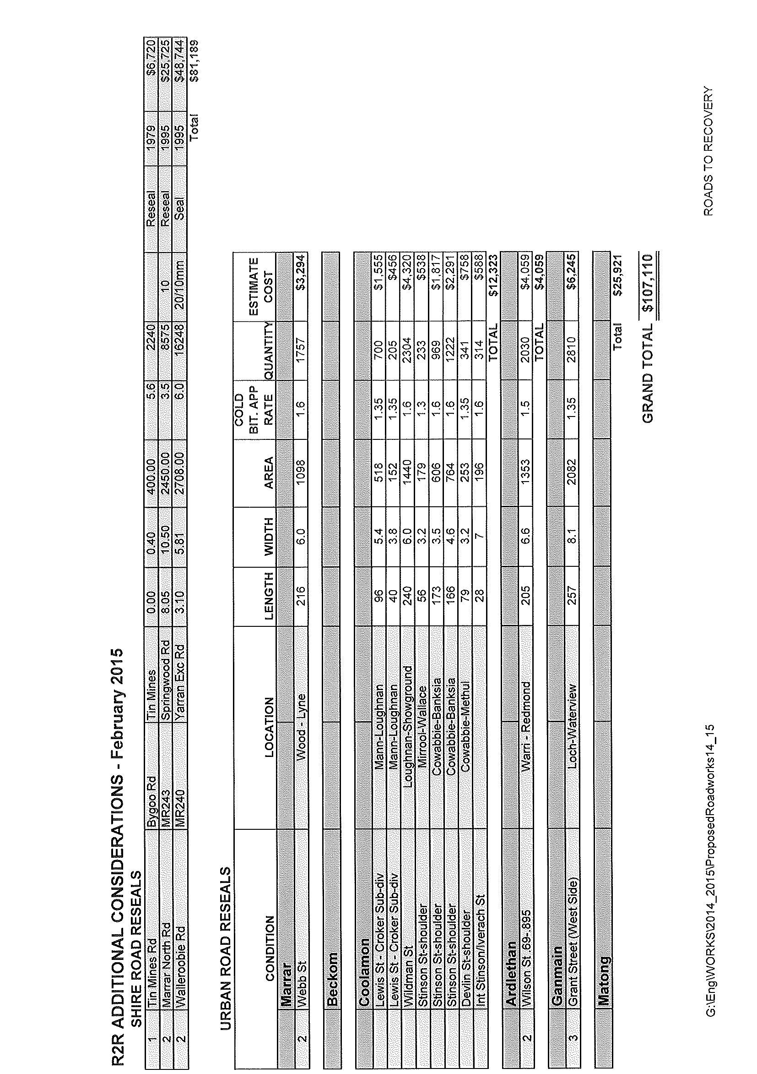

ES13) TRANSPORT FOR NSW – FIXING COUNTRY ROADS PROGRAMME (R.07-01, SC480)

Following an expression of interest and final submission stage where over 101 Rural Councils submitted 249 project proposals, the State Government has issued a Media Release advising that 77 projects totalling $42.85 Million has been successful under the Fixing Country Roads Programme (FCRP). Of the 77 projects Council have been successful with all five final submissions and are as follows:

Smokey Creek Bridge – Assessment, Mary Gilmore Way | $15,000
Crokers Grain Upgrades (Marrar South Road, Easticks Lane and Canola Way) | $940,000
Emerald Grain (Hodges Lane) Upgrade | $150,000
Ardlethan Grain Hub – Upgrading and Structure Assessments | $198,000
Ardlethan/Coolamon Road Upgrades | $897,000

➔ The Media Release and successful Project List has been distributed with the information papers. Attachment No. 15

All projects were well supported by the recently completed REROC Regional Freight Transport Plan and considered a key component of their success.

Individual Councils will be formally notified and require to attend briefing sessions to discuss payments and construction schedules.

Recommendation

For Council information.

RESOLVED on the motion of Clr Beard and seconded by Clr Huxtable that Council endorses any acceptance or signatures required in relation to Fixing Country Roads. 27/02/2015

4.4 MANAGER, PLANNING & ENVIRONMENTAL SERVICES REPORTS

HS1) DEVELOPMENT APPLICATIONS (B.05-03)

The following applications have been approved:

DEVELOPMENT APPLICATIONS

33/2014 61//1111377- 45 Menangle Street, Ganmain – Change of Use – Hall to be Used as Family Daycare.
55/2014 102//750818 - 7452 Newell Highway, Beckom – New Signage.
56/2014 52//599796 - 34 Loughnan Street, Coolamon – Covered Walkway.
57/2014 5/15/758657 - 5 Hume Street, Matong – Shed.
58/2014 2//623331 - Pearces Lane, Marrar – Dwelling & Inground Swimming Pool.
59/2014 3//740711 - 86 Lewis Street, Coolamon – Carport.
60/2014 5//6206 - Iverach Street, Coolamon – Shed.
61/2014 B//364299 - 31 Wade Street, Coolamon – Alterations & Additions to Dwelling.
63/2014 1/38/758428 - 37 Hannah Street, Ganmain – Dwelling.
66/2014 14//1096316 - 61 Stinson Street, Coolamon – Dwelling.
01/2015 20//260538 - 106 Bruce Street, Coolamon – Convert Part of Garage.
02/2015 5//5535 - 40 Logan Street, Coolamon – Transportable Dwelling.
03/2015 16//788459 - Keough Avenue, Ardlethan – Shed.
04/2015 142//730323 - 245 Ashbridge School Lane, Matong – Inground Swimming Pool.
05/2015 7/16/758650 - 44 Hare Street, Marrar – Dwelling & Shed.

COMPLYING DEVELOPMENT CONSENT

2014/17 2//777859 - 2-10 Quarry Road, Coolamon – Dwelling.
2014/18 9//878577 - 9 Jerricks Lane, Coolamon – Inground Swimming Pool.
2014/19 4//661125 - 4973 Ardlethan Road, Ardlethan – Inground Swimming Pool.

Recommendation

For Council information.

RESOLVED on the motion of Clr Logan and seconded by Clr Beard that the report be received. 28/02/2015

HS2) OPERATIONAL LAND MANAGEMENT PLAN AND COMMUNITY MANAGEMENT PLAN (A.11-01)

■ The annual inspection of all buildings and property has been carried out with the 2015 Community and Operational Land Management Plans being developed. These documents have been tabled for your information.

Council Staff will continue to utilise these documents as the primary method to identify upcoming and/or required works across the majority of Council’s assets. This will assist in the preparation of forthcoming budgets, particularly with regards to ensuring that sufficient maintenance, repair and operational budgets are provided.

Recommendation

For Council information.

RESOLVED on the motion of Clr Huxtable and seconded by Clr Brill that the report and the 2015 Community and Operational Land Management Plans be adopted. 29/02/2015

HS3) 2015 RIVERINA GROUP MENTORING PROGRAMME (SP43, PC71)

Council has been advised that Jesse Rapley has been chosen to participate in the Riverina Environmental Health & Building Professionals Group’s 2015 Mentoring Programme. The programme is facilitated by the Riverina Group with the aim of providing professional development opportunities to Environmental Health Officers, Building Surveyors and Planners located in regional areas where access to training is often limited, or inaccessible due to distance.

Under this programme, Trainees from Rural and Regional areas are sent to a major Metropolitan Council to undertake some work experience in the field of their choosing.

This is seen as a benefit to both Jesse’s career and Council in allowing the opportunity to gain new ideas and experiences in the field. Furthermore, as part of the conditions of the programme, Jesse must deliver a presentation to the annual Riverina Group conference outlining his experiences and detailing what new skills have been learnt. The conference is scheduled for mid-October 2015.

Recommendation

That Council endorse Jesse Rapley’s participation in the Riverina Group’s 2015 Mentoring Programme.

RESOLVED on the motion of Clr Logan and seconded by Clr White that Council endorse Jesse Rapley’s participation in the Riverina Group’s 2015 Mentoring Programme. 30/02/2015

HS4) COOLAMON CARAVAN PARK - PUBLIC RESERVES MANAGEMENT FUND APPLICATION (G.03-40, SC493)

Councillors will be aware that a funding submission was made to the NSW Crowns Lands Office in late 2014 under the Public Reserves Management Fund program. The application submitted by Council sought funding to assist with the upgrade and expansion of the Coolamon Caravan Park.

Council had originally budgeted $60,000 for the 2014-15 financial year for upgrades to the Caravan Park. The application sought an additional $80,500 to assist with the provision of an onsite caretakers cabin and expansion into the area about to be vacated by the Redgrave Park Tennis Club.

➔ Advice was recently received from the Minister’s office advising that Council has received a grant of $73,017. Whilst this figure is slightly less than what was applied for, Council now have approximately $130,000 for this project compared to the original $60,000 that was budgeted. A copy of the Ministers letter has been attached. Attachment No. 13.1

In order to be able to commence works, Council staff are currently working on a final site design. It is envisaged that this plan will be available to Councillors by the April 2015 Council Meeting. In addition to this, it is thought appropriate that Council commence planning for the construction of the caretakers cabin.

Council currently have 3 quotes for the construction of the caretakers cabin. These quotes are as follows:

Builder | Description | Quote
Colybuilt | Transportable pre-fabricated cabin (38.4m²) | $49,115 (excl. footings)
Austwide Homes | Transportable pre-fabricated cabin (37.9m²) | $52,000
J Tokley Constructions | Custom cabin built onsite  (38.5m²) | $53,800
*Note: These prices include kitchen/kitchenette. Air-conditioning and service connections not quoted. Final confirmation of quotes will need to be obtained, as original quotes were provided in October 2014.

➔ Plans and images of the above structures have been attached. Attachment No. 13.2
Whilst the table above indicates that the Colybuilt cabin is cheaper, it is also the least appealing in terms of aesthetics and is considered to be more a portable office than a cabin. The Austwide Homes cabin is considered more acceptable and visually appealing than the Colybuilt option, but its method of construction means that additional considerations such as access ramps will be required. Both the Colybuilt and Austwide quotes do not allow for a verandah. The custom built cabin quoted by local builder J Tokley Constructions is the most expensive, yet is the most visually appealing and contains the most inclusions. Furthermore, the slab-on-ground method of construction means that less consideration will need to be given to access ramps. It is therefore recommended that Council delegate negotiations for the construction of the onsite caretakers cabin by J Tokley Constructions to the General Manager.

Recommendation

1) That Council formally accept the grant offer for $73,017.

2) That Council delegate negotiations for the construction of the onsite caretakers cabin by J Tokley Constructions to the General Manager.

RESOLVED on the motion of Clr Hutcheon and seconded by Clr Logan that: 31/02/2015

1) Council formally accept the grant offer for $73,017.

2) Council delegate negotiations for the construction of the onsite caretakers cabin by J Tokley Constructions to the General Manager.

 ADJOURNMENT

RESOLVED on the motion of Clr Brill and seconded by Clr Logan that Council resolve into Committee of a Whole for the purpose of considering confidential matters as listed in the Committee of a Whole agenda for the reason that such matters are considered to be of a confidential nature and in accordance with Council's policy thereto. 32/02/2015

Council adjourned at 4.42pm into Committee of a Whole and reconvened at 4.45pm.
5) RECOMMENDATIONS OF THE COMMITTEE OF A WHOLE MEETING HELD 19TH FEBRUARY, 2015.

RESOLVED on the motion of Clr Huxtable and seconded by Clr Hutcheon that the Recommendations of the Committee of a Whole Meeting held 19th February, 2015 be adopted. 33/02/2015

6) REPORTS: DELEGATES/MAYOR/COUNCILLORS

There were no reports.

7) RECOMMENDATIONS OF THE COOLAMON SHIRE CONSULTATIVE COMMITTEE MEETING HELD 18TH DECEMBER, 2014.

RESOLVED on the motion of Clr Hutcheon and seconded by Clr Beard that the Recommendations of the Coolamon Shire Consultative Committee Meeting held 18th December, 2014 be adopted. 34/02/2015

Meeting Closed at 4.53pm.

Confirmed and signed during the Meeting held this 19th day of March, 2015.

......................................................
MAYOR

