Meeting commenced at 2.00pm.

BUSINESS:

1) Apologies

2) a. Confirmation of Minutes of the Meeting held 19th June, 2014.
b. Matters arising out of Minutes. (Not elsewhere reported)

3) Correspondence
a. Agenda A (Information Only)
b. Agenda B

4) General Manager’s Report
4.1 General Manager’s Report
4.2 Executive Manager, Corporate & Community Services’ Report
4.3 Executive Manager, Engineering & Technical Services’ Report
4.4 Manager, Planning & Environmental Services’ Report

5) Recommendations of the Staff Committee Meeting held 17th July, 2014.

6) Reports: Delegates/Mayor/Councillors

PRESENT: Clrs Seymour (Chairman), Logan, Hutcheon, Beard, White, McCann, Maslin and Huxtable.

STAFF: General Manager; Executive Manager, Corporate & Community Services; Executive Manager, Engineering & Technical Services; Finance Manager; Manager, Planning & Environmental Services; and Works Engineer.

APOLOGY: Clr Brill.

1) APOLOGY

RESOLVED on the motion of Clr Maslin and seconded by Clr White that the apology of Clr Brill be accepted. 161/07/2014
2a) CONFIRMATION OF MINUTES OF THE MEETING HELD 19TH JUNE, 2014.

RESOLVED on the motion of Clr McCann and seconded by Clr Logan that the Minutes of the Meeting held 19th June, 2014 as circulated be confirmed and adopted. 162/07/2014

2b) MATTERS ARISING OUT OF THE MINUTES
There were no matters arising out of the Minutes.

3) CORRESPONDENCE

AGENDA A (FOR INFORMATION ONLY)

1a) INFORMATION PAPERS

➔ The following papers have been distributed with Council’s supplementary material as being matters of information/interest to Councillors. If Councillors desire any further information on the matters distributed then that can be raised with the General Manager. Attachment No. 1

1) Local Government NSW Weekly Circulars 22, 23, 24, 25 and 26.

2) NSW Government Weekly Update from Adrian Piccoli dated 13th June, 20th June, 4th July and 11th July, 2014.

3) Minutes of the Advance Ganmain Committee Meeting held 17th June, 2014.

4) Information from Adrian Piccoli regarding the 2014 Community Building Partnership.

5) Newsletter from Katrina Hodginson, MP.

2a) ACTIVITY REPORTS

1) Coolamon Shire Multi Service Outlet Coordinator’s Monthly Report for the month of June 2014.
2) Operating Statistics of the Coolamon Shire Library for June 2014.
3) Tourism & Business Development Monthly Update for June 2014.
General Manager’s Note

➔ The above reports are operating reports only for use by Senior Staff. They are submitted to Council as part of Agenda A for information only. Attachment No. 2

RESOLVED on the motion of Clr Maslin and seconded by Clr Hutcheon that the Correspondence listed in Agenda A be received. 163/07/2014

AGENDA B

1b) NBN CO ROLLOUT IN NEW SOUTH WALES (T.02-06)

Forwarding a Media Release outlining that Coolamon has been included in the rollout using fixed line fibre and fixed wireless technologies. It is estimated from the Media Release it will be approximately 12 months before it will be operational.

This together with the previous Media Release about the fixed wireless at Ganmain, Marrar, Rannock and Ardlethan would indicate that the majority of communities within the Coolamon Shire will be connected to the National Broadband Network within approximately one year.

General Manager’s Note
➔ A copy of the Media Release is attached to Councillor’s information papers. Attachment No. 3

RESOLVED on the motion of Clr Huxtable and seconded by Clr Beard that the correspondence be noted. 164/07/2014

2b) GOLDENFIELDS WATER COUNTY COUNCIL – INFRASTRUCTURE CHARGES (W.01-02)

Goldenfields have released information to the media indicating a 20% reduction in developer charges to certain areas including the Coolamon LGA. This is seen as a positive step towards encouraging development.

General Manager’s Note
➔ A copy of the Media Release is attached to Councillor’s information papers. Attachment No. 15

RESOLVED on the motion of Clr McCann and seconded by Clr White that the correspondence be noted. 165/07/2014
4) GENERAL MANAGER’S REPORT

4.1 GENERAL MANAGER REPORTS

GM1) RIVERINA REGIONAL TOURISM (T.03-06)

➔ In light of Council’s decision at the last Council Meeting to continue its membership of Riverina Regional Tourism (RRT) an update has been provided for your information. Council will continue to monitor the activities of this organisation to ensure that they are meeting the key performance indicators that they have set for this year. Attachment No. 4

Recommendation

For Council information.

GM2) INFRASTRUCTURE PROJECTS – REBUILDING NSW (G.03-01)

➔ Mr Adrian Piccoli has formally contacted Council seeking input into any infrastructure projects that Council would like to view with priority funding. Attachment No. 5.1

Whilst this money is available on the sale of the NSW Government’s power assets, and therefore something that is not supported by Coolamon Shire, Council needs to consider what infrastructure projects would be appropriate for our Local Government area should this fund become available.

➔ As can be seen there is an expected timetable for this consultancy and future submissions, however, Council should consider their priorities. Included in the attachments are Key Questions and Answers direct from the website indicating what new infrastructure services will be provided. Attachment No. 5.2

Projects that may meet this criteria are:

- Ambulance Station in Coolamon
- Sewer at Ardlethan
- Ganmain Pool
- Tennis Courts, Coolamon

Recommendation

For Council information.

GM3) AUSTRALIAN GOVERNMENT BUDGET CUTS TO LOCAL GOVERNMENT (L.07-05)

Council has been advised by Local Government NSW of the action they have taken to raise the issues associated with:

- Freezing of the Commonwealth Financial Assistance Grants for the next three years.
- Discontinuation of the National Partnership on certain concessions for the Pensioner Card and Senior Card holders.
- Cuts to Family Day Care funding.

➔ This attachment sets out the issues identified that will affect Local Government in New South Wales and includes a letter to the Prime Minister, Tony Abbot requesting that he reconsider these measures. Attachment No. 6.1

➔ Council will recall that at the June Meeting, Council received correspondence from the Australian Local Government Association indicating similar concerns over the Federal Budget. As a result of this information, correspondence was sent to Michael McCormack advising of Council’s concerns. Attachment No. 6.2

Recommendation

For Council information.

GM4) COMPARATIVE INFORMATION ON NSW LOCAL GOVERNMENT 2012-13 (L.05-04)

■ A copy of the Comparative Information on NSW Local Government Councils has been tabled for your information.

➔ In addition, included in the attachments is the comparative data specific to Coolamon Shire. In order to give some context to this information I have also included the information of our close neighbouring Councils to give a perspective of where Coolamon sits in relation to this. Attachment No. 7

As previously highlighted the 2013 T-Corp assessment gave Coolamon a financial sustainability rating of sound, with a negative outlook. The 2013 infrastructure audit also indicated that our management of infrastructure was very weak. Both of these matters are being addressed currently and will be rectified with the recent work undertaken on the Budget and Asset Management Programme. I note that Council’s spending on assets is in excess of the required asset maintenance.
Recommendation

For Council information.

RESOLVED on the motion of Clr Huxtable and seconded by Clr Hutcheon that the General Manager’s Reports (GM1 to GM4) be noted. 166/07/2014

GM5) COUNCIL COMMITTEES AND APPOINTMENT OF DELEGATES (D.01-01)

1) APPOINTMENT OF DELEGATES

Due to the change over in General Managers that was endorsed at the last Council Meeting, Council should now look at the Committees and their structure that included the General Manager. The following Committees are those which Mr Terrey Kiss was delegated to:

 | ORGANISATION | DELEGATES
a | Riverina Regional Library | Clr G Beard  General Manager, T Kiss
b | Riverina Eastern Regional Organisation of Councils (REROC) | Mayor, Clr J Seymour  General Manager, T Kiss
c | Local Emergency Management Committee | Executive Manager, Engineering & Technical Services, T Kelly  General Manager, T Kiss
d | Coolamon/Junee Police Community Consultative Committee | Clr J Seymour  Clr B Hutcheon  General Manager, T Kiss

All of these Committees are still current and relevant to this organisation and it is recommended that Council by way of resolution formalise the replacement of Terrey Kiss to the new General Manager.

In regard to Riverina Regional Library, Tony Donoghue was the alternate delegate. It is thought appropriate that Courtney Armstrong will now take that role.

Recommendation

1) That Tony Donoghue be included as the delegate to the following Organisations:

2) That Courtney Armstrong be the Alternate Delegate to the Riverina Regional Library.

 | ORGANISATION | DELEGATES
a | Riverina Regional Library | Clr G Beard  General Manager, T Donoghue  Alternate Delegate: Executive Manager, Corporate & Community Services, C Armstrong,
b | Riverina Eastern Regional Organisation of Councils (REROC) | Mayor, Clr J Seymour  General Manager, T Donoghue
c | Local Emergency Management Committee | Executive Manager, Engineering & Technical Services, T Kelly  General Manager, T Donoghue
d | Coolamon/Junee Police Community Consultative Committee | Clr J Seymour  Clr B Hutcheon  General Manager, T Donoghue

RESOLVED on the motion of Clr Hutcheon and seconded by Clr Maslin: 167/07/2014

1) That Tony Donoghue be included as the delegate to the following Organisations:

2) That Courtney Armstrong be the Alternate Delegate to the Riverina Regional Library.

 | ORGANISATION | DELEGATES
a | Riverina Regional Library | Clr G Beard  General Manager, T Donoghue  Alternate Delegate: Executive Manager, Corporate & Community Services, C Armstrong,
b | Riverina Eastern Regional Organisation of Councils (REROC) | Mayor, Clr J Seymour  General Manager, T Donoghue
c | Local Emergency Management Committee | Executive Manager, Engineering & Technical Services, T Kelly  General Manager, T Donoghue
d | Coolamon/Junee Police Community Consultative Committee | Clr J Seymour  Clr B Hutcheon  General Manager, T Donoghue
2) COUNCIL COMMITTEE STRUCTURE

All these Committees are still relevant to Council’s operation and should include the new General Manager on them replacing Terrey Kiss.

- Executive Management Committee:
General Manager, T Kiss (Chairman)
Deputy General Manager, T Donoghue
Executive Manager, Engineering & Technical Services, T Kelly
Executive Manager, Corporate & Community Services, C Armstrong

- To consider operational issues as determined by the General Manager.
- To review and prepare budgets and other financial documentation prior to submission to Council.
- To review Council’s Strategic 10 Year Plan prior to submission to Council.
- To undertake policy and strategic review issues prior to Council consideration.

- Consultative Committee:
General Manager, T Kiss
Deputy General Manager, T Donoghue
Mr J Mitchell
Mrs M Pattison
■ one Work Staff Member to be added

- Council by law is required to constitute a Consultative Committee. The Committee considers issues of an industrial nature with recommendations coming to Council.

- Code of Conduct Committee

Coolamon Code of Conduct Committee
Gary Lavelle, Temora Shire Council
Kris Dunstan, Temora Shire Council
Steve Firth, Temora Shire Council
Temora Code of Conduct Committee
Terrey Kiss
Courtney Armstrong
Tony Donoghue

Recommendation

That Tony Donoghue be included on the following Council Committees:

- Executive Management Committee:
General Manager, T Donoghue (Chairman)
Executive Manager, Engineering & Technical Services, T Kelly
Executive Manager, Corporate & Community Services, C Armstrong

- To consider operational issues as determined by the General Manager.
- To review and prepare budgets and other financial documentation prior to submission to Council.
- To review Council’s Strategic 10 Year Plan prior to submission to Council.
- To undertake policy and strategic review issues prior to Council consideration.

- Consultative Committee:
General Manager, T Donoghue
Mr J Mitchell
Mrs M Pattison
■ one Work Staff Member to be added

- Council by law is required to constitute a Consultative Committee. The Committee considers issues of an industrial nature with recommendations coming to Council.

- Code of Conduct Committee

Coolamon Code of Conduct Committee
Gary Lavelle, Temora Shire Council
Kris Dunstan, Temora Shire Council
Steve Firth, Temora Shire Council
Temora Code of Conduct Committee
Tony Donoghue
Courtney Armstrong

RESOLVED on the motion of Clr McCann and seconded by Clr Logan that Tony Donoghue be included on the following Council Committees: 168/07/2014

- Executive Management Committee:
General Manager, T Donoghue (Chairman)
Executive Manager, Engineering & Technical Services, T Kelly
Executive Manager, Corporate & Community Services, C Armstrong

- To consider operational issues as determined by the General Manager.
- To review and prepare budgets and other financial documentation prior to submission to Council.
- To review Council’s Strategic 10 Year Plan prior to submission to Council.
- To undertake policy and strategic review issues prior to Council consideration.

- Consultative Committee:
General Manager, T Donoghue
Mr J Mitchell
Mrs M Pattison
■ one Work Staff Member to be added

- Council by law is required to constitute a Consultative Committee. The Committee considers issues of an industrial nature with recommendations coming to Council.

- Code of Conduct Committee

Coolamon Code of Conduct Committee
Gary Lavelle, Temora Shire Council
Kris Dunstan, Temora Shire Council
Steve Firth, Temora Shire Council
Temora Code of Conduct Committee
Tony Donoghue
Courtney Armstrong

GM6) COOLAMON SHIRE COMMUNITY BENEFIT FUND COMMITTEE (A.09-02)

The Coolamon Shire Community Benefit Fund Committee has as one of its members Mr Terrey Kiss who sits on this Committee primarily as the General Manager of Council.

Whilst I will be required to sit on this Committee as the new General Manager, it is thought appropriate that Mr Kiss can continue to act as a member representing the community.

Terrey Kiss has a vast experience in relation to these matters and a knowledge and understanding of the communities that the fund can be to the benefit of.

Recommendation

That Mr Kiss remains on the Coolamon Shire Community Benefit Fund Committee as a community member and that Tony Donoghue be included in his capacity as General Manager.

RESOLVED on the motion of Clr Huxtable and seconded by Clr McCann that Mr Kiss remains on the Coolamon Shire Community Benefit Fund Committee as a community member and that Tony Donoghue be included in his capacity as General Manager. 169/07/2014
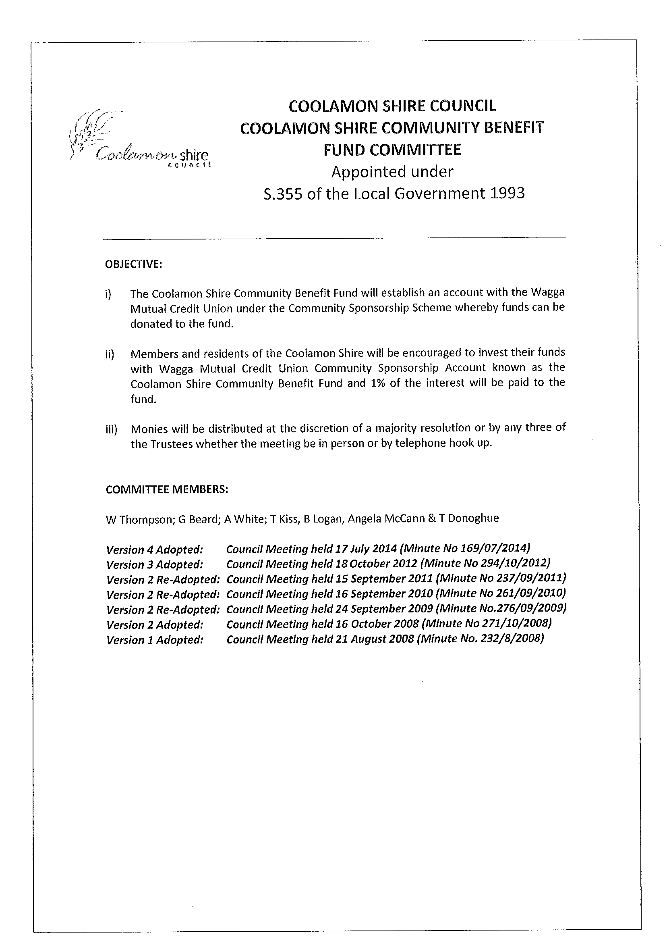

GM7) COOLAMON AMBULANCE STATION (H.03-03)

Coolamon Shire Council has been requesting advice from the Minister for Health and Medical Research, Julian Skinner as to the prospects of providing an Ambulance Station at Coolamon.

The responses to date have indicated that whilst this is an important project the last State Budget and Infrastructure Planning processes have meant that no commitment could be made as to funding. This is despite the fact that there is an increasing and identified need for such a service in Coolamon and the surrounding district as well as a support to the growing Wagga needs.

➔ The recent budget has revealed that no funding has been committed towards an Ambulance Station at Coolamon for this financial year. The budget does however, indicate that there is $4 Million allocated to improve Ambulance infrastructure in rural areas. It appears that in order for this matter to be progressed, Council will need to be more proactive and agitate for it to be prioritised. Attachment No. 8

It is thought that the provision of an Ambulance Station in Coolamon to service the district would significantly increase the community’s access to appropriate health services. The current lag time in emergency situations and the speed of medical care arriving on the scene needs to be improved for the safety of our communities.

Council has received access to a significant bequeathment from an Estate to be used primarily for health related services. If Council is to progress the matter of an Ambulance Service then it would appear we will need to encourage the State Government by helping provide additional funding towards the project.

With this funding Council may now wish to increase the offer to the NSW Ambulance Service of land together with significant funding in the vicinity of $100,000 towards the capital cost of an Ambulance Station.

Recommendation

1) That Council contact the Hon Julian Skinner, MP to advise of Council’s offer of land and $100,000 towards the construction of an Ambulance Station.

2) That Council contacts the NSW Ambulance to discuss costings of an Ambulance Station in Coolamon.

RESOLVED on the motion of Clr McCann and seconded by Clr Maslin that: 170/07/2014

1) Council contact the Hon Julian Skinner, MP to advise of Council’s offer of land and $100,000 towards the construction of an Ambulance Station; and

2) Council contacts the NSW Ambulance to discuss costings of an Ambulance Station in Coolamon; and

3) Council reiterate to NSW Ambulance that any Ambulance Station located in Coolamon should not affect any other existing Ambulance services in the Coolamon Shire.

GM8) COOLAMON MEN’S SHED (C.07-08)

A meeting was held with the Coolamon Men’s Shed in order to determine their options in regard to location and operation.

Council has previously offered a site on the corner of Devlin and Methul Streets for them to locate their activities and construct a shed.

It appears that this site has been floundering and there seems to be some change of heart in relation to this site.

➔ The Coolamon Men’s Shed group has now advised that they would like to take up the offer of utilising the currently vacant sheep pavilion shed at the Coolamon Showground. (See Attachments). Attachment No. 9

This shed is currently vacant and has a roof and three sides. Power is currently located to the shed and toilets are in close proximity. This appears to be a far better option for the Men’s Shed to commence their operations and move into a more permanent home.

In light of this development Council should withdraw the offer of providing space on the Corner of Methul and Devlin Streets and now permit the occupation of the shed down at the Showground.

This will have additional benefits of providing another community user to the Showground that can help with the running and management of the Showground.

Recommendation

1) That Council offer use of the former sheep pavilion to the Coolamon Men’s Shed.

2) That Council withdraw the offer of a space at the Council Depot yard at the corner of Methul and Devlin Street.

RESOLVED on the motion of Clr Hutcheon and seconded by Clr McCann that the previous motion offering space at the Depot yard be rescinded. 171/07/2014

RESOLVED on the motion of Clr Hutcheon and seconded by Clr McCann that Council offer use of the former sheep pavilion to the Coolamon Men’s Shed. 172/07/2014

GM9) COOLAMON RURAL WOMEN’S GATHERING (C.07-11)

➔ Council has received a letter from the Coolamon Rural Women’s Gathering Committee (CRWGC) requesting support for their upcoming event on the 12-14th September, 2014. A copy of this correspondence is in the Attachments.
Attachment No. 10

The support being requested is the waiving of the fee when using the Up-to-Date Store.

In light of the recent changes to Council’s hiring rates that were included in our budget process, and the stance that the users of these facilities should pay, it is thought appropriate that Council request that a payment be made.

I note in the same letter the CRWGC comment is that they would like any proceeds received from fundraising to go towards the Coolamon Shire Community Benefit Fund. Council would appreciate that fundraising be put to this fund, however, it is thought appropriate that all costs should be borne by the organisation prior to the allocation of charity funding.

Council believes that the Coolamon Shire Community Benefit Fund is a worthwhile charity and appreciates the thoughts and promotion of this fund. At the same time the running costs associated with the Up-to-Date Store and the benefit that this facility has for the community should not suffer in order to provide a larger donation.

Recommendation
For Council decision.
RESOLVED on the motion of Clr McCann and seconded by Clr Hutcheon that the Coolamon Rural Women’s Gathering Committee be advised that Council will not accede to their request for assistance. 173/07/2014

GM10) ALLAWAH COMMUNITY CENTRE (P.12-01)

Discussions held about the fees associated with the Allawah Community Centre were held at the last Council Meeting. The resolution that was adopted was to set the fees as per the policy attached which required all users to pay a fee. During the meeting there was some discussion over the Hospital Auxiliary and that this organisation would be excluded from paying the fee. This was not noted in the Minutes at the time and there appears to be conflicting memories around the discussion on whether or not this amendment to the Policy was resolved.

Whilst not wishing to completely revisit the discussion, I would like some confirmation on the intention of the recommendation to ensure that Council Officers can enforce the policy.

Recommendation

For Council discussion.

RESOLVED on the motion of Clr Huxtable and seconded by Clr Beard that the Allawah Community Centre Policy to include an exemption for the Coolamon-Ganmain Hospital Auxiliary in relation to the application of fees. 174/07/2014
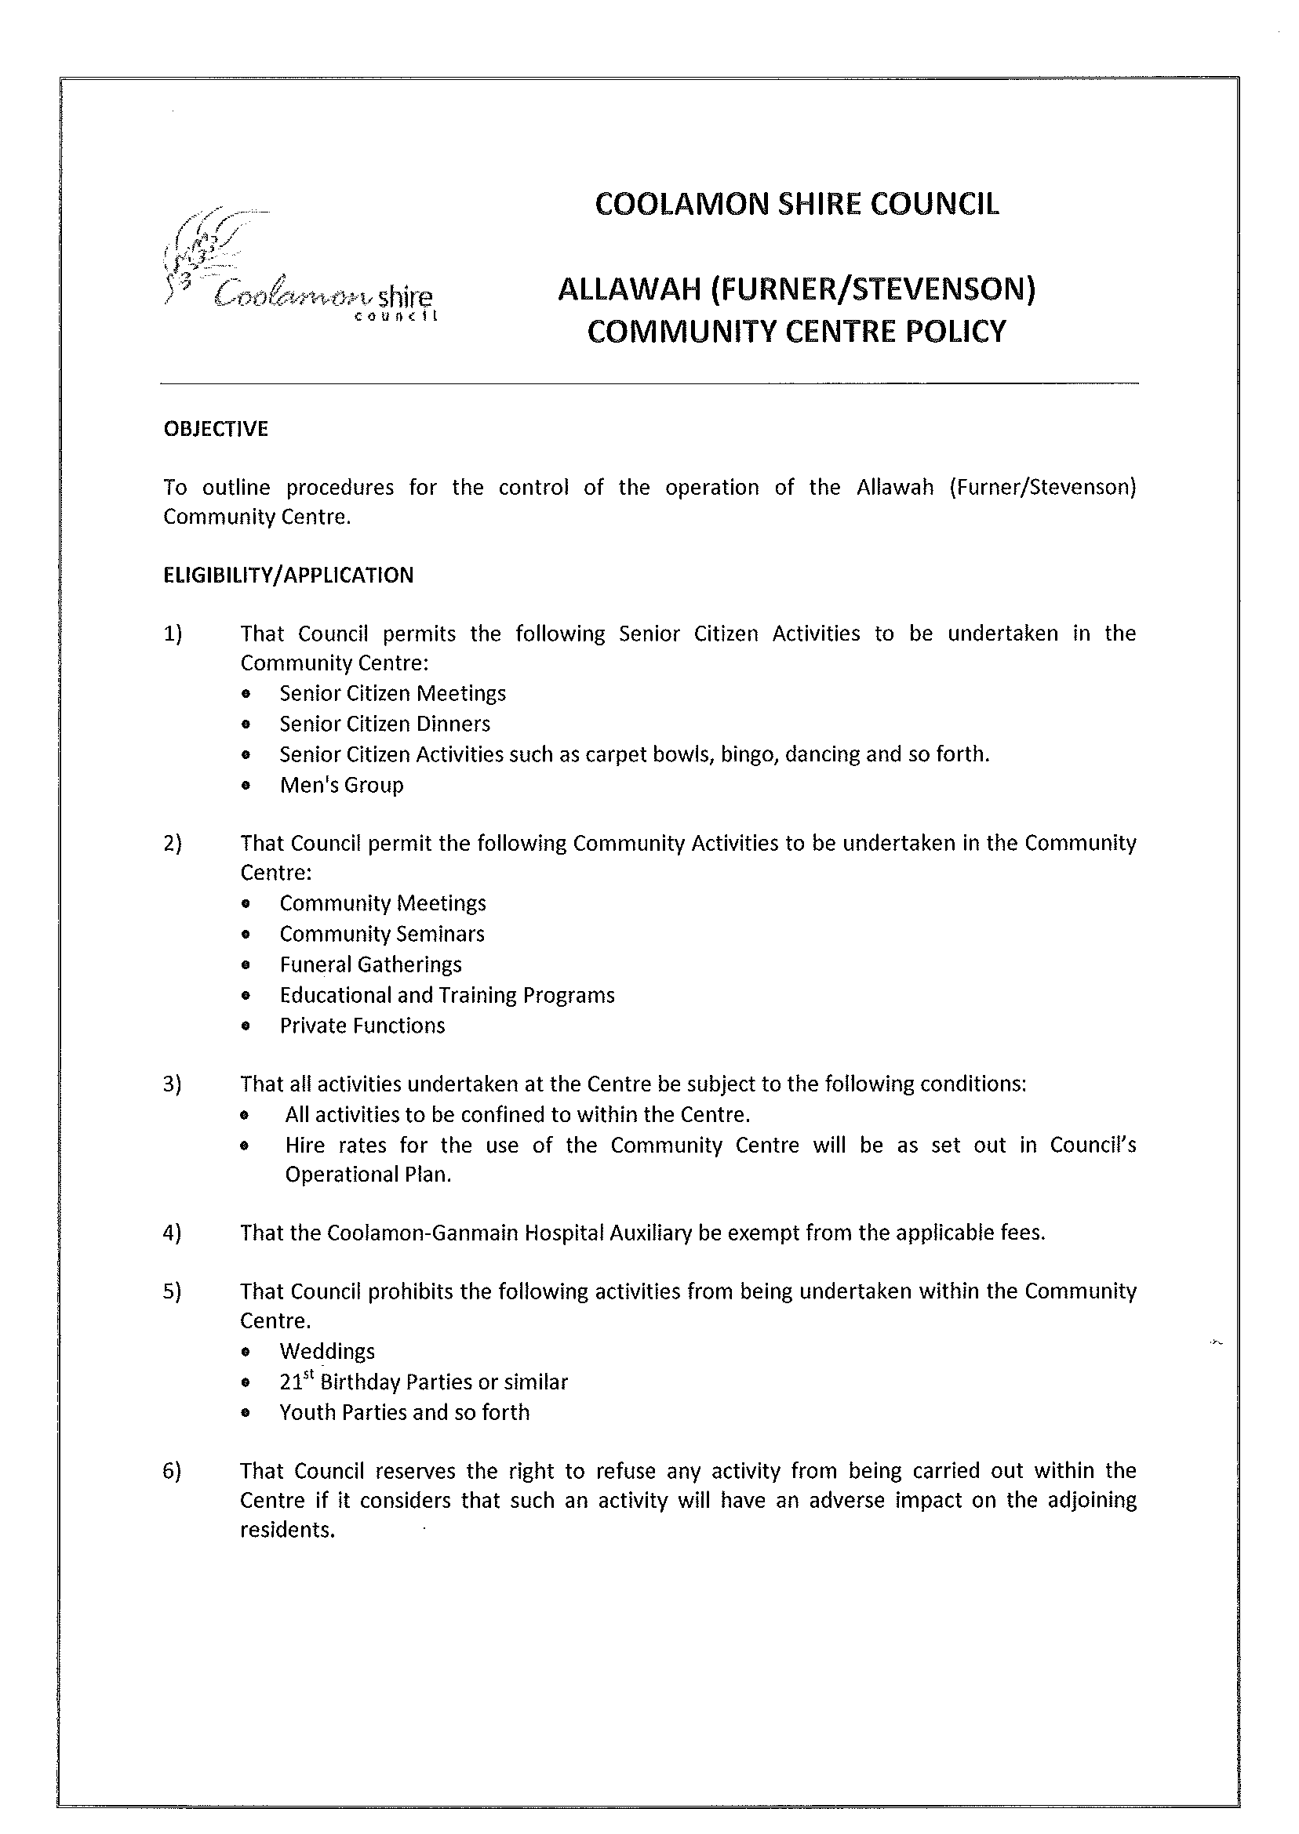
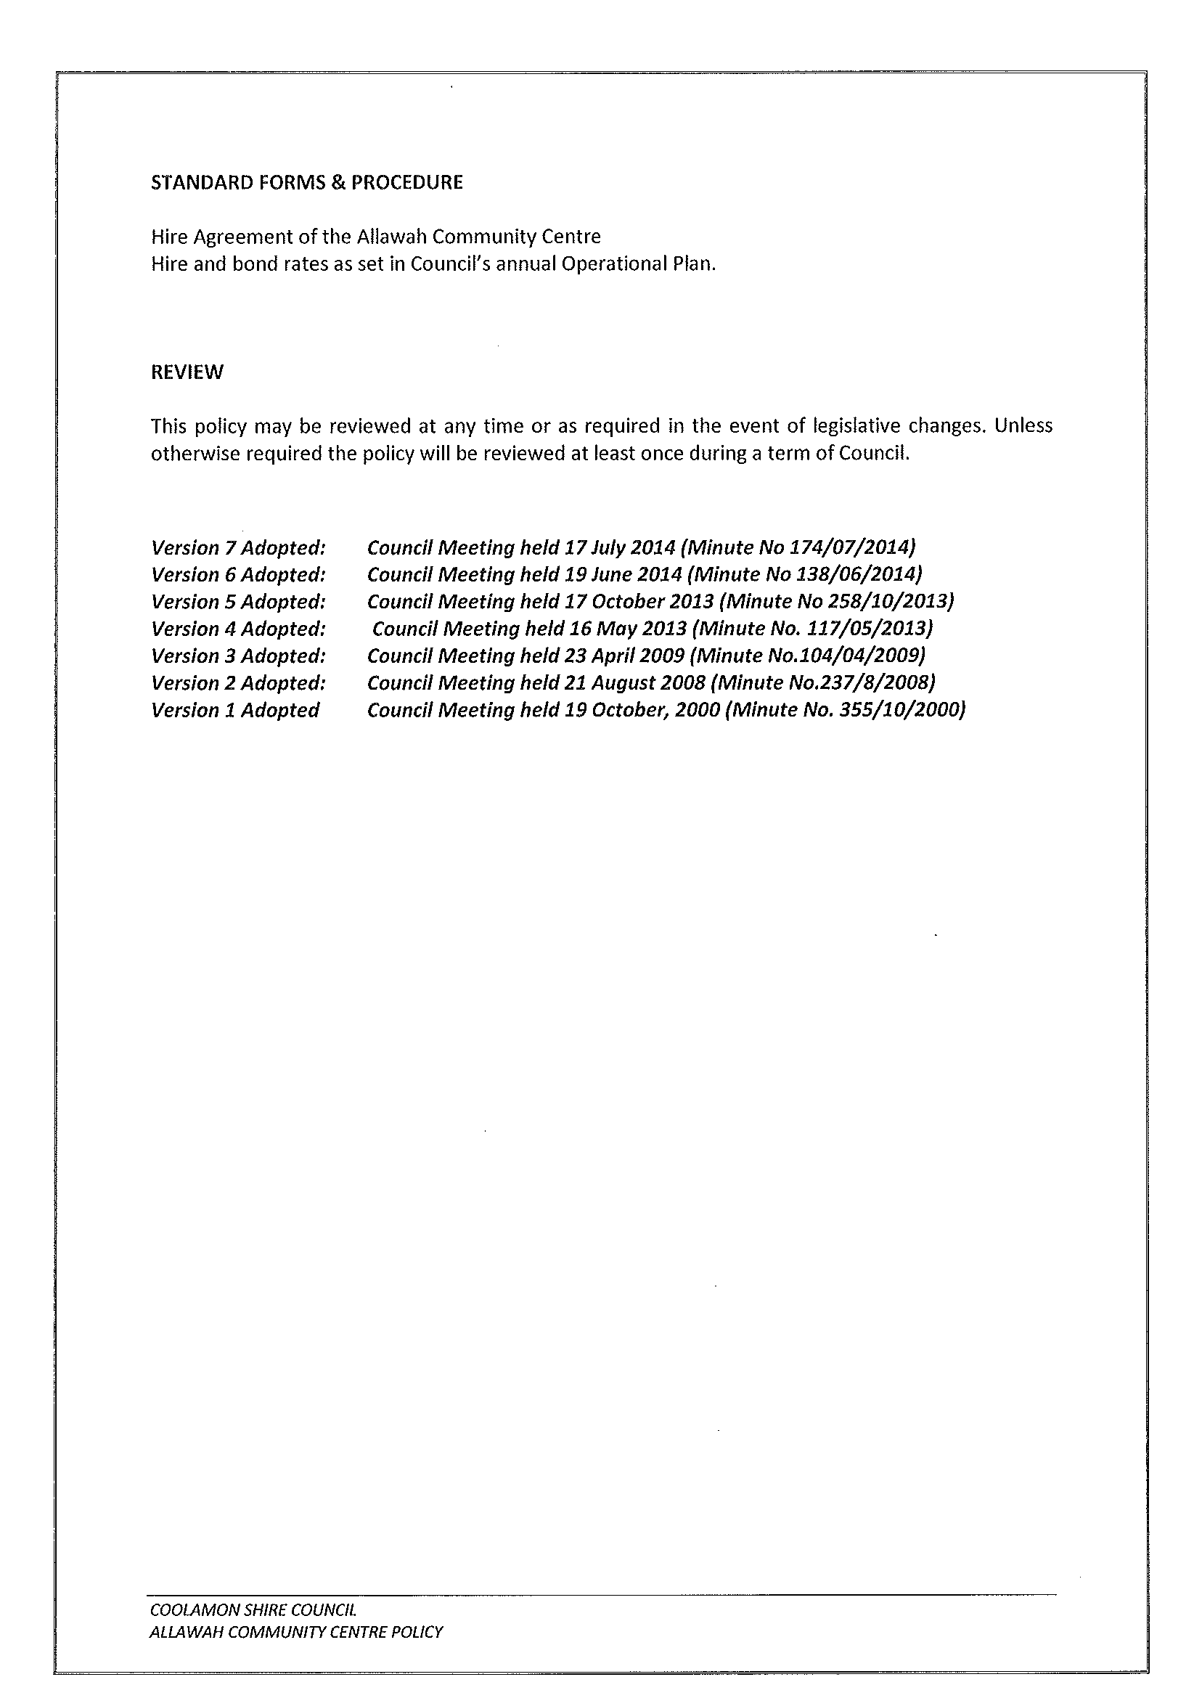
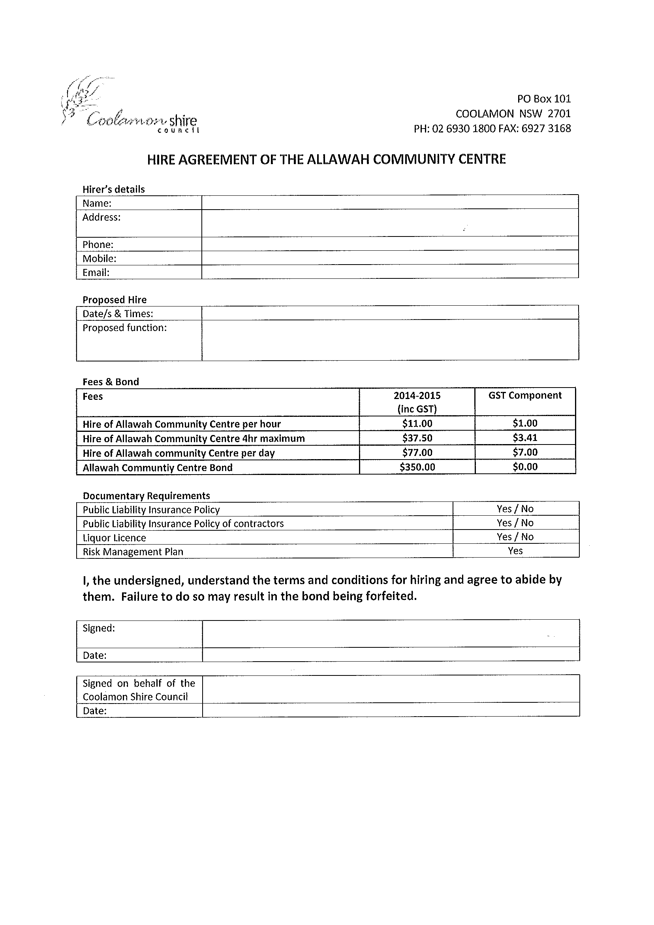
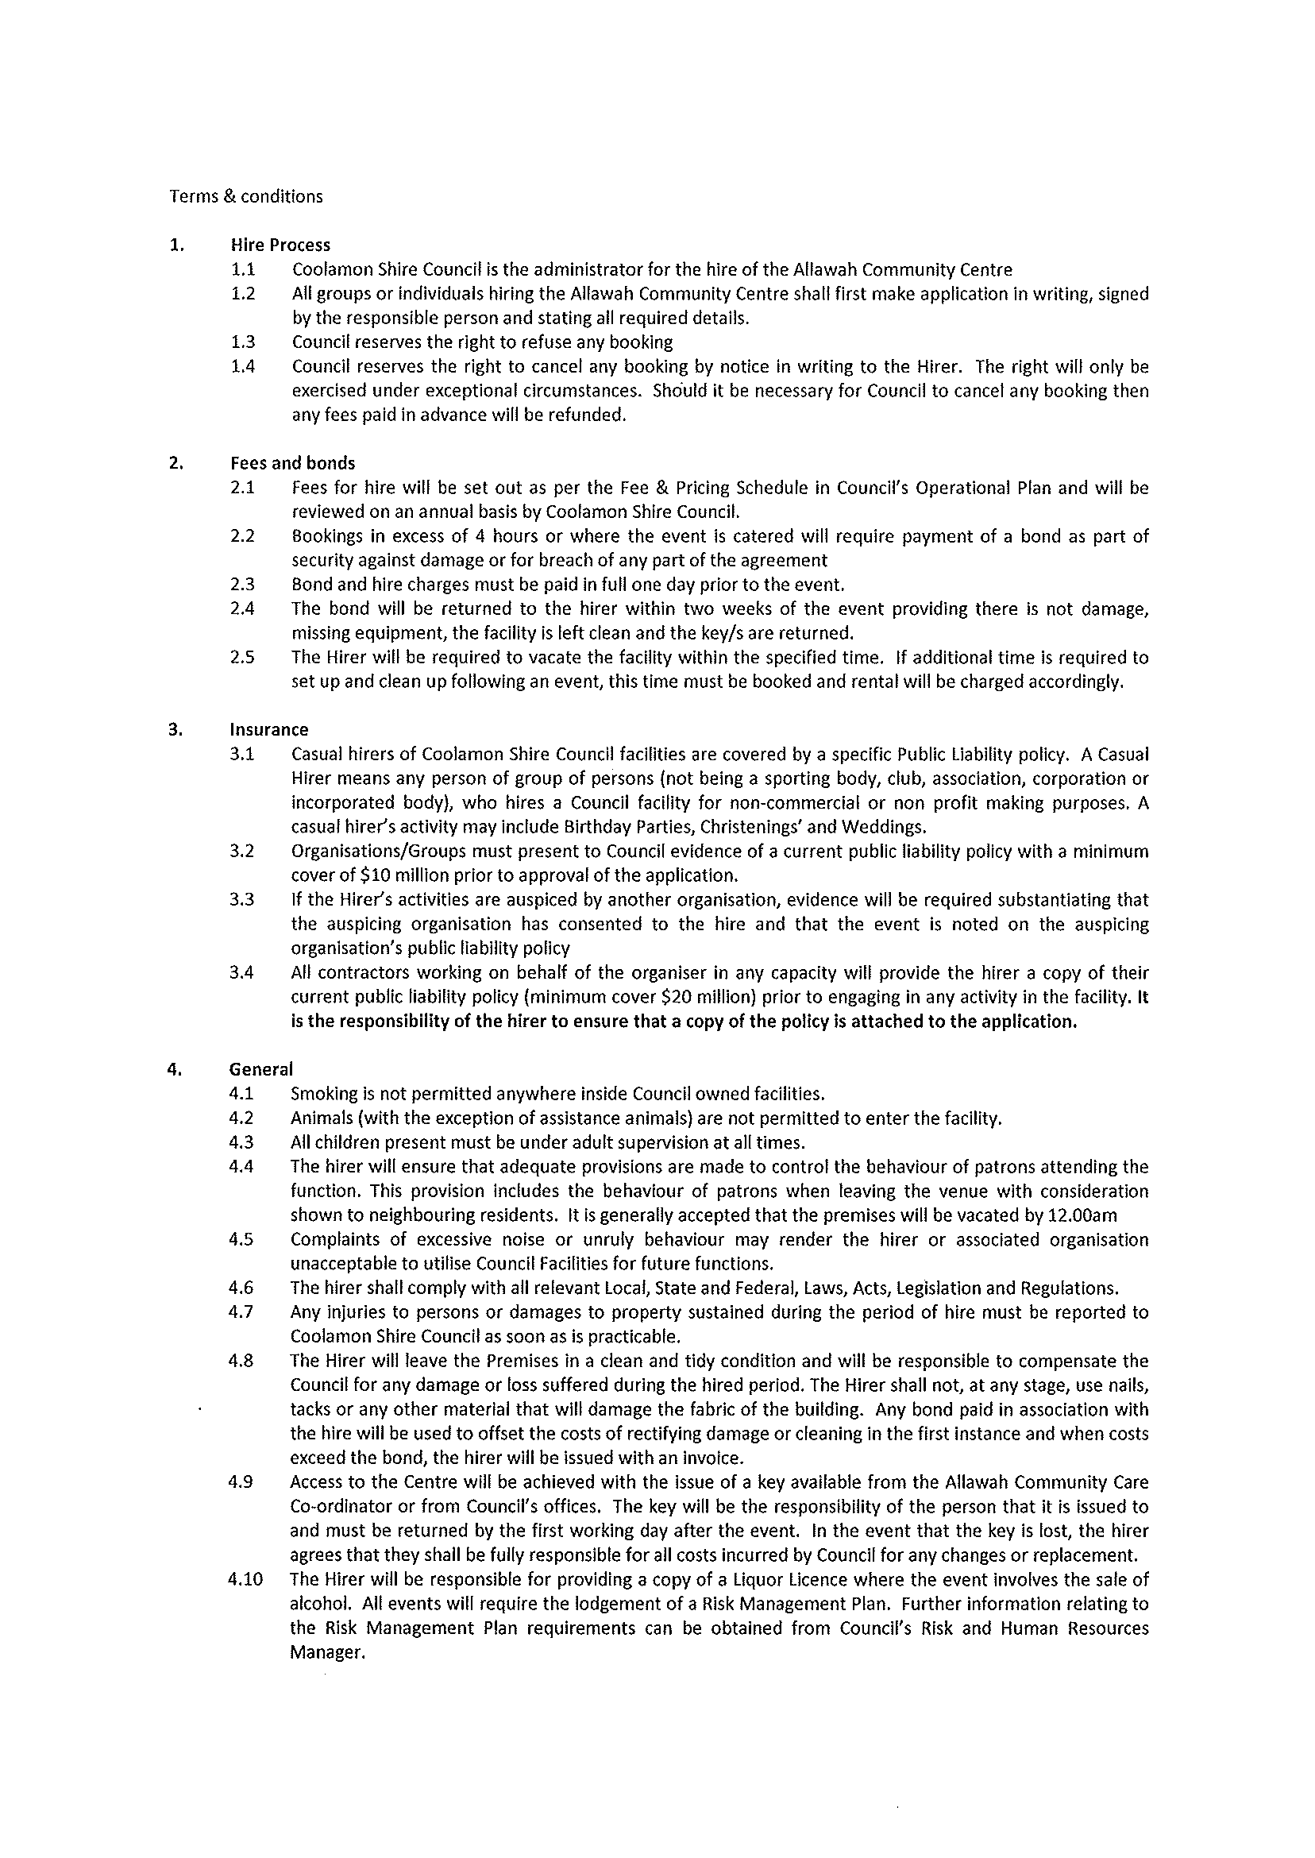

GM11) AMBULANCE SERVICE OF NEW SOUTH WALES (H.03-03)

➔ Council has received correspondence from the Ambulance Service of New South Wales advising that they propose to hold a joint meeting with Fire & Rescue NSW in an open public forum to discuss the possibility of forming a Community First Responder group. I have attached for your information the letter and information associated with Ambulance Volunteers and Community First Responders. Attachment No. 16

I have contacted the local Fire & Rescue NSW personnel and their Captain, Phil Furnell has advised that they have reservations about this.

Council also has concerns on several grounds:

- Current FRNSW officers are volunteers and their attendance at any call out is dependent on their availability.

- It is envisaged that they would expect an additional 100 call outs in addition to their existing 50 (approx) call outs per year. This would mean a call out rate of approximately one every 2.5 days.

- Does the volunteer base have the capacity to attend this many call outs?

- Do the employers of these volunteers both FRNSW officers or first responders have the ability to allow them to leave work to attend these responses?

- This places pressure on employees to ensure that their staff are continually available for the safety of the community.

- This creates additional responses and incidents when volunteer firefighters who joined to fight fires are now primarily a Rescue/Ambulance organisation.

- Any proposed first responder officers do not have any vehicle and do not transport patients. In essence, they get there onsite to stabilise people and then call for an ambulance.

It appears that the NSW Ambulance Service are attempting to cover the shortcoming of the Coolamon district health needs by covering the response times with accredited volunteers most likely from Fire & Rescue NSW.

Coolamon Shire Council has been negotiating with the NSW Ambulance Service for approximately five years to have a fully serviced facility located within the Coolamon Township.
It is believed that the proposal currently on the table is not acceptable and Council would like to continue negotiations for a fully serviced facility.

I have contacted Susan Webster about the possibility of holding a meeting between Council Representatives, the local FRNSW Captain and herself prior to the open forum. She was receptive to this idea.

Recommendation

1) That Council meet with the Ambulance Service of New South Wales prior to the public meeting.
2) That Council reinforce the position that a fully serviced station be provided in Coolamon.

RESOLVED on the motion of Clr White and seconded by Clr McCann that: 175/07/2014

1) Council meet with the Ambulance Service of New South Wales prior to the public meeting; and
2) Council reinforce the position that a fully serviced station be provided in Coolamon.

GM12) MURRUMBIDGEE LOCAL HEALTH DISTRICT (H.03-01)

The Murrumbidgee Local Health District has advised that they are proposing to hold a Forum for Local Health Advisory Committee Members in Wagga Wagga on the 8th/9th October, 2014. In order to encourage as many community representatives to attend as possible, they are seeking the support of Council to enable community representatives to attend. The suggested contribution is $100.00 per representative and they are seeking up to 10 persons.

I am not quite convinced that this is a Local Government responsibility for local Councils to contribute to the State Government undertaking Health Consultation Services within our communities.

Recommendation
That the request be denied.

RESOLVED on the motion of Clr Beard and seconded by Clr McCann that the Murrumbidgee Local Health District be advised that Council will not be contributing for representatives to attend the forum. Further, that Council delegate any response of this or any future requests in regards to the Murrumbidgee Local Health District requests to the General Manager. 176/07/2014
4.2 EXECUTIVE MANAGER, CORPORATE & COMMUNITY SERVICES’ REPORTS

CS1) FINANCE REPORT AS AT 30TH JUNE, 2014

RESOLVED on the motion of Clr Huxtable and seconded by Clr Beard that the report be received. 177/07/2014

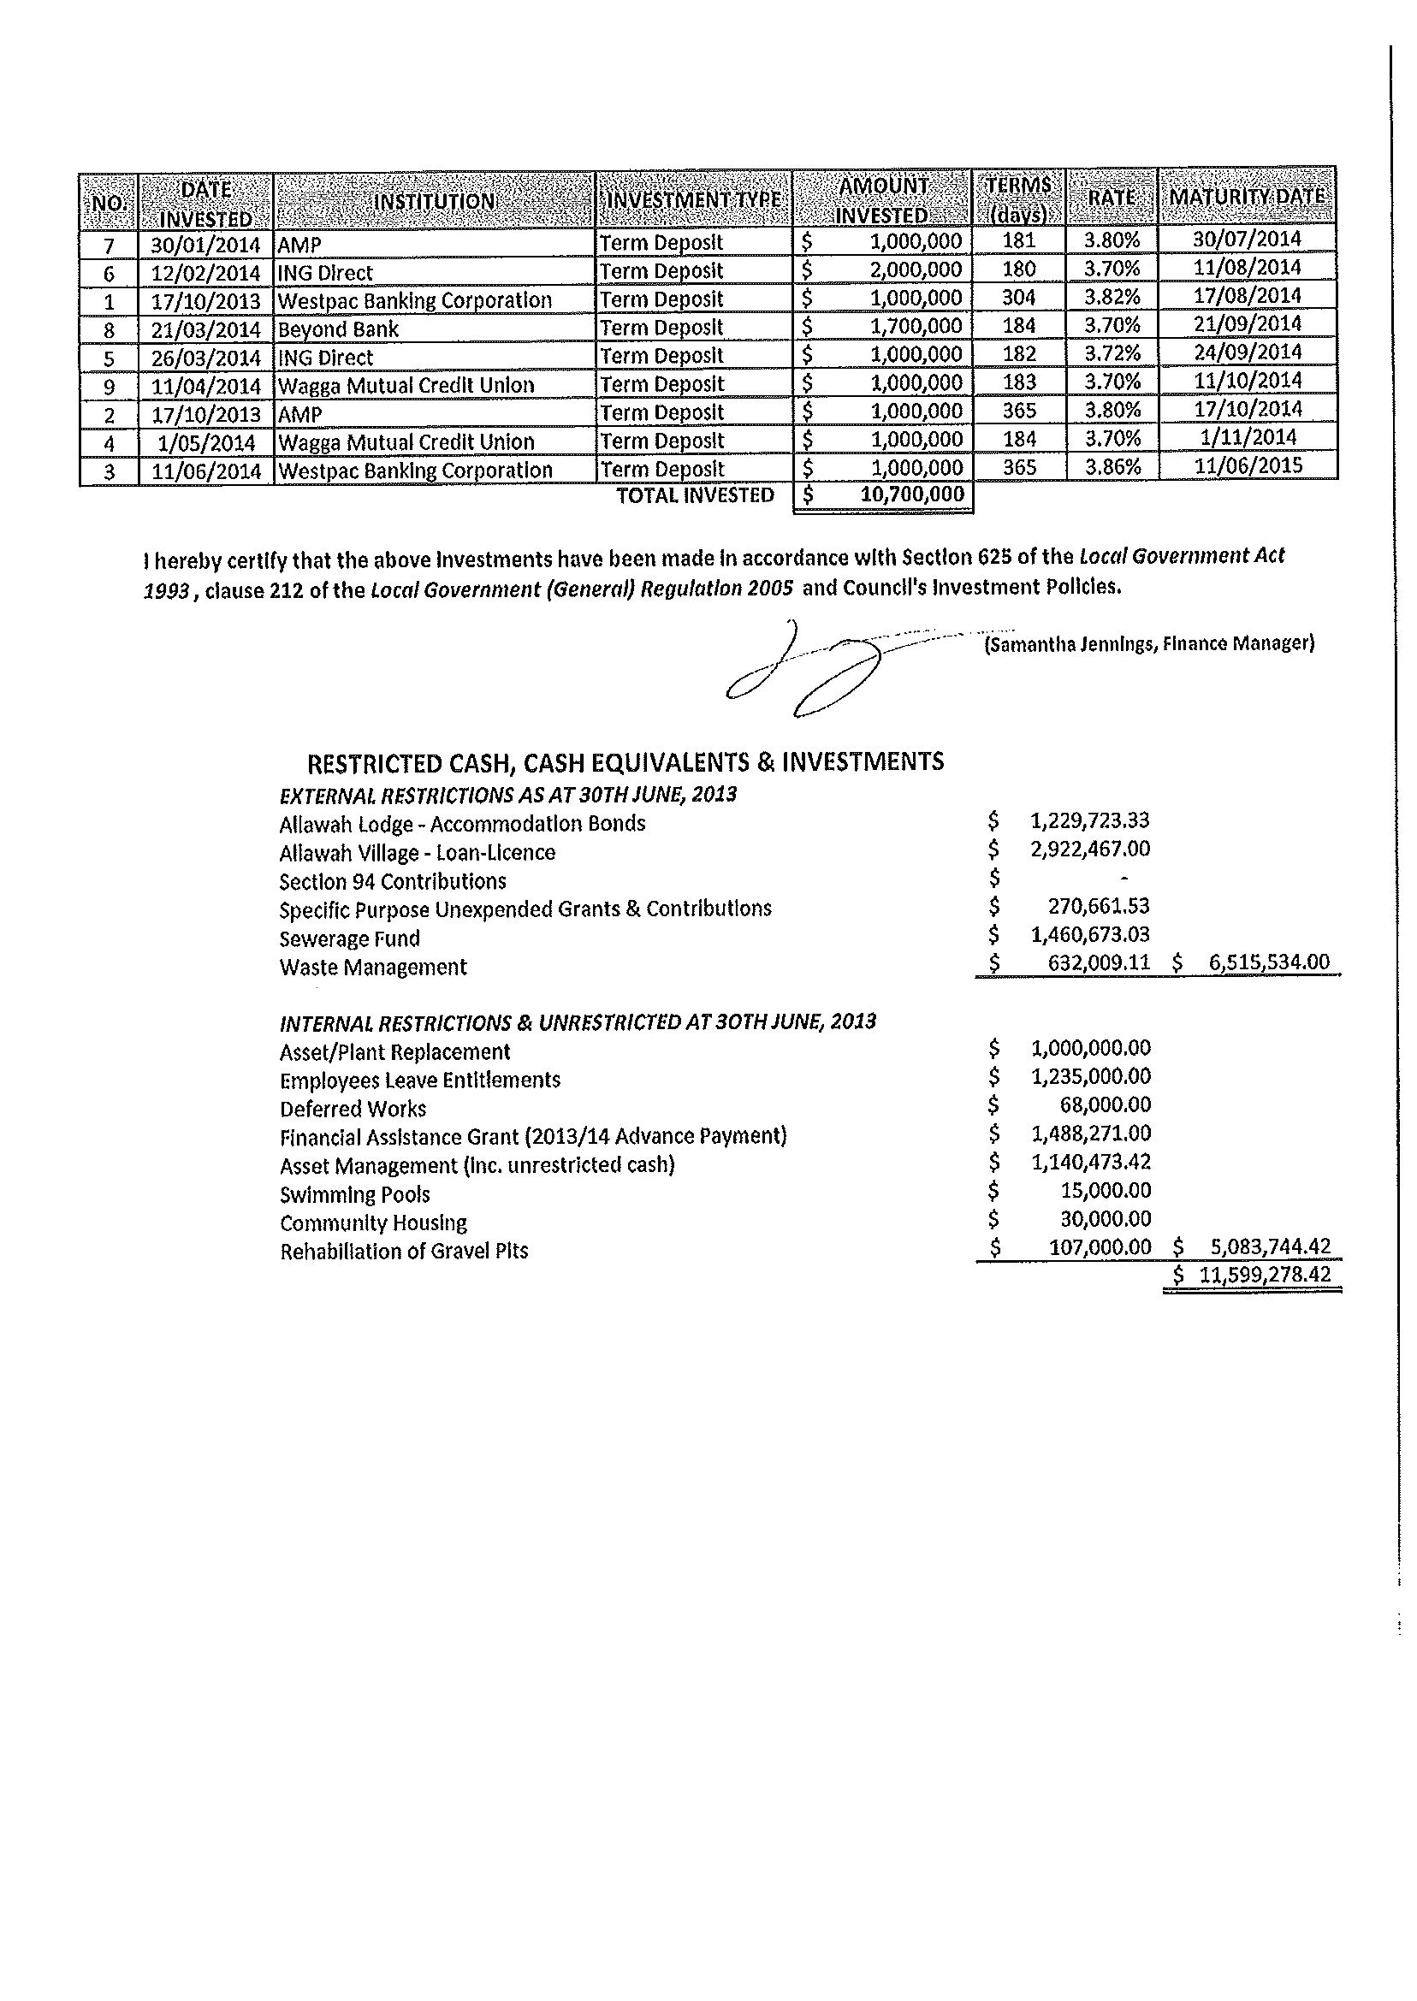
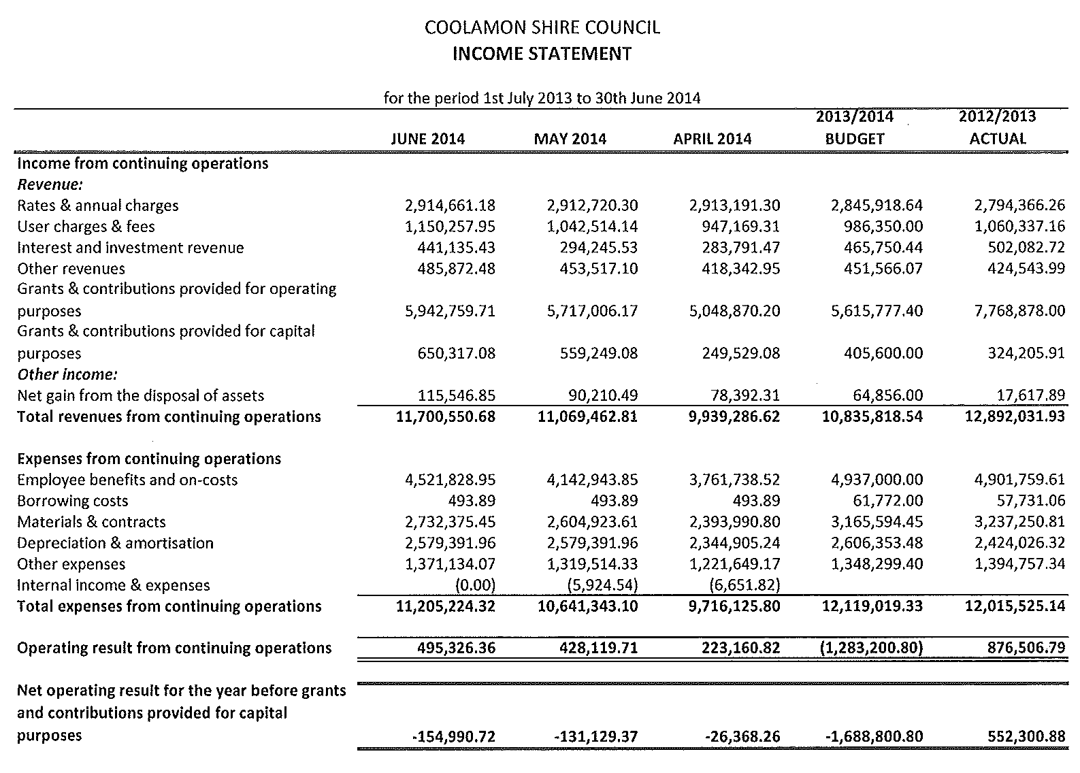
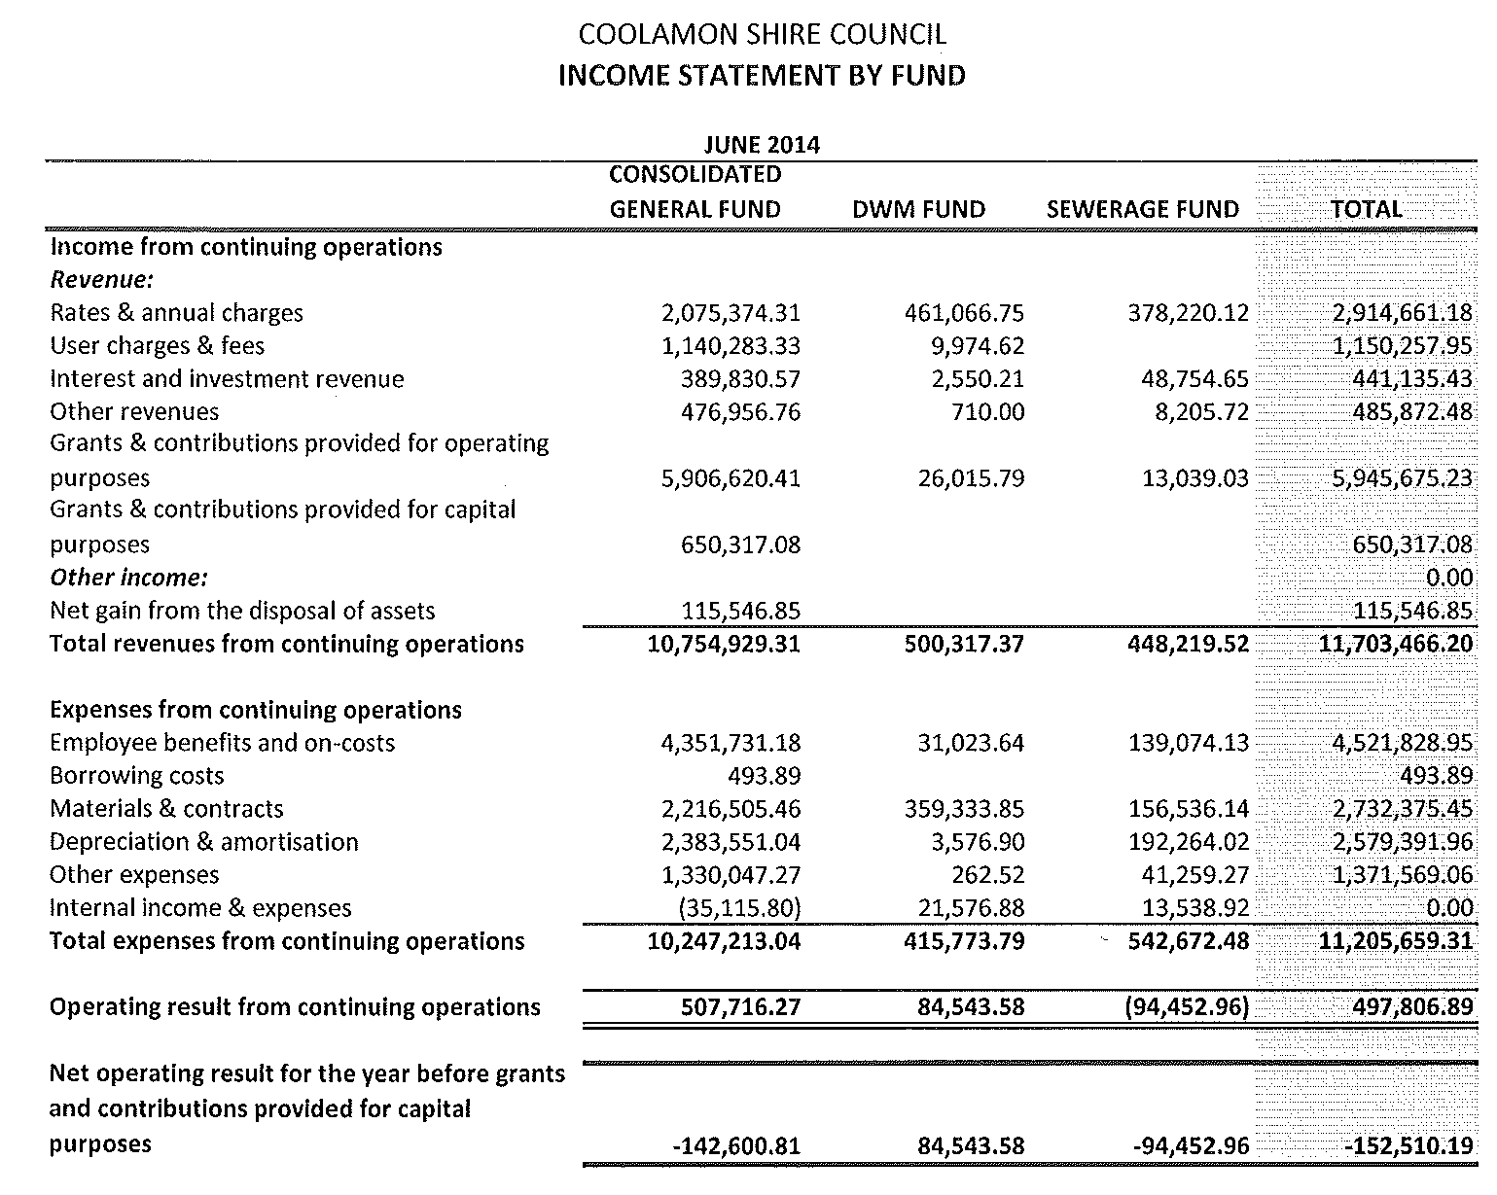
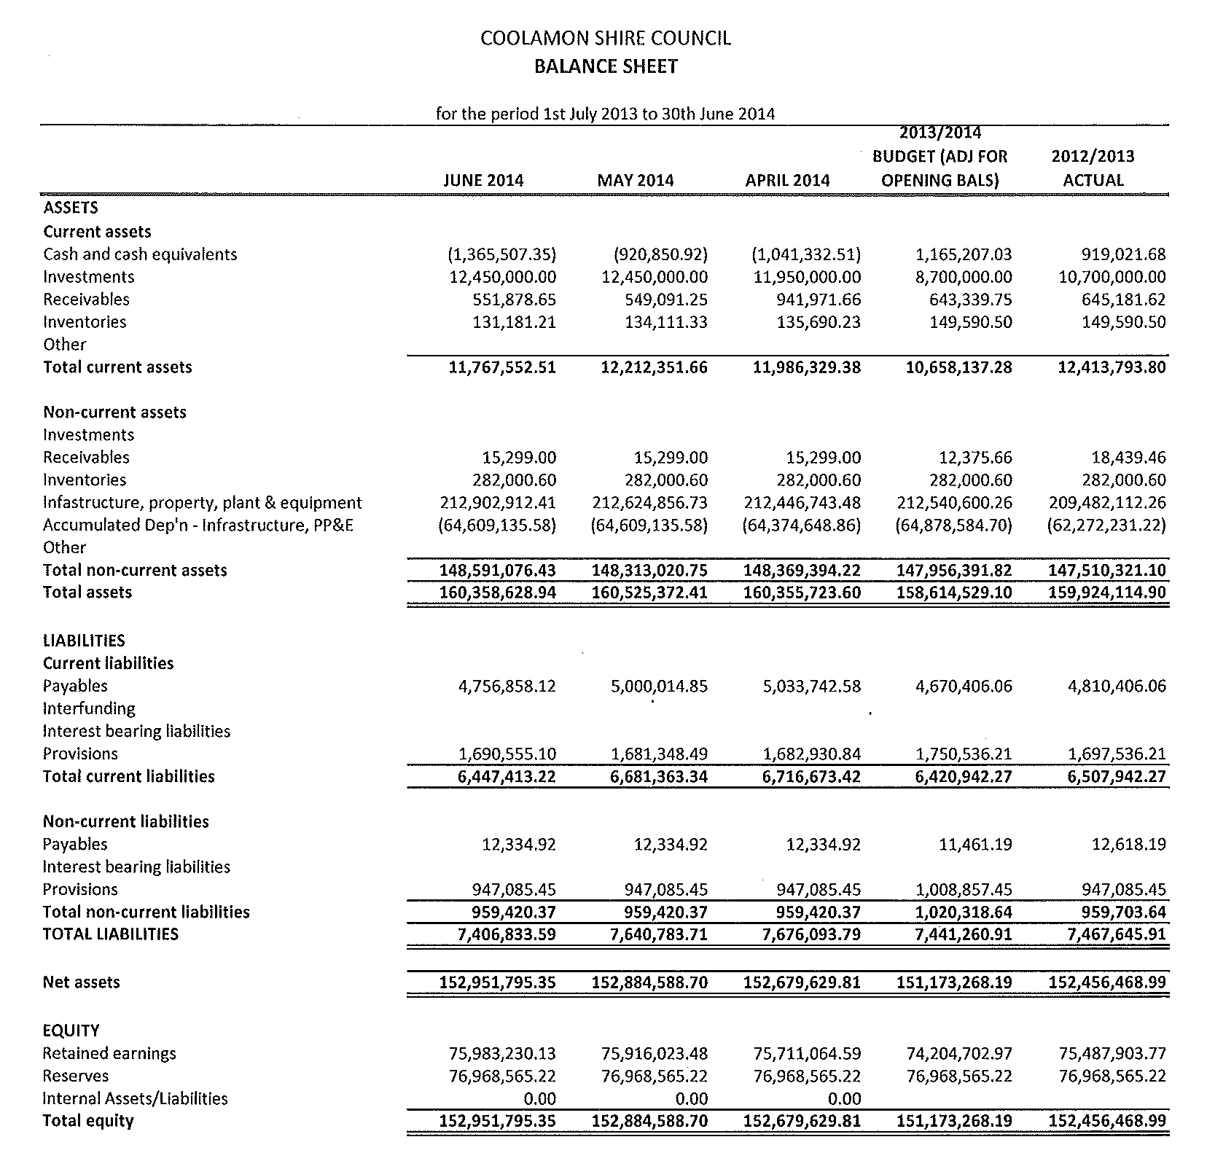
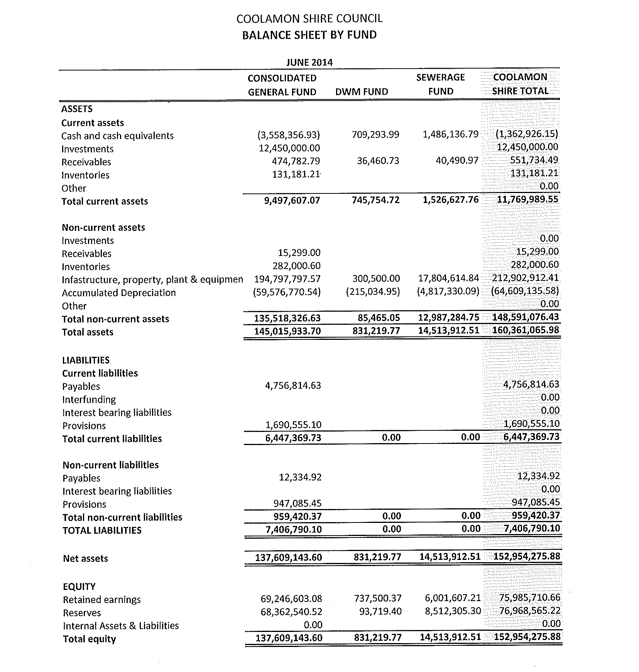
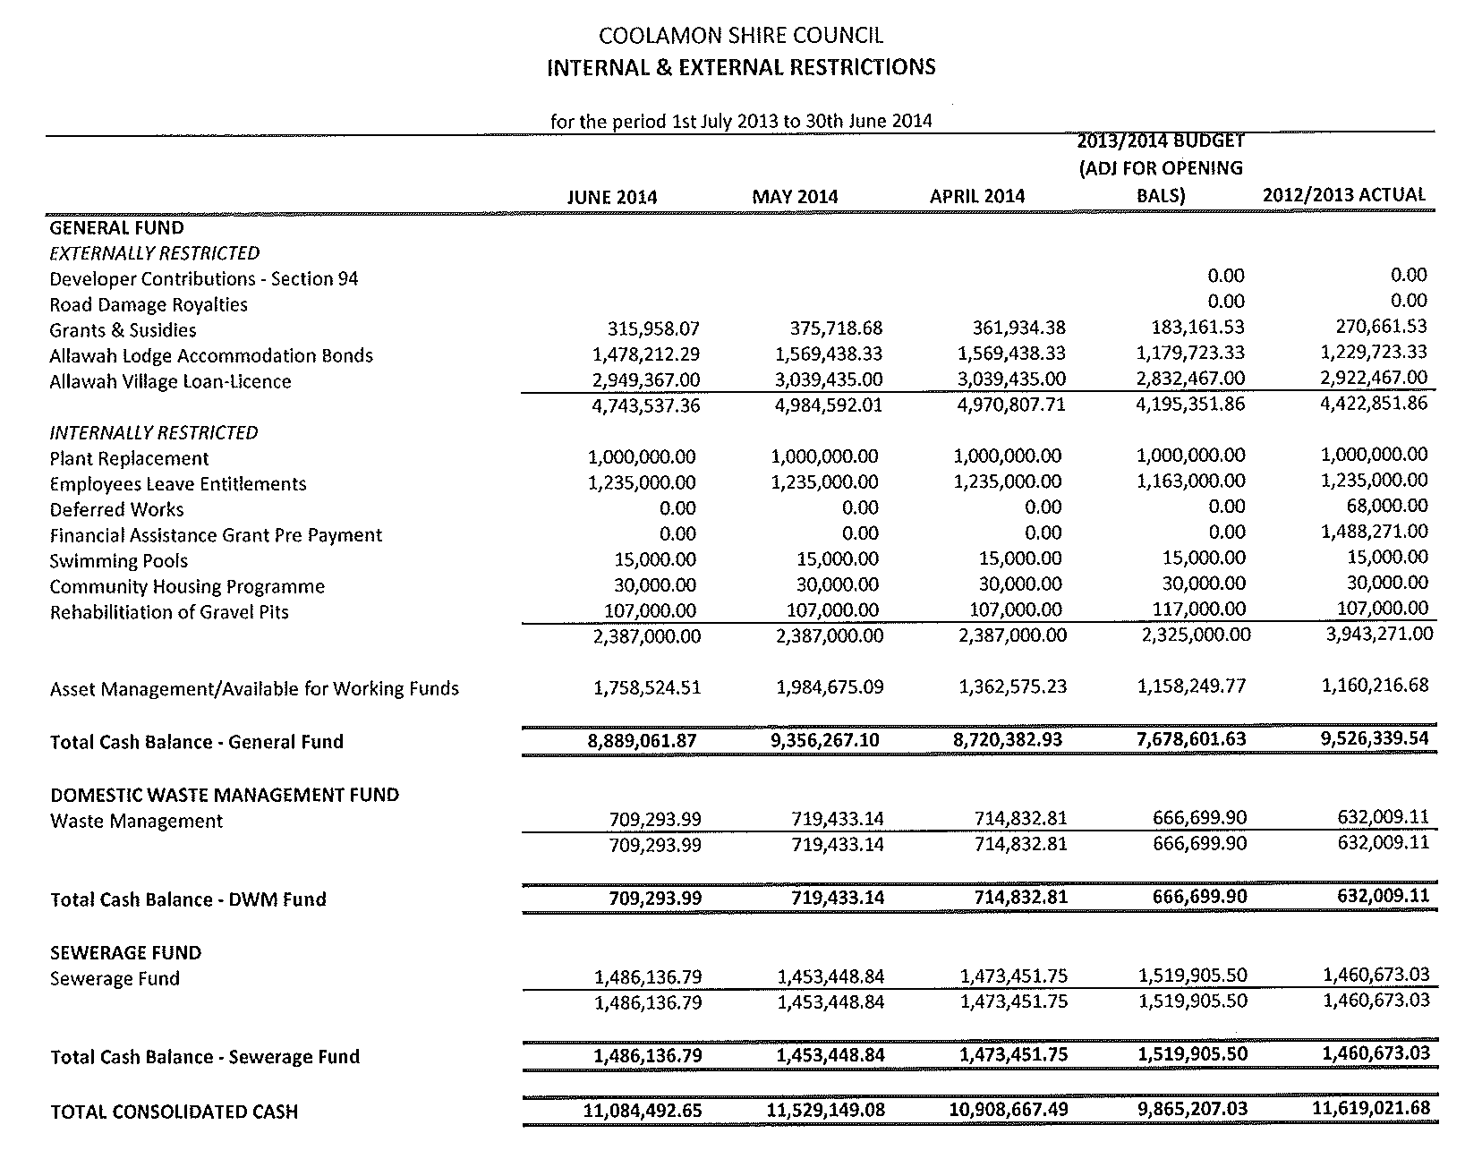
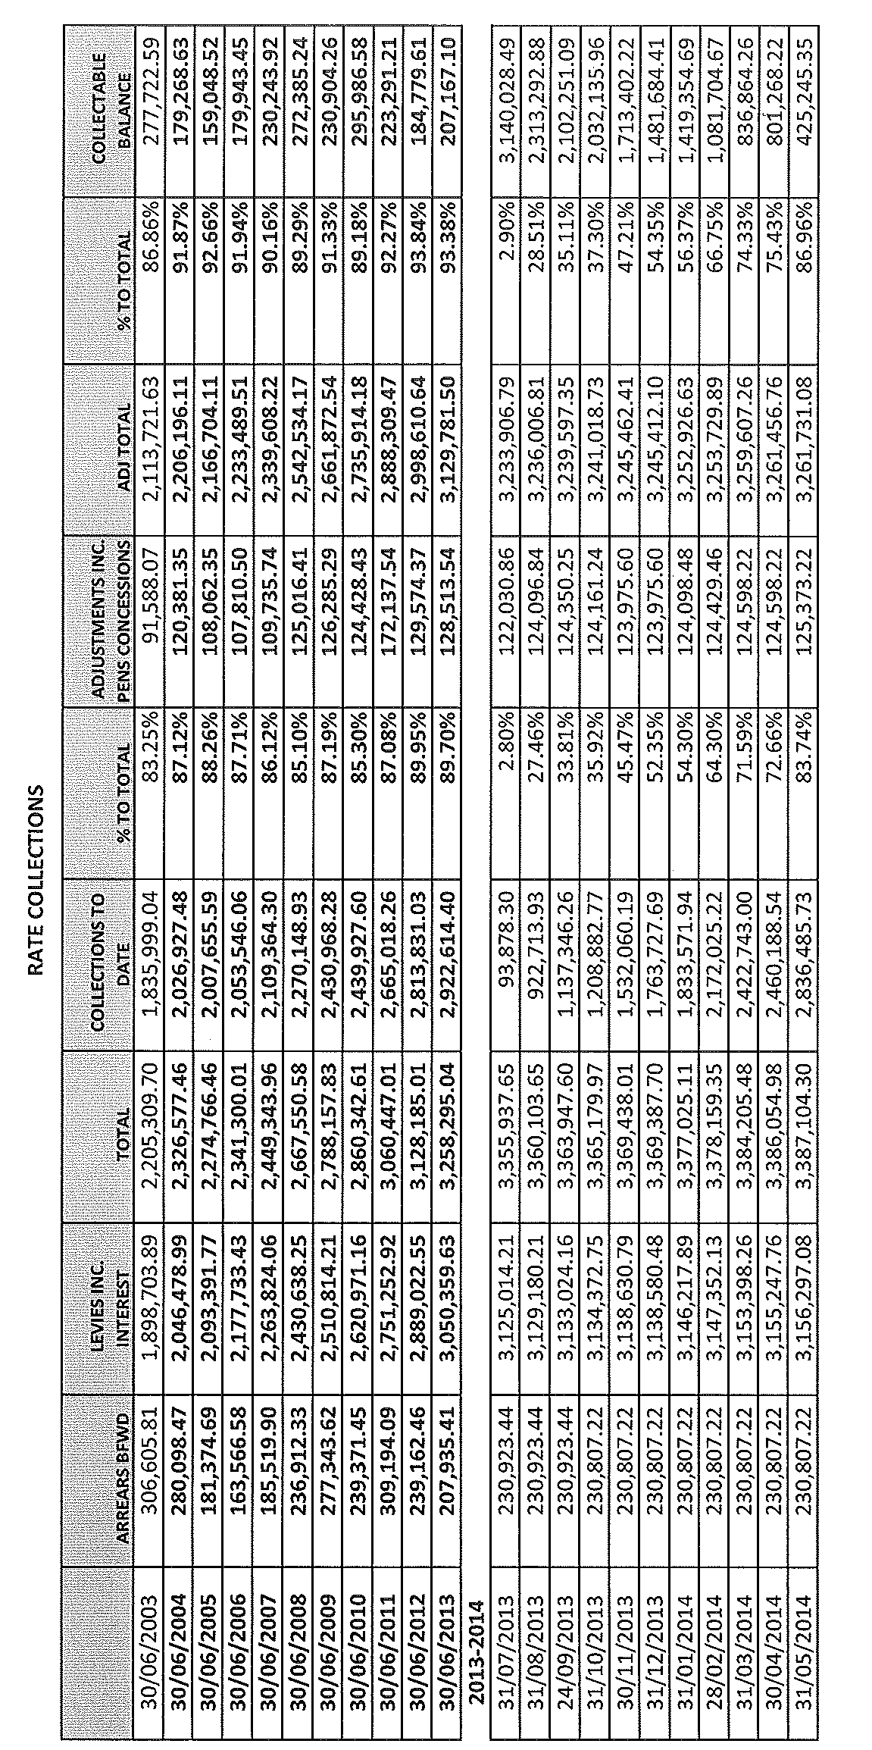
4.3 EXECUTIVE MANAGER, ENGINEERING & TECHNICAL SERVICES’ REPORTS

ES1) SHIRE ROAD RESHEETS, STABILISATION & MAINTENANCE

Since the last meeting the following roads have received maintenance and resheeting attention:

1) MAINTENANCE

- Murrell Creek Road (Pamandi Road to Ardlethan Road)
- Lawrences Lane (Berry Jerry Lane to Lynham Lane, patches)
- Uley Lane (Ardlethan Road to McDougalls Lane)
- Willows Road (SH17 to boundary)
- McDougalls Lane (Uley Lane to Irish Jims Lane)
- Litchfields Lane (SH17 to boundary)
- Seymours Lane (Johnsons Hill Lane to Berry Jerry Lane)
- Pamandi Road (Narrandera boundary)

2) RESHEETING

- Seymours Lane (Johnsons Hill Lane to Armstrongs Lane)

ES2) BOGGY CREEK, GANMAIN – POPLAR TREES (P.01-05)

➔ Following an investigation of Boggy Creek bridge by Integrity Testing in March 2012, Council has become aware of repairs required to the abutments. (See attached Executive Summary Point 3). Attachment No. 11.1

➔ Whilst Council can arrange for the repairs to be performed it may be prudent to determine the cause of the damage to avoid any future expensive repair costs. As can be seen from the attached report by Council’s Facilities Maintenance Officer and photos, a number of poplar trees are the cause of this damage and require removal. It is proposed that the first large poplar on the South/Eastern corner be retained with the other 2-3 poplars located on the same corner in the abutment be removed. Further monitoring of other trees located in the creek will require ongoing assessment. Attachment No. 11.2

Recommendation

For Council information.

ES3) PARKS & GARDENS REPORT (P.01-01)

Facilities Maintenance Officer Reports

PARKS AND GARDENS

- Staff have been concentrating on rose pruning throughout the Shire along with hedge trimming.

- Minor revegetation projects will be undertaken at several quarry sites over winter.

- Footpath Inspections – All defects identified in recent inspections have been rectified.

- Favourable Feedback has been received on the condition of the Jim Thompson Fields currently used by the local Soccer Team. Improvements scheduled for Spring on the fields include aeration, application of gypsum and continued control of kikuyu.

PROPERTY MAINTENANCE

- Unit 5, Kindra Lodge is currently being renovated to resolve issues relating to a lack of wet seal in the shower. The unit will be painted, have new carpet installed ready for a new tenant in late July.

- Other properties receiving attention include:

- Childcare Centre
- Allawah Lodge
- Shire Depot
- General Manager’s Office

- Maintenance staff are currently constructing a new toilet at Ganmain at the rear of Commins Hendriks, Solicitors which should be completed by late July/early August.

ES4) NOXIOUS WEEDS OFFICER’S REPORT (N.02-01)

Noxious Weeds Officer Reports

- Mapping continues throughout the three Shires. June has been characterised by many days where weed spraying has not been possible either from rain, wind or dew. Consequently, there is a backlog of spraying jobs to do. Fortunately plant growth has been reduced due to colder weather.

- Coolatai Grass is the main weed to feature in this report. Roadside outbreaks of the weed have been cut and bagged at Yathella Road, Pikedale Lane, Marrar Road, Whittackers Lane and Mirrool Road. In addition, Coolatai Grass has been sprayed on Waterworks Road and Bethungra Road.

- Coolatai Grass is due to be sprayed along the road from Old Junee to the Coolamon boundary and along the railway tracks. John Holland Rail was informed on 12 June 2014 of a large incursion of the weed 2km south of the Rockview crossing. Enquiries as to when these sites will be controlled was put at July but latest enquiries have blown out to at least three weeks after that which brings the time taken between advising John Holland Rail and the latest “probably” date at six weeks. This brings in the question of whether the Coolatai Grass will be sprayed before seed drop.

- Other work being undertaken includes spraying of African Boxthorn and Prickly Pear in various areas and mapping for the purpose of locating other noxious weeds for spraying. The spectrum of these is likely to increase as we approach the warmer months.

- Other weeds of note in this report include Johnson Grass and Wild Radish with both enjoying rapid growth with the earlier warm weather. Much of the Johnson Grass has been sprayed. Wild Radish, despite the fact that it is no longer a noxious weed, is still regarded by RENWA as a weed to be discouraged and landholders with it on their property are being asked to do something about it in the interest of neighbourly relations.

- RENWA staff assisted the running of an educational day put on by Goldenfields Water County Council (GWCC) at Temora on 23 June 2014. The day was part of a project being run by GWCC with the construction of a 500km tree corridor. Some 150 local primary school children attended and it was a great success.

- A number of meetings have been held aimed at introducing GPS mapping. This will provide benefits over the present system. This includes greater accuracy in siting weed outbreaks and more flexibility in using recorded information.

ES5) 2012 FLOOD REHABILITATION WORKS

Following the floods of February/March 2012 Council was able to obtain $2,017,388 in funding from the State Government to reinstate Council’s roads to pre-flood conditions. Council Staff have been able to complete these works internally without seeking contractor contribution with many of the staff making themselves available on weekends and working extended hours. Council can be satisfied with the results of the funding as evident on its Road Network.

Recommendation

For Council information.

RESOLVED on the motion of Clr Huxtable and seconded by Clr Hutcheon that the Executive Manager, Engineering & Technical Services Reports’ (ES1 to ES5) be noted. 178/07/2014

ES6) COMMUNITY SERVICE ORDERS SCHEME (C.08-01)

Council has been approached by Corrective Services NSW to inform it of the Community Service Orders Scheme. The Scheme provides Courts with a sentencing option that is usually an alternative to a period of imprisonment.

The programme encourages offenders to work in the community in order to make reparation for harm caused by their offending, and gives them an opportunity to utilise their skills, talents and interests and make constructive use of their leisure time.

What this means for Council is that they are provided staff to perform duties which would be considered part of a wish list, assist in providing services to various community groups or assist Council day labour staff in performing their duties where required.

It is proposed that the Scheme would provide a team with a maximum of 10 individuals, would provide one days service on a fortnightly basis and be supervised at all times by a Correctional Services provided Supervisor. Initial works that can be considered for application of the Scheme include:

- Tip surrounding cleaning
- Roadside verge cleaning
- Cemetery maintenance, (ie. monumental sections including Berry Jerry and Rannock Cemetery)
- Community Assistance Projects
- Drainage maintenance

Council does not intend to utilise the programme to replace duties existing staff are currently performing.

➔ Attached with the information papers is a guide explaining the programme. Attachment No. 12

Recommendation
For Council information.

RESOLVED on the motion of Clr Hutcheon and seconded by Clr Maslin that Council Officers proceed with discussions with Corrective Services NSW with an aim to utilise the Community Service Orders Scheme in the future. 179/07/2014

ES7) REGIONAL FREIGHT TRANSPORT PLAN (R.13-08)

■ The Regional Freight Transport Plan is a product of the REROC Infrastructure Committee which was one of many Committees which were developed as a result of the REROC Action Plan - Local Government Without Borders. A copy of the Plan is tabled for the Councillors information. Other Committees that were developed covered strategic themes such as:

- Resource Sharing
- Workforce Development
- Community Planning and Culture
- Economic Development
- Environment
- Advocacy and Lobbying

The Committee first met in May 2012, was chaired by the General Manager of Coolamon Shire Council and comprised mainly of Engineers from fellow REROC Councils with a total of 13 Committee Members. Additional input was sought from the key Industries and Transport holders such as:

- National Road Association,
- Vizy,
- Roads & Maritime Services, and
- Port of Melbourne
The overall aim of the project was to develop a regional approach to transporting planning whereby significant road and rail freight corridors were mapped and constraints on those corridors were identified. To prioritise the issues raised a weighted matrix was developed resulting in a set of goals and strategies being identified that will assist the region to realise its full potential in relation to the provision of freight transport solutions. To achieve the goals extensive mapping was required with the identification of the following:

- Roads – Federal, State, Regional and Local roads as well as B-Double Road Train 4.6 high and higher mass limit routes.

- Rail – Open and closed rail lines as well as freight only and passenger and freight lines.

- Model Points – Identifying silos, bunkers, abattoirs, forestry, feedlots, industry, airports, ethanol plants, quarries etc.

- Bridges – Bridges were identified as approved or unapproved for higher mass limit vehicles.

- Strategic Routes – Committee members identified strategic routes throughout their region.

- Route Constraints – From these strategic routes, route constrains were identified, route constraints included such issues as road geometry, road widths, low rail bridge over road, closed rail lines etc.

The Plan is seen as a very valuable tool for the region in campaigning and lobbying the government to provide funding and address specific issues which will facilitate the efficient and effective movement of freight within and through the region. The Plan fills the void noted in the NSW Government’s Long Term Master Plan in relation to identifying specific issues in the Riverina Region. It is thought to be the first plan of its kind in the state with RAMROC in the process of developing an identical plan for their region.

Recommendation

For Council endorsement.

RESOLVED on the motion of Clr McCann and seconded by Clr Maslin that Council endorse the Regional Freight Transport Plan as produced by the REROC Infrastructure Committee. 180/07/2014

ES8) 2014/2015 UNSEALED LOCAL ROADS – RESHEETS AND STABILISATON (S.11-06)

At the time of adopting Council’s Delivery Program 2014/2018 and Operational Plan 2014/2015 a detailed list of proposed works under the Unsealed Local Roads Resheet and Stabilisation Program was unable to be provided as a consequence of the ongoing maintenance provided under the Flood Rehabilitation Funding Program.

Council have now completed the Flood Rehabilitation Works and are now able to assess its Unsealed Road Network. An assessment of all Council unsealed roads has been performed, assessing the road condition against its hierarchical classification and provide the following list for consideration. Future consideration items are listed for future years or bought forward into the current year under the roads to Recovery Program if deemed suitable following harvest.

Recommendation

❐ That the attached list be adopted for gravel resheeting and stabilisation works in the Delivery Program 2014/2018 and Operational Plan 2014/2015.

RESOLVED on the motion of Clr Huxtable and seconded by Clr Maslin that the attached list be adopted for gravel resheeting and stabilisation works in the Delivery Program 2014/2018 and Operational Plan 2014/2015. 181/07/2014

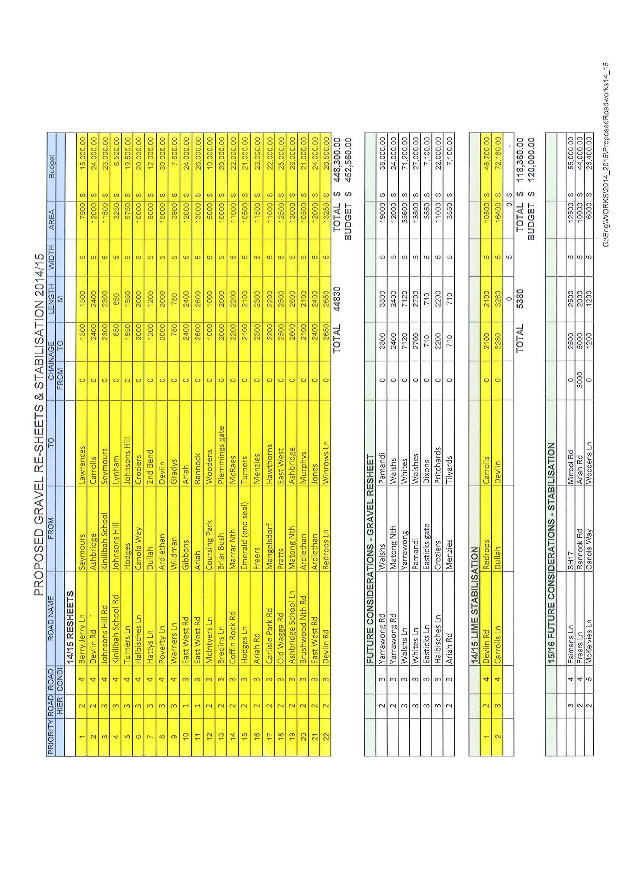
ES9) QUOTATION 2014/03 – INSITU PAVEMENT STABILISATION

❐ Quotations were called for the supply of Insitu Pavement Stabilisation for the year 2014/2015. A summary of the quotations is attached with this report.

Stabilised Pavements Australia (SPA) have provided the most financially beneficial quotation and have been Council’s Contractor for the last 17 years and have proved to be a reliable and efficient Contractor who works well with Council staff to a satisfactory standard.

Recommendation

That Council accepts the quotation from Stabilised Pavements of Australia for the 2014/2015 financial year.

RESOLVED on the motion of Clr Huxtable and seconded by Clr Logan that Council accepts the quotation from Stabilised Pavements of Australia for the 2014/2015 financial year. 182/07/2014

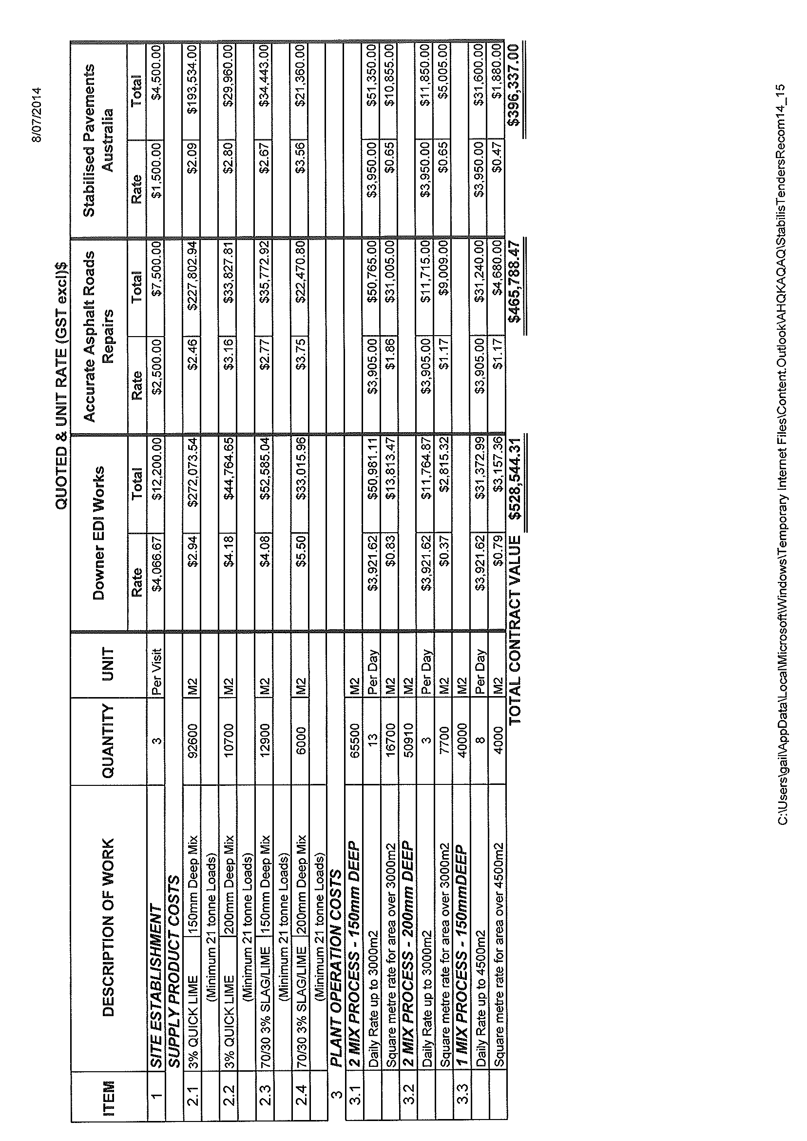
ES10) COOLAMON TENNIS COURTS (S.07-08)

Further investigation into power supply and associated costings have been finalised. (See table below). Unfortunately Essential Energy will not provide a second power source to the one parcel of land and Council have little alternative but to draw power from the Sports Club and install a second meter point at the new tennis courts. Contracts have estimated the works to cost an additional $20,000, bringing the total construction cost of the tennis courts to $273,800. With grants ($60,000) and Tennis Club contribution ($40,000), Councils resulting contribution is $173,800.

Recommendation
For Council information.

Item No | Works | Cost (GST Inc)
1 | Survey, Design & Legals | $ 5,000
2 | Site Preparation & Reinstatement (landscaping) | $ 5,000
3 | Tree Clearing | $ 1,800
4 | Drainage Diversion | $ 9,000
5 | Fencing (powder coated) | $ 36,000
6 | Lights | $ 17,000
7 | Light Poles | $ 13,000
8 | Electrical Works (Power board to Poles) | $ 10,000
9 | Electrical Works (Sports Club to Powerboard) | $ 20,000
10 | Base Construction | $ 49,000
11 | Synthetic Grass | $ 83,000
12 | Nets & Posts | $ 10,000
13 | Storage Shed | $ 15,000
 | Total Construction Cost | $ 273,800
 | PROJECT CONTRIBUTION
1 | Grant | $ 60,000
2 | Tennis Club Contribution | $ 40,000
3 | Council Contribution | $ 173,800

RESOLVED on the motion of Clr McCann and seconded by Clr White that Council provides a capped amount of $150,000 to the construction of the tennis courts. Construction costs above this will need to be funded by the Tennis Club or other parties. 183/07/2014
ES11) EXPRESSIONS OF INTEREST CALLED FOR FIXING COUNTRY ROADS (R.07-01)

➔ Council has received notification from Transport NSW advising funding of $37.5 Million in the New South Wales 2014-2015 Budget to “Fix Country Roads - Local Roads and Bridges”. A copy of the correspondence is attached with the information papers for Councillor’s information. Attachment No. 19

Expressions of interest are currently being sought by the NSW Government from Councils for eligible projects satisfying the following criteria:

1) Improved access and productivity.
2) Growth and economic benefits.
3) Strategic alignment and partnership.
4) Deliverability and Project readiness.

The following projects have been identified by Council for submission in the Expression of Interest period:

1) Hodges Lane Reconstruction – Access to Emerald Grain.
2) Easticks Lane Reconstruction – Removal of heavy vehicles from Webb Street, Marrar.
3) Canola Way Reconstruction – From Marrar town entrance to Marrar Cemetery.
4) Smokey Creek – Mary Gilmore Way bridge assessment.
5) Bygoo Road – Structural assessment of culverts and pavement.
6) Matong North Road Reconstruction (0.3-0.8kms from Canola Way).

The closing date for Expressions of Interest is 4th August, 2014.

Recommendation
For Council consideration.

RESOLVED on the motion of Clr Huxtable and seconded by Clr White that the following projects be submitted for the Expression of Interest: 184/07/2014

1) Hodges Lane Reconstruction – Access to Emerald Grain.
2) Easticks Lane Reconstruction – Removal of heavy vehicles from Webb Street, Marrar.
3) Canola Way Reconstruction – From Marrar town entrance to Marrar Cemetery.
4) Smokey Creek – Mary Gilmore Way bridge assessment.
5) Bygoo Road – Structural assessment of culverts and pavement.
6) Matong North Road Reconstruction (0.3-0.8kms from Canola Way).
4.4 MANAGER, PLANNING & ENVIRONMENTAL SERVICES’ REPORTS

HS1) DEVELOPMENT APPLICATIONS (B.05-01)

The following applications have been approved:-

DEVELOPMENT APPLICATIONS

21/2014 53//750819 – 668 Pamandi Road, Matong – Dwelling.
22/2014 5//1076678 – 23 Curtis Lane, Coolamon – Swimming Pool.
23/2014 28//750846 – 89 Campbells Lane, Coolamon – New Dwelling/Demolish & Remove Old House.
24/2014 11//1158604 – Rannock Road, Coolamon - Transportable Dwelling.

COMPLYING DEVELOPMENT CONSENT

2011/07 C//394678 – 21 Waterview Street, Ganmain – Alterations & Additions to Dwelling.

Recommendation

For Council information.

RESOLVED on the motion of Clr White and seconded by Clr Maslin that the report be received. 185/07/2014

HS2) BUILDING ENTITLEMENT – LESTERFIELD LANE, COOLAMON - LOT 35, DP 750829 (PF 238/115)

Council has received a written request to erect a dwelling on the above mentioned property.

➔ A copy of the letter has been attached. Attachment No. 13

This property was subject to a Development Approval granted by Council on 11 August 2008 (DA 21/2008). This consent lapsed on the 11 August 2013. There was no substantial commencement of this approval.

In accordance with Clause 4.2B of the Coolamon Local Environmental Plan 2011 the following applies:

(3) Development consent must not be granted to the erection of a dwelling house on land to which this clause applies, and on which no dwelling house has been erected, unless the land is:

(a) a lot that is at least the minimum lot size specified for that land by the Lot Size Map, or

(b) a lot created before this Plan commenced and on which the erection of a dwelling house was permissible immediately before that commencement, or

(c) a lot resulting from a subdivision for which development consent (or equivalent) was granted before this Plan commenced and on which the erection of a dwelling house would have been permissible if the plan of subdivision had been registered before that commencement, or

(d) an existing holding.

History

In 1995 this property was part of an existing holding that also included Lots 27, 29 & 34 in Parish of Coolamon and Part 32 in Parish of Derry. In 1996 a development application was approved to create a house lot on Lot 34 with an existing dilapidated mud brick/pisi dwelling. In 1997 a house was approved on Lot 34, to replace the old cottage and this left Lots 27, 29 and 35 as an existing consolidation for rating purposes.

At this point in time a dwelling was permitted upon one of the 3 lots, as the combined area of all three combined was in excess of 200 hectares and held under the one ownership. Subsequently consent was given in 2008 (DA21/2008) to allow a dwelling on Lot 35. This consent therefore extinguished the allowance of a dwelling on Lots 27 and 29.

Also in 2008, the rating consolidation was split upon the sale of the property. Lots 27 and 29 were purchased together, whilst the subject Lot 35 was purchased separately with a valid development consent for a dwelling.

Application of LEP

The subject land is 64.75 hectares and therefore in accordance with Clause (a) is under the size specified that permits a dwelling entitlement.

The subject lot has never been subjected to a subdivision or boundary adjustment, therefore Clause (c) does not apply.

Because the land parcels were subject to a split in 1996, Lot 35 is not considered an existing holding in accordance with Clause (d) of the LEP.

The important statement is therefore found within Clause (b), specifically the terms “permissible immediately before that commencement”. A reasonable interpretation of Clause (b) would imply that if a dwelling house would have been permissible immediately before the new plan, then a dwelling right exists.

In this instance the right to erect a dwelling upon the land was confirmed by the Development Approval in 2008. This statement therefore suggests that a dwelling was permissible immediately prior to the gazettal date of the current LEP.

In this case, Council should consider the consequences of this interpretation (as well as its opposite), together with the possible outcomes of such assessments. These are:

- Should Council consider that a house right exists then the new owner of the land, who has bought the property in good faith, will continue to build a dwelling as planned (subject to obtaining the necessary consents and the provision of appropriate infrastructure).

- Should Council refuse any house right it may be subject to legal action. While not shying away from such a proposition, such an uncertain assessment from Council Officers means that Council’s position cannot be legally guaranteed in this regard.

From a practical planning and commonsense point of view, this land is prime agricultural land that was previously granted a dwelling entitlement as it met the intention of the LEP at the time. The land size is such that there will be little to no detrimental effect in amenity, neighbours and/or agricultural production. The surrounding land is broadacre agriculture with sparsely located rural dwellings, similar to this proposal.

Summary

On the weight of all probabilities it is thought acceptable that the dwelling entitlement that existed at the time of the LEP’s gazettal (in the form of a Development Consent) will allow Council to assess and approve a dwelling entitlement if received by way of a formal Development Application.

The Development Application process will also ensure that any proposed dwelling complies with the requirements of the Building Code of Australia, that appropriate infrastructure is provided and that the adequate treatment and disposal of effluent is achieved.

Recommendation

1) That Council respond to the applicant advising that any formal assessment and subsequent approval would be solely reliant upon the submission of a Development Application; and

2) That Council delegate the assessment of any application received proposing a dwelling on Lot 35, DP 750829 to the General Manager.

RESOLVED on the motion of Clr Hutcheon and seconded by Clr White that: 186/07/2014

1) Council respond to the applicant advising that any formal assessment would be solely reliant upon the submission of a Development Application; and

2) Council delegate the assessment of any application received proposing a dwelling on Lot 35, DP 750829 to the General Manager.

HS3) GANMAIN AGED UNITS (A.05-07)

Following recent Council discussion, staff have engaged the services of an architect to design a concept for the provision of 4 aged units in Ganmain behind the Ford Street business area.

➔ A copy of the plans have been attached. Attachment No. 14

The plans have been provided to Councillors for discussion with a view of further advancing the concept in consultation with the Ganmain community.

Further work is being undertaken by an independent planning consultant in preparation for the potential subdivision of this land from the land used to build the previous 2 low-care aged units in 2012.

Recommendation

For Council discussion.

RESOLVED on the motion of Clr White and seconded by Clr Beard that: 187/07/2014

1) Council Officers undertake discussions with the Community of Ganmain to investigate the current support for low income aged units in Ganmain.

2) Council discuss with the current resident of the Ganmain Retirement Unit as to her interest in purchasing or otherwise the unit she resides in.

HS4) TRAFFIC ROUTE LIGHTING SUBSIDY SCHEME FOR 2013/2014 (S.14-01)

Advice has recently been received from the NSW Roads & Maritime Services (RMS) notifying Council that it has been successful in receiving a $16,000 subsidy for streetlighting on State roads.

Council Staff have previously been unaware of the existence of such a subsidy and it therefore came as a surprise when the notification was received. When contacted about the payment, a spokesman for RMS advised that a thorough review was undertaken on the Traffic Route Lighting Subsidy Scheme in February 2013. This review highlighted that many Councils were not taking advantage of the Scheme and likewise many Councils were being oversubsidised.

The funds received by Council were a result of the allocation for the 2013/2014 financial year. Discussions with RMS indicate that a similar figure can be expected for the current 2014/2015 financial year. These details are currently being finalised by the RMS and as such will be made available to Council once completed.

➔ A copy of the correspondence received from the NSW RMS has been attached for Councillor’s information. Attachment No. 17

Recommendation

For Council information.

HS5) STREETLIGHTING ENERGY CONTRACT (S.14-01)

➔ Under the umbrella of Local Government Procurement, Council along with 45 other New South Wales Councils and 3 Not-for-Profit Organisations have taken part in a tender for the provision of streetlighting energy. Recommendations from the tender were provided to staff earlier this week. The nature of electricity prices has meant that a short turnaround time was required between receiving the recommendation and Council entering into a Contract. The proposed pricing to which Council will be contracted is for a period of 40 months. A copy of the Summary Report and Overall Evaluation and Analysis Report have been attached for the information of Councillors. Attachment No. 18

The Contract relates only to energy pricing and does not have a bearing on network charges.

Prior to accepting the proposed new pricing structure, Council staff undertook a comparison of its current streetlighting charges compared to the new charges, details of this comparison have been provided in the table below. Based on Council’s latest streetlighting bill (June 2014) Council stands to save in the order of $321.60 per month on streetlighting charges. This potentially equates to a saving of $3,859.17 over a twelve month period.

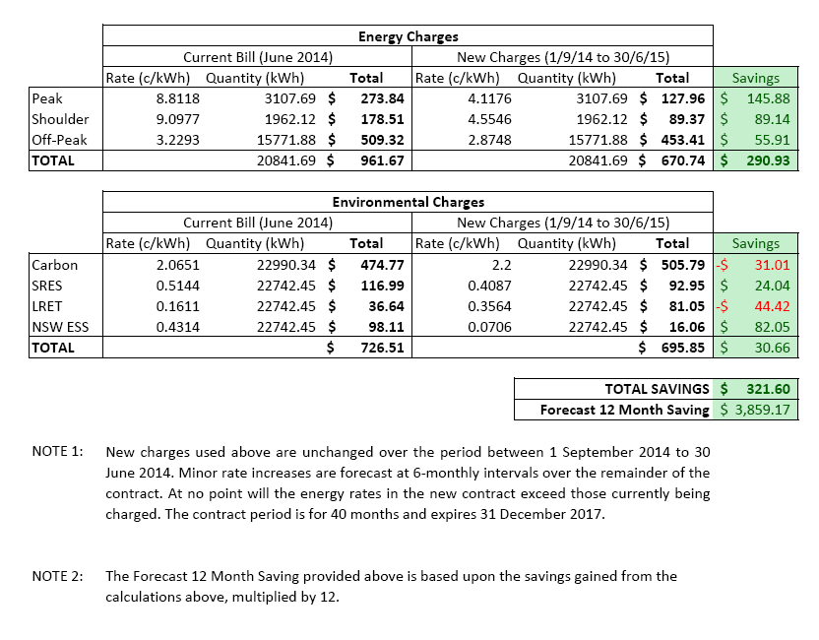

Recommendation
For Council information.

RESOLVED on the motion of Clr McCann and seconded by Clr Maslin that (HS4 and HS5) be noted. 188/07/2014
5) RECOMMENDATIONS OF THE STAFF COMMITTEE MEETING HELD 17TH JULY, 2014.

RESOLVED on the motion of Clr McCann and seconded by Clr Beard that the Recommendations of the Staff Committee Meeting held 17th July, 2014 be adopted. 189/07/2014

6) REPORTS: DELEGATES/MAYOR/COUNCILLORS

There were no Reports.

Meeting Closed at 5.00pm.

Confirmed and signed during the Meeting held this 21st day of August, 2014.

......................................................
MAYOR

