Meeting commenced at 2.00pm.

BUSINESS:

1) Apologies

2) a. Confirmation of Minutes of the Meeting held 19th February, 2015.
b. Matters arising out of Minutes. (Not elsewhere reported)

3) Correspondence
a. Agenda A (Information Only)
b. Agenda B

4) General Manager’s Report
4.1 General Manager’s Report
4.2 Executive Manager, Corporate & Community Services’ Report
4.3 Executive Manager, Engineering & Technical Services’ Report
4.4 Manager, Planning & Environmental Services’ Report

5) Reports: Delegates/Mayor/Councillors.

6) Recommendations of the Noxious Weeds Meeting of Coolamon, Junee & Temora held 24th February, 2015.

PRESENT: Clrs Seymour (Chairman), Hutcheon, Huxtable, McCann, Logan, Brill, Beard and Maslin.

STAFF: General Manager; Executive Manager, Corporate & Community Services; Executive Manager, Engineering & Technical Services; Finance Manager; and Manager, Planning & Environmental Services.

APOLOGY: Clr White.

1) APOLOGY

RESOLVED on the motion of Clr Hutcheon and seconded by Clr Maslin that the apology of Clr White be accepted. 35/03/2015

2a) CONFIRMATION OF MINUTES OF THE MEETING HELD 19TH FEBRUARY, 2015.

RESOLVED on the motion of Clr Brill and seconded by Clr Huxtable that the Minutes of the Meeting held 19th February, 2015 as circulated be confirmed and adopted. 36/03/2015

2b) MATTERS ARISING OUT OF THE MINUTES
There were no matters arising out of the Minutes.

3. CORRESPONDENCE

AGENDA A (FOR INFORMATION ONLY)

1a) INFORMATION PAPERS

➔ The following papers have been distributed with Council’s supplementary material as being matters of information/interest to Councillors. If Councillors desire any further information on the matters distributed then that can be raised with the General Manager. Attachment No. 1

1) NSW Shires Association Weekly Circulars 6, 7, 8, 9 and 10.

2) Minutes of the Friends of the Up-to-Date Cultural Precinct Meeting held 2nd March, 2015.

3) Minutes of the Advance Ganmain Committee Meeting held 17th February, 2015.

4) Issue 11 – Fit for the Future Newsletter.

5) A message from Keith Rhoades, President, Local Government NSW regarding State Election Priorities.

2a) ACTIVITY REPORTS

1) Coolamon Shire Multi Service Outlet Coordinator’s Monthly Report for the month of February 2015.

2) Operating Statistics of the Coolamon Shire Library for February 2015.
3) Tourism & Business Development Monthly Update for February 2015.

General Manager’s Note

The above reports are operating reports only for use by Senior Staff. They are submitted to Council as part of Agenda A for information only. Attachment No. 2

3a) NSW RURAL FIRE SERVICE (F.03-02, SC179)

Enclosing a copy of the publication titled “Every Day” that has been produced by the Australasian Fire and Emergency Service Authorities Council. The publication showcases the extraordinary work of fire and emergency service personnel across the country in protecting and servicing their local communities.
General Manager’s Note

■ A copy of the publication has been tabled for the information of Councillors.

RESOLVED on the motion of Clr Beard and seconded by Clr McCann that the Correspondence listed in Agenda A be received. 37/03/2015

AGENDA B

1b) HON KATRINA HODGKINSON MP (P.06-01, SC310)

With the impending State Election the Mayor has written to the current representatives of both the Government and Opposition that will be contesting the new seat of Cootamundra which Coolamon Shire Council has been included in.

The Country Labour Party Member, Mr Charlie Sheen attended Council to meet with the General Manager and Mayor and discuss the topics identified in Katrina Hodgkinson’s response.

General Manager’s Note

➔ The information received from Katrina Hodgkinson has been provided for your information. Attachment No. 3

RESOLVED on the motion of Clr McCann and seconded by Clr Hutcheon that the letter be received. 38/03/2015

2b) LOCAL GOVERNMENT REMUNERATION TRIBUNAL (C.12-03, SC146)

Advising that the Local Government Remuneration Tribunal has commenced its review for the 2015 annual determination.

General Manager’s Note

➔ A copy of the letter has been distributed with Councillor’s information papers. Attachment No. 4

RESOLVED on the motion of Clr Maslin and seconded by Clr Brill that the letter be received. 39/03/2015

3b) CHARLIE SHEAHAN, COUNTRY LABOR CANDIDATE FOR COOTAMUNDRA (H.03-03, SC225)

Forwarding a Press Release announcing that a Foley Labor Government will recruit an additional 500 paramedics and increase ambulance resources.

General Manager’s Note

➔ A copy of the Press Release and a copy of the letter to the Hon Luke Foley MLC has been distributed with the information papers. Attachment No. 15

RESOLVED on the motion of Clr McCann and seconded by Clr Maslin that the letter be received. 40/03/2015

4. GENERAL MANAGER’S REPORT

4.1 GENERAL MANAGER REPORTS

GM1) AUSTRALIA DAY CEREMONIES (A.13-01, SC38)

The Advance Marrar Committee has responded to Council’s offer to hold the 2016 Australia Day Ceremony and they have advised that they would be pleased to conduct the celebration.

Bronwyn Hatty will now liaise with the Committee to ensure that all will run smoothly.

➔ In addition, I have attached a draft Itinerary for future Australia Day Ceremonies. In developing this Itinerary it was attempted to give all communities access to the event and that it alternate as best as possible between North and South. Attachment No. 5

It is acknowledged that this is not held in stone but more a guideline.

Recommendation

For Council information.

RESOLVED on the motion of Clr Huxtable and seconded by Clr McCann that the report be received. 41/03/2015

GM2) AMBULANCE SERVICES – COOLAMON SHIRE COUNCIL (H.03-03, SC225)

Council will no doubt be aware that the Minister for Health, Jillian Skinner has issued a Media Release indicating:

- That a new Ambulance Station has been promised for the township of Coolamon.

- That the existing Ambulance Services provided at Ardlethan will be retained with minor capital upgrades.

This promise has been tied to the Baird Government being re-elected and subject to community endorsement.

➔ I have attached the Media Release for your information. Attachment No. 6

Council welcomes this announcement and congratulates the community on the hard work undertaken to push for this outcome.

Recommendation

For Council information.

RESOLVED on the motion of Clr Beard and seconded by Clr Huxtable that the report be received. 42/03/2015

GM3) ELECTRICITY UTILITY PROVIDERS (E.02-01, SC520)

➔ Information has been received from the Mayor of Wingecarribee Shire Council seeking Council’s support in ensuring that any leasing or privatisation of the power infrastructure is carried out in such a manner as to ensure that the safety and appearance of this infrastructure and asset protection requirements are agreed to. A copy of the correspondence has been attached to the information papers. Attachment No. 7

Recommendation

For Council information.

RESOLVED on the motion of Clr Hutcheon and seconded by Clr McCann that the report be received. 43/03/2015

GM4) RURAL FIRE SERVICE (F.03-11, SC459)

➔ Further to Council continuing its push for a review of the financial management of the Rural Fire Service, Council has now received correspondence from both Adrian Piccoli, the current Member for Murrumbidgee and Katrina Hodgkinson, the Nationals Candidate for the new seat of Cootamundra. A copy of their correspondence has been provided. Attachment No. 8

The response from the Minister is identical and very generic. Whilst it explains the current process it does not really address the issues raised by Council.

It should be noted that REROC have also taken on board the issue of an RFS review and will be calling for a similar review of the financial model that currently exists.

Recommendation

For Council information.

RESOLVED on the motion of Clr Brill and seconded by Clr Beard that the report be received. 44/03/2015

GM5) ALLAWAH LODGE PIANO (A.05-02, SC7)

➔ A request has been received from Ian McLean requesting that Council purchase a new piano for the residents of Allawah Lodge. (See Attachments). Attachment No. 9

In discussions with the Manager of the Allawah facility, she advised that she had not received any comment from staff or volunteers about the piano. In addition, residents hold regular meetings and this issue has never been raised.

It should be noted that at least two other people make themselves available to play the piano for the elderly and no requests have been received from them.

Preliminary cost estimates would be around $2,000 for a secondhand upright piano or upwards of $4,500 for a new one. There are now available digital pianos that are cheaper than the conventional piano.

Whilst it may be of benefit to those individuals using the piano, it is thought that finances could be used more wisely when providing facilities to the Allawah residents.

Recommendation

That the request be noted.

RESOLVED on the motion of Clr Hutcheon and seconded by Clr Maslin: 45/03/2015

1) That Clr Maslin and Clr Logan investigate the availability and suitability of a secondhand piano.

2) That Staff source prices for an electronic piano.

3) That Staff to seek funding from Service Clubs and the Residents.

GM6) FIT FOR THE FUTURE (L.05-05, SC275)

As identified at the last Meeting, Council’s Senior Staff and the Mayor will be attending the Advance Committee Meetings of the individual communities within the Shire.

At these meetings discussions will be held around the current Local Government Reforms and the Communities opinions in this regard. To support this consultation phase, Council will be developing a Survey that can be completed by individuals electronically on the Survey Monkey host site. In addition, Survey forms will also be provided to allow individuals to fill out these forms and return them. A copy of this proposed Survey will be provided as a late attachment on Meeting day.

Councillors are encouraged to attend the meetings within their communities and the dates as received presently are set out below:

Community | Date | Time | Venue
Ardlethan | Monday, 13 April 2015 | 7.30pm | Ardlethan Hall
Marrar | Tuesday, 14 April, 2015 | 7.30pm | Marrar Hall
Ganmain | Wednesday, 22 April, 2015 | 7.00pm | Ganmain Hall

Recommendation

That Council develops a Survey to gain an understanding of the Community’s thoughts on the matter of Local Government Reform.

RESOLVED on the motion of Clr McCann and seconded by Clr Logan that Council develops a Survey to gain an understanding of the Community’s thoughts on the matter of Local Government Reform. 46/03/2015

GM7) HEAVY VEHICLE NATIONAL LAW (R.09-05, SC339)

Coolamon Shire Council has been advised by the Roads & Maritime Service that delegation has been granted for the relevant Road Managers to issue exemptions by permit under the Heavy Vehicle National Law. This delegation has been renewed for a further twelve months whilst the NHVR develops a new Permit Management System.

➔ In accordance with the Local Government Act this delegation is granted to the General Manager who can delegate this to the most appropriate person and in this case being the Engineer. A copy of the delegation has been provided with the information papers. Attachment No. 10
Recommendation

That Council delegates to the General Manager the power to:

1) Issue permits directly to heavy vehicle operators for journeys by these vehicles within their Local Government Area of Coolamon Shire Council.

2) Charge $70.00 for the issue of such a permit.

RESOLVED on the motion of Clr McCann and seconded by Clr Brill that Council delegates to the General Manager the power to: 47/03/2015

1) Issue permits directly to heavy vehicle operators for journeys by these vehicles within their Local Government Area of Coolamon Shire Council.

2) Charge $70.00 including GST for the issue of such a permit.

3) Council writes to the State and Federal Ministers, RMS and NHVR regarding its concerns.

GM8) COOLAMON SHIRE COMMUNITY BENEFIT FUND ACCOUNT (A.09-02, SC30)

Currently the signatories for this account are Mr Bill Thompson and Mr Terrey Kiss. Mr Kiss was the signatory in his capacity as General Manager. Mr Thompson is a signatory in his capacity as Council’s Solicitor.

With the change in General Managers that occurred in July 2014, the signatory of Mr Kiss needs to be now changed to that of Mr Tony Donoghue.

This change is a necessary requirement to appropriately reflect the current management structure of the Fund.

Recommendation

That Council amends the signatories to the Coolamon Shire Community Benefit Fund Account to remove Mr Terrey Kiss and replace with Mr Tony Donoghue.

RESOLVED on the motion of Clr McCann and seconded by Clr Hutcheon that Council amends the signatories to the Coolamon Shire Community Benefit Fund Account to remove Mr Terrey Kiss and replace with Mr Tony Donoghue. 48/03/2015
GM9) ARDLETHAN SHORT STAY CARAVAN PARK (C.01-04)

As a result of last meeting’s decision to close the Ardlethan Long Stay Caravan Park on Wilson Street, it is thought appropriate that Council now consider future funding associated with improvements to the Short Stay facility.

Council has held discussions both at Council Meetings and with the community on the annual Tour, talking about how the facility and area can be improved. In the past there have been considerations about providing additional stopover places to the east where the current Men’s Shed has been located. As a result of the fire at the Ardlethan Bowling Club there have been some discussions about providing additional spaces to the west.

It is thought appropriate that Council Staff now develop some plans that can be brought to Council for comment.

Regardless of these future plans it is thought appropriate that money be allocated towards giving these toilets a good clean and revamp.

Recommendation

1) That Council be provided with some options for additional short term facilities in the Ardlethan Park.

2) That Council provide funding for improvements to the toilet facilities in Lions Park Ardlethan.

RESOLVED on the motion of Clr McCann and seconded by Clr Hutcheon: 49/03/2015

1) That Council be provided with some options for additional short term facilities in the Ardlethan Park including seeking whether the Ardlethan Bowling Club are interested in working with Council.

2) That Council provide funding for improvements to the toilet facilities in Lions Park Ardlethan.

GM10) COUNCIL COMMUNITY ENGAGEMENT AT WAGGA WAGGA POLICE STATION (P.05-01)

Council’s Mayor and General Manager were invited to meet with Superintendent Bob Noble of the Wagga Police Area Command.

This was an informal meeting that had two major issues:

1) Emergency Management within this zone.
2) The opportunity to speak with Mr Noble on a variety of issues.

At this meeting Council were provided with statistics associated with each of the regions and this information has been tabled for your information.

The second issue that was discussed was the current push by the Wagga Area Command to increase Police numbers within the Wagga Region. This would have a benefit to Coolamon in ensuring that the Regional Offices would not be required to be called into support the Wagga needs.

It was also discussed about the increase in drug related occurrences within not only the State but this Region and that Mr Noble does not have a dedicated Drug Investigation Team within his precinct.

Recommendation

1) That Council provide a letter of support to be sent to the Local Members of Wagga and Cootamundra indicating support for an increase in Officers to the Wagga Area Command.

2) That the Wagga Area Command be provided with a dedicated Drug Investigation Team including 4 or 5 Investigators to help the rise in drug related incidences.

RESOLVED on the motion of Clr Maslin and seconded by Clr Huxtable: 50/03/2015

1) That Council provide a letter of support to be sent to the Local Members of Wagga and Cootamundra indicating support for an increase in Officers to the Wagga Area Command and that sectors should not be the first point of call to replace absences.

2) That the Wagga Area Command be provided with a dedicated formalised Drug Investigation Team including 4 or 5 Investigators to help combat the rise in drug related incidences.

4.2) EXECUTIVE MANAGER, CORPORATE & COMMUNITY SERVICES’ REPORTS

CS1) FINANCE REPORT

RESOLVED on the motion of Clr Beard and seconded by Clr Logan that the report be received. 51/03/2015

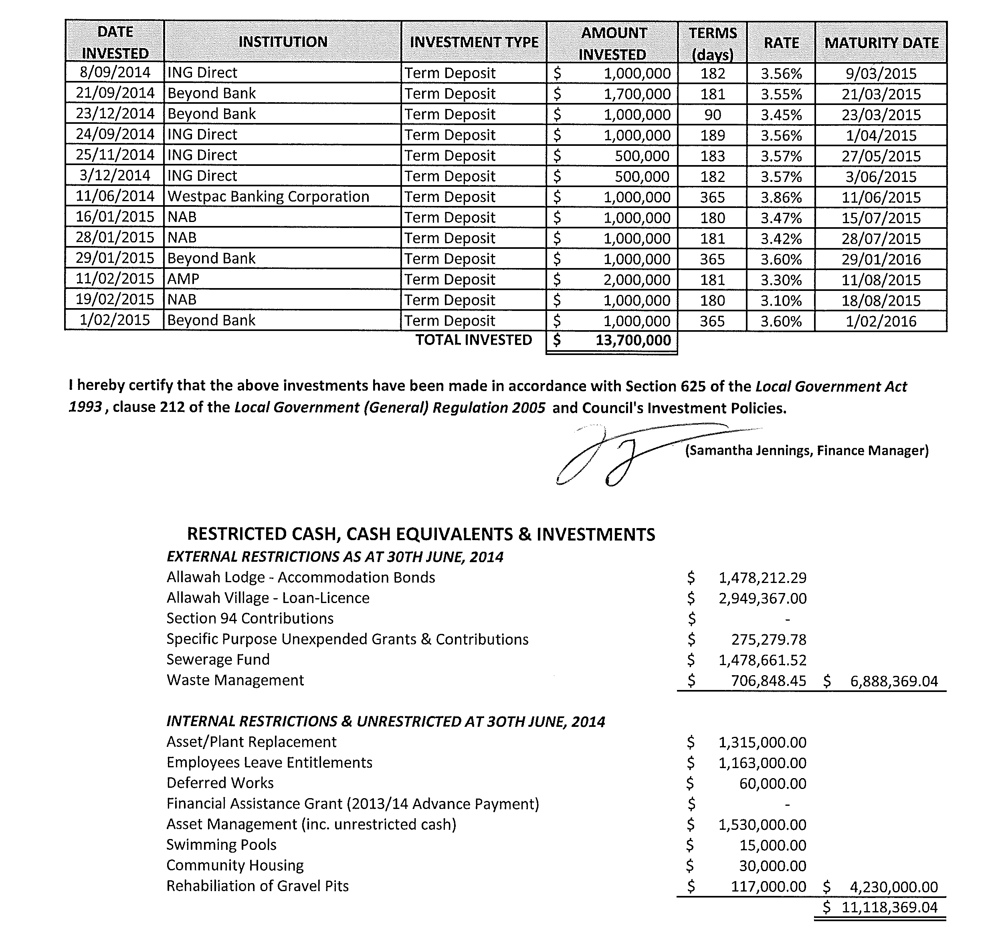
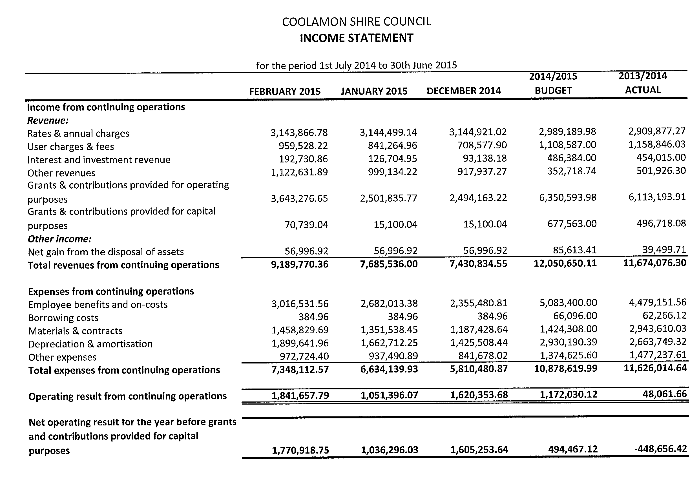
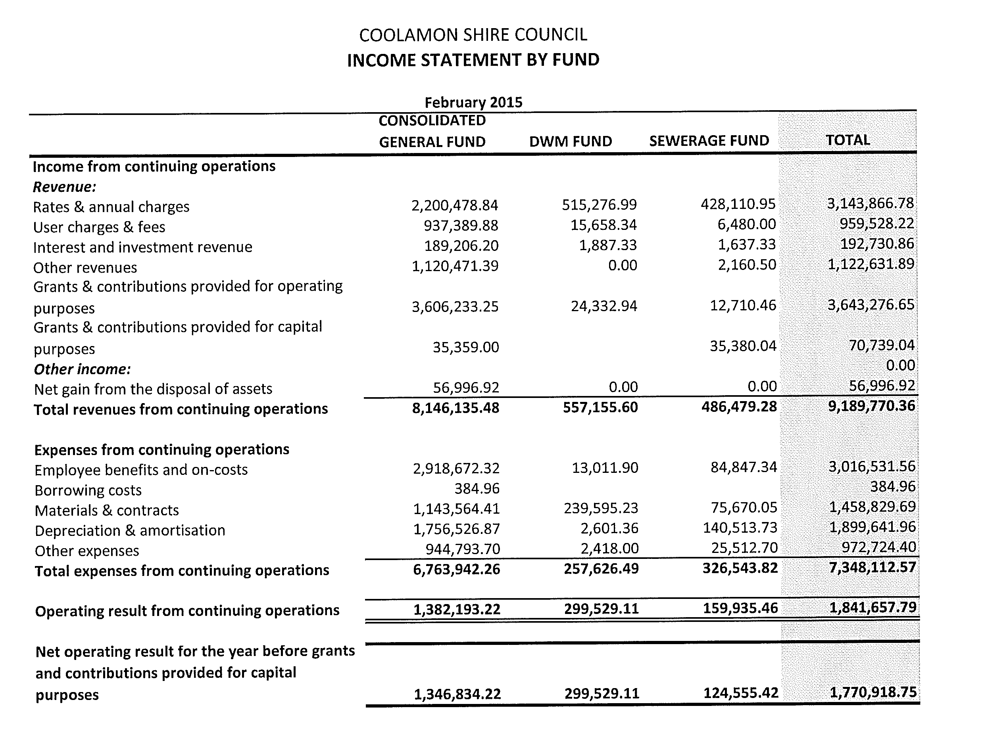
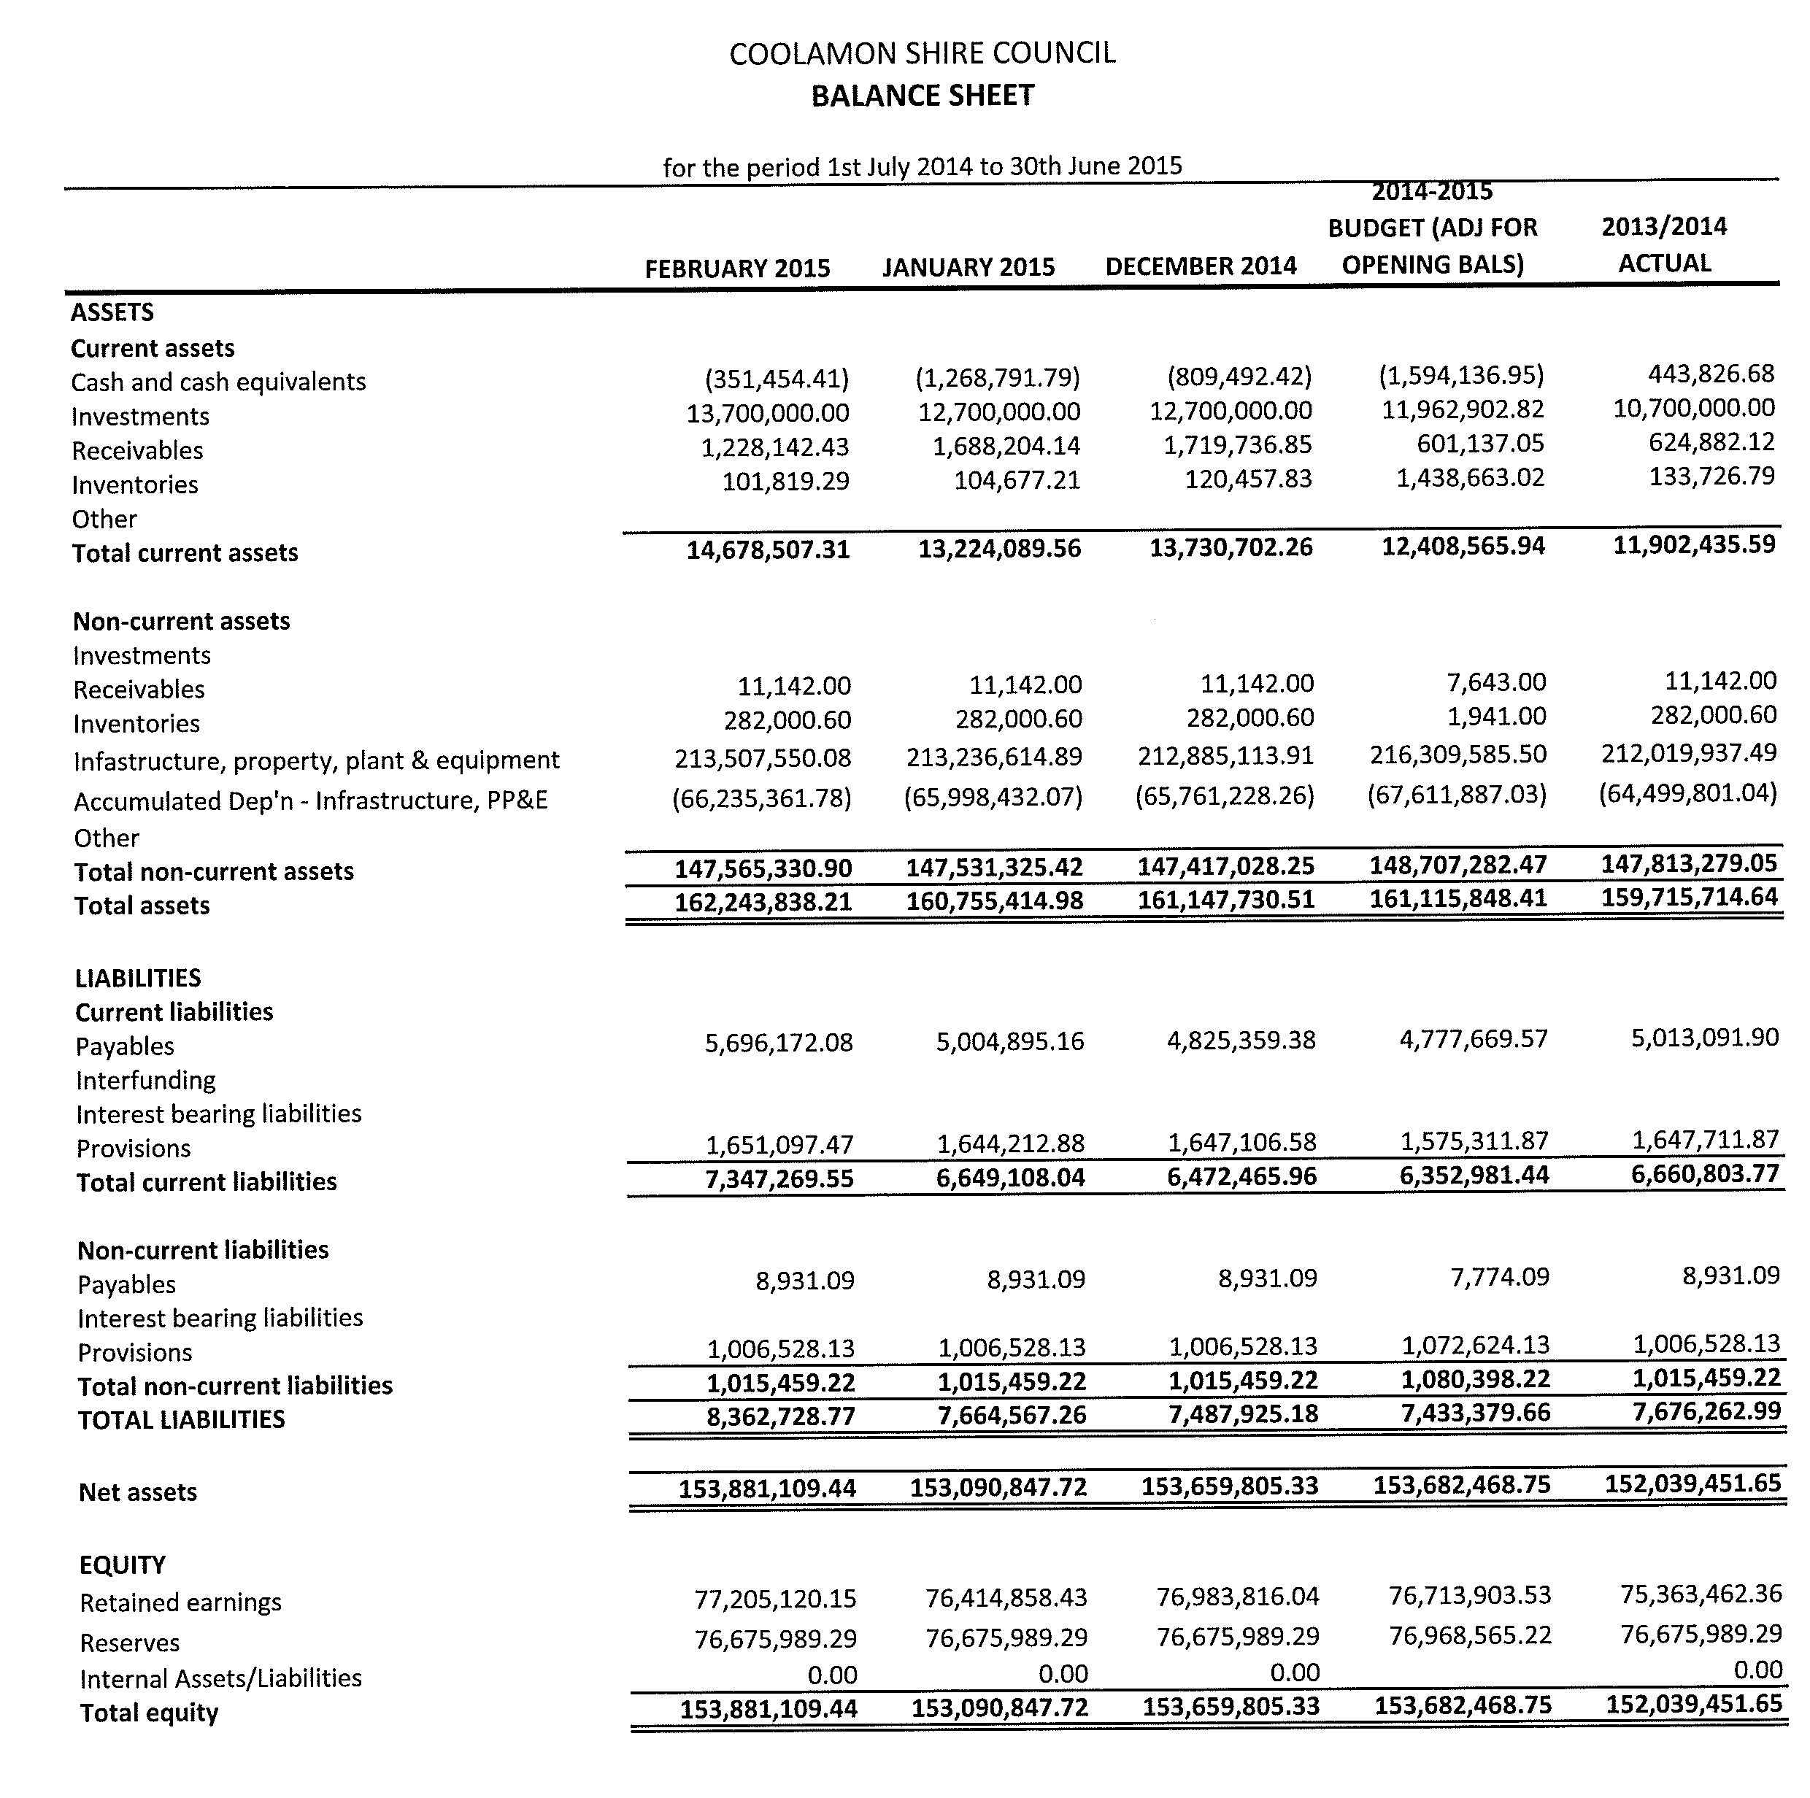
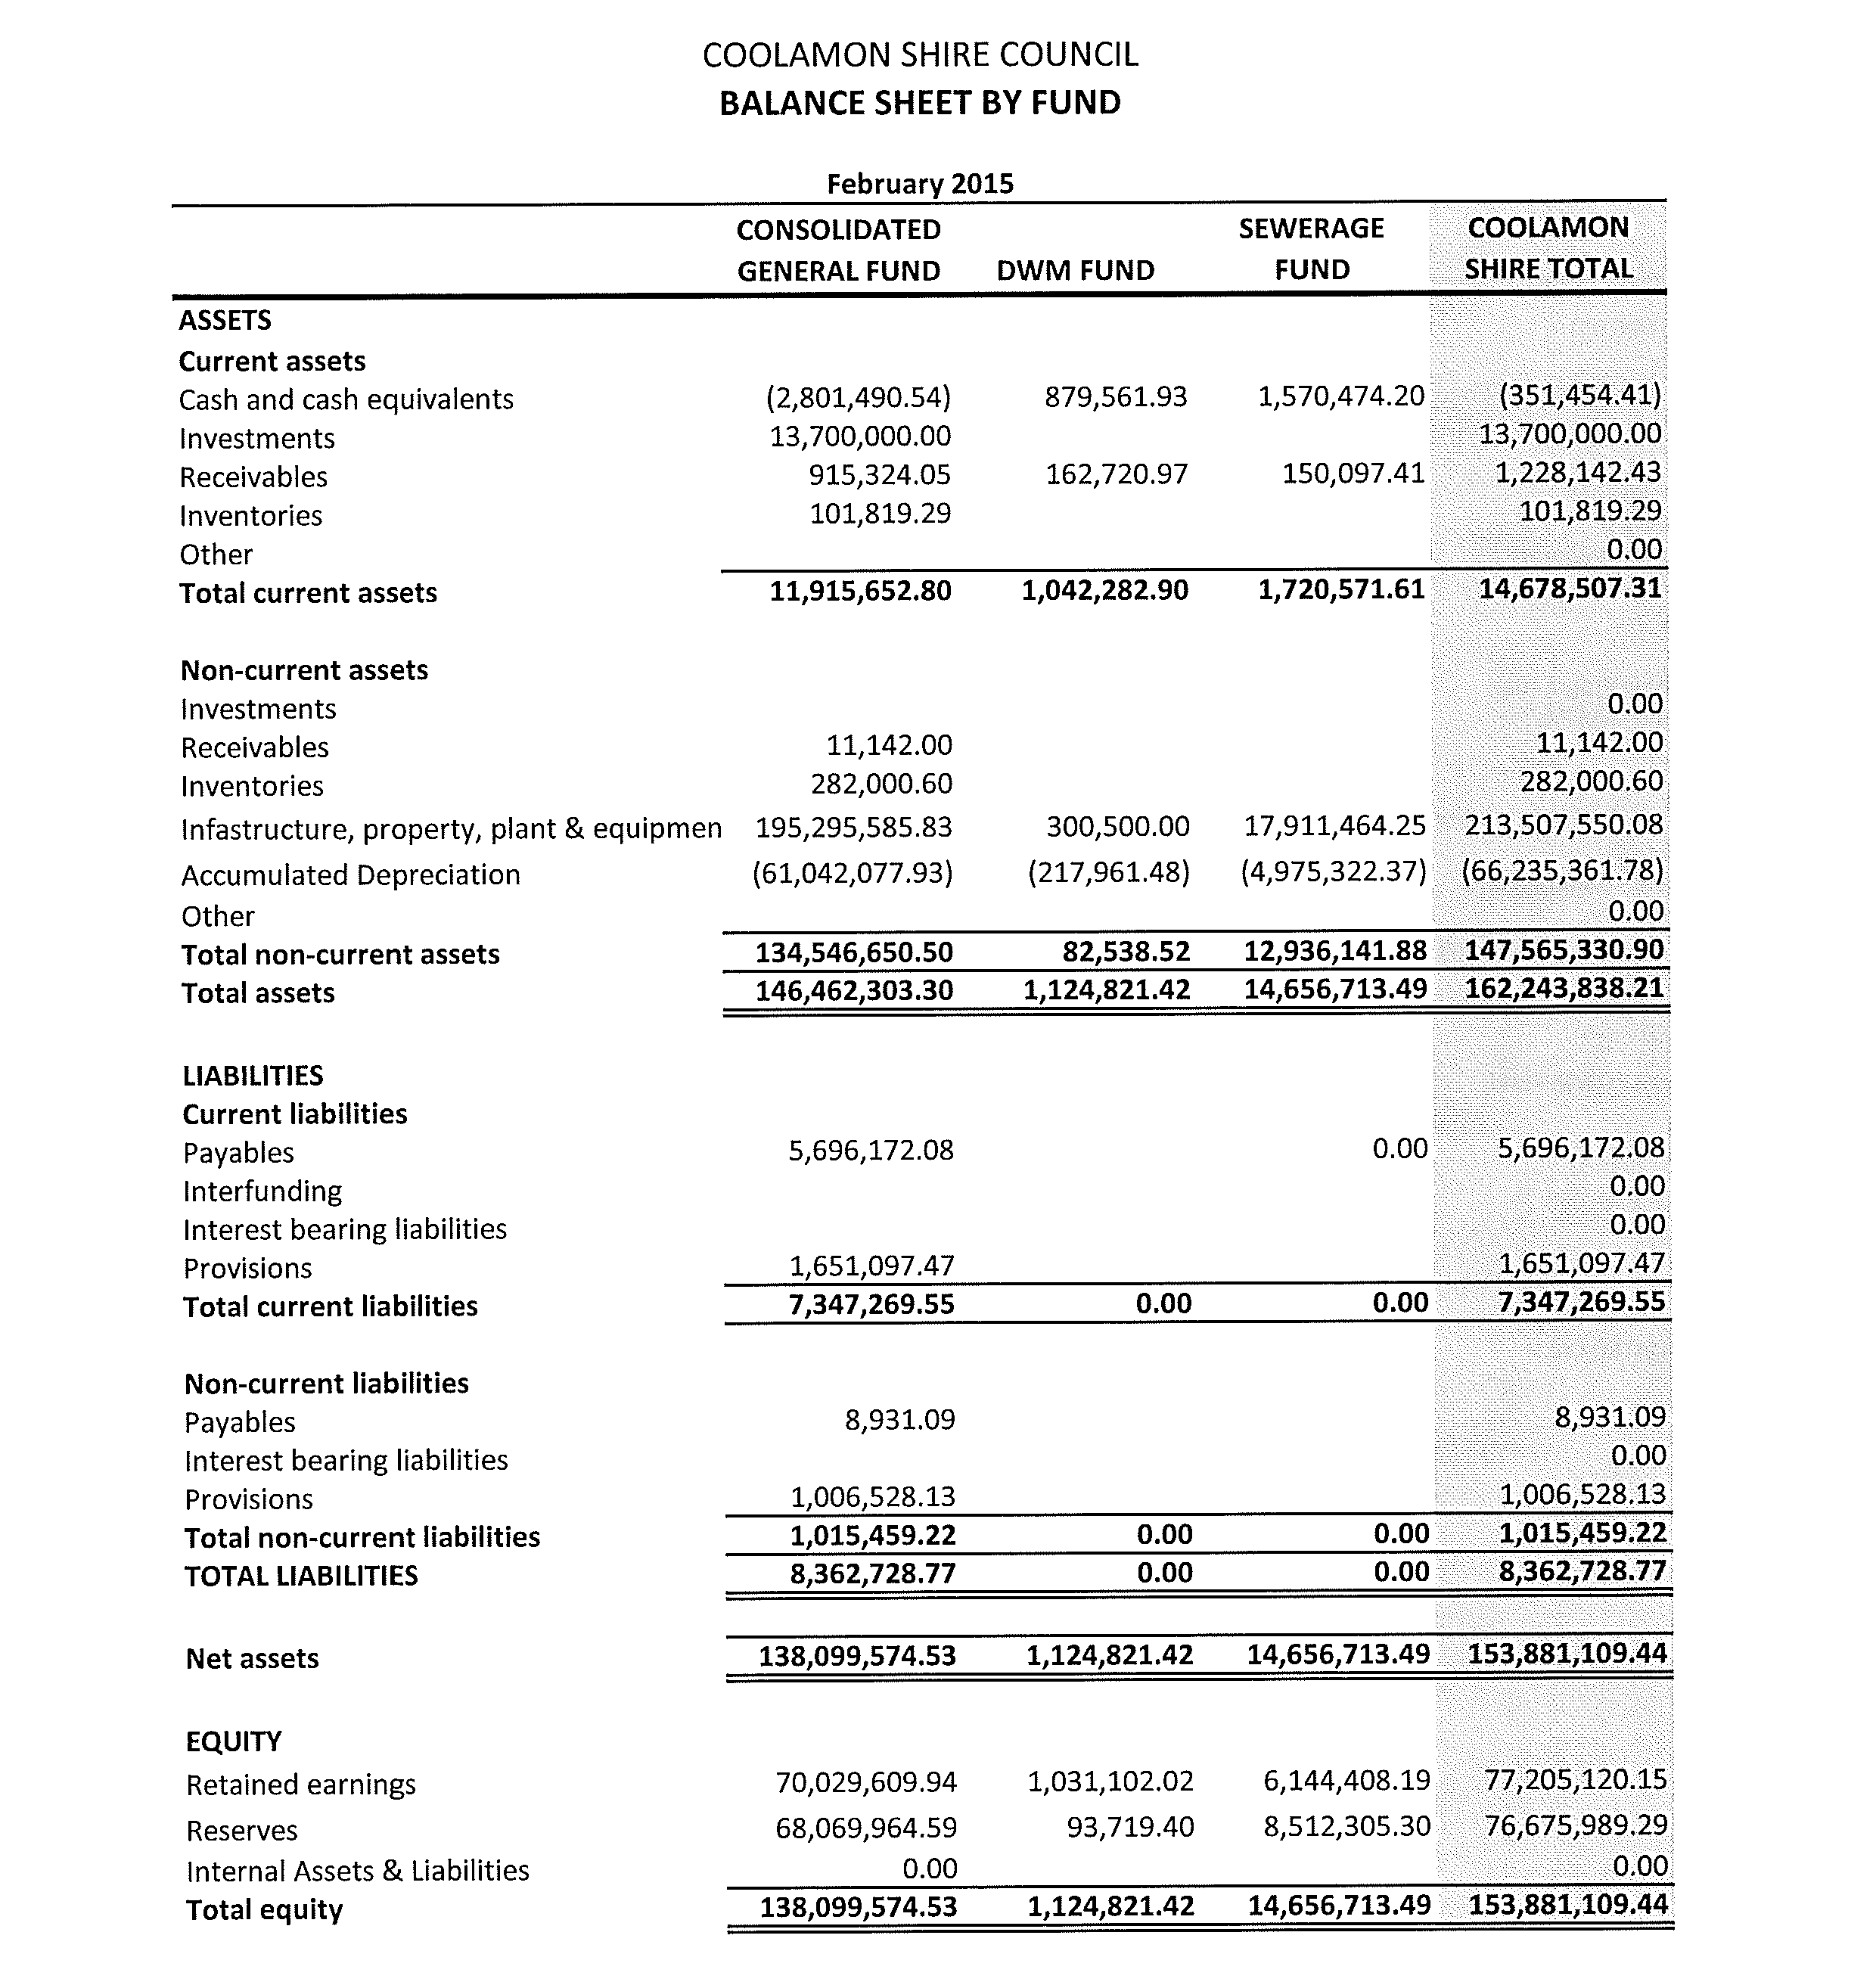
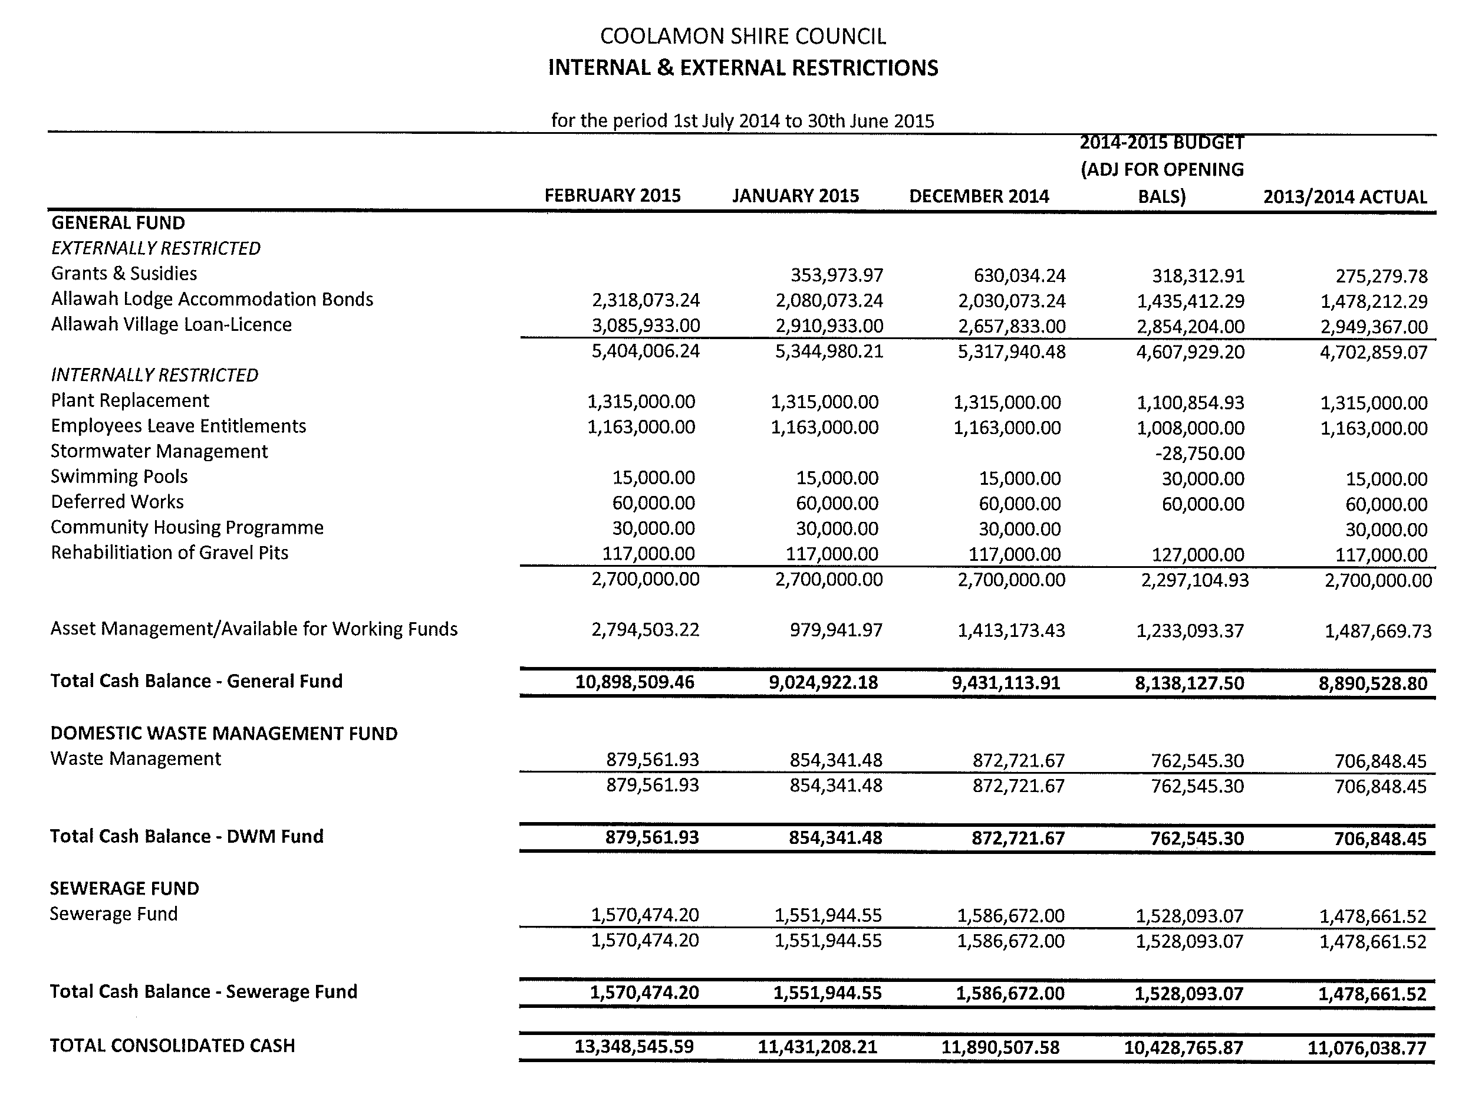
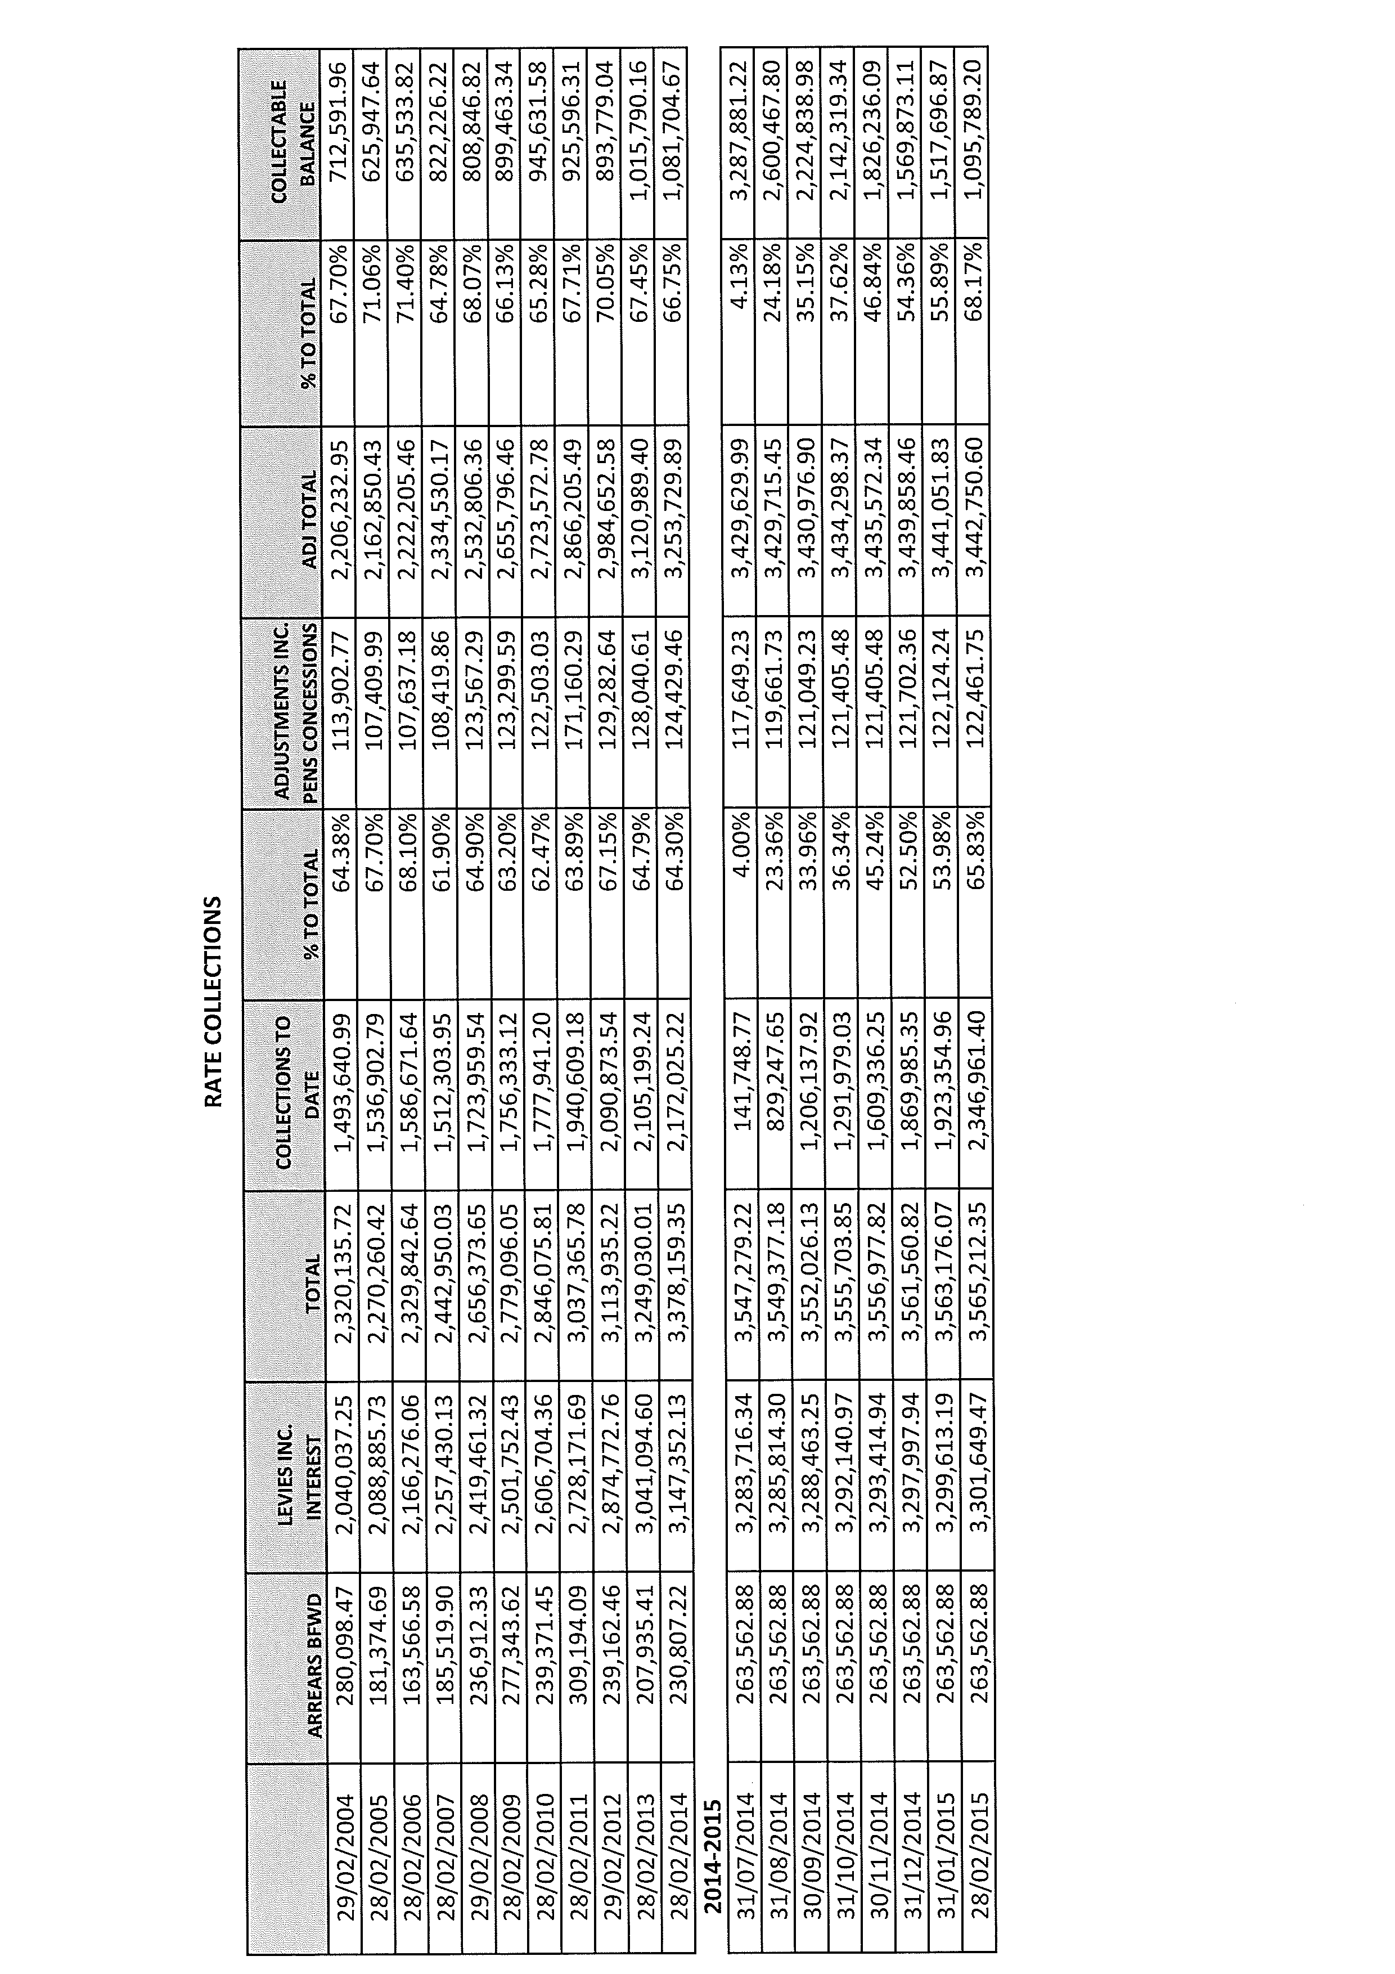
CS2) COOLAMON SHIRE COUNCIL FIRE & RESCUE NSW, RURAL FIRE SERVICE & STATE EMERGENCY SERVICE CONTRIBUTIONS 2014/2015 (F.03-12)

➔ Attached to this report is a letter from Fire & Rescue NSW detailing Council’s contribution for the 2014/2015 financial year for the Coolamon Fire District at $15,473. The letter also contained a summary of the state wide expenditure for Fire & Rescue NSW, Rural Fire Service and State Emergency Service, the Local Government Contribution relating to this expenditure and Coolamon Shire Council’s contribution is broken down into instalments for the 2014/2015 year. Attachment No. 11

The Fire & Rescue NSW and State Emergency Service contributions relate solely to the Coolamon Shire but the Rural Fire Service Contribution relates to the total Riverina Zone, as Coolamon is the lead Council. Coolamon Shire Council’s share of the total contribution is $155,024.56. This is offset by the reimbursable amount of $50,310.10 therefore meaning that a net contribution of $104,714.46 will be levied to Council. Council’s original budget allowed for a net contribution of $106,527.

Recommendation

That the report be noted.

RESOLVED on the motion of Clr Logan and seconded by Clr McCann that the report be noted. 52/03/2015

4.3) EXECUTIVE MANAGER, ENGINEERING & TECHNICAL SERVICES

ES1) SHIRE ROADS RESHEETING AND STABILISATION WORKS

The following roads have received attention:

Maintenance

- Chamberlains Lane (Canola Way to Coolamon Road)
- Parmenters Lane (Coolamon Road to Tooyal Road)
- Williamsons Lane (Tooyal Road to Millwood Road)
- Boundary Lane (Millwood Road to Mowsers Lane)
- Bradleys Lane (Millwood Road to Lesterfield Lane)
- Lesterfield Lane (Bradleys Lane to Canola Way)
- Brushwood North Road (Canola Way to Murphys Lane)

ES2) BLOCK GRANT

COOLAMON ROAD (4.0 TO 5.3KMS) 1.3KMS

Reconstruction works involving formation corrections, stabilisation and sealing have now been completed. Contractors have been engaged to perform line marking and are scheduled for April.

ES3) REPAIR PROGRAMME

1) CANOLA WAY (26.7 to 28.1KMS) 1.4KMS WEST OF COOLAMON

Reconstruction works involving the importation of suitable material, stabilisation and sealing have now been completed along this section of road. Line marking is scheduled for April.

2) WADE STREET, COOLAMON (COWABBIE STREET TO JACARANDA STREET)

Reconstruction of the road to improve pavement condition is progressing well with stabilisation and sealing scheduled for late March.

ES4) ROADS TO RECOVERY PROGRAMME 2014/2015 & FIXING COUNTRY ROADS

HODGES LANE (CANOLA WAY TO EMERALD GRAIN ENTRANCE) 600 METRES

Reconstruction works to provide a pavement which can withstand the forces of higher mass vehicles has commenced. Stabilisation and sealing works are scheduled for late March. On completion of the works an asphalt overlay at the intersection with Canola Way, rail crossing and entrance to Emerald Grain will be performed.

ES5) ACTIVE TRANSPORT PROGRAMME (R.07-08, SC333)

Council has received correspondence from the State Government advising that its submissions under the 2015/2016 Programme have been successful. Projects and costings are as follows:

1) ACTIVE TRANSPORT PROJECTS

Programme | Project Description | RMS Funding | Council Funding | Total
Cycling | Bitumen path on west side of See Street, Marrar (York Street to School) 330m x 2.5m | $16,500 | $16,500 | $33,000
Walking | Construct kerb blisters and crossing on S/E corner of Intersection of See Street/Centenary Drive. | $7,500 | $7,500 | $15,000

➔ A copy of the letter is distributed with the information papers for Councillor’s information. Attachment No. 12

2) WATERVIEW STREET, GANMAIN (FORD STREET TO BOWLING CLUB NORTH SIDE)

Construction of a 2.1 metre wide path to replace the deteriorating concrete path continues along this section of nature strip. Works are progressing well with an anticipated completion date of mid March.

3) INTERSECTION LANGHAM STREET AND FORD STREET, GANMAIN

Construction of pedestrian refuges at the North East and South East corners of the intersection have been performed, minor finishing works are required and are anticipated to be completed in the coming weeks.

ES6) NOXIOUS WEEDS REPORT (N.02-01, SC284)

Senior Weeds Officer, Robert Ferguson Reports

- Continued stormy weather and warm soil temperatures have contributed to extended germination and growth of weeds. Comparisons with prior year’s records indicate that numbers are five times that of previous years. In addition, these weeds are being found in places never before seen. This anecdotal information comes from many district landholders, weed officers as well as RENWA staff. The amount of summer-based weeds is unprecedented. A good example is Cartwright’s Lane which normally has 100 – 200 Silverleaf Nightshade plants; this year it has over 700.

- A major operation was carried out on the 25 February along the Olympic Highway to destroy a Silverleaf Nightshade incursion on eight different sites comprising an estimated 3600 plants.

- Devils Claw, Johnston Grass, Blue Heliotrope and Bathurst Burr numbers have also been in numbers probably never seen before.

- A new incursion of Coolatai Grass has been discovered at Old Junee. They are of the Class 3 weed and only a small area of 40m² and was detected on 24 January and sprayed the following day. This brings the total number of sites in Junee Shire to five with the major outbreak centred on the railway between Rockview Crossing and Old Junee.

- Baylis Lane, previously thought not to be part of the Junee Shire Council network, has recently been confirmed to be so. With regard to noxious weeds, this thoroughfare has, over a decade, been a conduit for Silverleaf Nightshade, Blue Heliotrope and Bathurst Burr. RENWA will now be including this lane in its route responsibilities.

- The NSW Fire Service is in the process of making the Old Junee Hall a “safe place” in times of emergencies for the village community. A noxious weed, Tree of Heaven, has been growing around the hall. The owner of the land has sprayed the weed after previously knocking down the bulk of it in 2014. A further spraying may be necessary. The issue is being overseen by RENWA staff.

ES7) FACILITIES MAINTENANCE OFFICER’S REPORT (P.01-01, SC513)

Facilities Maintenance Officer Reports

- Units at Kindra and Centenary Lodge have recently been refurbished whilst vacant. Replacement of wet seals in bathrooms, retiling and painting works have been completed.

- Work has also been undertaken at several units in the Allawah Retirement Complex during vacancies, this work included painting and new carpet for several units.

- The SES building is currently receiving attention to repair water damage from a faulty roof and gutter.

- Demand is still high for treated effluent, however, at this stage the Golf Club dam should be able to be maintained at adequate levels for the remainder of the season.

- Several large trees have been removed at the Ganmain Cemetery due to disease. This area has been levelled and ready for replanting over winter.

- Tree planting will also take place along sections of Waterview Street following recent footpath upgrades.

Recommendation

For Council information.

RESOLVED on the motion of Clr Maslin and seconded by Clr Hutcheon that the Executive Manager, Engineering & Technical Services Reports (ES1 to ES7) be received. 53/03/2015

ES8) CEMETERY ROSE GARDENS AND NICHE WALLS (C.02-01, SC67)

As discussed at the recent Advance Committee and Councillor Tour, a number of the existing Niche Walls and Rose Gardens are now at capacity and consideration for further capacity is required. Cemeteries requiring consideration are as follows:

- COOLAMON ROSE GARDEN

◆ The existing Rose Garden is now at capacity with 22 plots present and first interment occurring in 2002. A plan is attached and provides various concept options for consideration.

- GANMAIN NICHE WALL

◆ The existing Niche Wall is also at capacity with the option of constructing an additional Niche Wall (double sided) providing an additional 42 plots or utilising the surrounding garden area and creating a Rose Garden area which would have a capacity of approximately 20 plots. A copy of the plan is attached.

Recommendation

For Council consideration.

RESOLVED on the motion of Clr McCann and seconded by Clr Hutcheon that the concept plan indicated as Option D be developed as the additional site for the Rose Garden in Coolamon. 54/03/2015

RESOLVED on the motion of Clr Logan and seconded by Clr Brill that an additional Niche Wall be provided in Ganmain. 55/03/2015

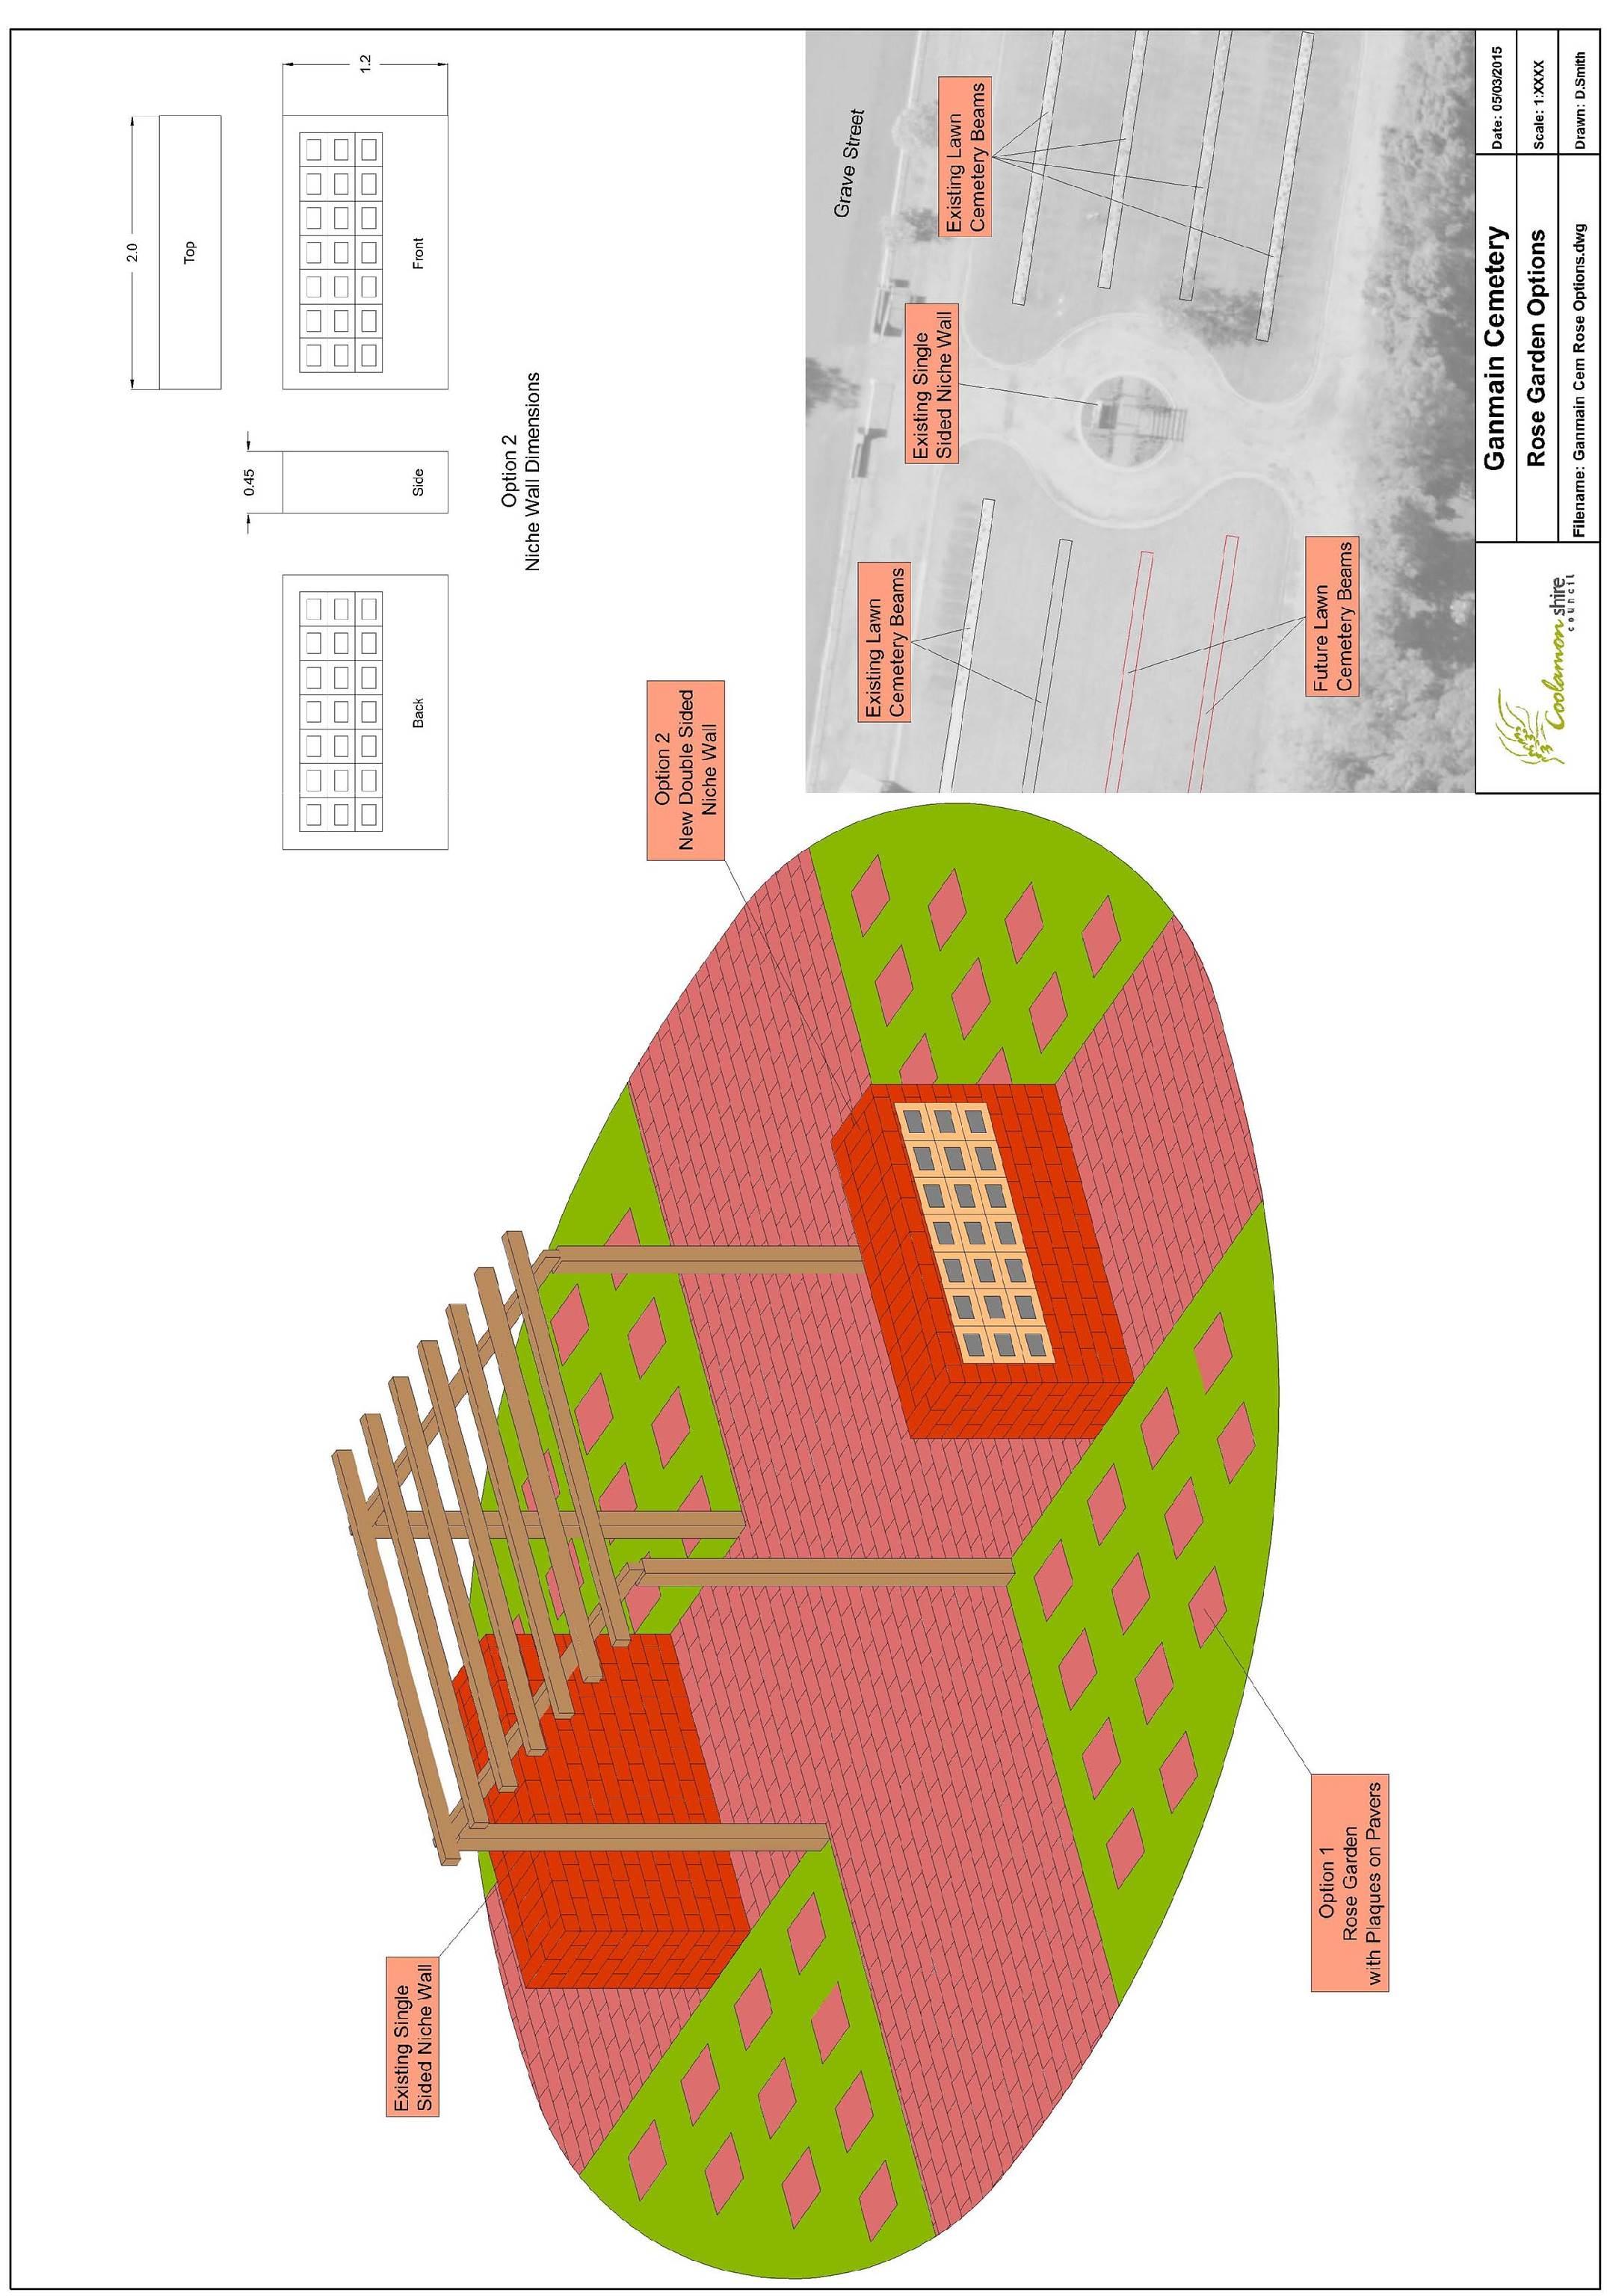
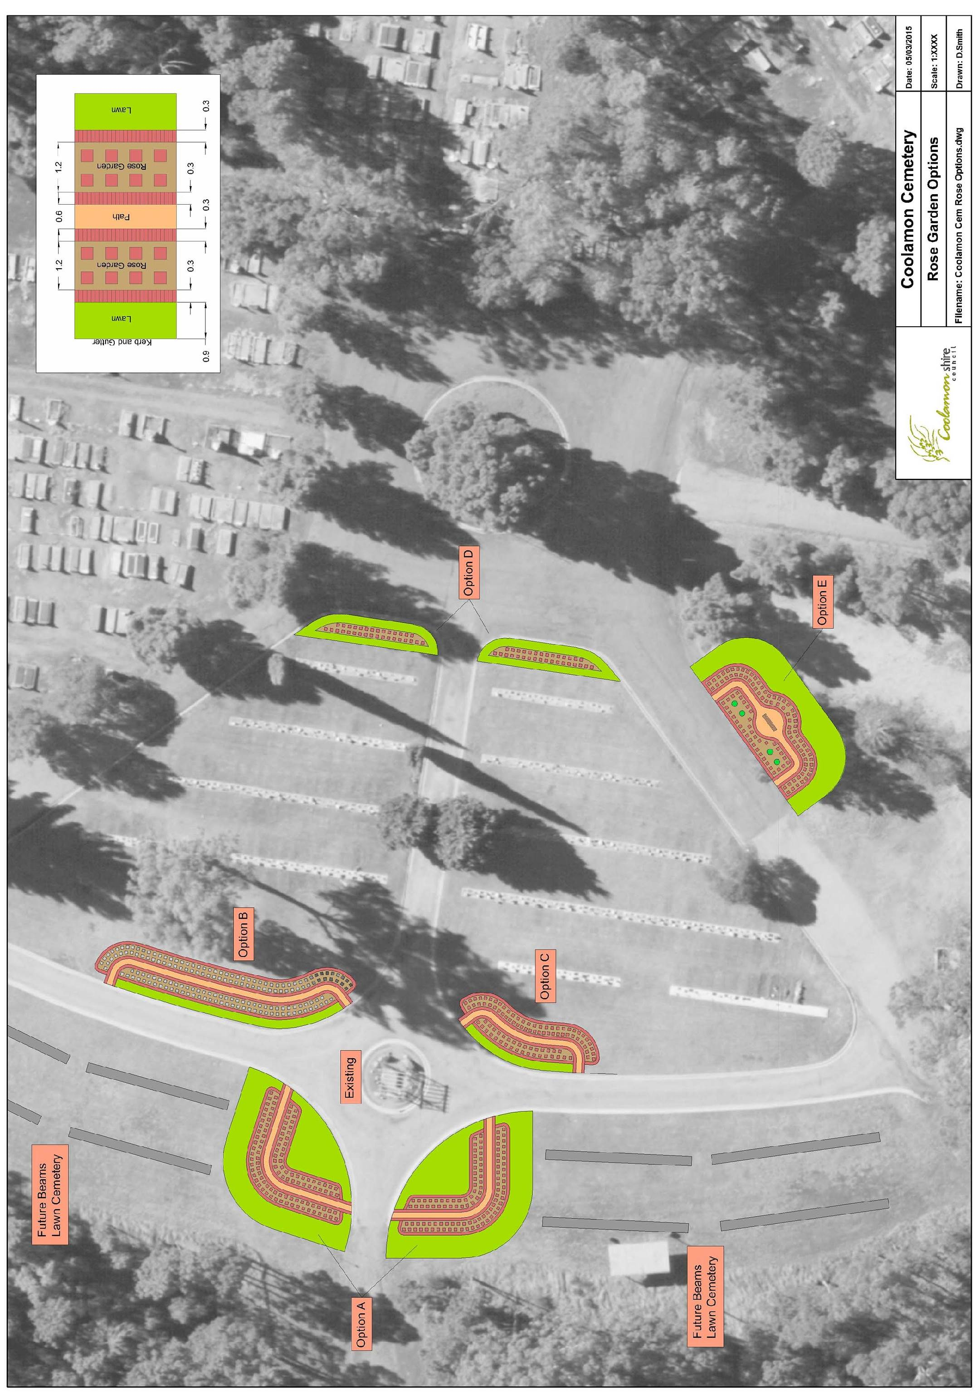
ES9) 2015/2019 DELIVERY PROGRAMME AND 2015/2016 OPERATIONAL PLAN

1) TOWN WORKS

◆ Following Council’s Community and Councillor Tour held in early February 2015, all issues raised have been considered in the development of the 2015/2019 Delivery Programme and 2015/2016 Operational Plan for Town Works. Projects have been listed in priority order from an Asset Management perspective. (See attached).

Recommendation

For Council consideration.

RESOLVED on the motion of Clr McCann and seconded by Clr Hutcheon: 56/03/2015

1) That the drainage improvements to the Intersection of Thompson/Dunrobin Streets be moved to Number 6 in the order of works and that all remaining items be moved down accordingly as shown below.

2) That the Town Works Programme be referred to the 2015/16 Draft Operational Budget.

2) GRAVEL RESHEETING/IMPROVEMENT/STABILISATION PROGRAMME

◆ Following an inspection and condition rating of all Council’s roads as part of the Asset Management process the attached roads have been identified for works under Council’s 2015/2016 Gravel Resheeting and Stabilisation programmes.

Recommendation

For Council consideration.

RESOLVED on the motion of Clr Brill and seconded by Clr Maslin that the priority list of projects to be funded by Gravel Resheeting/Improvement/Stabilisation programme be referred to the 2015/16 Draft Operational Plan. 57/03/2015

3) PLANT REPORT - 2015/2016 CONSIDERATIONS

◆ The attached report details the replacement items proposed for the forthcoming year. (See Plant Replacement Schedule attached). The following major items are up for consideration:

1) Replacement of one 10m3 Gravel Truck (Plant No.123). This Truck is on an eight year replacement cycle and is due this year with over 270,000km of work accrued. 10m3 Gravel Truck (Plant No.123) will replace 10m3 water truck (Plant No.118) with over 400,000km of work accrued.

2) Overhaul of 3 gravel 10m3 Pig Trailers (Plant No.150, 151, 152). These Pig Trailers are located with gravel trucks (Plant No.123, 124, 130) and are on a re-assess annual cycle and are due for a rebuild.

3) Replacement of one Ardlethan Depot tractor (Plant No.87). This tractor is on a re-assess annually replacement cycle and has been sold through auction in 2014 due to high maintenance and repair cost

4) Replacement of one Heavy Tractor (Plant No.91). This Tractor is on a re-assess annually replacement cycle and is due this year with over 10,000hrs of work accrued. The replacement heavy tractor will be allocated to construction gang 2 with Heavy Tractor (Plant No. 95) transferring to Maintenance Grader Gang 3 to tow heavy combination roller.

5) Parks and Gardens Plant Report 15/16

No major mowers require replacement this year with community mowers continuing to be a valuable asset for Matong, Marrar and Beckom. The usage of the community mowers varies so annual reviews of requirements are necessary.
Usage hours will be monitored throughout the year.

Replacement of one community mower is due this year with Matong the likely recipient.

Recommendation

That the Plant Report as presented is received, and the items listed be presented for consideration in the draft estimates.

RESOLVED on the motion of Clr Brill and seconded by Clr McCann that the priority list of projects for the Plant Report be referred to the 2015/16 Draft Operational Plan. 58/03/2015
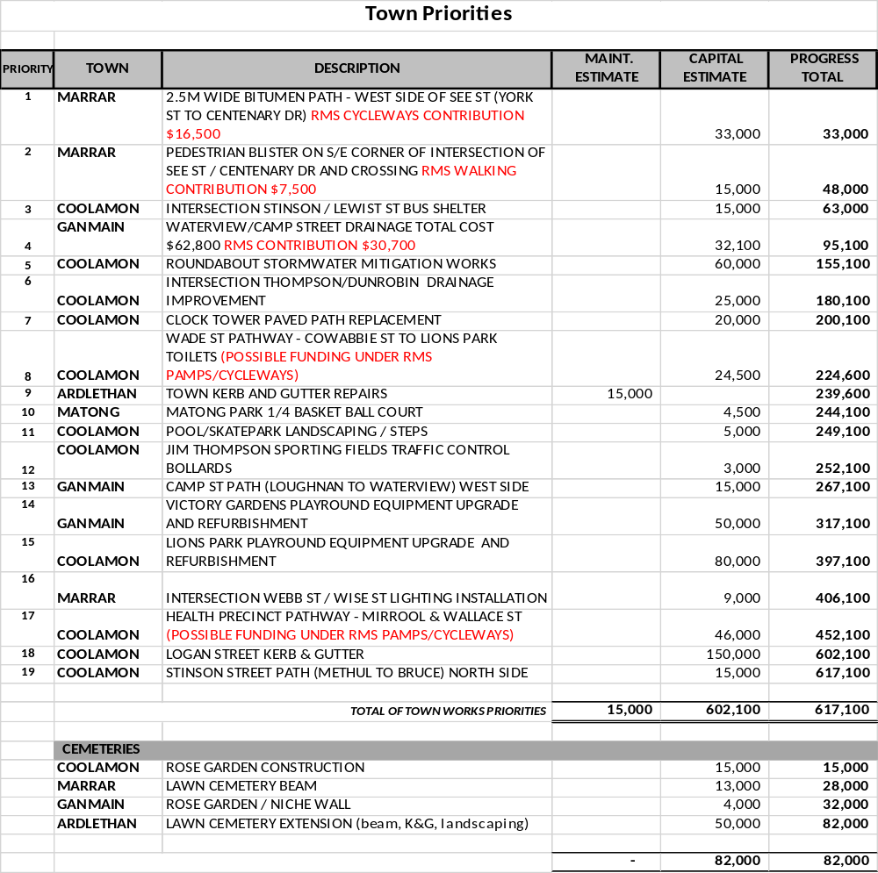

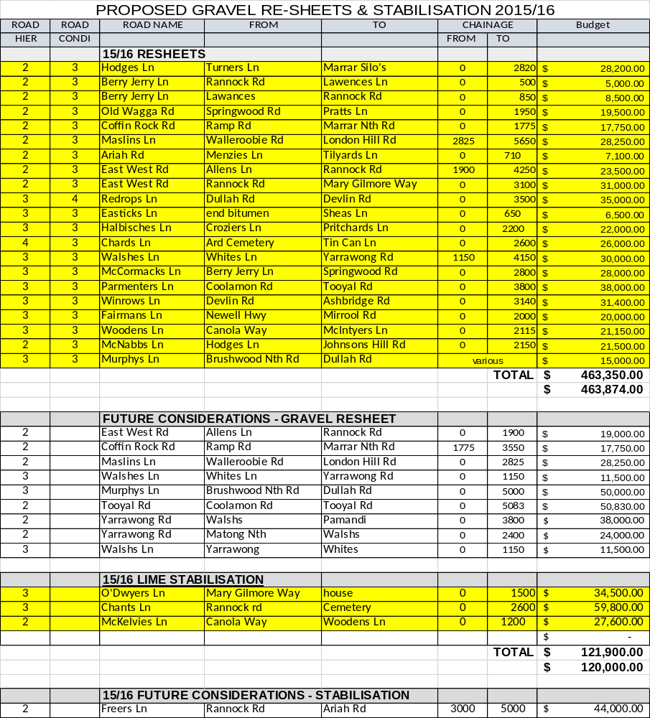

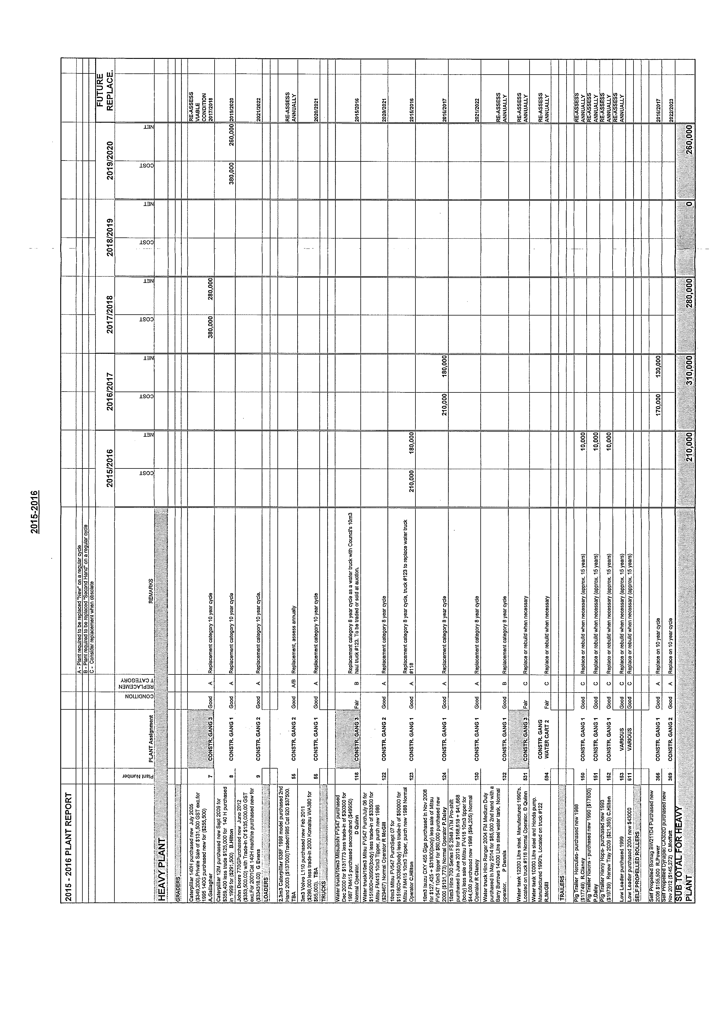
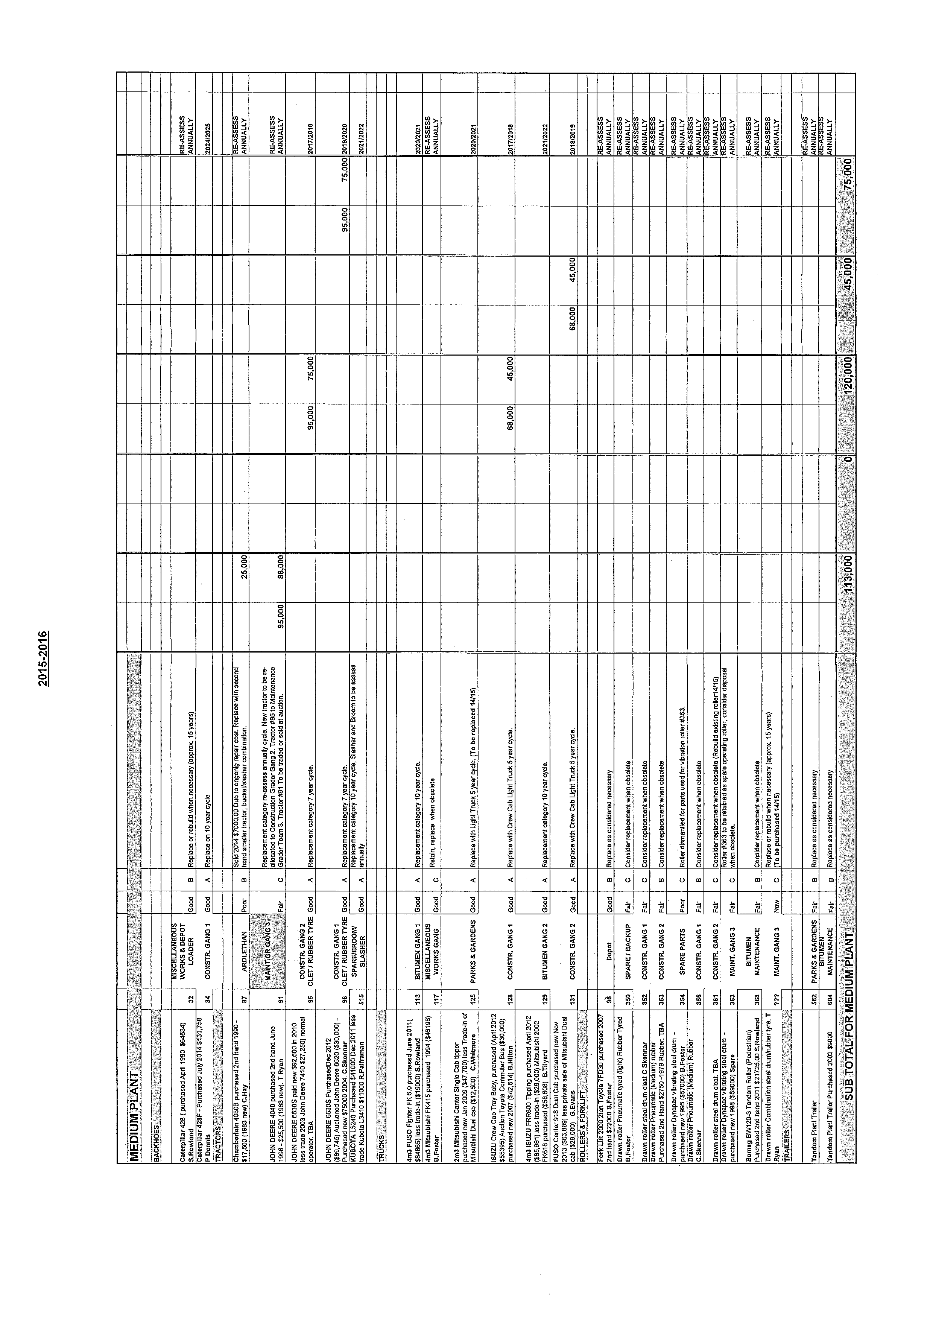

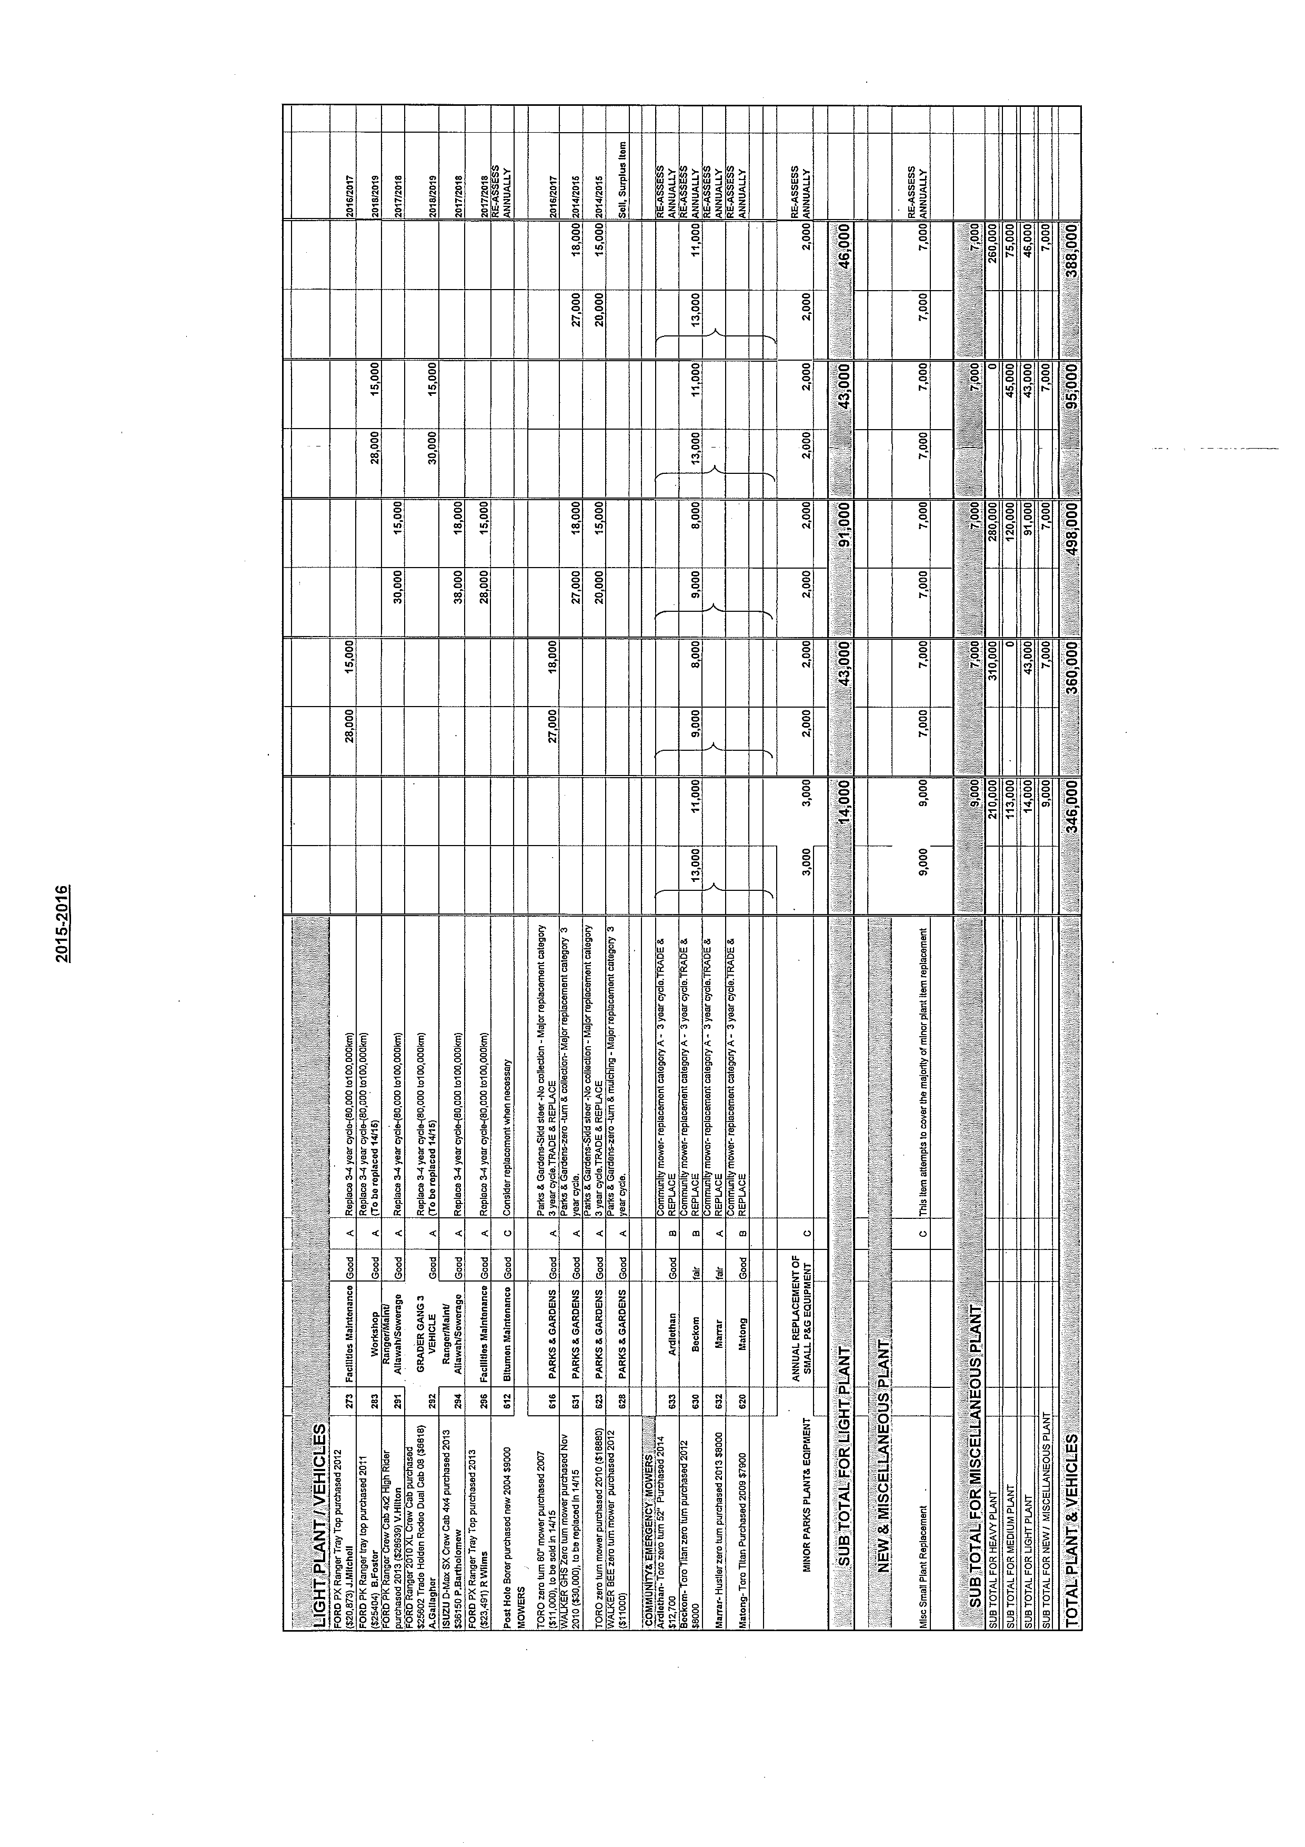
ES10) 2015/2016 ROADS TO RECOVERY PROGRAMME (R.07-05, SC332)

Under the current 2014/2019 programme, Council receives $575,148 per year in funding with an additional allocation of $575,148 for 2015/2016 totalling $3,450,889 for use on Council’s Local road Network. To allow Council to perform the works required and address the road issues as they arise, it is prudent to evenly distribute the additional allocation across the 5 year period providing an annual budget of $690,111.80.

◆ Following an assessment of Council’s Rural Local and Urban Sealed Roads the following list of reconstruction and reseal works are provided for consideration under the 2015/2016 Roads to Recovery Programme. (See attached).

Recommendation

For Council consideration.

RESOLVED on the motion of Clr Maslin and seconded by Clr Hutcheon that the priority list of projects to be funded by the Roads to Recovery programme be referred to the 2015/16 Draft Operational Plan. 59/03/2015

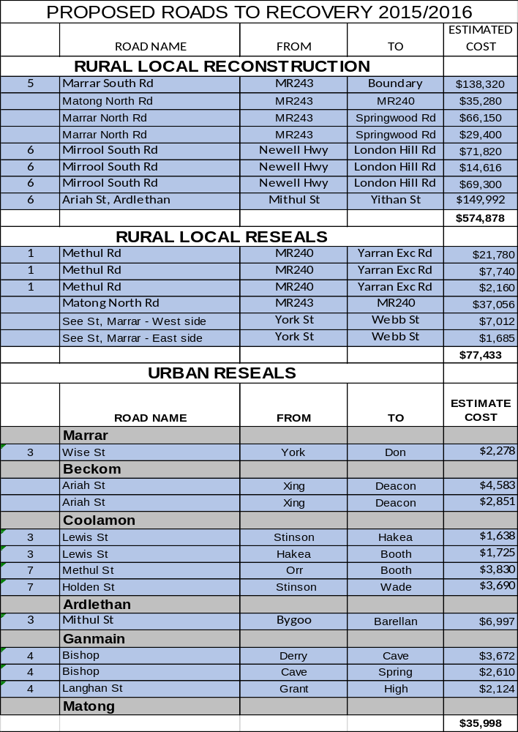

4.4 MANAGER, PLANNING & ENVIRONMENTAL SERVICES REPORTS

HS1) DEVELOPMENT APPLICATIONS (B.05-03, SC58)

The following applications have been approved:-

DEVELOPMENT APPLICATIONS

46/2014 A & B/332315 – 123-125 Cowabbie Street, Coolamon – Retail, Restaurant & Residence.
65/2014 100/750867 – 20 Barellan Street, Ardlethan – Shed.
06/2015 33/1159116 – 68 Lewis Street, Coolamon – Dwelling.
08/2015 35/1159116 – 64 Lewis Street, Coolamon – Shed.
11/2015 36/1159116 – 62 Lewis Street, Coolamon – Dwelling.
13/2015 2/663950 – 56 Cowabbie Street, Coolamon – Carport.

Recommendation

For Council information.

RESOLVED on the motion of Clr Huxtable and seconded by Clr Beard that the report be received. 60/03/2015

HS2) GANMAIN ORGANIC WASTE COLLECTION (G.01-11, SC199)

In December 2014, Council applied for grant funding under the NSW EPA & Environmental Trusts ‘Waste Less Recycle More Initiative’ for the establishment of a fortnightly Kerbside Organic Waste Collection in Ganmain. It was recently announced that Council were successful in obtaining a grant of $21,405.

The application was submitted on the back of the success of the Coolamon Organic Waste Collection, which commenced in 2012, following on from a regional trial conducted by the Riverina Eastern Regional Organisation of Councils (REROC) that included the towns of Coolamon, Cootamundra, Junee and Gundagai. Residents are levied $55/annum for the service. All waste collected is composted for re-use across Council’s many parks and gardens located throughout the Shire.

An expanded service would provide Ganmain residents with an additional 240L garbage bin in which organic waste (i.e. most food and garden wastes) would be collected fortnightly, similar to the current recycling collection. Should Council proceed with implementing the service in Ganmain, approximately 2/3 of the Shire’s village-based population will have access to a Kerbside Organic Waste Collection.

In February, information was provided to Ganmain residents to introduce the idea of a Kerbside Organics Collection. Feedback was sought regarding this via an optional survey, which received a response rate of approximately 25%, surpassing all expectations.

➔ A breakdown of the survey data has been attached. Attachment No. 13

In summary the results of the survey are as follows:

- 76% believed that an organics collection is a good idea.
- 71% would like Council to provide the service.
- 63% are prepared to pay for such a service via an annual rate levy of $55 or approximately $1/week (the same as the existing Coolamon service).
- 38% currently dispose of their food waste in the red-lid bin, 32% home compost, whilst 29% feed leftover food to their pets (chooks, dogs, etc.).
- 53% currently dispose of their green waste to landfill, whilst 34% home compost.

Most respondents in favour of the collection did not provide additional written comments. Of those that did, the most common response was that the collection is a great idea, especially those without the means or ability to currently transport organic waste to the landfill site. Other responses raised legitimate concerns such as how to control odour, and what to do if the bin got too heavy. Naturally Council received its share of negative feedback, with some community members labelling the proposal as an excuse to generate more income and a green tax.

The above results however clearly indicate that the majority of the Ganmain community would support the introduction of a fortnightly kerbside organics collection. The grant funding also ensures that Council can roll-out the programme with minimal expense. Ongoing costs would be levied in exactly the same way as Coolamon residents are levied (i.e. $55/annum or approx. $1/week), ensuring that the programme continues to be relatively cost-neutral.

Recommendation

1) That Council accept the grant offer to assist in the establishment of a fortnightly Kerbside Organics Collection in Ganmain.

2) That Council commence educating the Ganmain community prior to the rollout of a fortnightly Organics Waste Collection commencing in July 2015.
RESOLVED on the motion of Clr McCann and seconded by Clr Huxtable: 61/03/2015

1) That Council accept the grant offer to assist in the establishment of a fortnightly Kerbside Organics Collection in Ganmain.

2) That Council commence educating the Ganmain community prior to the rollout of a fortnightly Organics Waste Collection commencing in July 2015.

HS3) SOLID WASTE LANDFILL PROPOSAL AT THE ARDLETHAN TIN MINE (G.01-12, SC519)

➔ Council Staff have recently been in discussion with the owners of the former Ardlethan Tin Mine Site who are proposing a Solid Waste Landfill Project. A background paper detailing the project has been attached. Attachment No. 14

In summary the proposal would see the facility accepting upwards of 400,000 tonnes of putrescible waste from the Sydney Metropolitan area per annum. The waste would be transported to the site via rail. The proposal also has scope to accept waste from local Council areas.

Due the scale of the project it is regarded as being State Significant Development in accordance with the State Environmental Planning Policy (State and Regional Development) 2011. In essence this means that the Consent Authority is the NSW Government (specifically the Minister for Planning). Because of this the planning process is somewhat different to the process usually experienced by Council and its communities.

The process is essentially commenced by the applicant, who is to make application to the Department of Planning for Director-General’s requirements. Once this has occurred the applicant meets with all relevant State Government Departments (eg: EPA, Department of Planning, RMS etc) and Council to provide a framework for an Environmental Impact Statement (EIS). This is Council’s opportunity to raise the majority of its concerns in terms of planning and environmental outcomes.

Once the EIS has been prepared the applicant can lodge the DA with the Department. At this point the development is put on public exhibition to allow members of the public and other relevant stakeholders to make submissions where required. The assessment process will then be determined according to the number of submissions received and accordingly will go one of either two directions. If there are less than 25 submissions that object to the proposal, there are no objections by Council, and there are no reportable political donations by the applicant, then the application maybe assessed by senior officers of the Department of Planning. If any of these three criteria are not met, the application will be assessed and determined by the Planning Assessment Commission.

It is noted that on Wednesday, 11th March, 2015 the proponent made application with the Department of Planning for Director-General’s requirements. A meeting between the applicant, Council Staff and the relevant State Government Agencies is currently being scheduled.

This is not the first instance of a proposal to utilise the former Tin Mine Site for waste management. Councillors may recall a similar proposal that was refused by a Commission of Inquiry in the late 1990’s.

Since that time a similar project has been approved and has subsequently commenced operating out of a disused mine site at Woodlawn, located between Goulburn and Canberra. Similarly the Woodlawn operation receives waste via train from the Sydney Metropolitan area and is disposed of in a former mining pit. The Woodlawn site is considered to be at the forefront of waste management in Australia at this point in time, primarily because of the overall environmental sustainability of the site. Methods and technology used onsite not only dispose of the waste, but also capture gases and energy that provide electricity to the New South Wales Electricity Grid. Heat captured from the generation of electricity at the site is also used to operate a Barramundi Fish Farm also located on the site.

The relevance of this site to the proposal currently being put before Council is that Councillors and the general public have an opportunity to view firsthand how waste management can be undertaken on such a large scale, in a somewhat similar method to that proposed.

At this stage the proposal is still in its infancy, however, the applicant’s recent application for Director-General’s requirements indicate a genuine desire to move forward with the project. Accordingly it is recommended that a tour of the Woodlawn Site be arranged for Councillors and Senior Staff in order to gain a better understanding of the scale and type of development that could potentially take place in Ardlethan.

Recommendation

1) For Council information.

2) That a tour of the Woodlawn Waste Management Facility be arranged for Councillors and Senior Staff to attend.

RESOLVED on the motion of Clr Huxtable and seconded by Clr Beard that a tour of the Woodlawn Waste Management Facility be arranged for Councillors and Senior Staff on Thursday, 9th April, 2014. 62/03/2015

HS4) Development Application 10/2015 – change OF USE: FIRE STATION TO FIRE MUSEUM – Lot 1 DP 1099329 – 46 LOUGHNAN Street Coolamon (PF1166 & RT1001165)

Council is in receipt of a Development Application seeking a change of use of the former Coolamon Fire Station to a Fire Museum. The building is currently managed by Council under a lease recently acquired from the Crown.

➔ A copy of the proposal has been attached. Attachment No. 16.1

In accordance with Council policy the application was notified to adjoining landholders and on Council’s website. 2 submissions were received.

➔ A copy of the submissions have been attached. Attachment No. 16.2

Council are required to consider these submissions under Section 79C of the Environmental Planning & Assessment Act 1979. Both submissions support the proposal in the first instance, however they also indicate that they don’t wish for the development to cause an increase in parking in the service road cul-de-sac on the western side of Cowabbie Street.

Ultimately parking is the biggest issue with this application. This is based primarily around the unique location of the site which is an island within the north/south traffic lanes of Cowabbie Street at the junction of Loughnan Street. Aside from one worker parking space at the rear (which in itself is difficult to access), there can be no visitor parking on-site due to traffic vision issues at this intersection. This is one of the reasons that forced Fire & Rescue NSW into seeking a new location. Therefore by default pedestrian access is the only method of accessing the site for any visitor.

In saying this, the intent around parking in the Cowabbie Street Business Precinct as outlined in Council’s Draft Development Control Plan is to encourage park and walk activities. At approximately 230-250m in length, the precinct is well within the 400m distance provided by planning guidelines for this kind of situation.

Furthermore, whilst the nearby cul-de-sac is close, it is difficult to access and further away from the remainder of the business precinct. Based on this notion, an increase in parking in this specific location is highly unlikely.

As mentioned, pedestrian access is essentially the sole means of accessing the site. At present this is not considered a major issue, as the forecourt of the site forms part of the existing pedestrian Loughnan Street pedestrian link. This pedestrian access has existed for many decades with minimal issues. A 50kph vehicular speed limit also applies in this area. Based on this, additional traffic calming measures are not considered necessary at this point in time, but may be considered in future as a precinct-wide measure.

Further consideration should also be given to the close proximity to the existing Up-to-Date Museum Precinct. The close proximity and similar uses of the two should result in synergies whereby a mutual patronage will be shared, most likely resulting in a spread of visitors across both sites. This spread is also likely to carry through to other matters such as parking and toilet use.

The only other major issue associated with the development is internal disabled access. The building itself is only small (approx. 90m²) and has 2 differing floor levels – another reason for the departure of FRNSW. Therefore making the building comply with accessibility requirements is a difficult task without substantial re-construction works which would prove cost-prohibitive and ultimately make the building obsolete for any future use. The applicant has made proposals to alleviate these issues by aiming to provide fold-away ramps and potentially re-configuring the existing shower room into a disabled toilet. These issues can be addressed through appropriate conditions of consent.

An assessment undertaken by staff has determined that all other aspects of the application are considered acceptable and in keeping with Council planning and environmental policies. On account of this, it is recommended that Council approve the proposed Fire Museum subject to conditions of consent listed below.

NOTE: Council is both the Land Manager and Consent Authority for this parcel of land. This report and assessment is based solely on the land use issues associated with the EP&A Act. Whilst this recommendation would permit the proposed use by the applicant, any agreement to use and operate a museum in this space is subject to a separate negotiation by Council.

Recommendation

That Council approve Development Application 10/2015 subject to the following conditions of consent:

The development shall be undertaken in accordance with the plans and supporting documentation lodged in respect of this application except where varied by the following conditions.

All aspects of this development shall comply with the Environmental Planning and Assessment Act 1979 and all relevant Acts and Regulations thereunder, together with all Council planning and development policies. In particular all construction and associated building works shall comply with the Building Code of Australia and any applicable Australian Standards thereunder.

GENERAL

- The development shall not interfere with the amenity of the neighbourhood by reason of the omission of noise, vibrations, smell, fumes, smoke, vapour, steam, soot, ash, dust or water waste, waste products or grit, oil or any other form of pollution that may affect the neighbouring amenity.

- Site signage shall apply, and must be erected on the site in a prominent, visible position, stating that unauthorised entry to the site is not permitted. It should show the name of the builder or another person responsible for the site and a telephone number at which the builder or other persons can be contacted outside working hours. Any structures erected to meet requirements of this condition must be removed when it is no longer required for the purposes for which it was erected.

- Provision shall be made on site for the proper storage and disposal of waste such that no builder’s waste shall be left in the open. Specific attention should be given to items which are subject to relocation by the action of wind, e.g. paper, sheets of iron, ridge capping, cement and lime bags and the like.

- Care shall be taken to ensure all existing plumbing and drainage lines are protected from damage during construction. Should any existing pipelines be affected by the building work then they will need to be re-laid clear of the building alignment and in accordance with the requirements of Australian Standards 3500. Full details of this work must be submitted to and approved by Council prior to proceeding.

- Building and construction materials, plant, equipment and the like are not to be placed or stored at any time on Council’s footpath or roadway.

- Stormwater shall be discharged to the roadside kerb and gutter. Any penetration of the kerb is to be done so as to not cause any damage to the existing kerb and gutter.

- The door to a fully enclosed sanitary compartment must:
    - open outwards
    - slide or
    - be readily removable from the outside of the compartment, unless there is a clear space of at least 1.2 metres between the closet pan within the sanitary compartment and the nearest part of the doorway.

- Any disable ramps and handrails shall be installed in accordance with Australian Standard 1428.1- 2009 Design for Access and Mobility, Part 1: General Requirements for Access – New Building Work.

- Provision shall be made in the building and onsite for:

- Access to the building for people with disabilities in accordance with the National Construction Code (formerly the Building Code of Australia).

- Toilet facilities for people with disabilities in accordance with the National Construction Code (formerly the Building Code of Australia), such facilities shall be accessible to persons working in or using the building, and in accordance with this requirement.

- One motor vehicle parking space on the site for the exclusive use of people with disabilities. This parking space must have a direct path to the building and all required accessible areas complying with AS1428.

- Braille and tactile signage must comply with AS 1428.1 and Specification D3.6 of the Building Code of Australia.

- Signage in accordance with AS1428.1 must be provided for accessible unisex sanitary facilities to identify if the facility is suitable for left or right handed use.

- The building must be provided with tactile ground surface indicators at the path of travel meeting a vehicular way adjacent to the principal public entrance to a building, where there is no kerb or kerb ramp at that point. Any tactile ground surface indicators required must comply with AS 1428.4.1.

- The applicant is to obtain an Occupation Certificate pursuant to Section 109C of the EP&A Act 1979, as amended, from either Council or an Accredited Certifying Authority at the completion of the works to certify that works have been completed in accordance with the applicable standards of this consent.

FIRE SAFETY

- The early fire hazard indices of materials and assemblies must comply with Specification C1.10 of the Building Code of Australia.

- The owner shall submit to Council a Final Fire Safety Certificate stating that each essential fire safety measure specified in the current Fire Safety Schedule for the building to which the certificate relates:

- Has been assessed by a properly qualified person, and

- Was found, when assessed, to be capable of performing to a standard not less than that required by the current Fire Safety Schedule for the building.

Further, the assessment is to be carried out within a period of three (3) months of the date on which the Final Fire Safety Certificate was issued. The owner of the building shall forward a copy of the Certificate to the NSW Fire Brigades and also prominently display a copy in the building.

Note: A Final Safety Certificate must be provided before a Final Occupation Certificate can be issued for the building.

- The building is to comply with the attached Fire Safety Schedule.

Note: The attached schedule supersedes any earlier fire safety schedules and will cease to have effect when any later schedule is issued.

- The owner shall submit to Council an Annual Fire Safety Statement each twelve months after the Final Safety Certificate was issued.

- Portable fire extinguishers containing an extinguishing agent suitable for the risk being protected must be installed in accordance with AS 2444. Whilst the building is under construction not less than 1 extinguisher to suite Class A, B and C fires and electrical fires must be provided at all times adjacent to each required exit.

- Exit signs are to be installed over each required exit in accordance with AS 2293.1.

- All exits must not incorporate a step or ramp at any point closer to the doorway than the width of the door leaf.

- Exit doors are to have a minimum height of 2000mm and a minimum width of 750mm.

- An exit door must not be blocked at the point of discharge and where necessary, suitable barriers must be provided to prevent vehicles from blocking the exit, or access to it.
- In a required exit or path of travel to an exit there must be an unobstructed height throughout of not less than 2 metres and an unobstructed width throughout of not less than 1 metre.

RESOLVED on the motion of Clr McCann and seconded by Clr Logan that Council approves Development Application 10/2015 subject to the following conditions of consent: 63/03/2015

The development shall be undertaken in accordance with the plans and supporting documentation lodged in respect of this application except where varied by the following conditions.

All aspects of this development shall comply with the Environmental Planning and Assessment Act 1979 and all relevant Acts and Regulations thereunder, together with all Council planning and development policies. In particular all construction and associated building works shall comply with the Building Code of Australia and any applicable Australian Standards thereunder.

GENERAL

- The development shall not interfere with the amenity of the neighbourhood by reason of the omission of noise, vibrations, smell, fumes, smoke, vapour, steam, soot, ash, dust or water waste, waste products or grit, oil or any other form of pollution that may affect the neighbouring amenity.

- Site signage shall apply, and must be erected on the site in a prominent, visible position, stating that unauthorised entry to the site is not permitted. It should show the name of the builder or another person responsible for the site and a telephone number at which the builder or other persons can be contacted outside working hours. Any structures erected to meet requirements of this condition must be removed when it is no longer required for the purposes for which it was erected.

- Provision shall be made on site for the proper storage and disposal of waste such that no builder’s waste shall be left in the open. Specific attention should be given to items which are subject to relocation by the action of wind, e.g. paper, sheets of iron, ridge capping, cement and lime bags and the like.

- Care shall be taken to ensure all existing plumbing and drainage lines are protected from damage during construction. Should any existing pipelines be affected by the building work then they will need to be re-laid clear of the building alignment and in accordance with the requirements of Australian Standards 3500. Full details of this work must be submitted to and approved by Council prior to proceeding.

- Building and construction materials, plant, equipment and the like are not to be placed or stored at any time on Council’s footpath or roadway.

- Stormwater shall be discharged to the roadside kerb and gutter. Any penetration of the kerb is to be done so as to not cause any damage to the existing kerb and gutter.

- The door to a fully enclosed sanitary compartment must:
    - open outwards
    - slide or
    - be readily removable from the outside of the compartment, unless there is a clear space of at least 1.2 metres between the closet pan within the sanitary compartment and the nearest part of the doorway.

- Any disable ramps and handrails shall be installed in accordance with Australian Standard 1428.1- 2009 Design for Access and Mobility, Part 1: General Requirements for Access – New Building Work.

- Provision shall be made in the building and onsite for:

- Access to the building for people with disabilities in accordance with the National Construction Code (formerly the Building Code of Australia).

- Toilet facilities for people with disabilities in accordance with the National Construction Code (formerly the Building Code of Australia), such facilities shall be accessible to persons working in or using the building, and in accordance with this requirement.

- One motor vehicle parking space on the site for the exclusive use of people with disabilities. This parking space must have a direct path to the building and all required accessible areas complying with AS1428.

- Braille and tactile signage must comply with AS 1428.1 and Specification D3.6 of the Building Code of Australia.

- Signage in accordance with AS1428.1 must be provided for accessible unisex sanitary facilities to identify if the facility is suitable for left or right handed use.

- The building must be provided with tactile ground surface indicators at the path of travel meeting a vehicular way adjacent to the principal public entrance to a building, where there is no kerb or kerb ramp at that point. Any tactile ground surface indicators required must comply with AS 1428.4.1.

- The applicant is to obtain an Occupation Certificate pursuant to Section 109C of the EP&A Act 1979, as amended, from either Council or an Accredited Certifying Authority at the completion of the works to certify that works have been completed in accordance with the applicable standards of this consent.

FIRE SAFETY

- The early fire hazard indices of materials and assemblies must comply with Specification C1.10 of the Building Code of Australia.

- The owner shall submit to Council a Final Fire Safety Certificate stating that each essential fire safety measure specified in the current Fire Safety Schedule for the building to which the certificate relates:

- Has been assessed by a properly qualified person, and

- Was found, when assessed, to be capable of performing to a standard not less than that required by the current Fire Safety Schedule for the building.

    - Further, the assessment is to be carried out within a period of three (3) months of the date on which the Final Fire Safety Certificate was issued. The owner of the building shall forward a copy of the Certificate to the NSW Fire Brigades and also prominently display a copy in the building.

    - Note: A Final Safety Certificate must be provided before a Final Occupation Certificate can be issued for the building.
- The building is to comply with the attached Fire Safety Schedule.

    - Note: The attached schedule supersedes any earlier fire safety schedules and will cease to have effect when any later schedule is issued.

- The owner shall submit to Council an Annual Fire Safety Statement each twelve months after the Final Safety Certificate was issued.

- Portable fire extinguishers containing an extinguishing agent suitable for the risk being protected must be installed in accordance with AS 2444. Whilst the building is under construction not less than 1 extinguisher to suite Class A, B and C fires and electrical fires must be provided at all times adjacent to each required exit.

- Exit signs are to be installed over each required exit in accordance with AS 2293.1.

- All exits must not incorporate a step or ramp at any point closer to the doorway than the width of the door leaf.

- Exit doors are to have a minimum height of 2000mm and a minimum width of 750mm.

- An exit door must not be blocked at the point of discharge and where necessary, suitable barriers must be provided to prevent vehicles from blocking the exit, or access to it.

- In a required exit or path of travel to an exit there must be an unobstructed height throughout of not less than 2 metres and an unobstructed width throughout of not less than 1 metre.

The Mayor called for a division

Those voting in favour: All present
Those voting against: Nil

HS5) ADDENDUM TO WASTE AND RECYCLING COLLECTION CONTRACT – HAYCON ENVIRONMENTAL SERVICES (LD7J, LF64)

Further to Council’s Report presented to the December 2014 Council Meeting, a copy of the Addendum to the Contract for Waste and Recycling Collection by Haycon Environmental Services requires the Seal of Council to be affixed to same.

Recommendation

That the Seal of Council be affixed to the Addendum to the Contract for Waste and Recycling Collection by Haycon Environmental Services.

RESOLVED on the motion of Clr Beard and seconded by Clr Huxtable that the Seal of Council be affixed to the Addendum to the Contract for Waste and Recycling Collection by Haycon Environmental Services. 64/03/2015

6) REPORTS: DELEGATES/MAYOR/COUNCILLORS

There were no reports.

7) RECOMMENDATIONS OF THE NOXIOUS WEEDS MEETING OF COOLAMON, JUNEE & TEMORA HELD 24TH FEBRUARY, 2015.

RESOLVED on the motion of Clr Brill and seconded by Clr Beard that the Recommendations of the Noxious Weeds Meeting of Coolamon, Junee & Temora held 24th February, 2015 be adopted. 65/03/2015

Meeting Closed at 4.48pm

Confirmed and signed during the Meeting held this 16th day of April, 2015.

......................................................
MAYOR

