Meeting commenced at 2.15pm.

BUSINESS:

1) Apologies

2) a. Confirmation of Minutes of the Meeting held 16th April, 2015.
b. Matters arising out of Minutes. (Not elsewhere reported)

3) Correspondence
a. Agenda A (Information Only)
b. Agenda B

4) General Manager’s Report
4.1 General Manager’s Report
4.2 Executive Manager, Corporate & Community Services’ Report
4.3 Executive Manager, Engineering & Technical Services’ Report
4.4 Manager, Planning & Environmental Services’ Report

5) Reports: Delegates/Mayor/Councillors

6) Recommendations of a Committee of a Whole Meeting held 21st May, 2015

7) Recommendations of the Coolamon Shire Work, Health & Safety Committee Meeting held 12th March, 2015.

PRESENT: Clrs Seymour (Chairman), Hutcheon, McCann, Logan, Beard, Maslin and White.

STAFF: General Manager; Executive Manager, Corporate & Community Services; Executive Manager, Engineering & Technical Services; Finance Manager; and Manager, Planning & Environmental Services.

APOLOGIES: Clr R Huxtable and Clr D Brill.

1) APOLOGIES

RESOLVED on the motion of Clr Hutcheon and seconded by Clr Logan that the apologies of Clr Huxtable and Clr Brill be accepted. 86/05/2015

2a) CONFIRMATION OF MINUTES OF THE MEETING HELD 16TH APRIL, 2015.

RESOLVED on the motion of Clr McCann and seconded by Clr Beard that the Minutes of the Meeting held 16th April, 2015 as circulated be confirmed and adopted. 87/05/2015

2b) MATTERS ARISING OUT OF THE MINUTES
There were no matters arising out of the Minutes.

3) CORRESPONDENCE

AGENDA A (FOR INFORMATION ONLY)

1a) INFORMATION PAPERS

➔ The following papers have been distributed with Council’s supplementary material as being matters of information/interest to Councillors. If Councillors desire any further information on the matters distributed then that can be raised with the General Manager. Attachment No. 1

1) NSW Shires Association Weekly Circulars 15, 16, 17 and 18.

2) Minutes of the Advance Ardlethan Committee Meeting held 3rd April, 2015.

3) Minutes of the Advance Marrar Committee Meeting held 6th January, 2015.

4) Media Release from Katrina Hodgkinson MP – 100 Scholarships to boost young regional artistic talent.

5) Media Release from Katrina Hodgkinson MP – Katrina calls for local visual artists to apply for NSW Government Fellowship.

6) Quarterly Newsletter from Eastern Riverina Arts.

7) Media Release from Katrina Hodgkinson MP – Katrina welcomes $25 million for mobile black spot investment in regional NSW.

8) Media Release from Katrina Hodgkinson MP – Katrina says let’s find our Hidden Treasures.

9) Letter from Jan Barham, MLC, The Greens, regarding NSW Government funding of Public Libraries.

2a) ACTIVITY REPORTS

1) Operating Statistics of the Coolamon Shire Library for April 2015.

General Manager’s Note

The above reports are operating reports only for use by Senior Staff. They are submitted to Council as part of Agenda A for information only. Attachment No. 2

3a) STATEWIDE MUTUAL (I.05-10, SC256)

Enclosing a copy of their Annual Report and Financial Statements for the year ended 30th June, 2014.

General Manager’s Note

■ A copy of the Report and Financial Statements has been tabled for the information of Councillors.

RESOLVED on the motion of Clr White and seconded by Clr Maslin that the Correspondence listed in Agenda A be received. 88/05/2015

4) GENERAL MANAGER’S REPORT

4.1 GENERAL MANAGER REPORTS

GM1) CHRISTINE ATKINSON (SP196, PC4)

As you are aware one of Council’s Staff, Christine Atkinson passed away suddenly on Tuesday, 5th May, 2015 at the Wagga Wagga Base Hospital after a short illness. Christine was employed as Council’s Allawah Community Care Co-ordinator and commenced in that role in March 2007.

Her role involved co-ordinating Council’s Meals on Wheels, Community Transport, Home Modifications, Home Care Packages, Community Meals and other various duties mainly revolving around working with our volunteers and seniors.

The passing of Christine was a sudden and sad occasion and her funeral was held on the 12th May, 2015. As was mentioned on this occasion her empathy and sense of justice seemed boundless. This was witnessed by the many members of the Coolamon and Shire Communities that attended.

Christine will be remembered as a caring and valuable employee who will be sadly missed by both staff and the community.

Recommendation

For Council information.

GM2) NATIONAL HEAVY VEHICLE REGULATOR (NHVR) PERMIT SYSTEM (R.09-05)

➔ Council will recall that as a result of the March Meeting, correspondence was sent to both the State and Federal Government about the inconsistencies and problems with the current permit system. A response from both Transport NSW and the Office of the Hon Warren Truss MP were received. A copy of these responses have been attached. Further to this the NHVR staff contacted Council and asked if they could attend and present information to the REROC Infrastructure Committee Meeting. Attachment No. 3

This presentation occurred on Tuesday, 12th May, 2015 together with a representative from RMS that detailed the current system, both positive and negative, in regard to the permit process around heavy vehicle movements.

The upshot of this information indicated that the process is still in its infancy and they are rolling out the programme whilst ironing out the bugs.

Recommendation

For Council information.

GM3) NSW LOCAL GOVERNMENT OPERATIONAL AND MANAGEMENT EFFECTIVENESS REPORT – FINANCIAL YEAR - FY13 and FY14

Coolamon Shire Council has received the above mentioned reports that details how the Local Government Industry is operating across a variety of performance indicators and compares individual Councils across the State against these benchmarks.

It should be noted that participation in this report was not compulsory and therefore not all Councils participated in the programme. The sample size is approximately 80 Councils.

➔ I have attached a copy of both these reports for your information and would like to point out that Coolamon Shire Council performs quite well in the majority of indicators that are given. I note that where Council significantly differs from the averages, there is a practical reason for this difference. Attachment No. 4

In addition to this information it is interesting that Coolamon Shire Council is used as a case study about Succession Planning.

Council should be pleased with this acknowledgement that was put in place under previous management. It was based on a principle of training our own staff and being proactive in education and retention. I note with interest that one of the problems identified with rural and Regional Local Government under the Fit for Future Reforms is a lack of ability to attract and maintain professionally qualified staff. This is something that Coolamon have overcome through this initiative and investment.

Recommendation

For Council information.

GM4) COMMUNITY CONSULTATION (L.05-05, SC275)

Council’s Mayor and the Senior Staff of General Manager and Executive Manager, Corporate & Community Services attended four Community Meetings at Ardlethan, Coolamon, Ganmain and Marrar to discuss the issues of Local Government Reform. These meetings were unanimous in supporting Council’s position that Coolamon Shire Council should maintain its independence and not merge with any neighbouring Councils.

➔ The Marrar Community endorsed their sentiments by way of resolution at their Advance Marrar Committee meeting. A copy of the advice is attached.
Attachment No. 5

It should also be noted that whilst there were four meetings, the communities of Beckom were invited to the Ardlethan consultation and similarly Matong were invited to Ganmain.

These Community Meetings also provided the opportunity for questionnaires to be provided to the public so that individuals could have their say. These questionnaires and the Survey Monkey that is currently still in process, will be collected at the end of this month, tabled and used to support the Fit for Future Submission.

These meetings also allowed the community an opportunity to talk with the Mayor and Senior Staff on any issues they thought were relevant. This opportunity was taken up by each community.

Recommendation

For Council information.

RESOLVED on the motion of Clr McCann and seconded by Clr Maslin that the General Manager’s Reports (GM1 to GM4) be received. 89/05/2015

GM5) IPART’S PROPOSED ASSESSMENT MODEL FOR THE FIT FOR THE FUTURE SUBMISSION (L.05-05, SC275)

➔ At the end of April, Council received a flurry of activity and information around the Local Government Reform process. A copy of this information is provided. Most of this was information about selecting IPART to undertake the assessment of Councils and to advise of consultation dates around this process. Attachment No. 6.1

➔ On the 2nd May, 2015 Coolamon Shire Council received the Consultation paper titled “Methodology for Assessment of Council Fit for the Future Proposals” from IPART. Council has until the end of this month, (ie. 30th May, 2015) to make a submission in relation to this report. Attachment No. 6.2

After the submissions are received about the assessment model the State Government will consider these submissions and release the final modelling. All this must be considered before Council puts in its final Fit for the Future Submission which is set down for the end of June.

As can be seen from the timetables provided, there is an extremely tight turn around between the final modelling associated with this Local Government Reform and the required submission date. Further to this tight timeframe, the road show set down for this region is to be held in Wagga on the 21st May, 2015.

This gives the impression that this consultation period is to tick a box and that the IPART assessment modelling has been all but predetermined.

This may well be acceptable if the IPART assessment model agreed with current information, however, the model makes some changes to information that has previously been provided to Councils. Eg:

- Group C Councils were identified as Rural Councils and have previously been advised that they can just consider the Rural Council Model if they wish. There has been no requirement to undertake any business study or assessment of a merger. This latest document now appears to require a more robust assessment of a merger proposal before considering the Rural Council option.

- There is a discussion that indicates FAGs Grants will be counted as own source revenue for Rural Councils.

- There is now a clear distinction between what is a Rural Council and what is a Stand Alone Council under Template 2. It is more specific about the scale and capacity criteria and the Terms of Reference make a more rigid stepped process to meet their standards.

- Councils must meet the Fit for Future forecasts within three years, previously this has been flexible and talked about meeting targets as long term goals.

As can be seen some of these changes are quite significant imposts on Council, delivered at the eleventh hour. Council is preparing its Fit for the Future Submission and a significant amount of its energy is being put into this process.

Council now has to determine its priorities and consider making a submission to the assessment modelling to ensure that it is in keeping with all previous information provided, or whether it is to second guess the final modelling report to be provided at the beginning of June and attempt to make a submission that meets these guidelines.

As a result of this confusion and slight change in language, Coolamon Shire, together with representatives of Gundagai, Junee and Temora visited Katrina Hodgkinson to discuss these issues and put forth our collective position that the Councils within the Riverina REROC Region should not be required to undertake any forced amalgamations due to their previous history of collaboration and their individual strength in representing their communities. These Councils received a very good hearing from Katrina Hodkinson who had available advisors to the Local Government Minister together with representatives from the Office of Local Government.

It was again reinforced that we accepted 85-90% of the recommendations of the Local Government Review Panel and that the work we had done in considering our finances and work practices were very helpful and beneficial to our Councils.

Katrina Hodgkinson advised that the National Party stance was that provided you were Fit for the Future, then Councils could continue to operate and represent their communities.

In addition to this visit Council also met with Alex Greenwich MP, the Independent Member for Sydney who was proposing a motion to oppose forced amalgamations. Again all the Councils received a good hearing and it was positive to hear that not all State Members support any forced amalgamations.

Regardless of these visits Council must face the reality that they should make comment in regard to the IPART Terms of Reference for assessing Fit for the Future Councils. The fear is that these Terms of Reference are so narrow and that the time to process this information is so short that Councils may not get a good hearing in this submission process.

It is extremely disappointing that the Premier and Local Government Minister have provided such a short and complex timeframe to assess conflicting information and provide a submission. Regardless of this Council will prepare a submission.

Whilst Council has previously been considering Template 2 as a Stand Alone Council, this latest information indicates that it would appear more appropriate to consider Template 3 for Rural Councils.

Both of these options (Template 2 and Template 3) allow Coolamon Shire Council to Stand Alone, however, there is a slight change in how the Templates are to be filled and the ease with which they fit through the different pinch points within this process. For example, Template 2 requires that the first requirement is to indicate through robust measurement why the individual Council did not follow the recommendations of the Local Government Review Panel. In our case this would be Rural Council (Template 3). This means that significant work has to be done proving why we should be allocated or permitted to complete Template 2 when the reality may be best to put the majority of information into reinforcing Council’s position that they are Fit for the Future and can Stand Alone.

For this reason I feel it is appropriate, and if the decision is undertaken now then it will be of negligible impost, that Council change tact slightly and complete a Rural Council Template. The submission will be provided to Council at the next meeting for comments prior to being submitted.

Recommendation

1) That Council make a submission expressing their concern over the changes made at the eleventh hour.
2) That Council contact the Local Member advising of its disapproval of this process.
3) That Council complete Template 3 as its submission as part of the Fit for Future Local Government Reform.

RESOLVED on the motion of Clr McCann and seconded by Clr White that: 90/05/2015

1) Council make a submission expressing their concern over the changes made at the eleventh hour; and

2) Council contact the Local Member advising of its disapproval of this process; and

3) Council complete Template 3 as its submission as part of the Fit for Future Local Government Reform.

GM6) RRL BRANCH LIBRARY VISIT (L.03-03, SC269)

The Riverina Regional Library Management Team would like to make a visit to the Library Branches within their footprint to discuss issues with Council, Staff and Councillors on an informal basis. With this in mind they have advised that they will be visiting Coolamon on Thursday, 4th June, 2015 between 12.30pm and 1.30pm.

Unfortunately this date clashes with a meeting of Local Government NSW in regard to Rural and Regional issues that will be held in Sydney. In the current environment it is felt that this matter has some importance. The Mayor and General Manager have already been booked in to attend this.

It is requested that some Councillors be in attendance to meet the Riverina Regional Library Management Team and individuals are being sought to attend.

Recommendation

That Council ensure delegates are available for the Riverina Regional Library Meeting.

RESOLVED on the motion of Clr McCann and seconded by Clr Hutcheon that Council delegates will attend the Riverina Regional Library visit on 4th June, 2015. 91/05/2015

GM7) FINANCIAL ASSISTANCE GRANT TO LOCAL GOVERNMENT (G.03-02, SC202)

Local Government NSW is continuing to encourage Local Government to support a move to pressure the Commonwealth Government into reversing its decision on the freezing of indexation to its Financial Assistance Grants (FAG).

➔ Ultimately this freeze in grant indexation will result in a permanent reduction of 13% to the FAGS base. A letter from the President of Local Government NSW has been attached for Councillor’s information. This correspondence details the concerns by the body representing Local Government. Attachment No. 7

This issue affects Local Communities across Australia in maintaining their infrastructure. Council supports any action that protects financial assistance returning to Local Government.

For this reason Council should support Local Government NSW in its position advocating for a change to the Commonwealth’s decision.
Recommendation

1) That Council acknowledges the importance of Federal funding through the Financial Assistance Grants Programme for the continued delivery of Council services and infrastructure.

2) That Council acknowledges that Council will receive $3,191,992.00 in 2014/2015

3) That Council will ensure that this Federal funding, and other funding provided by the Federal Government under relevant Grant Programmes, is appropriately identified as Commonwealth Grant funding in Council publications, including Annual Reports.

RESOLVED on the motion of Clr Maslin and seconded by Clr White that: 92/05/2015

1) Council acknowledges the importance of Federal funding through the Financial Assistance Grants Programme for the continued delivery of Council services and infrastructure; and that

2) Council acknowledges that Council will receive $3,191,992.00 in 2014/2015; and that

3) Council will ensure that this Federal funding, and other funding provided by the Federal Government under relevant Grant Programmes, is appropriately identified as Commonwealth Grant funding in Council publications, including Annual Reports.

GM8) JUNE COUNCIL MEETING (C.11-04, SC140)

It is proposed to move the June Meeting which was to be held on the 18th June, 2015 to now have it held on Thursday, 25th June, 2015.

The reason for requesting to move this meeting date is for two reasons:

1) As a result of the last Council Meeting there was a resolution to consider undertaking a loan associated with the Coolamon Caravan Park. This is subject to a report at this meeting and should Council wish to include the outcomes of this report and resolution, then it will require a change in the budget which will in turn require its statutory period of advertising and consultation. By moving the meeting back one week, this statutory period will occur and Council can adopt the budget on the 25th June, 2015.

2) Council are aware that a Fit for the Future Submission must be provided to the Office of Local Government on the 30th June, 2015. In order to give Council Officers the maximum time to prepare this document and provide it to Council for comment, the meeting being moved to the 25th June, 2015 will help this process. This will still allow adequate time between the June Meeting date until the Submission date for Council to make any changes as determined by the Council.

Recommendation

That the June Meeting be moved from the Thursday, 18th June, 2015 to Thursday, 25th June, 2015.

RESOLVED on the motion of Clr McCann and seconded by Clr Maslin that the June Meeting be moved from Thursday, 18th June, 2015 to Thursday, 25th June, 2015. 93/05/2015

GM9) AUSTRALIA DAY CEREMONY 2017 (A.13-01, SC38)

Council has received a request to hold the Australia Day Celebrations in Rannock for 2017.

➔ I have attached the request where it explains the reasons why Rannock should be chosen. Attachment No. 8

Council will recall that at the last meeting a 10 year rolling programme was developed in order to put some strategic direction into this process. Rannock was not included on that rolling programme, however, it should be noted that Rannock has held the event in the past being 1999.

Councillors already locked in Marrar for 2016 and it is thought appropriate that Council reconsider allocating the 2017 location after the events in Marrar.

Recommendation

That the information be noted and that consideration be given at the Council Meeting in February 2016.

RESOLVED on the motion of Clr Hutcheon and seconded by Clr Beard that the information be noted and that consideration be given at the Council Meeting in February 2016. 94/05/2015
GM10) LOCAL GOVERNMENT NSW ANNUAL CONFERENCE 2015 (L.07-04, SC484)

This year’s Annual Conference has been set down for Sunday, 11th to Tuesday, 13th October, 2015 at the Rosehill Gardens Racecourse in Sydney.

Council has in the past attended Conferences and sees them as an important part of gaining information and contacts on the current issues that affect Local Government. This year will be a particularly important event as it will coincide with the impending outcomes and decisions of the Fit for the Future programme.

Historically Council have sent the Mayor, Deputy Mayor and General Manager.

In addition to attendance at this Conference Council is required to nominate and register their voting delegates.

Council may also wish to submit motions to the Conference for debate.

➔ A copy of the invitation and information around the voting and motion process has been attached for your information. Attachment No. 17

Recommendation

That Council send the Mayor, Deputy Mayor and General Manager to attend the 2015 Local Government NSW Conference.

RESOLVED on the motion of Clr McCann and seconded by Clr Logan that the Mayor, Deputy Mayor and General Manager attend the 2015 Local Government NSW Conference. 95/05/2015

GM11) AER FINAL DETERMINATION (E.02-03, SC161)

Council has received information from Essential Energy explaining the impacts that the Final Determination will have on their business model and therefore the services they provide. It also indicates that they are considering an appeal of this decision.

➔ I have attached their information together with the fact sheet from the AER to provide Councillors with a balanced view of the situation. Attachment No. 18

Council made a submission to the AER in relation to this matter advising that it thought public lighting charges should not be increasing to the level identified.

Recommendation

For Council information.

RESOLVED on the motion of Clr Hutcheon and seconded by Clr Logan that the report be received. 96/05/2015
4.2 EXECUTIVE MANAGER, CORPORATE & COMMUNITY SERVICES’ REPORTS

CS1) FINANCE REPORT

RESOLVED on the motion of Clr Logan and seconded by Clr Beard that report be received. 97/05/2015
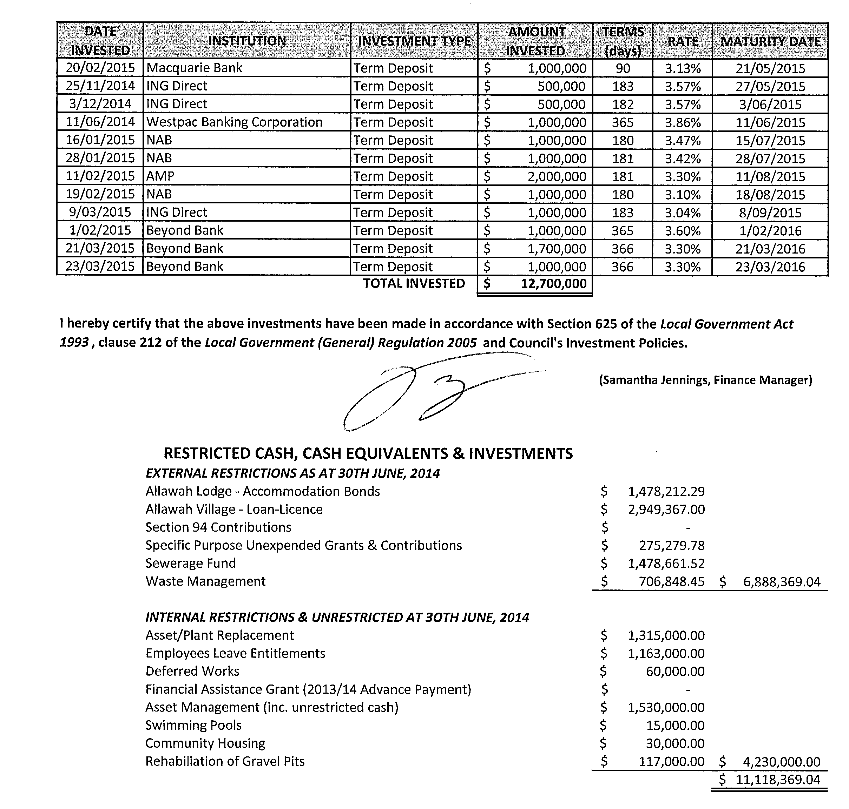
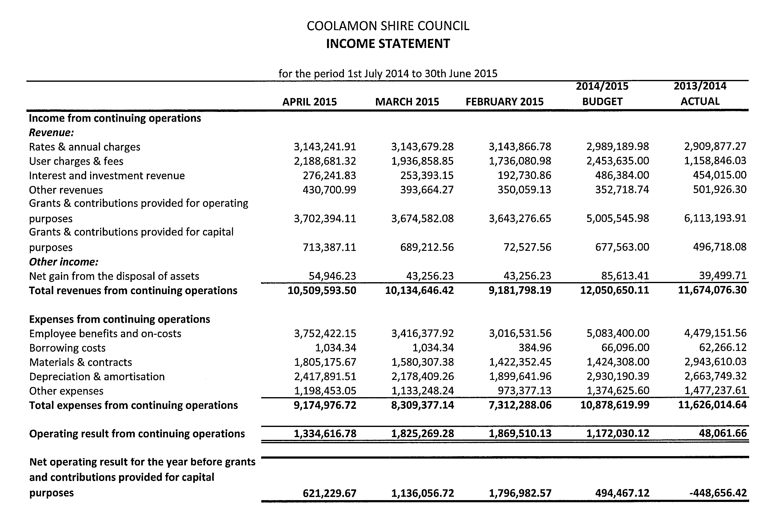
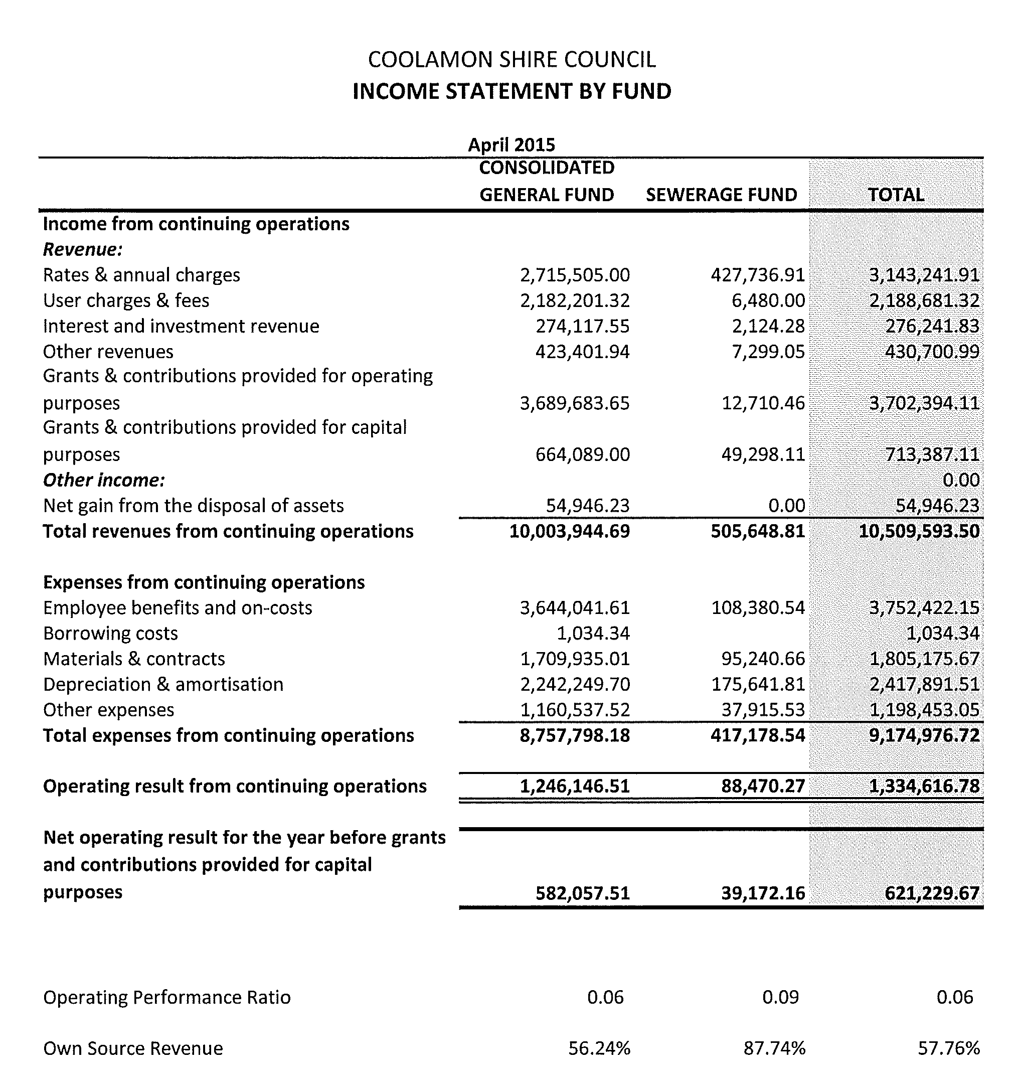
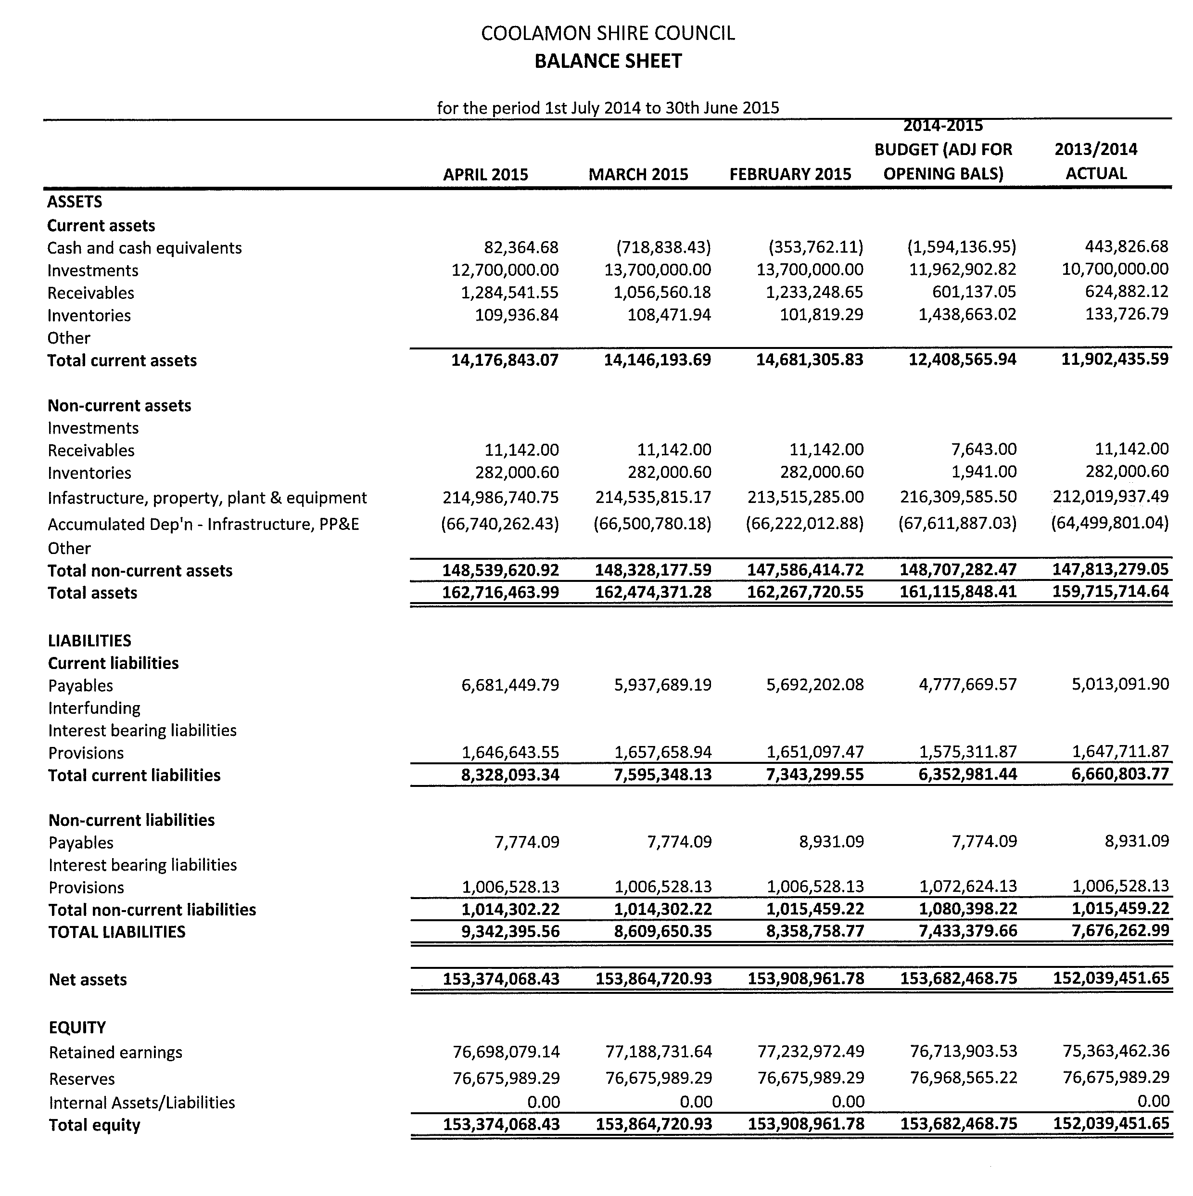
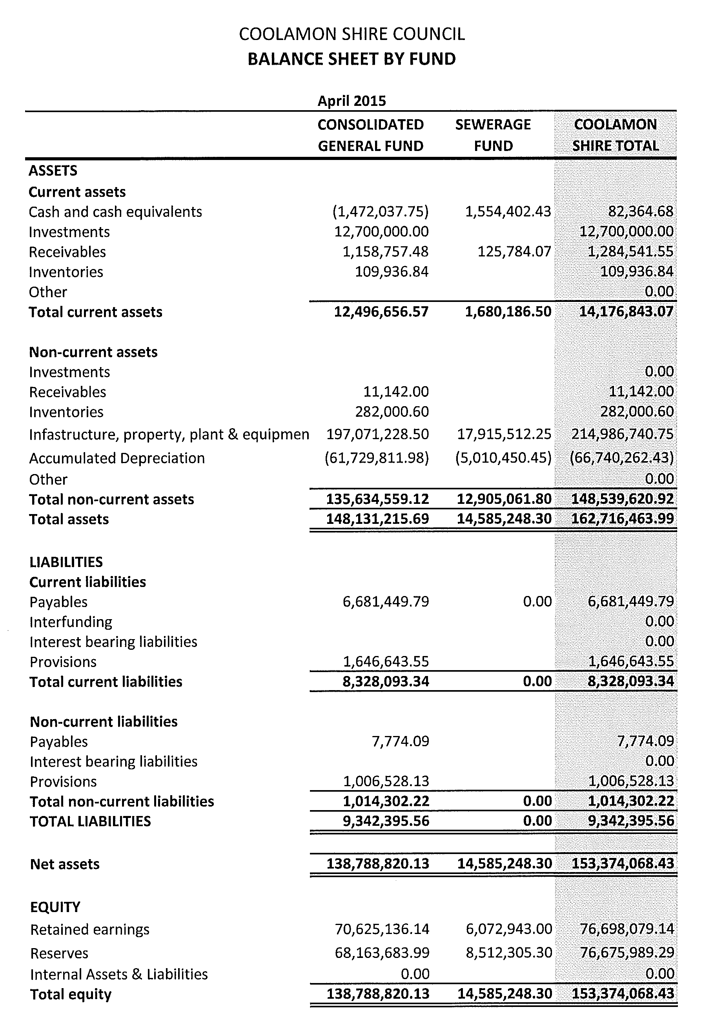
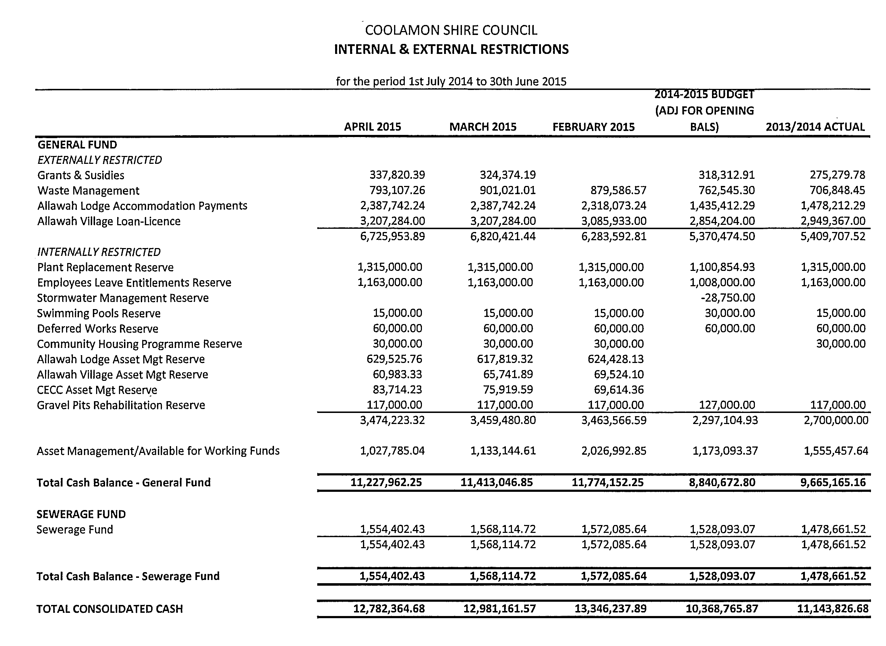
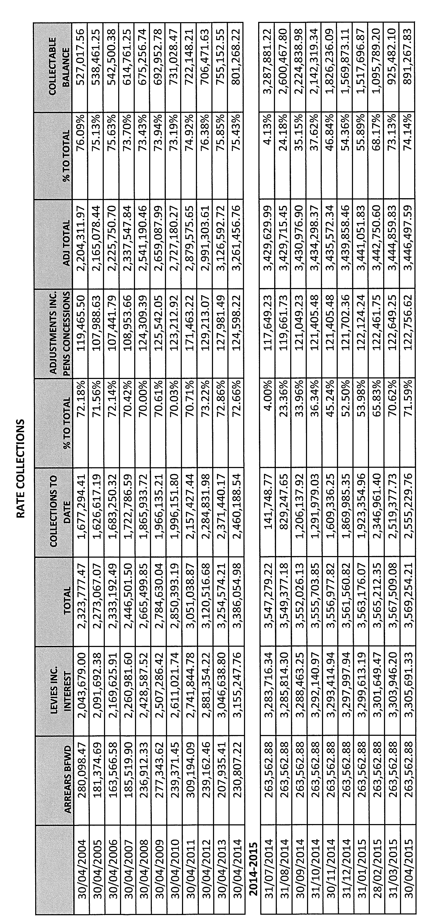
CS2) ALLAWAH LODGE ACCOMMODATION PAYMENTS (A.05-02, SC7)

Following the introduction of the Living Longer, Living Better reforms by the Federal Government, Councillors may recall that changes were made to the amounts that could be charged by Council to enter Allawah Lodge Aged Persons Hostel. Under the previous regime, Council charged a “bond” that was dependent on the resident’s ability to pay and from that bond amounts were retained on a monthly basis for the first five years of residency. Historically this had resulted in income of approximately $64,000 per annum.

Council is no longer able to retain money from the accommodation payment of residents that entered the facility after 1 July 2014, resulting in the loss of the $64,000 retention income. To offset this expected loss, Council increased the maximum accommodation payment to $250,000. The maximum payment of $250,000 is still subject to the resident’s ability to pay as determined by the Department of Human Services.

By increasing the maximum accommodation payment Council’s interest revenue was expected to increase as a result of holding larger accommodation payments. This would offset the $64,000.00 loss.

It should be noted that aged care facilities were allowed to set their own bond amount up to $450,000.00. Most have set their bonds at close to the maximum, Coolamon is one of the few that have not. In setting the fee Council was mindful of the Communities ability to pay the bond and then provide for the ongoing care requirements.

➔ Attached is the final report from KPMG showing the financial impacts of the reforms given a variety of assumptions. Attachment No. 9

To assist residential aged care providers with the accommodation payment reforms, the Department of Social Services appointed KPMG to provide transitional business advisory services. Completely subsidised by the Department of Social Services, KPMG was offering two levels of service and Council staff applied to have the financial impact of the reforms modelled for Allawah Lodge Aged Persons Hostel.

As detailed in the report, Council will have to continue to monitor its resident ratios and accommodation payment balances to ensure that Allawah Lodge Aged Persons Hostel continues to be a financially sustainably business arm of Council.

Recommendation

For Council information.
RESOLVED on the motion of Clr White and seconded by Clr Hutcheon that the report be received. 98/05/2015

CS3) 2016 COUNCIL ELECTIONS (E.01-02, SC158)

Councillors would recall a report presented to the October 2014 meeting of Council regarding the engagement of the NSW Electoral Commission to conduct the 2016 Local Government Election for the Coolamon Shire on Council’s behalf.

➔ Council has now received the Contract from the Electoral Commission for signature. The Contract also contained an estimate of the costs of providing services to Council which equates to $30,843 excluding GST. (See attachments).
Attachment No. 10

This amount has already been included in the budget. Future documentation will be received in regard to this process and it may be appropriate that Council endorse the signing of any of these documents to ensure that the process can run smoothly and efficiently.

Recommendation

That Council delegate the General Manager and Mayor to sign documents associated with the Electoral Commission conducting the 2016 local Election.

RESOLVED on the motion of Clr Beard and seconded by Clr McCann that Council delegate the General Manager and Mayor to sign documents associated with the Electoral Commission conducting the 2016 local Election. 99/05/2015

CS4) COUNCIL BANKING SERVICES (B.01-03, SC50)

Council will recall the decision by Westpac Banking Corporation to close the in-store branch in June of last year. At the time, Council requested that staff investigate the opportunities of a transfer of Council’s banking services to Beyond Bank.

Council Staff have had numerous contact with Beyond Bank to date and at this point in time its current electronic banking platform is not compatible with Council’s finance system to enable a complete transfer of Council’s Banking Services. Council have been utilising the Beyond Bank branch in Coolamon to undertake daily deposits and withdrawals but this has resulted in additional “back office” work for staff with electronic transfers of funds having to be initiated to and from Council’s Westpac accounts. This process means that deposits are double handled and funds have to clear at Beyond Bank prior to them being transferred to Westpac delaying Council’s Bank Reconciliation matching process.
In recent times, Westpac Banking Corporation has announced that it has come to an arrangement with Australia Post to provide banking services from Post Offices. This service will allow Council to deposit and withdraw with Australia Post with no additional costs. Staff are currently completing the required paperwork to enable Council to take advantage of this opportunity.

Council staff will remain in contact with representatives from Beyond Bank so that in the event that changes to its electronic banking platform are made that it could be considered as an alternative provider for Council’s banking services.

Recommendation

That the report be noted.

RESOLVED on the motion of Clr Hutcheon and seconded by Clr Maslin that the report be received. 100/05/2015

CS5) QUARTERLY BUDGET REVIEW AS AT 31 MARCH 2015 (F.02-02, SC178)

➔ Enclosed with the attachments is the Quarterly Budget Review Statements to the 31 March 2015 for Council’s information. The Review reveals a change in Council’s anticipated operating result after capital amounts from a surplus of $1,172,030 to a surplus of $1,948,986. Attachment No. 11

Council’s anticipated nett cash position has decreased from a deficit of $707,272 to a surplus of $1,671,492 being a favourable variance of $2,380,456.

The following items have been subject to material forecast changes:

Administration/Engineering
Expenditure
Item | Original Budget | YTD  31/03/15 | Amended Budget | Variance  ($) | Variance  (%)
Office Equipment Depreciation | 52,000 | 57,364 | 76,000 | (24,000) | 270.59 (U)
Overheads Charge to other Works | (260,000) | (345,398) | (400,000) | 140,000 | 53.85 (F)

- Office Equipment Depreciation – additional expenditure following the completion of the purchase of Council’s finance system.
- Overheads Charge to Other Works – Council’s overhead charging regime has resulted in the additional offsets being achieved.

Community Services & Education

Expenditure
Item | Original Budget | YTD  31/03/15 | Amended Budget | Variance  ($) | Variance  (%)
Allawah Community Care – Grants Funds | 0 | 0 | 15,000 | 15,000 | (U)

- Allawah Community Care – Grant Fund – Council, after acquitting the grant funds is required to return any excess monies held.
Housing & Community Amenities
Income
Item | Original Budget | YTD  31/03/15 | Amended Budget | Variance  ($) | Variance  (%)
Development Application Fees | 10,000 | 18,868 | 19,000 | 9,000 | 90.00 (F)
Cemeteries (net) |  |  |  | 15,000 | (F)

- Development Application Fees – Additional income has been achieved year to date.
- Cemeteries – additional income has resulted in this favourable variance.

Recreation & Culture
Expenditure
Item | Original Budget | YTD  31/03/15 | Amended Budget | Variance  ($) | Variance  (%)
Parks & Gardens – Water Charges | 30,000 | 33,227 | 40,000 | (10,000) | 33.33 (U)

- Parks & Gardens – Water charges – higher than anticipated water charges are expected given year to date expenditure

Economic Affairs
Income
Item | Original Budget | YTD  31/03/15 | Amended Budget | Variance  ($) | Variance  (%)
Allawah Lodge Fees & Subsidy | 1,390,000 | 1,128,750 | 1,500,000 | 110,000 | 7.91 (F)

- Allawah Lodge Fees & Subsidy – based on year to date figures additional income is expected

Capital Incomes
Item | Original Budget | YTD  31/03/15 | Amended Budget | Variance  ($) | Variance  (%)
Coolamon Caravan Park Grant | 0 | 73,017 | 73,017 | 73,017 | (F)
Fixing Country Roads | 0 | 0 | 448,000 | 448,000 | (F)

- Coolamon Caravan Park Grant – successful grant application for the upgrade of the Coolamon Caravan Park
- Fixing Country Roads – successful grant application

Investing Activities
Expenditure
Item | Original Budget | YTD  31/03/15 | Amended Budget | Variance  ($) | Variance  (%)
Community Housing Properties | 30,000 | 0 | 0 | 30,000 | (F)
Council Chambers | 40,000 | 38,439 | 38,439 | 1,561 | (F)
Fixing Country Roads | 0 | 0 | 448,000 | 448,000 | (U)
RTC Airconditioning | 0 | 14,409 | 14,409 | 14,409 | (U)
87 Cowabbie Street | 0 | 230,000 | 230,000 | 230,000 | (U)
Coolamon Caravan Park | 0 | 60,000 | 0 | 60,000 | (F)
Coolamon Preschool | 0 | 27,070 | 27,070 | 27,070 | (U)
Real Estate Development | 1,024,860 | 32,300 | 40,000 | (984,860) | (F)

- Community Housing Properties – expenditure has been transferred to operational
- Fixing Country Roads – expenditure of grant funds expected this year
- RTC Airconditioning – replacement of airconditioner was not included in Council’s original budget
- 87 Cowabbie Street – purchase of building was not included in Council’s original budget
- Coolamon Caravan Park – works have been deferred until next financial year
- Coolamon Preschool – works have been undertaken to rectify subsidence issues. This will be offset by an insurance claim that is yet to be finalized.
- Real Estate Development – The development of Doughty/Hornby subdivision will only involve drafting this financial year.

Responsible Accounting Officer Statement

It is my opinion that the Quarterly Budget Review as presented to Council for the quarter ended 31 March 2015 indicates that Council’s projected financial position at 30 June 2015 will be satisfactory, having regard to the projected estimates of income and expenditure and the original budgeted income and expenditure.

Recommendation

That the Quarterly Budget Review Statements as at 31 March 2015 be received and noted and the revised budgeted income and expenditure be voted.

RESOLVED on the motion of Clr McCann and seconded by Clr Logan that the Quarterly Budget Review Statements as at 31st March, 2015 be received and noted and the revised budgeted income and expenditure be voted. 101/05/2015

CS6) ARDLETHAN PRESCHOOL FUNDING (C.04-02, SC76)

➔ Attached to this report is the proposed budget for the Ardlethan Preschool that was included in Council’s Draft Operational Plan currently on public exhibition. As can be seen in the forward projections, the preschool’s funding has dropped resulting in projected ongoing operational losses. Attachment No. 12.1

Council received advice in 2013 that the funding for the preschool would be changed. At the time Council sought assurances from the Minister for Education, Adrian Picolli who indicated that the preschool would not be detrimentally affected by the changes to the funding model. The 2016 calendar year is the first year of the transitional period where the funding received will be reduced by 50% with the new model fully implemented in the 2017 calendar year.

➔ The changes have been supported by the State Government’s Operational Support Program to help community preschools adjust to the new Preschool Funding Model. Council has already participated in Stage 1 of this program which involved face-to-face business advisory support. This report is attached for Councillor information. Attachment No. 12.2

Stage 2 of the program commenced in March 2015 and involves more customised, sector-specific advice and mentoring. The ultimate aim of the Operational Support Program is to ensure that community preschools are operated under a business model ensuring that they are optimizing funding received, maximising enrolments, have appropriate fee structures in place, ensure an ongoing improvement plan is developed and underway and that suitably qualified staff can be attracted, retained and developed.

The ongoing operation of the preschool is vital to the Ardlethan community and its surrounds. Council became involved with the preschool in 2007 when the Department of Community Services provided funding to Council to upgrade the Mullins Centre as a premises suitable to conduct the Preschool from. The capital funding was conditional on Council taking on the operation of the Preschool from the Community Committee. Since that time Council has operated the preschool on a user pays principle. If Council was to try to offset the funding reduction by an increase in fees it would require fees to be almost doubled which could result in reduced enrolments.

➔ The State Government has announced that a Community Preschool Viability Funding Program will be available recognising that some community preschools may require additional support to ensure that access to local early childhood education is maintained. (See attached Guiding Principles) The document indicates that the sector will be provided with additional information regarding the Viability Funding in 2015. Attachment No. 12.3
Recommendation

That Council make representations to State Member for Cootamundra, Katrina Hodgkinson; Minister for Education, Adrian Picolli; and Minister for Early Childhood Education, Leslie Williams; regarding the loss of funding and the long term sustainability of the operation of the Ardlethan Preschool.

RESOLVED on the motion of Clr Maslin and seconded by Clr Logan that Council make representations to State Member for Cootamundra, Katrina Hodgkinson; Minister for Education, Adrian Picolli; and Minister for Early Childhood Education, Leslie Williams; regarding the loss of funding and the long term sustainability of the operation of the Ardlethan Preschool. 102/05/2015

CS7) INTERNAL AUDIT COMMITTEE (A.12-02, SC35)

The Internal Audit Alliance recently met to discuss the future of the Alliance and the ongoing program of Internal Audit. It was decided that four Councils, Coolamon, Gundagai, Junee and Temora, would continue with the program for the next two years. The group will be seeking a quotation from the current consultant to provide the services for those two years.

Part of the arrangements for the future is that representatives from the Coolamon Shire Council (Tony Donoghue, General Manager and Courtney Armstrong, Executive Manager, Corporate & Community Services) will be available to be members of the Internal Audit Committee at the Gundagai Shire Council. To date, Council’s representatives have been members of the Audit Committee at Temora Shire Council.

In addition to this the representatives previously from Gundagai Shire Council on Coolamon’s committee would be replaced with representatives from Temora Shire Council.

The Internal Audit Committee does not make binding decisions, but reviews the results of the internal audit process and makes recommendations to Council.

The current committee membership, adopted at the September 2014 Meeting is as follows:

- Mr P McMurray, Gundagai Shire Council
- Mr P Luff, Gundagai Shire Council
- Clr B Hutcheon
- Clr R Huxtable
- Clr D Brill (alternate)

Recommendation

That Mr P McMurray and Mr P Luff be removed from the Internal Audit Committee and that Council invite Mr Gary Lavelle, General Manager and Mr Steve Firth, Director of Administration & Finance from Temora Shire Council to be members of the Coolamon Shire Internal Audit Committee.

RESOLVED on the motion of Clr Hutcheon and seconded by Clr Maslin that Mr P McMurray and Mr P Luff be removed from the Internal Audit Committee and that Council invite Mr Gary Lavelle, General Manager and Mr Steve Firth, Director of Administration & Finance from Temora Shire Council to be members of the Coolamon Shire Internal Audit Committee. 103/05/2015

CS8) 10 WRIGHT STREET, GANMAIN (A.05-07, SC11)

Council has in the past considered reports relating to the provision of aged housing in Ganmain, and resolved to subdivide Lot 5 Section 53 DP 3786 and Lot 2 DP 1174150 to allow for staged construction of units.

Approval for the subdivision has been granted with the connection of services to the proposed new allotments currently underway.

Upon registration of the subdivision, Council will then be in a position to sell the property known as 10 Wright Street.

Recommendation

That Council sell 10 Wright Street, Ganmain upon registration of the subdivision.

RESOLVED on the motion of Clr Logan and seconded by Clr Beard that Council sell 10 Wright Street, Ganmain upon registration of the subdivision. 104/05/2015

4.3 EXECUTIVE MANAGER, ENGINEERING & TECHNICAL SERVICES’ REPORTS

ES1) SHIRE ROADS RESHEETING, STABILISATION AND MAINTENANCE

The following roads have received attention:

1) MAINTENANCE

- Ramp Road (Murrulebale Road to Coffin Rock Road)
- Coffin Rock Road (Ramp Road to Marrar North Road)
- Murrell Creek Road (Ardlethan Road to Pamandi Road)
- McDougalls Lane (Irish Jims Lane to Uley Road)
- Devlin Road (Carrolls Lane to Redrops Lane)
- Carrolls Lane (Devlin Road to Dullah Road)
- Uley road (Ardlethan Road to McDougalls Lane)

2) STABILISATION

- Devlin Road (Redrops Lane to Carrolls Lane)
- Carrolls Lane (Devlin Road to Dullah Road)

3) RESHEETING

- Hodges Lane (End of bitumen to Golders gate)
- Brushwood North Road (Ardlethan Road 2.1kms)
- Carlisle Park Road (Manglesdorfs Lane 2.2kms)
- Poverty Lane (Ardlethan Road to Devlin Road)
- Devlin Road (Redrops Lane to Winrows Lane)
- Devlin Road (Ashbridge Road to Carrolls Lane)

4) ROAD SEALED SHOULDER MAINTENANCE

- London Hill Road (SH17 to Mirrool South Road)

ES2) ROADS TO RECOVERY PROGRAMME 2014/2015 AND FIXING COUNTRY ROADS

1) HODGES LANE (CANOLA WAY TO EMERALD GRAIN ENTRANCE) 600M

Following completion of reconstruction works an asphalt overlay has been applied at the Intersections of:

- Canola Way/Hodges Lane
- Hodges Lane/Emerald Grain Entrance
- Either side of Rail Crossing

2) MATONG NORTH ROAD CULVERT EXTENSION (18.6KMS)

Contractors have commenced works to extend both sides of the culvert at Cowabbie Creek. The extension works will remove existing hazards and liability issues as a result of the non-existent road shoulder and 1.5m drop off.

ES3) BLOCK GRANT 2014/2015 AND TOWN WORKS

INTERSECTION OF WATERVIEW/GRANT STREETS, GANMAIN

Drainage improvement works have been completed at this intersection. Works include:

- excavation of existing drainage network
- realignment of services such as gas, Telstra and water
- installation of improved capacity stormwater pits and pipes
- stabilisation and sealing of road pavement
- reinstatement of nature strip

The new drainage network has an increased capacity and will be able to remove surface water in a more efficient manner alleviating the flooding concerns of surrounding landholder with short intense storms.

ES4) FIXING COUNTRY ROADS

Contractors have performed bridge and culvert inspections at the following locations:

- Smokey Creek Bridge, Mary Gilmore Way
- Kindra Creek Bridge, Ardlethan Road
- Mirrool Street, Ariah Street and Bygoo Road culverts

The results of the assessments will allow Council to make informal decisions as to whether they can withstand the loads of heavy vehicles at Higher Mass Limit.

ES5) COOLAMON TENNIS COURTS

The construction of the new tennis courts are nearing completion. Works performed include:

- Realignment and installation of drainage system
- Court foundation construction to required levels
- Laser levelling of surface and installation of playing surface
- Electricity supply to site and installation of lighting to required standards
- Fencing, top dressing of surrounding area
- Removal of unsuitable trees and replacement with appropriate species

Final costs are yet to be determined with minor maintenance works to be completed. Once final costs have been determined and if any funds remain, further discussions will be held with the Tennis Club to ascertain if any operational issues require attention.

The courts are operational and the Tennis Club have been given access.

ES6) PARKS AND GARDENS REPORT (P.01-01)

Facilities Maintenance Officer Reports

- TENNIS COURTS

Root barrier has been installed on the southern side of the new courts and new trees and shrubs planted on the eastern side.

The surrounds of the courts have been seeded with ryegrass to stabilize soil around the courts.

- COMMUNITY SERVICE

Participants of the Community Service Scheme have recently completed painting of the Cemetery gates at Ganmain, Coolamon and Marrar. This programme has been working extremely well.

Future projects will include works at the Coolamon Golf Course.

- ANZAC DAY

Staff installed a Flagpole in Coolamon’s main street to enable dual flags to be flown for ANZAC Day and other events throughout the year.
- FACILITIES MAINTENANCE

- RFS Shed

Work has continued at the RFS shed repairing faulty building construction when it was originally built.

- Low Incoming Housing

Work is progressing on the final low income home in Dunrobin Street, Coolamon bringing it to a saleable condition.

The property has had floor coverings removed and the kitchen which had been previously damaged also removed.

The property has been painted and the new kitchen and floor coverings will be installed in coming weeks. This is the last of three homes that have been renovated and all are now ready for sale.

- Allawah/Aitken Logan Wing

Recent extensions to perimeter fencing at the Aitken Logan Wing seem to have solved the issue of residents scaling the fence. Sections closest to the building have been extended and the option to extend the entire fence is available if required.

- Other facilities to receive attention in the last month include:

- Coolamon Early Childhood Centre
- Allawah Village Units
- Kindra Units
- Centenary Lodge

ES7) NOXIOUS WEEDS OFFICER’S REPORT (N.02-01)

Noxious Weeds Officer Reports

- The district received good falls of rain during the month and with soil temperatures still warm and daylight temperatures mild, growing conditions for weeds have been ideal. The same has been the case for broad scale crop sowing.

- The Weeds Action Plan 1520 for the Riverina Local Land Services Region has been completed and submitted. This plan is the mechanism by which the State Government contributes financially to weed management in NSW.

- The first major change resulting from the NRC Weeds Review will take place in the next 6 months. The Eastern and Western Riverina Noxious Weeds Advisory groups will be reformed into LLS region based weeds Advisory Committees formed under the LLS Act. The RENWA area is in the Riverina LLS area. The Riverina Noxious Weeds Project Officer will continue to provide services to the Riverina and Murray LLS Regions.

- A Field day to promote awareness to the invasive weeds Orange Hawkweed & Mouse Eared Hawkweed at Tooma was attended. The Hawkweeds are present on limited sites in small numbers in Kosciusko National Park. They are highly invasive and the RENWA area is well within their potential expansion range. An extensive eradication operation is underway.

- An example of the dangers of carelessly buying seed over the internet was discovered in Bland Shire. Weeds Officers networking effectively led to the seizure of a quantity of seeds labelled Kochia scoparia. The seeds were sourced from China and imported for resale. Kochia scoparia is a Class 1 State Prohibited Weed across NSW. That particular weed cost the Western Australian government millions of dollars to control when an infestation was discovered. No seeds were sold and the individual involved cooperated fully. A great result.

- Mapping of all Shires continue with every road, lane and weed harbour being inspected. The need for this ongoing mapping has never been more important with the news that a single Parthenium plant was discovered in the Quandialla/West Wyalong area. The cost of a Parthenium weed outbreak in the region would be devastating. The necessity to conduct regular, thorough mapping is essential. . A trial involving the common base mapping system shared by all RENWA councils will commence shortly. The trial is to ascertain if a more integrated data system can be evolved.

- Preparation for research into Silver leaf nightshade (SLN) control in 2016 as mentioned in the March Report, continues with more sites being added to the list. 2015 has been a year of unprecedented outbreaks of this hard to kill perennial weed. The research, which starts in earnest next year, will collate the results of different herbicide applications from many landholders and other practitioners to narrow down the most successful methodology.

- In June, Tiger Pear along the old Gundagai Road have been inspected and a plan to remove this thorny problem has been formed. The outbreak has thankfully not spread due to its continued area. Tiger Pear is readily spread by stock and vehicles.

- Still on Tiger Pear, a quantity of the weed was sent to Orange DPI Institute two months ago for it to be inoculated with a specific strain of insect from the Cochineal family. These insects feed specifically on Tiger Pear and have been returned and distributed along Halbishes Lane at Matong and Boginderra Road and Boyd’s Road, Temora. Results of their effect are not expected for six months but according to Aaron Simmons from DPI Orange, a significant result is expected.

- In Coolamon Shire further outbreaks of Prairie Ground Cherry has been detected. As well as the known sites along Rannock Road and Bootheys Lane, two new sites have been identified and sprayed on the Wagga Road. As well as extension of the original site at Bootheys Lane, three more sites have been identified. Furthermore, a new site has been located at the northern end of Berry Jerry Road. All these sites have been sprayed and the results noted for later comparison

- In view of the discovery of these new sites of Prairie Ground Cherry and the expansion of the already know sites, an information day was held in the old Rannock School. Local landholders were notified of the day (15) and the relevance of the meeting was highlighted by the fact that only a few had heard of the weed and nearly all saying that they had never seen it. This was hardly surprising as only six cases of the weed had been recorded in ten years. In addition, the weed is not widely distributed and has a “low profile” with scrambling growth. Like Silverleaf nightshade, Prairie Ground Cherry has a deep root system and is notoriously hard to kill. Participants on the day were made familiar with the weed and what is believed to be the vector for its spread – the fox.

- Blue heliotrope has also been a problem with known sites becoming infested again as well as new outbreaks being found. All these sites are scheduled for spraying.

Recommendation

For Council information.

RESOLVED on the motion of Clr Beard and seconded by Clr White that the Executive Manager, Engineering & Technical Services Reports (ES1 to ES7) be received. 105/05/2015

ES8) JOHN HOLLAND RAIL (JHR) – ARDLETHAN SIDING EXTENSION (R.09-11, SC345)

John Holland Rail have advised Council of the intention to construct an extension to the rail siding west of the Mirrool Street level crossing. The proposal is to extend the existing siding towards town with the turn out relocated approximately 80m west of the Mirrool Street Crossing with the intension for an 1100m long train to be contained within the siding. As can be seen in Council’s Manager, Planning & Environmental Services report both Graincorp and Emerald Grain intend to invest heavily in their sites and install overhead rail siding facilities which will result in a significant number of heavy vehicles being removed from the road network. Indications are that only grain for domestic use will be transported from the site by heavy vehicles.

➔ JHR have engaged the services of BG&E to develop a Functions and Requirements Report which Council will be making comment on, document and proposal attached. Attachment No. 13

Councils Manager, Environmental & Technical Services and Manager, Planning & Environmental Services attended a project start up meeting and site inspection on Wednesday, 29th April, 2015 and highlighted the following as issues to be considered:

1) Flooding of Ardlethan, debris buildup on existing rail culverts, impact of proposal and the development of a Flood Study which is its final stages.

2) Increase drainage capacity under rail line to cater for additional run-off from extended grain bunker areas.

3) Replacement of removed vegetation.

4) Rail crossing delays.

JHR have responded confirming the following points:

1) Amend to include JHR (in addition to Emerald Grain) as being open to planting trees within their boundary to offset the removal of mature trees.

2) Rail levels of any new track work must not be higher than the adjacent existing mainline at any kilometrage, because of reports that the existing rail line “acts as a kind of spillway”.

3) Mirrool Street Level Crossing is not to have rail wagons across it whilst any wagons are in the process of being loaded and require each train to pass across this Level Crossing in a single movement to minimize road user delay as far as practicable.

4) Incorporate the new culvert in the concept site plan.

Ultimately the proposal satisfies the objectives of the Regional Freight Transport Plan and is intended to be completed prior to the 2015/2016 harvest.

Recommendation

For Council information.

RESOLVED on the motion of Clr Maslin and seconded by Clr Beard that the report be received. 106/05/2015

ES9) MASLINS LANE (PF2157)

➔ Council has become aware of an irregularity with regard to the Road Reserve boundary and road formation of Maslins Lane that occurred somewhere as far back as 1989. (See attached Plan). Attachment No. 14.1

➔ At the time of this issue coming to the attention of Council, correspondence with the then landholders PE & FJ Minchin and KD & JN Riseborough indicated that Council had reached an agreement with the previous owner, Ron Williams to relocate the road on the basis that there would be a land swap. Ron Williams confirmed that he had agreed to the land swap on the basis that Council would pay for all costs and fees in relation to the transfer of the old roadway to Mr Williams and the declaration of the new roadway. Council has responded to the Minchins and Riseboroughs by acknowledging the issue was not rectified at the time with Mr Williams and would now commit to rectify the situation.
Attachment No. 14.2

To complicate the issue the existing Road Reserve is part Council Public Road and part Crown Road. In order for the transfer to occur the Crown Lands Department have advised that the best option for Council is to have the Crown Road section transferred to Council, close the whole Council Road under the new Land Department process, create the new road reserve and apply to the Lands Department for a land swap. Resolving this issue will remove any liability issues Council are currently open to. Since previous correspondence with landowners, the Minchins have sold their interest in the subject land to the Riseboroughs.

Recommendation

That Council proceed with the closure of the Road Reserve, creation of new Road Reserve and land swap with KD & JN Riseborough.

RESOLVED on the motion of Clr McCann and seconded by Clr Hutcheon that Council proceed with the closure of the Road Reserve, creation of new Road Reserve and land swap with KD & JN Riseborough. 107/05/2015

4.4 MANAGER, PLANNING & ENVIRONMENTAL SERVICES’ REPORTS

HS1) DEVELOPMENT APPLICATIONS (B.05-03)

The following applications have been approved:-

DEVELOPMENT APPLICATIONS

07/2015 11//866258 – 91 Cowabbie Street, Coolamon – Cheese Factory & Office.
16/2015 26//750835 – 745 Dullah Road, Ganmain – Alterations & Additions to Dwelling.
23/2015 275//750867 – 18 Wilson Street, Ardlethan – RFS Fire Shed.
24/2015 26//1096316 – 3 Hakea Drive, Coolamon – Dwelling.
25/2015 8//878577 – 10 Jerricks Lane, Coolamon – Alterations & Additions to Dwelling & Shed.
28/2015 106//750838 – 44 Matong North Road, Matong – Alterations & Additions to Dwelling.
29/2015 62//1109825 – 1 Kingdon Drive, Coolamon – Dwelling.
30/2015 2//1174150 – 10-12 Wright Street, Ganmain – Subdivision.
31/2015 5//663949 – 46 Cowabbie Street, Coolamon – Enclosure of Verandah.

Recommendation

For Council information.

RESOLVED on the motion of Clr Beard and seconded by Clr White that the report be received. 108/05/2015

HS2) ARDLETHAN FLOOD STUDY (F.04-03, SC185)

On the 30th April, 2015 Council facilitated a Public Meeting regarding the progress of the Ardlethan Flood Plain Risk Management Plan and Study. The meeting was attended by Council’s General Manager; Manager, Planning & Environmental Services; and Clr Maslin. Also in attendance was Trevor Clark from GHD (Council’s Flood Consultant) and approximately 20 members of the public.

At the meeting it became readily apparent that the community do not necessarily agree with the majority of recommendations held within the draft report, specifically in relation to the role that the Railway plays during a flood event. As a result, council have already received photos from Ardlethan residents to support their claims. These photos were forwarded through to GHD for their perusal.
The other major point of contention raised at the meeting was in relation to a proposal within the report to install flood warning devices within the Bygoo and Mirrool Creek Catchments. This matter has also been raised by the Committee on previous occasions, as Council would be required to pay for equipment (as well as any maintenance) for a system that would provide a greater benefit for towns downstream as Ardlethan and Beckom are located too high in the Catchment.

➔ Since the meeting GHD have provided an updated draft report (which has been attached) that acknowledges the Public Meeting and the Community’s perspective on flood behaviour. Attachment No. 15

GHD have proposed that the draft report be placed on public exhibition to enable formal feedback from the public (inclusive of Ardlethan and Beckom residents) and other key stakeholders including State Government Departments.

Recommendation

That the draft Ardlethan Flood Plain Risk Management Plan and Study be placed on public exhibition.

RESOLVED on the motion of Clr Maslin and seconded by Clr Beard that the draft Ardlethan Flood Plain Risk Management Plan and Study be placed on public exhibition. 109/05/2015

HS3) ARDLETHAN GRAIN TERMINALS & RAIL LOADING FACILITIES

Further to the earlier report by the Executive Manager Engineering & Technical Services relating to the extension of the Ardlethan rail siding, discussions have been held with both Graincorp and Emerald Grain relating to proposed overhead rail loading facilities by each organisation at their Ardlethan sites located on Kamarah Tank Rd.

Each Company’s proposal is directly related to the extension of the previously discussed rail siding to the west of the Mirrool Street level crossing, with Council having been advised by John Holland Rail representatives that the siding works could only proceed if both organisations committed themselves to improved loading infrastructure. With John Holland Rail now finalising design work, it would be fair to say that both grain handlers are also committed.

As Councillors are aware from the meeting held in August 2014, Emerald Grain have already commenced seeking in-principle support from Council for an overhead conveyor linking their Kamarah Tank Rd site to the rail siding. In addition to Emerald’s proposal, Graincorp have also indicated their intention to develop significant overhead infrastructure alongside the rail approximately 300m to the west of the Emerald proposal.

Should both projects be approved, approximately 200,000 tonnes of grain would be able to be loaded direct to rail. In comparison it is estimated that only half this quantity, perhaps less, actually leaves Ardlethan on rail at present.

The principle of loading grain onto rail for freight is one that Council supports. It removes freight vehicles from the Road Network and better utilises existing rail infrastructure.

At this stage Development Applications are yet to be lodged, however it is understood that both grain handlers will be submitting applications within the next 1-2 months with an anticipated commencement of operations prior to the forthcoming harvest.

Once applications are submitted they will be dealt with appropriately under the EP&A Act.

Recommendation

For Council information.

RESOLVED on the motion of Clr Maslin and seconded by Clr McCann that the report be received. 110/05/2015

HS4) Development Application 03/2013 – REFURBISHMENT, RENOVATION & pARTIAL RECONSTRUCTION OF HOTEL – Lot 4 SECTION 6 DP 758657 – FARMERS HOME HOTEL MATONG STREET MATONG (RT1000942)

➔ Council recently received sufficient information to proceed with a Development Application originally submitted by the owner of the Farmers Home Hotel in Matong in 2013. A copy of the proposal has been attached. Attachment No. 16.1

➔ The application was submitted, along with an application for a Building Certificate following proceedings in the NSW Land & Environment Court in 2009 between Council & the owner, who had reconstructed much of the fire-damaged structure without Council consent. The Short Minutes of Order from the Court ruling have been attached for reference. Attachment No. 16.2

In accordance with Council policy the Development Application was notified to adjoining landholders and a notice also placed on Council’s website. No responses were received.
Following an assessment of the development proposal it is considered that the requirements of Section 79C of the Environmental Planning & Assessment Act 1979 have been met. In other words, there do not appear to be any potentially negative aspects of the proposal from a planning perspective. However with that being said, the major issue surrounding this development has always been structure-related, and in particular guaranteeing the structural soundness of the building in its entirety.

➔ In 2012 the applicant applied for a Building Certificate, as per the Court Order, however Council deferred its determination for a number of reasons, none of which have been rectified to date. Copies of correspondence dated 15 August 2012 and 11 February 2013 highlighting Council’s reasons for the deferral of a Building Certificate thus far have been attached. Attachment No. 16.3

Building Certificates are issued under Section 149A of the Act, and are essentially a method of determining that a premises is free of any physical or legislative defect that would otherwise cause Council to issue an Order. Once a Building Certificate is issued, Council are prevented under the Act from placing an Order over a property for a period of 7 years. It is therefore imperative that Council are thorough and have complete certainty regarding all facets of a premises prior to issuing a Building Certificate.

Since the previous decision by Staff to defer the Building Certificate, the building has sat dormant with no further rectification works undertaken. This gives reason for Staff to hold concerns regarding whether or not the building is suffering from the ingress of weather and rainwater which has already contributed to the decay of some of the illegal works already undertaken prior to the Court proceedings. This also brings into question the validity of the structural report (dated 10 July 2012) as provided by the applicant in previous correspondence.

Of particular concern is the state of the cracking over the main entrance on the northern elevation of the building. A comparison has been provided below to depict how damage to this element of the structure has deteriorated over the past 6 years:

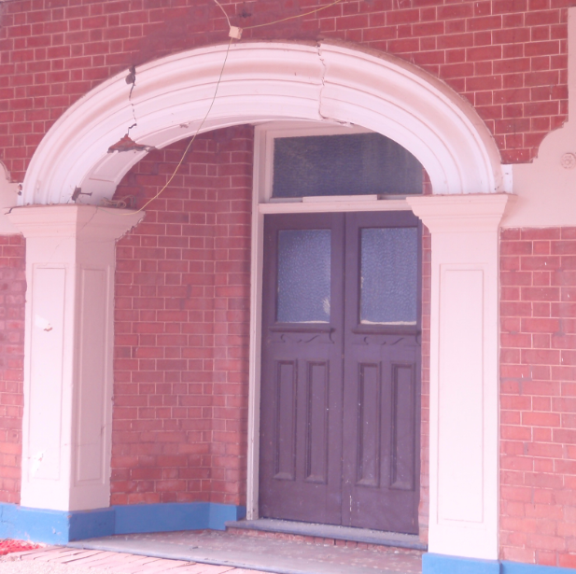  25/3/2009 | 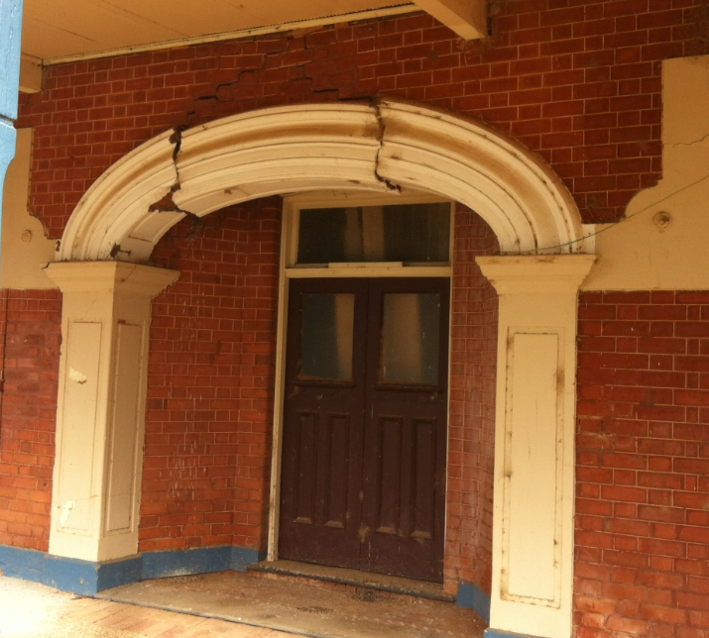  11/5/2015

From the above images it can be clearly seen that the cracks around the upper-most section of the doorway arch have continued to open, and as a result the section of the arch has dropped approximately 50mm into the open space below. What makes this structural defect worrying to staff is that it is significant enough to suggest that there are other parts of the building that aren’t as visible that may also be failing as a result of either the age of the building, and/or the effects of the fire that destroyed the hotel in 2007.

The fact that the arch borders public land should also be of concern to Council. It is therefore considered appropriate for Council to require the applicant to provide an updated Structural Certification for the purposes of both the Development Application and the Building Certificate.

In summary there are 2 main issues for Council to consider. These are primarily whether or not there are significant planning grounds that need to be considered prior to the granting of a Development Consent, and whether or not the building can be proven to be structurally adequate to allow Council to issue a Building Certificate.

Given that the development proposal is to re-affirm the use of the site as a hotel, it is recommended that Council approve Development Application 03/2013 subject to the conditions of consent listed below. It is also recommended that the determination of the Building Certificate be deferred until such time as the applicant provides to Council an updated structural engineers certification that categorically confirms that the building in its present state (i.e. no earlier than May 2015) is structurally adequate.

Recommendation

1) That Council defer its determination on a building certificate until such time as an updated structural engineers certification has been provided confirming that the building in its present state (i.e. no earlier than May 2015) is structurally adequate; and

2) That Development Application 03/2013 be approved subject to the following conditions of consent:

The development shall be undertaken in accordance with the plans and supporting documentation lodged in respect of this application except where varied by the following conditions.

All aspects of this development shall comply with the Environmental Planning and Assessment Act 1979 and all relevant Acts and Regulations thereunder, together with all Council planning and development policies. In particular all construction and associated building works shall comply with the Building Code of Australia and any applicable Australian Standards thereunder.

PRIOR TO CONSTRUCTION

- Prior to construction of the approved development it is necessary to obtain a Construction Certificate. A Construction Certificate may be issued either by Council or an appropriately accredited certifier. A separate application, complete with detailed plans and specification must be submitted and approved prior to any work on site.

- Amended plans shall be submitted for approval by Council prior to the commencement of works specifically to include an additional room for short-term accommodation that is accessible for people with a disability (together with accessible shower and toilet facilities on the same level).

NOTE: Also refer to Condition 34.

- Prior to the commencement of works, a certification from a practicing structural engineer is to be provided to Council confirming that the building in its present state (i.e. no earlier than May 2015) is structurally adequate.

- Full details of the proposed onsite-sewage management system (i.e. the septic), including tank and effluent disposal details, are to be provided to Council for approval prior to the commencement of construction.

- Structural Engineers drawings prepared by a Practicing Structural Engineer of professional status are to be provided in respect of:

a) Structural steelwork.
b) Slab design
c) Roof trusses.
d) Bracing detail.

- A certification from a suitably qualified professional in respect to the developments compliance with Section J of the Building Code of Australia, which specifically relates to Energy Efficiency.

- Due to the building being listed as having local heritage significance, any change of colour or building material used on the external façade, all signage, advertising and/or notices associated with this development (including corporate brandings) must be submitted to and approved by Council prior to its application or erection on site and before a Construction Certificate is issued.

DURING CONSTRUCTION

- Site signage shall apply, and must be erected on the site in a prominent, visible position, stating that unauthorised entry to the site is not permitted. It should show the name of the builder or another person responsible for the site and a telephone number at which the builder or other persons can be contacted outside working hours. Any structures erected to meet requirements of this condition must be removed when it is no longer required for the purposes for which it was erected.

- For the purpose of inspection, twenty-four (24) hours notice must be given to the Principal Building Surveyor in respect of the following works for reasons of required inspections:-
- Footings;
- Slab and other Steel Reinforcement;
- Frame (including subfloor where applicable);
- Wet area waterproofing;
- Stormwater;
- Final prior to occupation.

- Construction work shall take place during normal working hours, namely 7.00am to 5.00pm, Mondays to Fridays and 8.00am to 1.00pm Saturdays (no work on Sundays or Public Holidays) and in a manner so as not cause a nuisance (by the generation unreasonable noise or other activity) to the owners and/or residents of adjoining properties.

- The development shall not interfere with the amenity of the neighbourhood by reason of the omission of noise, vibrations, smell, fumes, smoke, vapour, steam, soot, ash, dust or water waste, waste products or grit, oil or any other form of pollution that may affect the neighbouring amenity.

- In accordance with the Plumbing and Drainage Act 2011 and the regulations thereunder, the person responsible for the plumbing and drainage works is required to submit the following documentation to Council:

  - A Notice of Work prior to commencement;
  - A Certificate of Compliance upon completion of the work; and
  - A Sewer Service Diagram upon completion of the work and prior to a final inspection being carried out by Council.

NOTE: The Act also requires that a copy of the Certificate of Compliance and the Sewer Service Diagram be supplied to the owner of the premises upon completion of the works.

- All requirements of the Workcover Authority (including the Dangerous Goods Branch) shall be complied with for the duration of all demolition and building work.

- Demolition or removal of any existing buildings, or its parts shall be carried out in a manner so that the risk of injury to the health and safety of site personnel and public persons will be minimised. Identify and locate service supply mains – Water, Electricity and notify controlling Authority to disconnect such services prior to demolition.

- For the duration of any work on site, the Builder must maintain a copy of the specification, stamped approved plans, copy of Development Consent and Construction Certificate on site.

- At all times during construction the site shall be provided with adequate fencing and barricades to restrict any access to the site by the public.

- Provision shall be made on site for the proper storage and disposal of waste such that no builder’s waste shall be left in the open. Specific attention should be given to items which are subject to relocation by the action of wind, e.g. paper, sheets of iron, ridge capping, cement and lime bags and the like.

- Where site conditions require the provision of a retaining wall, all drainage associated with this work hall disperse clear of the building and any other building on site. The retaining wall shall be designed and installed by a suitably qualified person.

- Care shall be taken to ensure all existing plumbing and drainage lines are protected from damage during construction. Should any existing pipelines be affected by the building work then they will need to be re-laid clear of the building alignment and in accordance with the requirements of Australian Standards 3500. Full details of this work must be submitted to and approved by Council prior to proceeding.

- Building and construction materials, plant, equipment and the like are not to be placed or stored at any time on Council’s footpath or roadway.

- All framework to comply with the National Timber Framing Code AS 1684 – 2006.

- Where new or replacement hot water systems are installed, the system must deliver hot water to a maximum of 50 C to all outlets within the building that are to be set aside for personal hygiene.

- All water services are to be tested in accordance with the requirements of the Plumbing Code of Australia.

- Plumbing and drainage installation and alterations shall be carried out in accordance with the provisions of the NSW Code of Practice for Plumbing and Drainage which adopts the National Plumbing and Drainage Code AS 3500, with NSW variations.

For the purpose of complying with these standards inspections shall be carried out:
1. When all internal plumbing work is installed and prior to concealment.
2. When all external plumbing work is installed and prior to backfilling.

PRIOR TO OCCUPANCY

- The applicant is to obtain an Occupation Certificate pursuant to Section 109C of the EP&A Act 1979, as amended, from either Council or an Accredited Certifying Authority at the completion of the works to certify that works have been completed in accordance with the applicable standards of this consent.

- As a Licenced Premises serving alcohol and potentially providing gaming opportunities, the development is to comply with all requirements of the NSW Office of Liquor, Gaming & Racing. Evidence of such compliance shall be provided to Council prior to occupancy being granted.

- All stormwater shall be discharged to the roadside kerb and gutter. Any penetration of the kerb is to be done so as to not cause any damage to the existing kerb and gutter.

- The building is to be protected from attack by subterranean termites. A notice showing full details of the termite barrier system complying with AS3660.1 – 1995 is to be submitted to Council BEFORE COMMENCEMENT OF WORK.

IT SHOULD BE NOTED THAT:
Council will not permit the use of hand held sprays for treatment beneath slab construction as the effective life of the treatment is limited. To retreat the slab it is necessary to drill holes throughout the slab at 400mm centres and introduce fresh chemical.

- Clause B1.3(j) of the Building Code of Australia requires that a durable notice must be permanently fixed to the building in a prominent location, such as in a meter box or the like, indicating:
a.the method of protection; and
b.the date of installation of the system; and
c. where a chemical barrier is used, its life expectancy as listed on the National Registration Authority; and
d.the need to maintain and inspect the system on a regular basis.

- The door to a fully enclosed sanitary compartment must:
    - open outwards
    - slide or
    - be readily removable from the outside of the compartment, unless there is a clear space of at least 1.2 metres between the closet pan within the sanitary compartment and the nearest part of the doorway.
- All wet areas including shower rooms, slop hopper or sanitary compartments must be water-resistant or waterproof in accordance with AS 3740 and the requirements of F1.7 of the Building Code of Australia.

- All rooms must be provided with light and ventilation in accordance with Part F4 of the Building Code of Australia.

- Any disabled access ramps and handrails shall be installed in accordance with Australian Standard 1428.1- 2009 Design for Access and Mobility, Part 1: General Requirements for Access – New Building Work.

- The building must be provided with tactile ground surface indicators at the path of travel meeting a vehicular way adjacent to the principal public entrance to a building, where there is no kerb or kerb ramp at that point. Any tactile ground surface indicators required must comply with AS 1428.4.1.

- Provision shall be made in the building and onsite for:

- Access to the building for people with disabilities in accordance with the Building Code of Australia).

- Toilet facilities for people with disabilities in accordance with the Building Code of Australia, such facilities shall be accessible to persons working in or using the building, and in accordance with this requirement.

- One motor vehicle parking space on the site for the exclusive use of people with disabilities. This parking space must have a direct path to the building and all required accessible areas complying with AS1428.

- In accordance D3.1 of the Building Code of Australia, at least 1 room for short-term accommodation is to be made accessible. This shall also include access on the same storey to accessible shower and toilet facilities.

- Braille and tactile signage must comply with AS 1428.1 and Specification D3.6 of the Building Code of Australia.

- Signage in accordance with AS1428.1 must be provided for accessible unisex sanitary facilities to identify if the facility is suitable for left or right handed use.

FOOD HANDLING & TRADE WASTE REQUIREMENTS

- The kitchen and any other section of the building to be used for the preparation, storage or sale of food, together with all finished surfaces, equipment and appliances in that section, shall be constructed and be of a type that is strictly in accordance with the provisions of the Food Act 2003, as amended, the Regulations made thereunder, and the Australian Standard AS4674 – 2004 Construction and Fit Out of Food Premises.

- All food preparation areas are to be provided with separate basins used solely for the purpose of hand washing. Hot and cold running water is to be provided through a single mixing spout. Soap and paper towels are to be provided to each of these hand wash basins.

- The kitchen must be provided with a kitchen exhaust hood complying with AS/NZS 1668.1 and AS 1668.2 where:
  - Any cooking apparatus has:
    - A total maximum electrical power input exceeding 8kW; or
    - A total gas power input exceeding 29MJ/h; or

- The development is to comply with the requirements of the NSW Office of Water’s ‘Liquid Trade Waste Regulation Guidelines’. Specifically this will require, but may not be limited to:
- The provision of a minimum 1,000 litre grease trap for the collection and removal of all oils, fats and grease from the premises prior to entering the on-site sewage management system (i.e. the septic). Details of the grease trap and its location must be submitted to and approved by Council prior to the commencement of any plumbing work.

OCCUPANT SAFETY – CONSTRUCTION REQUIREMENTS

- The floor/ceiling separating the upper and lower storeys must:

  - Be a floor/ceiling system incorporating a ceiling which has a resistance to the incipient spread of fire to the space above itself of not less than 60mins; OR
  - Have an FRL of at least 30/30/30; OR
  - Have a fire protective covering on the underside of the floor, including beams incorporated in it, if the floor is of a combustible material.

- Internal doorways separating the residence from the upper-storey public corridor, and doorways separating each room used for short-term accommodation, are to be self-closing, tight-fitting solid core doors, not less than 35mm thick.

- Construction of the stairways are to comply with D2.13 of the Building Code of Australia.

- A continuous balustrade or other barrier must be provided along the side of any stairway, corridor, verandah, deck or balcony if:

  - It is not bounded by a wall; and
  - Its level above the surface beneath is more than 1m.
NOTE: Construction of the balustrade/barrier must be in accordance with D2.16 of the Building Code of Australia.

- The space below the internal stairway must not be enclosed to form a cupboard or other enclosed space unless:

- The enclosing walls and ceilings have an FRL of not less than 60/60/60; and
- Any access doorway to the enclosed space is fitted with a self-closing -/60/30 fire door.

- A window opening must be provided with protection, if the floor below the window is 2m or more above the surface beneath for any bedroom within the building.

Where the lowest level of the window opening is less than 1.7m above the floor, a window opening, as required above, must comply with the following:

- The openable portion of the window must be protected with –
  - A device capable of restricting the window opening; or
  - A screen with secure fittings.
- A device or screen as required by (a) must –
  - Not permit a 125mm sphere to pass through the window opening or screen; and
  - Resist an outward horizontal action of 250 N against the window restrained by a device or screen protecting the opening; and
- Have a child resistant release mechanism if the screen or device is able to be removed, unlocked or overridden.

A barrier with a height not less than 865mm above the floor is required to an openable window –
- In addition to window protection, when a child-resistant release mechanism is required as per above; and
- Where the floor below the window is 4m or more above the surface beneath if the window is not covered as per above.

Such a barrier must not permit a 125mm sphere to pass through it, and must not have any horizontal or near horizontal elements between 150mm and 760mm above the floor that facilitate climbing.

- The early fire hazard indices of materials and assemblies must comply with Specification C1.10 of the Building Code of Australia.

OCCUPANT SAFETY – GENERAL FIRE SAFETY REQUIREMENTS

- The owner shall submit to Council a Final Fire Safety Certificate stating that each essential fire safety measure specified in the current Fire Safety Schedule for the building to which the certificate relates:

- Has been assessed by a properly qualified person, and

- Was found, when assessed, to be capable of performing to a standard not less than that required by the current Fire Safety Schedule for the building.

Further, the assessment is to be carried out within a period of three (3) months of the date on which the Final Fire Safety Certificate was issued. The owner of the building shall forward a copy of the Certificate to the NSW Fire Brigades and also prominently display a copy in the building.

Note: A Final Safety Certificate must be provided before a Final Occupation Certificate can be issued for the building.

- The building is to comply with the attached Fire Safety Schedule.

Note: The attached schedule supersedes any earlier fire safety schedules and will cease to have effect when any later schedule is issued.

- The owner shall submit to Council an Annual Fire Safety Statement each twelve months after the Final Safety Certificate was issued.

- A fire hydrant system must be provided to service the building. This can be by way of existing Goldenfields County Council network provided it complies with AS 2419. Certification of the hydrant system must be provided with the final Fire Safety Schedule.
- A fire hose reel is to be provided not more than 4 metres from a required exit door and located so that the nozzle of the fully extended fire hose reel will reach every part of the floor.

The fire hose reel is to comply with AS 1221 and AS 2441 and Clause E1.4 of the Building Code of Australia.

- Portable fire extinguishers containing an extinguishing agent suitable for the risk being protected must be installed in accordance with AS 2444. Whilst the building is under construction not less than 1 extinguisher to suite Class A, B and C fires and electrical fires must be provided at all times adjacent to each required exit.

- Exit signs are to be installed over each required exit in accordance with AS 2293.1.

- An emergency lighting system is to be installed in accordance with AS 2293.1 and E4.2 of the Building Code of Australia.

- Provision of:

1. A smoke alarm system complying with Specification E2.2a of the Building Code of Australia; or
2. Smoke alarms;
a. complying with AS3786 or listed in the SSL Register of Accredited Products; and
b. where the building is provided with mains electrical power, connected to the mains and have a standby poser supply; and
c. installed in suitable locations on or near the ceiling in
- Any storey containing bedrooms between each area containing bedroom and the remainder of the dwelling, including any hallway associated with the bedrooms; or
- In each bedroom; and
- Any storey containing bedrooms.

UPON COMPLETION A LICENSED ELECTRICIAN CERTIFIES THE INSTALLATION.

- All exits must not incorporate a step or ramp at any point closer to the doorway than the width of the door leaf.

- Exit doors are to have a minimum height of 2000mm and a minimum width of 750mm.
- An exit door must not be blocked at the point of discharge and where necessary, suitable barriers must be provided to prevent vehicles from blocking the exit, or access to it.

- In a required exit or path of travel to an exit there must be an unobstructed height throughout of not less than 2 metres (1980mm in any doorway) and an unobstructed width throughout of not less than 1 metre.

- The exit path in the rear storage/ loading area must be clearly defined by way of a painted exclusion zone on the floor to ensure it is not blocked or hindered by storage requirements.

- A door forming part of a required exit must be readily openable without a key from the side that faces a person seeking egress, by a single hand downward action or pushing action on a single device which is located between 900mm and 1200mm from the floor.

*This motion will require a division of Councillors*

RESOLVED on the motion of Clr Hutcheon and seconded by Clr Beard that: 111/05/2015

1) Council defer its determination on a building certificate until such time as an updated structural engineers certification has been provided confirming that the building in its present state (i.e. no earlier than May 2015) is structurally adequate; and that

2) Development Application 03/2013 be approved subject to the following conditions of consent:

The development shall be undertaken in accordance with the plans and supporting documentation lodged in respect of this application except where varied by the following conditions.

All aspects of this development shall comply with the Environmental Planning and Assessment Act 1979 and all relevant Acts and Regulations thereunder, together with all Council planning and development policies. In particular all construction and associated building works shall comply with the Building Code of Australia and any applicable Australian Standards thereunder.

PRIOR TO CONSTRUCTION

- Prior to construction of the approved development it is necessary to obtain a Construction Certificate. A Construction Certificate may be issued either by Council or an appropriately accredited certifier. A separate application, complete with detailed plans and specification must be submitted and approved prior to any work on site.

- Amended plans shall be submitted for approval by Council prior to the commencement of works specifically to include an additional room for short-term accommodation that is accessible for people with a disability (together with accessible shower and toilet facilities on the same level).

NOTE: Also refer to Condition 34.

- Prior to the commencement of works, a certification from a practicing structural engineer is to be provided to Council confirming that the building in its present state (i.e. no earlier than May 2015) is structurally adequate.

- Full details of the proposed onsite-sewage management system (i.e. the septic), including tank and effluent disposal details, are to be provided to Council for approval prior to the commencement of construction.

- Structural Engineers drawings prepared by a Practicing Structural Engineer of professional status are to be provided in respect of:

a) Structural steelwork.
b) Slab design
c) Roof trusses.
d) Bracing detail.

- A certification from a suitably qualified professional in respect to the developments compliance with Section J of the Building Code of Australia, which specifically relates to Energy Efficiency.

- Due to the building being listed as having local heritage significance, any change of colour or building material used on the external façade, all signage, advertising and/or notices associated with this development (including corporate brandings) must be submitted to and approved by Council prior to its application or erection on site and before a Construction Certificate is issued.

DURING CONSTRUCTION

- Site signage shall apply, and must be erected on the site in a prominent, visible position, stating that unauthorised entry to the site is not permitted. It should show the name of the builder or another person responsible for the site and a telephone number at which the builder or other persons can be contacted outside working hours. Any structures erected to meet requirements of this condition must be removed when it is no longer required for the purposes for which it was erected.

- For the purpose of inspection, twenty-four (24) hours notice must be given to the Principal Building Surveyor in respect of the following works for reasons of required inspections:-
- Footings;
- Slab and other Steel Reinforcement;
- Frame (including subfloor where applicable);
- Wet area waterproofing;
- Stormwater;
- Final prior to occupation.

- Construction work shall take place during normal working hours, namely 7.00am to 5.00pm, Mondays to Fridays and 8.00am to 1.00pm, Saturdays (no work on Sundays or Public Holidays) and in a manner so as not cause a nuisance (by the generation unreasonable noise or other activity) to the owners and/or residents of adjoining properties.

- The development shall not interfere with the amenity of the neighbourhood by reason of the omission of noise, vibrations, smell, fumes, smoke, vapour, steam, soot, ash, dust or water waste, waste products or grit, oil or any other form of pollution that may affect the neighbouring amenity.

- In accordance with the Plumbing and Drainage Act 2011 and the regulations thereunder, the person responsible for the plumbing and drainage works is required to submit the following documentation to Council:

- A Notice of Work prior to commencement;
- A Certificate of Compliance upon completion of the work; and
- A Sewer Service Diagram upon completion of the work and prior to a final inspection being carried out by Council.

NOTE: The Act also requires that a copy of the Certificate of Compliance and the Sewer Service Diagram be supplied to the owner of the premises upon completion of the works.

- All requirements of the Workcover Authority (including the Dangerous Goods Branch) shall be complied with for the duration of all demolition and building work.

- Demolition or removal of any existing buildings, or its parts shall be carried out in a manner so that the risk of injury to the health and safety of site personnel and public persons will be minimised. Identify and locate service supply mains – Water, Electricity and notify controlling Authority to disconnect such services prior to demolition.

- For the duration of any work on site, the Builder must maintain a copy of the specification, stamped approved plans, copy of Development Consent and Construction Certificate on site.

- At all times during construction the site shall be provided with adequate fencing and barricades to restrict any access to the site by the public.

- Provision shall be made on site for the proper storage and disposal of waste such that no builder’s waste shall be left in the open. Specific attention should be given to items which are subject to relocation by the action of wind, e.g. paper, sheets of iron, ridge capping, cement and lime bags and the like.

- Where site conditions require the provision of a retaining wall, all drainage associated with this work hall disperse clear of the building and any other building on site. The retaining wall shall be designed and installed by a suitably qualified person.

- Care shall be taken to ensure all existing plumbing and drainage lines are protected from damage during construction. Should any existing pipelines be affected by the building work then they will need to be re-laid clear of the building alignment and in accordance with the requirements of Australian Standards 3500. Full details of this work must be submitted to and approved by Council prior to proceeding.

- Building and construction materials, plant, equipment and the like are not to be placed or stored at any time on Council’s footpath or roadway.

- All framework to comply with the National Timber Framing Code AS 1684 – 2006.
- Where new or replacement hot water systems are installed, the system must deliver hot water to a maximum of 50 C to all outlets within the building that are to be set aside for personal hygiene.

- All water services are to be tested in accordance with the requirements of the Plumbing Code of Australia.

- Plumbing and drainage installation and alterations shall be carried out in accordance with the provisions of the NSW Code of Practice for Plumbing and Drainage which adopts the National Plumbing and Drainage Code AS 3500, with NSW variations.

For the purpose of complying with these standards inspections shall be carried out:
1. When all internal plumbing work is installed and prior to concealment.
2. When all external plumbing work is installed and prior to backfilling.

PRIOR TO OCCUPANCY

- The applicant is to obtain an Occupation Certificate pursuant to Section 109C of the EP&A Act 1979, as amended, from either Council or an Accredited Certifying Authority at the completion of the works to certify that works have been completed in accordance with the applicable standards of this consent.

- As a Licensed Premises serving alcohol and potentially providing gaming opportunities, the development is to comply with all requirements of the NSW Office of Liquor, Gaming & Racing. Evidence of such compliance shall be provided to Council prior to occupancy being granted.

- All stormwater shall be discharged to the roadside kerb and gutter. Any penetration of the kerb is to be done so as to not cause any damage to the existing kerb and gutter.

- The building is to be protected from attack by subterranean termites. A notice showing full details of the termite barrier system complying with AS3660.1 – 1995 is to be submitted to Council BEFORE COMMENCEMENT OF WORK.

IT SHOULD BE NOTED THAT:
Council will not permit the use of hand held sprays for treatment beneath slab construction as the effective life of the treatment is limited. To retreat the slab it is necessary to drill holes throughout the slab at 400mm centres and introduce fresh chemical.

- Clause B1.3(j) of the Building Code of Australia requires that a durable notice must be permanently fixed to the building in a prominent location, such as in a meter box or the like, indicating:
a. the method of protection; and
b. the date of installation of the system; and
c. where a chemical barrier is used, its life expectancy as listed on the National Registration Authority; and
d. the need to maintain and inspect the system on a regular basis.

- The door to a fully enclosed sanitary compartment must:
- open outwards
- slide or
- be readily removable from the outside of the compartment, unless there is a clear space of at least 1.2 metres between the closet pan within the sanitary compartment and the nearest part of the doorway.

- All wet areas including shower rooms, slop hopper or sanitary compartments must be water-resistant or waterproof in accordance with AS 3740 and the requirements of F1.7 of the Building Code of Australia.

- All rooms must be provided with light and ventilation in accordance with Part F4 of the Building Code of Australia.

- Any disabled access ramps and handrails shall be installed in accordance with Australian Standard 1428.1- 2009 Design for Access and Mobility, Part 1: General Requirements for Access – New Building Work.

- The building must be provided with tactile ground surface indicators at the path of travel meeting a vehicular way adjacent to the principal public entrance to a building, where there is no kerb or kerb ramp at that point. Any tactile ground surface indicators required must comply with AS 1428.4.1.

- Provision shall be made in the building and onsite for:

    - Access to the building for people with disabilities in accordance with the Building Code of Australia).

    - Toilet facilities for people with disabilities in accordance with the Building Code of Australia, such facilities shall be accessible to persons working in or using the building, and in accordance with this requirement.

    - One motor vehicle parking space on the site for the exclusive use of people with disabilities. This parking space must have a direct path to the building and all required accessible areas complying with AS1428.

- In accordance D3.1 of the Building Code of Australia, at least 1 room for short-term accommodation is to be made accessible. This shall also include access on the same storey to accessible shower and toilet facilities.

- Braille and tactile signage must comply with AS 1428.1 and Specification D3.6 of the Building Code of Australia.

- Signage in accordance with AS1428.1 must be provided for accessible unisex sanitary facilities to identify if the facility is suitable for left or right handed use.

FOOD HANDLING & TRADE WASTE REQUIREMENTS

- The kitchen and any other section of the building to be used for the preparation, storage or sale of food, together with all finished surfaces, equipment and appliances in that section, shall be constructed and be of a type that is strictly in accordance with the provisions of the Food Act 2003, as amended, the Regulations made thereunder, and the Australian Standard AS4674 – 2004 Construction and Fit Out of Food Premises.

- All food preparation areas are to be provided with separate basins used solely for the purpose of hand washing. Hot and cold running water is to be provided through a single mixing spout. Soap and paper towels are to be provided to each of these hand wash basins.

- The kitchen must be provided with a kitchen exhaust hood complying with AS/NZS 1668.1 and AS 1668.2 where:
  - Any cooking apparatus has:
    - A total maximum electrical power input exceeding 8kW; or
    - A total gas power input exceeding 29MJ/h; or

- The development is to comply with the requirements of the NSW Office of Water’s ‘Liquid Trade Waste Regulation Guidelines’. Specifically this will require, but may not be limited to:

The provision of a minimum 1,000 litre grease trap for the collection and removal of all oils, fats and grease from the premises prior to entering the on-site sewage management system (i.e. the septic). Details of the grease trap and its location must be submitted to and approved by Council prior to the commencement of any plumbing work.

OCCUPANT SAFETY – CONSTRUCTION REQUIREMENTS

- The floor/ceiling separating the upper and lower storeys must:

  - Be a floor/ceiling system incorporating a ceiling which has a resistance to the incipient spread of fire to the space above itself of not less than 60mins; OR
  - Have an FRL of at least 30/30/30; OR
  - Have a fire protective covering on the underside of the floor, including beams incorporated in it, if the floor is of a combustible material.

- Internal doorways separating the residence from the upper-storey public corridor, and doorways separating each room used for short-term accommodation, are to be self-closing, tight-fitting solid core doors, not less than 35mm thick.

- Construction of the stairways are to comply with D2.13 of the Building Code of Australia.

- A continuous balustrade or other barrier must be provided along the side of any stairway, corridor, verandah, deck or balcony if:

    - It is not bounded by a wall; and
    - Its level above the surface beneath is more than 1m.
NOTE: Construction of the balustrade/barrier must be in accordance with D2.16 of the Building Code of Australia.

- The space below the internal stairway must not be enclosed to form a cupboard or other enclosed space unless:

- The enclosing walls and ceilings have an FRL of not less than 60/60/60; and
- Any access doorway to the enclosed space is fitted with a self-closing -/60/30 fire door.

- A window opening must be provided with protection, if the floor below the window is 2m or more above the surface beneath for any bedroom within the building.

Where the lowest level of the window opening is less than 1.7m above the floor, a window opening, as required above, must comply with the following:

- The openable portion of the window must be protected with –
  - A device capable of restricting the window opening; or
  - A screen with secure fittings.
- A device or screen as required by (a) must –
  - Not permit a 125mm sphere to pass through the window opening or screen; and
  - Resist an outward horizontal action of 250 N against the window restrained by a device or screen protecting the opening; and
- Have a child resistant release mechanism if the screen or device is able to be removed, unlocked or overridden.

A barrier with a height not less than 865mm above the floor is required to an openable window –

- In addition to window protection, when a child-resistant release mechanism is required as per above; and
- Where the floor below the window is 4m or more above the surface beneath if the window is not covered as per above.

Such a barrier must not permit a 125mm sphere to pass through it, and must not have any horizontal or near horizontal elements between 150mm and 760mm above the floor that facilitate climbing.

- The early fire hazard indices of materials and assemblies must comply with Specification C1.10 of the Building Code of Australia.

OCCUPANT SAFETY – GENERAL FIRE SAFETY REQUIREMENTS

- The owner shall submit to Council a Final Fire Safety Certificate stating that each essential fire safety measure specified in the current Fire Safety Schedule for the building to which the certificate relates:

- Has been assessed by a properly qualified person, and
- Was found, when assessed, to be capable of performing to a standard not less than that required by the current Fire Safety Schedule for the building.

Further, the assessment is to be carried out within a period of three (3) months of the date on which the Final Fire Safety Certificate was issued. The owner of the building shall forward a copy of the Certificate to the NSW Fire Brigades and also prominently display a copy in the building.

Note: A Final Safety Certificate must be provided before a Final Occupation Certificate can be issued for the building.

- The building is to comply with the attached Fire Safety Schedule.

Note: The attached schedule supersedes any earlier fire safety schedules and will cease to have effect when any later schedule is issued.

- The owner shall submit to Council an Annual Fire Safety Statement each twelve months after the Final Safety Certificate was issued.

- A fire hydrant system must be provided to service the building. This can be by way of existing Goldenfields County Council network provided it complies with AS 2419. Certification of the hydrant system must be provided with the final Fire Safety Schedule.

- A fire hose reel is to be provided not more than 4 metres from a required exit door and located so that the nozzle of the fully extended fire hose reel will reach every part of the floor.

The fire hose reel is to comply with AS 1221 and AS 2441 and Clause E1.4 of the Building Code of Australia.

- Portable fire extinguishers containing an extinguishing agent suitable for the risk being protected must be installed in accordance with AS 2444. Whilst the building is under construction not less than 1 extinguisher to suite Class A, B and C fires and electrical fires must be provided at all times adjacent to each required exit.

- Exit signs are to be installed over each required exit in accordance with AS 2293.1.

- An emergency lighting system is to be installed in accordance with AS 2293.1 and E4.2 of the Building Code of Australia.

- Provision of:

1. A smoke alarm system complying with Specification E2.2a of the Building Code of Australia; or
2. Smoke alarms;
a) complying with AS3786 or listed in the SSL Register of Accredited Products; and
b) where the building is provided with mains electrical power, connected to the mains and have a standby poser supply; and
c) installed in suitable locations on or near the ceiling in
- Any storey containing bedrooms between each area containing bedroom and the remainder of the dwelling, including any hallway associated with the bedrooms; or
- In each bedroom; and
- Any storey containing bedrooms.

UPON COMPLETION A LICENSED ELECTRICIAN CERTIFIES THE INSTALLATION.

- All exits must not incorporate a step or ramp at any point closer to the doorway than the width of the door leaf.

- Exit doors are to have a minimum height of 2000mm and a minimum width of 750mm.

- An exit door must not be blocked at the point of discharge and where necessary, suitable barriers must be provided to prevent vehicles from blocking the exit, or access to it.

- In a required exit or path of travel to an exit there must be an unobstructed height throughout of not less than 2 metres (1980mm in any doorway) and an unobstructed width throughout of not less than 1 metre.

- The exit path in the rear storage/ loading area must be clearly defined by way of a painted exclusion zone on the floor to ensure it is not blocked or hindered by storage requirements.

- A door forming part of a required exit must be readily openable without a key from the side that faces a person seeking egress, by a single hand downward action or pushing action on a single device which is located between 900mm and 1200mm from the floor.
The Mayor called for a division.

Those voting in favour of resolution: All present
Those voting against resolution: Nil

HS5) COOLAMON CARAVAN PARK (C.01-03, SC65)

Councillors will recall from the previous meeting discussions regarding the proposed expansion of the Coolamon Caravan Park. At the meeting a revised concept plan was endorsed, with the following additional matters raised:

1) The potential for Council to take out a loan and undertake all of the required works at once; and

2) Investigate the potential for several sites to provide ensuite facilities, and therefore utilise a tiered pricing approach;

3) That Council potentially maintain a minimal pricing structure as a means of enticing visitors into the Shire for an extended period of time, with the real economic benefit realised by the community, not through profits generated by Council.

Budget

The current budget for the proposed works is $130,000, which includes a $70,000 Crown Lands grant. With the potential for additional works, the current budget will need to be adjusted. Current estimates suggest the new concept will cost approximately $370,000. The breakdown is as follows:

 | Cost/Estimate
Caretaker Cabin | $75,000
Water & Sewage | $20,000
Stormwater Drainage | $17,500
Driveway, Parking & Linemarking | $60,500
Electrical (incl. lighting) | $50,000
Landscaping (Trees & Turf) | $30,000
Fencing/Security | $15,000
Fire Services (Hose Reels) | $10,000
Camp Kitchen | $10,000
Ensuite Facilities | $30,000
Signage (Site ID, directional, etc.) | $5,000
Survey & Design | $3,000
Administration (DA, etc.) | $2,000
Park Furniture (Bins, Seating, etc.) | $10,000
Contingencies | $30,000
TOTAL | $368,000

Should Council proceed with the revised concept, it must be determined how the additional works will be funded. Basically there are 3 options: internally fund from within the current budget, seek an external loan, or borrow internally.

1) Internally fund

This would require Council to reallocate funds from an existing project (or projects) identified in the 2015/16 budget.

2) External loan

Quotes have been obtained from Westpac for a loan of $250,000. These have been summarised as follows:

- Fixed Rate:
4.35% over 10 years with 2 repayments per year of $15,548.60
Total Interest: $60,971.94.
Note: No offset would be allowed and no acceleration of principal repayments.

- Variable Rate:
3.97% (and subject to change).
If the rate remained the same over the life of the loan, 2 payments of $15,267.06 per year. The interest would be approximately $55,000.

3) Internal Loan

Council does have the ability to borrow internally. Council would have to make application to the Minister for approval, but could borrow the money from sewer fund. The relevant section of the Local Government Act 1993 states that:
410 Alternative use of money raised by special rates or charges
(1) This section applies to money that has been received by a council as a result of the levying of a special rate or a charge.
(2) If the special rate or charge has been discontinued and the purpose for which the money was received has been achieved, or is no longer required to be achieved, any remaining money may be used by the council for any other purpose if, and only if:
(a) a proposal to that effect has been included in a draft operational plan for the current year or for a previous year, and
(b) public notice of the fact that the proposal was included in the operational plan adopted by the council for that year has been published in a newspaper.
(3) Money that is not yet required for the purpose for which it was received may be lent (by way of internal loan) for use by the council for any other purpose if, and only if, its use for that other purpose is approved by the Minister.
(4) In granting such an approval, the Minister must impose conditions as to the time within which the internal loan must be repaid and as to any additional amount, in the nature of interest, that is to be paid in connection with that loan.
It is anticipated that if an internal loan was pursued, the following options would be available:

- Fixed Rate:
3.5% over 10 years with 2 repayments per year of $14,922.81
Total Interest: $48456.12.

- Variable Rate:
3.91% (and subject to change).
If the rate remained the same over the life of the loan, 2 payments of $15,222.86 per year. The interest would be approximately $54,457

Note: A variable rate for an internal loan would be based on Council’s current investment rate +1%. This is to ensure that the fund from which the loan is sourced is not penalised as a result of the borrowing.

In summary an Internal Loan would potentially save Council approximately $12,500 in interest over the expected 10 loan period. Any interest generated from the internal loan would be returned back into the sewer fund.

Costs

In order to determine the break-even amount at the Caravan Park that would permit the repayment of any loan, the following figures have been determined:

Costs – Current Financial Year v Forecasted Running Costs

2014/15 | 2016/17
$34,800 | $70,000
Includes Insurance, Electricity, water, rates, depreciation, operational costs, cleaning and subsidy | Includes all costs doubling and including an approximate Management Contract of $20,000

Annual Costs = Running Costs + Loan Repayment

Running Costs (as per above table) 70,000
Annual Loan Repayment ($250,000 over 10 years,
based on internal loan) 30,000
$100,000

Break-Even Income

In order to generate $100,000 per annum, the following occupancy rates would need to be achieved:

Scenario 1 – 50% Occupancy (119 Uses per week)
15 Sites x $15.00 = $225
2 Sites x $25.00 = $50
$275 per night = $100,100

Scenario 2 – 47% Occupancy (112 Uses per week)
12 Sites x $15.00 = $180
4 Sites x $25.00 = $100
$280 per night = $101,920

Note: Based on the proposed concept, the caravan park could potentially cater for a maximum of 238 uses per week.

Based on the above scenarios, Council would need approximately 50% of the sites to be occupied all of the time in order to break-even. Anything above this occupancy rate would be considered profit.

The ultimate question for Council in this regard is whether the Caravan Park should be provided as either:

a) A facility for the economic benefit of the community (i.e. a facility that draws/keeps visitors in the town); or

b) A facility with the sole aim of generating a profit for Council.

Summary

In summary if Council were to pursue the concept plan endorsed at the April meeting then additional budgetary considerations need to be addressed. An internal loan would be the most effective way of achieving this outcome. The loan can be sourced from the current sewer fund and it will not detrimentally affect the current or future use of this reserve to manage our sewer infrastructure. It has the potential to be a beneficial impact by way of increased interest revenue.

At present there is a budget of approximately $130,000 for works within the 2015-16 financial year. If the additional loan of $250,000 was taken, this would be spent within the 2016-17 year budget, therefore requiring works to be undertaken over 2 financial year periods.

The upgraded Caravan Park would be fully completed and operational by the 2017-18 Financial Year (at the latest). The required fee increase (currently anticipated at $15/night for a normal powered site and $25/night for an ensuite site) would coincide with the completion of the upgrade. These fees ensure a break-even price point with the Caravan Park 50% occupied.

Recommendation

1) That Council proceed with the upgrades and improvements as detailed within the above report.

2) That Council undertake a loan of $250,000 in order to complete the works by way of either:
a) An internal loan subject to the approval by the appropriate Minister; or
b) A commercial loan with a recognised banking institution.

3) That Council delegates and authorises the signing and approval of any documentation related to the loan to the General Manager.

RESOLVED on the motion of Clr McCann and seconded by Clr Hutcheon that: 112/05/2015

1) Council proceed with the upgrades and improvements as detailed within the above report.

2) That Council undertake a loan of $250,000 in order to complete the works by way of an internal loan subject to the approval by the appropriate Minister;

3) That Council delegates and authorises the signing and approval of any documentation related to the loan to the General Manager.

HS6) ARDLETHAN / YITHAN SOLID WASTE LANDFILL PROJECT (G.01-12)

Council have recently been advised that the NSW Department of Planning & Environment have issued the Secretaries Environmental Assessment Requirements (SEARs) for the project.

➔ The SEARs were prepared following submissions from Council, Department of Primary Industry, EPA, the Office of Environment & Heritage, Transport for NSW and Trade & Investment. A copy of the SEARs has been attached together with a copy of each of the Agencies submissions. Attachment No. 19
The SEARs are generally consistent with the matters raised by Council.

In terms of the process for State significant development the next step is reliant on the applicant submitting a Development Application with the Department as well as an associated Environmental Impact Statement addressing the matters raised within the SEARs. The SEARs that have been issued by the Department are valid for two years and must be reviewed if a DA and EIS have not been submitted within that timeframe.

Recommendation

For Council information.

RESOLVED on the motion of Clr Beard and seconded by Clr Maslin that the report be received. 113/05/2015

5) REPORTS: DELEGATES/MAYOR/COUNCILLORS

RIVERINA REGIONAL TOURISM

Prior to the meeting, Mr Greg Lawrence, Chief Executive Officer and Sonia Casanova, Project Officer of Riverina Regional Tourism gave a presentation on the benefits of being associated with Riverina Regional Tourism and the projects that they were currently undertaking.

Council then considered the presentation as was given and highlighted the recent news of the Coolamon Cheese Factory commencing its development together with the decision to make improvements and increase the capacity of the Caravan Park in Coolamon. Accordingly, it was thought best that Council continue its membership of Riverina Regional Tourism.

RESOLVED on the motion of Clr Beard and seconded by Clr Hutcheon that Council maintain its membership of Riverina Regional Tourism for the 2015/2016 financial year. 114/05/2015

 ADJOURNMENT

RESOLVED on the motion of Clr Hutcheon and seconded by Clr White that Council resolve into Committee of a Whole for the purpose of considering confidential matters as listed in the Committee of a Whole agenda for the reason that such matters are considered to be of a confidential nature and in accordance with Council's policy thereto. 115/05/2015
Council adjourned at 4.26pm into Committee of a Whole and reconvened at 4.33pm.

6) RECOMMENDATIONS OF A COMMITTEE OF A WHOLE MEETING HELD 21ST MAY, 2015.

RESOLVED on the motion of Clr Logan and seconded by Clr Beard that the Recommendations of the Committee of a Whole Meeting held 21st May, 2015 be adopted. 116/05/2015

7) RECOMMENDATIONS OF THE COOLAMON SHIRE WORK, HEALTH & SAFETY COMMITTEE MEETING HELD 12TH MARCH, 2015.

RESOLVED on the motion of Clr Maslin and seconded by Clr Beard that the Recommendations of the Coolamon Shire Work, Health & Safety Committee Meeting held 12th March, 2015 be adopted. 117/05/2015

Meeting Closed at 5.05pm

Confirmed and signed during the Meeting held this 25th day of June, 2015.

......................................................
MAYOR

