Meeting commenced at 1.30pm.

BUSINESS:

1) Apologies

2) a. Confirmation of Minutes of the Meeting held 21st February, 2013.
b. Matters arising out of Minutes. (Not elsewhere reported)

3) Correspondence
a. Agenda A (Information Only)
b. Agenda B

4) General Manager’s Report
4.1 General Manager’s Report
4.2 Executive Manager, Corporate & Community Services’ Report
4.3 Executive Manager, Engineering & Technical Services’ Report
4.4 Deputy General Manager, Planning & Environmental Services’ Report

5) Reports: Delegates/Mayor/Councillors.

6) Recommendations of the Staff Committee Meeting held 21st February, 2013.

7) Recommendations of the Staff Committee Meeting held 21st March, 2013.

8) Recommendations of a Committee of a Whole Meeting held 21st March, 2013.

PRESENT: Clrs Seymour (Chairman), Logan, Brill, Huxtable, Hutcheon, McCann and Maslin.

STAFF: General Manager; Executive Manager, Corporate & Community Services; Executive Manager, Engineering & Technical Services; Deputy General Manager, Planning & Environmental Services.

APOLOGIES: Clr Beard and Clr White.

1) APOLOGIES

RESOLVED on the motion of Clr McCann and seconded by Clr Huxtable that the apologies of Clr White and Clr Beard be accepted. 46/03/2013
Council received a presentation from Mr Chris Taylor, Area General Manager, Telstra Countrywide regarding mobile phone coverage within the Coolamon Shire Local Government Area and the National Broadband Network.

2a) CONFIRMATION OF MINUTES OF THE MEETING HELD 21ST FEBRUARY, 2013.

RESOLVED on the motion of Clr McCann and seconded by Clr Huxtable that the Minutes of the Meeting held 21st February, 2013 as circulated be confirmed and adopted. 47/03/2013

2b) MATTERS ARISING OUT OF THE MINUTES

There were no matters arising out of the Minutes.

3) CORRESPONDENCE

AGENDA A (FOR INFORMATION ONLY)

1a) INFORMATION PAPERS

➔ The following papers have been distributed with Council’s supplementary material as being matters of information/interest to Councillors. If Councillors desire any further information on the matters distributed then that can be raised with the General Manager. Attachment No. 1

1) NSW Shires Association Weekly Circulars 7, 8, 9 and 10.
2) Independent Local Government Review Panel Media Release and Reports.
3) Coolamon Up-to-Date Store Cultural Precinct Monthly Activities Report.

2a) ACTIVITY REPORTS

1) Coolamon Shire Multi Service Outlet Coordinator’s Monthly Report for the month of February 2013.

2) Operating Statistics of the Coolamon Shire Library for February 2013.

3) Tourism & Business Development Monthly Update for February 2013.

General Manager’s Note

The above reports are operating reports only for use by Senior Staff. They are submitted to Council as part of Agenda A for information only. Attachment No. 2

3a) DOCUMENTS TO BE TABLED

1) Riverina Regional Library report Annual Report 2011-2012.

4a) SHIRES ASSOCIATION OF NSW (L.07-01)

Formally noting the cessation of the previous Local Government Association and the Shires Association and the formation of the new body entitled “Local Government NSW”.

AGENDA B

1b) NSW GOVERNMENT WEEKLY UPDATE – ADRIAN PICCOLI, MP (P.06-01)

➔ Attached to Council’s information papers is a copy of the NSW Parliament Update from Mr Piccoli. Attachment No. 8

RESOLVED on the motion of Clr Hutcheon and seconded by Clr McCann that the Correspondence listed in Agenda A and Agenda B be received. 48/03/2013

4) GENERAL MANAGER’S REPORT

4.1 GENERAL MANAGER REPORTS

GM1) MODEL CODE OF CONDUCT (C.14-01)

The Division of Local Government has forwarded to Council a copy of a Circular concerning the new Model Code of Conduct which commenced on the 1st March, 2013.

➔ The Division has requested that a copy of the Circular be made available to all Councillors. It was noted that the Circular has been included in Council’s information papers. Attachment No. 3

Recommendation

For Council information.

RESOLVED on the motion of Clr Logan and seconded by Clr Brill that the report be received. 49/03/2013

GM2) COOLAMON SHIRE COUNCIL – FINANCIAL SUSTAINABILITY ASSESSMENT (F.02-01)

➔ Attached for Council’s information is a copy of the Financial Sustainability Report undertaken by the Treasury Corporation of this Council’s finances. Attachment No. 4

I have also enclosed a copy of Council’s Auditor Statement in respect of that report.

The report notes that Council has been well managed in terms of its financial operations, however, it did raise concern in respect of Council needing to address additional revenue sources to decrease its risk and relying on operating grants. It should be noted that the percentage in this respect is slanted somewhat given that Council has undertaken a number of services in respect of community services and aged care that specifically provide for income via grants. Both reports are submitted with Council’s information papers for their assessment.

Recommendation

For Council information.

RESOLVED on the motion of Clr Hutcheon and seconded by Clr Brill that the report be received. 50/03/2013

GM3) COOLAMON LIONS CLUB – FORKLIFT (LD142)

For a number of years Council has made available to the Coolamon Lions Club a forklift for the purposes of the Club undertaking the recycling operations. The forklift was originally surplus to Council’s requirements and was placed on permanent loan with the Club. The basis of the understanding was that whilst the Club had the access to the machine on a full time basis, Council would still undertake the necessary maintenance and repair work.

In recent times Council has undertaken considerable expenditure in maintaining the forklift and the order to alleviate such expenditure in the future has attempted to place protocols on its usage with the Club. These arrangements have not proved satisfactory to the Lions Club and it is suggested that Council restructure the arrangements by ensuring that the forklift is transferred formally to the Coolamon Lions Club with the Club then accepting full responsibility for its maintenance and operation.

Recommendation

That Council transfer Hyster Forklift (Plant No. 097) to the Coolamon Lions Club.

Clr McCann and Clr Hutcheon both declared a non-pecuniary interest due to their membership of the Coolamon Lions Club and left the meeting room at 2.03pm.

RESOLVED on the motion of Clr Huxtable and seconded by Clr Maslin that Council transfer Hyster Forklift (Plant No. 097) to the Coolamon Lions Club. 51/03/2013

Clr McCann and Clr Hutcheon returned to the meeting room at 2.06pm.

GM4) 355 COMMITTEES (C.09-01)

Council during the latter half of 2012 resolved to restructure its 355 Committees and centralize them into one Committee in each of the towns. Those Committees would then have the responsibility for liaising with Council on development of the town as well as managing the community assets within those towns. At this point the following Committees have been formed and it remains with Council to formalise their appointment:

1) MARRAR

Committee Members:

Terry Langtry, Collette Wallace, Rebecca Allen and John Pattison

Recommendation

That in accordance with Section 355 of the Local Government Act, Council formally delegate to:

- Terry Langtry
- Collette Wallace
- Rebecca Allen and
- John Pattison

the following responsibilities:

i) To control, manage and maintain the following assets on Council’s behalf:-
- Marrar Hall
- Marrar Recreation Reserve

ii) To represent the community of Marrar to consult, engage and work with Council to achieve outcomes identified for the Marrar Community included in Coolamon Shire’s Community Strategic Plan or otherwise.

iii) To carry out general promotional activities for the benefit of the Marrar community.

iv) To conduct fundraising activities within the Community on behalf of the Advance Marrar Committee.
RESOLVED on the motion of Clr Brill and seconded by Clr Maslin that in accordance with Section 355 of the Local Government Act, Council formally delegate to: 52/03/2013

- Terry Langtry
- Collette Wallace
- Rebecca Allen and
- John Pattison

the following responsibilities:

i) To control, manage and maintain the following assets on Council’s behalf:-
- Marrar Hall
- Marrar Recreation Reserve

ii) To represent the community of Marrar to consult, engage and work with Council to achieve outcomes identified for the Marrar Community included in Coolamon Shire’s Community Strategic Plan or otherwise.

iii) To carry out general promotional activities for the benefit of the Marrar community.

iv) To conduct fundraising activities within the Community on behalf of the Advance Marrar Committee.

2) GANMAIN

Committee Members

Sharon Walsh, Amanda Symons, Matt Hayes, Wayne Cutler, Rebecca Cutler, Matt Hatty, Michael Quinn, Barb Pieper, Bernadette Bodel, Cathy Booth, Gary Hilton, Peter Warren.

Recommendation

That in accordance with Section 355 of the Local Government Act, Council formally delegate to:

- Sharon Walsh
- Amanda Symons
- Matt Hayes
- Wayne Cutler
- Rebecca Cutler
- Matt Hatty
- Michael Quinn
- Barb Pieper
- Bernadette Bodel
- Cathy Booth
- Gary Hilton
- Peter Warren

the following responsibilities:

i) To control, manage and maintain the following assets on Council’s behalf:-
- Ganmain Hall
- Ganmain Haystack

ii) To represent the community of Ganmain to consult, engage and work with Council to achieve outcomes identified for the Ganmain Community included in Coolamon Shire’s Community Strategic Plan or otherwise.

iii) To carry out general promotional activities for the benefit of the Ganmain community.

iv) To conduct fundraising activities within the Community on behalf of the Advance Ganmain Committee.

RESOLVED on the motion of Clr Logan and seconded by Clr Huxtable that in accordance with Section 355 of the Local Government Act, Council formally delegate to: 53/03/2013

- Sharon Walsh
- Amanda Symons
- Matt Hayes
- Wayne Cutler
- Rebecca Cutler
- Matt Hatty
- Michael Quinn
- Barb Pieper
- Bernadette Bodel
- Cathy Booth
- Gary Hilton
- Peter Warren

the following responsibilities:

i) To control, manage and maintain the following assets on Council’s behalf:-
- Ganmain Hall
- Ganmain Haystack

ii) To represent the community of Ganmain to consult, engage and work with Council to achieve outcomes identified for the Ganmain Community included in Coolamon Shire’s Community Strategic Plan or otherwise.

iii) To carry out general promotional activities for the benefit of the Ganmain community.

iv) To conduct fundraising activities within the Community on behalf of the Advance Ganmain Committee.

3) ARDLETHAN

Committee Members

Dell Garrett, Pauline Beard, Dianne McDermott,

Recommendation

That in accordance with Section 355 of the Local Government Act, Council formally delegate to:

- Dell Garrett
- Pauline Beard
- Dianne McDermott

the following functions:

i) To control, manage and maintain the following assets on Council’s behalf:-
- Ardlethan Hall
- ACDC Facility
- Mullins Centre

ii) To represent the community of Ardlethan to consult, engage and work with Council to achieve outcomes identified for the Ardlethan Community included in Coolamon Shire’s Community Strategic Plan or otherwise.

iii) To carry out general promotional activities for the benefit of the Ardlethan Community.

iv) To conduct fundraising activities within the Community on behalf of the Advance Ardlethan Committee.

RESOLVED on the motion of Clr Hutcheon and seconded by Clr McCann that in accordance with Section 355 of the Local Government Act, Council formally delegate to: 54/03/2013

- Dell Garrett
- Pauline Beard
- Dianne McDermott

the following functions:

i) To control, manage and maintain the following assets on Council’s behalf:-
- Ardlethan Hall
- ACDC Facility
- Mullins Centre

ii) To represent the community of Ardlethan to consult, engage and work with Council to achieve outcomes identified for the Ardlethan Community included in Coolamon Shire’s Community Strategic Plan or otherwise.

iii) To carry out general promotional activities for the benefit of the Ardlethan Community.

iv) To conduct fundraising activities within the Community on behalf of the Advance Ardlethan Committee.

4) BECKOM

At this point Council has only received the two nominations from Beckom and advice has been received from Clr Maslin that the Community are still finalizing the persons to go on the Committee. When that has been completed the matter will be brought to Council.

GM5) SUBMISSION OF LOCAL GOVERNMENT PANEL REVIEW (L.05-05)

➔ Councils were invited to make a Submission to the Independent Local Government Review Panel by the 22nd March, 2013. Council’s Submission was sent earlier this week and a copy is enclosed with Council’s information papers. Generally the Submission favours the retention of Independent Local Government Units but with a mandatory approach to Resource Sharing and Regional Cross Border Planning throughout the Riverina. Attachment No. 9

Recommendation

For Council comment and information.

RESOLVED on the motion of Clr McCann and seconded by Clr Logan that Council endorses the Submission made to the Local Government Panel Review. 55/03/2013

GM6) REROC RESPONSE TO LOCAL GOVERNMENT REVIEW (L.05-05)

➔ Attached to Council’s information papers is a copy of the REROC Response to the Local Government Review Panel. Attachment No. 10

Recommendation

For Council information.

RESOLVED on the motion of Clr Hutcheon and seconded by Clr Brill that the report be received. 56/03/2013

GM7) LOCAL GOVERNMENT EARLY INTERVENTION BILL (L.05-05)

Councillors may have received an email from the Lord Mayor of the City of Sydney concerning the Local Government Amendment (Early Intervention) Bill 2013. The Bill was introduced by the Minister into the NSW Parliament without any consultation with Local Government. The joint Presidents of Local Government NSW have now had meetings with the Minister and discussions are ensuing. The joint Presidents have supplied the Minister with the issues that are of concern to Local Government and these negotiations are apparently continuing.

Recommendation

For Council information.
RESOLVED on the motion of Clr Brill and seconded by Clr Huxtable that the report be received. 57/03/2013

GM8) BECKOM HALL (PF69, C.09-07)

Council pursuant to earlier resolutions has been in discussions with the former Trustees of the Beckom Hall for a period of time. Negotiations have now been completed and the Beckom Hall is in a position where it can be transferred to Council in a formal manner for the sale of price of $1.00.

Recommendation

That all documents in relation to the transfer of the Beckom Hall to Council be executed under Seal of Council.

RESOLVED on the motion of Clr Maslin and seconded by Clr McCann that all documents in relation to the transfer of the Beckom Hall to Council be executed under Seal of Council. 58/03/2013

GM9) TOWN WORKS, PARK PRIORITIES AND ROAD WORKS (F.02-02)

The Town Works/Parks/Roadworks priorities etc., were delivered to Council with the formal agenda. Since that time it has become obvious that there needs to be further advice given to Council to enable Council to reach some conclusions in that respect.

As a point of a clarification re the earlier report, I stress that the list of works was presented to Council based on asset needs/asset depreciation. It remains with Council to determine any political/community viewpoint and to amend that programme accordingly.

The normal decisions that would be taken at this meeting would enable Council to amend the list and rank all listed works in priority order and Council Staff will then draw the line in accordance with budgetary needs and Council formally adopt the Budget at the April Meeting.

There are some significant matters however, that differentiate the current year from past years and hence the need to provide advice to Council. These issues are:

During 2013/2014 Council will have additional funds available for expenditure on roadworks. This is the last year of the current Roads to Recovery Programme and as such there will be funds over and above what has been provided for in past years. In addition, this is the second year of grants being made available under the Flood Damage Programme and Council will be required to expend those funds during 2013/2014. It must be remembered that Council have to expend funds from within its own Untied Revenue on its Road Network to become entitled to the Roads to Recovery Grant. These programmes place limitations on the amount of work that Council can undertake via its own Works Staff and resources. Council’s Staffing and plant numbers are at a level that equates to normal budgetary expenditure patterns. It is not recommended that Council increase these in order to cater for a one off expenditure peak.

Listed below as a point of explanation are the grants under which Council carries out roadworks:

Financial Assistance Grant - Roads Component – untied revenue but Roads to Recovery funding conditions classifies it as external source funding. Does not require any matching by Council’s own funds. ($1,159,717-2012/2013 estimated entitlement).

Block Grant – Regional Road funding from Roads & Maritime Services that can only be spent on Regional Roads. Does not require any matching by Council’s own funds. ($1,035,000- 2012/2013 Allocation).

Repair Programme – Specific Regional Road funding from Roads & Maritime Services that can only be spent on approved projects on Regional Roads. Requires matching funding which Council does so from the Block Grant allocation. ($315,600-2013/2014 allocation).

PAMPS/Cycleways – Specific funding for PAMPS & Cycleways projects from Roads & Maritime Services. Requires matching funding from Council’s own funds. ($40,000-estimated allocation).

RMS Natural Disaster – Specific funding approved following a declared Natural Disaster from Roads & Maritime Services. Does require some matching from Council’s own funds but for the works that are programmed for 2013/2014 Council is not required to contribute as this has been done in previous years. ($900,000-estimated balance of works to be completed).

Developer Funding – Developer funding can be received for specific works or more generally under Council’s Section 94 Contributions Plan. Specific Developer funding is considered to be external funding.

Own Source Funding – Council’s untied revenue in the majority from land rates and the general component of the Financial Assistance Grant.
Roads to Recovery Funding Conditions require Council to maintain a level of expenditure that is funded by Council’s own sources. This level of funding is determined by undertaking an assessment of historical expenditure and determining an average/mean amount.

Council’s Roads expenditure can be categorised as follows:

Urban Local Roads – General Maintenance, Town Maintenance & Town Works Priorities.

Sealed Local Roads – Bitumen Maintenance, Bitumen Improvement & Roads to Recovery.

Unsealed Local Roads – Gravel Maintenance, Harvest Maintenance.

Regional Roads – Block Grant & Repair Programme.

Bridges
Having regard to the above it is suggested that the Priority List as given to Council for Town Works/Parks/Roads etc., be amended as follows:

MP1 – Coolamon Wade Street Upgrade West - This can be reduced to $206,400 with pavement works of $85,000 coming out of the Block Grant for 2013/2014.

MP4 – This matter can be deleted, however, it will be done under the Roads to Recovery Programme 2013/2014.

MP5 – These works will be done out of a Block Grant for 2012/2013.

TW22 – These works have been completed out of Maintenance Budget 2012/2013.

TP6, TP7, TP8 – Are annual allocations that are automatically included in the Budget. If Council wishes them to be either in or out, this decision can be taken at the April Meeting.

Having regard to the earlier commentary concerning availability of resources and the current workload within existing Grant Programmes, it is suggested that the only Town Works to be completed during 2013/2014 be as follows. These will have no impact on Council’s Construction Gangs:

MP6 – York Street Upgrade $40,000
TW1 – Mann Street Laneway Drainage $15,000
TW2 – Ganmain Nature Concrete Causeway $10,000
In addition, in order to balance the expenditure on Council’s Road Network matching to the Roads to Recovery Programme, it is suggested that the item entitled “Springwood Road” ($248,000) be taken out of the Roads to Recovery Programme and dealt with under Council’s own Untied Revenue Programme.

This will then give Council the necessary expenditure required from within its own Budget (Untied Revenue) to match the Roads to Recovery Programme.

Replacement of the Springwood Road Programme in the Roads to Recovery will be done via a number of other individual allocations to Council’s Local Road Network. This would comprise a variety of Local Road projects that will come to Council in due course, however, these projects will include a mix of Council’s own resources and external Contractors, thus easing the demands on programmes utilising Council’s own resources.

■ Attached to this report is a copy of the new list of works.

Recommendation

For Council discussion.

RESOLVED on the motion of Clr Hutcheon and seconded by Clr Huxtable that: 59/03/2013

1) Council note the adjustments to the report as outlined to the Forward Program of Works in the General Managers report.

2) Council’s Town Works priorities be:

MP6 – York Street Upgrade $40,000
TW1 – Mann Street Laneway Drainage $15,000
TW2 – Ganmain Nature Concrete Causeway $10,000

3) Council transfer Springwood Road works $248,000.00 to Council Roadworks Program to be funded under the Local Road Program.

4) The Executive Manager, Engineering & Technical Services prepare a further report to Council for replacement works to be done under the Roads to Recovery Program.

5) The following items be deleted from Council’s forward Program of Works:

TW8 | Touch Field Barricades, Coolamon | $5,000
TW15 | Ford Street Ganmain Footpath | $10,000
TW17 | General Street Lighting Upgrade Ganmain | $20,000
TW18 | Hill St Ganmain Formation & Gravelling | $10,000
TW19 | General Urban Street Lighting Upgrade Ardlethan | $20,000
TW20 | Lake Street Ganmain Rail Crossing | $12,000
TW21 | Bourke Street West, Matong Sealing | $8,000
TP3 | Coolamon Railway Pedestrian Crossing Upgrade | $15,000
TP4 | Boggy Creek Lagoon Development – Landscaping North Western side Ford to Menangle | $10,000
TP6 | Shire Annual Heritage Furniture Annual Allocation | $5,000
TP7 | Shire Annual re-mulching of Garden Beds Annual Allocation | $5,000
TP8 | Shire Refurbishment/Rehabilitation of Parks Annual Allocation | $25,000

4.2) EXECUTIVE MANAGER, CORPORATE & COMMUNITY SERVICES’ REPORTS

CS1) FINANCE REPORT

RESOLVED on the motion of Clr Brill and seconded by Clr Hutcheon that the report be received. 60/03/2013

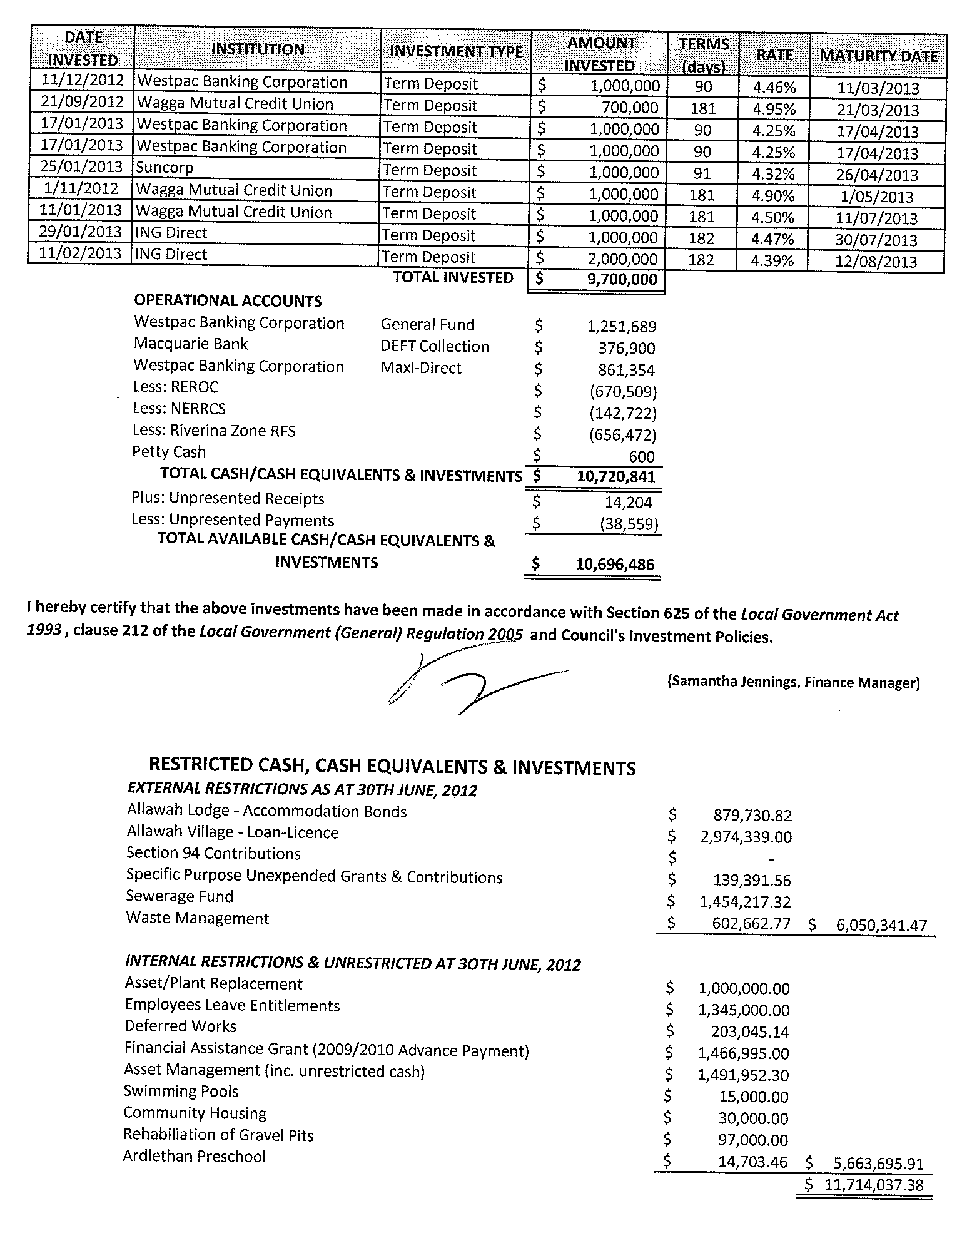
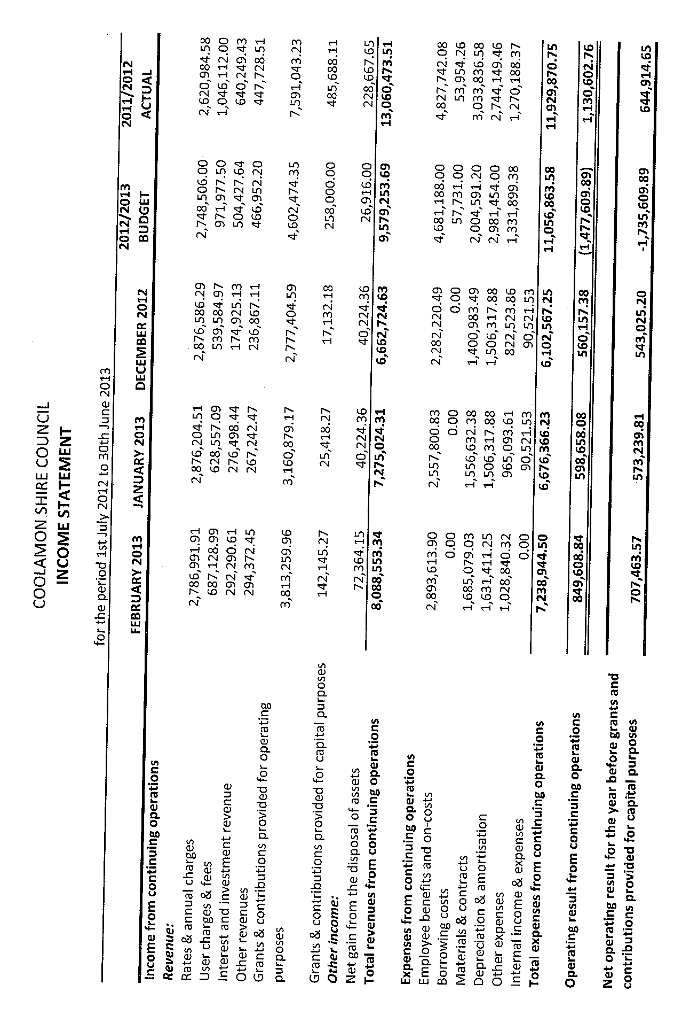
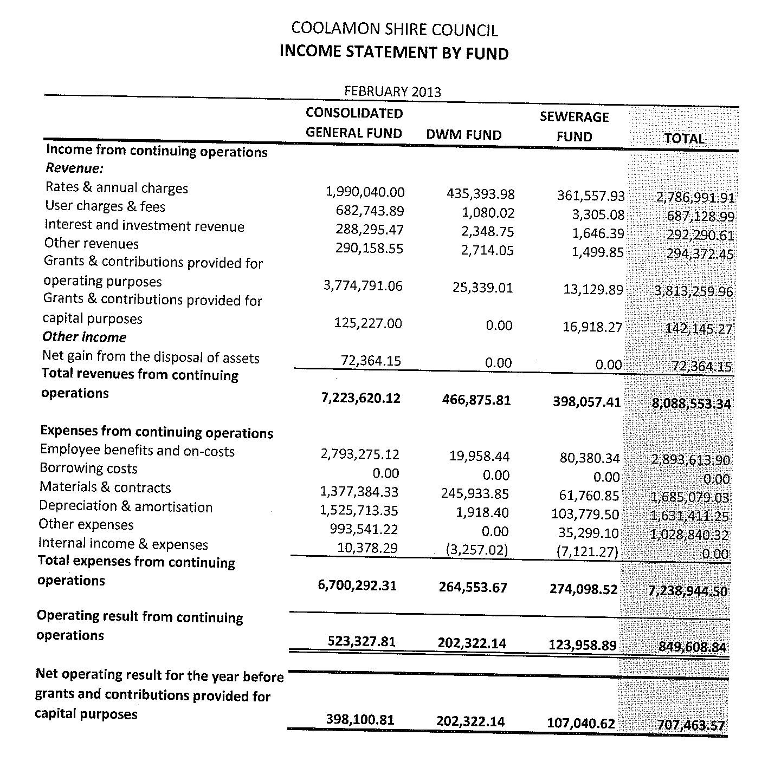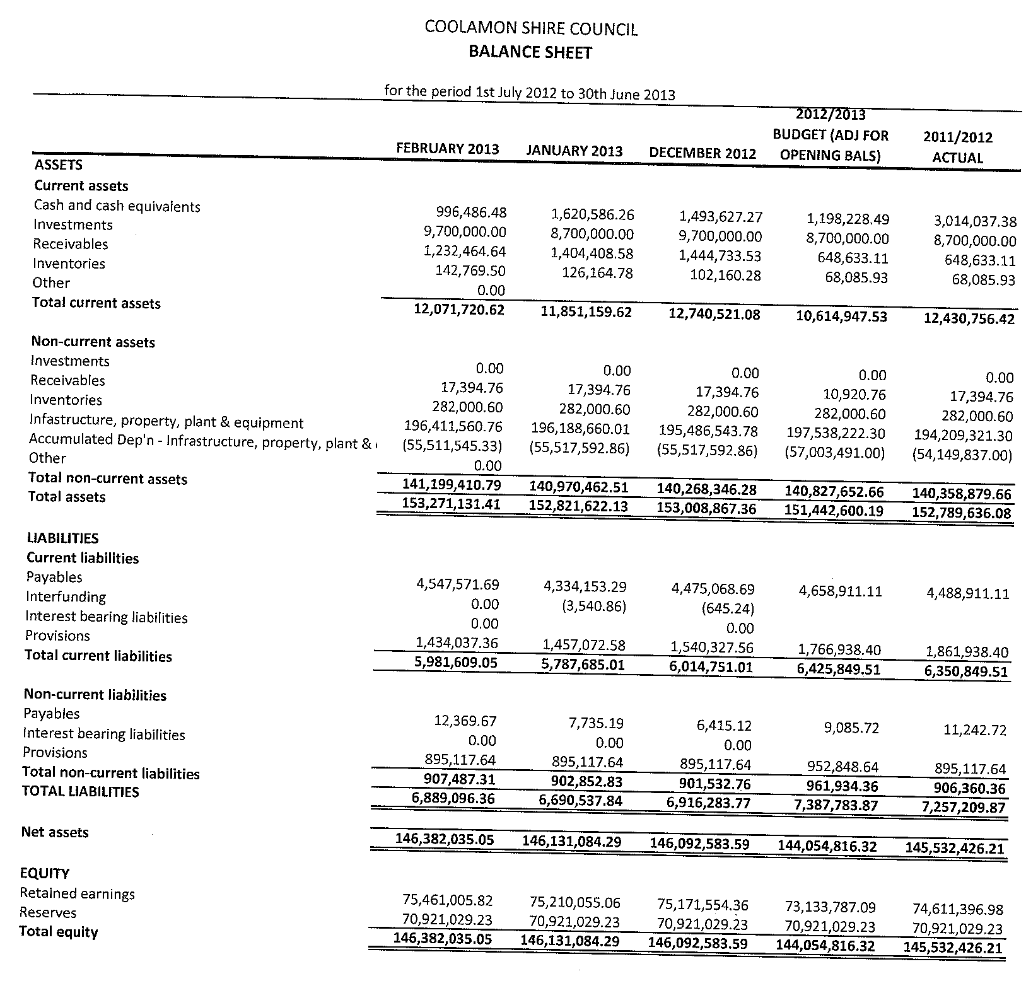
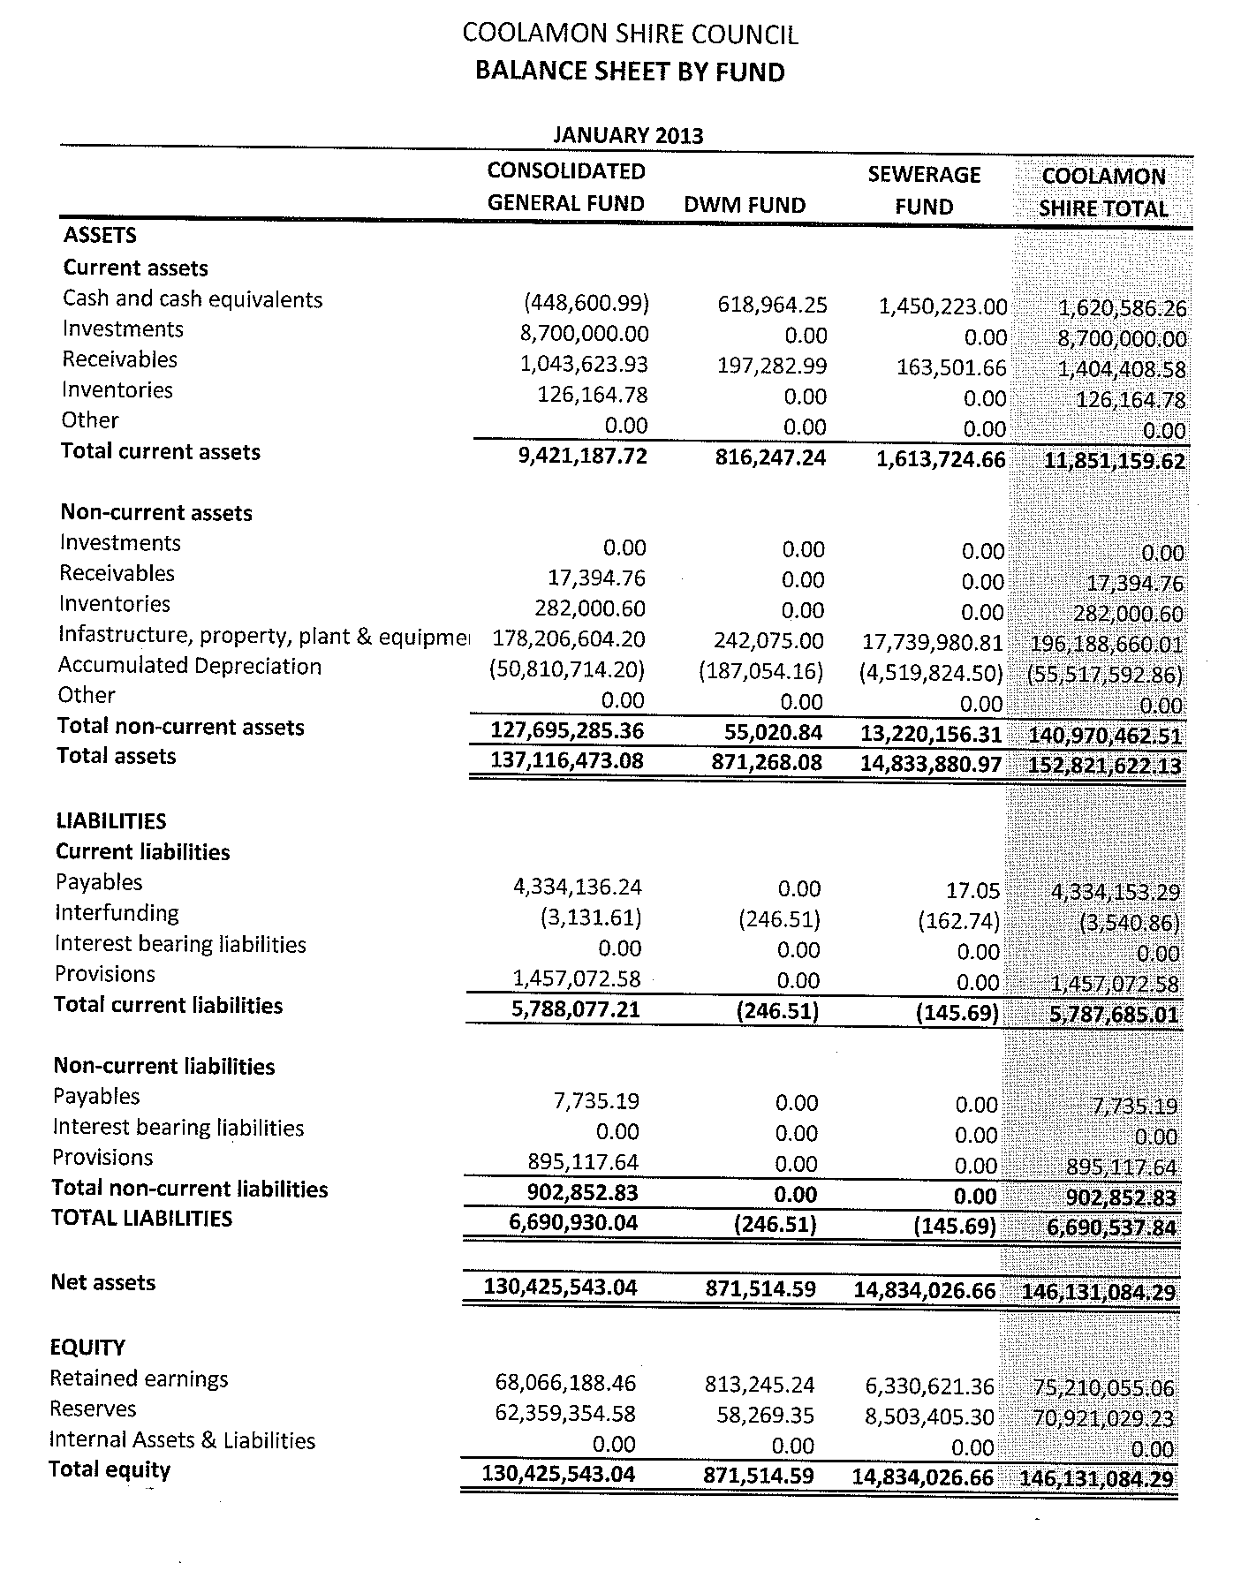
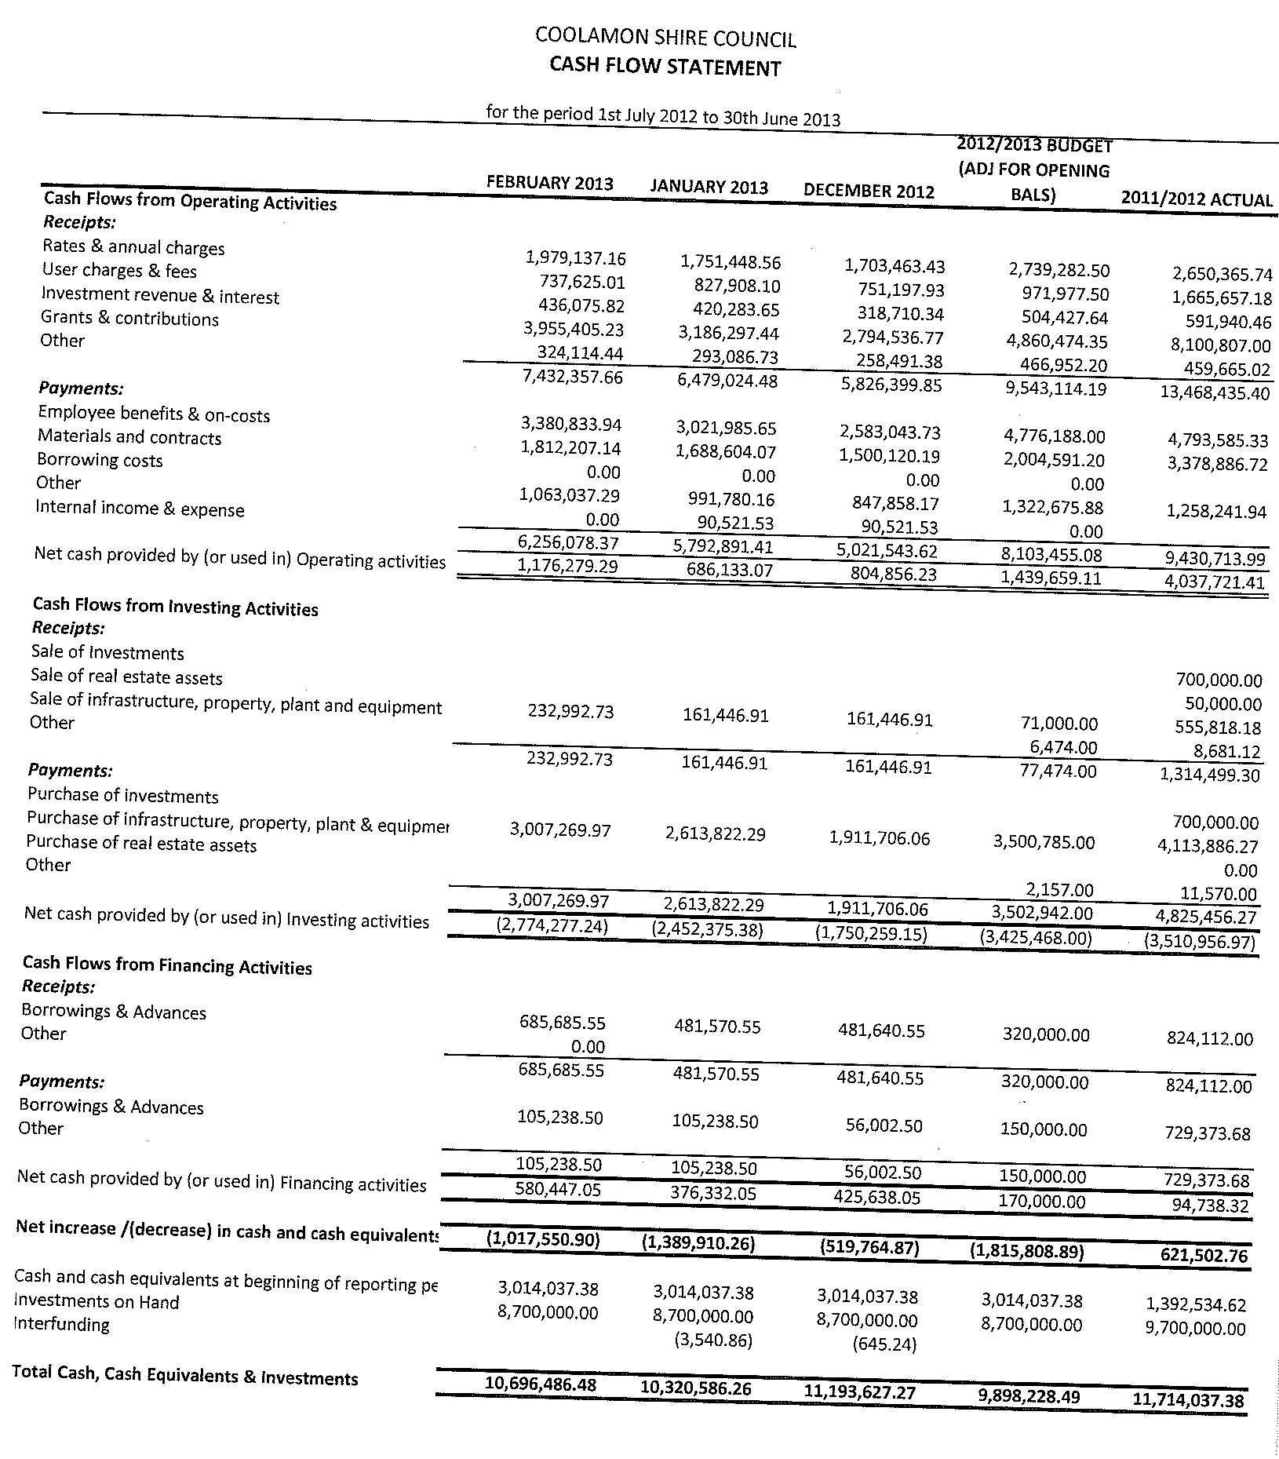
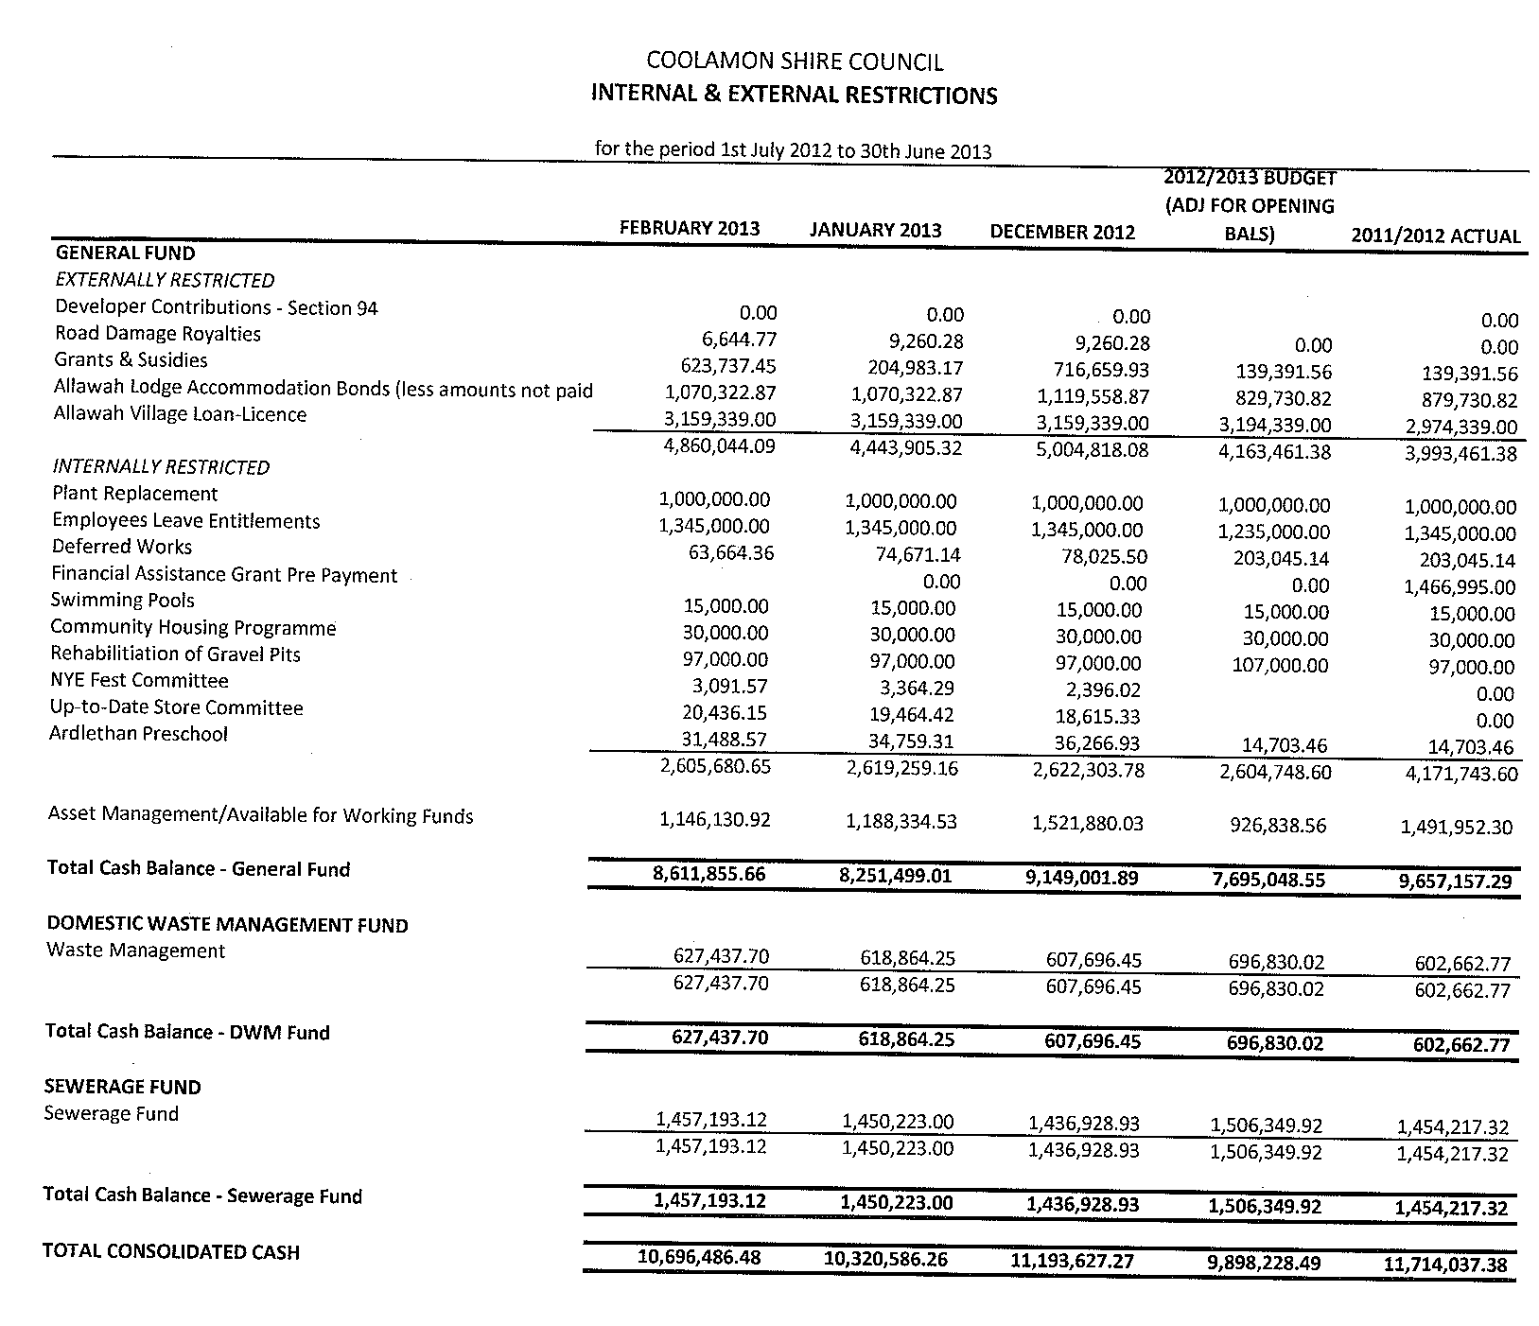
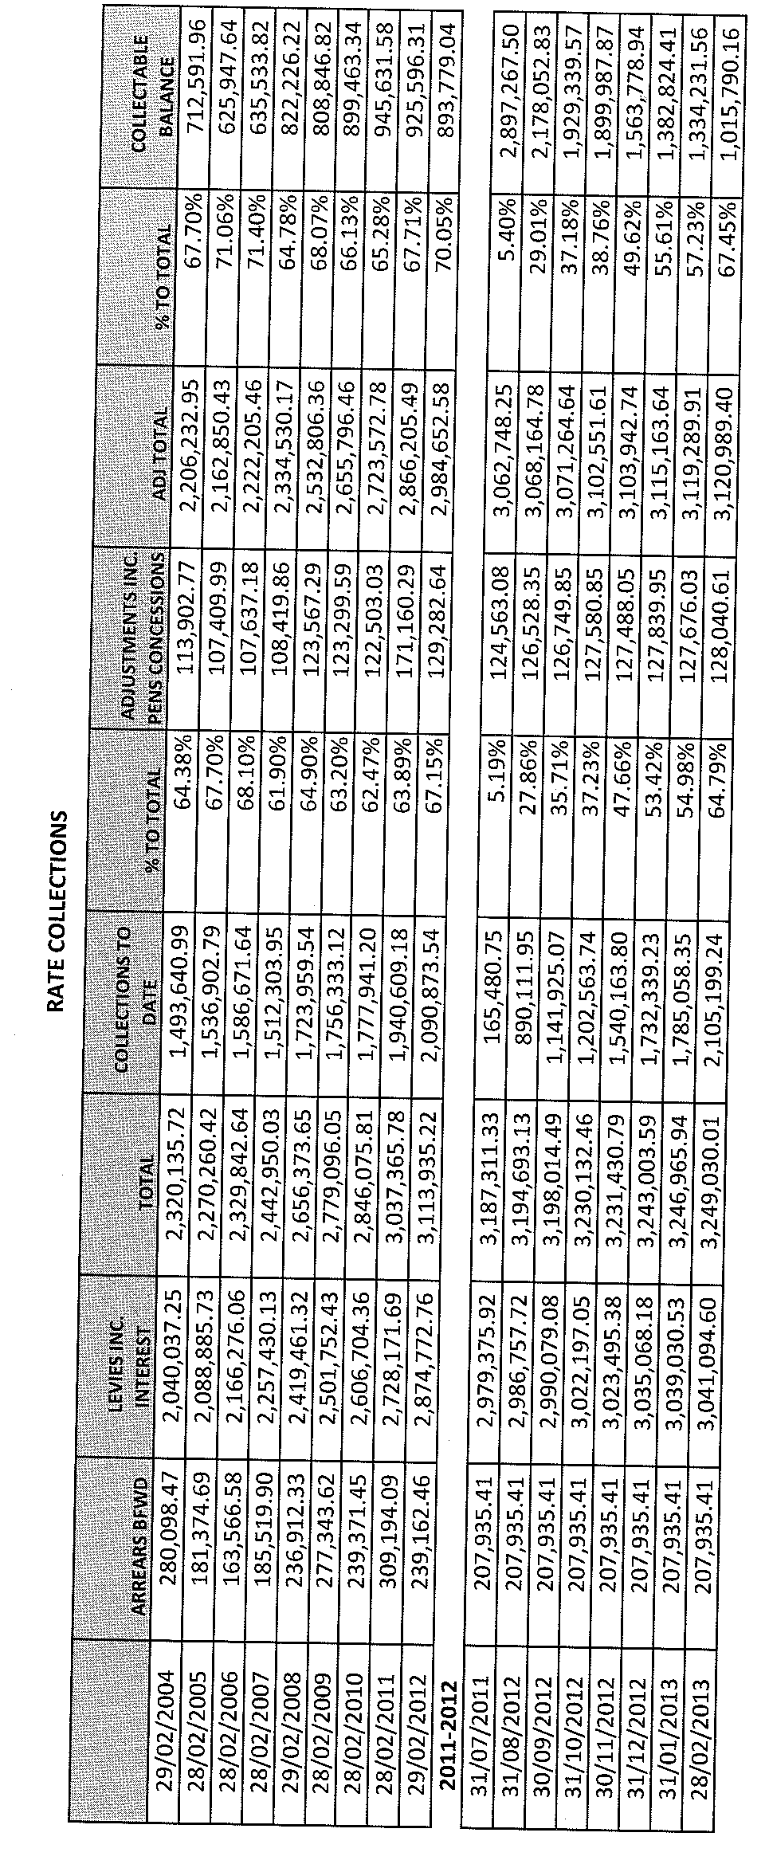
CS2) EXTERNAL AUDIT TENDER (A.12-01)

You will recall that at the December 2012 meeting, Council was advised that the current external Audit Contract is due to expire on 30th June, 2013. In accordance with Council’s resolution, tenders were called for External Audit Services for the period 1st July, 2013 to 30th June, 2019 with four compliant tenders being received.

Details of the tenders received are listed below (GST exclusive):

SCHEDULE OF TENDER PRICES | Morse  Group | Auswild  & Co | Hill Rogers Spencer  Steer | Adams Kenneally White
1. Audit cost for Coolamon Shire Council | $22,876.00 | $19,000.00 | $38,500.00 | $11,250.00
2. Audit of Special Funding (rate per hour) | $700/4 hours | $181.18 principal $109.091manager | $38,500.00 | $118.18
2014 additional for transition to new computer system | $2,272.73 |  | $38,500.00
3. Audit cost for REROC | $2,000.00 | $2,600.00 | $38,500.00 | $1,000.00
4. Audit cost for NERRCS | $2,000.00 | $880.00 | $38,500.00 | $500.00
5. Audit cost for RFS – Riverina Zone | $2,000.00 | $840.00 | $38,500.00 | $500.00
Increase | ABS Weekly Earnings | CPI (Sydney – All Groups) | CPI (Sydney – All Groups) | Wage price Index

In addition to providing the schedule of tender prices, each of the tenderers also gave an indication to the hours and proposed visits that would be required to attend to the external auditing services as follows:

 | Morse  Group | Auswild  & Co | Hill Rogers Spencer Steer | Adams Kenneally White
Partner/Principal | 16 hrs | 67 hrs | 30 hrs | 22 hrs
Manager/Audit Supervisor | 2 hrs | 83 hrs | 150 hrs | 28 hrs
Graduate | 55 hrs |  | 150 hrs | 37 hrs
Accountant | 61 hrs |  | 150 hrs | 37 hrs
Support Staff |  |  |  | 2 hrs
TOTAL | 134 hrs | 150 hrs | 180 hrs | 89 hrs
Interim audit | 2 days | 3 days | 3 days | 1 day
End of Year Audit | 3 days | 3 days | 3 days | 2 days

Each of the tenderers have demonstrated experience with Local Government audits with current local government clients for each firm listed below:

Morse Group | Auswild & Co | Hill Rogers Spencer Steer | Adams Kenneally White
EXTERNAL AUDIT  Blue Mountains City Council  Campbelltown City Council  Dubbo City Council  Lithgow City Council  Orange City Council  Central Tablelands Water County Council  Bathurst Regional Council  Mid-Western Regional Council  Bland Shire Council  Cobar Shire Council  Cowra Shire Council  Cabonne Shire Council  Central Darling Shire Council  Cootamundra Shire Council  Forbes Shire Council  Gilgandra Shire Council  Lachlan Shire Council  Moree Plains Shire Council  Oberon Shire Council  Parkes Shire Council  Upper Lachlan Shire Council  Weddin Shire Council  Wellington Shire Council  INTERNAL AUDIT/AUDIT COMMITTEE  Coonamble Shire Council  Narromine Shire Council  Walgett Shire Council  Warren Shire Council  Warrumbungle Shire Council | EXTERNAL AUDIT  Bombala Council  Boorowa Council  Carrathool Shire Council  Central Murray Shire Council  Conargo Shire Council  Coolamon Shire Council  Cooma-Monaro Shire Council  Goldenfields Water County Council  Griffith City Council  Junee Shire Council  Leeton Shire Council  Lockhart Shire Council  Murray Shire Council  Murrumbidgee Shire Council  Narrandera Shire Council  Palerang Council  Southern Slopes County Council  Temora Shire Council  Young Shire Council INTERNAL AUDIT/AUDIT COMMITTEE  Tumut Shire Council | EXTERNAL AUDIT  Ashfield Council  Burwood Council  City of Botany Bay  City of Canterbury  Hunter’s Hill Council  Hurstville City Council  Ku-Ring-Gai Council  Manly Council  Mosman Council  North Sydney Council  Pittwater Council  Randwick City Council  City of Ryde  Warringah Council  Waverley Council  Wollongong City Council  Woollahra Municipal Council  Blayney Shire Council  Brewarrina Shire Council  Bogan Shire Council  Bourke Shire Council  Coonamble Shire Council  Harden Shire Council  Muswellbrook Shire Council  Narrabri Shire Council  Narromine Shire Council  Queanbeyan City Council  Walgett Shire Council  Warren Shire Council  Castlereagh Macquarie County Council  Upper Hunter County Council  INTERNAL AUDIT/AUDIT COMMITTEE  City of Canada Bay  Par Macquarie Hastings Council  Central Darling Shire Council | EXTERNAL AUDIT  Gundagai Shire Council  Hay Shire Council  Jerilderie Shire Council  Tumut Shire Council  Urana Shire Council  Wagga Wagga City Council  Wakool Shire Council
From the tables detailed above the following inferences can be made:

1) Adams Kenneally White has submitted the lowest tender by price ($13,250 for Coolamon Shire, REROC, NERRCS & RFS Riverina Zone). This price is some $10,070 less than the next lowest tender submitted by Auswild & Co ($23,320).

2) When taking into consideration the total number of hours that each firm has proposed, the hourly rate for each firm to undertake the core audit functions for Coolamon Shire Council, REROC, NERRCS & RFS Riverina Zone is as follows:

 | Morse  Group | Auswild  & Co | Hill Rogers Spencer  Steer | Adams Kenneally White
Total Core Audit Functions | $26,876.00 | $23,320.00 | $38,500.00 | $13,250.00
Total Hours | 134 hrs | 150 hrs | 180 hrs | 89 hrs
Calculated Hourly Rate | $200.567/hour | $155.467/hour | $213.889/hour | $148.876/hour

3) There is a notable difference in the total hours and breakdown of the hours that each firm has submitted in their tenders. Specifically Auswild & Co has submitted a tender where the Partner/Principal of the firm will attend to in excess of double the hours of any other firm. The tender submitted by Adams Kenneally White allows for a total of 89 hours some 49 hours less than the next lowest tender when considering hours.

4) All four firms have the adequate experience and professional qualifications to fulfill the tender specifications.

5) Council will during the 2013/2014 financial year be transitioning its core financial software from Practical + to Authority, therefore the first year of the six year contract will be affected by that transition. Morse Group indicated in their tender a separate cost to allow for this transition.

Given the points above, I think the most pertinent are that of 2 and 3 and given the information gleaned from those, the tenders could be shortlisted to those submitted by Adams Kenneally White and Auswild & Co. Adams Kenneally White are obviously the “cheapest” tender by overall price and calculated hourly rate, but when comparing the breakdown of hours into Principal/Partner and other staff, the hours presented by Auswild & Co indicate that three times the number of hours will be undertaken by the Principal/Partner as compared to Adams Kenneally White.

Recommendation

For Council decision.

NOTES PRIOR TO RESOLUTION

1) The Mayor invited the General Manager and the Executive Manager, Corporate & Community Services to make comment on various issues concerning the Auditor. The General Manager advised the Mayor and Council that all the facts were in the report and it was not appropriate for staff to make comment on the performance of the Auditor having regard to the fact that the Auditor reports directly to Council and his report is based on staff performance.

2) Councillors noted that three of the four tenderers had hourly commitments ranging from 134 hours through to 180 hours. The fourth tenderer being the lowest had a hourly commitment of 89 hours. Councillors queried whether the quality of the audit could be done in 89 hours given the hourly commitment of the three other tenderers.

3) Councillors noted the particularly onerous year to be expected in 2013/2014 with the change-over of Council’s computer system.

4) Council noted the availability of the Principals of each firm and the availability of those Principals to provide advice and assistance to staff.

RESOLVED on the motion of Clr Brill and seconded by Clr Hutcheon that the External Audit Tender received from Auswild & Co be accepted for the period 1st July, 2013 to 30th June, 2019. This tender, was accepted by Council on the basis that although it is not the lowest tender Council took into account the factors raised in the notes above. Specifically this referred to Council’s desire to ensure the quality of the Audit and the lowest tenderer being prepared to only commit for a time of 89 hours which was considerably lower than any of the other three tenderers. Council’s concern was to maintain quality in Audit Control. 61/03/2013

CS3) BUDGET CONSIDERATIONS (F.02-02)

➔ Attached to this report is a listing of the issues raised on the 2013 Promotions & Development and the 2013 Councillor Tours. Attachment No. 13.1

The majority of these items will be addressed in the town works and town parks reports presented by Council’s Executive Manager, Engineering & Technical Services, but some building related items need to be considered on an individual basis. Specifically the construction of a disabled toilet and storage area at the Ganmain Hall and the refurbishment of the Ganmain Haystack. Both projects are estimated to cost $30,000 each and have not previously been included in Council’s forward planning.

➔ Also attached to this report is a copy of the Major Capital Projects 2012/2013 to 2021/2022 adopted by Council as part of the 2012/16 Delivery Program and 2012/13 Operational Plan. The timing of these projects, except for the current financial year, are subject to Council’s ongoing approval and funding opportunities. Attachment No. 13.2

Those items listed in the 2012/2013 financial year will be finalised this year, so Council’s attention is drawn to years 2 to 10 and the projects listed for those years. Council staff are currently assessing the estimates for these projects and they will be updated for the 2013/2014 Operational Plan.

In addition to these, Council staff has identified two other major projects.

1) Aitken-Logan Wing Fire Sprinklers – Council resolved at the February 2013 meeting to have compliant fire sprinklers installed in the Aitken-Logan Wing by March 2016. It is estimated that the installation will cost in the vicinity of $150,000.

2) Effluent Re-use Extension – Council has completed an extension of the effluent re-use scheme to water parks and garden areas north of the railway line in Coolamon. Council has received quotes for a further extension of this scheme to water Lions Park and the gardens at the Allawah Complex that amounts to $50,000.

Recommendation

That Council prioritise the Ganmain Hall disabled toilets and Ganmain Haystack and that the Aitken-Logan Wing Fire Sprinklers and Effluent Reuse Extension be accounted for in Council’s Major Capital Projects

RESOLVED on the motion of Clr McCann and seconded by Clr Maslin that Council include the Ganmain Hall Disabled Toilets and Ganmain Haystack in Council’s Forward Program of Works and that the Aitken-Logan Wing Fire Sprinklers and Effluent Reuse Extension be accounted for in Council’s Major Capital Projects. 62/03/2013

4.4 DEPUTY GENERAL MANAGER, PLANNING & ENVIRONMENTAL SERVICES REPORTS

DEPARTURE FROM STANDING ORDERS

RESOLVED on the motion of Clr McCann and seconded by Clr Hutcheon that Council move away from standing orders to deal with the Deputy General Manager, Planning & Environmental Services Report (HS5). 63/03/2013

HS5) PUBLIC TOILETS – MAIN STREET OF COOLAMON (T.05-01)

As a result of the request from last month’s Council Meeting together with the knowledge that a petition is currently circulating, an investigation has been conducted into the provision of public toilets within the main street of Coolamon. This matter has been discussed at previous meetings with the resolution not to proceed.

The current number of toilets around Coolamon has been relatively consistent since the sale of the School of Arts building in 2005. Prior to that there were public toilets behind the School of Arts that Council maintained. These were closed down due to vandalism prior to the building being sold as excess to Councils needs.

In undertaking a review of toilets within the main street the following matters need to be considered:

- Number and location of existing toilets

➔ In order to better represent this discussion a map has been developed that identifies a central location within the main park at Cowabbie Street, Coolamon. This has been attached for your information. Attachment No. 7.1

This map identifies all toilets accessible to the public including both Council provided toilets and toilets required for patrons of businesses. As can be seen the public toilets provided by Council are in Lions Park, Redgrave Park and the Up-to-Date Store facility.

The Up-to-Date Store is open during the business hours of both the Library and Ajanta. Currently the only day they are closed is on Monday.

The toilets in Redgrave Park are available 24 hours, seven day per week.
The Lions Park toilets are now closed at 7.00pm till 7.00am and have been for about a year. Vandalism has slowed since this closing occurred.
The facilities associated with businesses are required to be available to their patrons whilst the business is in operation.

As can be seen from the map no individual would be further than 2-3 minutes from a toilet if they were in the main street.

- Events

In recent years the majority of concerns that have been raised in regard to the lack of toilets stem from the New Year’s Eve function in the main street.

Council needs to clarify the difference between a one off event and regular everyday need for toilets by the public. Should a large event occur anywhere within the Shire it is the responsibility of the event organizers to ensure that adequate toilets, waste disposal etc., are provided.

In hindsight Council should have required from the Event Organisers suitable toilet fixtures to suit the needs of the patrons at last year’s New Year’s Eve night.

Council should not confuse the need for toilets at individual events with the general requirement for toilets. This is akin to buying a 50 seat bus to transport a family of four around.

- Heritage aspects of the Main Street

The Coolamon main street with its wide avenue and central parklands has created an eye catching main street. Council has identified this main street and its heritage aspect as an important part of Coolamon’s future. With this in mind the proposed location of any toilets would be an important consideration given the need to maintain this heritage precinct. Any toilets in the main street reserve (ie. the parks) would be considered detrimental to the street amenity. Other than the existing Council owned assets that provide public toilets, the only remaining block owned by Council is the plaza located between Cobbers Café and the Newsagent. Any wish to put a building in this location would need to ensure that it meets any heritage requirements and not be detrimental to the existing streetscape.

- Vandalism

A sad reality is that public toilets tend to be a meeting place for those individuals that seem to wish to damage public infrastructure. Council currently undertakes regular vandalism repairs and maintenance associated with damage to public toilet facilities within Coolamon. Approximately two months ago the Redgrave Public Toilets were burnt causing extensive damage that required significant maintenance. The Lions Park Toilets suffer from vandalism and require regular maintenance. For this reason they are now locked at night.

Council is reluctant to invite this element into the main street of Coolamon. Whilst it is acknowledged that individuals can and do congregate in the main park and plaza in Coolamon’s main street, they do not historically cause extensive damage. Sadly this cannot be said for the current toilet facilities provided by Council.

In short Council needs to ask whether they wish to invite these problems into the high profile area of the main street.

- Neighbouring Councils/Towns

As part of the research a few neighbouring Councils were investigated to determine the location and access to public toilets. A quick search of www.toiletmap.gov.au/browse.aspoc?id indicates that Coolamon is quite well catered for in regard to numbers and distance from the main street.
It is noted that currently Redgrave Park is not on this webpage and Council will contact the organisation to update this change.

The majority of public toilets maintained by Councils are located within the Tourist Information Centre which is not always located in the main street, for example Wagga and Narrandera. There are very few places that have the public toilets located within the middle of the main street. In regard to smaller towns, only Temora and Peak Hill come to mind.

- Infrastructure Provision

➔ The design and location of Council’s Sewer Network is such that there is no physical means of connecting to the sewer within the main street and parkland of Cowabbie Street. (See attached map). The cost of getting this infrastructure is exorbitant and makes any proposed project unviable. Attachment No. 7.2

The only available location for such a public convenience would be within the plaza.

In view of the information surrounding the heritage aspects of the main street, it would need to be set back towards the rear of the property where it would not dominate the streetscape.

This would require the removal of carparking access and car spaces as well create potential vandalism hangouts. This location would then be similar to the previous toilets at the School of Arts that were removed due to vandalism issues.

- Future Considerations

➔ Council have in the past discussed creating a walkway link from the Main Street Plaza through to Redgrave Park. This would possibly increase access and knowledge from the main street through to the public toilet facilities. Due to the financial implications of the previous reports being discussed in Committee of a Whole, this attachment is only distributed to Councillors and Senior Staff. Attachment No. 7.3

Further, Council are currently in negotiations with the New South Wales Fire Brigades (RFNSW) to determine how the building that they currently reside in will be left and for what purpose it can be used after they leave. This may have potential to be used for public toilets.

SUMMARY

The issue of toilets in the main street has really only been raised since Council purchased and developed the plaza. For the previous seven years Council received no requests for toilets in the main street. In fact prior to 2005 Council were receiving requests to remove the main street toilets as they were vandalized, dirty and an embarrassment.

It is hard to believe that the purchase of land by Council has triggered the need for toilets.

The issue of events and festivals is a different matter and should be considered specific to the needs of each event. Council will need to ensure adequate facilities are provided for any future events.

Possible Strategic Plans for the main street and the potential connection of Redgrave Park by way of a walkway may alleviate most of the concerns and issues raised. The ongoing discussions with FRNSW allow Council to explore future options for toilets without the need to rush in and construct facilities. This is in addition to the fact the number and location of existing facilities do not warrant additional facilities. Rather an opportunity may exist to improve on current facilities that would comply with the issues raised in this report.

Recommendation

1) That Council maintains the public toilets that it currently has.

2) That Council continues negotiations with the FRNSW and the Lands Department in regard to the existing Fire Station.

RESOLVED on the motion of Clr Maslin and seconded by Clr McCann that: 64/03/2013

1) Council maintains the public toilets that it currently has and arranges for additional signage to indicate the location of the existing public toilets.

2) That Council continues negotiations with the FRNSW and the Lands Department in regards to the existing Fire Station.

HS1) DEVELOPMENT APPLICATIONS (B.05-03)

The following applications have been approved:-

COMPLYING DEVELOPMENT CONSENT

2013/03 13//875940 – 666 Seymours Lane, Marrar – Swimming Pool.
2013/04 8/15/758650 – 32 Hare Street, Marrar – Shed.
2013/05 9/11/758650 – 20 Webb Street, Marrar – Dwelling.
2013/07 21//1096316 - 31 Lewis Street, Coolamon – Shed.

Recommendation

For Council information.

RESOLVED on the motion of Clr Logan and seconded by Clr Brill that the report be received. 65/03/2013

HS2) SWIMMING POOL LEASES (S.19-01)

Council operates three pools within its Shire boundaries, they being:

- Coolamon (built in 1956)
- Ardlethan (built in 1965)
- Ganmain (built in 1972)

Each of these pools are managed by individuals under a Lease Agreement. Historically these leases have been renewed annually with the incumbent Manager being given the option of returning for the next year.

➔ Two of the pools (Ganmain and Coolamon) are Reserve Trusts administered by the Crown Land. For this reason they require a Lease with the Lands Department. In order to have them all administered collectively all three pools have a similar lease. A copy is attached. Attachment No. 5.1

➔ This lease also comes with a Tied Grant (Deed). This Deed spells out the requirements that Council expects the Lessee to undertake. A copy is attached.
Attachment No. 5.2

A summary of the management arrangements of each pool is set out below:

- COOLAMON POOL

Currently leased to Mr Peter Tulk. This lease commenced in November 2011 and he has therefore been operating the pool for two years.

The lease with the Crown Lands commenced on the 1st November, 2011 and terminates on the 31st March, 2012. This lease includes an option to renew for a period of two further terms of five months.

This means that under the Lease arrangement with the Crown Lands there is the option for one further swimming season.

- ARDLETHAN POOL

Currently Donna Horan manages this pool under the Lease Agreement. Donna commenced at the Ardlethan Pool in the 2005 swimming season with this being her 8th season in charge of the pool. The current lease with the Coolamon Shire Council commenced on the 1st November, 2012 and terminates on the 31st March, 2013.

This lease has an option to renew for a period of two further terms.

- GANMAIN POOL

The current Leaseholder for the Ganmain Pool is Shane and Tammy Lenon and they have held this lease since the 2004 season, a total of 9 swimming seasons. The current lease commenced on the 1st November, 2012 and terminates on the 31st March, 2013.
This lease has an option to renew for a period of two further terms.
In the case of all pools the Deed of Agreement has been set up to roll over annually to line up with the lease. (Crown lease in the case of Coolamon and Ganmain). The Pool Manager only has to indicate their intention to renew and upon accepting the offer the management continues.

From a legal perspective provided the leaseholder has complied with both the Lease and Deed then they have the right of continuing this management. Should Council wish to terminate the lease then they would need to establish that a breach of these arrangement has occurred.

SUMMARY

In this instance the Coolamon Pool has one more season to run while the Ganmain and Ardlethan pools have two more seasons. Provided the pools are being operated successfully and in accordance with the Deed and Lease Agreements then the current Managers should be able to continue.

If considered appropriate Council could require that at the end of each three year period that the pool management could be advertised. In the past Council has not pursued the advertising due to the difficulty in finding Managers to take on the position.

Recommendation

For Council information.

RESOLVED on the motion of Clr Logan and seconded by Clr Maslin that expressions of interest in regard to the Pool Leases be advertised every three years. 66/03/2013

HS3) 75 FORD STREET, GANMAIN – SALE OF SENIOR CITIZENS BUILDING (LD 3AQ)

As a result of the Senior Citizens February Meeting correspondence was received by Council advising that they agreed to the sale of 75 Ford Street, Ganmain. Shortly after this correspondence Council received an offer from the neighbouring landowner to purchase the building. Council negotiated a price for the sale that was agreed to by both parties. Council is now required to endorse these Contracts for the Sale of Land.

Recommendation

That the Seal of Council be affixed to the documents in relation to the sale of 75 Ford Street, Ganmain.

RESOLVED on the motion of Clr Brill and seconded by Clr Huxtable that the Seal of Council be affixed to the documents in relation to the sale of 75 Ford Street, Ganmain. 67/03/2013

HS4) DEVELOPMENT APPLICATION 04/2013 – GRAIN LOADING SHED INCORPORATING DUST EXTRACTION - LOT 5, DP 826313, LYNE STREET, MARRAR (PF1803/21)

Council are in receipt of a development application to construct a shed at the Croker Grain site in Marrar. The principle purpose of the shed is to allow for weather-proof drive-through loading of trucks and containers whilst also allowing for an integrated dust extraction system.

➔ A copy of the proposal has been attached. Attachment No. 6

The application is a result of ongoing discussions between Council and Croker Grain, and Croker Grain and the Marrar community that have focused on recent complaints regarding raised grain dust together with Croker Grain’s continued presence within Marrar community. As a result of these discussions Croker Grain has been steadily upgrading its site. This application together with the upgrading of its internal ground surfaces to a less dust prone surface approximately 12-18 months ago are examples of Croker Grain working with Council and the community to ensure a coexistent future.

In accordance with Council policy, the proposal was advertised to neighbouring landholders. The advertising period is due to conclude on 28th March 2013.

In accordance with Council’s LEP, the subject site is zoned RU5 – Village. The Croker Grain business has operated from this its current capacity for a number of decades; nevertheless Council’s LEP regards the site as a rural industry which is permissible in this zone.

The proposed location of the shed is considered acceptable. Specifically the setback is approximately 25m, which is significantly further than other structures already located on site, including silos, storage sheds and the office and weighbridge.

There are two main issues that need to be considered by Council in determining this application. First and foremost is the height of the structure, which is approximately 5.5m. The second issue is the potential for noise and waste generation created by the dust extraction system.

- Height

With a height of 5.5m, the proposed shed would generally be considered as bordering excessive in the village zone. However in the context of the site, many existing structures including storage sheds and grain silos are much taller, some in excess of 15m. For this reason there is likely to be minimal impact, if any, upon neighbouring properties by way of loss of solar access, loss of any significant views or loss of streetscape amenity. Any such impact is likely to be wholly contained within the subject site.

The proposed shed height is therefore not considered out of place.

- Noise and Waste Generation

The second issue for Council to consider is that of noise and waste generation.

The mechanical nature of the proposed dust extraction system creates potential for noise impacts, however, as with the concerns of the building height Council also need to consider this in the context of the site in its entirety. At present there is significant noise already being generated on site from heavy machinery including trucks, tractors and grain augers. This noise is generated year-round, and has generally not been seen as a key site issue in the past.

Prior to any determination being made, Council can request further details relating to noise mitigation on the dust extraction system, however this is often applied as a condition of development consent. Similar approvals in the past have required mechanical noise to be no higher than 5 dBA above existing background noise levels.

The second point relating to this issue is waste generation, specifically how Croker Grain propose to deal with the waste dust captured by the extraction system. Once more, Council can request further details regarding waste disposal prior to a determination, or alternatively specify a minimum level of compliance as a condition of development consent.

Summary

The proposal at hand is for the construction of a loading shed that incorporates a dust extraction system. This is the result of ongoing discussions between Croker Grain, the Marrar community and Coolamon Shire Council.

As a whole, the proposal serves to improve air quality in the immediate vicinity of the site, done so by improving site operations that ultimately aim to limit the potential for neighbour complaints.

In the context of the wider site, the proposal is seen as a minor extension structurally, yet an extension that has the potential to achieve far reaching benefits, especially in terms of comfort for neighbouring land holders.

In accordance with the considerations reported above, and in consideration of the development application still being upon notification, it is deemed reasonable for Council to delegate assessment to the General Manager. This will also allow Council staff to assess any submission relating to the proposal, and apply the most appropriate conditions of consent if warranted.

Recommendation

That Council delegate assessment of Development Application 04/2013 to the General Manager.

HS4) DEVELOPMENT APPLICATION 04/2013 – GRAIN LOADING SHED INCORPORATING DUST EXTRACTION - LOT 5, DP 826313, LYNE STREET, MARRAR (PF1803/21) (Continued)

➔ Since the writing of this report Council has received a Submission in regard to the proposed Dust Extraction Shed at Crokers Grain in Marrar. Attachment No. 12

This letter suggests that it is “a great concept if everything is carried out by the book”.

Council and the applicant have every intention of ensuring that the work undertaken will reduce the amount of dust on the site by way of a purpose built shed to fill containers.

It is considered appropriate that any issues raised in this correspondence can be dealt with by Council through assessment and if approved, conditions of consent.

The recommendation in the original report is still the most appropriate method to deal with the Application.

RESOLVED on the motion of Clr Hutcheon and seconded by Clr McCann that Council delegate assessment of Development Application 04/2013 to the General Manager. 68/03/2013

HS6) COOLAMON CARAVAN PARK (C.01-03)

➔ As part of the Budget estimates Council has asked for more information in relation to the proposed extension to the Coolamon Caravan Park. A plan of the proposed work has been provided in the information papers. As can be seen this work proposes a new roadway with four additional sites that will all have power, water and access to sewer. Attachment No. 14

Room has been left available for a 5 huts/Managers residence. This is subject to future planning outside of next year’s proposed budget.

Council has recently been in discussion with the Service Groups that would like to consider undertaking a project and providing a camp kitchen similar to the one inspected in Ariah Park.

This is early in the negotiation phase of this project, however, as can be seen an area has been allocated should this be pursued.

Recommendation

For Council information.

RESOLVED on the motion of Clr Hutcheon and seconded by Clr McCann that the report be noted. 69/03/2013

HS7) IMPROVED GPS ACCURACY (C.09-05, PF2467/104)

Council has been working in partnership with the NSW Land & Property Information in setting up a Reference Station in Ardlethan. CORSnet-NSW contacted Council as there was a gap in their service area around Ardlethan and asked if it could be located on the Mullins Centre building. Coolamon Shire Council agreed and it has now become operational.

This will now provide a 2cm GPS accuracy across the Coolamon Shire.

➔ This will be helpful in Council’s daily operations together with increased access and accuracy for agricultural operations. A copy of the coverage map has been provided for your information together with a proposed Media Release of the project. Attachment No. 14

Recommendation

That Council include into the Council Newsletter information on CORSnet-NSW.

RESOLVED on the motion of Clr Huxtable and seconded by Clr Brill that Council include in the Council Newsletter information on CORSnet-NSW. 70/03/2013
4.3) EXECUTIVE MANAGER, ENGINEERING & TECHNICAL SERVICES

ES1) SHIRE ROADS RESHEETING, MAINTENANCE & STABILISATION

1) MAINTENANCE

The following roads have received attention:

- Devlin Road (Carrolls Lane to Redrops Lane)
- Seymours Lane (Armstrongs Lane North)
- Seymours Lane (Berry Jerry Lane to Armstrongs Lane)
- Pearces Lane (Marrar North Road to gate)
- Hodges Lane (End of bitumen to Marrar Silo)
- Yarrawong Road (Matong North Road to Walshs Lane)
- Brills Lane (Rail crossing to Derrain North Road)
- Pritchards Lane (Deepwater Road to Halbischs Lane)

2) RESHEETING

The following roads have received attention:

- Pykes Lane (Coolamon Road to Learys Lane)

3) STABILISATION

Stabilisaton to the following roads has now been completed:

- Devlin Road (0.0-3.0kms from Carrolls Lane)
- East West Road (0.0-2.8kms from Pratts Lane)

ES2) ROADS TO RECOVERY PROGRAMME 2012/2013

1) MATONG NORTH ROAD

A bituminous seal has been applied to the following sections of Matong North Road bringing it to a conclusion:

- 0.82 to 1.48ms (0.66kms) Reconstruction
- 2.07 to 2.65kms (0.58kms) Reconstruction
- 4.58 to 4.74kms (0.16kms) Reconstruction
- to 0.5kms (0.5kms) Reseal
- 1.48 to 2.07kms (0.59kms) Reseal

2) SEYMOURS LANE (3.3 TO 6.5KMS FROM BERRY JERRY LANE)

3.2kms of stabilisation to Seymours Lane has now been completed.

ES3) TOWN WORKS

1) Intersection Langham Street/Camp Street (Pre School) - Kerb and Gutter

Laying of the kerb and gutter, drainage works and back filling are now completed. A bituminous seal will be provided once the pavement has settled sufficiently.

2) Gresham Street, Ganmain – Kerb and Gutter

Laying of kerb and gutter, backfilling and sealing are now completed.

3) Ganmain Units, Wright Street

A bituminous seal has now been applied to the roads surrounding the units and brings the project to an end.

4) Stinson Street, Coolamon – Kerb and Gutter

Sealing of the roadway up to the kerb and gutter has been performed and brings the project to an end.

5) Mirrool Street, Coolamon – Laneway Seal (Allens Buses)

Work involving shaping, gravelling and sealing of the laneway has now been completed.

ES4) LOCAL ROAD RESEALS

The following roads have received a bituminous reseal:

Marrar North Road | 10.54 – 11.40 | (0.86kms)
Marrar North Road | 11.40 – 12.42 | (1.02kms)
Rannock Road | 8.75 – 10.82 | (10.07kms)
Marrar South Road | 0.4 – 1.14 | (0.74kms)
Walleroobie Road | 1.04 – 3.05 | (3.01kms)

ES5) PYKES LANE – UPGRADE

Works involving removal of trees/stumps, realigning, shaping and gravelling of road has commenced.

ES6) REGIONAL AND LOCAL ROAD HEAVY PATCH REHABILITATION

Heavy patch rehabilitation works involving stabilisation and seal have commenced on the following roads:

- Canola Way – East
- Canola Way – West
- Coolamon Road
- Ardlethan Road
- Mary Gilmore Way
- Dullah road
- Methul Road
- Mirrool Road

A total of 3410m² will receive treatment.

ES7) BLOCK GRANT – CANOLA WAY WEST (9.2-10.3KMS) RECONSTRUCTION

Reconstruction works involving stabilisation and sealing have now been completed. Linemarking will be incorporated in a future programme.

ES8) NOXIOUS WEEDS REPORT (N.02-01)

Senior Weeds Officer, Robert Ferguson Reports

- Order 30 as presented for public consultation with the following additions/changes from the previous order:

- African Boxthorn – changed scientific name, class 4 & not knowingly distributed.
- Bathurst/Noogoora/Hunter/South American/Californian/cockle burrs – Removed.
- Blackberry – State-wide Class 4.
- Buffalo Burr – Class 3.
- Coolatai grass – Class 3 and not sold, propagated or knowingly distributed.
- Giant reed/Elephant Grass – Class 4, new, and not sold, propagated or knowingly distributed.
- Green Cestrum – Class 3 new.
- Grey Sallow – Class 3 new.
- Horehound – Removed.
- Johnson grass – lowered to Class 4.
- Paterson’s Curse- Removed.
- Perennial ground cherry – upgraded to Class 3.
- Silverleaf Nightshade – Class 4 and not sold, propagated or knowingly distributed.
- Spiny Burr grass – Lowered to Class 4 and not sold, propagated or knowingly distributed.
- St John’s Wort – Class 4 and not sold, propagated or knowingly distributed.
- Tree of Heaven – Removed.
- Fireweed to be declared Class 3 across the Riverina.

- Flea bane whist not declared is proving to be a major problem in all areas. The current advice is to effect control whilst the plant is in the 2-3 leaf stage.
At this age it is susceptible to chemical application and good control can be achieved. Once stem elongation has occurred and the tap root is established, fleabane cannot be effectively controlled with herbicide alone.

- Regionally: Attended both Eastern and Western Riverina Noxious Weeds Advisory Group meetings.
- New DPI Weeds theme based around Hygiene, (vehicle, plant & equipment) is under development.
- The Region’s Project Officer is finalising a vehicle hygiene protocol for the Riverina.
- Survey on the use of Red Guideposts to signal important weed sites.
- New Incursions Response Plan available on Riverina weeds web site.
- Riverina MERI plan endorsed.
- Region is creating a Bio – control data base.
- Region is involved in Alligator weed funding.
- Attended LLS meeting at Hay.

- All roads and lanes continue to be inspected across the three Shires. The long running dry period has finally ended with good rainfall to usher in sowing. During the ‘dry’, only the hardiest of weeds were on show but this has already changed with Johnson grass springing to life and a lot of weed appearing. Silverleaf Nightshade has been controlled in some areas depending on storm events with other areas still to dry out.

- Two Spiny Burr Grass outbreaks have been detected in Coolamon along the railway adjacent to the Graincorp facility and at Brushwood Graincorp. Relevant authorities have been contacted with regard to their control measures. Follow up inspections will be made as both sites are repeat offenders.

- Johnson grass is still appearing while Blue Heliotrope is also posing problems on roads where it has not been detected before. On Cartwrights Lane in Junee Shire, this spread seems to be coinciding with Silverleaf Nightshade. Tree of Heaven is also spreading with a number of private sites being targeted for spraying.

- A project looking at establishing specific native species for weed control will be kicking off in late March. At a meeting onsite on the 13th February 2013, Peter Orchard from the Department Primary Industries (DPI) spoke about how his team had been propagating plant material for the trial and is very enthusiastic about commencing the sowing and planting of the material. The project is being jointly run with Wagga DPI, Coolamon Shire and RENWA.

- Another project in Junee is looking at some alterations in road reserves to enable boom spraying vehicles access. A selection of roads is being chosen for a series of test cases. A cost benefit analysis will be made comparing the expected cost savings from the project against the cost of road reserve modifications.

ES9) FACILITIES MAINTENANCE OFFICER’S REPORT (P.01-01)

Facilities Maintenance Officer Reports

- The Parks Crew has been busy with mowing over recent weeks and slashing operations have recommenced throughout urban areas prior to roadways receiving attention.

- Landscape works will commence shortly with brick edging and synthetic turf being installed at the Cowabbie and Booth Street Intersection.

- The other major landscape project will see the water garden redeveloped in Pieper Park, Coolamon. The water feature is outdated and will be replaced with paving, street furniture and soft landscaping to improve the aesthetics and amenity of the main business area.

- Maintenance – The Coolamon Childcare, Allawah Village, Coolamon Library, Coolamon Medical Centre, Ardlethan Preschool have all had minor maintenance undertaken.
- Pool Shutdowns – Council’s Swimming Pools will be closing for the off season by the 25th March, 2013. Programmed maintenance will be undertaken at all pools during winter.

- Organics – Collection and processing of organic material has continued with around 6 tonnes on average being collected per pickup. Contamination rates are relatively low and the composting process is progressing well.

RESOLVED on the motion of Clr McCann and seconded by Clr Brill that the Executive Manager, Engineering & Technical Services Reports (ES1 to ES9) be received. 71/03/2013

ES10) PLANT REPORT 2013/2014 CONSIDERATIONS (P.04-01)

The attached report details the replacement items proposed for the forthcoming year. (See Plant Replacement Schedule attached). The following major items are up for consideration:

1) Replacement of one 10m3 Gravel Truck (Plant No.122). This Truck is on an eight year replacement cycle and is due this year with over 210,000km of work accrued. 10m3 Gravel Truck (Plant No.122) will replace 10m3 water truck (Plant No.109) with over 400,000km of work accrued.

2) Replacement of one Construction Gang 2 Crew Cab truck (Plant No.126). This truck is on five year replacement cycle and is due this year with over 115,000km of work accrued.

3) Replacement of one Facilities Maintenance utility (Plant No.282). This vehicle is on a three/four year replacement cycle and is due this year with over 90,000km of work accrued.

4) Replacement of one Works Foreman utility (Plant No.291). This vehicle is on a three/four year replacement cycle and is due this year with over 100,000km of work accrued.

5) Replacement of one Ranger/Sewer utility (Plant No.293). This vehicle is on a three/four year replacement cycle and is due this year with over 80,000km of work accrued.

6) Overhaul of Construction Gang 1 water tank (Plant No.531). This water tank is located on truck (Plant No.118) and is on a re-assess annually cycle and is due for a rebuild.

7) Overhaul of Construction Gang 2 water tank (Plant No.594). This water tank is located on truck (Plant No.109) and is on a re-assess annually cycle and is due for a rebuild.

8) Parks and Gardens Plant Report 12/13

- Replacement of One Parks and Gardens 60” skid steer mower (Plant No.616). This mower is on a three year replacement cycle and is due this year with over 450hrs accrued.

- Towns currently being supplied with mowers for use by community volunteers should continue to have access to a mower. The recommended replacement after 3 years should be continued.
- Provision has been made for annual replacement of small plant such as; push mowers, edgers, whipper snipers, hedgers, etc.

Recommendation

That the Plant Report as presented is received, and the items listed be presented for consideration in the draft Estimates.

RESOLVED on the motion of Clr Brill and seconded by Clr Maslin that the Plant Report as presented be received, and the items listed be presented for consideration in the Draft Estimates. 72/03/2013

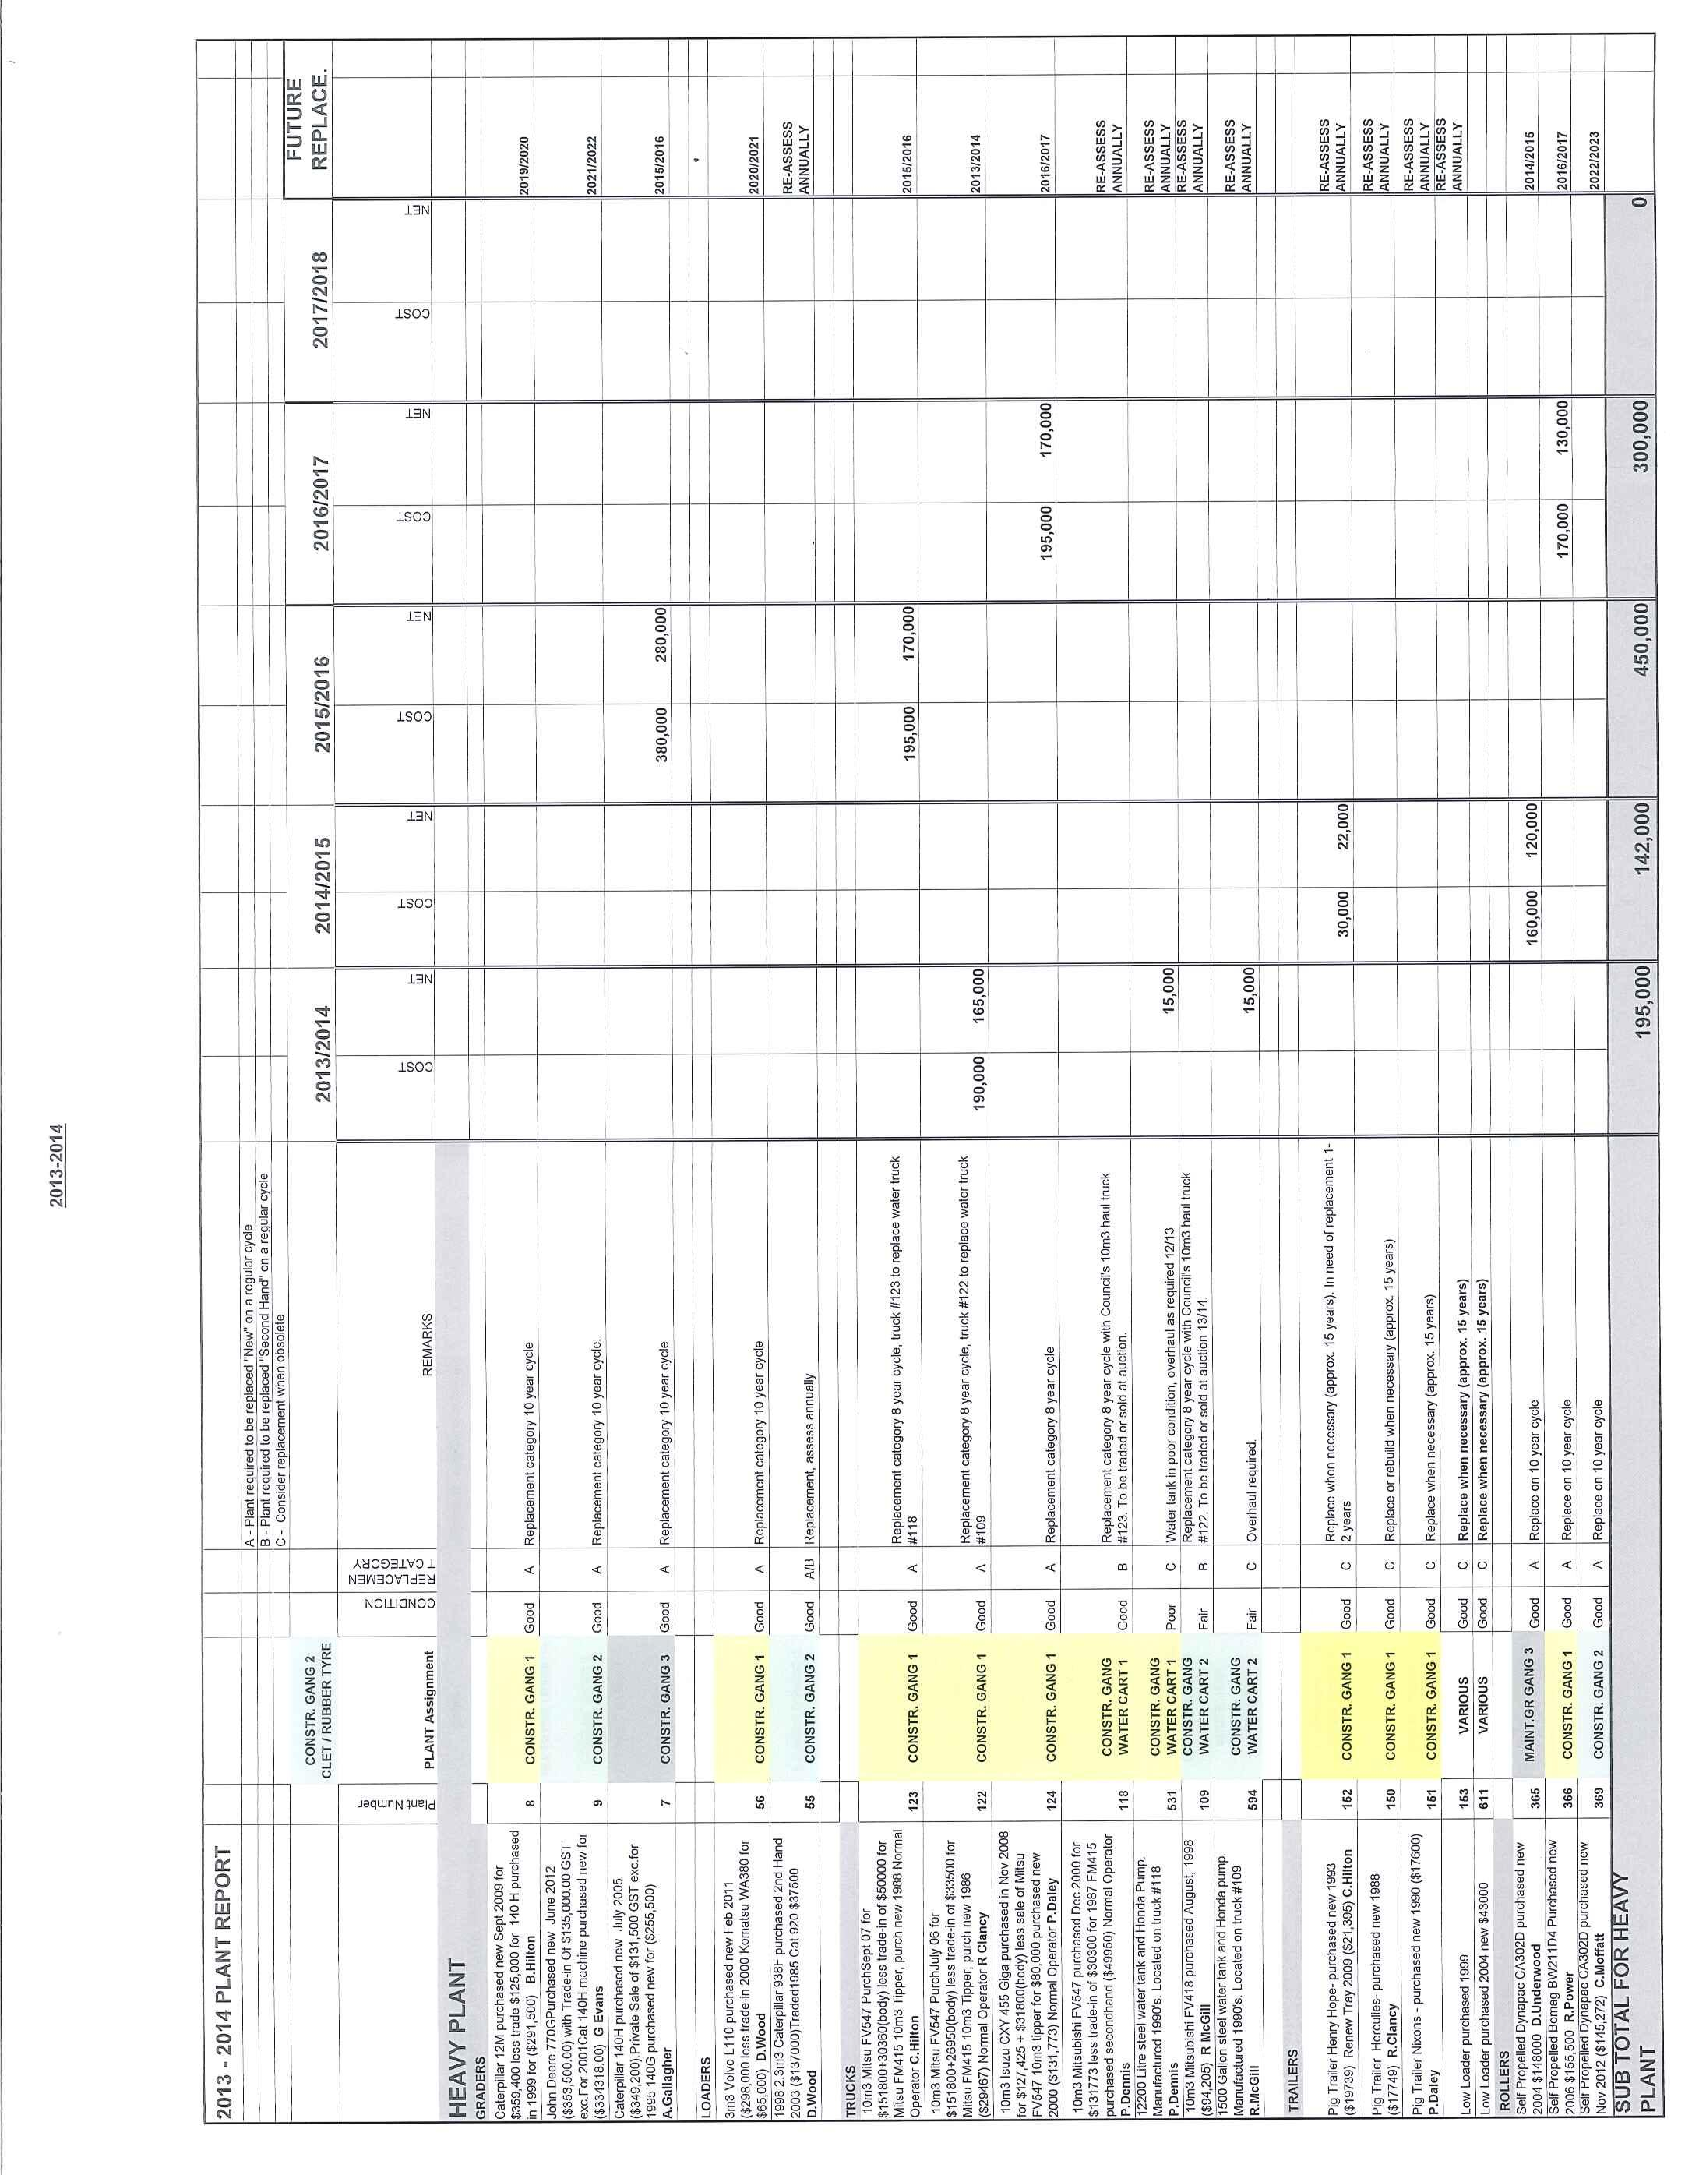
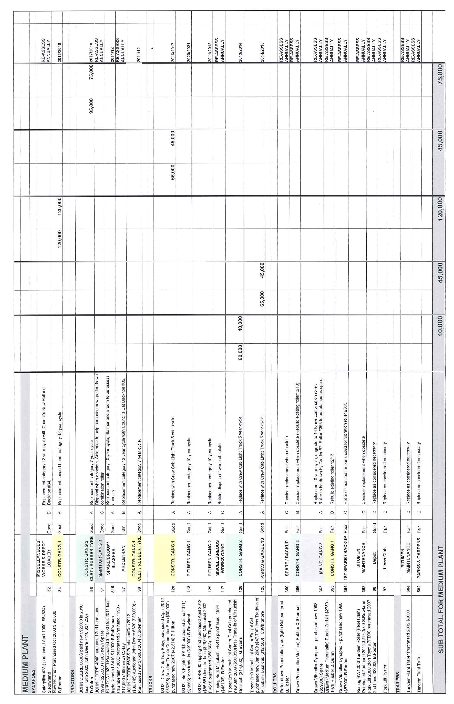
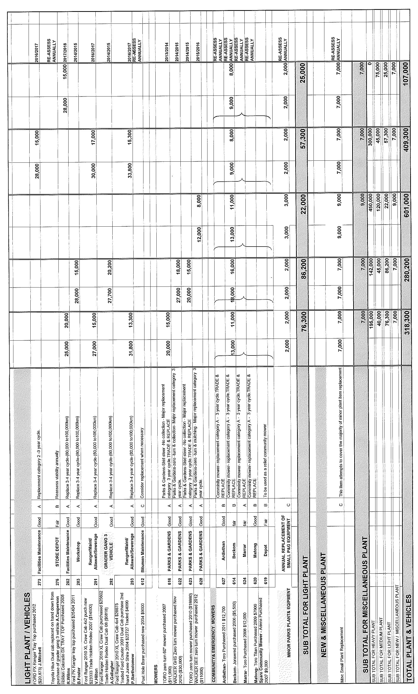
ES11) 2013/2014 TOWN WORKS / PARKS PRIORITIES (F.02-02)

The attached file separates projects into the categories of Major Projects (MP), Town Works (TW) and Town Parks (TP). Each category has been prioritorised according to asset condition and need for replacement.

Taking into consideration Council’s existing Works Programme involving Block Grant, Repair Program, Roads to Recovery, Flood Repairs, Gravel Maintenance and Stabilisation, Council will have limited time and resources available to perform Major Town Works. Projects located on the Regional Road Network may be able to be performed under the Block Grant Programme.

Recommendation

For Council consideration.

This matter was dealt with in conjunction with General Manager’s Report (GM9).
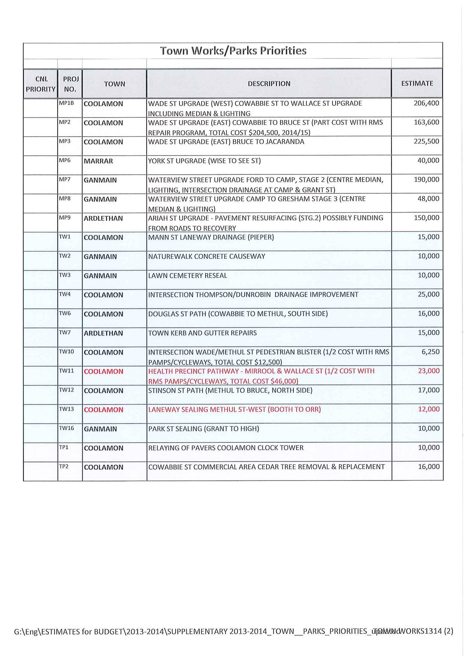
ES12) 2013/2014 ROADS TO RECOVERY

The existing allocation expires at the end of 2013/2014 financial year with Council having a budget of $640,000 remaining. The attached spreadsheet identifies projects to expire the remaining funds. The government has extended the programme for an additional five years from 2014/15 to 2018/19.

Recommendation

For Council consideration.

RESOLVED on the motion of Clr Hutcheon and seconded by Clr McCann that the report be adopted. 73/03/2013

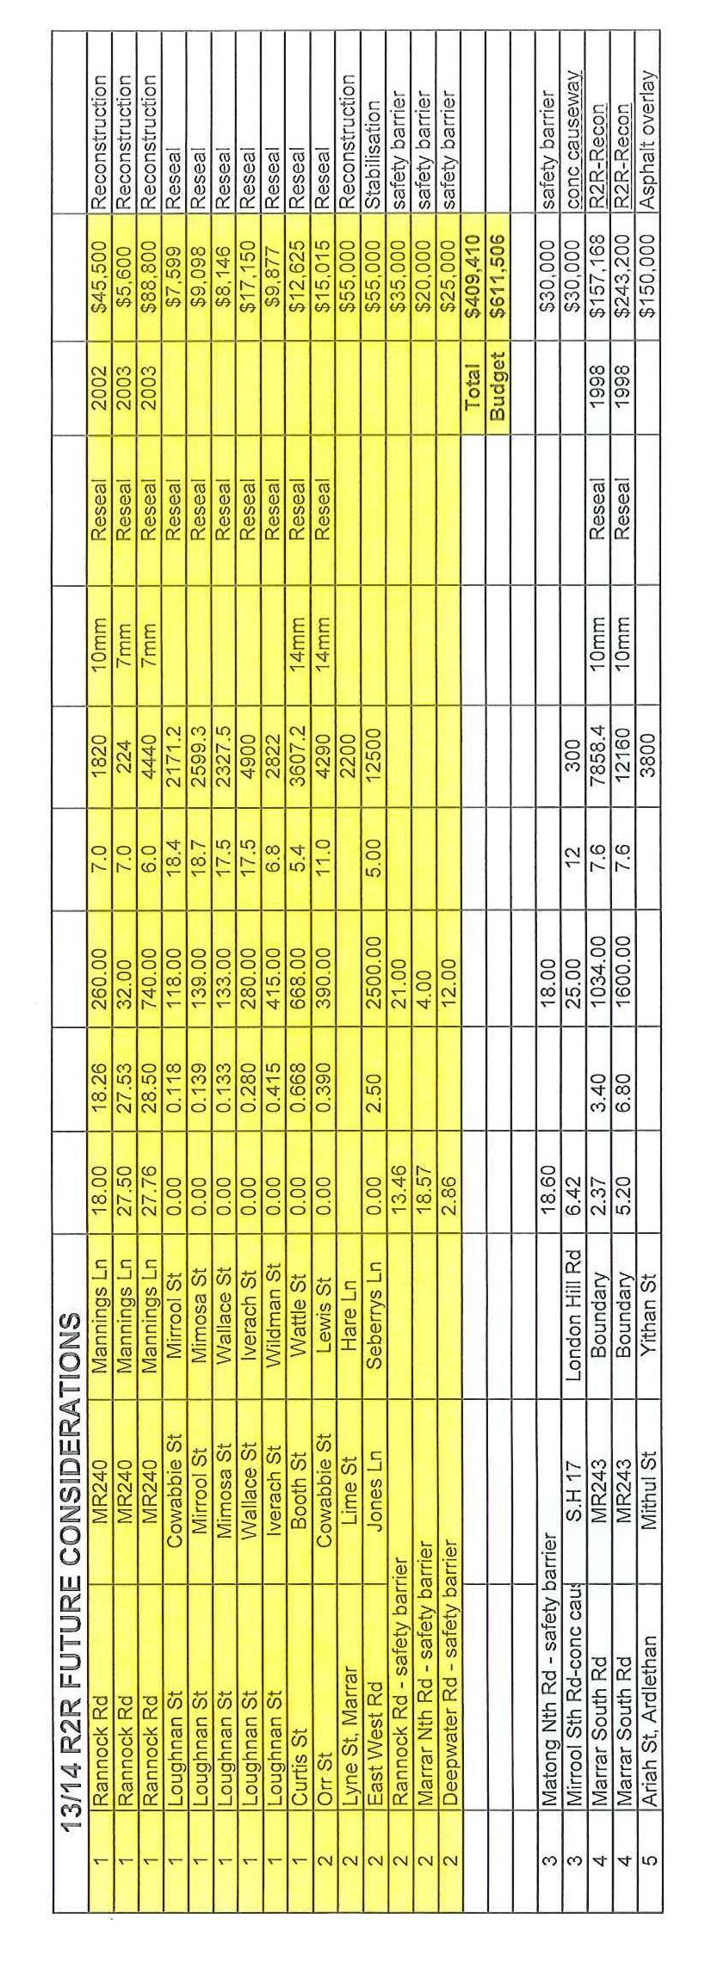
ES13) 2013/2014 STABILISATION

The attached spreadsheet identifies and prioritises gravel roads suitable for stabilisation. Road identified are those which are not of a high traffic volume or significant heavy vehicle route but still requires attention to achieve its hierarchical classification.

Recommendation

For Council consideration.

RESOLVED on the motion of Clr Brill and seconded by Clr Logan that the report be adopted. 74/03/2013

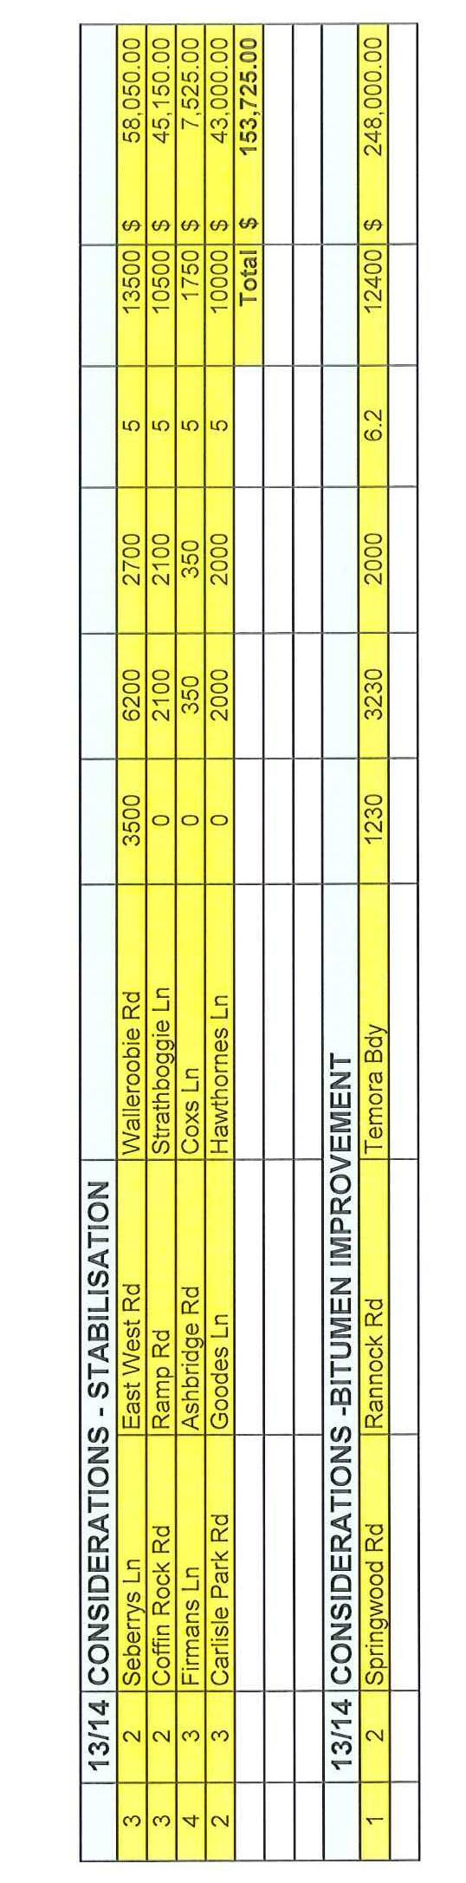
ES14) 2013/2014 PAMPS/CYCLEWAYS PROGRAMME

The attached spreadsheet identifies projects remaining from the 2005 Pamps and Cycleways Study. Projects have not been identified for the 2013/14 financial year and requires Council to recommend any modifications to the presented priority list.

Recommendation

For Council consideration.

RESOLVED on the motion of Clr Huxtable and seconded by Clr McCann that the report be adopted. 75/03/2013

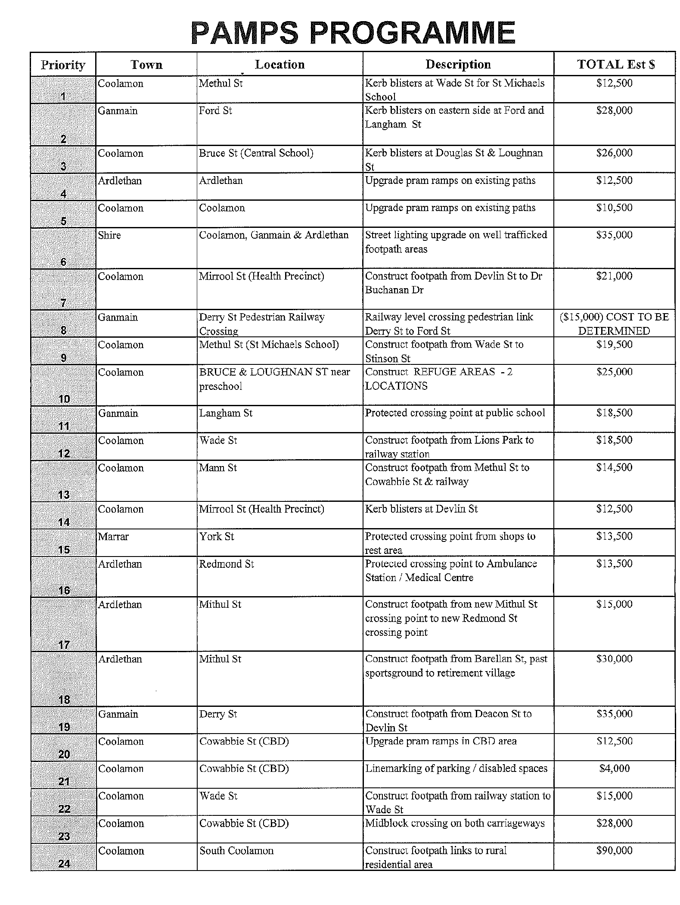
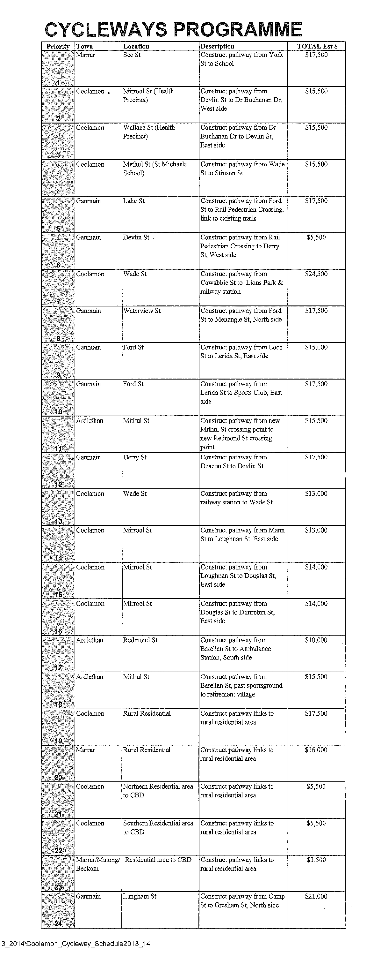
ES15) HIGHER MASS LIMITS (HML) ACCESS FROM TALLIMBA TO ARDLETHAN (R.09-17)

➔ Council has received a request from the Roads & Maritime Services to consider the operation of B-Doubles at Higher Mass Limits from Tallimba through Ardlethan. The roads involving the Coolamon Shire are as follows:
Attachment No. 11.1

- Bygoo Road and Wilson Street (Stewarts Lane to Ariah Street)
- Ariah Street (Wilson Street to Mirrool Street)
- Mirrool Street (Ariah Street to Mullins Street)

➔ This route is currently approved for B-Doubles (25/26 metres) general access vehicles and requires a Restricted Access Vehicle Route Assessment as per the RMS Guidelines. Attachment No. 11.2

The RMS are not requesting a variation to the vehicle configuration but an increase in mass limit only from a standard mass limit of 62.5 tonnes to a Higher Mass limit (HML) of 68 tonnes.

1) HIGHER MASS LIMITS (HML)

Higher Mass Limits (HML) is a nationally agreed scheme that permits access to approved routes for freight vehicles with a mass higher than GML/CML. Vehicles must have certain types of axle groups and include a range of vehicle combinations (ie. Short Combination, B-Double, Road Train, AB or B-triple).

To operate under HML, the vehicle must meet special regulatory conditions:

- Be fitted with road friendly suspension according to VSB 11.

- Be enrolled in IAP and carry a valid copy of the Intelligent Access Permit.

- Not exceed the allowable mass limit under HML and self-declare the Total Mass (TM) at the start of a journey, and whenever there is a change in the vehicle configuration or change in the total mass.

- Not exceed the manufacturer’s total mass limit for combination or component.

- Be accredited under the Mass Module of the National Heavy Vehicle Accreditation Scheme and display a mass accreditation label on the driver’s door of the prime mover of the vehicle.

- Comply with in-service and maintenance requirements for road friendly suspension under the National Heavy Vehicle Accreditation Scheme.

- Carry the notice or permit required for the vehicle configuration.
➔ Attachment No. 11.3

1.1 National Heavy Vehicle Accreditation Scheme (NHVAS)

The National heavy Vehicle Regulator (NHVR) opened for business in January 2013 and is Australia’s first National, Independent Regulator for all vehicles over 4.5 tonne. The NHVR is the controlling authority for offering NHVAS which encourages heavy vehicle operators to take more responsibility for loading their trucks correctly and ensuring that their trucks are not overloaded. Benefits to the community include better and more consistent compliance with road safety standards and should lead to greater road safety.

➔ To qualify for accredited the operator is required to develop a Mass Management System that records the loaded weight for each trip and prove the trucks were within the relevant mass limits. An independent audit to verify that the record keeping and procedures comply with the Mass Management System is performed on accreditation, 6 months after accreditation and then every 2-3 years. Internal audits are required to be performed on an annual basis. To satisfy the various audits the operator must comply with the eight Mass Management Standards (attached). Attachment No. 11.4

1.2 Intelligent Access Program (IAP)

IAP is a compliance program aimed to provide road authorities with the confidence that the right vehicles are travelling on the right roads, providing transport operators with the opportunity to obtain improved access arrangements at higher mass and the community greater assurances that the right trucks operate on the right roads.

➔ The system utilizes satellite based technology to remotely monitor where and when heavy vehicles are operating on the road network and to send non compliance reports to the RMS when the location is outside a defined set of conditions. The RMS will review non compliant events and use the information to assist them to be compliant. Traditional methods of enforcement may still be exercised if transport operators continue to be non compliant. Attachment No. 11.5

1.3 Road-Friendly Suspension (RFS)

RFS are designed to reduce the effects of increased vertical axle loads associated with HML. For suspensions to be considered road friendly and eligible for mass increases, they will need to meet the following performance standards:

- A sprung mass frequency of no greater than 2.0 Hz;
- Minimal critical damping of 20 percent;
- Static load sharing to within 5 percent; and
- Dual tyres.

The majority of air suspensions typically meet the criteria, but steel-sprung suspension can also be engineered to meet the performance standards.

It is believed the vertical forces of a well maintained suspension system under the more rigorously controlled Higher Mass Limit Scheme imparts a reduced vertical force compared to a general mass limit vehicle with an ineffective system.

2) INFRASTRUCTURE LOADING

An investigation is required whenever the proposed vehicle has a higher axle or gross mass, and/or different axle spacing and configuration than vehicles already approved to use the route. The consequence of not determining the structural capacity of the bridges and culverts can have catastrophic consequences and must be performed by a suitably qualified Engineer.

2.1) Bridge/Culvert Structures

An assessment of the proposed route identifies eleven structures of various dimensions and ages.

Many of the structures were constructed over 40 years ago and to an unknown specification. Six of the structures have nothing more than a wearing surface as cover and the impact of 40 years of operation over this period is unknown.

➔ Council does not have qualified staff to determine the existing structural capacity of the structures and approve them to the increased load impacts of the HML. Any structural investigation should be performed by a suitably qualified individual and at the expense of the applicant. Attachment No. 11.6

2.2) Pavement Wear

The implications of HMS are that an 8.8% pay load increase even with Road Friendly Suspension fitted could eventually result in an accelerated deterioration of the road surface, pavement and road shoulders. This could reduce the economic life of the particular road route and in turn require additional funds to maintain it to the current level of service.

There is also the argument that a vehicle operating under the rigorous controls of HML will impart reduced pavement wear for a set quantity of material.

 | GML | HML
Quantity of Material | 50,000 tonne | 50,000 tonne
Mass Limit | 62.5 tonne | 68 tonne
Number of Loads | 800 | 735

Under HML a reduction of 65 vehicle movements is achieved, it should also be noted that approval for higher mass limit is not restricted to the applicant only, but is an approval of the proposed route for any operator.

Of concern are the horizontal pavement loads applied to the pavement wearing course by vehicles in the following circumstances:

- During accelerating and braking, (eg: passive or active controlled road or rail junctions decent).

- Around tight curves, (eg: roundabouts, winding geometry).

- Turning movements at low speed, (eg: T Junctions).
- Sheer forces applied through drive wheel traction to overcome rolling resistance and grades (eg: climbing lanes).

The failure modes include fatigue cracking of the binder, bleeding and stripping of the wheel path of the wearing surface. Such failure is of course exasperated by higher mass vehicles.

Many of Council’s Local Road Network was constructed approximately 40-50 years ago and were essentially earth formed with a seal applied. They certainly do not have an appropriate depths of suitable base and sub-base material and are far from the construction standards displayed on the Regional and State Road Network.

In the last financial year (2011/12) Council performed $172,000 worth of works to repairs and cater for the existing transport needs. The work performed includes the asphalting of the intersections of Wilson Street/Ariah Street and Mirrool Street/Ariah Street and asphalt edge repair to Bygoo Road.

A recent inspection indicated pavement failures located at the intersection of Wilson Street/Ariah Street as a result of the existing horizontal forces exerted by heavy vehicles. Any increase in mass will only result in greater horizontal forces and accelerated deterioration.

➔ The eastern side of Bygoo Road is also displaying edge deterioration along its length and again with the increased loads deterioration will only accelerate requiring additional funds to maintain to the current level of service. Attachment No. 11.7

3) ACCESS FOR FREIGHT VEHICLES

The NSW Route Assessment Guide for Restructured Access Vehicles states: “A state road is the preferred road for freight transport and Regional Roads provide local freight connectivity to State Roads. The terminals at the origin or destination of a journey should be connected by the shortest local route to a Regional and/or State Road”.

An assessment of existing B-Double approved routes from Buralyang Road, Tallimba to State preferred routes provides the following:

1) Via Tallimba Road – 32kms
2) Via Ariah Park Road – 33kms
3) Via Bygoo Road – 47kms

➔ Bygoo Road is the longest of the possible routes and does not satisfy the Route Assessment Guide. Access from the Newell Highway and Burley Griffin Way to the Ardlethan Grain Terminal (Mullins Street) is a pre-approved B0Double HML route. Attachment No. 11.8

SUMMARY

Whilst it is important to recognize the significance of the Transport Industry in providing services to the needs of the locally based businesses the implications of an accelerated deteriorating Road Network requiring additional maintenance funds needs to be taken into consideration.

1) The load capacity of the various drainage structures are unknown and require a suitably qualified Structural Engineer to verify they can withstand the increased loading. Council, Community and Ratepayers see no direct income or benefit from permit HML. The Transport Operator is the main beneficiary whilst Council and the Community are left with a deteriorating Network and maintenance bill. As the primary beneficiary, the Transport Operator is responsible to finance any structural assessment.

2) Council’s ageing local Road Network is not of a structural standard which can withstand the changing and increasing transport demands. Council has invested considerable funds in recent years to provide maintenance along the proposed route and will now have to provide additional maintenance as a consequence of the deterioration inflicted by the existing heavy vehicles, let alone an increased load.

3) The Guide encourages Transport Operators to utilise the shortest possible route to the preferred freight transport route (State Road). The proposed route is the longest of the three options available.

Recommendation

That the HML Application be refused.

RESOLVED on the motion of Clr McCann and seconded by Clr Hutcheon that the HML Application be refused. 76/03/2013

5) REPORTS: DELEGATES/MAYOR/COUNCILLORS

1) Ardlethan Cemetery

Clr Maslin noted advice received from ratepayers concerning the presentation of the Ardlethan Cemetery. Clr Maslin noted that recent issues had been attended to and Council staff were to be complimented.

2) Composting Bins – Ganmain

RESOLVED on the motion of Clr Brill and seconded by Clr McCann that a report be submitted to Council concerning the potential for the introduction of composting bins in Ganmain. 77/03/2013

3) Ganmain Hall

Clr Logan raised the issue concerning the land behind the Ganmain Hall and the need for Council to fence off the Plaza from operations at the back.

RESOLVED on the motion of Clr Logan and seconded by Clr McCann that Council provides a report on ownership of all land at the rear of the Ganmain Hall through to Menangle Street. 78/03/2013

6) RECOMMENDATIONS OF THE STAFF COMMITTEE MEETING HELD 21ST FEBRUARY, 2013.

RESOLVED on the motion of Clr Hutcheon and seconded by Clr Maslin that the Recommendations of the Staff Committee Meeting held 21st February, 2013 as presented to Council be adopted. 79/03/2013

7) RECOMMENDATIONS OF A STAFF COMMITTEE MEETING HELD 21ST MARCH, 2013.

Council noted that the sensitivity of the issue presented at the Staff Committee Meeting and resolved that it be dealt with in Committee of a Whole.

 ADJOURNMENT

Council adjourned at 4.15pm into Committee of a Whole and reconvened at 4.25pm.

RESOLVED on the motion of Clr Logan and seconded by Clr McCann that Council resolve into Committee of a Whole for the purpose of considering confidential matters as listed in the Committee of a Whole agenda for the reason that such matters are considered to be of a confidential nature and in accordance with Council's policy thereto. 80/03/2013

8) RECOMMENDATIONS OF A COMMITTEE OF WHOLE MEETING HELD 21ST MARCH, 2013.

Council noted that this was a staff issue that had been referred to Committee of a Whole by the Staff Committee Meeting of 21st March, 2013.

RESOLVED on the motion of Clr Huxtable and seconded by Clr Brill that the Recommendations of the Committee of a Whole Meeting held 21st March, 2013 as read by the General Manager to Council, be adopted. 81/03/2012

Meeting Closed at 4.30pm.

Confirmed and signed during the Meeting held this 18th day of April, 2013.

......................................................
MAYOR

