Meeting commenced at 1.30pm.

BUSINESS:

1) Apologies

2) a. Confirmation of Minutes of the Meeting held 18th April, 2013.
b. Matters arising out of Minutes. (Not elsewhere reported)

3) Correspondence
a. Agenda A (Information Only)
b. Agenda B

4) General Manager’s Report
4.1 General Manager’s Report
4.2 Executive Manager, Corporate & Community Services’ Report
4.3 Executive Manager, Engineering & Technical Services’ Report
4.4 Deputy General Manager, Planning & Environmental Services’ Report

5) Reports: Delegates/Mayor/Councillors

PRESENT: Clrs Seymour (Chairman), Logan, Brill, Huxtable, McCann, Maslin, Beard, White and Hutcheon.

STAFF: General Manager; Executive Manager, Corporate & Community Services; Executive Manager, Engineering & Technical Services; Deputy General Manager, Planning & Environmental Services.

1) APOLOGIES

There were no apologies.

The Mayor advised of the passing of Mr Michael Curtis previous Shire Clerk to the Coolamon Shire Council from 1963 to 1984. A minutes silence was observed by the meeting.
2a) CONFIRMATION OF MINUTES OF THE MEETING HELD 18TH APRIL, 2013.

RESOLVED on the motion of Clr Maslin and seconded by Clr McCann that the Minutes of the Meeting held 18th April, 2013 as circulated be confirmed and adopted. 108/05/2013

2b) MATTERS ARISING OUT OF THE MINUTES

There were no matters arising out of the Minutes.

3) CORRESPONDENCE

AGENDA A (FOR INFORMATION ONLY)

1a) INFORMATION PAPERS

➔ The following papers have been distributed with Council’s supplementary material as being matters of information/interest to Councillors. If Councillors desire any further information on the matters distributed then that can be raised with the General Manager. Attachment No. 1

1) NSW Shires Association Weekly Circulars 15, 16, 17 and 18.

2) NSW Government Weekly Update from Adrian Piccoli dated 26 April, 2013 and 3 May, 2013.

3) Minutes of the Coolamon Showground Management Committee held 31 January, 2013.

4) Minutes of the AGM of the Beckom Hall Committee held 15th April, 2013.

2a) ACTIVITY REPORTS

1) Coolamon Shire Multi Service Outlet Coordinator’s Monthly Report for the month of April 2013.

2) Operating Statistics of the Coolamon Shire Library for April 2013.

3) Tourism & Business Development Monthly Update for April 2013.
General Manager’s Note

The above reports are operating reports only for use by Senior Staff. They are submitted to Council as part of Agenda A for information only. Attachment No. 2

3a) GUNDAGAI SHIRE COUNCIL (C.11-01)

Announcing the appointment of Mr Michael Brady as the new General Manager for Gundagai Shire Council.

4a) ADVANCE GANMAIN COMMITTEE (C.09-41)

➔ Forwarding a copy of their Minutes of the first meeting held on the 15th April, 2013. A copy of the Minutes is attached to Council’s information papers. Attachment No. 3

RESOLVED on the motion of Clr Maslin and seconded by Clr Hutcheon that the Correspondence listed in Agenda A be received. 109/05/2013

AGENDA B

1b) GANMAIN SHOW SOCIETY INC (S.04-03)

Seeking sponsorship of Council in the amount of $2,000.00 towards the Ganmain Show.

General Manager’s Note

Council does not have these funds in its Budget and when considering community events earlier in the year Council did not resolve to provide funding for this event.

RESOLVED on the motion of Clr McCann and seconded by Clr Hutcheon that it be deferred to the 2014/2015 events budget. Clr Logan voted against the motion.
110/05/2013

4. GENERAL MANAGER’S REPORT

4.1 GENERAL MANAGER REPORTS

GM1) STRATEGIC PLANNING PROCESS – INFRASTRUCTURE SERVICES (S.20-01)

Strategic Planning of Civil Infrastructure for Council’s major towns is currently underway. Former Council Engineer, Tim Morris has been working on this project on a part time basis for some time.

The intention is to map where Council may extend the services given normal growth over the next 25 years. An emphasis has been placed on the towns of Coolamon, Ganmain and Ardlethan where growth may occur and require additional services. Any growth in the other towns should be capable of being managed within existing services.

Work that has currently been completed in Coolamon:

- Sewerage
- Footpaths
- Kerb and Gutter
- Stormwater Drainage
- Projections still need to be done for Parks and Garden and Sealed Road Network.

Once Coolamon has been finished work will then commence on the other two towns.

➔ A copy of the work done to date is attached to Council’s information papers. Attachment No. 4

The completion of the work will allow Council to have a Strategic Plan for the next few years that will assist in its budgeting processes.

Recommendation

That the report be noted.

RESOLVED on the motion of Clr Maslin and seconded by Clr Logan that the report be received. 111/05/2013

GM2) LOCAL GOVERNMENT INDEPENDENT PANEL – REVIEW OF LOCAL GOVERNMENT (L.05-05)

Council at a recent Workshop reviewed the Submissions from Council and REROC together with the Reports from the Local Government Independent Review Panel. Council noted that a further Submission was to be presented to the Panel by the end of May and that discussions were to be held at Junee on the 29th May, 2013. A further Report from the Panel finalizing its conclusions should be completed by September 2013.

Following discussions at the Workshop Council should now formalise its position to enable its delegates to take a point of view to the next round of consultations with the Panel.

Recommendation

For Council decision.

RESOLVED on the motion of Clr McCann and seconded by Clr Logan that Council present a submission to the Independent Local Government Review Panel that:
112/05/2013

- Council desires to remain as an independent authority.
- Council supports the REROC proposal that provides for the establishment of a Regional Strategic Council as a regional co-ordinating body supporting general purpose Councils.
- Council support the redistribution of the Financial Assistance Grants funding to benefit Rural and Regional Councils.
- TCorp to review their analysis of Councils to incorporate the effects of cost shifting, ratepegging and redirected Financial Assistance Grants. Furthermore, TCorp be asked to provide a standardized formula for depreciation for all Councils and make assessment on Councils following those adjustments.
- Council arranges a delegation to Local Member, Adrian Piccoli and bring to his attention the deficiencies in the current report and of this Council’s desire to implement change but maintain its independence.
- Council advise LGNSW of its disappointment in its lack of support and commentary of the Panel’s activities.
- Council will contribute to the engagement of a qualified independent person to provide a peer review of the Panel’s latest report.

GM3) SECTION 355 COMMITTEES (C.09-01)

Further to Council’s report at the March Council Meeting regarding Section 355 Committees, advice has now been received by the following Section 355 Committees seeking formalization of their respective Committee:

1) ADVANCE BECKOM COMMITTEE

That in accordance with Section 355 of the Local Government Act, Council formally delegate to:

Errol Thomson, Julie Thomson, Marg McDonald, Linda Griffin, Paul Griffin, Anne Stewart, Helen Bray, Jim Bundy, Paul Horan, Marie Golden, Jim Gardner, Janesse Bundy, Margie Rees, Robyn Richards, Mike O’Hare, Viela O’Hare, Graham Maslin, Kathy Maslin, Leo Griffin, Stan Maslin, Judy Maslin, John O’Brien, Sally O’Brien, Marg Bradley, Mick Bradley, Mal Rees, Paul Bray, Kevin Popple, Janet Popple, Ellie Walton, Lee Jackson

the following functions:

1) To control, manage and maintain the following assets on Council’s behalf:-
- Beckom Hall

2) To represent the Community of Beckom to consult, engage and work with Council to achieve outcomes identified for the Beckom Community included in Coolamon Shire’s Community Strategic Plan or otherwise.

3) To carry out general promotional activities for the benefit of the Beckom community.

4) To conduct fundraising activities within the Community on behalf of the Advance Beckom Committee.

2) COOLAMON SHOWGROUND MANGEMENT COMMITTEE

That in accordance with Section 355 of the Local Government Act, Council formally delegate to:

Helen Turner, Wendy Dennis - Coolamon Trotting Club
Vinnie Leary, Ken Hussey - Coolamon Endurance Riders Inc
David Williams, Jamie McInerney - Coolamon Team Penning
Del Williams, Barb Wiscombe - Coolamon Pony Club
The following functions:

i) The Committee is vested with general control over the Coolamon Showground Reserve and is responsible for the general maintenance of all assets contained within this Reserve area.

ii) To conduct fundraising activities within the Community on behalf of the Coolamon Showground Management Committee.

iii) To control and regulate the community use of the Showground Reserve.

3) RANNOCK COMMUNITY CENTRE – RESERVE NO. 89397

That in accordance with Section 355 of the Local Government Act, Council formally delegate to:

B Rollins, B Chant, M Rollins, B Dennis, R Moncrieff, B Holden, F Grinter.

The following functions:

i) To provide management control over the Rannock Community Centre being responsible for the general maintenance of this asset.
ii) To conduct fundraising activities within the Community on behalf of the Rannock Community Centre.

4) FRIENDS OF THE COOLAMON UP-TO-DATE CULTURAL PRECINCT

That in accordance with Section 355 of the Local Government Act, Council formally delegate to:

Marg Furner, Sandra West, Fay Bocquet, Wayne Pearse, Penny Munro, Peter Lucas, Jeanette Campbell, Bill Levy, Angela McCann and Ivan Furner

Council Delegates:
Clr B Hutcheon, Clr J Seymour, Clr D McCann

the following functions:

    - To facilitate the operation of the Up-to-Date Store Precinct, and to develop a vibrant cultural and conference centre for the Shire.

    - To work alongside the Precinct Co-ordinator to implement regular and ongoing activities and events which raises the profile of the Coolamon Shire and the Precinct.

    - To research and recommend ideas and initiatives for the development and enhancements to the Up-to-Date Store Precinct.

    - To work co-operatively with the Precinct Co-ordinator to achieve the goals and objectives set out in the Strategic Plan.

Recommendation

For Council confirmation.

RESOLVED on the motion of Clr Brill and seconded by Clr Huxtable that:
113/05/2013

1) BECKOM HALL & COMMUNITY COMMITTEE

That in accordance with Section 355 of the Local Government Act, Council formally delegate to the Beckom Hall & Community Committee comprising of:

Errol Thomson, Julie Thomson, Marg McDonald, Linda Griffin, Paul Griffin, Anne Stewart, Helen Bray, Jim Bundy, Paul Horan, Marie Golden, Jim Gardner, Janesse Bundy, Margie Rees, Robyn Richards, Mike O’Hare, Viela O’Hare, Graham Maslin, Kathy Maslin, Leo Griffin, Stan Maslin, Judy Maslin, John O’Brien, Sally O’Brien, Marg Bradley, Mick Bradley, Mal Rees, Paul Bray, Kevin Popple, Janet Popple, Ellie Walton, Lee Jackson

the following functions:

1) To control, manage and maintain the following assets on Council’s behalf:-
- Beckom Hall

2) To represent the Community of Beckom to consult, engage and work with Council to achieve outcomes identified for the Beckom Community included in Coolamon Shire’s Community Strategic Plan or otherwise.

3) To carry out general promotional activities for the benefit of the Beckom community.

4) To conduct fundraising activities within the Community on behalf of the Advance Beckom Committee.

2) COOLAMON SHOWGROUND MANGEMENT COMMITTEE

That in accordance with Section 355 of the Local Government Act, Council formally delegate to:

Helen Turner, Wendy Dennis - Coolamon Trotting Club
Vinnie Leary, Ken Hussey - Coolamon Endurance Riders Inc
David Williams, Jamie McInerney - Coolamon Team Penning
Del Williams, Barb Wiscombe - Coolamon Pony Club

The following functions:

i) The Committee is vested with general control over the Coolamon Showground Reserve and is responsible for the general maintenance of all assets contained within this Reserve area.

ii) To conduct fundraising activities within the Community on behalf of the Coolamon Showground Management Committee.

iii) To control and regulate the community use of the Showground Reserve.

3) RANNOCK COMMUNITY CENTRE – RESERVE NO. 89397

That in accordance with Section 355 of the Local Government Act, Council formally delegate to:

B Rollins, B Chant, M Rollins, B Dennis, R Moncrieff, B Holden, F Grinter

the following functions:

i) To provide management control over the Rannock Community Centre being responsible for the general maintenance of this asset.

ii) To conduct fundraising activities within the Community on behalf of the Rannock Community Centre.

4) FRIENDS OF THE COOLAMON UP-TO-DATE CULTURAL PRECINCT

That in accordance with Section 355 of the Local Government Act, Council formally delegate to:

Marg Furner, Sandra West, Fay Bocquet, Wayne Pearse, Penny Munro, Peter Lucas, Jeanette Campbell, Bill Levy, Angela McCann and Ivan Furner.

Council Delegates:
Clr B Hutcheon, Clr J Seymour, Clr D McCann

the following functions:

i) To facilitate the operation of the Up-to-Date Store Precinct, and to develop a vibrant cultural and conference centre for the Shire.

ii) To work alongside the Precinct Co-ordinator to implement regular and ongoing activities and events which raises the profile of the Coolamon Shire and the Precinct.

iii) To research and recommend ideas and initiatives for the development and enhancements to the Up-to-Date Store Precinct.

iv) To work co-operatively with the Precinct Co-ordinator to achieve the goals and objectives set out in the Strategic Plan.

4.2 EXECUTIVE MANAGER, CORPORATE & COMMUNITY SERVICES’ REPORTS

CS1) FINANCE REPORT AS AT 30 APRIL 2013

RESOLVED on the motion of Clr Huxtable and seconded by Clr McCann that the report be received. 114/05/2013

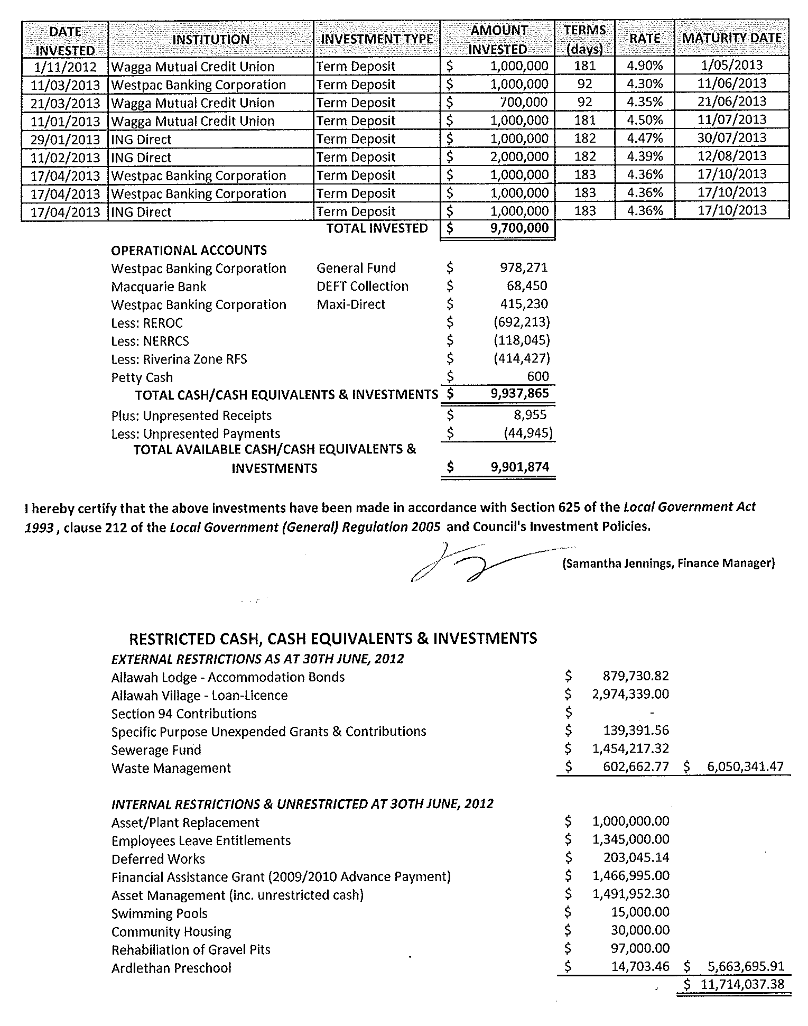
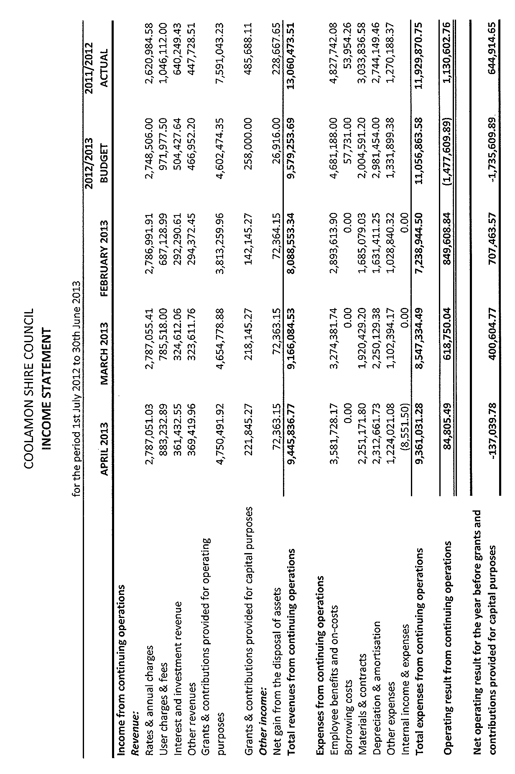
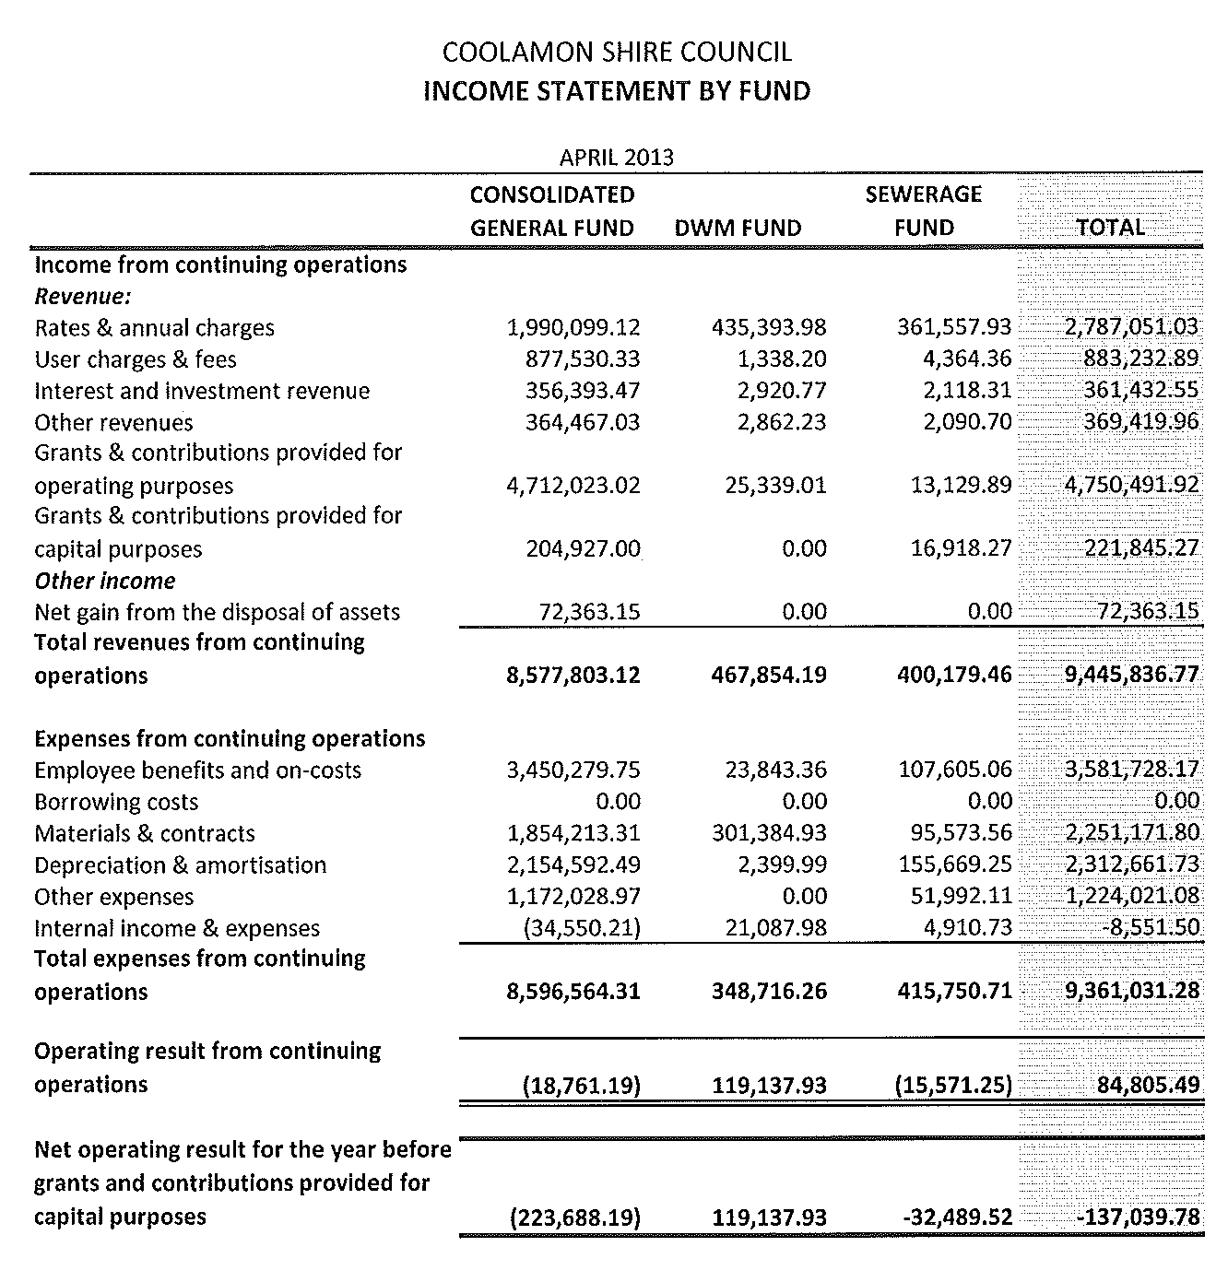
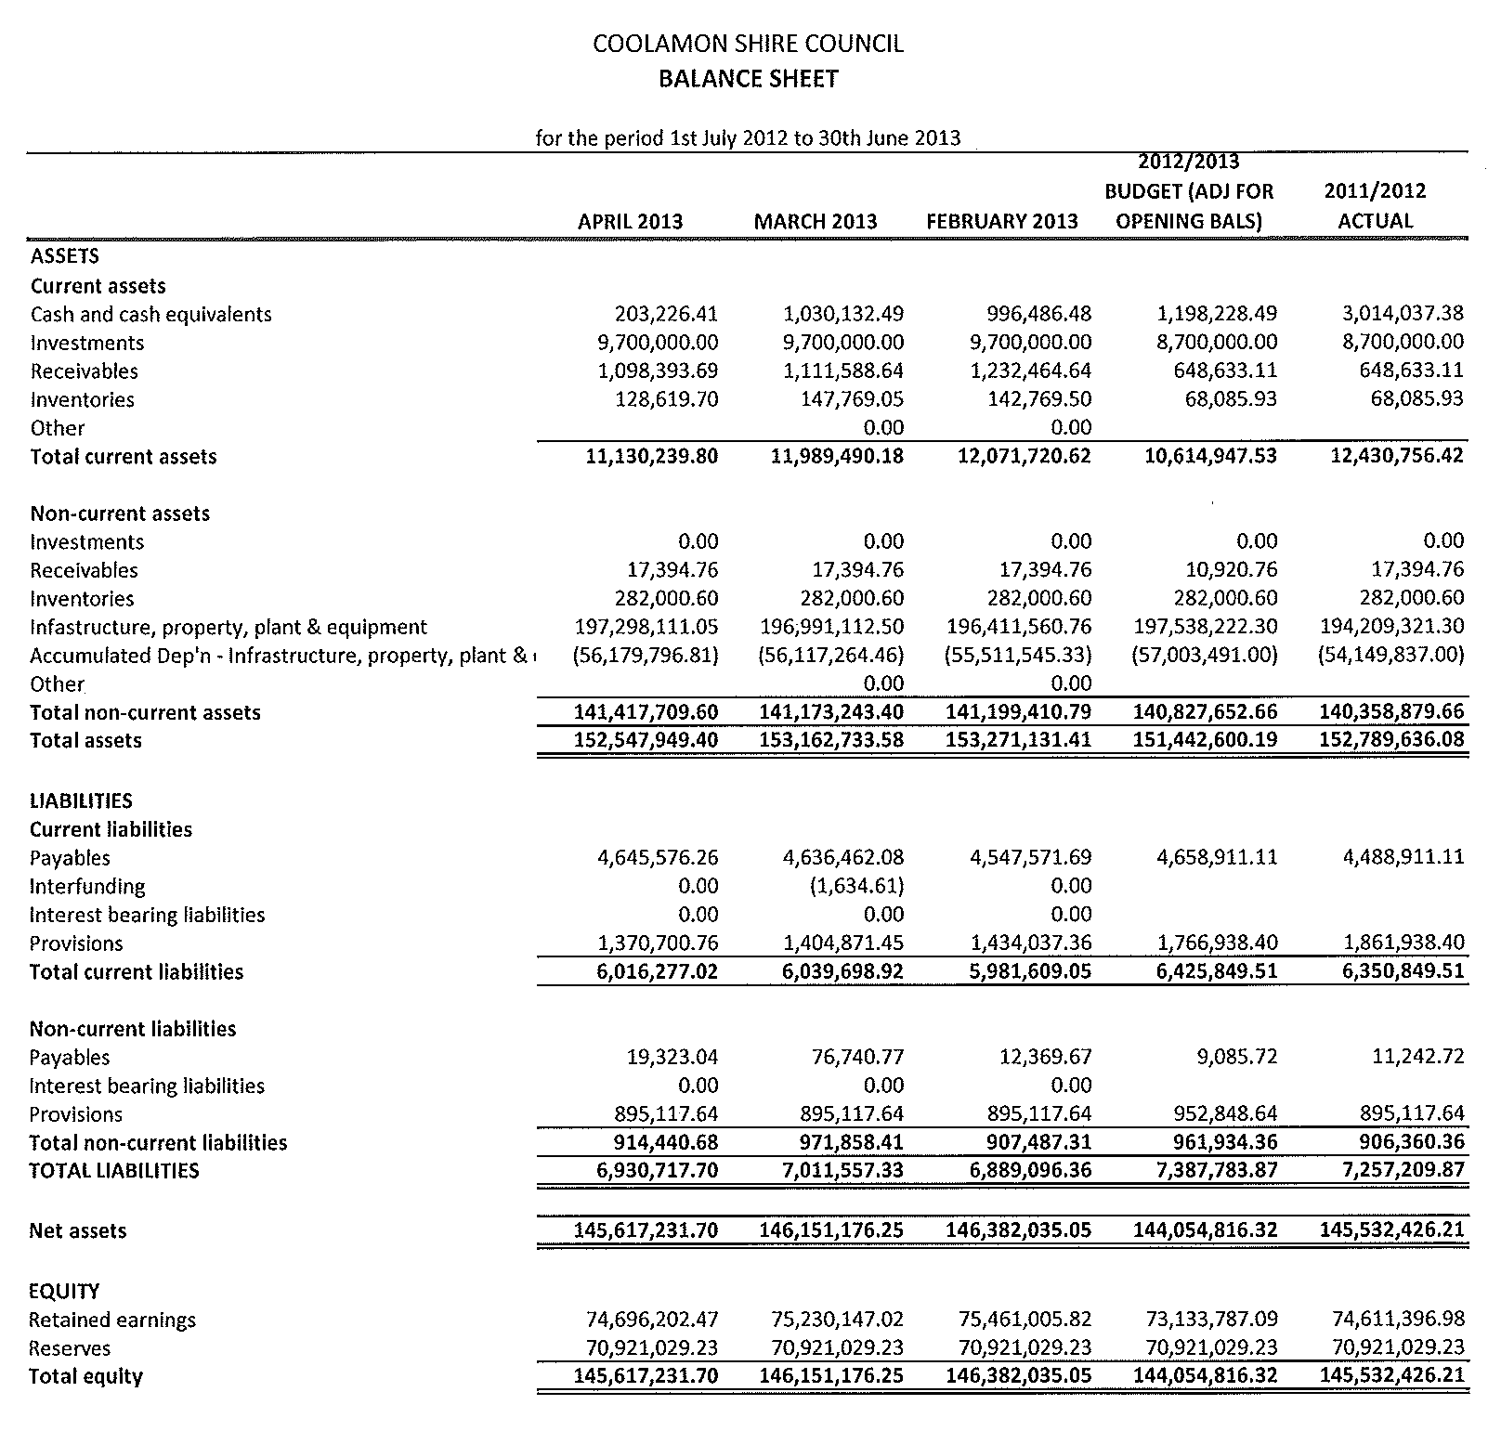
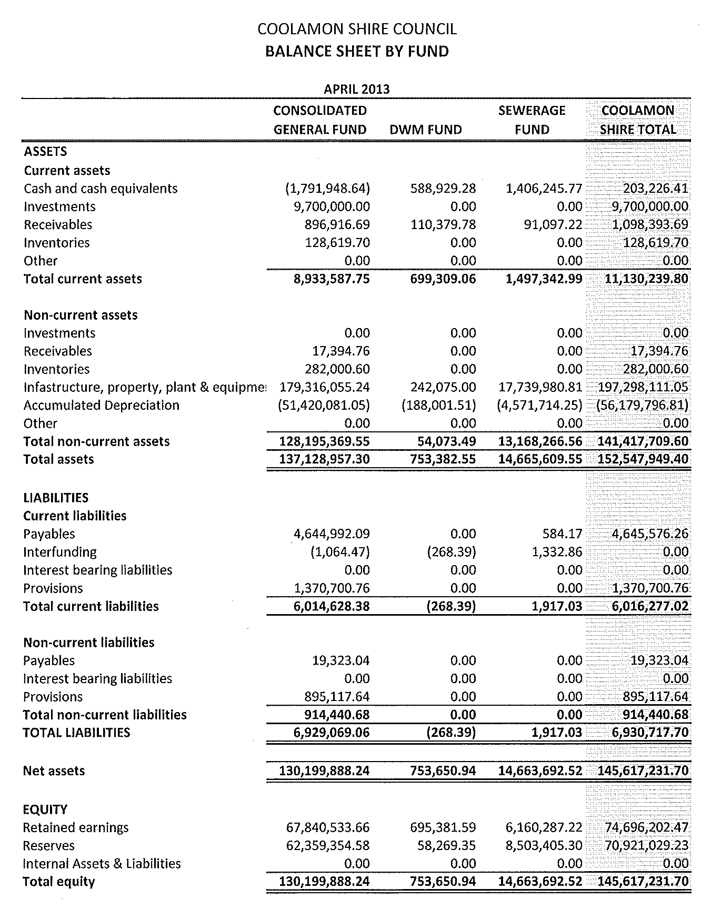
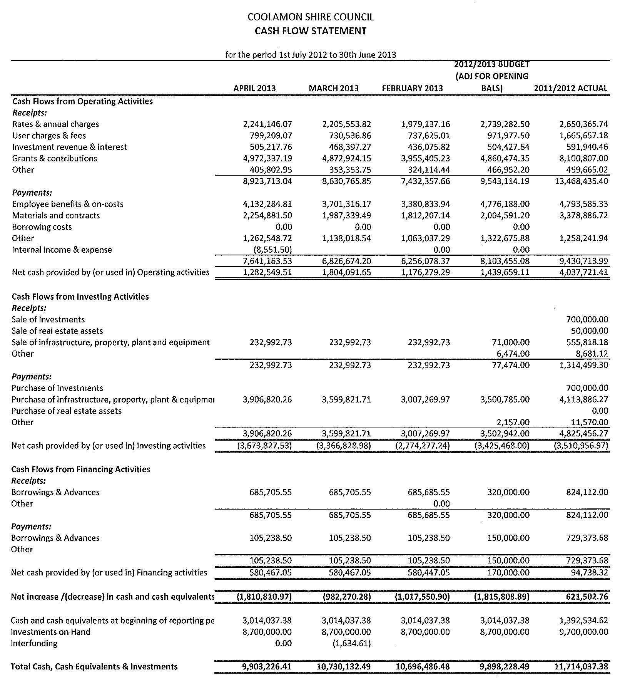
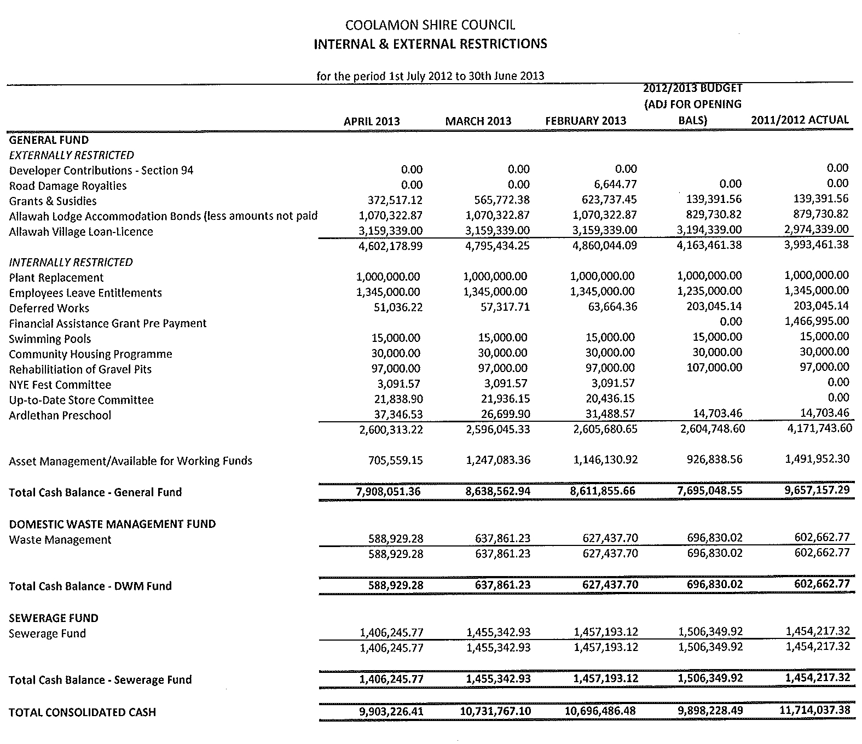
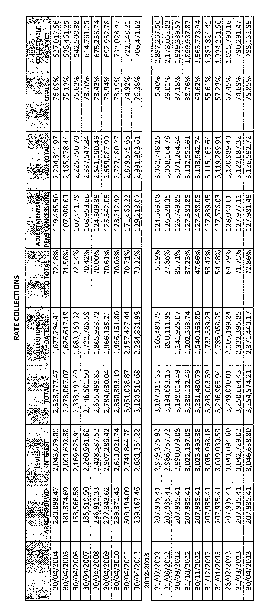
CS2) DRAFT 2013/2017 DELIVERY PROGRAM & DRAFT 2013/2014 OPERATIONAL PLAN ALTERATIONS (S.11-06, F.02-02)

Bitumen Improvement allocation transfer to Gravel Resheeting

Council may recall at the March and April Council meetings, discussions regarding the requirement to maintain expenditure from Council’s own sources as part of the Roads to Recovery Funding Program.

Council staff has now reconsidered the allocation of funds to the Bitumen Improvement works proposed on Springwood Road for the 2013/2014 financial year and would prefer that the $248,000 allocated was transferred across to increase the Gravel Resheeting/Improvement Program budget.

Springwood Road will return to the list of priorities that can be considered under the Roads to Recovery Program.

Recommendation

That the Bitumen Improvement allocation for the 2013/2014 year be reduced to $0 and that the Gravel Resheeting/Improvement budget be increased by $248,000 to a total of $498,000.
Huxtable and brill

Waterview Street Upgrade

Council resolved at its last meeting that a report be brought forward concerning the timing of the Waterview Street Upgrade in Ganmain.

Part of this review identified those major capital town works, either proposed or partially completed, for Coolamon – Wade Street, Ganmain – Waterview Street and Ardlethan – Ariah Street and the breaking down of these projects into various components and then ranking those components based on asset need.

➔ The review of these projects has been done by Council’s Manager, Engineering & Technical Services and is attached for Councillor information. Attachment No. 5

From this review, it has been identified that Council’s Draft Operational Plan and Draft Delivery Program did not allow for external funding to be utilised to undertake some of these works. The review has also identified a saving of approximately $81,000 to complete all of the proposed works.

It is proposed that the timing of the works could be as follows:

Year 1 2013/2014 – Wade Street Upgrade (Stage 1) – Total cost $114,500 (RMS Contribution $87,000)
Year 2 2014/2015 – Wade Street Upgrade (Stages 2 & 3) – Total cost $253,800 (RMS Contribution $205,000) & Waterview/Grants Street Drainage – Total cost $70,900 (RMS Contribution $22,600)
Year 3 2015/2016 – Waterview/Camp Street Drainage – Total cost $62,800 (RMS Contribution 30,700), Ariah Street Upgrade $150,000, Waterview Street Upgrade (Ford to Camp) $92,400
Year 4 2016/2017 – Waterview Street Upgrade (Camp to Gresham) $50,500 & Wade Street Upgrades (Stages 1-2 Aesthetics) - $197,000
Year 5 2017/2018 – Wade Street Upgrade (Stage 3 Aesthetics) $36,500

This would enable the works of the highest asset need to be commenced and completed prior to commencing and completing the aesthetic works for both Waterview Street and Wade Street.

To fit these works into the budget as proposed and to allow for the additional external funding, Council Draft Operational Plan & Delivery Program would require the following alterations.

Year 1 2013/2014 – An additional vote of $27,500 being funded by Council.
Year 2 2014/2015 – A reduction in total expenditure of $27,500 – to offset additional expenditure in Year 1. To compensate for the works proposed for Wade & Waterview Streets being partially funded by RMS, Council would be required to allocate $245,400 to other road projects from its own sources.
Year 3 2015/2016 – an additional vote of $49,000 being funded by Council.
Year 4 2016/2017 – an additional vote of $4,500 being funded by Council.
Year 5 2017/2018 – a reduction in total expenditure of $53,500 to offset additional expenditures in Years 3 & 4. This would leave a balance of $60,000 that Council would be required to allocate towards road projects funded from its own sources.

Council’s budget considerations over the past few years have identified the need for an adjustment to the expenditure split between rural and urban road works, therefore it is proposed that the other roads projects to be funded by Council’s own source funds should be rural road works. This can then be reconsidered as part of the 2014/2015 Operational Plan and 2014/2018 Delivery Plan formulation.

Recommendation

That the major capital projects be included in Council’s Draft 2013/2014 Operational Plan, 2013/2017 Delivery Program and Long Term Financial Plan as follows:

Year 1 2013/2014 – Wade Street Upgrade (Stage 1) – Total cost $114,500 (RMS Contribution $87,000)
Year 2 2014/2015 – Wade Street Upgrade (Stages 2 & 3) – Total cost $253,800 (RMS Contribution $205,000) & Waterview/Grants Street Drainage – Total cost $70,900 (RMS Contribution $22,600)
Year 3 2015/2016 – Waterview/Camp Street Drainage – Total cost $62,800 (RMS Contribution 30,700), Ariah Street Upgrade $150,000, Waterview Street Upgrade (Ford to Camp) $92,400
Year 4 2016/2017 – Waterview Street Upgrade (Camp to Gresham) $50,500 & Wade Street Upgrades (Stages 1-2 Aesthetics) - $197,000
Year 5 2017/2018 – Wade Street Upgrade (Stage 3 Aesthetics) $36,500

RESOLVED on the motion of Clr Hutcheon and seconded by Clr Huxtable that the Gravel Resheeting/Improvement Program for Year 2 2014/2015 be increased to $555,400 and the allocation for Year 5 2017/2018 be increased to $510,000. These increases account for the increased RMS contributions towards the works in both Wade and Waterview Street. 115/05/2013

PAMPS/CYCLEWAYS PROJECTS

Council’s Draft 2013/2014 Operational Plan allowed for two projects under the RMS PAMPS and Cycleways funding programmes. Council’s budget did not allow enough funds for the Douglas Street Footpath and the estimated total cost needs to be increased to $16,000 which is an additional $3,500 in operating expenditure. This additional expenditure will be partially offset by additional grant income under the RMS funding programmes.

Recommendation

That the allocation for the 2013/2014 year for the Douglas Street Footpath be increased to $16,000 and that the income estimate for the PAMPS and Cycleways program be increased from $15,250 to $17,000.

RESOLVED on the motion of Clr McCann and seconded by Clr White that the allocation for the 2013/2014 year for the Douglas Street Footpath be increased to $16,000 and that the income estimate for the PAMPS and Cycleways program be increased from $15,250 to $17,000. 116/05/2013
CS3) POLICY REGISTER (P.12-01)

Sick Leave Policy

➔ Council at a meeting of the 14th September, 2005 (See attached Staff Committee Report and associated resolution) adopted the Staff Committee Recommendation concerning the payout of sick leave to employees where those employees had their services terminated because of death by misadventure or illness.
Attachment No. 6.1

Council has in the past held an insurance policy to cover payments to specific staff. Generally this covered long standing employees with a significant liability. The policy has not been renewed over the past few years, although staff are arranging for a quotation to cover specific staff where the liability is considered to be material.

Having regard to the fact that Council have resolved as they did in September, a specific Staff Sick Leave Policy is now attached for Council’s consideration. The policy formalises the decision taken at the September 2005 Meeting.

Policies to be removed

Termite Protection in New Buildings Policy – This policy was put in place prior to the Building Code of Australia being updated to reflect the effective life of spray termite treatments. As a result of the updated Building Code, this policy is no longer required.

Domestic Waste Collection Service Policy – This policy was put in place prior to the introduction of the Tip Access Fee on all occupied properties within the shire that enables free access to Council’s waste depots for the dumping of domestic waste. To ensure that Council maintains tight control over the defined scavenging areas it is proposed that all requests for an extension to the existing service beyond these areas should be brought to Council along with any community consultation where it would also involve landholders in addition to the applicant.

Landfill Fires Policy – This policy is no longer required but forms part of the normal operations of Council’s landfill sites.

Categorisation of Food Shops Policy – This policy is no longer required as the Food Act has been amended and includes the categorisation.

Resource Sharing – Staff, Plant & Equipment Policy – Council’s resource sharing abilities are monitored by the General Manager.
Plant & Equipment Advertising Policy – this policy is not required as legislation and Council’s Purchasing Policy incorporates the requirements for all purchases including plant and equipment.

Policy Review

➔ The following policies are presented to Council, with recommended marked amendments where necessary. See Attachments. Attachment No. 6.2

Coolamon Shire Community Bus Policy – no amendments recommended.
Allawah Lodge Liquidity Management Strategy – this policy has been amended to include an additional year of information relating to bond balances and repayments.

Allawah (Furner/Stevenson) Community Centre Policy – amendments proposed to references made to the building and to Council’s Operational Plan and the terms of review.

On-site Sewage Management System Classification and Inspection Policy – amendments to zoning classifications as a result of the gazettal of Council’s Local Environmental Plan and the terms of the review.

Rejection or withdrawal of Development Applications Policy – amendments to include the words “Upon application” and terms of the review.

Keeping Pigs in Areas Zoned RU5 – Village Policy – amendments to the name and references to towns/villages within the policy to reflect the gazettal of Council’s Local Environmental Plan.

Australia Day & Honoured Citizen Awards Policy – no amendments recommended.

Recommendation

1) That the following policies be adopted:

- Sick Leave Policy
- Coolamon Shire Community Bus Policy
- Allawah Lodge Liquidity Management Strategy
- Allawah (Furner/Stevenson) Community Centre Policy
- On-site Sewage Management System Classification and Inspection Policy
- Rejection or withdrawal of Development Applications Policy
- Keeping Pigs in Areas Zoned RU5 – Village Policy
- Australia Day & Honoured Citizen Awards Policy
2) That the following policies be removed from Council’s policy register:

- Termite Protection in New Buildings Policy
- Domestic Waste Collection Service Policy
- Landfill Fires Policy
- Categorisation of Food Shops Policy
- Resource Sharing – Staff, Plant & Equipment Policy
- Plant & Equipment Advertising Policy

RESOLVED on the motion of Clr McCann and seconded by Clr Maslin that:
117/05/2013

1) The following policies be adopted:

- Sick Leave Policy
- Coolamon Shire Community Bus Policy
- Allawah Lodge Liquidity Management Strategy
- Allawah (Furner/Stevenson) Community Centre Policy
- On-site Sewage Management System Classification and Inspection Policy
- Rejection or withdrawal of Development Applications Policy
- Keeping Pigs in Areas Zoned RU5 – Village Policy
- Australia Day & Honoured Citizen Awards Policy

2) The following policies be removed from Council’s policy register:

- Termite Protection in New Buildings Policy
- Domestic Waste Collection Service Policy
- Landfill Fires Policy
- Categorisation of Food Shops Policy
- Resource Sharing – Staff, Plant & Equipment Policy
- Plant & Equipment Advertising Policy

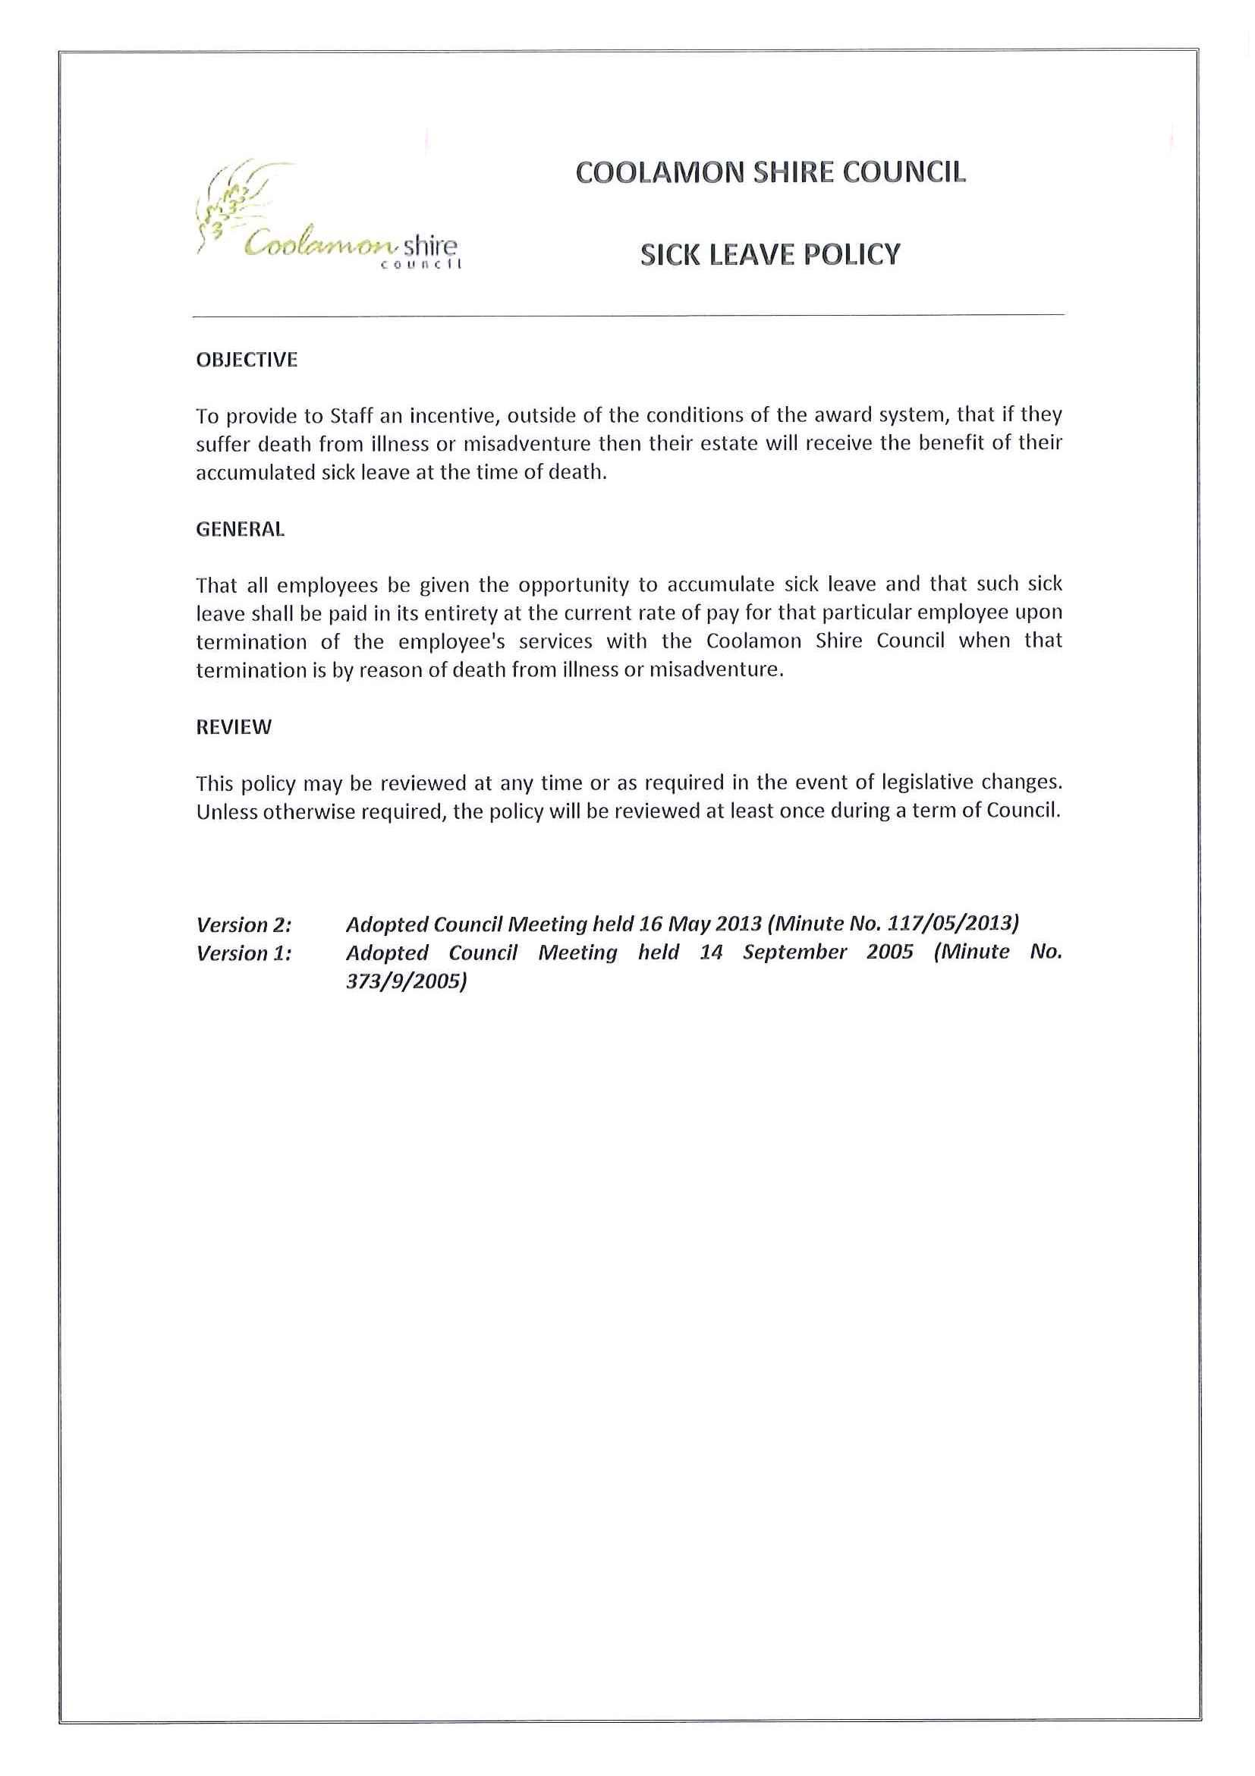
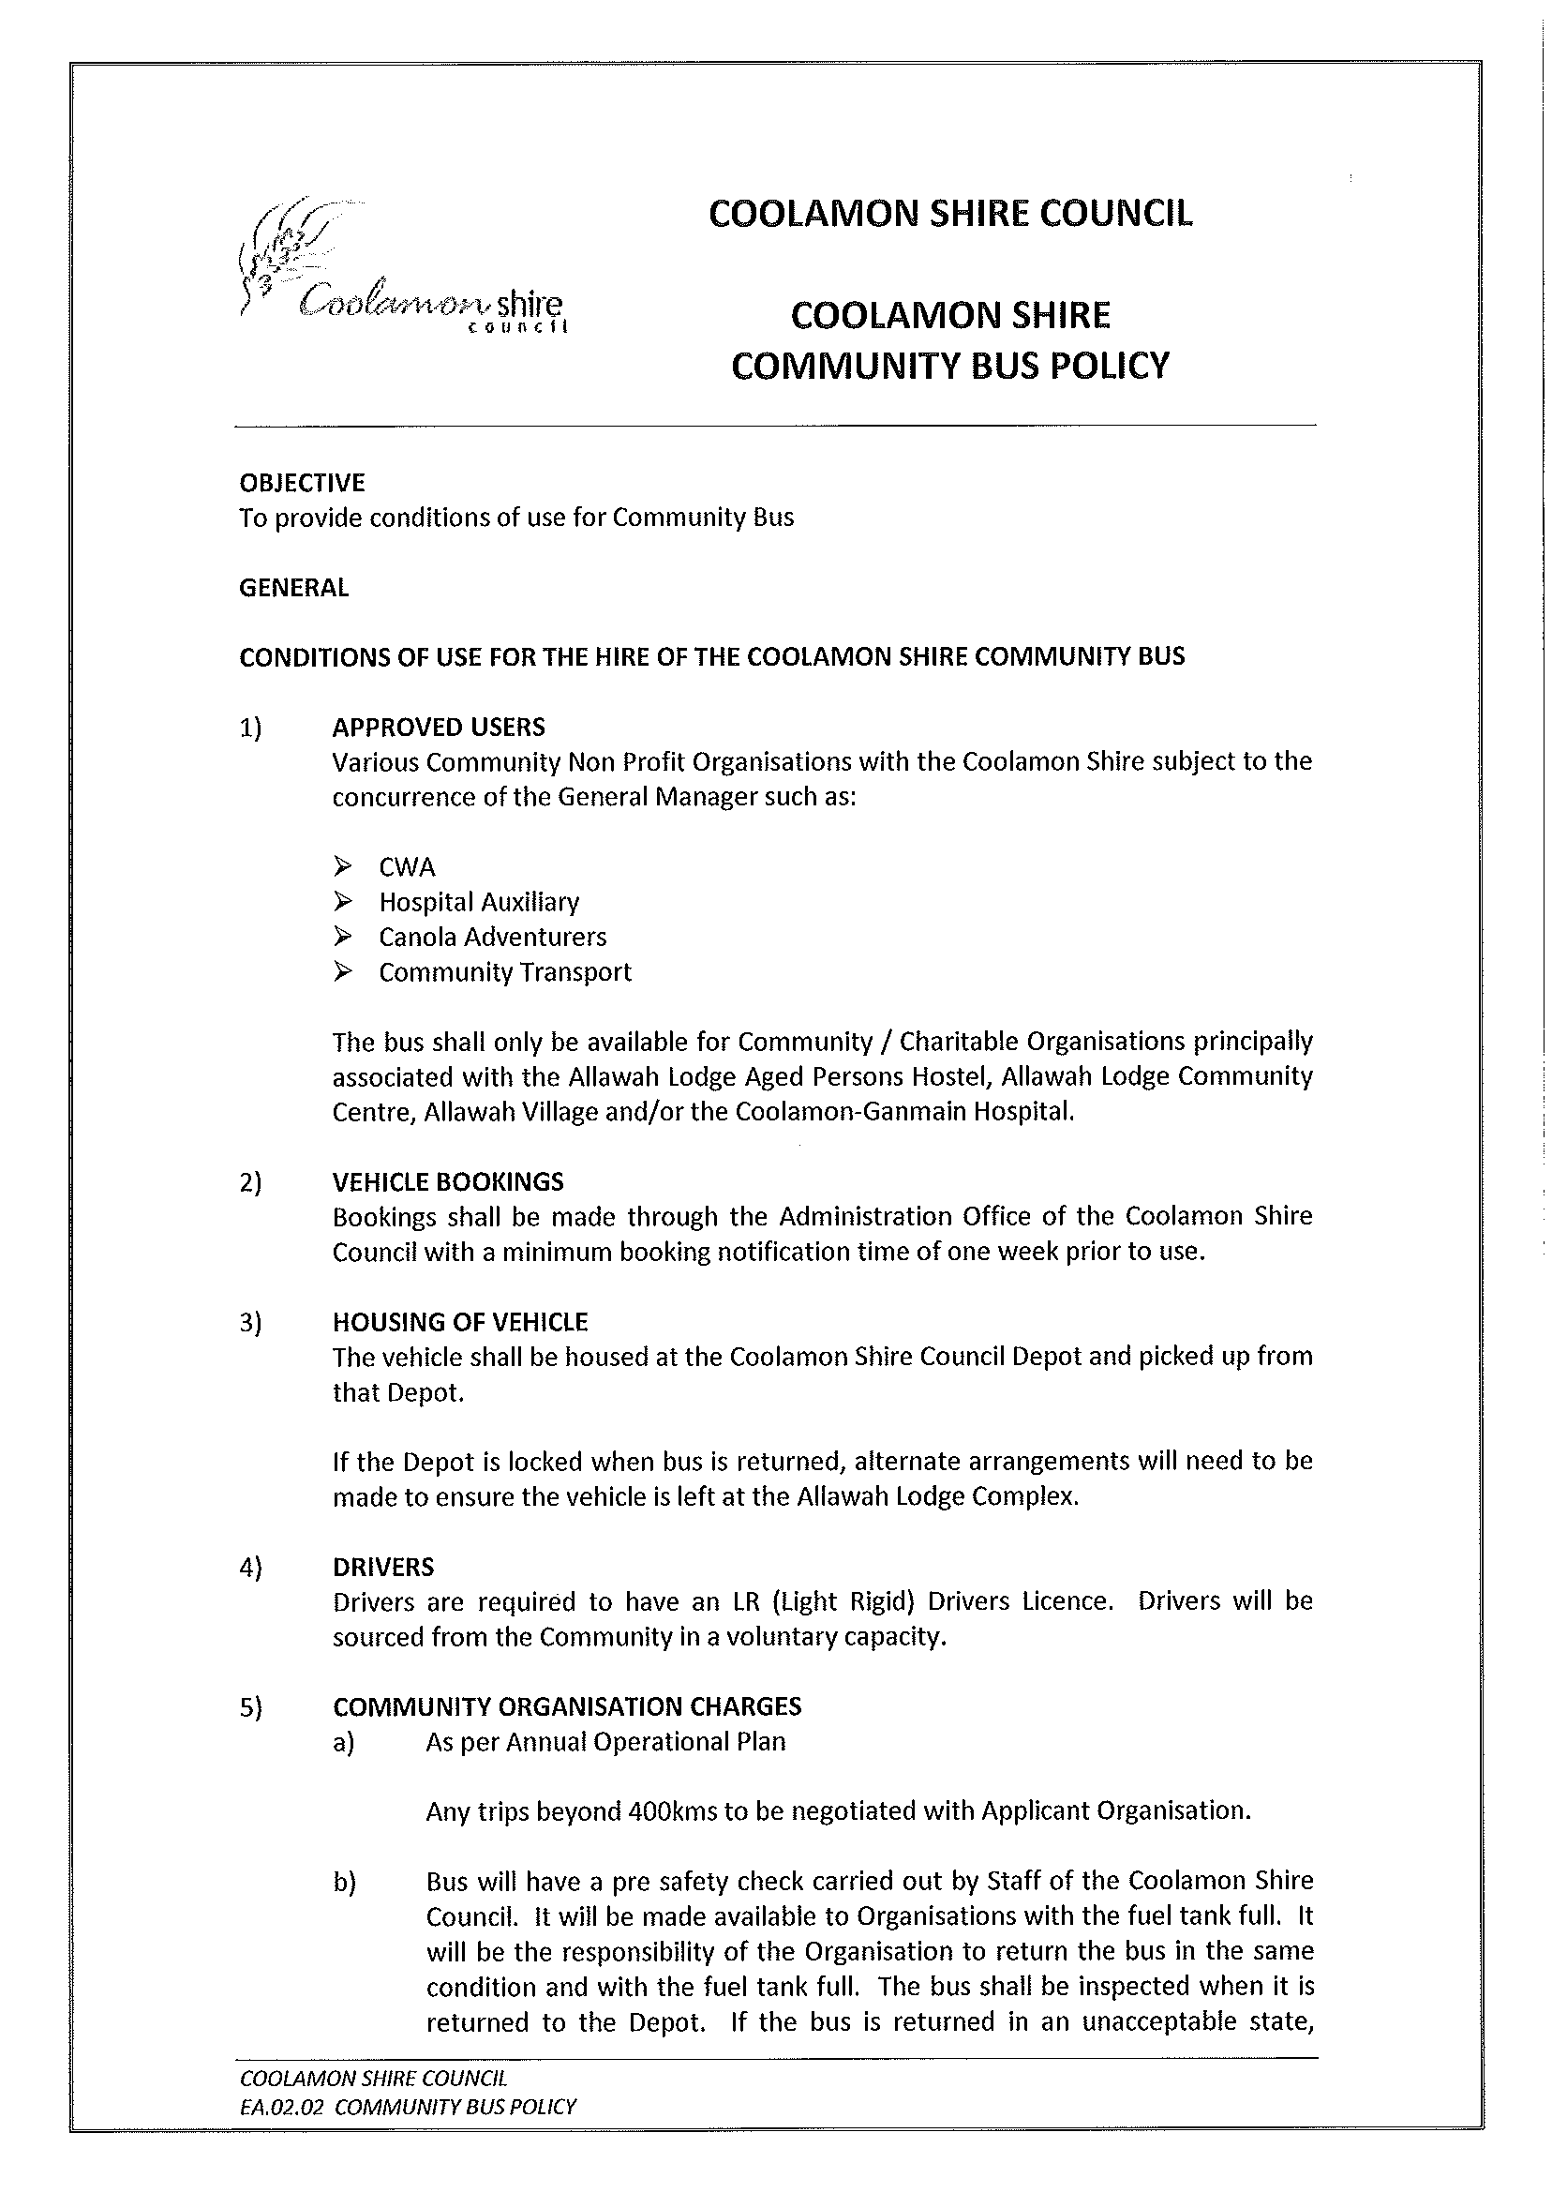
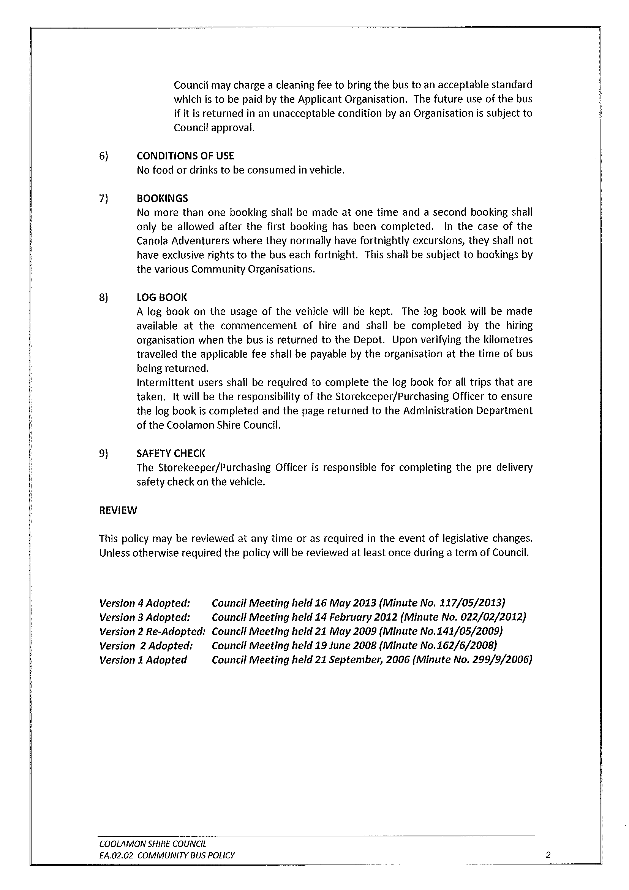
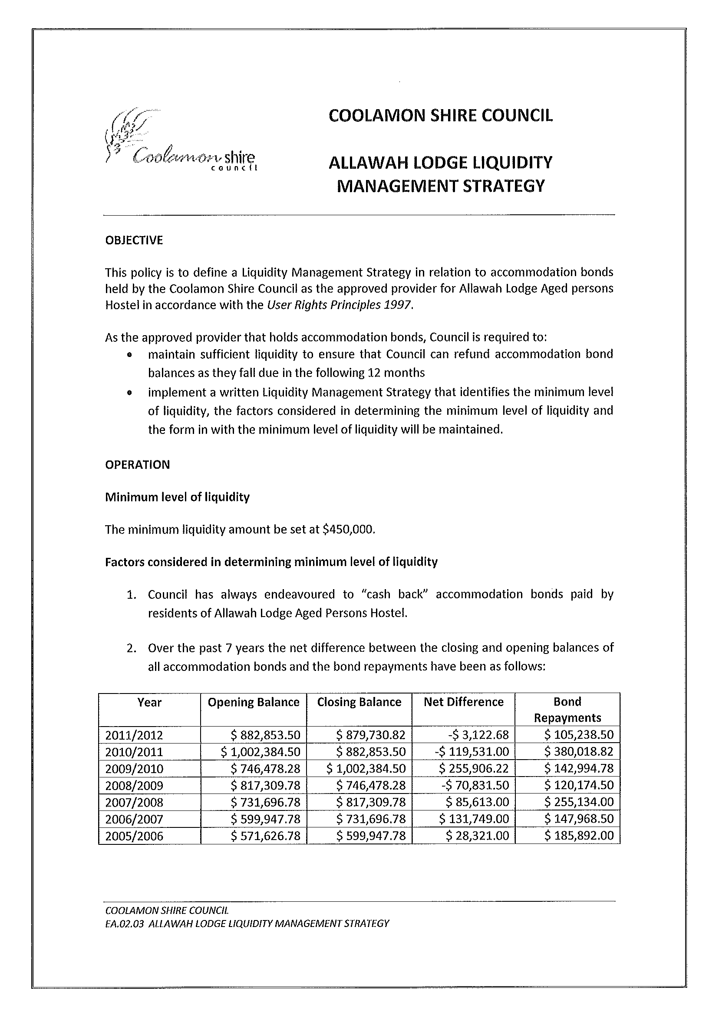
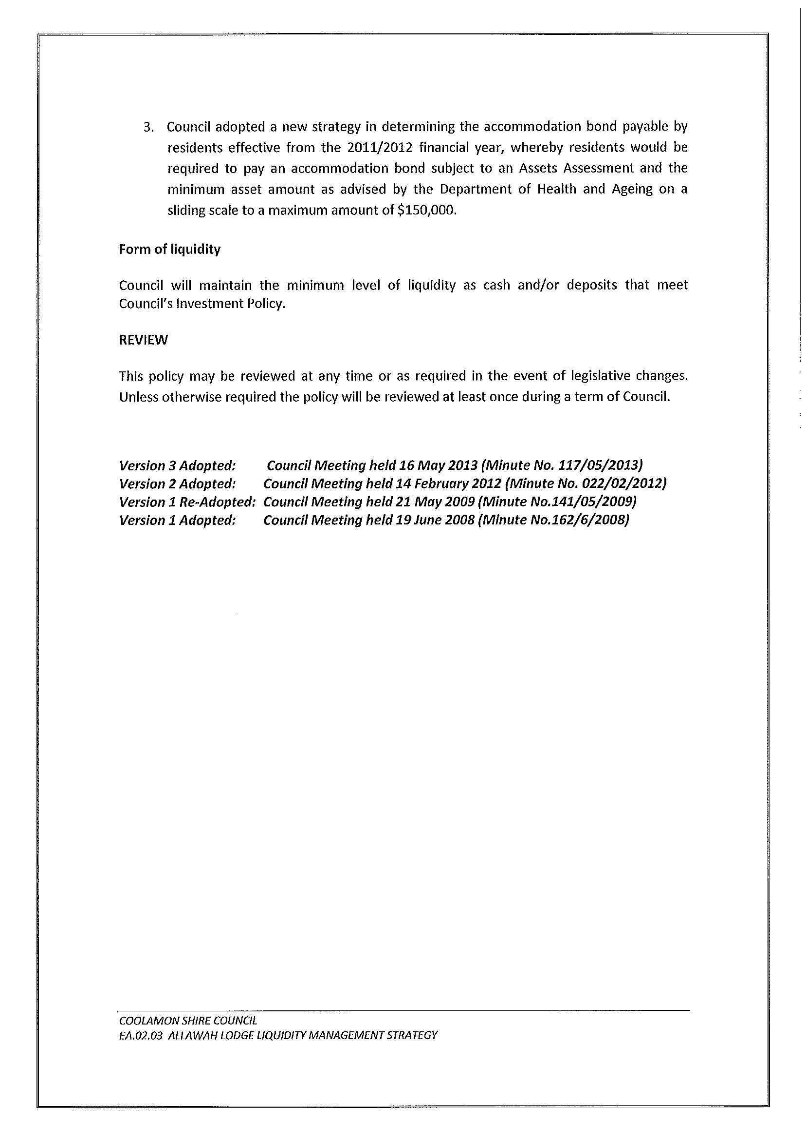
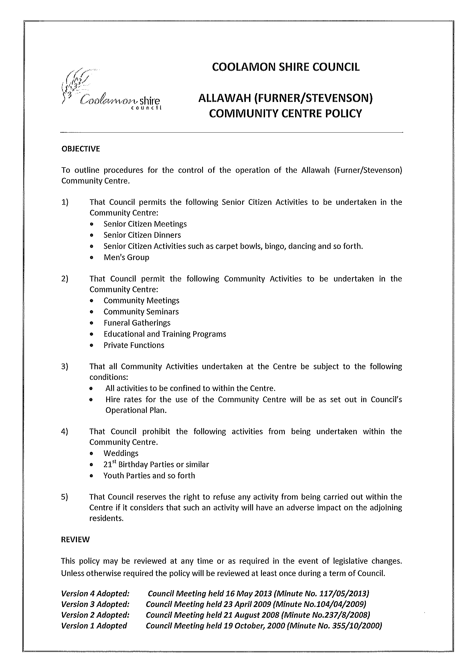
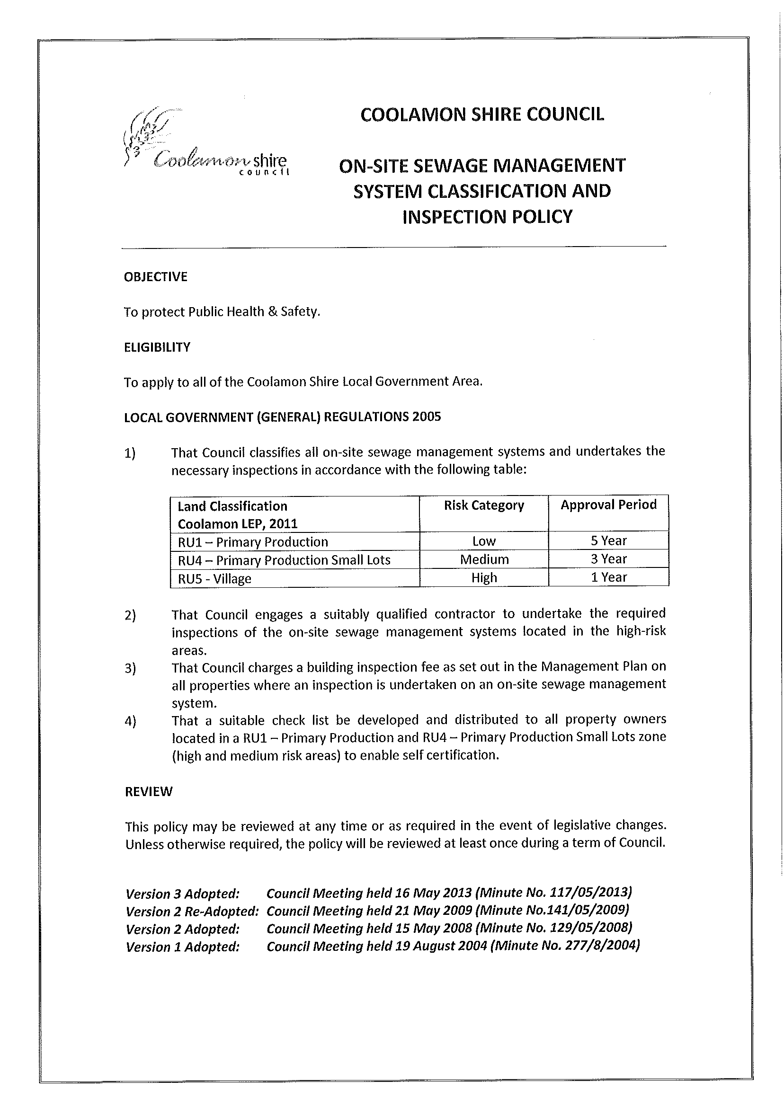
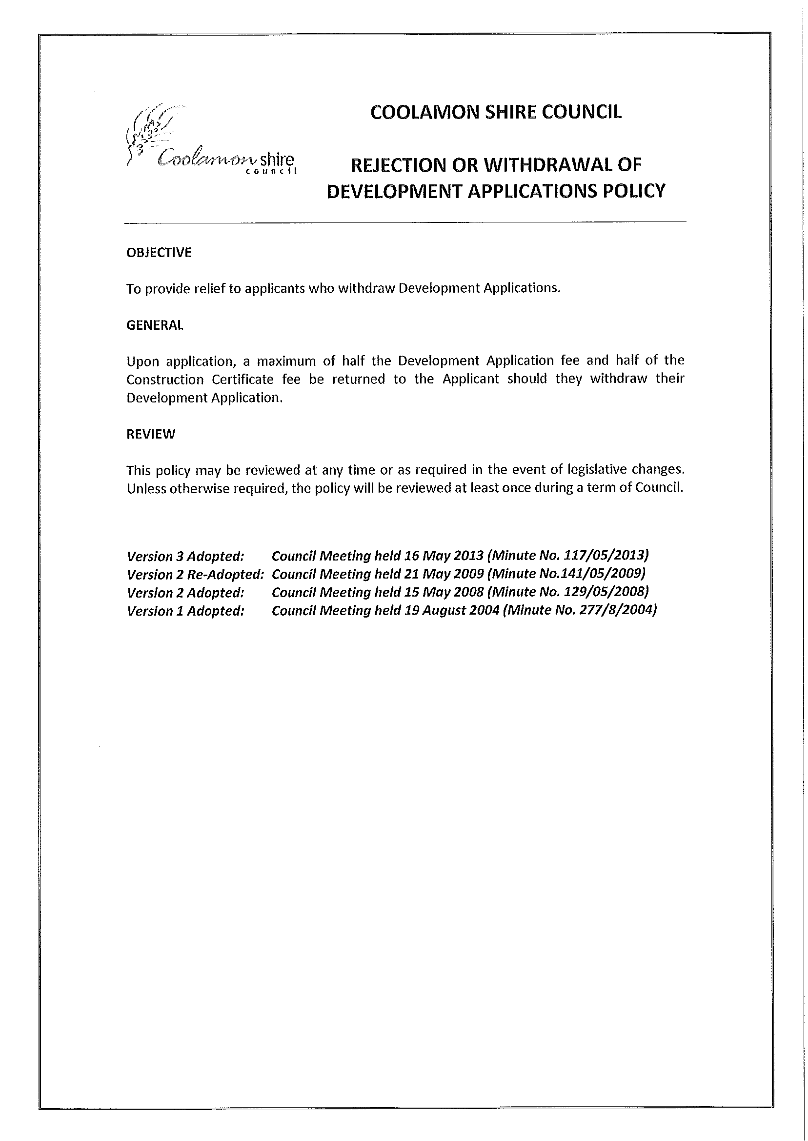
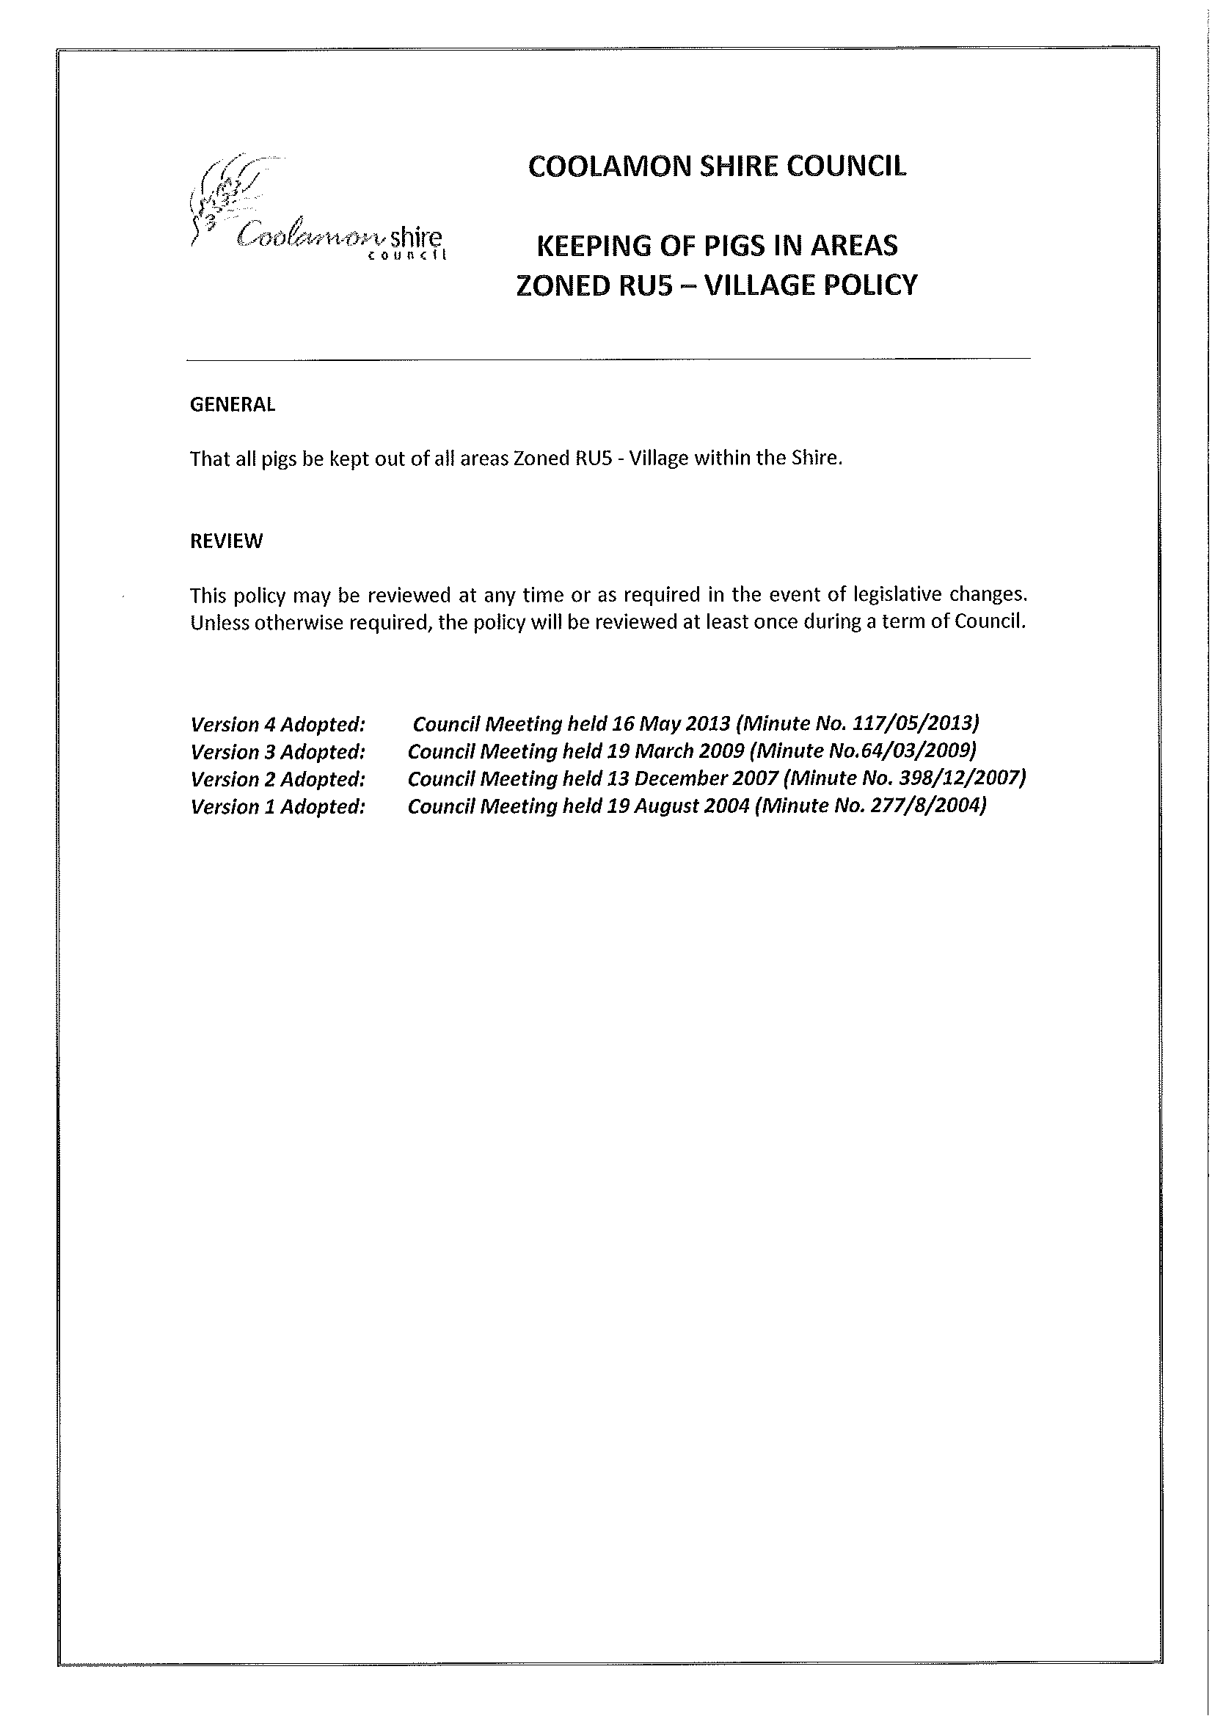
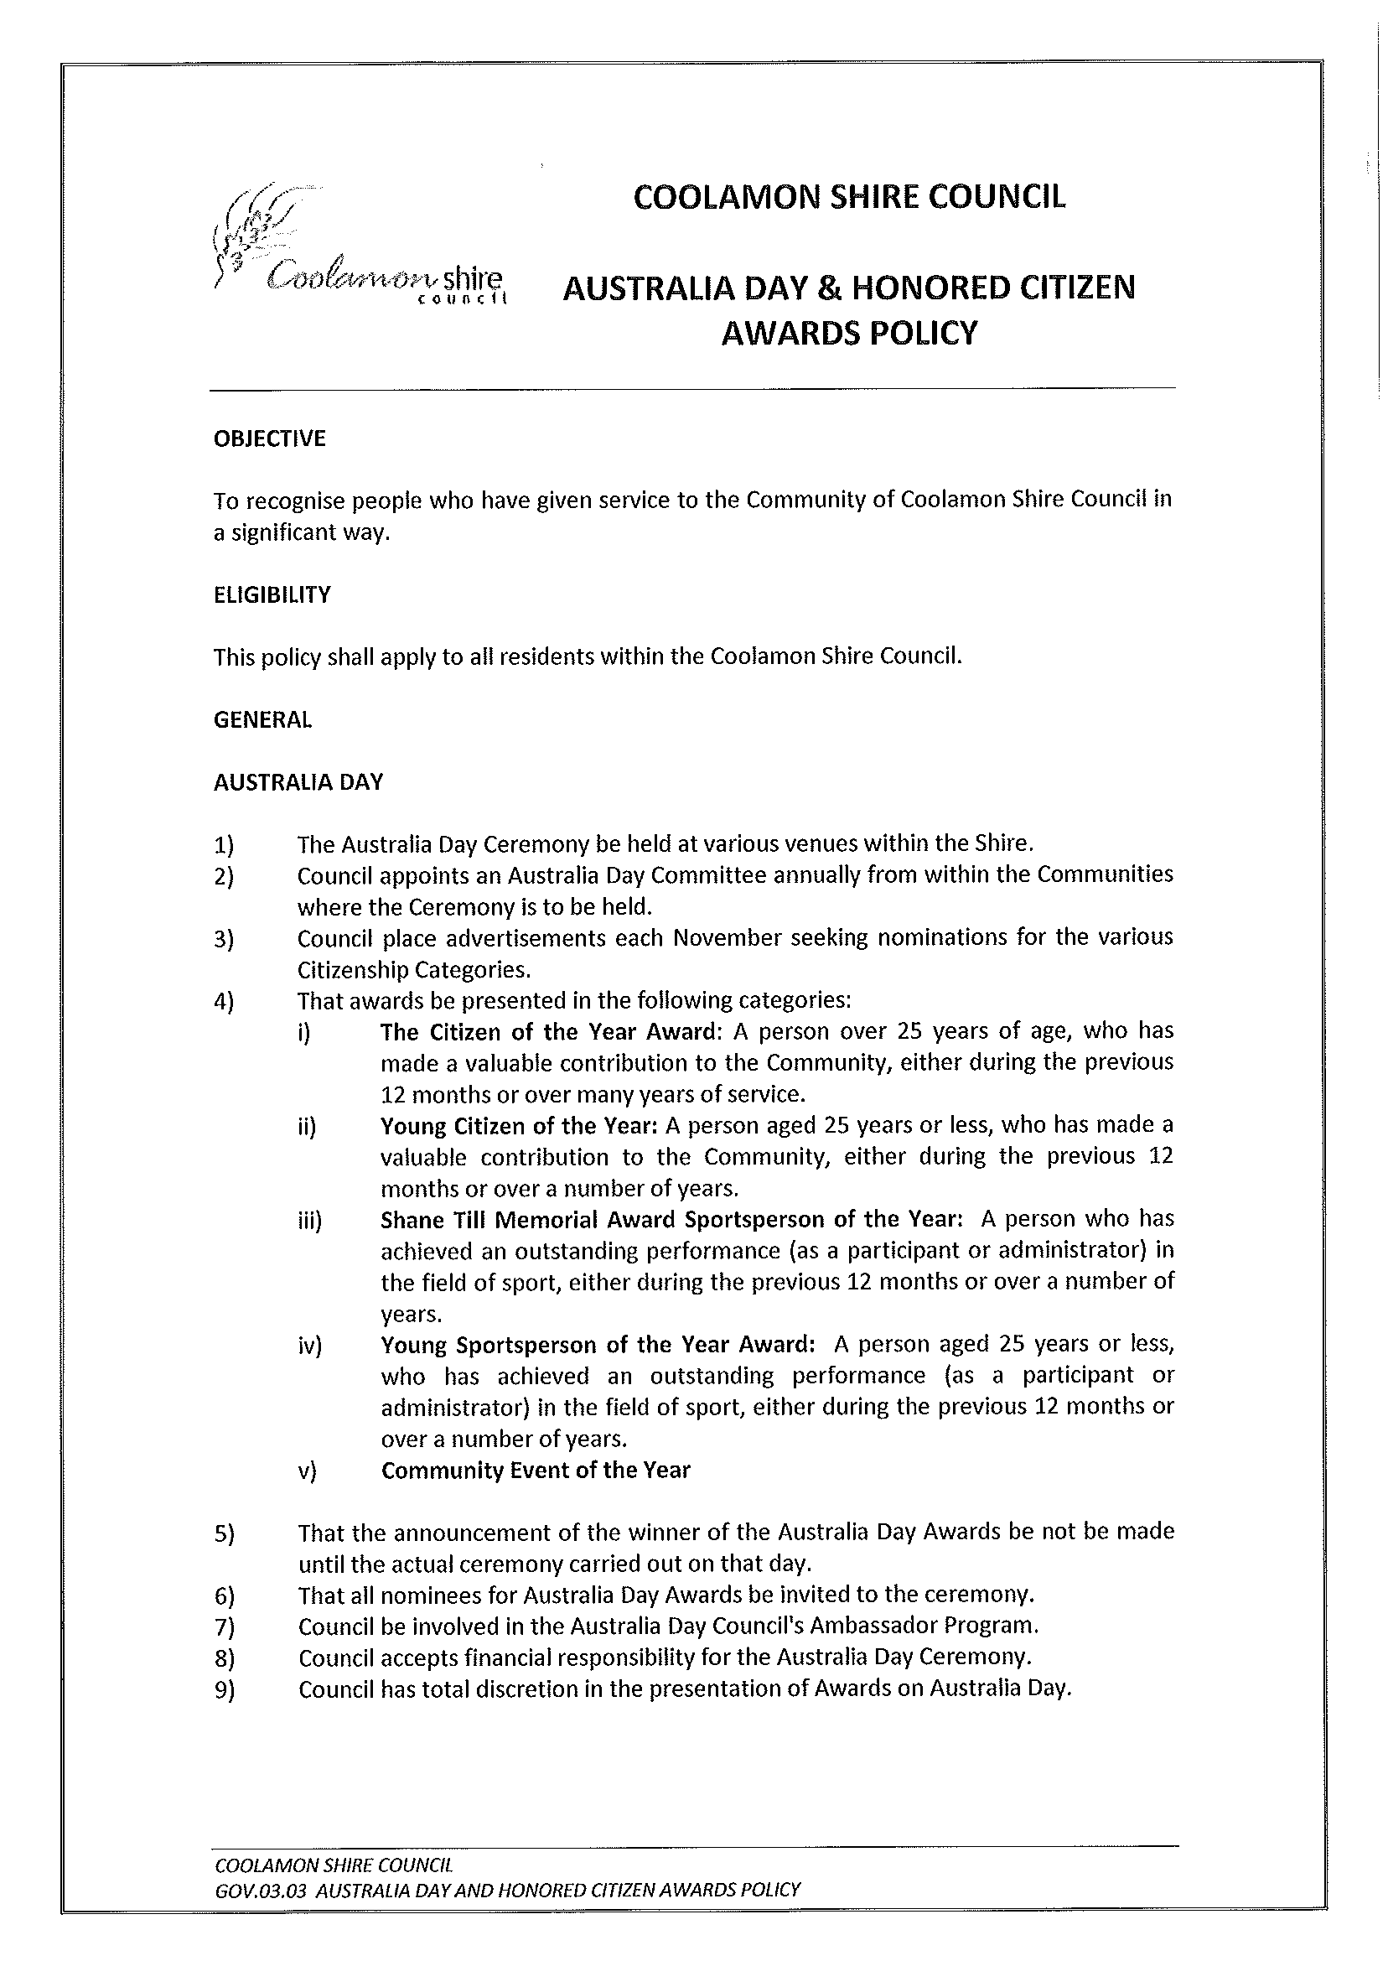
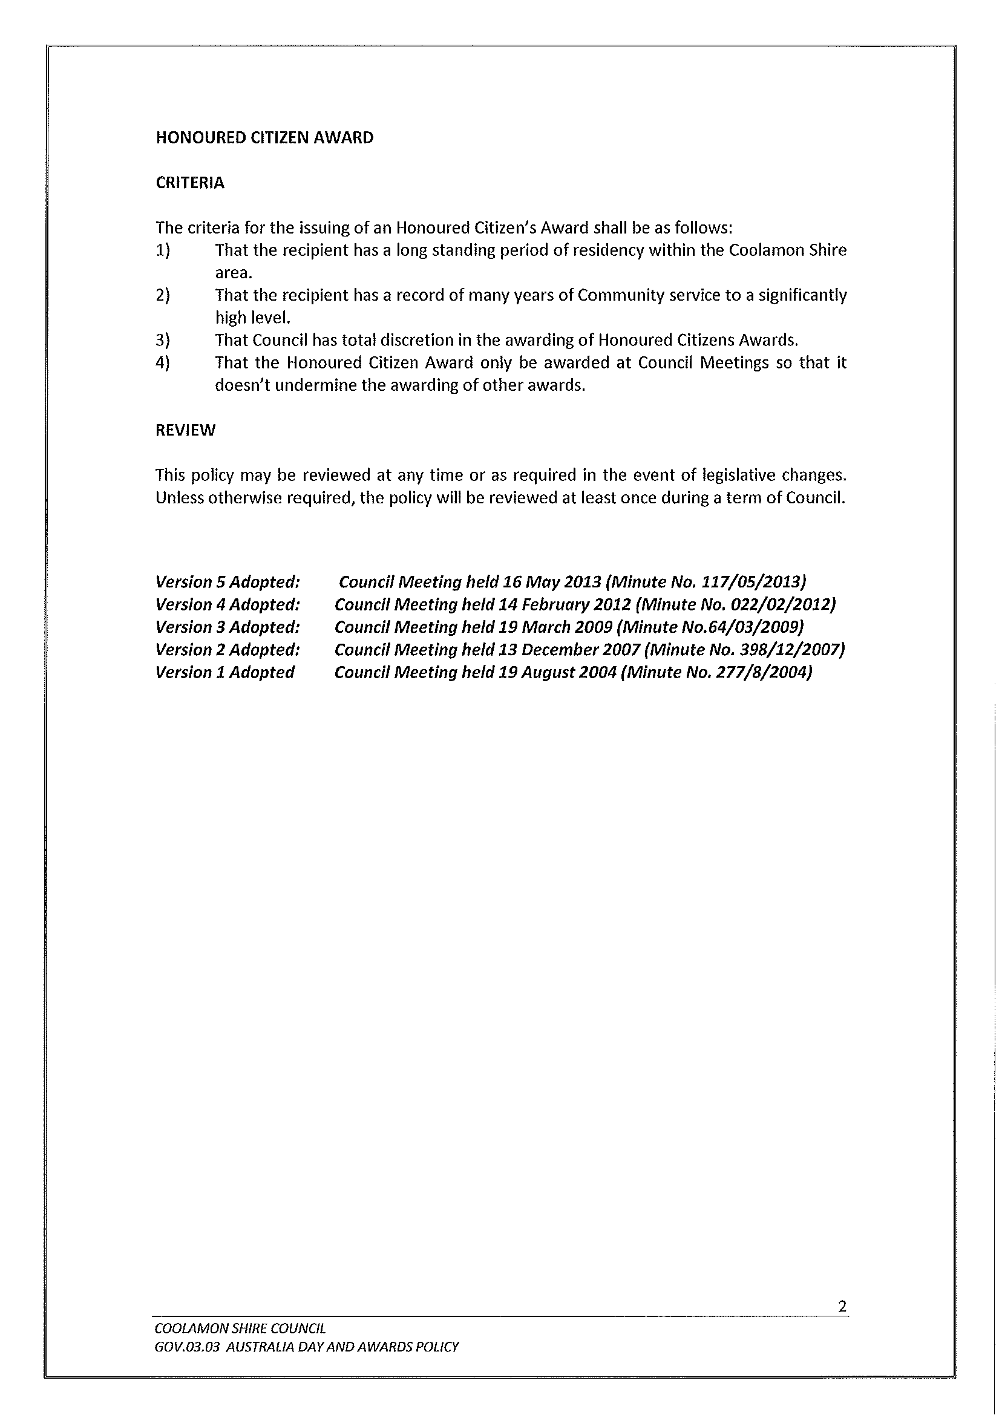
4.3 EXECUTIVE MANAGER, ENGINEERING & TECHNICAL SERVICES’ REPORTS

ES1) SHIRE ROADS – RESHEETS, STABILISATION AND MAINTENANCE

The following roads have received attention:

Maintenance

- Murrell Creek Road (Ardlethan Road to Pamandi Road)
- Marrarvale Lane (Marrar South Road to Coolamon Road)

Resheeting

- Pamandi Road (Murrell Creek Road to Harrisons Lane)
- Cains Lane (Dyces Lane to Jerricks Lane)
- Coopers Lane (Millwood Road to Coolamon Road)
- Quarry Road (Millwood Road to end bitumen)
- Gilmores Lane (East West Road to gate)
- Warners Lane (Loughnan Street to Gradys Lane)
- Gradys Lane (Railway to Tony Browns)
- East West Road (Gilmores Lane to Methul Road)
- East West Road (Methul Road to Mary Gilmore Way)
- Wildman & Dunrobin Street (Showground to Lonsdale Lane)
- Crick Street, Marrar (Webb Street to Loch Street)
- McNabbs Lane (Hodges Lane to Johnsons Hill Road)
- Seberry Lane (East West Road to Walleroobie Road)

ES2) TOWN WORKS

COWABBIE STREET WATER FEATURE RE-DEVELOPMENT

Works involving the following have now been completed in the re-development of Cowabbie Street Water Feature:

- Excavation of Water Feature
- Relocation of electricity
- Laying of pavers
- Installation of irrigation and modification of existing irrigation
- Laying of turf
- Installation of garden bed and plants
- Installation of street furniture (tables, seats and bin)

ES3) BLOCK GRANT – REGIONAL ROAD LINE MARKING

New and renewal line marking has been performed on the following roads:

- Canola Way East
- Canola Way West
- Ardlethan Road
- Mary Gilmore Way
- Coolamon Road
- Matong North Road
- Marrar South Road

ES4) PRIVATE WORKS

Approximately 80m of road formation work has been performed along Crick Street, Marrar (South of Webb Street) to provide access to a proposed new residence.

ES5) NOXIOUS WEEDS OFFICER’S REPORT (N.02-01)

Noxious Weeds Officer Reports

- Mapping of noxious weeds continues on road, lanes and weed harbours across the three Shires. The extended dry weather has greatly reduced weed burdens across the Shires and at the same time, setting the 2013 grain growing season back with many crops being dry sown.

- A medium sized outbreak of Coolatai Grass has been spotted on the railway line between Old Junee and Rockview. Landholders are concerned and Chris Slinger has alerted the John Holland Group to the situation and is currently looking for an answer to this problem. The problem is exacerbated by the fact that plants in the Coolatai outbreak are of differing ages with some close to seed-set while others are still green. As a contrast, 95% of other growth has died months ago. The solution is likely to involve burning to cater for this age difference.

- In view of Glyphosphate resistance, a herbicide mixture has been developed without the chemical for council spraying of road shoulders. This mix is anticipated to deliver a good result while at the same time, delay glyphosphate resistance and maximise its effective operating life. Neil Durning from Ag n Vet and Robert Ferguson from RENWA have devised the mixture.

- Road reserves in Junee Shire continue to be rated as to their suitability to be modified to allow boom-spraying to operate. It is anticipated that significant savings will be made particularly in time and labour.

- The Gundagai Noxious Weed Inspector has advised of an outbreak of Cobblers Peg in that shire. Preparations are being made to view the site.

ES6) PARKS AND GARDENS & BUILDING MAINTENANCE REPORT (P.01-01)

Facilities Maintenance Officer Reports

1) NATURE STRIPS

A draft Nature Strip Policy has been developed and subject to Council approval will give the Shire the mechanism to control and guide nature strip developments.

Council is supportive of people developing nature strips to improve aesthetics and functionality of this space, however, we need to ensure certain guidelines are adhered to.

2) WATERFEATURE GARDEN - COOLAMON

Redevelopment of the Water Feature garden is completed in Coolamon’s Pieper Park. The redevelopment creates extra seating and an open space that should be well utilised by locals and tourists.

Thanks to Gardening Staff and Contractors who completed the work on time and to a high standard.

3) TREATED EFFLUENT

Irrigation has been turned off or heavily reduced in most areas. The treated effluent supply held in storage was depleted by around 40% so it appears that if storages are at 100% at the start of Spring we have sufficient water in storage to service current User Groups. It should be noted that this year saw some problems that inhibited delivery of water so consumption may well have been 10% higher had there been no problems.

4) BUILDING MAINTENANCE

Works have been completed at the following locations:

- New Units at Ganmain.
- Rural Transaction Centre, Ganmain
- Allawah Lodge
- Allawah Village
- Storage Yard, Coolamon
- Childcare Centre

Recommendation

For Council information.

RESOLVED on the motion of Clr Beard and seconded by Clr McCann that the Executive Manager, Engineering & Technical Services Reports (ES1 to ES6) be noted. 118/05/2013

ES7) YORK STREET MARRAR UPGRADE (SEE STREET TO WISE STREET)

➔ Attached is a plan identifying the works proposed in the upgrade of York Street, Marrar. Attachment No. 7

The extension of the layback and concreting of driveway at the access to the Marrar Service Station are considered as upgrades to a private business. As per Council’s Property Access Policy 2, Urban locations (including 1c Zones), all property within Village and 1c zones, the cost and ongoing maintenance of any access crossings will be at full cost to the applicant. The works proposed will eliminate erosion issues that Council are currently experiencing as a result of run-off from the block as well as improving access to the property. Both Council and the landholder will benefit from various components of the upgrade and for the works to proceed a contribution is justifiable. It is estimated the full cost of the work to be $6,812.

Recommendation

That a contribution of $3,406 be received for additional upgrades to proceed at the access of the Marrar Service Station.

RESOLVED on the motion of Clr White and seconded by Clr Hutcheon that a contribution of $3,406 be sought for additional upgrades to proceed at the access of the Marrar Service Station. 119/05/2013

ES8) QUOTATION FOR THE SUPPLY OF TRUCK – 10m3 TIPPER (T.03-06)

INTRODUCTION

Quotations have been received for the supply and replacement of one of Council’s Gravel Trucks under the Local Government Procurement Process (LGP). As Councillors are aware this unit is a major plant item owned by Council and will be used by all major Construction Gangs. The normal replacement cycle (as adopted in our annual plant report) is 8 years (approximately 200 000km).

QUOTATIONS RECEIVED

The specification called for the supply and delivery of one (1) new Bogie Drive Truck-Cab-Chassis with 10m3 capacity High Tensile Steel (HTS) Tipping Body. All quotations received are within the range.

Reference is made to the attached spreadsheet details that provide the specific quotation amounts and specifications for each Company under the “Local Government Procurement” process.

Council received 10 quotations ranging from $149,053.52 to $200,750.00 GST Inc for the supply of one truck (no Body).

Three quotes were received for truck bodies ranged from $35,420.00 to $44,250.00 GST Inc as per specifications.

Trade in prices varied from $18,177.50 to $44,000.00 GST Inc from suppliers and one private purchase quote for $35,000.00 GST Inc.

Nine Trucks have been quoted from Five Companies. Wagga Trucks (Hino) - 4 trucks, Westrac (Caterpillar) - 1 truck, Wagga Motors (Isuzu) - 2 trucks, Inland Truck Centres Wagga (Kenworth) - 1 truck and Johnsons Truck and Coach Services Mildura (UD) - 1 truck.

EVALUATION

In consultation with Council’s Workshop Supervisor and Local other Council’s with similar truck and trailer combinations, the following trucks where arranged for inspection:

- Hino 700 Series FS2848 - Air Suspension Automated Manual Transmission
- Isuzu 455 Giga Premium – Air Suspension Automated Manual Transmission
- UD GW26420 – Air Suspension Automated Manual Transmission
- Kenworth T359 – Air Suspension Manual Transmission
Note: The Caterpillar CT610B was not inspected due to a poor Quotation submission and high purchase price.

An inspection team comprising of Brett Foster (Workshop Supervisor), Roy Clancy (Heavy Truck Operator), Scott Buchanan (Works Engineer) and Tony Kelly (Manager) completed an evaluation on all trucks with considerations for:

- Operation and Performance
- Maintenance and Service Requirements
- Risk and Safety

Of the Four trucks inspected the Hino 700 series was very difficult to fault and continues to improve in power (473 HP), performance, reliability and technology advances on previous models. Wagga Trucks (Hino) provided four truck configurations for our consideration with the truck inspected having an Automated Manual Transmission (AMT) with the option of either operating the transmission in manual or full automatic mode. This model also provided a vehicle retarding system comprising of engine and transmission retardation during deceleration which provides a reduction in the use of braking during normal operations and along with the AMT system reduces drive line loading and shocks which are present in manual transmission drivelines. The Hino 700 Series provides a 3 seat cabin as standard for the provision of transporting staff, along with a superior ride and noise reduction.

The Isuzu 455 Giga inspected is very simular to the truck Council has in its fleet at the moment, with the option of an AMT and only engine exhaust braking being available. Wagga Motors (Isuzu) provided two truck configurations for our consideration. This model of truck has proven to be a reliable truck in Councils fleet. A Road test of the AMT model truck inspected was not provided. The Isuzu Giga meets all our requirements with power (453HP), performance and service but little change from previous models.

The UD GW26420 inspected meets all our requirements with power (413HP), performance and technology advances. Johnson’s Truck and Coach provided one truck configuration for our consideration with an AMT with the option of either operating the transmission in manual or full automatic mode. This model also provided a four stage engine brake retarding system. The GW26420 does not provide a transmission braking retardation system. A demonstration truck was provided for inspection and road test by CMV Wodonga. This model of truck is supplied with a new engine and transmission configuration different from previous models. The UD truck is well appointed with attention to detail, appearance and driver comfort.

The Kenworth T359 meets our requirements relating to power (440HP), performance, reliability and service. Inland Truck Centres Wagga provided one truck configuration for our consideration with a manual transmission only. The T359 Cabin is small with very little space for extra equipment and no option for a third seat. This truck is simple in the configuration and easy to maintain but has had very little technology changes over the years.

Truck body quotations were supplied with all truck submissions, meeting Council’s requirements and specifications.
- Nixon’s Engineering Wagga has provided a number of high quality bodies for Council’s existing fleet with a local component being provided.
- Chriss Body Builders is located in North Sunshine, Victoria with good recommendations from truck dealerships.
- M and S Truck Bodies is located in Port Kembla, NSW with good recommendations from truck dealerships.

SUMMARY

The Hino 700 Series FS 2848 Proshift and UD GW 26420 provide a high quality truck with excellent attention to detail and operator comfort. Both trucks can be serviced and supported locally with excellent reviews from other Council’s. The Hino 700 series is superior in the vehicle retardation system with a two stage engine brake and a three stage transmission intarder combined with a 16 speed automated manual transmission is ideally suited to a truck and pig tipper application.

The Hino 700 Series FS2848 Proshift is the preferred machine with Wagga Trucks providing the best trade in price for Council’s surplus truck and a net figure superior to the other companies.

Recommendation

That Council accepts:

- The Wagga Trucks quotation for the Hino 700 Series FS 2848 AMT Pro-shift Air suspension priced at $168,618.12 GST Inc.
- The body quotation from Chriss Body Builders for $35,420.00 GST Inc.
- The trade in price from Wagga Trucks (Hino) for $44,000.00 GST Inc for the surplus truck (1998 Mitsubishi FV547 PL109).

The net price to Council equates to $160,038.12 GST Inc.

RESOLVED on the motion of Clr Hutcheon and seconded by Clr McCann that Council accepts: 120/05/2013

1) The Wagga Trucks quotation for the Hino 700 Series FS 2848 AMT Pro-shift Air suspension priced at $168,618.12 GST Inc.

2) The body quotation from Nixons for $41,668.00 GST Inc.

3) The trade in price from Wagga Trucks (Hino) for $44,000.00 GST Inc for the surplus truck (1998 Mitsubishi FV547 PL109).

4.4 DEPUTY GENERAL MANAGER, PLANNING & ENVIRONMENTAL SERVICES’ REPORTS

HS1) DEVELOPMENT APPLICATIONS (B.05-03)

The following applications have been approved:-

DEVELOPMENT APPLICATIONS

04/2013 5//826313 – Grain Loading Shed with Dust Extraction – Lynne Street, Marrar.
06/2013 3-4//836550 – 4 Unit Residential Development – 20 Loughnan Street, Coolamon.
08/2013 3//1100673 – Relocatable Dwelling – 12 Booth Street, Coolamon.
09/2013 8/37/758277 – Relocatable Dwelling – 9-11 Methul Street, Coolamon.
10/2013 187//750834 – Shed – 29 Ford Street, Ganmain.
11/2013 204//750847 – Dwelling – Crick Street, Marrar.

COMPLYING DEVELOPMENT CONSENT

2013/10 2//357686 – Shed & Skillion - 40 Cowabbie Street, Coolamon.
2013/11 8/41/758428 – Alterations & Additions to Dwelling – 26 Moore Street, Ganmain.
2013/12 18//750846 – Shed – 11 Curtis Street, Coolamon.

Recommendation

For Council information.

RESOLVED on the motion of Clr Huxtable and seconded by Clr Beard that the report be received. 121/05/2013

HS2) HOUSEHOLD HAZARDOUS WASTE COLLECTION (G.01-01)

REROC run an annual collection for household hazardous waste. Coolamon Shire Council has been allocated a half day on the 25th June, 2013 for this collection to take place.

In the past this collection has been located in the Council Depot at the rear of the Council Chambers.

In accordance with the funding arrangements Council is required to undertake its own advertising and promotional material for this event. Items that can be collected are: paint, fluorescent tubes, chemicals, smoke detectors, etc.

Council will need to commence promoting this collection in order to ensure a successful event.

Recommendation

That Council conduct and advertise the Household Hazardous Waste Collection.

RESOLVED on the motion of Clr Hutcheon and seconded by Clr Huxtable that Council conduct and advertise the Household Hazardous Waste Collection.
122/05/2013

HS3) E-WASTE (R.06-04)

The REROC Waste Forum have been negotiating with two Companies to set up a Regional Collection of Electronic Waste.

Two Companies started the negotiation and offered to help facilitate this regional collection. REROC has successfully negotiated a Product Stewardship Agreement with DHL. This requires that E-Waste can be collected within the Local Government area and transported to Kurrajong where it is recycled.

■ REROC will now need to formalise an Agreement with each of the Councils involved. I have tabled a copy of this Agreement for those interested.

In summary, Council is required to accept, store and allow transfer of all E-Waste in accordance with the relevant Australian Standards and Workplace Health & Safety Laws.

Council proposes to set this up at the Coolamon Facility for two reasons:

1) This is where the majority of the population are available to use it.

2) That it is in keeping with the proposed changes to Coolamon becoming a Transfer Station in the future.

Council together with REROC will now be sourcing some funding to provide these collection and storage areas.

This is seen as an excellent opportunity to provide another method of appropriately sorting the waste stream to provide for recycling and reuse. This also adds to the life of our current pits.

Recommendation

 That Council formally sign all documents for an E-Waste Designated Collection Facility Agreement with REROC.

RESOLVED on the motion of Clr White and seconded by Clr Brill that Council formally sign all documents for an E-Waste Designated Collection Facility Agreement with REROC. 123/05/2013

HS4) SWIMMING POOL LEGISLATION (S.19-01)

There has recently been some advice to Councils and in the media about changes to NSW Swimming Pool Legislation.

As of the 29th April, 2013 all owners of backyard swimming pools are required to register their swimming pool on a Statewide Register.

➔ Council has a Register of pools that were approved since 2004. All of these pools will receive a letter from Council indicating their new responsibilities. A copy of this letter together with the information from the Department of Local Government has been provided for your information. Attachment No. 8

This programme is being rolled out over this coming winter with the first step in the new legislation being a self assessment and registration online.

The mandatory swimming pool inspection and accredited certification will commence later this year around October.

Council will need to ensure that residents are aware of their responsibilities to ensure that compliance can be carried out.

Recommendation

That Council provide information into the Newsletter in relation to changes to the NSW Swimming Pool Legislation.

RESOLVED on the motion of Clr Maslin and seconded by Clr Huxtable that Council provide information into the Newsletter in relation to changes to the NSW Swimming Pool Legislation. 124/05/2013
HS5) KEEPING OF HORSES POLICY (P.12-01)

The State Government has introduced some exemptions to the requirement for Animal Shelters. This has implications for Council’s Policy relating to the Keeping of Horses.

➔ Council has previously required that any stable would require a Development Application that would be notified to neighbouring properties. In light of this State Policy, Council has needed to amend the existing Keeping of Horses Policy to be in line with State Legislation. A copy of the amended Policy has been provided for your information. Attachment No. 9

Recommendation

That Council endorse the Policy relating to Keeping of Horses in the Coolamon Shire.

RESOLVED on the motion of Clr McCann and seconded by Clr Maslin that Council adopt the Policy relating to Keeping of Horses in the Coolamon Shire. 125/05/2013

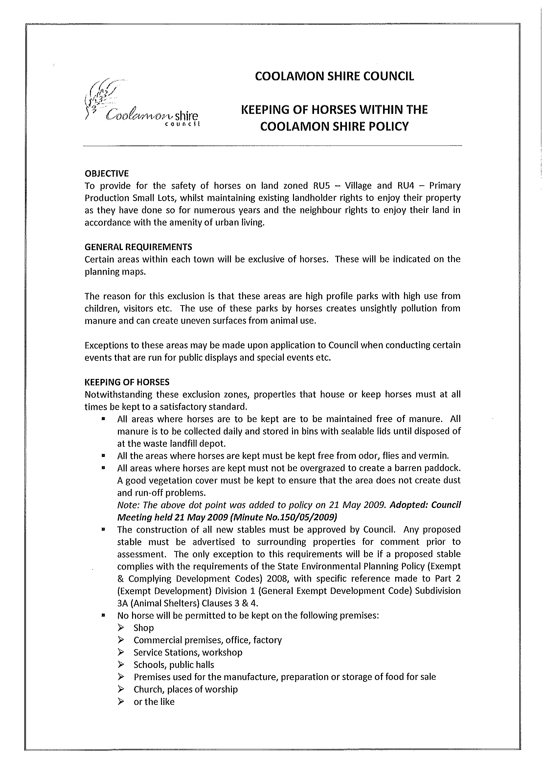
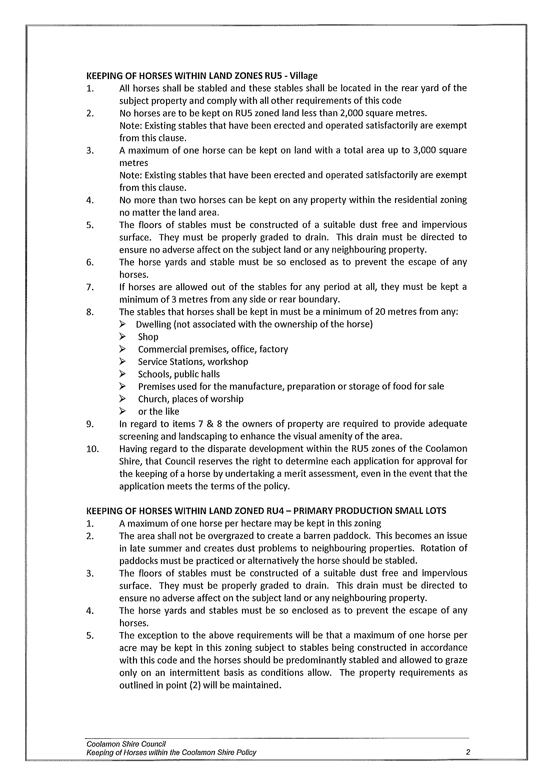
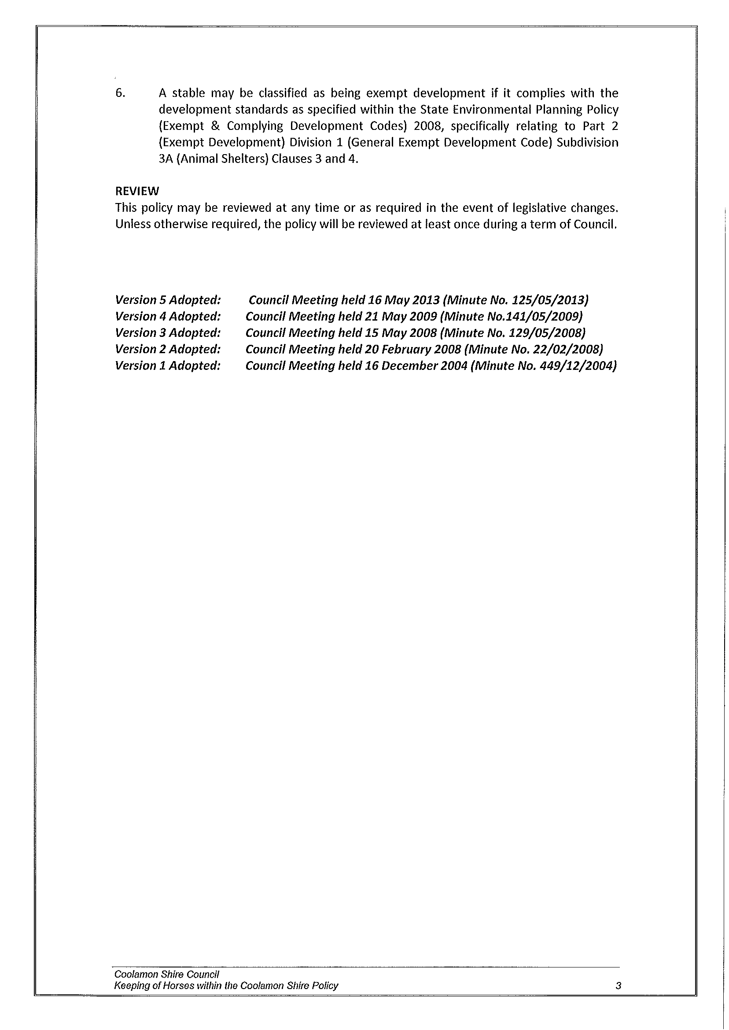
HS6) GANMAIN ORGANICS (G.01-11)

Information regarding the possibility of a roll out of the Organics Collection to Ganmain was requested at a previous Council Meeting.

Since this time there has been significant movement in the EPA with money being allocated to a waste and resource recovery initiative. Within this allocation $70 Million has been targeted towards organics over five years.

With this in mind the REROC Waste Forum have been investigating the opportunity of undertaking some regional programmes that can benefit our communities. Council will also be investigating any opportunities that will be available for the Council individually.

In accordance with these opportunities it is thought appropriate for Council to continue these investigations and develop an Organics programme that suits Council’s needs and meets the funding criteria.

Further information will be provided to Council in this regard, when Council officers have had more time to digest the new funding programme.

Recommendation

That Council continue to investigate funding towards Organics programmes for Communities in the Shire.

RESOLVED on the motion of Clr Brill and seconded by Clr White that Council continues to investigate funding towards Organics programmes for Communities in the Shire. 126/05/2013

HS7) NATURE STRIP POLICY (P.12-01)

Council has noted a recent increase in households using the front or side nature strip for more alternative garden features or surface material.

This new use is generally based on a more water sensitive material (ie. crushed granite) and is commendable. However, this has lead to some people using inappropriate material (ie. bark) that does not allow safe use.

➔ For this reason Council has developed a policy that simply states what the objectives are and some simple guidelines for development. A copy is attached for your information. Attachment No. 10

Recommendation

For Council adoption.

RESOLVED on the motion of Clr McCann and seconded by Clr Huxtable that the Nature Strip Policy be adopted and that it be promoted to the residents of the Shire. 127/05/2013

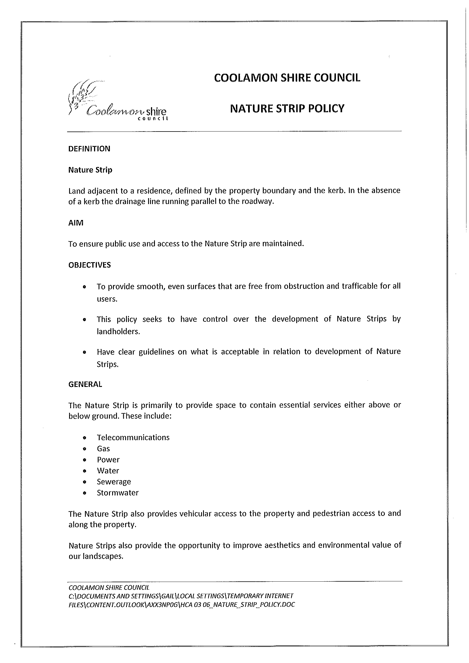
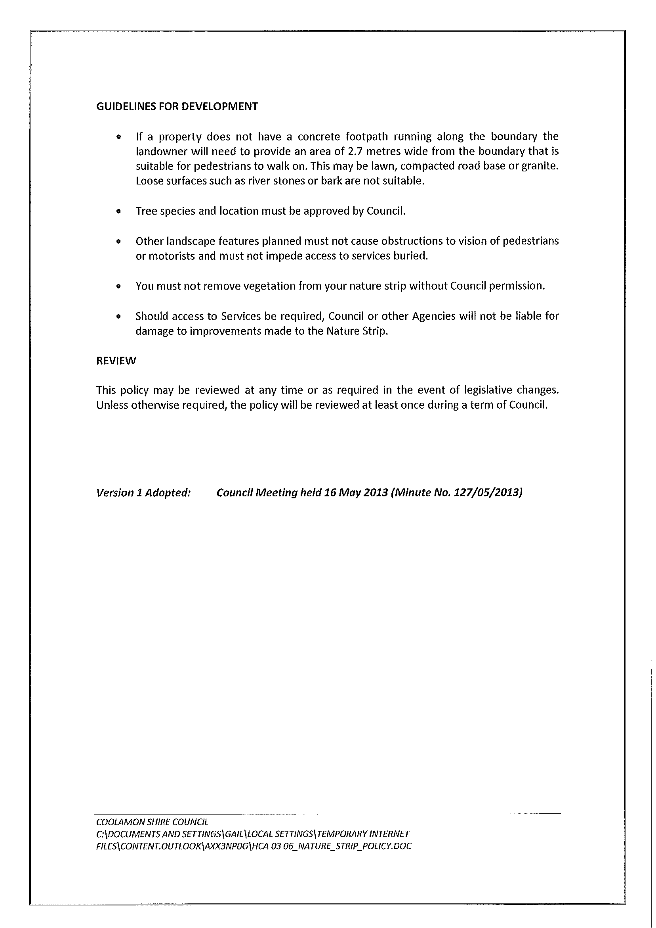
HS8) COOLAMON FIRE STATION (F.03-12)

➔ Correspondence has been received from Chris and Joanne Berry advising that they have fire brigade memorabilia and collectables. They have heard that the existing Coolamon Fire Station is to become vacant and would like to propose to use the vacant Fire Station to house this display. I have attached the correspondence for your information. Attachment No. 11

The Berry’s currently reside in the ACT but are hoping to retire in Coolamon.

Recommendation

For Council information.

RESOLVED on the motion of Clr McCann and seconded by Clr Hutcheon that Council staff continue discussions with Mr and Mrs Berry regarding their collection. 128/05/2013

5) REPORTS: DELEGATES/MAYOR/COUNCILLORS

There were no reports.

Meeting Closed at 2.55pm.

Confirmed and signed during the Meeting held this 20th day of June, 2013.

......................................................
MAYOR

